**Software Firm Management System**



**Session 2024 - 2028**

**Submitted by:**

Muhammad Hassan Raza 2024-CS-213

Muhammad Saad Asif 2024-CS-200

Muhammad Umair 2024-CS-192

**Supervised by:**

Nazeef ul Haq

**Course:**

CSC-104 Database Systems

Department of Computer Science,

**University of Engineering and Technology**

**Lahore, Pakistan**

**Semester Final Project Description**

* **Title**

**Software Firm Management System**

* **Description**

The project, henceforth, chosen by the group, with the group lead Muhammad Hassan Raza (2024-CS-213) and the members Muhammad Saad Asif (2024-CS-200) and Muhammad Umair (2024-CS-192), aims to be a GUI, user-friendly, efficient and responsive application running on a central database. The application will provide the users a comprehensive conduct for addressing data operations, such as the insertion, updating, deletion and retrieval of data, in accordance with their respective roles, without having to manually address the database through SQL queries.

The application aims to be a real-world solution for the computational problems encountered by a software firm. It would allow the admins to offer their services, manage transactions, and record orders and update a central, normalized inventory through their employees. Furthermore, it would allow the customers to place orders and avail all the services presented.

The application will also incorporate security constraints through an efficient sign-up/login authentication system.

* **Users of the Application** 
  1. **Customer:** Clients who can create accounts and purchase services, such as a request to build a specific software or a website.
  2. **Admin:** The prime administrator, having access to the complete application, database, finance management and reports.
  3. **Employee:** The employees of the firm, having access to a subset of the admin’s authorities. Can deal customers directly as per the admin’s instructions.
* **Details of Each User**
  1. **Admin:**
     1. The Admin of the application will have access to all of the tasks available. They can handle employees, hire them, pay salaries and assign designation to employees.
     2. They will be allowed to add, edit or remove a service shown to the customers; such as web-development, android development, desktop application development, cloud computing, website development etc.
     3. They will be able to edit special projects. A special project is a service served to a customer that required significant employee-contribution and development time to complete, and which received good reviews upon its completion. The software firm can display it is a way of advertising its prowess as a credulous and trustworthy organization.
     4. They will have the authority to allow a new admin to sign up.
     5. They will manage users and customers through employees.
     6. They will have the authority to manipulate the technologies available to the firm to execute orders. For example, for website development, the firm may use HTML, CSS and Node.js; for Andriod application development, the firm may use Google’s Andriod Studio; for cloud computing-based applications, the firm may opt Microsoft’s Azure; for game development, Unity and Unreal Engine may be used, etc. The Admin could add a new technology, edit an existing one or delete an unused or obsolete technology.
     7. They can generate and view financial reports of the organization, so as to get an analysis of the profit and loss incurred over a time period.
  2. **Employee:**
     1. An Employee will be able to login in to application using their username and password.
     2. They will interact with the customers directly by displaying them all the services a customer can avail from the software firm, such as website development, android development, graphics design, etc.
     3. On the Admin’s instruction, an Employee could entitle a completed project served to a client as a “special project.” Special projects will then be displayed to future clients as an advertisement to build trust and credibility.
     4. An Employee will take orders from customers and record the order date, service ID, and the user ID.
     5. On the Admin’s instruction, an Employee can be made a supervisor over one or more employees. A supervisor can manage and allocate tasks when working on a client’s project, or they can oversee the general workflow of the organization and report to the Admin.
  3. **Customer:**
     1. A customer is a day-to-day client or a visitor of the firm. They can easily create an account in the application, and then login to avail services.
     2. A customer will have access to only a limited number of authorities in the application.
     3. A customer can view all the available services provided by the software firm, such as web development, Andriod development etc. These services will be shown to the customer through an employee.
     4. They can avail the services of an employee and place an order. The order date, customer ID and the ID of the employee who serves the customer will be duly recorded in the application’s database.
     5. On the completion of an order, the customer can give their feedback to the software firm. The feedback will be kept credential and will be used to improve the services of the firm.
* **Some Important Entity Types**
  1. **Service:**

A service is a facility provided to the users by the software firm to solve real-world technology development problems. The major services include:

* + 1. Web development
    2. Andriod app development
    3. Game development
    4. Cloud-computing based application development
    5. Database design
    6. .NET Framework development
    7. Desktop application development
    8. Artificial intelligence models
    9. Machine learning models
    10. Enterprise application development
    11. Internet of Things (IOT) application development
  1. **Special Project:**

A special project is a large scale completed project order that gained good reviews form clients. The Admin may decide to instruct an employee to entitle such a project as a special project and save its contents on the served user’s consent to advertise the prowess and skills of the software firm to future clients and customers.

* 1. **Technologies:**

Technologies include all the technological tools, softwares, frameworks, programming languages and IDE’s that each of the offered services would require to be completed. Some of the important technologies for the above mentioned services would include te following.

|  |  |
| --- | --- |
| **Service** | **Technologies** |
| Web development | Python Flask, Node.js, HTML, CSS |
| Andriod app development | Andriod Studio, Dart, Kotlin |
| Game development | Unreal Engine, Unity, C#, C++, Ruby |
| Cloud-computing based app development | Microsoft Azure, Google Cloud Platform (GCP), Amazon Web Services (AWS), IBM Cloud |
| Database design | MySQL, Oracle, MS Access |
| .NET Framework development | C#, Microsoft Visual Studio |
| Desktop app development | Windows Presentation Foundation(WPF), Python, JavaScript, HTML |
| Artificial intelligence models | Python, Spyder, TensorFlow, PyTorch, PyCharm, VS Code |
| Machine learning models | Google Cloud AutoML, TensorFlow, PyTorch |
| Enterprise application development | WinForms, Java, VS Code |
| Internet of Things (IOT) application development | Sensors, Arduino, C++, C, Python |

* **Functional Requirements**

|  |  |  |  |
| --- | --- | --- | --- |
|  | **Role** | **Access** | **Authorities** |
| **1** | Admin/Client/Employee | Dashboard | Easily navigate the application. |
| **2** | Admin | Order management | View all orders placed by customers, update order status, delete an order, generate reports and more. |
| **3** | Admin | Manage finance | View and handle transactions, generate financial reports. |
| **4** | Admin/Employee | Services management | Enlist all the services offered, with descriptions, to the clients. |
| **5** | Admin | Employee management | Hire employees, pay salaries and bonuses, etc. |
| **6** | Admin/Employee | Reviews | Attain the customers’ feedback anonymously. |
| **7** | User | Reviews | Add reviews and ratings based on the service acquired. |
| **8** | Admin/Employee/User | Profile Registration | Create and edit profile. |
| **9** | User | Offered services | Browse available services. |
| **10** | User | Order | Place an order from the given services. |
| **11** | User | Order book | View a history of past orders, transactions and ratings. |

* **Tools and Softwares to be Used to Build the Project**

|  |  |
| --- | --- |
| IDE | Microsoft Visual Studio |
| Programming language | C# |
| Application | Microsoft Windows Form App (.NET Framework) |
| Database | MySQL Workbench |
| Query language | MySQL |
| Object-Relational Mapping (ORM) tool | Entity Framework 6, MySql.Data, MySql.Data.EntityFramework |

* **Some Important Database Relations**

1. USER(Id, Username, Password, Email)
2. SERVICE(Id, Type, Sub_service_id, Technology_id, Description)
3. TECHNOLOGY(Tech_id, Service_id, Description)
4. SUBSERVICE(Subservice_id, Service_id)
5. ORDER(Id, User_id, Employee_id, Order_date, Price)
6. ORDER_DETAILS(Details_id, Order_id, Service_id, Description, Platform_id)
7. EMPLOYEE(Employee_id, Name, Phone, Designation, User_id)
8. SPECIAL_PROJECT(Sp_id, Order_id, Sub_service_id, Technology_id)
9. REVIEW(Id, Order_id, Stars, Dscription)
10. LOOKUP(Lookup_id, Key, Value)
11. ALLOCATED_EMPLOYEE(Id, Order_id, Employee_id)
12. ADMIN(Id, Name, Password)

* **Tentative ER Model**

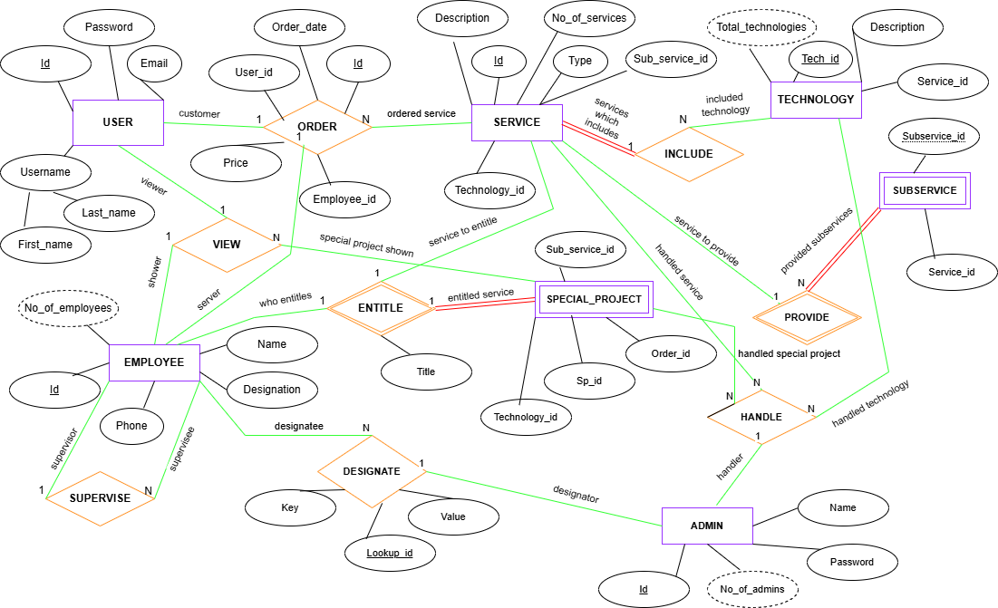

* **Preliminary UI Draft**

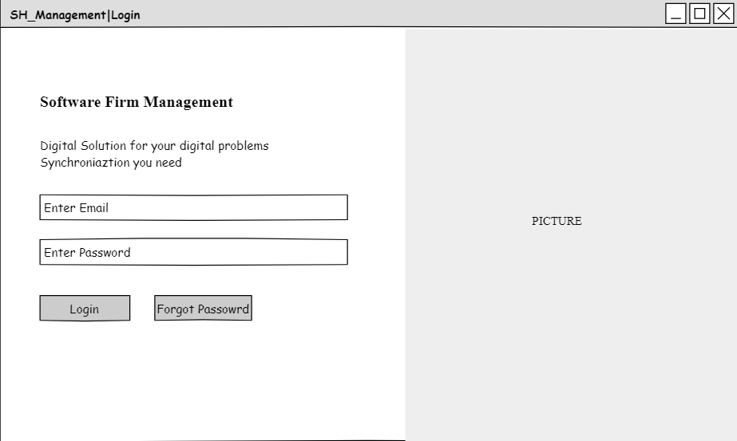

Login Interface

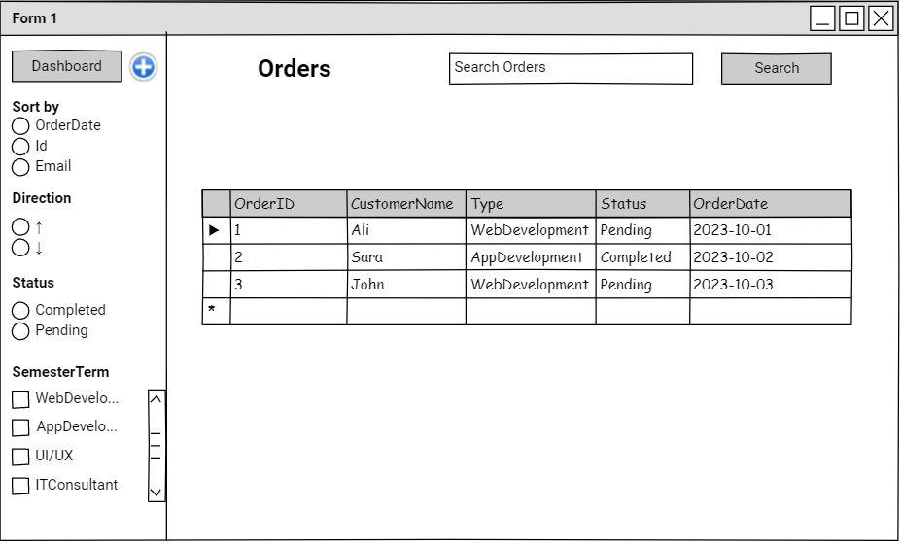

All Orders (Admin)

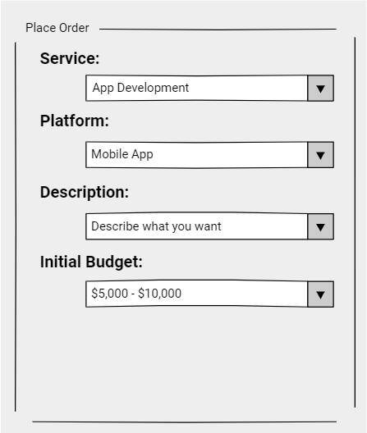

Order Placing (Customer)

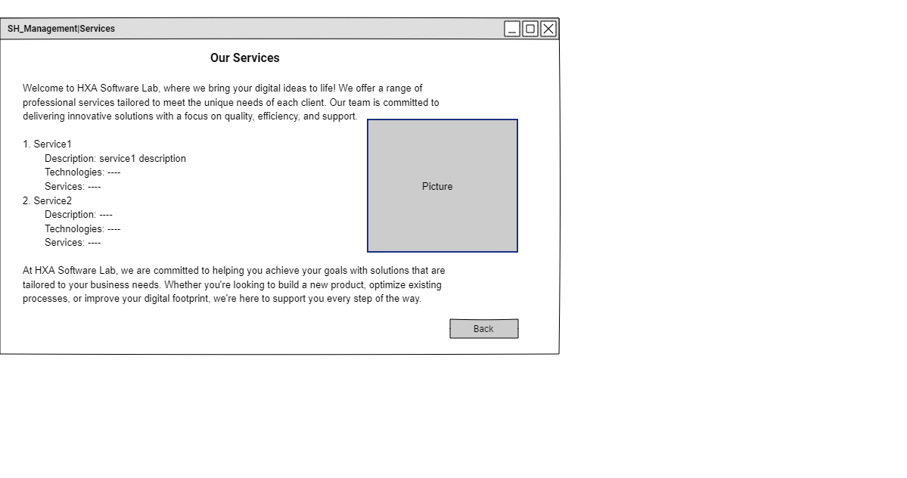

Our services(Customer)

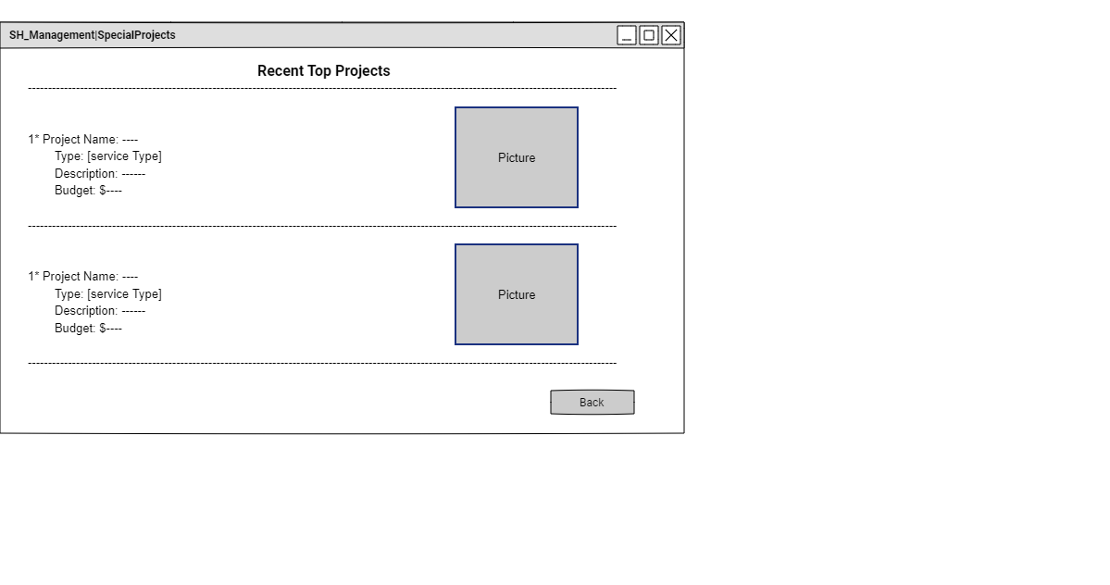

SpecialProjects(Customer)