Project Title

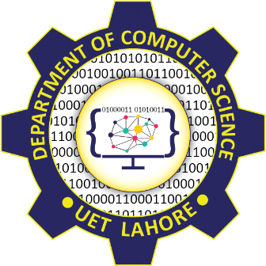

Submitted by:
Name 1 2024-CS-xx
Name 2 2024-CS-xx
Name 3 2024-CS-xx
Name 4 2024-CS-xx
Name 5 2024-CS-xx

Subject:
CSC-205L Computer Organization & Assembly Language
Session 2024 – 2028

Supervised by:
Syed Tehseen Ul Hasan Shah

Department of Computer Science
University of Engineering and Technology Lahore, Pakistan.

Abstract:

Introduction:

Methodology:

Implementation:

Data Flow Diagram (DFD):

Flowchart:

Circuit Diagram:

Future Work/Extension Suggestions:

References:

