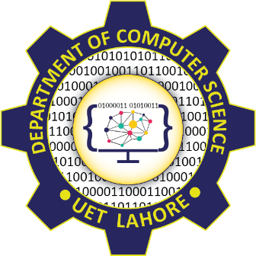

Session 2024 - 2028

Submitted by:
Muhammad Hassan Raza 2024-CS-213

Supervised by:
Syed Tehseen-ul-Hassan Shah

Course:
CSC-205L COAL LAB

Department of Computer Science
University of Engineering and Technology, Lahore Pakistan

Project Proposal

DeptSync

The Universal Digital Notice Board

Executive Summary
This proposal introduces DeptSync, a digital replacement for the traditional paper-based notice boards used within the university department. By utilizing an ESP32-controlled e-paper display system, this project aims to transition the department toward a more efficient, environmentally friendly, and real-time communication infrastructure.
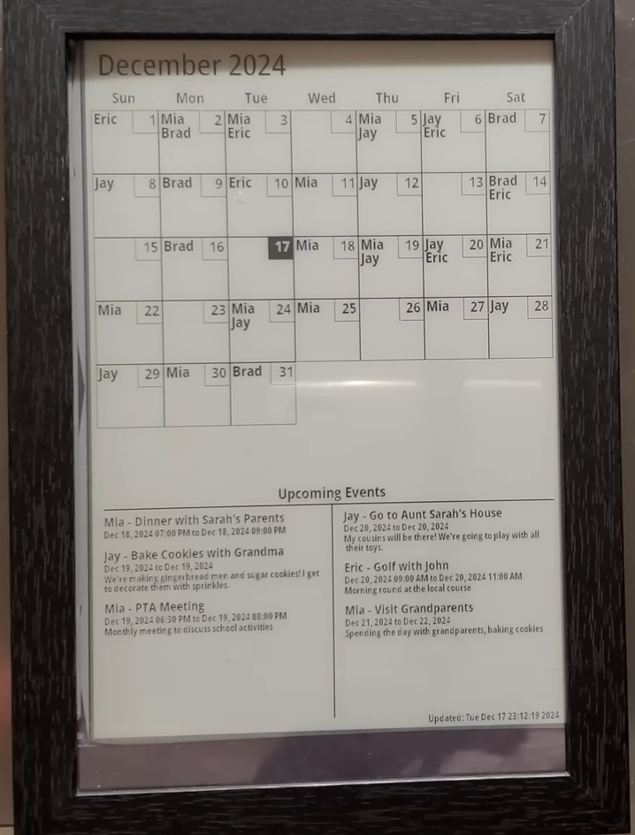

Problem Statement
The current reliance on physical notice boards presents several operational challenges:

Update Delays
- News and critical tasks are often not posted at the time they are needed, leading to information gaps [User Query].

Resource Inefficiency
- The continuous clipping of paper is not only labor-intensive for staff but also contributes significantly to environmental waste [User Query].

Clutter
- Physical boards become crowded with outdated memos, making it difficult for students and staff to identify the latest updates [User Query].

Proposed Solution
The DeptSync project proposes a sleek, wall-mounted "Todo Screen" inspired by existing e-paper calendar architectures. This system will serve as a centralized hub for all department news and tasks.

Automatic Synchronization
- The screen will fetch data directly from a digital source (such as Google Calendar or a dedicated app), ensuring that up to six or more upcoming events and tasks are displayed neatly and intuitively.

Effortless Management
- Staff can update information seamlessly through a mobile app or web interface, and the screen will automatically refresh to display the latest content.

Mesmerizing Visuals
- The e-paper screen updates one event at a time, creating a professional and "mesmerizing effect" that draws attention to new updates.

Hardware Requirements
To build a robust and energy-efficient system, the following hardware will be required, based on proven ESP32 project designs:

ESP32 Microcontroller
- Acts as the core of the system, handling Wi-Fi connectivity to fetch real-time data from the cloud.

High-Resolution E-Paper Display
- Selected for its low power consumption and professional, paper-like appearance.

Power Management System
- As e-paper only draws power during refreshes, the device can be battery-powered, allowing for a cordless and clean installation.

Professional Housing
- A repurposed picture frame or custom 3D-printed enclosure will be used to ensure the device matches the department's professional aesthetic.
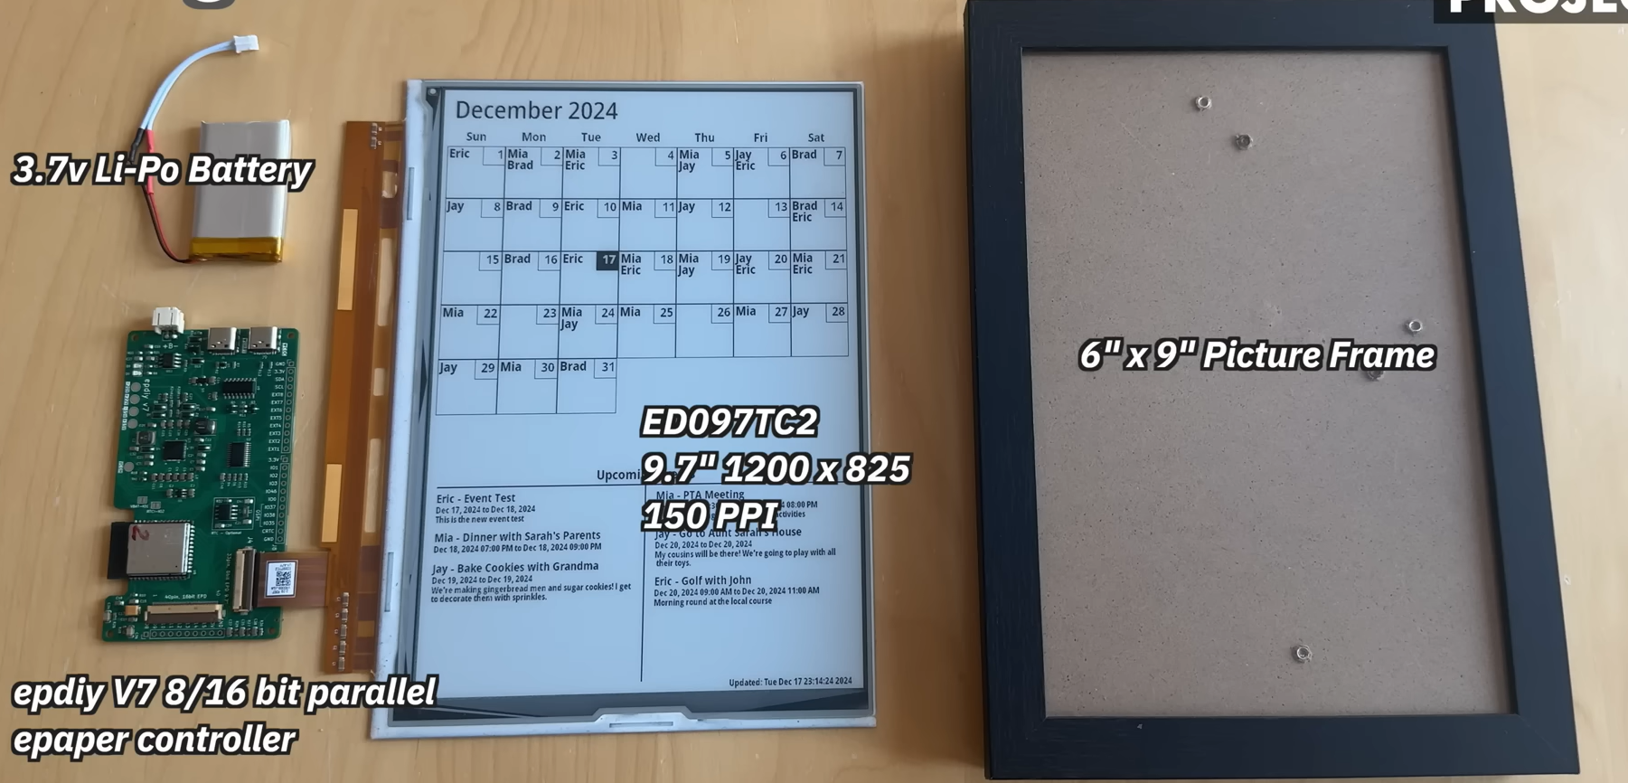

Problem Solved and Benefits

Real-Time Updates
- Eliminates the delay between a news event occurring and its appearance on the board, as the system can be programmed to refresh at specific intervals or immediately upon an update.

Environmental Sustainability
- By removing the need for paper and ink, the department contributes to a "green" campus initiative [User Query].

Operational Efficiency
- Staff are freed from the manual task of clipping papers; a single digital entry from an office computer or phone automatically syncs with the display.

Information Clarity
- The digital layout ensures that only the most relevant, upcoming tasks are visible, reducing cognitive load and information clutter.

