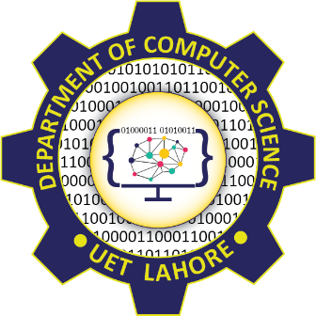

Session 2024 - 2028

Submitted by:
Muhammad Hassan Raza 2024-CS-213

Supervised by:
Syed Tehseen-ul-Hassan Shah

Course:
CSC-205L COAL LAB

Department of Computer Science
University of Engineering and Technology, Lahore Pakistan

Project Proposal

ESP32-Based

Universal Multimedia Control System

Executive Summary
This proposal outlines the development of a centralized Universal Remote system designed to streamline the operation of multimedia projectors within university lecture theaters and department rooms. By leveraging the ESP32 microcontroller's versatile connectivity, this project aims to eliminate the operational inefficiencies caused by lost remote controllers and the manual activation of ceiling-mounted equipment.
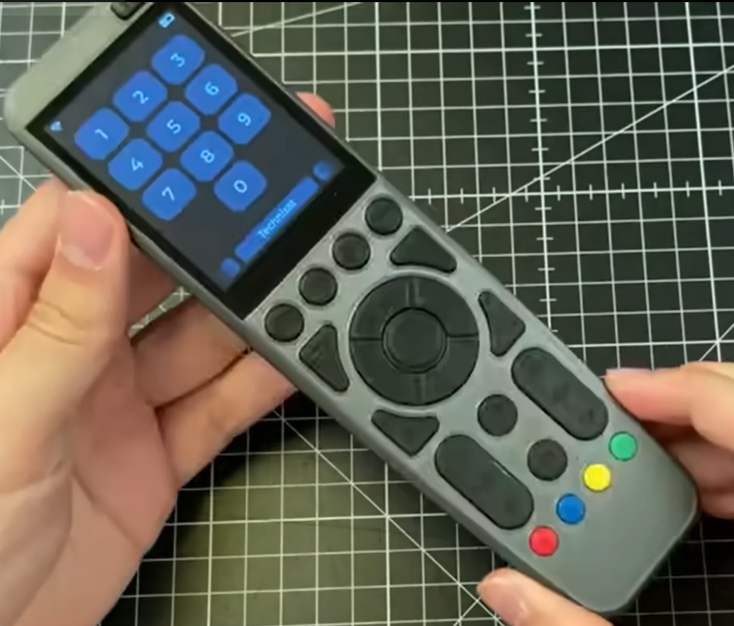

Problem Statement
The university department currently faces significant logistical challenges regarding its multimedia infrastructure. Most video projectors are mounted high on walls or ceilings, making physical access difficult. Staff are frequently forced to use manual implements, such as long sticks, to reach the "on" buttons [User Query]. Furthermore, the original remote controllers for many units have been lost, leading to delays in lectures and presentations [User Query]. There is a critical need for a singular, reliable device that can manage all multimedia units from a central location, such as the main department office.

Proposed Solution
The proposed solution is a custom-built, high-performance universal remote based on the ESP32 platform. This device will function as a "command center" capable of interfacing with various multimedia brands used across the department. Unlike standard remotes, this system will utilize a combination of Infrared (IR) for direct control and Wi-Fi/Bluetooth for potential network-based management, ensuring compatibility with both legacy and modern projectors. A single unit located in the main office will be programmed to control every multimedia device in the department, providing a professional and efficient alternative to current manual methods [User Query].

Hardware Requirements
To ensure a robust and user-friendly interface, the project will utilize the following hardware components based on proven ESP32 project architectures:

ESP32 Microcontroller
- The heart of the system, providing the necessary processing power and wireless connectivity (Wi-Fi and Bluetooth).

2.8-inch Capacitive Touchscreen
- Provides an intuitive and "snappy" user interface for selecting specific lecture theaters or projector models.

Infrared (IR) Transmitter
- Essential for mimicking the signals of the lost original remotes to power the projectors on and off.

Tactile Switch Grid
- A 5x5 grid of 24 tactile switches to allow for quick-access hotkeys for the most frequently used rooms.
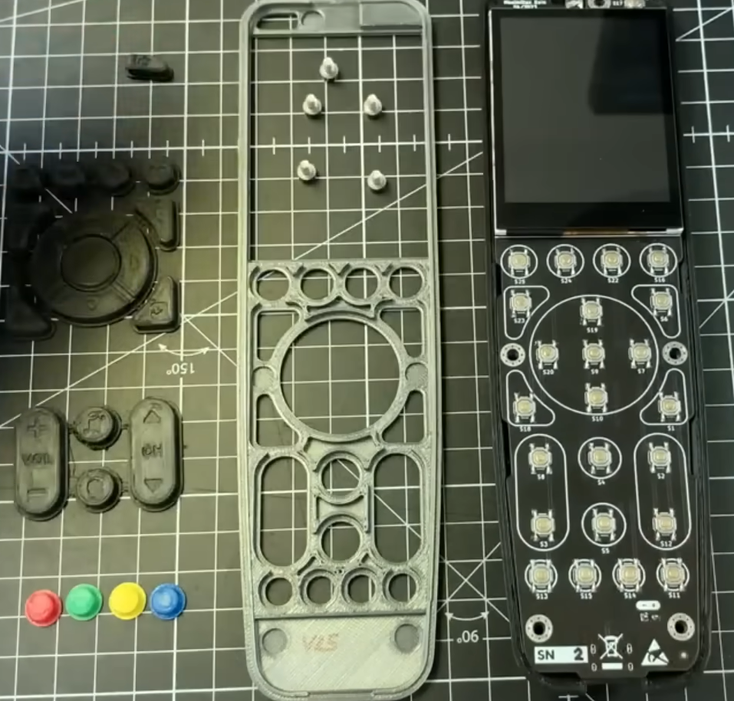

High-Capacity Battery & Power Management
- To allow the device to remain portable and run for months on a single charge through optimized power consumption.

Custom 3D Printed Enclosure
- To provide a professional finish and protect the internal electronics in a high-use environment.

5. Implementation and Benefits

Centralized Control
- A single remote can be programmed with the specific IR codes for every projector in the department, eliminating the need for multiple controllers.

Improved Accessibility
- Staff no longer need to physically reach for mounted equipment; all power commands can be sent from a distance or a central desk.

Customization
- As the design files and firmware are open-source, the system can be fully customized to include new projectors as the department upgrades its hardware.

Reliability
- By using a dedicated ESP32-based device with an optimized user interface, the department ensures a long-term, scientifically reliable solution for classroom management.

