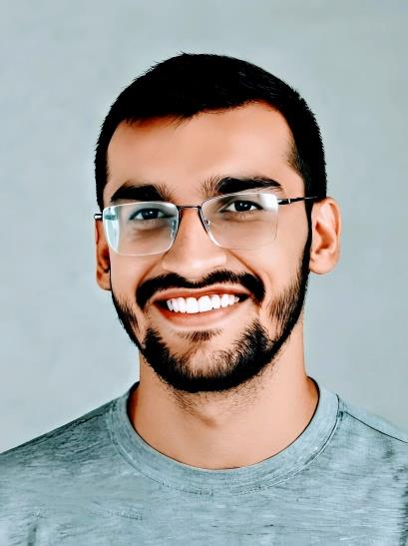

|  |  |  |
| --- | --- | --- |
| Profile |  | Muhammad  Irfan  **( fronted web developer )** |
| Within approx. two years’ experience in computing field. I have developed many on demand skills so that I can add some values to the community. Starting from graphic design soon I jumped to web development. Besides of it I have also great understanding of backed web development. Contact **PHONE:**  0343-1015961  **WhatsApp:**  0343-1015961  **LinkedIn:**  www.linkedin.com/in/irfan-riaz-06738b2a9  **Github**:  <https://github.com/M-Irfan-Riaz>  **EMAIL:**  riazr8873@gmail.com Supporting skills Adobe Photoshop and illustrator  SEO  Copy writer |  | EDUCATION   **FSC** **[2022-2023]**  I had done my FSC in Punjab college Taunsa with 85% plus  Marks.  **Matric[2021-2022]**  I had done my matric from High School Taunsa with 95%  Marks. WORK EXPERIENCE **Learning experience**  [ I have one year learning experience which is about **JavaScript** and **React JS**, **Node JS** and **Mongodb**. It consist of many beginner level projects]  **.**  **Open source projects**  [Participated in many **open source project** and started my own project **roadmap** which help to choose right path.] – **Website developer Instructor**  Taught 15 plus programming geeks for 2 month Boot camp**.** **SKILLS**  * **Fronted web development** * **Figma** * **Adobe Xd** * **Node JS** * **Express JS** * **MongoDB** |