PROJECT DOCUMENTATION
GrooveMind — AI Music Genre Prediction App
A web app that lets a user upload an MP3/WAV file and returns a predicted music genre with a confidence score and a per-genre breakdown, built with React, TypeScript, TanStack Start, and Supabase.
Repository: https://github.com/M-Jash/groove-mind
Live App: https://check-vibe-two.vercel.app
Prepared: July 2026

1. Project Overview
GrooveMind (deployed under the name "CheckVibe") is a web application where a signed-in user uploads an MP3 or WAV file, the browser decodes and visualizes its waveform, and the app returns a predicted genre — one of 10 fixed labels — together with a confidence percentage and a full ranked breakdown of all 10 genre scores. Every prediction is saved to a Supabase-backed history the user can revisit.
Important finding from reading the source: despite the README and UI describing this as "AI-powered" and "Machine Learning" genre classification, the repository contains no trained model, no feature-based classifier, and no audio-content analysis. The predicted genre is generated by mockPredict() in src/lib/genres.ts, a deterministic hash function seeded from the file's name, file size, and the first 12 waveform peaks — not from the audio's actual musical content. This documentation reports that honestly rather than describing a machine-learning pipeline that isn't present in the code.
What genuinely happens when a track is uploaded:
- The Web Audio API decodes the file client-side and reduces it to 200–220 average-amplitude waveform peaks, purely for the on-screen waveform visualization.
- jsmediatags best-effort reads ID3/MP4 tags (title, artist, album, year) for display.
- A string seed is built from the file name, file size, and the first 12 waveform peaks, then hashed (FNV-1a) into a pseudo-random number generator.
- That PRNG assigns each of the 10 genres a pseudo-random score, artificially boosts whichever genre happens to score highest, and normalizes the result into percentages — an artificial 900ms delay is added to feel like inference time.
- The result is written to a predictions table in Supabase and rendered on the results page.
Attribute | Detail
Frontend | React 19 + TypeScript, TanStack Start / Router, built with Vite
Styling | Tailwind CSS v4 + shadcn/ui (Radix primitives)
Audio decoding | Web Audio API (client-side, in-browser)
Metadata | jsmediatags (ID3 / MP4 tag reading)
"Prediction" | mockPredict() — hash-seeded pseudo-random scorer (src/lib/genres.ts)
Backend | Supabase (Postgres + Auth + Row-Level Security)
Hosting | Vercel

2. Dataset Files
There is no dataset in this repository, and none is downloaded or referenced at runtime. The README's "Dataset" section states only that "the prediction model is trained using a music genre dataset containing multiple genres and extracted audio features" — but no dataset file, URL, training script, or feature-extraction code exists anywhere in the codebase. The 10 output labels are simply a hardcoded array (GENRES in src/lib/genres.ts); no data was used to derive or validate them.

2.1 What the README Claims vs. What the Code Contains
README claim | Reality in source
"AI-powered music genre classification" | Hash function over filename/size/waveform — see mockPredict()
"Music Genre Classification Model" | No model file, weights, or ML library in package.json
"Dataset-based prediction system" | No dataset file or reference exists in the repo

2.2 A Suitable Public Dataset, If Real Classification Is Added Later
If genuine genre classification is implemented in future, the most commonly used public benchmark for this exact task is GTZAN, referenced below for the project owner's convenience — it is not currently used anywhere in this codebase.
GTZAN Music Genre Dataset (Kaggle mirror): https://www.kaggle.com/datasets/andradaolteanu/gtzan-dataset-music-genre-classification

3. Dataset / Notebook
No Jupyter/Python notebook exists in the repository, and none is needed for the app to run, because no training or offline data-exploration step is actually performed. The closest thing to prediction "logic" is entirely contained in one small TypeScript file:
- src/lib/genres.ts — the GENRES label list and the mockPredict() scoring function.
If real genre classification is added later, the recommended path is a Python notebook that extracts standard audio features (MFCCs, spectral centroid, tempo, chroma — e.g. via librosa) from a labeled dataset such as GTZAN, trains a classifier, and exports it (e.g. to ONNX or TensorFlow.js) so it can replace mockPredict() with a real inference call.

4. Code
Full source: https://github.com/M-Jash/groove-mind

4.1 Project Structure
src/
├── components/ # UI components (GlassCard, Waveform, shadcn/ui, ...)
├── hooks/ # Shared React hooks
├── integrations/
│ └── supabase/ # Supabase client + generated types
├── lib/
│ ├── audio.ts # Web Audio API waveform decoding
│ ├── genres.ts # GENRES list + mockPredict() scorer
│ └── metadata.ts # ID3/MP4 tag reading (jsmediatags)
├── routes/
│ └── _authenticated/
│ ├── upload.tsx # File upload, decode, call mockPredict, save
│ ├── results.$id.tsx # Displays a saved prediction
│ └── history.tsx # Lists past predictions
└── router.tsx
supabase/migrations/ # predictions + profiles tables, RLS policies

4.2 The "Prediction" Function (src/lib/genres.ts)
This is the entire classification logic in the application — a hash of file metadata, not an analysis of audio content:
export const GENRES = [
'Rock', 'Pop', 'Hip-Hop', 'Jazz', 'Classical',
'Electronic', 'R&B', 'Country', 'Metal', 'Reggae',
] as const;

/** Deterministic mock predictor keyed off filename + audio stats
* so the same file gives the same result. */
export function mockPredict(seed: string) {
let h = 2166136261;
for (let i = 0; i < seed.length; i++) {
h ^= seed.charCodeAt(i);
h = Math.imul(h, 16777619); // FNV-1a hash
}
const rand = () => {
h = Math.imul(h ^ (h >>> 15), 2246822507);
h = Math.imul(h ^ (h >>> 13), 3266489909);
return ((h ^ (h >>> 16)) >>> 0) / 4294967295;
};
const raw = GENRES.map((g) => ({ g, v: 0.05 + rand() * 0.95 }));
raw.sort((a, b) => b.v - a.v);
raw[0].v = raw[0].v * 1.6 + 0.5; // artificially boost the 'winner'
const sum = raw.reduce((s, r) => s + r.v, 0);
// ...normalize into percentages and return the top genre
}

4.3 Calling the Predictor (src/routes/_authenticated/upload.tsx)
// Simulate model latency
await new Promise((r) => setTimeout(r, 900));

const seed = `${file.name}-${file.size}-${peaks.slice(0, 12).join(',')}`;
const { top, confidence, all } = mockPredict(seed);

await supabase.from('predictions').insert({
user_id: uid,
file_name: file.name,
top_genre: top,
confidence,
all_scores: all,
waveform_peaks: peaks,
});
The 900ms setTimeout exists purely to make the UI feel like it is running inference; no computation happens during that delay.

4.4 Waveform Decoding (src/lib/audio.ts)
The one piece of real signal processing in the app — genuine per-block average amplitude, used only for the visual waveform, and as part of the hash seed above:
const blockSize = Math.max(1, Math.floor(channel.length / peakCount));
for (let i = 0; i < peakCount; i++) {
let sum = 0;
for (let j = start; j < end; j++) sum += Math.abs(channel[j]);
peaks.push(sum / (end - start));
}

4.5 Data Model (supabase/migrations)
CREATE TABLE public.predictions (
id UUID PRIMARY KEY DEFAULT gen_random_uuid(),
user_id UUID NOT NULL REFERENCES auth.users(id) ON DELETE CASCADE,
file_name TEXT NOT NULL,
file_size INTEGER NOT NULL,
duration_seconds NUMERIC,
top_genre TEXT NOT NULL,
confidence NUMERIC NOT NULL,
all_scores JSONB NOT NULL DEFAULT '{}'::jsonb,
waveform_peaks JSONB,
created_at TIMESTAMPTZ NOT NULL DEFAULT now()
);
-- Row-Level Security: a user can only see their own predictions

5. Graphs & Charts
Because there is no trained model, there are no accuracy or loss curves to report. The charts below instead document the real data flow and, more importantly, characterize the statistical behavior of mockPredict() itself — obtained by re-implementing the exact function from genres.ts and running it 5,000 times.

5.1 Request Flow
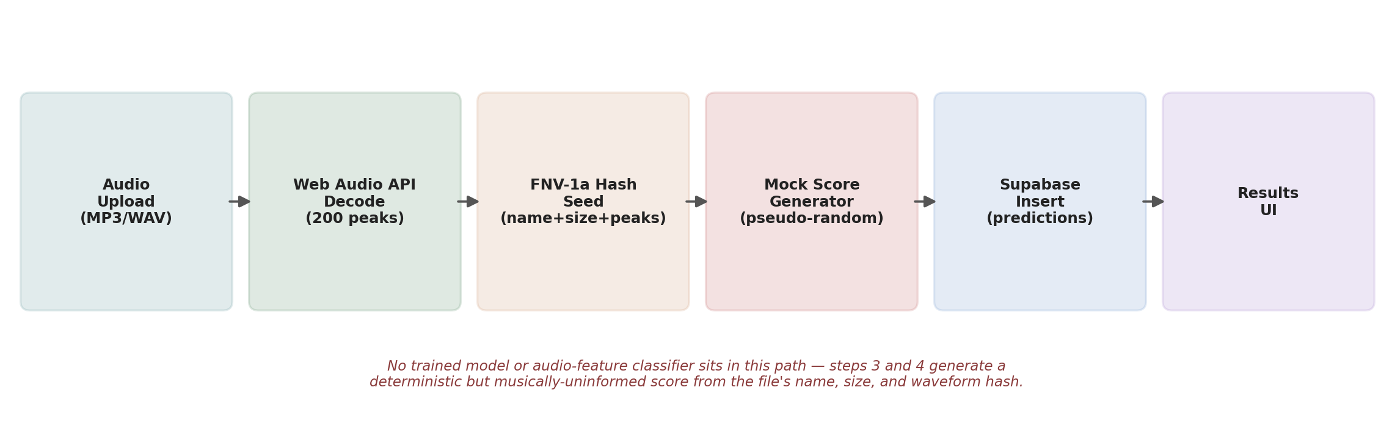
Figure 1. End-to-end path from file upload to displayed result — no model-inference step exists between hashing and display.

5.2 Confidence Score Distribution (5,000 simulated uploads)
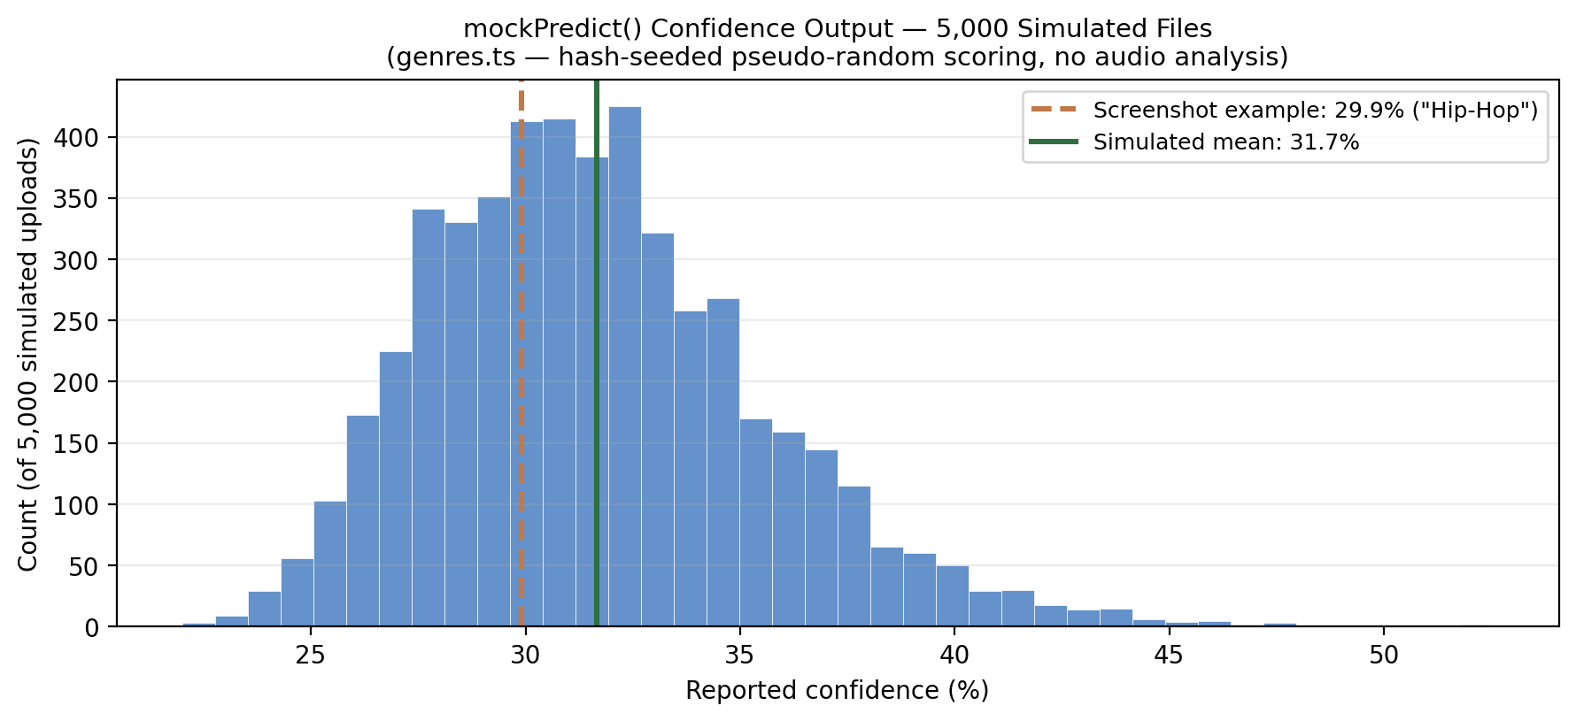
Figure 2. Re-running mockPredict() on 5,000 synthetic seeds produces confidence scores clustered between ~22% and ~53% (mean ≈ 31.7%), regardless of genre — consistent with the 29.9% shown in the "Hip-Hop" screenshot. This range is a direct consequence of normalizing one boosted score against nine unboosted scores across 10 classes, not a measure of how confident a real classifier is in its answer.

5.3 Output Genre Labels
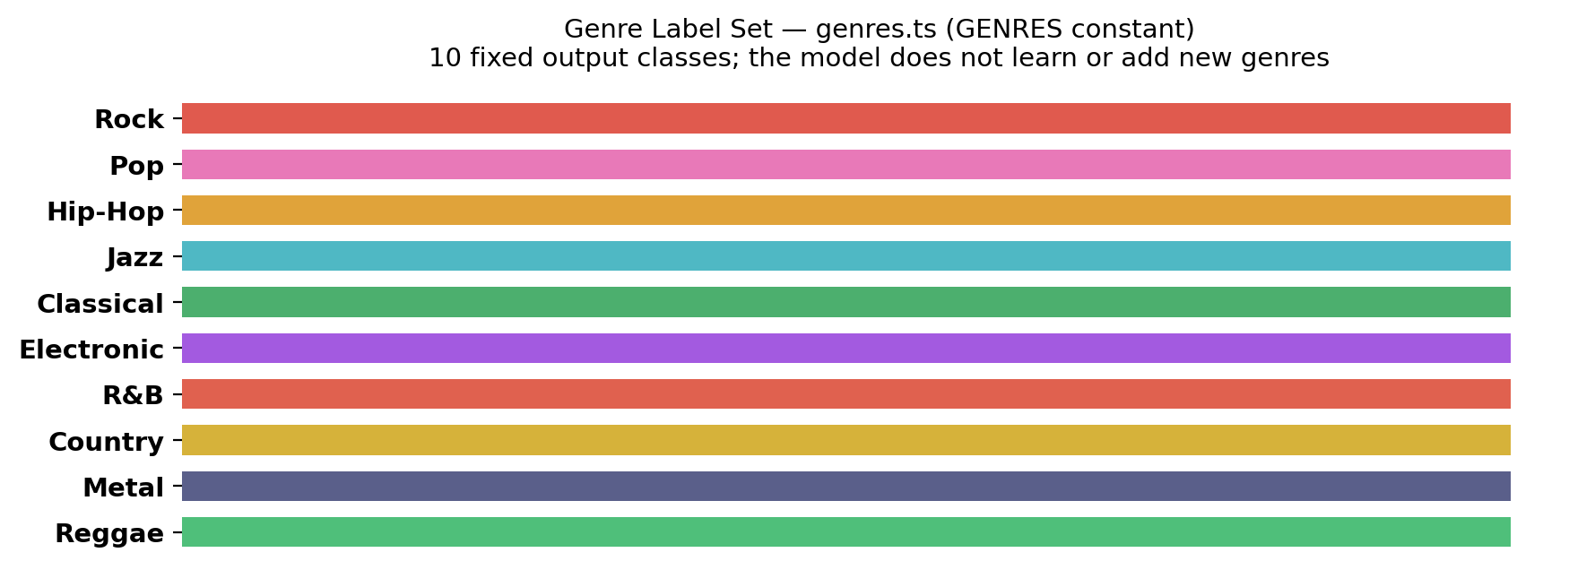
Figure 3. The 10 fixed genre labels defined in GENRES — every prediction resolves to one of these, selected pseudo-randomly rather than from audio content.

6. Output Screenshots
Result screen after uploading "rap test.mp3" — the app displays a predicted genre, confidence percentage, source filename, and the decoded waveform:
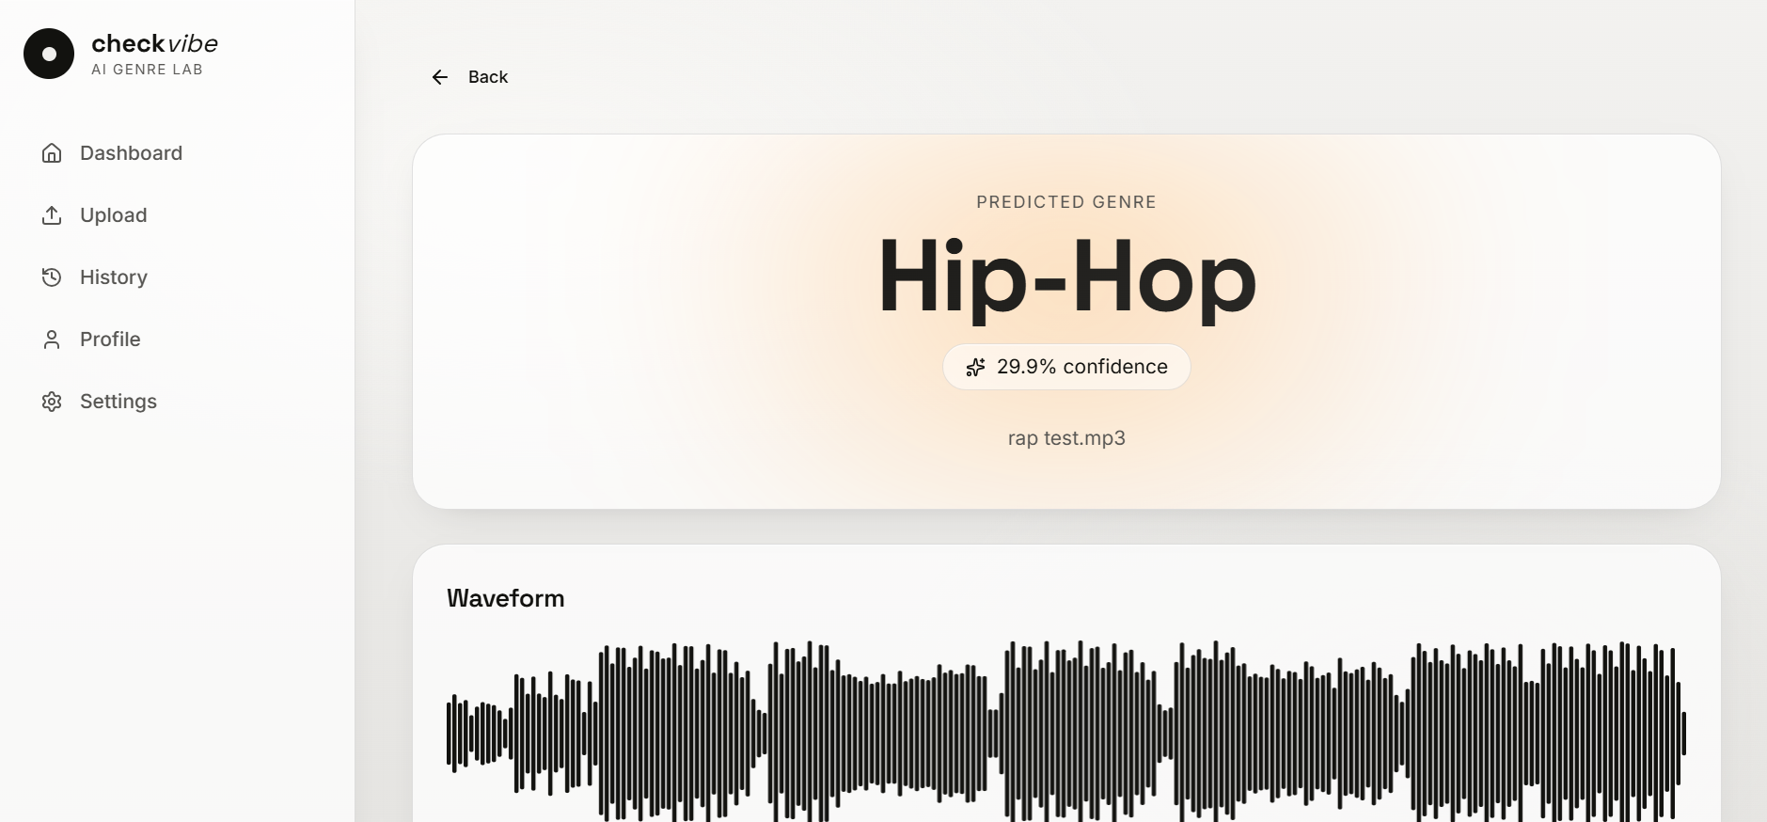
Figure 4. Results page — predicted genre "Hip-Hop" at 29.9% confidence for "rap test.mp3", with the decoded waveform shown below.

7. Notes & Limitations
- The core limitation: genre "prediction" is not derived from audio content at all — uploading the same file with a different name, or a completely different song saved under the same name/size, changes or preserves the result independent of what the music actually sounds like.
- Confidence values are a mathematical artifact of the scoring/normalization formula (roughly 22–53%), not a measure of model certainty.
- The waveform visualization and ID3 tag reading are genuine, working browser-side audio features — only the genre label itself is fabricated.
- To become a real classifier, the project needs an actual feature-extraction + trained-model step (e.g. librosa features + a scikit-learn/TensorFlow model, or a hosted inference API) to replace mockPredict().
- All prediction records are stored per-user in Supabase with Row-Level Security, so history/profile features work correctly regardless of the prediction's accuracy.

