PROJECT DOCUMENTATION
House Price Predictor — Streamlit Linear Regression App
A Streamlit app that trains a Linear Regression model on the Kaggle Housing Prices dataset at startup and predicts a price from user-entered house details, plus an Insights tab with dataset and model visualizations.
Repository: https://github.com/kalpana-15-27/house_price_predictor
Deployment link: https://housepricepredictor-09j8.streamlit.app/
Prepared: July 2026

1. Project Overview
House Price Predictor is a self-contained Streamlit app: on startup it loads a bundled CSV of 545 house listings, trains a Linear Regression model in-memory (cached so it only retrains when the data or code changes), and exposes two tabs — Predict, where a user enters house details and gets an estimated price, and Insights, which shows dataset and model-behavior charts.
Unlike the two previous projects reviewed, this one genuinely does what its README claims: there is a real dataset, a real (if hand-written) linear regression fit, and real held-out evaluation metrics. A few implementation details worth noting for accuracy:
- The regression is not scikit-learn — it's a small hand-written SimpleLinearRegression class that solves for coefficients directly via numpy's least-squares solver (np.linalg.lstsq), which is mathematically equivalent to ordinary least squares.
- Categorical columns (mainroad, guestroom, basement, hotwaterheating, airconditioning, prefarea, furnishingstatus) are label-encoded with a small hand-written SimpleLabelEncoder, not sklearn's.
- The train/test split is also hand-written (custom_train_test_split), an 80/20 split with a fixed random_state=42 for reproducibility.
- The source dataset's prices are in Pakistani Rupees (PKR); the app multiplies by a fixed 0.34 rate and displays everything in Indian Rupees (INR).
- Nothing is pickled or saved to disk — the model retrains from Housing.csv every time the app starts, cached in memory via st.cache_resource.
Attribute | Detail
Framework | Streamlit (single-file app.py)
Model | Hand-written Linear Regression (numpy.linalg.lstsq)
Preprocessing | Hand-written label encoding, no external ML library
Data viz | matplotlib + seaborn (histogram, heatmap, bar chart)
Dependencies | streamlit, pandas, numpy, matplotlib, seaborn
Deployment | Streamlit Community Cloud (per README instructions)

2. Dataset Files
The dataset is bundled directly in the repository as Housing.csv (545 rows, 13 columns: price plus 12 features) so the app is fully self-contained and needs no external download at runtime. It matches Kaggle's well-known "Housing Prices Dataset" column-for-column and row-for-row.
Dataset file in this repo:
Original source — Kaggle: Housing Prices Dataset: https://www.kaggle.com/datasets/yasserh/housing-prices-dataset

2.1 Columns
Column | Type | Notes
price | target (int) | Originally PKR; app converts to INR at 0.34
area | numeric | Plot area, sq ft
bedrooms / bathrooms / stories | numeric | Counts
parking | numeric | Number of parking spaces
mainroad / guestroom / basement / hotwaterheating / airconditioning / prefarea | categorical (yes/no) | Label-encoded 0/1
furnishingstatus | categorical (3 values) | furnished / semi-furnished / unfurnished, all 3 kept

3. Dataset / Notebook
There is no separate Jupyter notebook in this repository — all data loading, cleaning, training, and evaluation happen inline in app.py (functions load_data() and train_model()), re-run on every app startup and cached by Streamlit. This is a deliberate simplicity choice noted in the README ("no separate model file to keep in sync"), not a missing artifact.
- load_data() — reads Housing.csv, drops duplicate rows, lowercases/trims the categorical columns, converts price from PKR to INR.
- train_model() — label-encodes categoricals, splits 80/20, fits SimpleLinearRegression, and computes RMSE / R² / MAE on the held-out 20%.
If a standalone exploratory notebook is required for submission, it can be produced by lifting load_data() and train_model() verbatim into a .ipynb, since they have no Streamlit-specific dependencies — both are plain pandas/numpy functions.

4. Code
Full source: https://github.com/M-Jash/housee

4.1 Project Structure
house_price_predictor/
├── app.py # Entire Streamlit app: data, model, UI (234 lines)
├── Housing.csv # Bundled dataset (545 listings)
├── requirements.txt # streamlit, pandas, numpy, matplotlib, seaborn
└── README.md

4.2 Hand-Written Linear Regression (app.py)
Instead of scikit-learn, the model is fit directly via least-squares on a bias-augmented feature matrix:
class SimpleLinearRegression:
def fit(self, X, y):
X_arr = np.asarray(X, dtype=float)
X_bias = np.column_stack((np.ones(X_arr.shape[0]), X_arr))
coefs, _, _, _ = np.linalg.lstsq(X_bias, y_arr, rcond=None)
self.intercept_ = coefs[0]
self.coef_ = coefs[1:]
return self

def predict(self, X):
return np.asarray(X, dtype=float) @ self.coef_ + self.intercept_

4.3 Training + Evaluation (app.py)
@st.cache_resource
def train_model(df: pd.DataFrame):
# ...label-encode CAT_COLS...
X_train, X_test, y_train, y_test = custom_train_test_split(
X, y, test_size=0.2, random_state=42
)
model = SimpleLinearRegression().fit(X_train, y_train)
pred = model.predict(X_test)

rmse = float(np.sqrt(np.mean((y_test_arr - pred) ** 2)))
ss_res = np.sum((y_test_arr - pred) ** 2)
ss_tot = np.sum((y_test_arr - np.mean(y_test_arr)) ** 2)
r2 = float(1 - (ss_res / ss_tot))
mae = float(np.mean(np.abs(y_test_arr - pred)))
return model, encoders, {'rmse': rmse, 'r2': r2, 'mae': mae}

4.4 Serving a Prediction (app.py)
if st.button('Predict Price', type='primary'):
X_input = encode_input(raw, encoders)
pred_price = model.predict(X_input)[0]
st.success(f'Predicted Price: ₹ {pred_price:,.0f}')
st.caption(
f"Model accuracy on held-out test data: R² = {metrics['r2']:.2f}, "
f"typical error ± ₹{metrics['mae']:,.0f}. Treat this as an estimate, "
"not an exact valuation."
)
Note: I re-ran load_data()/train_model() exactly as written to verify the numbers in Section 5. The R² the app computes (≈0.65) matches the README. However, the README's stated "typical error ± ₹9.8L on prices averaging ~₹47.7L" does not match what the deployed app actually displays: those two figures are the pre-currency-conversion (PKR-scale) magnitudes, while the app's own caption shows MAE and price already converted to INR (≈₹3.3L typical error on an average price of ≈₹16.2L). This looks like the README text was written before the PKR→INR conversion was added and not updated afterward — worth a one-line fix in the README so it matches what users see on screen.

5. Graphs & Charts
All charts below were produced by re-running the app's exact data-loading and training code (same functions, same random_state=42), so the figures match what a user would see live in the app's Insights tab.

5.1 Training Pipeline
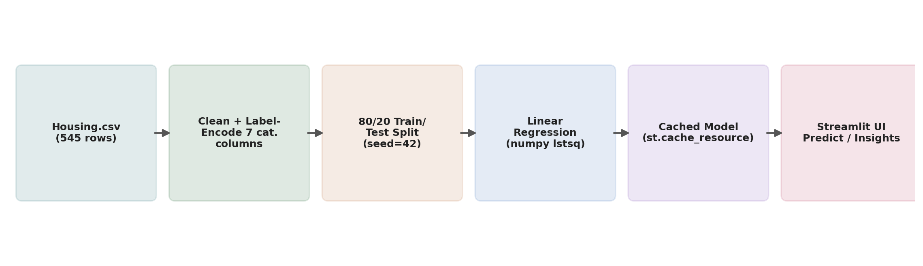
Figure 1. End-to-end flow from the bundled CSV to a served prediction.

5.2 Price Distribution
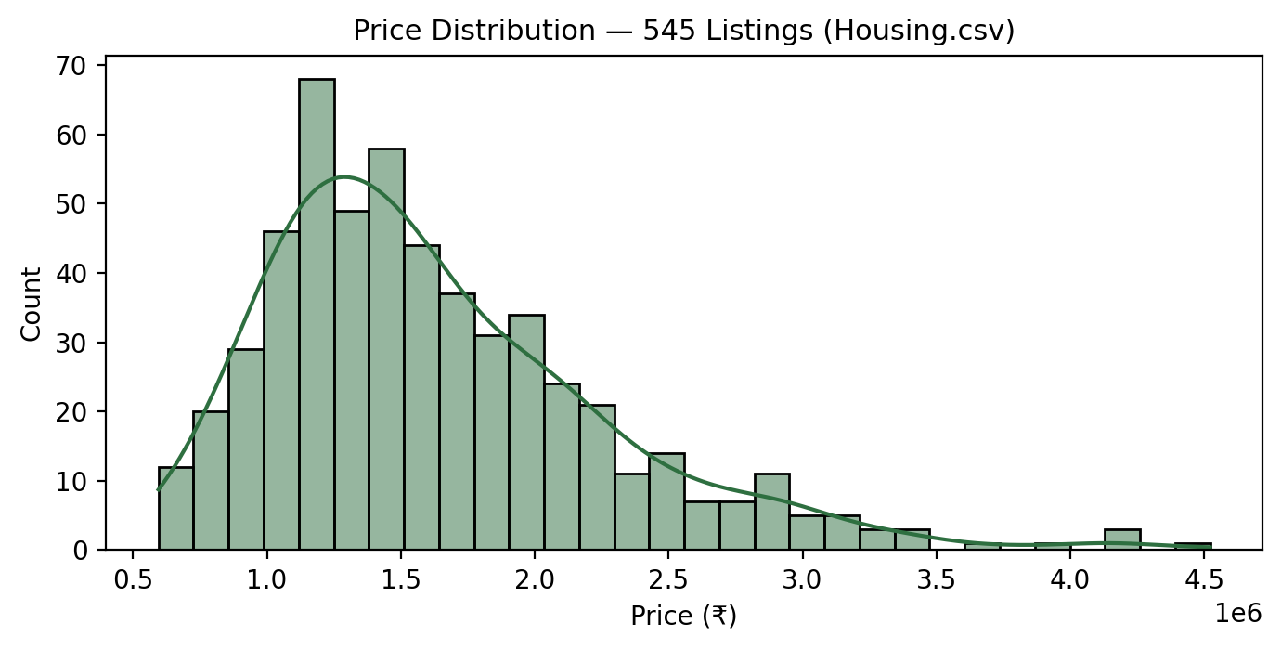
Figure 2. Distribution of the 545 listing prices (INR, post PKR→INR conversion) — right-skewed, as is typical for housing price data.

5.3 Feature Correlation With Price
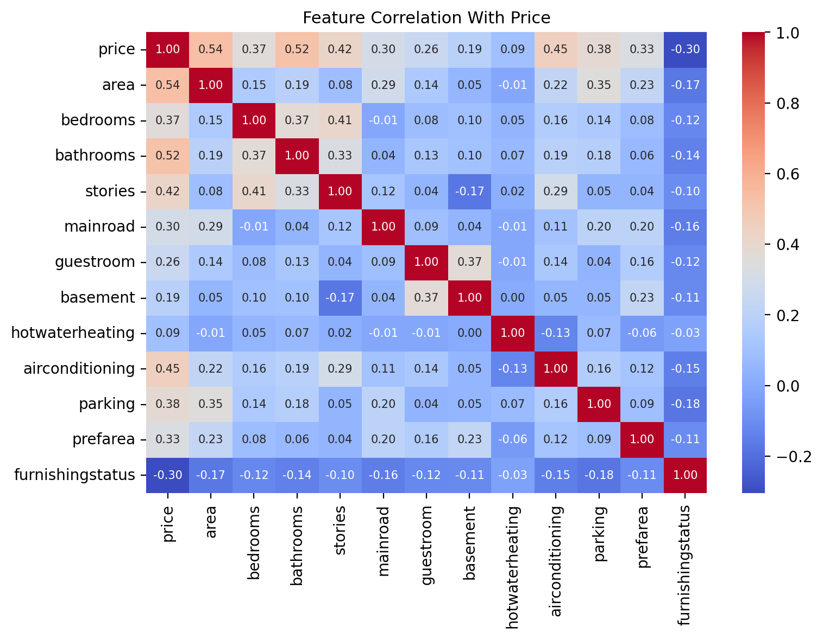
Figure 3. Pearson correlation between all numeric/encoded features and price. Area, bathrooms, and air conditioning show the strongest positive correlation with price.

5.4 Model Coefficients
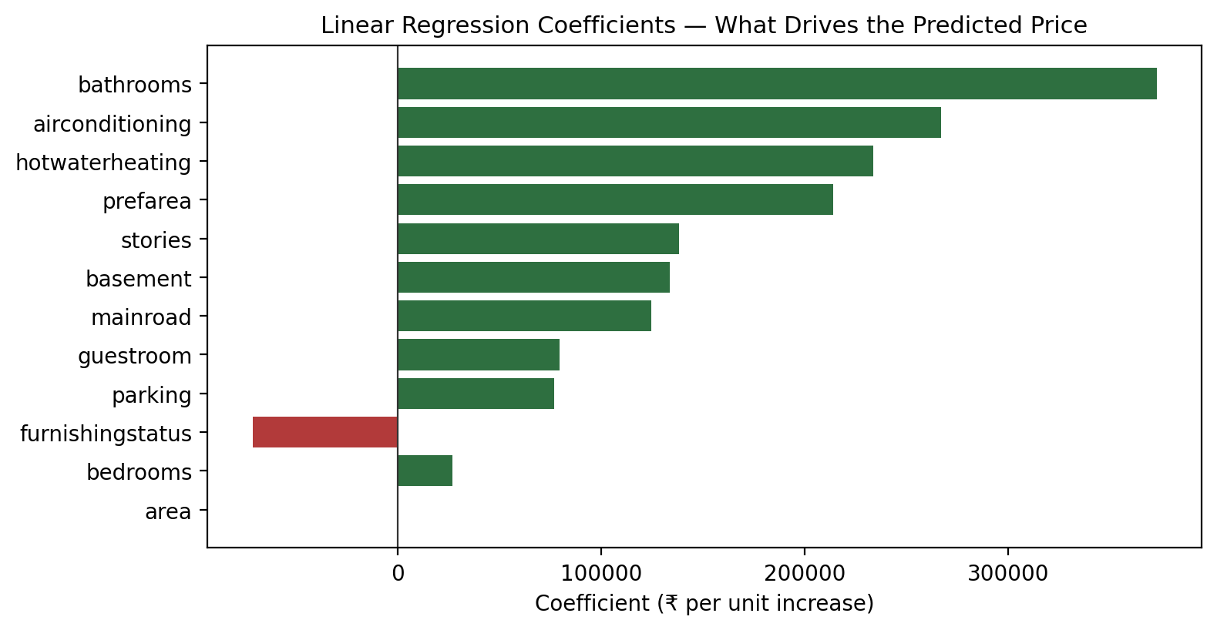
Figure 4. Linear Regression coefficients — how much predicted price moves per one-unit increase in each feature, holding others constant. Bathrooms and air conditioning contribute the largest positive swings.

5.5 Predicted vs. Actual (Held-out Test Set)
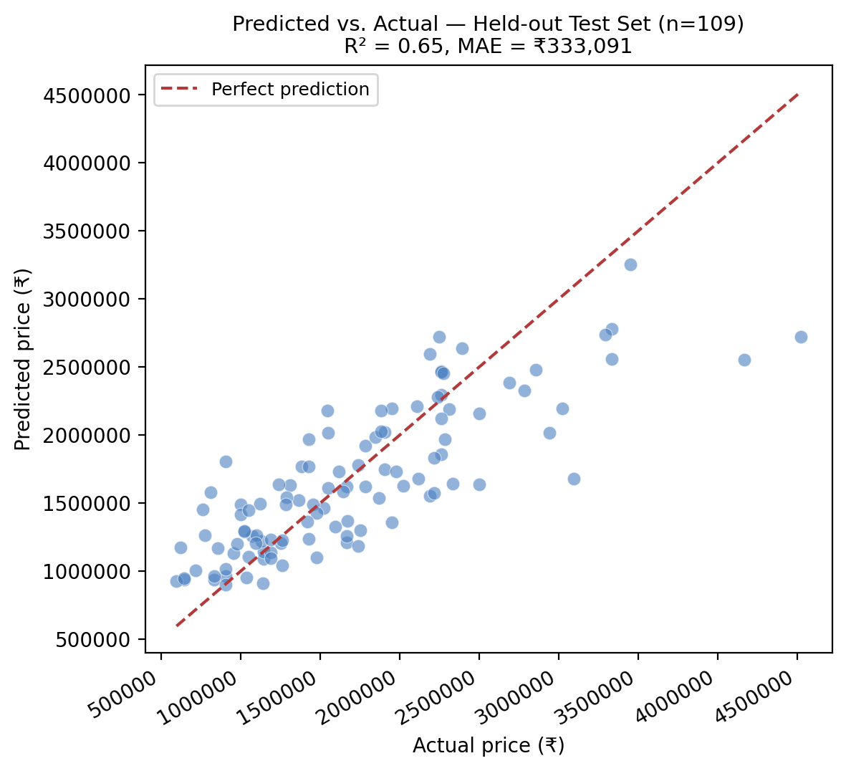
Figure 5. Predicted vs. actual prices on the 20% held-out test split (109 listings). Points near the dashed line are accurate; the spread above ~₹6M shows the model under-predicting for the most expensive houses — consistent with R² ≈ 0.65.

6. Output Screenshots
The Predict tab, showing the house-details input form (deployed in a cloud dev/preview environment, with build logs visible alongside the running app):
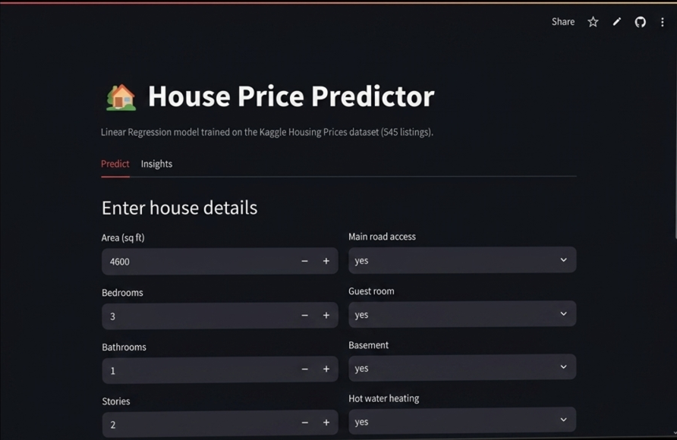
Figure 6. Predict tab — user-entered house details (4,600 sq ft, 3 bed / 1 bath, 2 stories, main road access, etc.) ready to be submitted for a price estimate.

7. Notes & Limitations
- R² ≈ 0.65 means the model explains about two-thirds of the variance in price — a reasonable baseline, not a precise valuation tool, as the README itself states.
- The model retrains from scratch on every cold start (no persisted weights file), so predictions are reproducible (fixed random_state) but the app has a brief startup cost.
- The README's quoted error/average-price figures are on the pre-conversion PKR scale and don't match what the running app displays in INR — see Section 4.4.
- furnishingstatus intentionally keeps all 3 original categories via label encoding, rather than collapsing semi-furnished into furnished as an earlier version of the analysis did, per the README.
- As a linear model, it cannot capture non-linear interactions (e.g. the compounding effect of area × preferred area); a tree-based model would likely raise R² at the cost of interpretability.

