Question 1: Optimal Binary Search Tree (OBST)
Title
Optimal Binary Search Tree Using Dynamic Programming
Aim
To construct an Optimal Binary Search Tree that minimizes the expected search cost.
Python Code
def optimal_bst(keys, freq, n):
cost = [[0] * n for _ in range(n)]
for i in range(n):
cost[i][i] = freq[i]
for L in range(2, n + 1):
for i in range(n - L + 1):
j = i + L - 1
cost[i][j] = float('inf')
total = sum(freq[i:j + 1])
for r in range(i, j + 1):
c = total
if r > i:
c += cost[i][r - 1]
if r < j:
c += cost[r + 1][j]
cost[i][j] = min(cost[i][j], c)
return cost[0][n - 1]
keys = [10, 12, 20]
freq = [34, 8, 50]
print("Minimum Cost =", optimal_bst(keys, freq, len(keys)))
Input
Keys = [10, 12, 20]
Freq = [34, 8, 50]
Output
Minimum Cost = 142
Time Complexity
O(n³)
Space Complexity
O(n²)
Result
The minimum search cost obtained is 142.
Conclusion
Dynamic Programming efficiently finds the optimal BST structure and minimizes search cost.
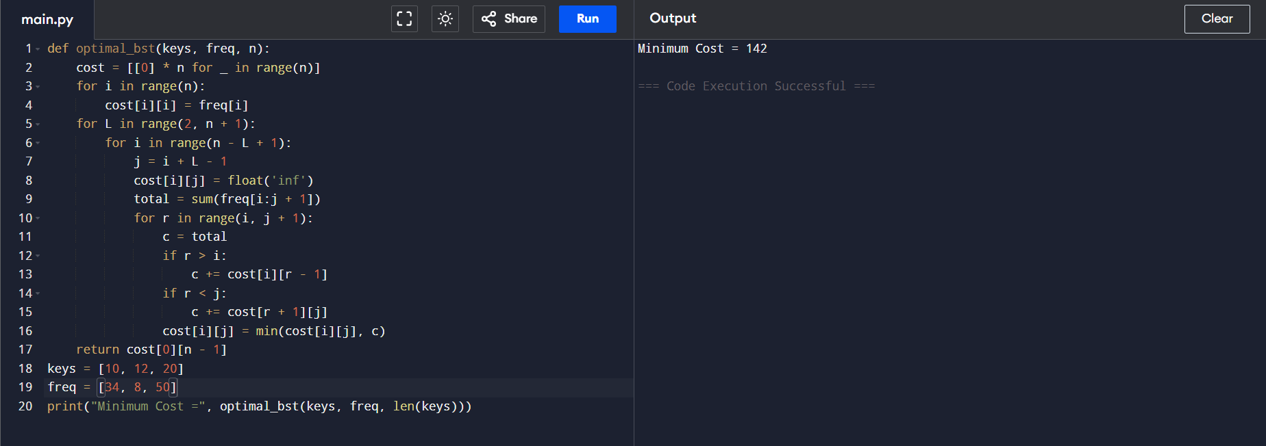

Question 2: Count Palindromic Substrings
Title
Count Palindromic Substrings Using Dynamic Programming
Aim
To count all palindromic substrings present in a string.
Python Code
def count_palindromes(s):
n = len(s)
dp = [[False] * n for _ in range(n)]
count = 0
for gap in range(n):
for i in range(n - gap):
j = i + gap
if gap == 0:
dp[i][j] = True
elif gap == 1:
dp[i][j] = (s[i] == s[j])
else:
dp[i][j] = (s[i] == s[j] and dp[i + 1][j - 1])
if dp[i][j]:
count += 1
return count
s = "aaa"
print("Count =", count_palindromes(s))
Input
s = "aaa"
Output
Count = 6
Palindromic Substrings
a
a
a
aa
aa
aaa
Time Complexity
O(n²)
Space Complexity
O(n²)
Result
Total palindromic substrings = 6.
Conclusion
Dynamic Programming efficiently counts all palindromic substrings by storing previously computed results and avoiding redundant calculations.
