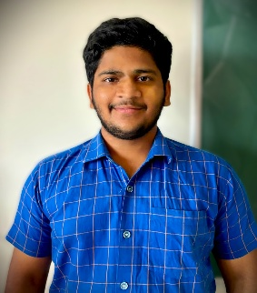
M Mallikarjuna Swamy

Interests, Hobbies:
Cricket, Dance, Kabbadi, Football
2022 - 2026
CGPA: 8.48/10.0
2022 Percentage: 80%
2020 Percentage: 64%

Education:
BE in Artificial Intelligence & Machine Learning
Ballari Institute of Technology and Management
12th Grade Sri Chaitanya PU College
10th Grade Dream World School

Internships:
- Python Intern – EZ Training & Technologies (EZTS) : (May 2024)
Developed and tested Python-based applications for real-world use cases- Strengthened debugging, collaboration, and agile development skills- Gained exposure to industry-standard software practices

Certificates:
● Python Course Certification – EZ Trainings and Technologies
● HackB-24 Hackathon Participation Certificate –BITM (24/02/2024)
● National Level STTP 2k24 Participation Certificate (On JAVA Full Stack with React JS&AI)–Organized by BITM

Projects:
• AI-Powered Virtual Interviewer(web app in which Virtual mock Interview for students to simulate a real-time virtual interviewer that interacts with candidates, evaluates their aptitude, communication skills, provides instant feedback.)Project Link https://github.com/M-Mallikarjuna5617/AI_Powered_Virtual_Interviewer
•Daily Task Manager (Mobile App for Daily Task Management using Andriod studio )
Project Link: https://github.com/M-Mallikarjuna5617/Daily-task-manager
•SPAM Email- Classification using Navies Bayes Classifier(displays email as spam or not spam)
Project Link: https://github.com/M-Mallikarjuna5617/spam_classifier_project
•Inno-Stay Hotel And Staff Management(Manages staff hotel and user) Project Link :
https://github.com/M-Mallikarjuna5617/Innostay-Smart-Hotel-Management-Management-System

Technical Skills:
- Programming Languages: Python, Java, C, C++.
- Core Knowledge: Data Structures & Algorithms (DSA), Artificial Intelligence (AI), Machine Learning (ML), Database Management Systems (DBMS).
Professional Summary: Passionate Artificial Intelligence And Machine Learning student with a strong focus on solving complex, real-world problems through innovative thinking and practical development. Known for tackling challenging projects with a clear, analytical approach and the ability to break down large problems into manageable solutions. Comfortable working across different technologies and always eager to push boundaries and build something impactful.
Date of Birth: 17 Jun-2005
Current Address: Sp-Cricle, Bank Colony 6th cross, Ballari, Karnataka, India - 583104

Email: msmsmallikarjuna@gmail.com
Contact: 9347307009
Linked In: www.linkedin.com/in/m-mallikarjuna
Git Hub: https://github.com/M-Mallikarjuna5617

