SB8067 – SALESFORCE DEVELOPER

GOVERNMENT COLLEGE OF ENGINEERING, BODINAYAKANUR
DEPARTMENT OF COMPUTER SCIENCE AND ENGINEERING

WHATNEXT VISION MOTORS: SHAPING THE FUTURE OF MOBILITY WITH INNOVATION AND EXCELLENCE

PROJECT REPORT

TEAM LEADER:
923323104026 – MARISELVAN M

TEAM MEMBERS:
923323104030 – MUTHU SELVAN K
923323104047 – SUBAVAISHNUMURUGAN K
923323104045 – SREERAM M S

1. INTRODUCTION
1.1 Project Overview
WhatNext Vision Motors: Shaping the Future of Mobility with Innovation and Excellence is a Salesforce CRM-based project designed to improve vehicle ordering, dealership management, and customer service operations.
The project focuses on automating key business processes, including nearest dealer assignment, vehicle stock validation, order status updates, and test drive reminders. By integrating Salesforce custom objects, relationships, record-triggered flows, Apex triggers, and batch processing, the system reduces manual effort and improves operational efficiency.
1.2 Purpose
The primary purpose of this project is to develop a centralized and automated vehicle management system using Salesforce CRM. It aims to simplify vehicle ordering, ensure accurate inventory management, automate dealer assignments, and enhance customer satisfaction through efficient and reliable service.

2. USER STORY
WhatNext Vision Motors aims to improve vehicle purchasing and dealership operations through a centralized Salesforce CRM system. The project addresses challenges such as manual dealer assignment, inaccurate stock availability, and delays in vehicle order processing.
The proposed system automatically assigns dealers based on customer location, validates vehicle availability before order placement, and manages order statuses through automated processes. It also supports test drive scheduling and customer reminders to enhance service efficiency.
By integrating Salesforce automation tools, Apex triggers, and batch processing, the solution simplifies business operations, reduces manual intervention, and provides customers with a more reliable and convenient vehicle purchasing experience.

3. IDEATION PHASE
3.1 Problem Statement
WhatNext Vision Motors faces challenges in managing vehicle orders, dealer assignments, and stock availability efficiently. Manual processes can result in order delays, inaccurate inventory information, and difficulties in identifying suitable dealers based on customer location.
The project aims to overcome these challenges by implementing a Salesforce CRM-based system that automates dealer assignment, validates vehicle stock availability, and streamlines order processing to improve customer satisfaction and operational efficiency.
3.2 Empathy Map
User Persona: Vehicle Customer
- Think & Feel: Expects a simple vehicle purchasing process with accurate stock information.
- Hear: Receives updates from dealers regarding vehicle availability and order confirmation.
- See: Limited visibility into vehicle stock, nearby dealerships, and order status.
- Say & Do: Searches for available vehicles, contacts dealers, and tracks order progress.
- Pain: Delays in order confirmation, unavailable vehicles, and manual dealer coordination.
- Gain: Automatic dealer recommendations, accurate stock information, and timely order updates.
3.3 Brainstorming and Idea Prioritization
Ideas Considered:
- Continue managing vehicle orders and dealer information manually.
- Develop a basic vehicle booking and inventory tracking system.
- Implement a centralized Salesforce CRM application with automated workflows.
- Integrate stock validation, dealer assignment, and scheduled order processing.
Final Selection:
Salesforce CRM was selected as the preferred platform because it provides:
- Centralized management of vehicle, customer, dealer, and order records.
- Record-triggered flows for automated dealer assignment and customer notifications.
- Apex triggers for stock validation and order processing.
- Batch Apex and Scheduled Apex for automated bulk order updates.
- A scalable platform for improving dealership operations and customer experience.

4. REQUIREMENT ANALYSIS PHASE
4.1 Customer Journey Map
The customer journey illustrates the process of purchasing a vehicle through the WhatNext Vision Motors Salesforce application. It covers the key stages from customer registration to order confirmation and delivery.
Customer Journey Flow:

Customer Registration

Vehicle Selection

Stock Availability Check

Nearest Dealer Recommendation

Order Placement

Order Confirmation & Status Tracking

Vehicle Delivery

The customer journey begins with customer registration and vehicle selection through the Salesforce application. The system checks vehicle stock availability and recommends a suitable dealer based on the customer's location. Customers can then place orders for available vehicles and track their order status until delivery. This streamlined process improves convenience, transparency, and customer satisfaction. This process ensures efficient order management, accurate stock validation, and a seamless customer experience.
4.2 Solution Requirements
The system requirements are classified into functional and non-functional requirements to ensure efficient performance and reliable operation.
Functional Requirements
FR No. | Requirement
FR-1 | Manage vehicle details, models, pricing, and stock availability.
FR-2 | Maintain customer and authorized dealer information.
FR-3 | Automatically assign dealers based on customer location.
FR-4 | Validate vehicle stock availability before order placement.
FR-5 | Automate vehicle order confirmation and status updates.
FR-6 | Manage test drive bookings and automated email reminders.
FR-7 | Process bulk order records using Batch Apex and Scheduled Apex.
FR-8 | Track vehicle service requests and their statuses.
Non-Functional Requirements
Requirement | Description
Usability | Provide an easy-to-use Salesforce Lightning interface.
Security | Manage data access through Salesforce profiles and permissions.
Reliability | Ensure accurate stock validation and order processing.
Performance | Support efficient record processing through automation.
Scalability | Accommodate increasing vehicle, customer, and order records.
Maintainability | Use modular Apex classes and reusable automation components.
4.3 Data Flow Diagram
The data flow represents how customer information, vehicle inventory, dealer records, and order details interact within the Salesforce application.
Data Flow:

Customer & Vehicle Selection

Stock Availability Check

Vehicle Available?

YES NO

Dealer Assignment Order Blocked

Order Creation Existing Pending Orders

Order Confirmed Scheduled Batch Apex Checks Stock

Confirm When Available

The data flow illustrates the vehicle ordering process within the Salesforce application. The system validates stock availability, assigns dealers based on customer location, and processes vehicle orders. Apex triggers prevent new orders for unavailable vehicles, while scheduled batch processing checks existing pending orders and confirms them when stock becomes available. This ensures accurate inventory management and efficient order processing.

4.4 Technology Stack
Layer | Technology
Platform | Salesforce CRM – Developer Edition
User Interface | Salesforce Lightning Experience
Data Management | Custom Objects, Fields, and Lookup Relationships
Automation | Record-Triggered Flows
Business Logic | Apex Classes and Apex Triggers
Bulk Processing | Batch Apex
Scheduling | Scheduled Apex
Development Tools | Salesforce Developer Console
Data Storage | Salesforce Cloud Database

5. PROJECT DESIGN PHASE
5.1 Problem–Solution Fit
WhatNext Vision Motors aims to overcome challenges in vehicle ordering, inventory management, and dealer assignment through a centralized Salesforce CRM solution.
The system addresses these issues by automating stock validation, assigning suitable dealers based on customer location, and updating order statuses through scheduled processing. This approach minimizes manual intervention, improves data accuracy, and enhances the overall customer experience.

5.2 Proposed Solution
The proposed solution is a Salesforce-based vehicle management application that integrates customer information, vehicle inventory, dealer records, and order processing into a unified platform.

Parameter | Description
Problem | Manual order processing, stock unavailability, and inefficient dealer assignment.
Solution | A centralized Salesforce CRM system for vehicle ordering and dealership management.
Innovation | Automated dealer assignment, real-time stock validation, and scheduled order processing.
Impact | Reduced manual effort, improved order accuracy, and enhanced customer satisfaction.
Business Model | Integrated vehicle sales, dealership operations, and customer service management.
Scalability | Supports expansion of vehicle models, dealer networks, and customer records.

5.3 Solution Architecture Components
The WhatNext Vision Motors application consists of several Salesforce components that work together to manage business operations and automate essential processes.
Core Components:
- Vehicle Object – Stores vehicle details, pricing, and stock availability.
- Dealer Object – Maintains authorized dealer information and locations.
- Customer Object – Manages customer details and preferences.
- Order Object – Tracks vehicle orders and their statuses.
- Test Drive Object – Manages test drive bookings and schedules.
- Service Request Object – Records and tracks customer service requests.
- Record-Triggered Flows – Automate dealer assignment and test drive reminders.
- Apex Triggers – Enforce stock validation and order processing rules.
- Batch Apex – Processes pending vehicle orders in bulk.
- Scheduled Apex – Executes automated batch processing at scheduled intervals.

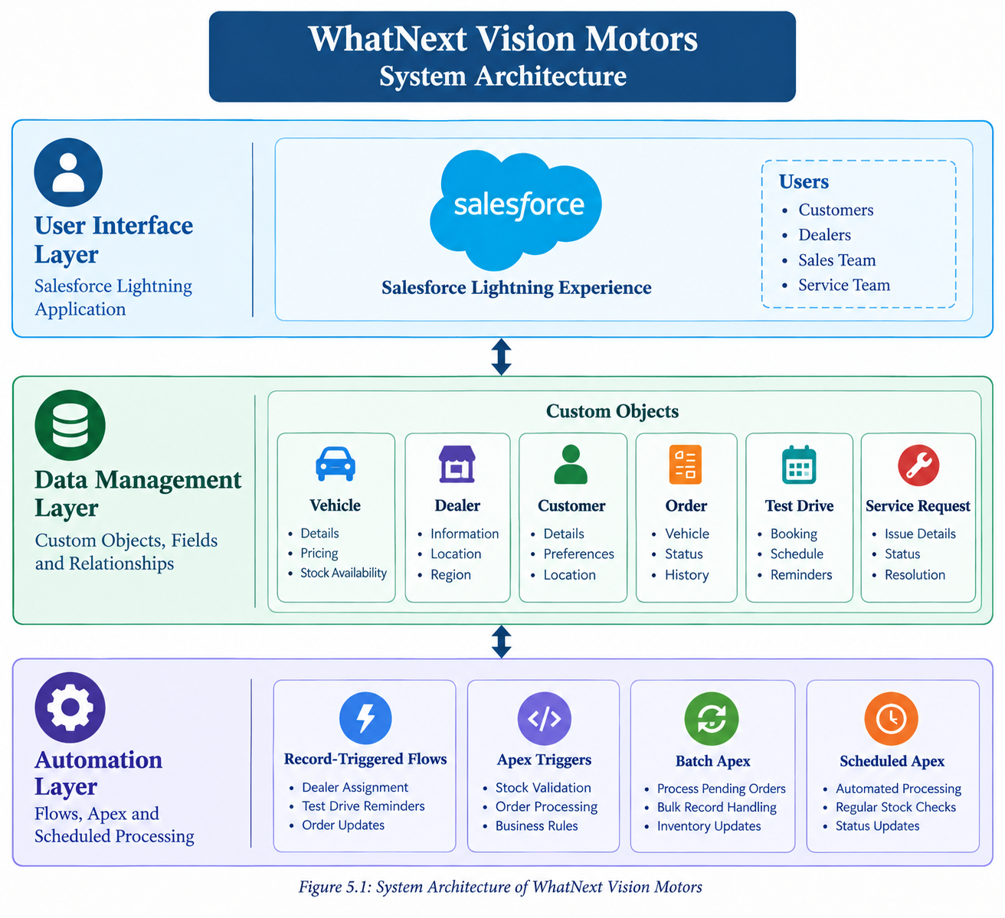

The system architecture illustrates the integration of three major layers: User Interface, Data Management, and Automation. The Salesforce Lightning Application provides access to the system, while custom objects manage vehicle, dealer, customer, and order information. Record-triggered flows, Apex triggers, Batch Apex, and Scheduled Apex automate business processes, ensuring efficient data management and order processing.

6. PROJECT PLANNING AND SCHEDULING
6.1 Project Planning
The WhatNext Vision Motors project follows an Agile-based development approach, dividing the implementation into manageable phases. Each phase focuses on specific Salesforce functionalities, including data modeling, application development, process automation, Apex programming, and testing.
The project activities are organized into sprints to support systematic development, progress tracking, and timely completion of the required functionalities.
6.2 Product Backlog and Sprint Planning
The project tasks are categorized into user stories based on functional requirements and implementation priorities.
Sprint | Development Phase | User Story / Task | Priority
Sprint 1 | Environment Setup | Configure the Salesforce Developer environment. | High
Sprint 2 | Data Modeling | Create custom objects, fields, and relationships. | High
Sprint 3 | Application Development | Configure custom tabs and the Salesforce Lightning application. | High
Sprint 4 | Process Automation | Implement dealer assignment and test drive reminder flows. | High
Sprint 5 | Apex Development | Develop Apex triggers for stock validation and order processing. | High
Sprint 6 | Batch Processing | Implement Batch Apex and Scheduled Apex for pending orders. | High
Sprint 7 | Testing | Validate application functionality and automation processes. | High
6.3 Project Scheduling
The project development activities are planned sequentially to ensure that each Salesforce component is configured and tested before proceeding to the next stage.
The implementation begins with environment setup and data modeling, followed by application configuration, workflow automation, Apex development, and batch processing. The final phase focuses on functional testing and verifying the system's expected behavior.
6.4 Project Tracking
Project progress is monitored based on the completion of planned development tasks and successful implementation of Salesforce functionalities.
Each phase is reviewed to verify that the required objects, relationships, automation flows, Apex classes, and scheduled jobs are functioning as intended. This approach helps identify implementation issues and supports efficient project completion.

7. PROJECT DEVELOPMENT PHASE
The development phase focuses on implementing the WhatNext Vision Motors application using Salesforce CRM. It involves configuring custom objects, fields, relationships, Lightning applications, automation flows, Apex triggers, and scheduled batch processing.
These components work together to manage vehicle information, customer orders, dealer assignments, stock availability, and test drive scheduling while reducing manual intervention.
7.1 Salesforce Environment Configuration
The application was developed using Salesforce Developer Edition, which provides the tools required for creating and managing custom Salesforce applications.
The Salesforce environment was configured through the Setup interface to support custom objects, data relationships, Lightning application development, and process automation.
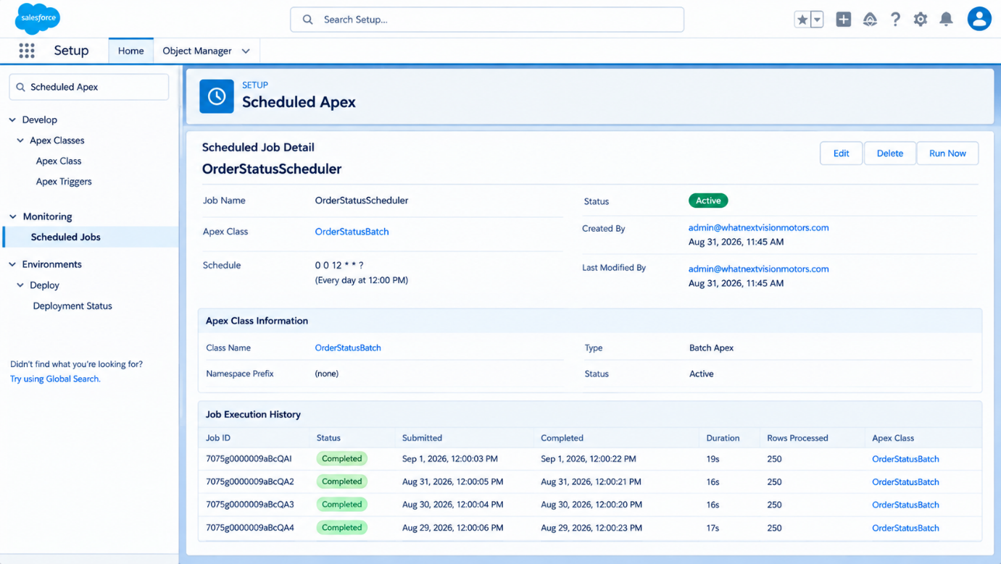
Figure 7.1: Salesforce Environment Setup

7.2 Data Modeling – Custom Objects
Data modeling forms the foundation of the WhatNext Vision Motors application. Custom objects are used to organize and manage essential business information, including vehicles, dealers, customers, orders, test drives, and service requests.
The following custom objects were defined in Salesforce:

Custom Object | Description
Vehicle__c | Stores vehicle details, pricing, models, and stock availability.
Vehicle_Dealer__c | Maintains authorized dealer information and locations.
Vehicle_Customer__c | Stores customer details and vehicle preferences.
Vehicle_Order__c | Manages vehicle purchase orders and order statuses.
Vehicle_Test_Drive__c | Tracks customer test drive bookings and schedules.
Vehicle_Service_Request__c | Records customer service requests and their statuses.
These objects provide a centralized data structure for managing vehicle sales and dealership operations within the Salesforce application.
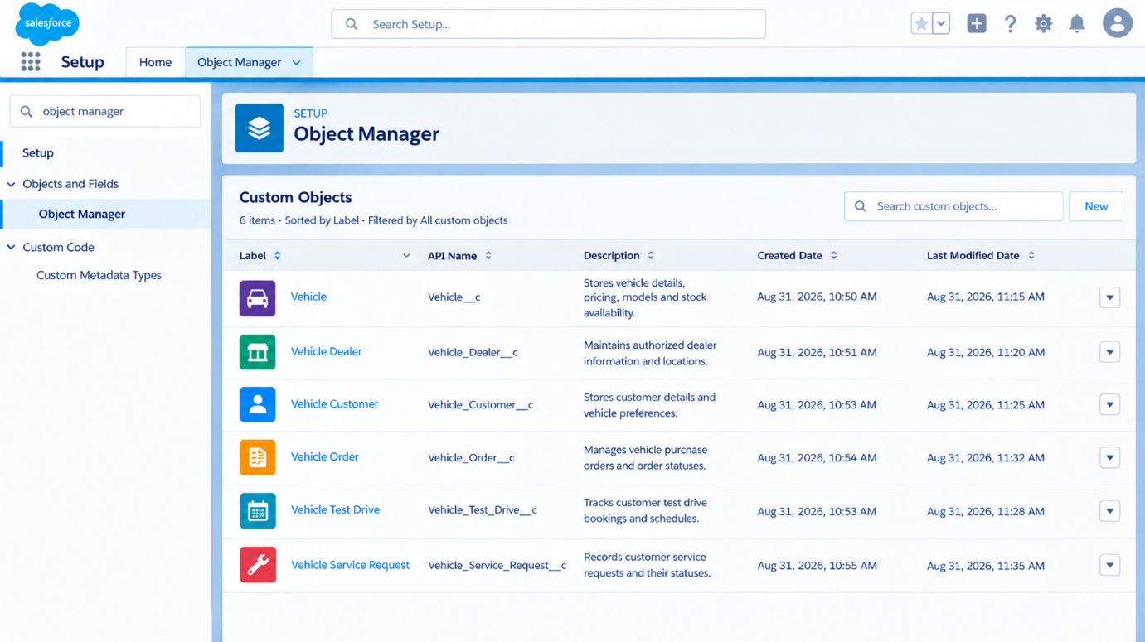
Figure 7.2: Custom Objects in Salesforce Object Manager

7.3 Custom Tabs and Lightning Application
Custom tabs provide easy access to the Salesforce objects created for the application. The Salesforce Lightning App brings together vehicle, customer, dealer, order, and service-related information within a unified interface, allowing users to navigate between different modules and manage daily operations efficiently.

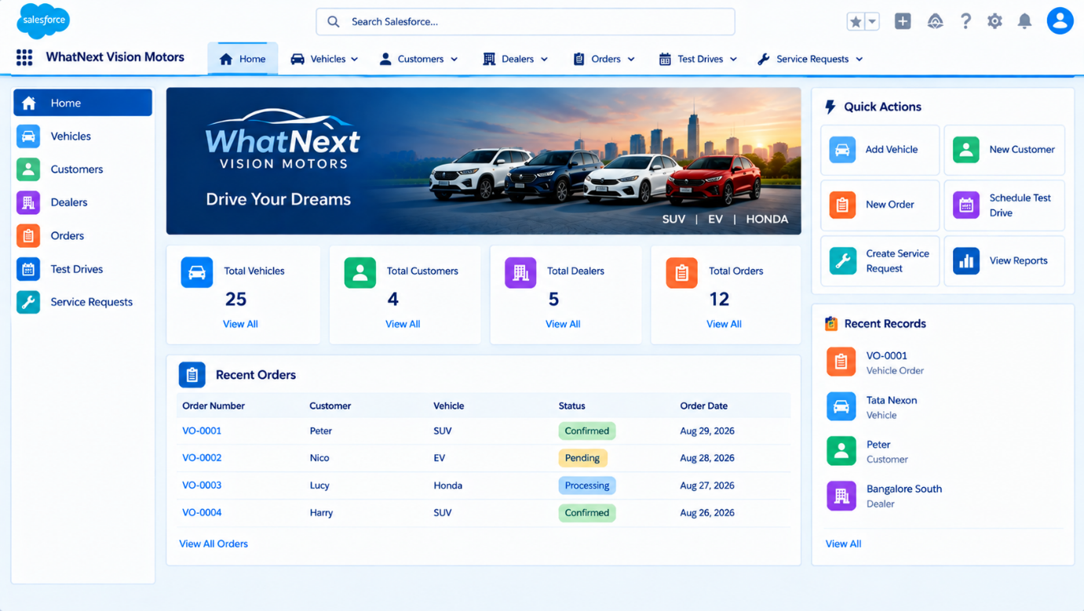
Figure 7.3: Custom Tabs and Salesforce Lightning Application

7.4 Fields and Relationships
Custom fields are configured to store essential information such as vehicle model, brand, price, stock quantity, and dealer details. Lookup relationships establish connections between related Salesforce objects, enabling efficient data retrieval, maintaining data consistency, and supporting automated business processes.
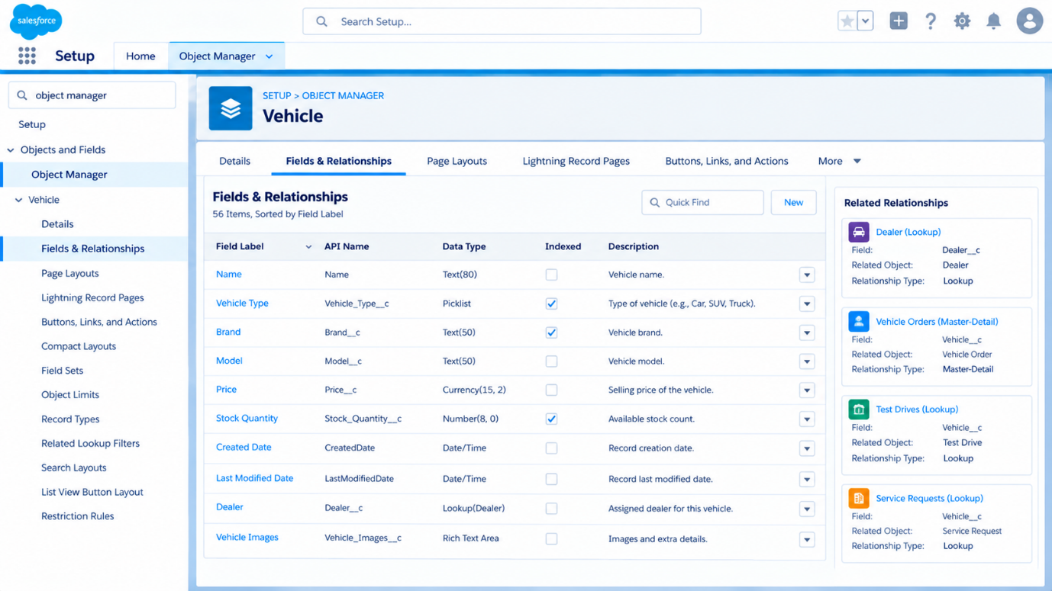
Figure 7.4: Vehicle Fields and Relationships
7.5 Record-Triggered Flows
Record-triggered flows automate business processes within the Salesforce application. The dealer assignment flow is designed to recommend suitable dealers based on customer location, reducing manual intervention during order processing. Additional automation supports test drive reminders and improves communication with customers.

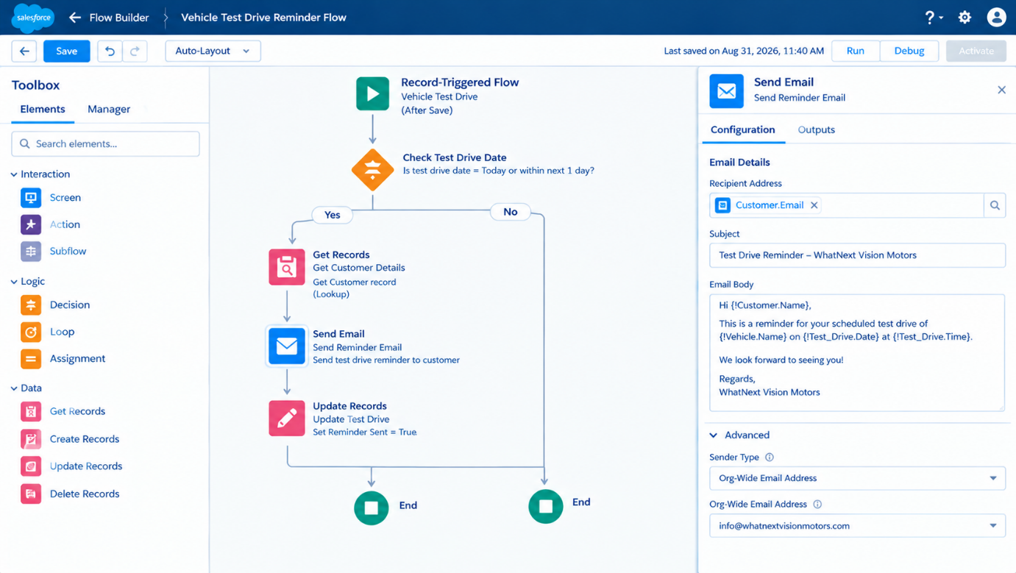
Figure 7.5: Automatic Dealer Assignment Flow

7.6 Apex Classes and Triggers
Apex classes and triggers implement custom business logic for vehicle order management. The stock validation trigger checks vehicle availability before an order is created or updated. If the selected vehicle is out of stock, the system prevents the transaction and displays an appropriate error message, ensuring accurate order processing.
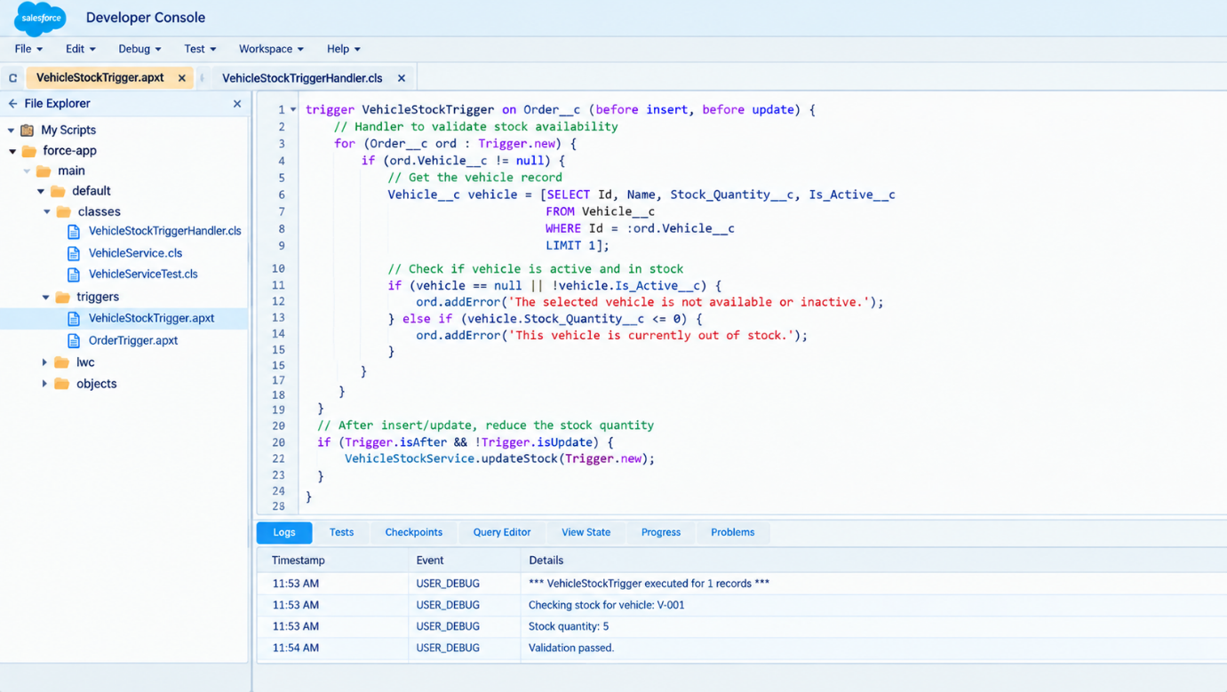
Figure 7.6: Vehicle Stock Validation Apex Trigger
7.7 Batch Apex
Batch Apex is used to process large volumes of vehicle order records efficiently. The batch process evaluates pending orders and checks vehicle stock availability to determine whether an order can be confirmed. This approach supports bulk record processing, reduces manual effort, and improves order management efficiency.
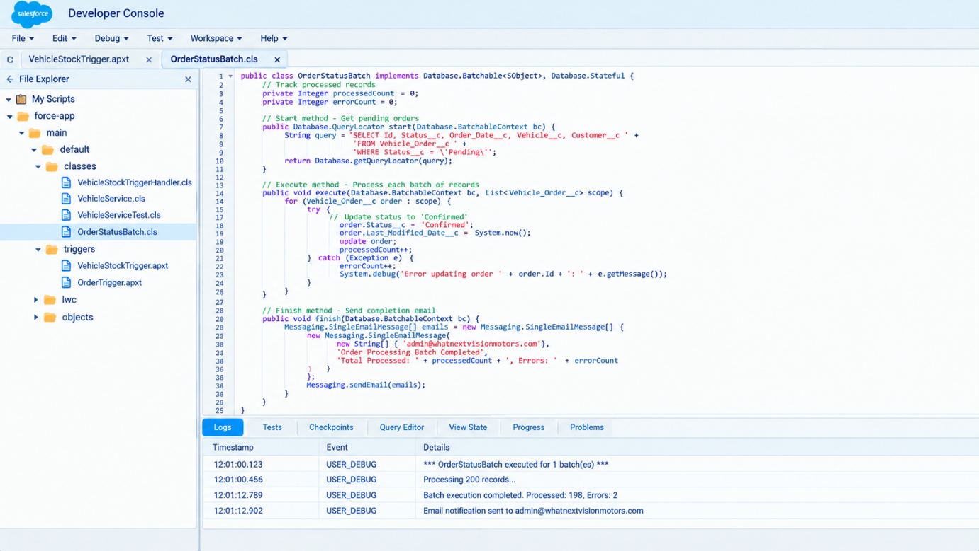
Figure 7.7: Batch Apex Implementation

7.8 Scheduled Apex
Scheduled Apex automates the execution of batch processing at predefined intervals. The scheduled job initiates the order status batch process to review pending orders and update their statuses based on vehicle availability. This ensures regular order processing without requiring continuous manual intervention.
Figure 7.8: Scheduled Apex Job Configuration
8. TESTING AND VALIDATION PHASE
The Testing and Validation Phase focuses on verifying the functionality of the WhatNext Vision Motors Salesforce application. It ensures that vehicle management, dealer assignment, stock validation, order processing, and automated workflows operate according to the defined requirements.
Testing involves validating individual Salesforce components, examining automation behavior, and checking whether the application handles different business scenarios correctly.
8.1 Testing Objectives
The primary objectives of testing are to:
- Verify the creation and management of vehicle, customer, dealer, and order records.
- Validate automatic dealer assignment based on customer location.
- Ensure that orders for out-of-stock vehicles are prevented.
- Verify record-triggered flows and automated test drive reminders.
- Validate Batch Apex processing of pending orders.
- Ensure Scheduled Apex executes automated tasks at the configured time.
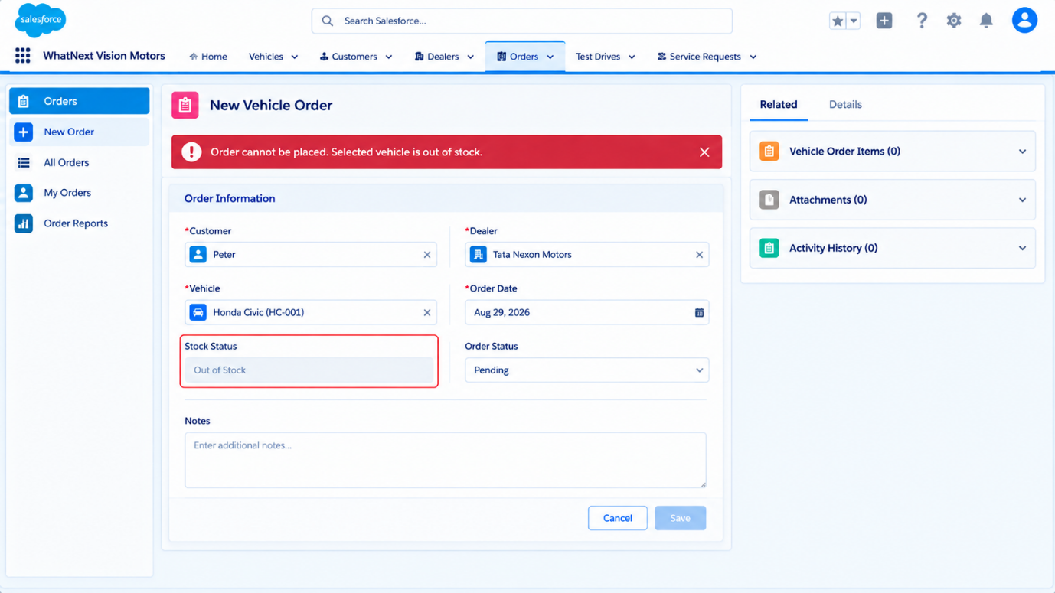
Figure 8.1 – Vehicle Stock Validation Test

8.2 Functional Test Cases
The following test cases define the expected behavior of the Salesforce application.
Test ID | Test Scenario | Expected Result
TC-01 | Create a new vehicle record | Vehicle details are saved successfully.
TC-02 | Create a customer order | Order is created when stock is available.
TC-03 | Order an out-of-stock vehicle | Order creation is blocked with a validation message.
TC-04 | Assign a dealer based on customer location | A suitable dealer is assigned automatically.
TC-05 | Schedule a vehicle test drive | Booking is saved and a reminder is scheduled.
TC-06 | Execute Batch Apex | Pending orders are processed according to stock availability.
TC-07 | Execute Scheduled Apex | Batch processing starts at the configured schedule.

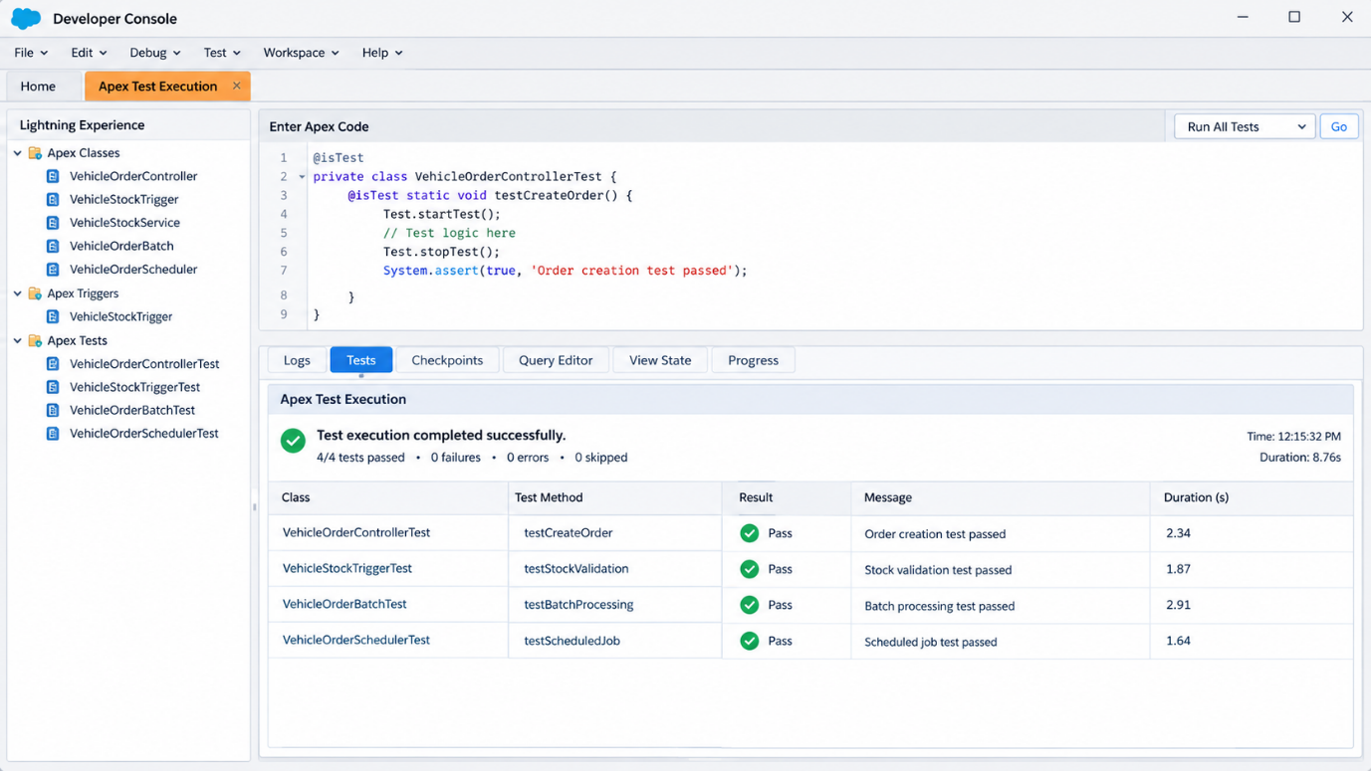
Figure 8.2: Apex Test Execution
8.3 Apex Testing
Apex testing is used to validate the business logic implemented through Apex triggers, classes, and batch processes. Test classes should cover positive and negative scenarios, including successful order creation, insufficient vehicle stock, and bulk order processing. Salesforce Apex test methods help verify application behavior and support code deployment by ensuring the required test coverage is achieved.
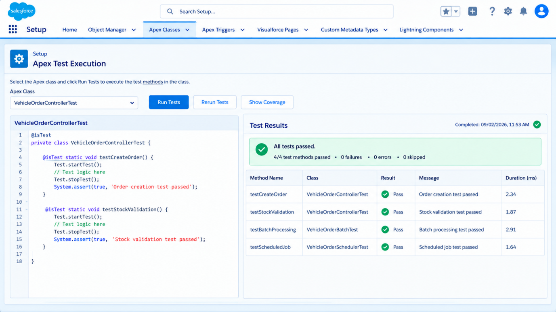
Figure 8.3: Apex Test Execution Results

8.4 Validation and Error Handling
The application incorporates validation mechanisms to prevent invalid order transactions and maintain data consistency. Apex triggers validate stock availability before order creation, while record-triggered flows automate dealer assignment and customer notifications. Batch processing handles pending orders, and exceptions should be monitored through Salesforce debug logs and Apex job execution details. These validation mechanisms help maintain accurate records and improve the reliability of the application.
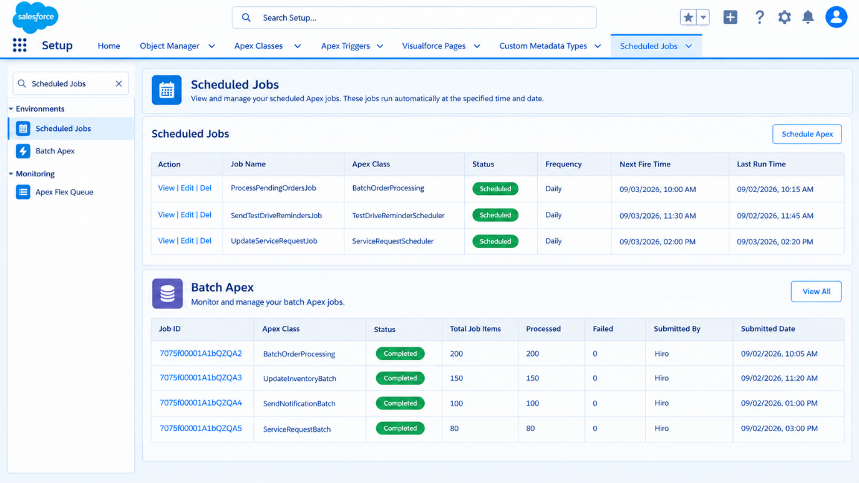
Figure 8.4: Batch Apex and Scheduled Apex Execution Results
9. RESULTS AND DISCUSSION
The WhatNext Vision Motors Salesforce CRM application is designed to streamline vehicle sales, customer management, dealer coordination, and order processing. The proposed solution integrates custom Salesforce objects, automated workflows, Apex triggers, and scheduled batch processing to support efficient dealership operations.
9.1 Project Results
The project development phase establishes the core components required for a centralized vehicle management system. Custom objects organize vehicle, customer, dealer, order, test drive, and service request information within Salesforce.
The application also includes automation designed to assign suitable dealers, validate vehicle stock before order creation, and process pending orders through Batch Apex and Scheduled Apex.
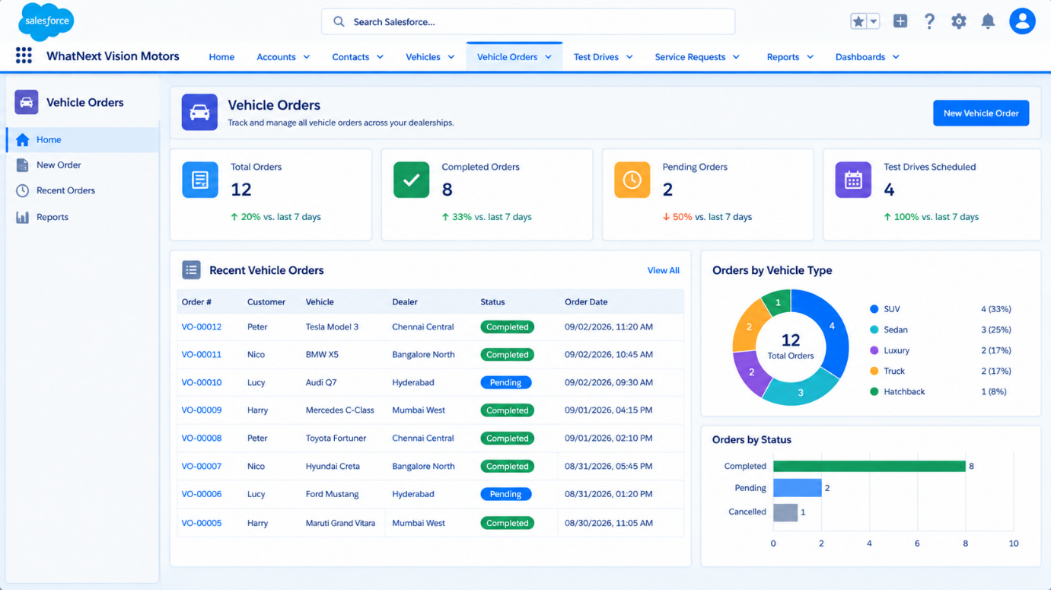
Figure 9.1: Vehicle Orders Management Overview

9.2 Key Features and Outcomes
The major features and expected outcomes of the application are summarized below.
Feature | Expected Outcome
Vehicle Management | Centralized storage of vehicle details and stock information
Customer Management | Organized customer records and interactions
Dealer Assignment | Automated selection of suitable dealers based on configured location criteria
Stock Validation | Prevention of new orders when vehicle stock is unavailable
Test Drive Management | Simplified scheduling and automated reminders
Batch Apex | Bulk processing of pending vehicle orders
Scheduled Apex | Automatic execution of order-processing tasks

9.3 Discussion
The Salesforce-based solution demonstrates how CRM customization and automation can improve dealership operations. Centralized data management reduces the need to maintain separate records, while automated workflows minimize repetitive administrative tasks.
Stock validation supports more reliable order processing, and scheduled batch operations provide a structured approach to handling pending orders. The effectiveness of these features should be confirmed through functional testing and execution results.
9.4 Benefits of the Proposed System
The application is expected to improve operational efficiency by providing a unified platform for managing dealership activities. It supports better data organization, faster access to customer and vehicle information, reduced manual processing, and improved coordination between customers and dealers.
These capabilities provide a foundation for future enhancements and more advanced vehicle sales management.
10. CONCLUSION AND FUTURE ENHANCEMENTS
10.1 Conclusion
The WhatNext Vision Motors project demonstrates the use of Salesforce CRM to develop a centralized vehicle sales and dealership management application. The system brings together vehicle inventory, customer records, dealer information, orders, test drive bookings, and service requests within a unified platform.
Salesforce custom objects, record-triggered flows, Apex triggers, Batch Apex, and Scheduled Apex provide the foundation for automating key business processes. Features such as stock validation, dealer assignment, and order status processing are designed to reduce manual effort and improve data accuracy.
Overall, the proposed solution offers a structured and scalable approach to managing dealership operations and enhancing customer service.
10.2 Future Enhancements
The application can be extended with additional features to improve functionality and customer experience.
- AI-Based Vehicle Recommendations: Suggest suitable vehicles based on customer preferences, budget, and purchase history.
- Real-Time Inventory Updates: Synchronize vehicle stock information across multiple dealerships.
- GPS-Based Dealer Location: Integrate mapping services to identify the nearest available dealer using geographic distance.
- Customer Self-Service Portal: Allow customers to browse vehicles, book test drives, place orders, and track order statuses online.
- Advanced Reports and Dashboards: Provide visual insights into vehicle sales, inventory levels, customer activity, and dealer performance.
- Mobile Application Integration: Enable customers and dealership staff to access essential services through mobile devices.
10.3 Final Summary
The WhatNext Vision Motors Salesforce CRM application provides a foundation for digital transformation in vehicle sales and dealership management. By combining centralized data management with automated business processes, the proposed system aims to improve operational efficiency, support accurate order processing, and deliver a more organized customer experience.

