Supplementary Note: Hydrophone Calibration and Spatial Field Mapping
Needle-hydrophone characterization of the ultrasound transducer field: baseline PDMS-channel scan (1.7 MHz) and 3D aneurysm-channel scan (2 MHz)
Prepared 12 Aug 2026; updated 13 Aug 2026 with the aneurysm-channel scan.

Experiment 1: baseline PDMS-channel scan (1.7 MHz)

S1. Hydrophone system and calibration
Spatial pressure mapping was performed using a needle hydrophone system supplied by Precision Acoustics Ltd (Dorchester, UK), comprising:
- Needle hydrophone, 0.5 mm sensor diameter (model NH0500), serial number 4746
- Submersible preamplifier, serial number HP34211
- DC coupler with power supply, serial number DCPS0895
The system was calibrated as a unit (hydrophone + preamplifier + DC coupler) under UKAS-accredited, ISO/IEC 17025 conditions. Calibration certificate 20251211-03 was issued 11 Dec 2025 (measurement date 10 Dec 2025) for University of Bern, using a shocked-wave substitution method (Smith & Bacon, 1990) per IEC 62127-2, with reported uncertainties evaluated per UKAS M3003 and JCGM 100:2008 at a coverage factor k=2 (~95% confidence). Calibration conditions: RG58 cable (1.5 m, 50 Ω), 25-cycle toneburst, de-ionised/de-gassed/filtered water (conductivity <5 μS/cm), water temperature 20 ± 1 °C, >30 min soak period.

S1.1 Calibrated sensitivity
The full calibration table (1–30 MHz) is provided in the attached original certificate (Precision_Acoustics_Calibration_Certificate_20251211-03.pdf, supplementary file). At the experimental frequency of 1.7 MHz, linear interpolation between the certificate's 1 MHz and 2 MHz sensitivity values (659.4124 mV/MPa and 654.0046 mV/MPa respectively) gives a sensitivity of S = 655.63 mV/MPa, with an interpolated uncertainty of approximately 8.0% (both bracketing points are individually quoted at 8.04% on the certificate).
Pressure was calculated from measured peak-to-peak voltage as: P_{pp} [kPa] = V_{pp} [mV] / 655.63 × 1000.

S1.2 Electrical configuration
Precision Acoustics specifies a 50 Ω acquisition load for this hydrophone system (needle hydrophone → HP34211 preamplifier → DCPS0895 DC coupler → 50 Ω acquisition system). Where the oscilloscope input is high-impedance, an external inline 50 Ω terminator is required at the scope input; the RG58/U cable used has a 50 Ω characteristic impedance but does not itself provide the required 50 Ω load. A 50 Ω termination was used at the oscilloscope input for all measurements reported here. The submersible preamplifier and DC coupler provide impedance buffering and a small signal gain that is already incorporated into the system calibration above and must not be separately divided out.

S2. Experimental conditions
- Operating frequency: 1.7 MHz
- Transducer drive: 20 Vpp
- Medium: water
- Hydrophone: Precision Acoustics needle hydrophone SN 4746 (as calibrated above)
- Oscilloscope: Tektronix TBS2072, 50 Ω termination, 2000-point records, 8 ns sample interval
- Transducer (reported separately, not confirmed for this specific unit): aperture ~19.5–20 mm, nominal focal distance ~25 mm, nominal operating frequency ~1.8 MHz; driven here at 1.7 MHz

S3. Important caveat: booster amplifier
Precision Acoustics separately supplies an optional Hydrophone Booster Amplifier for use with low-sensitivity needle hydrophones (typical gain 27 dB / voltage gain G ≈ 22.4, 50 kHz–130 MHz bandwidth, 50 Ω input/output). The calibration certificate for SN 4746 lists the hydrophone, preamplifier and DC coupler, but the booster amplifier serial-number field is blank on the calibration data sheet (distinct from the attenuator and signal-amplifier fields, which are explicitly marked “N/A”). The published sensitivity (655.63 mV/MPa at 1.7 MHz) therefore applies to the hydrophone + preamplifier + DC coupler system only, and NOT to an additional external booster stage.
Whether the booster amplifier was present in the signal chain for the measurements reported in Section S4 has not been confirmed. If it was, every pressure value in this note must be divided by G ≈ 22.4 (e.g. 34 mV → 1.52 mV before applying the 655.63 mV/MPa sensitivity). This changes the absolute pressure scale by roughly an order of magnitude but does not affect the relative spatial pattern. The raw peak-to-peak voltages (Vpp) are unaffected by this question and should be treated as the reliable primary measurement; the pressure values in this note are provisional pending confirmation of the signal chain.

S4. Spatial field-mapping data
The transducer field was mapped at 19 positions: a cross-pattern scan in X and Y at Z = 6 mm centered near (X=10, Y=12), four diagonal points, and a 3-point depth scan in Z at (X=10, Y=12). Peak-to-peak voltage (Vpp) was computed directly from each raw oscilloscope waveform in raw_csv/ (full-trace maximum minus minimum); pressure was then obtained from Vpp using the 655.63 mV/MPa sensitivity from Section S1.1.
CSV | X (mm) | Y (mm) | Z (mm) | Vpp (mV) | P_pp (kPa)
15 | 10 | 12 | 6 | 33.75 | 51.5
16 | 11 | 12 | 6 | 50.00 | 76.3
17 | 12 | 12 | 6 | 51.50 | 78.6
18 | 13 | 12 | 6 | 51.75 | 78.9
19 | 14 | 12 | 6 | 31.75 | 48.4
20 | 15 | 12 | 6 | 32.75 | 50.0
21 | 9 | 12 | 6 | 44.25 | 67.5
22 | 8 | 12 | 6 | 32.00 | 48.8
23 | 7 | 12 | 6 | 27.50 | 41.9
24 | 10 | 11 | 6 | 44.00 | 67.1
25 | 10 | 10 | 6 | 35.50 | 54.1
26 | 10 | 9 | 6 | 42.00 | 64.1
27 | 10 | 13 | 6 | 26.50 | 40.4
28 | 9 | 11 | 6 | 28.00 | 42.7
29 | 11 | 11 | 6 | 27.50 | 41.9
30 | 11 | 13 | 6 | 30.50 | 46.5
31 | 9 | 13 | 6 | 22.50 | 34.3
32 | 10 | 12 | 7 | 41.25 | 62.9
33 | 10 | 12 | 8 | 38.25 | 58.3

Note: during preparation of this note, two points (CSV 19 and CSV 28) were found to disagree with an earlier, hand-logged version of this table by 28–33% (hand-logged as 44 mV and 42 mV respectively). Recomputing Vpp directly from the raw waveform files resolved the discrepancy; the values above (31.75 mV and 28.00 mV) are taken from that direct recomputation. All other 17 points agreed with the hand-logged values within 1–3 mV.

S5. Field maps
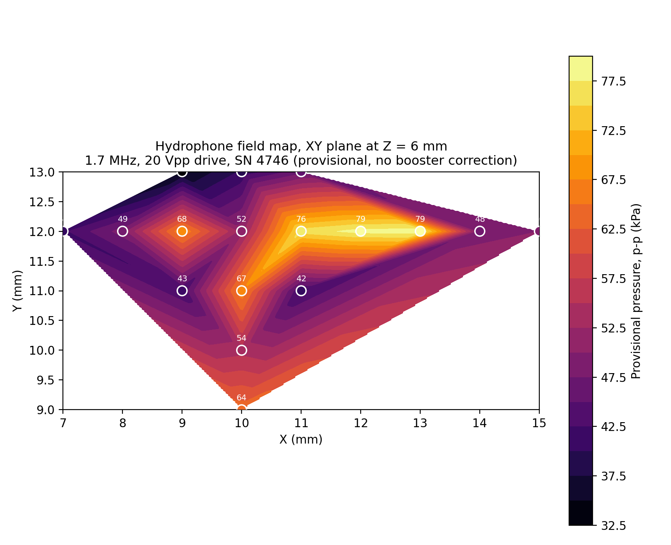
Figure S1. Interpolated pressure map of the XY scan plane at Z = 6 mm (provisional, no booster correction). Circles mark measured points; the filled region is linear-interpolated within the convex hull of the sampled points only.
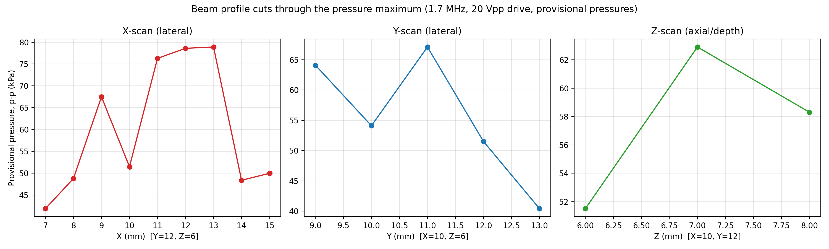
Figure S2. Line profiles through the pressure maximum: X-scan (Y=12, Z=6), Y-scan (X=10, Z=6), and Z-scan / depth (X=10, Y=12). Provisional pressures, no booster correction.

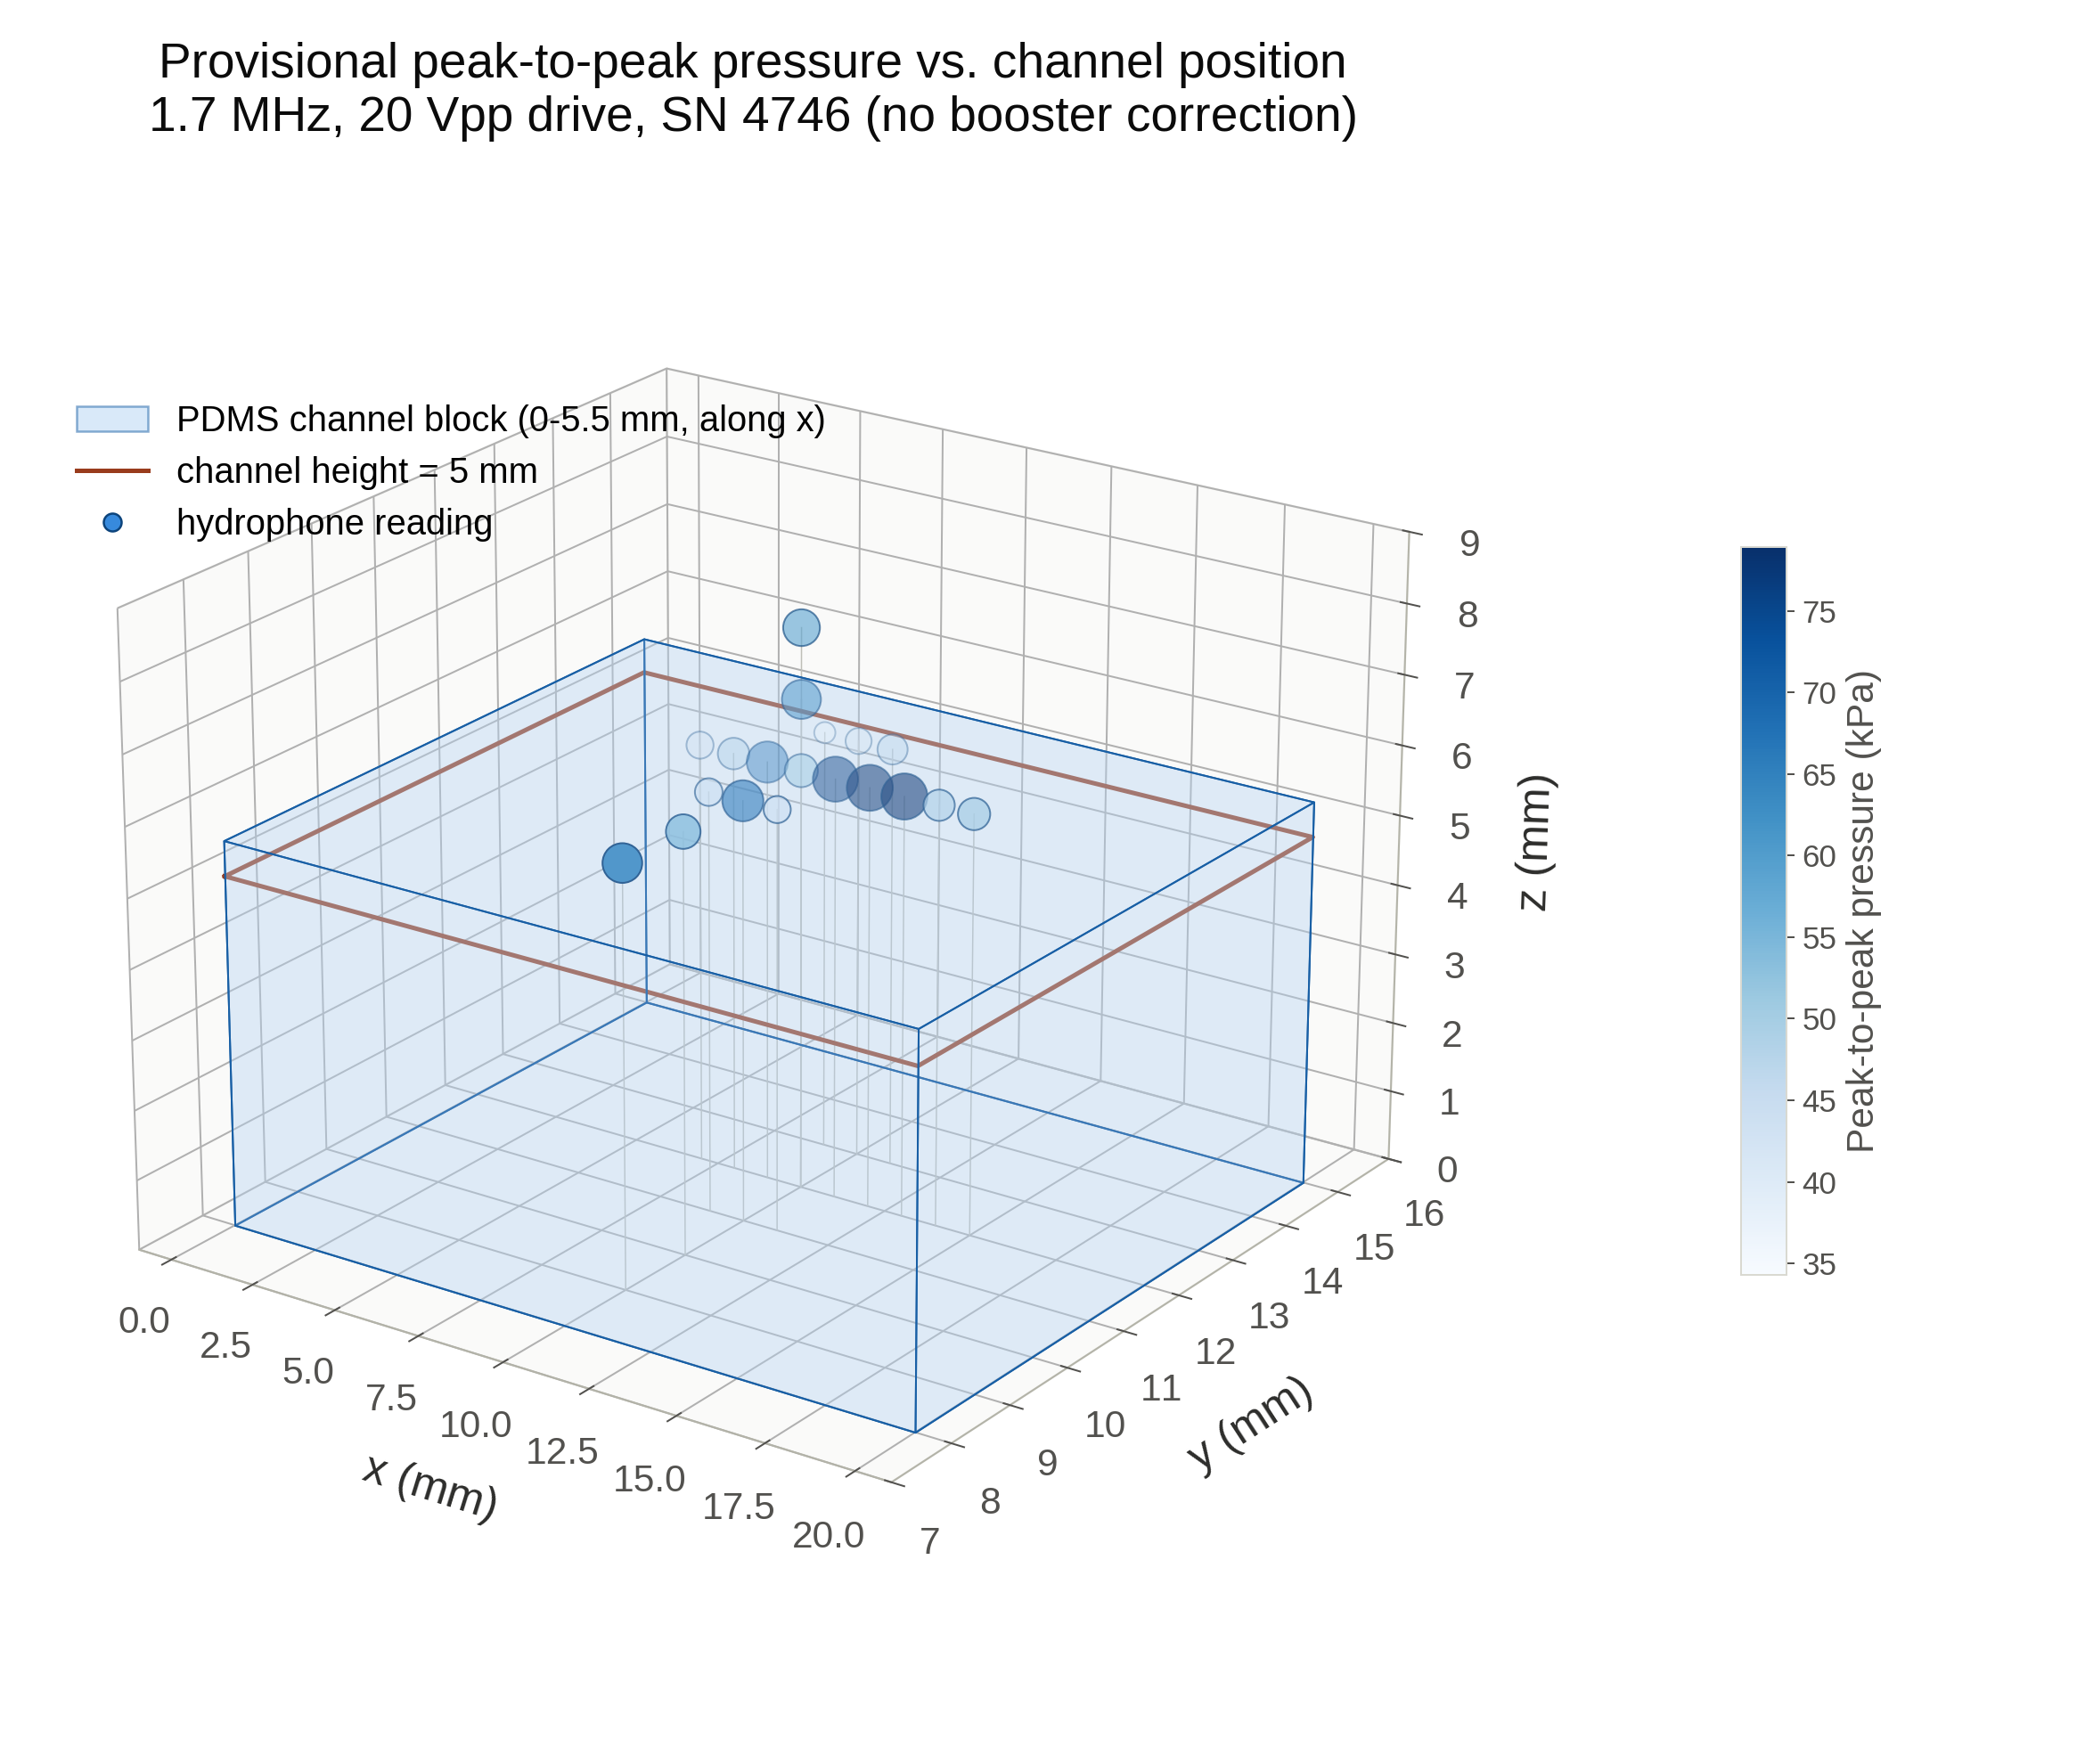
Figure S3. 3D scatter of all 19 measurement points relative to the PDMS channel block (0–5.5 mm in Z; channel height marker at Z=5 mm; cross-section Y=8–15 mm; long axis 20 mm in X, centered on X=10, the original scan center — the transducer offset along X was not independently confirmed). Marker size and color both encode provisional peak-to-peak pressure.

S5.1 Notable feature
Both the X-scan and Y-scan profiles (Figure S2) show a local minimum at the scan's nominal center point (X=10, Y=12, Z=6; 51.5 kPa), flanked by higher readings at adjacent grid points in both directions (e.g. X=9: 67.5 kPa, X=11: 76.3 kPa; Y=11: 67.1 kPa, Y=9: 64.1 kPa). This point's raw waveform matched the originally logged value closely (~1% difference), so it is not attributable to a transcription error; it may reflect a local interference null or an off-axis effect near the field center, and is noted here for awareness rather than explained.

Experiment 2: 3D aneurysm-channel scan (2 MHz)

S6. Aneurysm-channel scan
A second scan was performed on a 3D-printed/PDMS aneurysm-channel model, using the same Precision Acoustics hydrophone system (SN 4746) described in Section S1. The transducer drive was changed for this experiment.

S6.1 Experimental conditions
- Operating frequency: 2 MHz
- Transducer drive: 30 Vpp
- Medium: water, no microbubbles (a small set of bubble-reference readings was taken at the scan's start position but is held pending confirmation of measurement order — see Section S6.5)
- Hydrophone: Precision Acoustics needle hydrophone SN 4746 (same system and calibration as Experiment 1)
- Oscilloscope: Tektronix TBS2072, 50 Ω termination, 2000-point records, 8 ns sample interval
- Channel: larger cross-section than the PDMS channel in Experiment 1 (aneurysm phantom geometry)

S6.2 Calibration at 2 MHz
2 MHz is an exact calibration point on certificate 20251211-03, so no interpolation is needed: S = 654.0046 mV/MPa, uncertainty 8.04%. P_{pp} [kPa] = V_{pp} [mV] / 654.0046 × 1000. The same booster-amplifier caveat from Section S3 applies here: pressure values are provisional pending confirmation of whether the external booster was in the signal chain.

S6.3 Data collection and verification
Readings were called out live during acquisition (position + Vpp) and logged in real time as the scan progressed, then cross-checked once the raw oscilloscope CSVs were uploaded. All 28 points matched the live-logged values within normal measurement noise (largest deviation 5.2%); the table below uses the raw-waveform values throughout.
CSV | X (mm) | Y (mm) | Z (mm) | Vpp (mV) | P_pp (kPa)
37 | 10 | 11 | 13 | 44.00 | 67.3
38 | 9 | 11 | 13 | 57.00 | 87.2
39 | 8 | 11 | 13 | 41.00 | 62.7
40 | 7 | 11 | 13 | 20.00 | 30.6
41 | 6 | 11 | 13 | 33.00 | 50.5
42 | 10 | 9 | 13 | 62.50 | 95.6
43 | 11 | 9 | 13 | 56.50 | 86.4
44 | 12 | 9 | 13 | 36.50 | 55.8
45 | 12 | 9 | 13 | 39.00 | 59.6
46 | 13 | 9 | 13 | 56.00 | 85.6
47 | 13 | 9 | 13 | 65.50 | 100.2
48 | 14 | 9 | 13 | 59.50 | 91.0
49 | 9 | 9 | 13 | 70.50 | 107.8
50 | 8 | 9 | 13 | 43.50 | 66.5
51 | 7 | 9 | 13 | 31.50 | 48.2
52 | 6 | 9 | 13 | 43.50 | 66.5
53 | 5 | 9 | 13 | 30.50 | 46.6
54 | 10 | 8 | 13 | 40.50 | 61.9
55 | 10 | 7 | 13 | 27.50 | 42.0
56 | 10 | 10 | 13 | 67.50 | 103.2
57 | 10 | 11 | 13 | 33.00 | 50.5
58 | 9 | 11 | 13 | 42.50 | 65.0
59 | 9 | 10 | 13 | 70.50 | 107.8
60 | 9 | 8 | 13 | 54.00 | 82.6
61 | 11 | 8 | 13 | 31.50 | 48.2
62 | 11 | 7 | 13 | 34.00 | 52.0
63 | 11 | 10 | 13 | 39.00 | 59.6
64 | 11 | 11 | 13 | 28.00 | 42.8

Scan pattern: a single XY plane at Z = 13 mm, covering roughly X = 5-14 mm and Y = 7-11 mm, with denser sampling near X = 9-11, Y = 8-11. Four positions were measured twice; both readings are listed above (see Section S6.5).

S6.4 Field maps
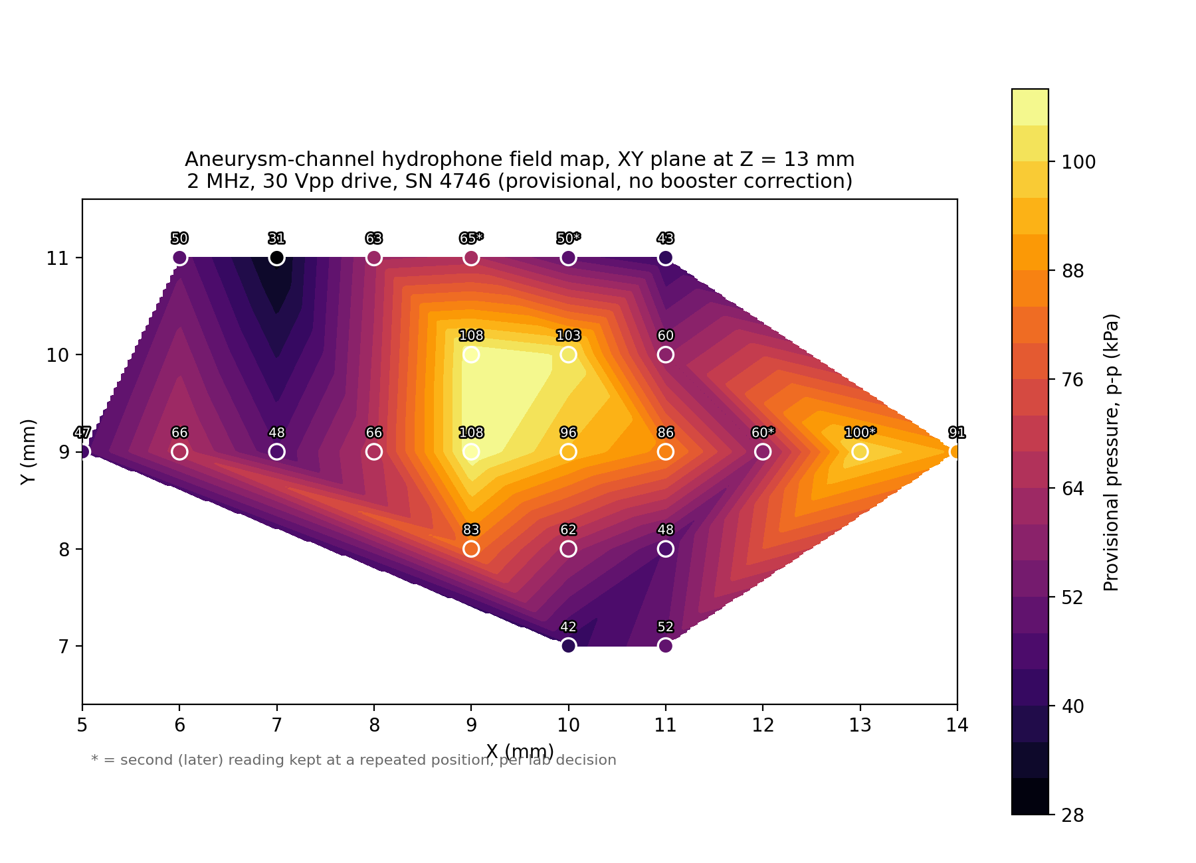
Figure S4. Interpolated pressure map of the XY scan plane at Z = 13 mm through the aneurysm channel (provisional, no booster correction). Circles mark measured points (* = second/later reading kept at a repeated position, per lab decision — see Section S6.5); the filled region is linear-interpolated within the convex hull of the sampled points only.
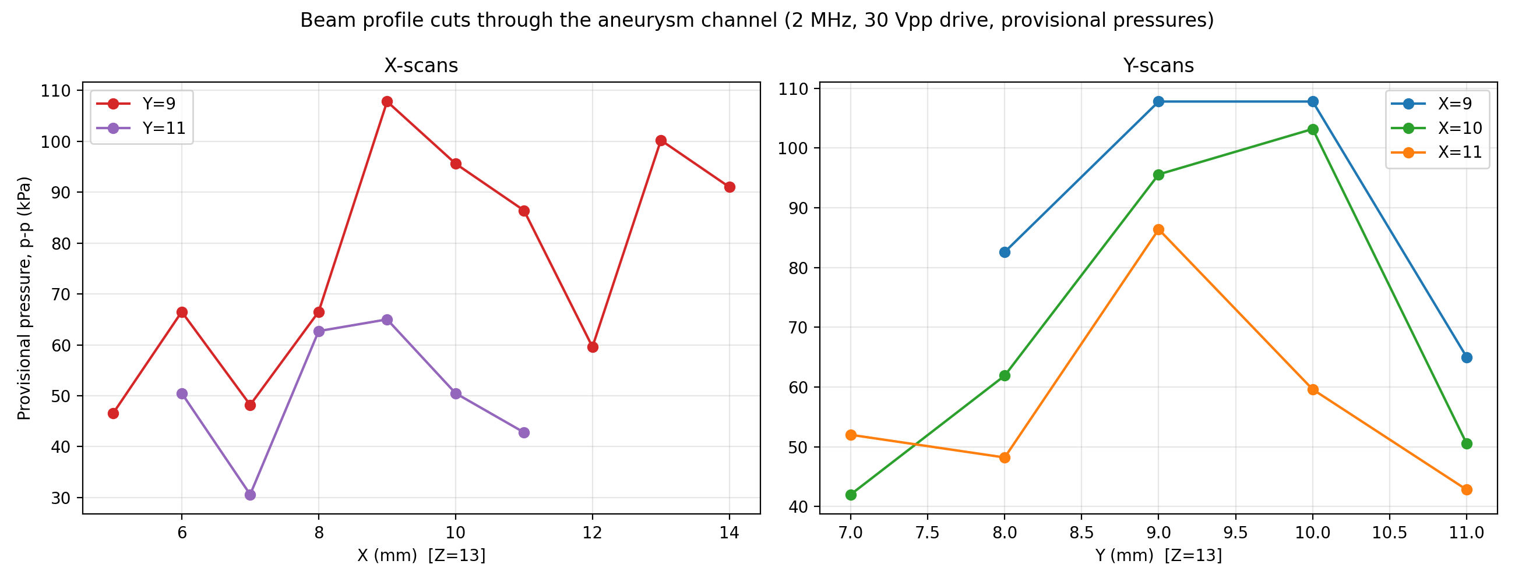
Figure S5. X-scan cuts at Y=9 and Y=11, and Y-scan cuts at X=9, 10 and 11, through the aneurysm channel. Provisional pressures, no booster correction.

S6.5 Reproducibility check
Four positions were measured twice during this scan:
Position | Readings (mV) | Spread
X=10, Y=11 (CSV37/57) | 44.0 / 33.0 | 25%
X=9, Y=11 (CSV38/58) | 57.0 / 42.5 | 25%
X=12, Y=9 (CSV44/45) | 36.5 / 39.0 | 7%
X=13, Y=9 (CSV46/47) | 56.0 / 65.5 | 15%

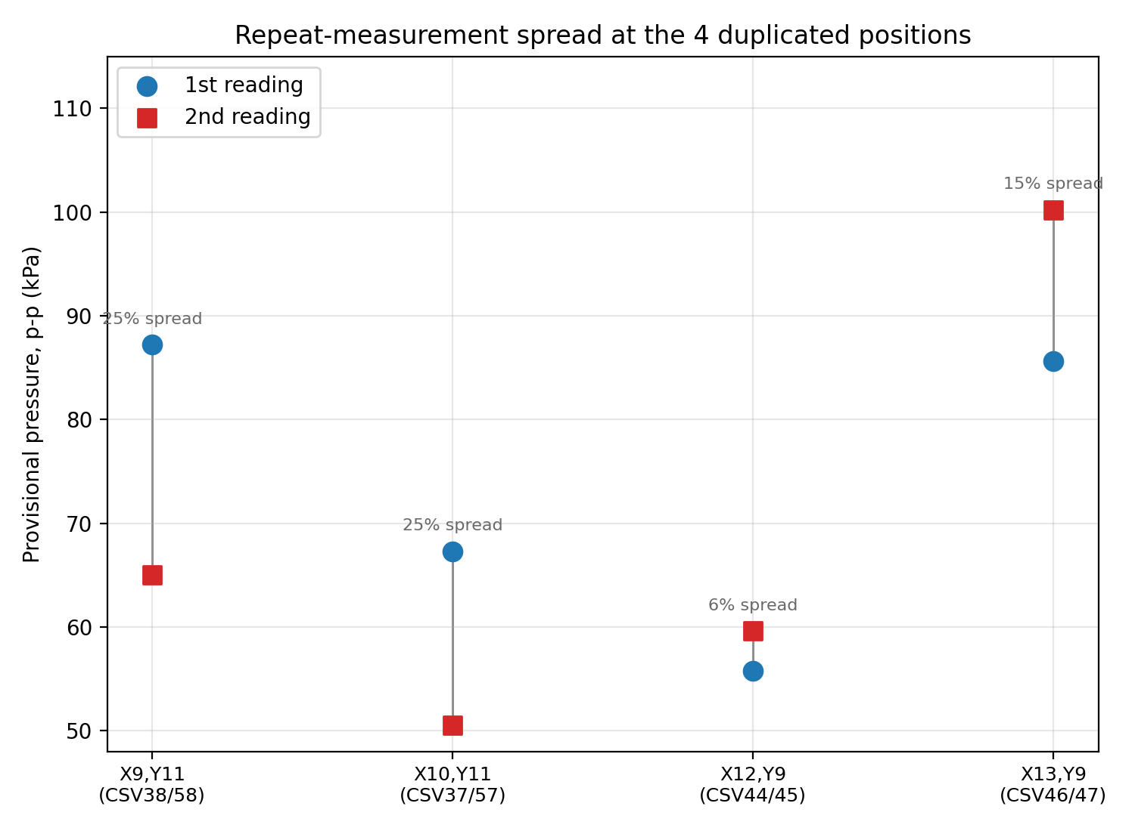
Figure S6. Both readings at each of the 4 repeated positions. The two largest-spread repeats are both at Y=11, the edge of the denser sampling region.
The 2D map and profile plots (Figures S4-S5) use the second (later) reading of each repeated pair, not an average, per lab decision; the table in Section S6.3 lists every individual raw reading, including the first (discarded-for-plotting) reading at each repeated position.

S6.6 Bubble-reference readings (pending)
Three additional readings (TEK00034-036) were taken at the scan's start position (X=10, Y=11, Z=13) before the main scan: 13.5 mV, 40.0 mV and 56.5 mV. The much lower first value is consistent with acoustic attenuation/scattering from microbubbles in the beam path, but the before/with/after-bubbles order across these three readings has not been confirmed and is not included in the data table above. These files are retained separately (raw_csv_pending_bubble_ref/) pending that confirmation.

S7. Data and code availability
Experiment 1 (baseline PDMS channel): the original Precision Acoustics calibration certificate (20251211-03), raw oscilloscope waveforms, the derived data table, and the Python scripts used to generate Figures S1-S3 are provided as supplementary data files.
Experiment 2 (aneurysm channel): raw oscilloscope waveforms, the derived data table, and the Python script used to generate Figures S4-S6 are provided as supplementary data files, including the three pending bubble-reference readings held separately from the main dataset.
All files will be made available in the associated GitHub repository for this project.

