University of Hertfordshire

School of Computer Science

BSc Computer Science

Module: Robotics

Module Code: 6WCM2006

Coursework Final Report

**Goalie Diving to Stop the Football**

Muhammad Muneeb Husnain

23000881

Level 6

Academic Year 2023-24

**Table of Contents**

**Project Aim:** 3

**Project Approach:** 3

**Source Code:** 4

**Related Work:** 4

**Design & Implementation:** 5

**Result & Evaluation:** 7

**Conclusion:** 9

Figure 1: Nao Robot’s Schematic Design 5

Figure 2: Left Dive Motion 6

Figure 3: Right Dive Motion 6

Figure 4: Left Dive 8

Figure 5: Right Dive 8

**Introduction**

# **Project Aim:**

**Problem Identification**

The project is mainly aimed at designing, developing, and implementing a robot goalkeeper in a robocop-style environment in a football stadium. The robot currently available is not able to fulfill the role of a goalkeeper hence lacking a crucial defensive role in the competitive field. The standard available features, motion, and functions are currently unable to save goals.

**Implemented Feature**

To solve the issue of incompetent goalkeeping, the NAO robot developed by Softbank Robotics is used, it’s being used in the RoboCup as well due to its humanoid design, sensors, and, capabilities. The main sensors include, cameras, inertial sensors, sonar sensors, touch sensors, and mainly actuators, which make the movement easy, hence in this case be a proper goalkeeper. The robot in focus here attempts to dive to stop the goal, it can also kick the ball to stop the expected goal. In the unexpected event of falling, it can also stand up, just like in the real world to continue the game.

**Criterion for Success**

The criterion of success here depends on the observer’s judgment. The robot should be able to stop the goal by **diving**, kicking, or even falling over the ball to stop the goal. This process should be consistent to ensure its effectiveness. But the main assigned topic is to stop the ball by diving.

# **Project Approach:**

This project is primarily focused on creating a goalkeeper who can perform the basic duties of a goalkeeper and stop the goal by diving using its sensors and actuators in a custom-built Webots simulation environment. Firstly for this process, the NAO robot that comes with most of the features is prebuilt, as it is also being used in the robocop tournament along with other robots mainly OP3.

The Goalkeeper is mainly developed by developing and programming the NAO robot. Firstly, for this process, the motion files are developed so that along with basic movement the robot can perform physical action such as diving and kicking to stop the ball from hitting the net.

In the programming phase, Python was selected because of its adaptability and robust libraries making the process buttery smooth. Now the goalkeeper was programmed to perform the actions of a goalkeeper, and the striking player’s file was also updated to fix some glitches and bugs, to make our simulation work without any ambiguities.

# **Source Code:**

The source code can be easily accessed using the following GitHub repository, along with the code, controllers, motion files, etc, the repository also hosts a video of the simulation working along with other relevant files.

<https://github.com/M-MuneebHusnain/RoboCup-Goalie>

# **Related Work:**

**Citation**

1. **Title of the work:** Webots User Guide | Softbank Robotics’ Nao
2. **Author(s):** Webots
3. **Weblink:** <https://cyberbotics.com/doc/guide/nao?version=R2021b>

**Summary of Source**

Cyberbotics is the official developer of Webots software that is used for developing robotic simulations, by offering many robots, tools, and prebuilt demos, that can be used to design and develop the robot.

The source given above is the base on which the project is developed. The documentation includes all the necessary information using which the goalkeeper robot was created using the sensors.

**Relation to Project**

My project is a goalkeeper robot that will stop the ball from hitting the net, and it is based on the given documentation and controller from the source. It contains the major portion of the system that is already there but only requires fine-tuning to make it work, the demo files were used and modified accordingly. The source provided technical insights and practical examples to build the goalkeeper robot using Webots simulation software. This documentation had a great positive impact on the development process and fast-tracked the work, by using the available content the robot was able to balance, and by drawing inspiration from the motion files and creating a couple of new motion files the robot was able to dive left, right to stop the ball and even if it fell down or wanted to stop the ball by kicking it, it was all happening without any error hence making it a the main pivot of inspiration in the project.

**Source Critique**

If a person is developing a project using Webots, I would recommend them to draw inspiration from more than one source as it will help them deeply understand the simulation process as well as the hardware integration along with the software integration, making them capable of making their robots in many different conditions.

Currently, this source acts as the base for building a robot in a generalized way hence requiring more effort from the person.

# **Design & Implementation:**

**Design**

My project is mainly based on using a Nao robot by SoftBank, a humanoid robot that is equipped with sensors including sonar, touch, inertial sensors, and cameras to see the ball. The robot is also being used for the Robocop soccer tournament, hence for this project, it was a perfect fit. The actuators it hosts are responsible for its movement and maneuverability.

Figure 1: Nao Robot’s Schematic Design

The sensors and rotational motors provide the required necessary control and power for the robot’s movements, for navigating the football field it uses its distance sensors along with a combination of camera, infrared, and sonar sensors. It then uses these sensors along with the necessary sensors to detect the ball in front and perform the necessary action to stop the ball.

Along with the hardware components, the soul of the robot was also made, and motion files were created to perform the necessary action in the situation. The figures below show the Left Dive, and Right Dive respectfully how the motors and actuators are moved to perform these actions.

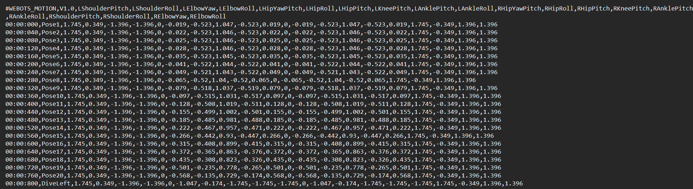

Figure 2: Left Dive Motion

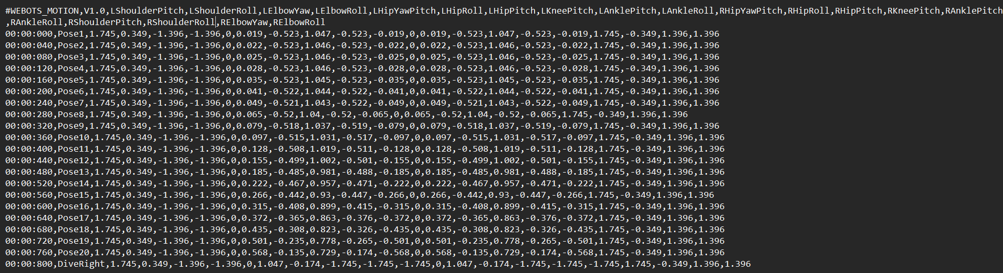

Figure 3: Right Dive Motion

Overall, the designed project uses robotic simulation, hardware, and software development.

**Implementation**

The Nao goalkeeper project is built using several tools, mainly Webots by Cyberotics is used for the simulation, thanks to its simulation capabilities, along with the built-in tools, demos, and guides making the development process smooth.

The robot is programmed using Python due to its efficiency, simplicity, and vast range of available libraries, tools, and functions that can support various aspects of the robot. Hence making the interaction with hardware components easier as well. There were two programs made, the main one was obviously for the goalkeeper/goalie and another one was for the player or striker.

**Sources**

During this project, some sources were utilized as well, the links and details are as follows:

1. **Cyberotics:** It served as the main guide during the whole project and it provided several tutorials and demos that significantly helped in the development process.

<https://cyberbotics.com/doc/guide/index>

1. **Webots libraries:** These libraries were very helpful in the programming phase from a simple hand movement to diving to stop the ball these libraries played a crucial role.

<https://cyberbotics.com/doc/guide/controller-programming#shared-libraries>

1. **Webots code:** The Python code provided in the demo helped in the process of programming the goalkeeper and its functions.

<https://github.com/cyberbotics/webots/blob/master/projects/robots/softbank/nao/controllers/nao_demo_python/nao_demo_python.py>

# **Result & Evaluation:**

**Results**

The process of creating a goalkeeper robot gave fruitful results and passed the rigorous testing process in the simulated football field in the Weebots, the robot consistently saved the goal by diving left, and right, kicking the ball away and even falling over the ball to stop the goal, hence ensuring the effectiveness and success of the developed nao goalkeeper robot.

A short table explains different tests on the goalkeeper robot.

|  |  |
| --- | --- |
| TEST | RESULT |
| Left Dive to stop the ball | Success |
| Right Dive to stop the ball | Success |
| Kick the ball | Success |
| Pick up the ball to stop the goal | Fail |
| Falling over to stop the ball | Success |

The robot’s sensors along with the actuators are working perfectly hence proved by the tests as well.

In the following figures, it is evident that the robot is using the motors and actuators and all the relevant sensors to dive to stop the ball successfully, the dives are done on both the left and right sides of the potential goal.

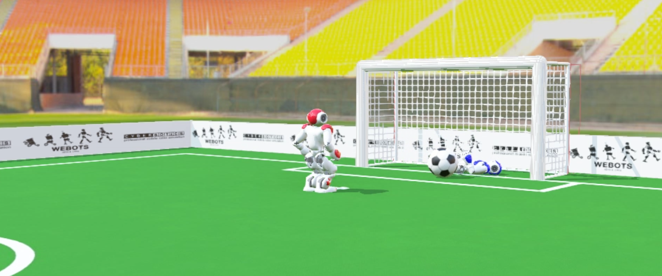

Figure 4: Left Dive

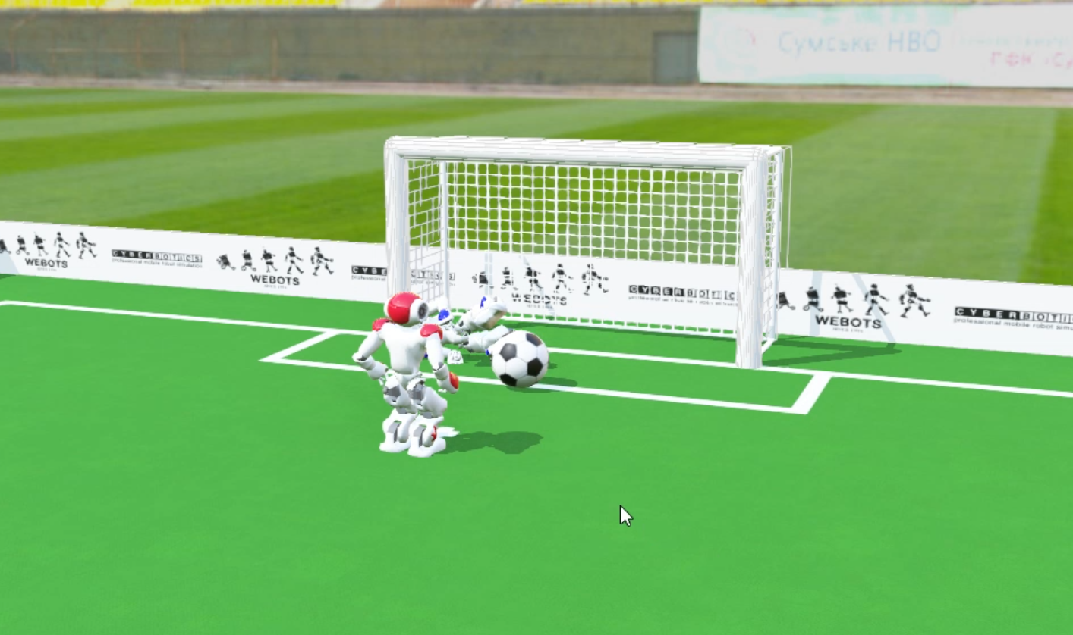

Figure 5: Right Dive

The accuracy and speed depend upon the controller of the robot as most of the time the reaction time was the key decider here and overall the algorithm behind the work was working flawlessly.

The only issue was that the robot could not pick up the ball, which will be discussed in the evaluation.

Overall the project is successful and the robot is working and is up to the mark of a goalkeeper using all the required and necessary components.

**Evaluation**

While evaluating the results and outcome of the project, the developed goalkeeper is working most of the time and as per the requirement is diving to stop the ball, which indeed was the primary task but on the other hand it is unable to pick up the ball hence it cannot be as efficient in a real football match. After careful examination of the project, it was found that the motion file for picking up the ball was missing and is also not provided by the simulation software and hence requires a lot of time and resources to create from scratch.

But overall the project is a success as it is doing the primary task of diving and stopping the ball along with additional functions such as kicking and falling over to stop the ball hence we can say that this project is successful.

# **Conclusion:**

The project is designed using Webots from Cyberbotics and primarily a goalkeeper robot is created using the software and is programmed using Python, the robot in focus was the Nao robot from Softbank Robotics. The robot was able to perform its duties most of the time by diving to stop the ball.

Regarding the criterion of success, the project was mostly successful as it was able to stop the goal by diving, and even had additional capabilities like kicking and falling over the ball, but it lacked the basic goalkeeper skill of picking up the ball, which was due to non-availability of the motion file of ball pickup. So, it is recommended to create/include a file for ball pickup with the addition of this skill the goalkeeper will become more efficient and hence be suitable for a real football match.

Another area of improvement is the speed of the robot, for a game like football speed plays a very vital role so it is recommended that in the future the speed of the robot should be increased by using a better and more efficient algorithm.

For anyone who is attempting a similar project, my advice and recommendation will be to invest your full time and focus in understanding the robot inside out from sensors, and actuators to software programming it requires full focus, and if rightly designed maybe you can make the next robotic David Beckham.

Overall, the project was implemented using Python and Webots, using the guidance provided by Cyberotics, along with the combination of libraries and tools, resulting in a successful project.