

**NAT**



May 13, 2023

Roll No: 20F_0290

**Task 1:**

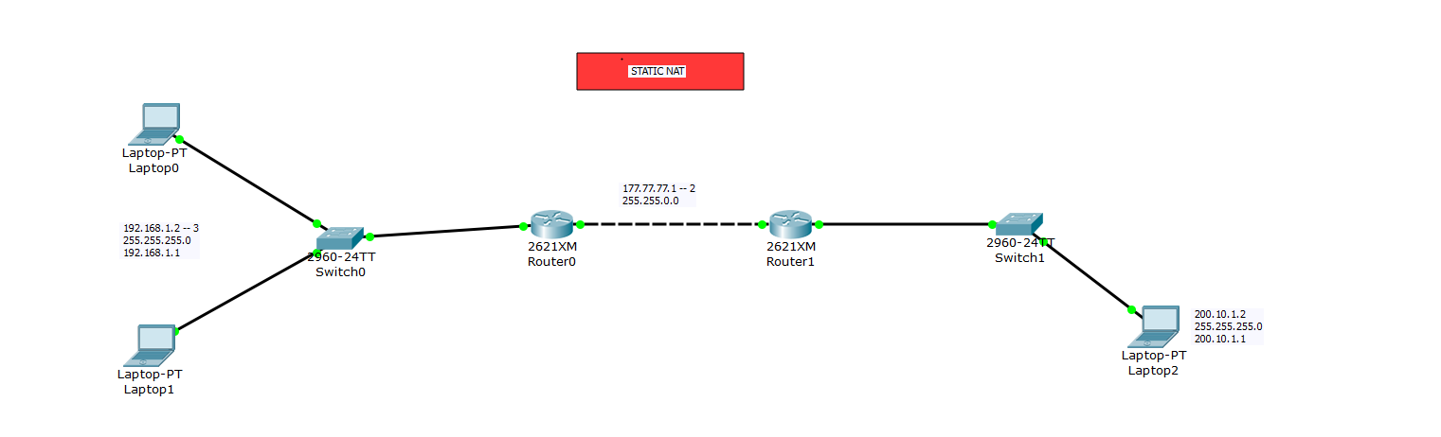

## Router 0:

## Router 1:

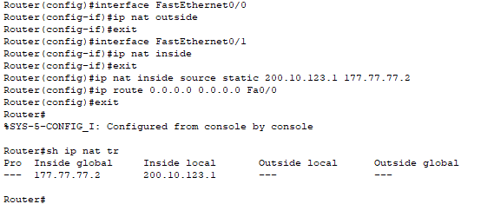

**Task 2:**

## Router 0:

## Router 1:

**Task 3:**

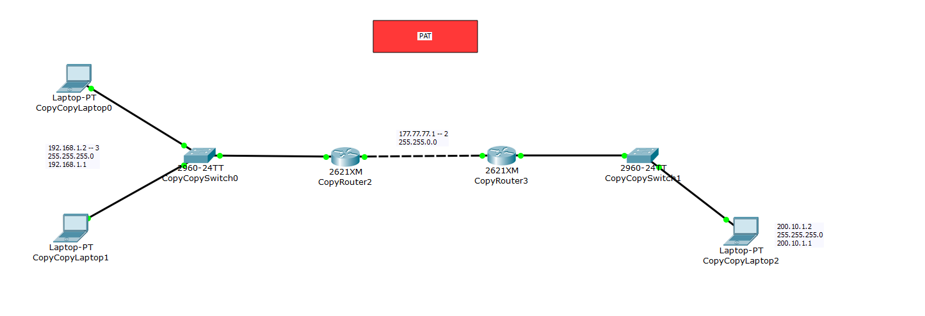

## Router 0:

## Router 1:

