

**VLAN**



May 13, 2023

**Task No 1:**

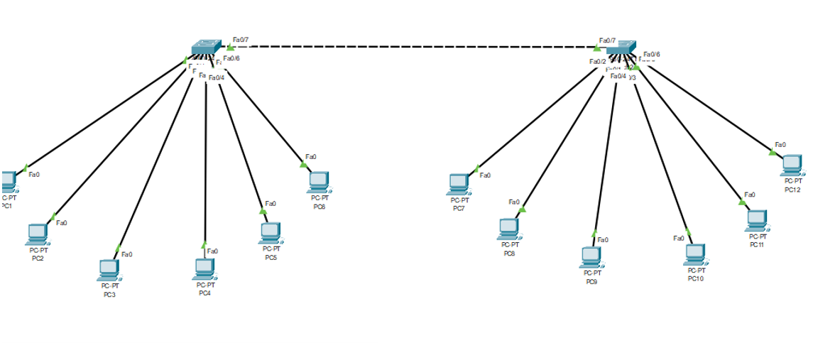

### Switch 0:

### Switch 1;

**Task No 2:**

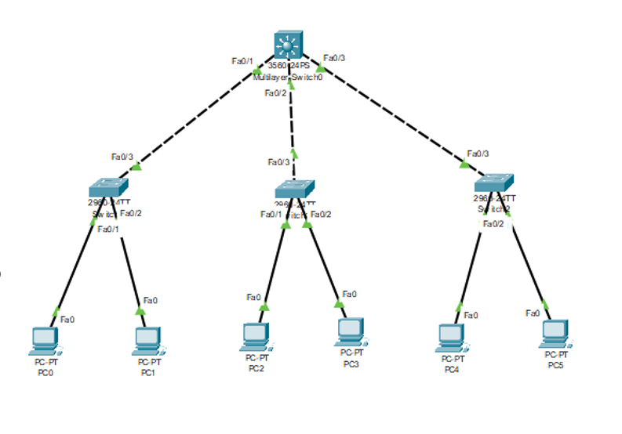

### Switch 0:

### Switch 1:

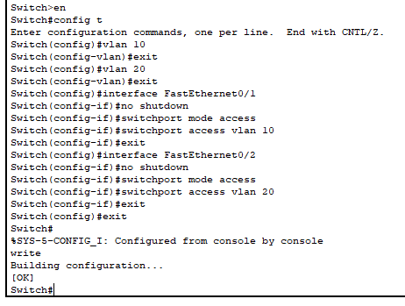

### Switch 2:

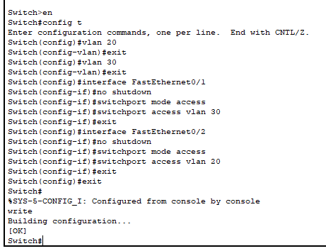

### Multiplayer Switch:

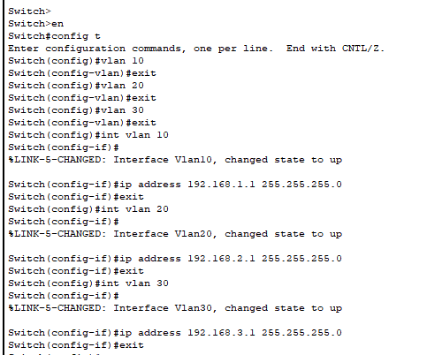

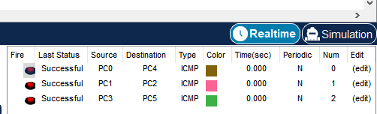

**Task No 3:**

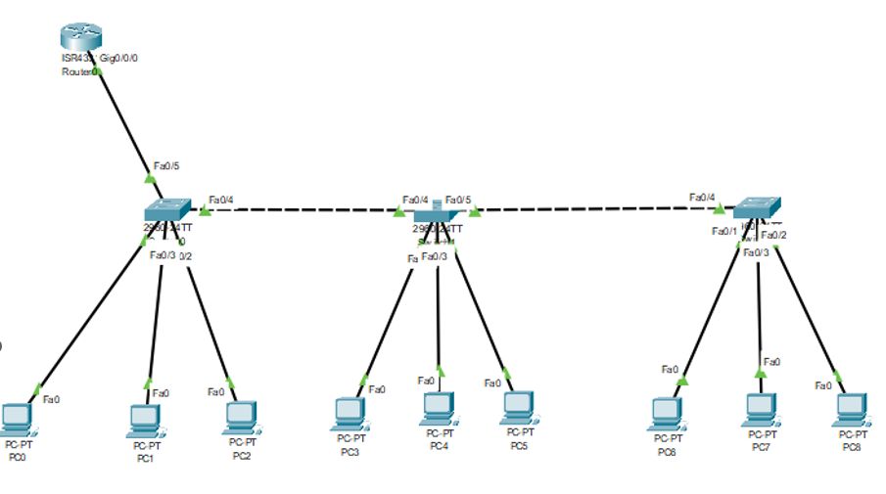

### Switch 0:

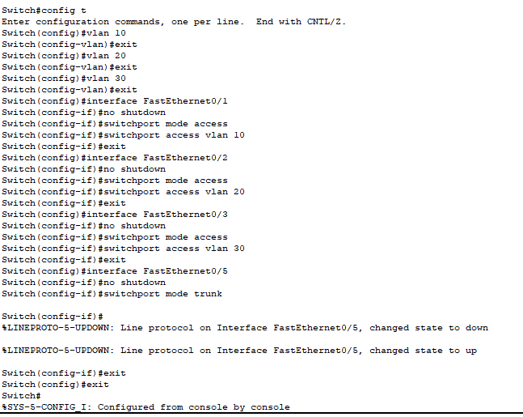

### Switch 1:

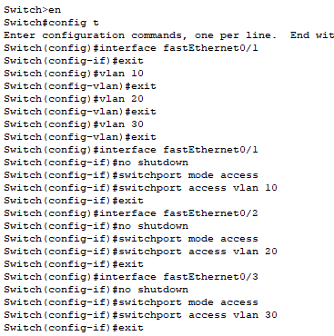

### Switch 2:

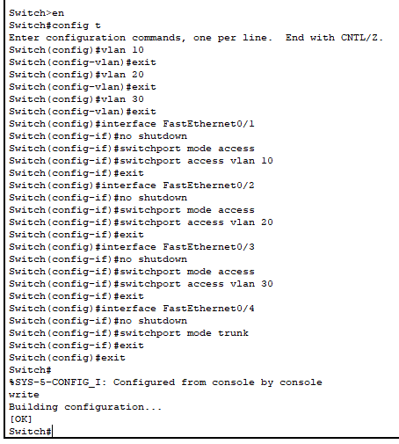

### Router:

