Adaptive Software Engineering
2420030279

Experiment 09: Static Code Analysis

Step 1: Create the following project structure:
C:\Users\Naveena\Desktop\sonar-java-demo\src\main\java\DuplicateCode.java

Step 2: Create the Initial Java Program
Create a file named DuplicateCode.java and add the following code:
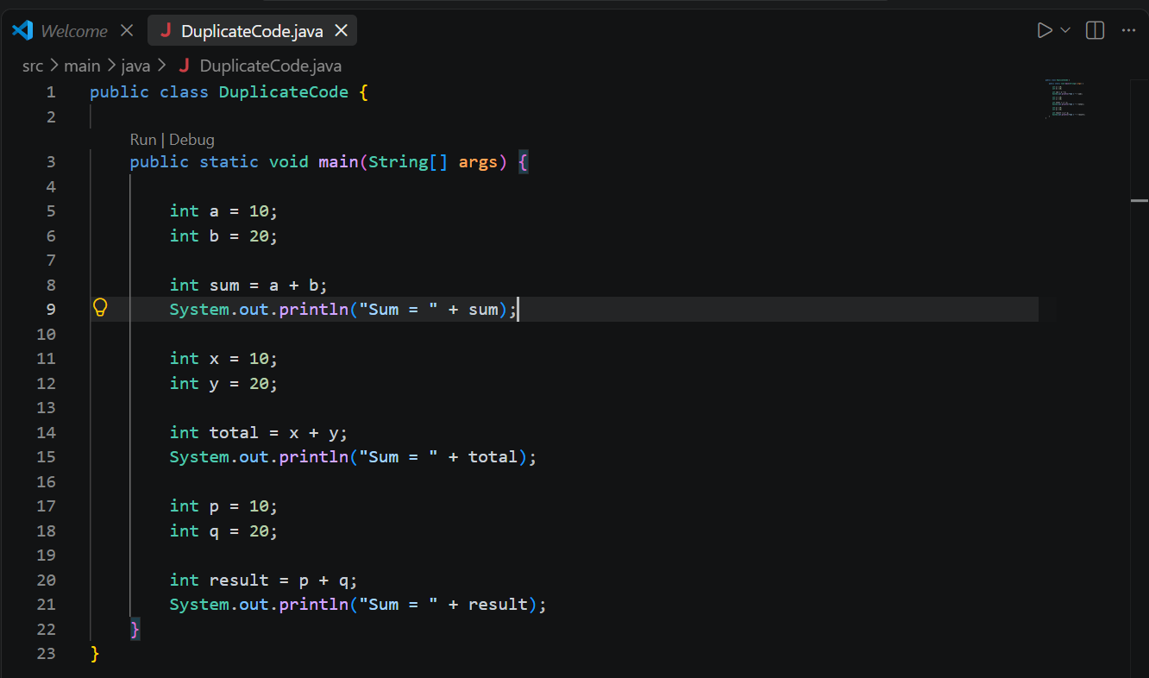
Open Command Prompt and execute:
cd /d C:\Users\Naveena\Desktop\sonar-java-demo
javac src\main\java\DuplicateCode.java
java -cp src\main\java DuplicateCode
Expected output:
Sum = 30
Sum = 30
Sum = 30
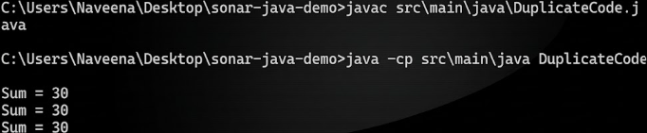

Step 3: Start SonarQube Server
Open Command Prompt and run:
cd /d C:\Users\Naveena\Desktop\sonarqube-26.9.0.129388\bin\windows-x86-64
StartSonar.bat
After the server starts, open http://localhost:9000 in a browser and log in to SonarQube.
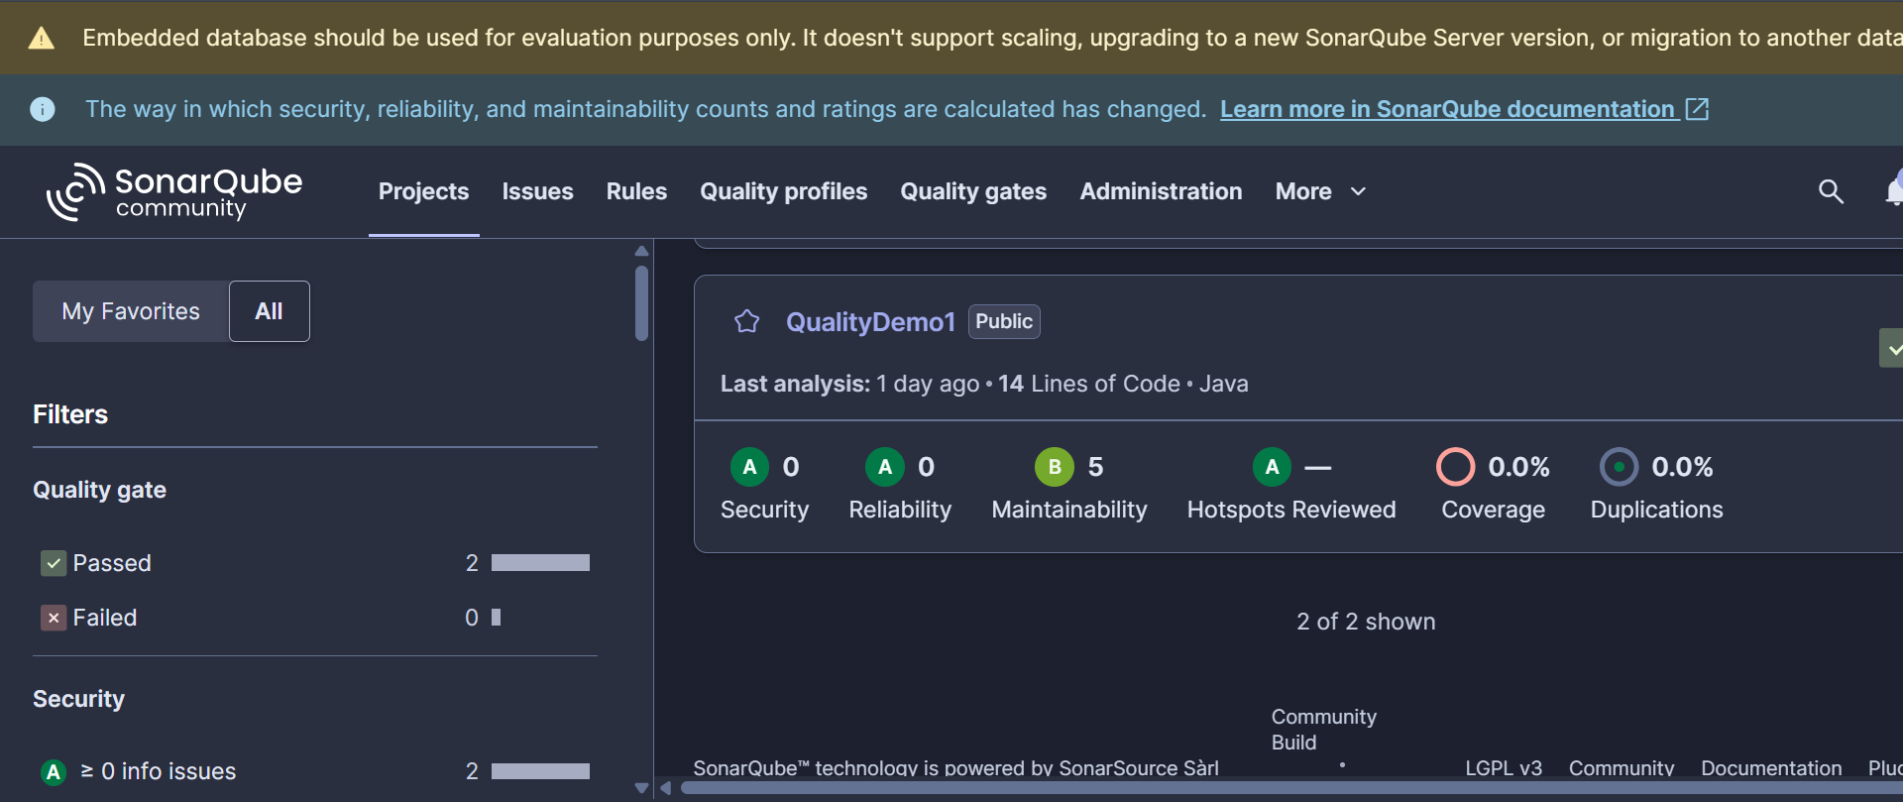

Step 4: Create SonarQube Project
Create a local project in SonarQube. Use the project name:
Java Duplicate Code Analysis
The project key used for the successful analysis is:
Java-Duplicate-Code-Analysis
For the new-code definition, the instance default (Previous version) can be retained.

Step 5: Generate a token
Generate an analysis token in SonarQube and keep it private. Do not include the token in screenshots or in this report.

Step 6: Verify the installation
Run:
sonar-scanner -v
The command should display the installed SonarScanner CLI version and the operating system information.

Step 7: Run the first SonarQube
Open Command Prompt and run the following from the project directory:
cd /d C:\Users\Naveena\Desktop\sonar-java-demo
sonar-scanner -Dsonar.projectKey=Java-Duplicate-Code-Analysis -Dsonar.sources=src/main/java -Dsonar.host.url=http://localhost:9000 -Dsonar.token=YOUR_NEW_TOKEN
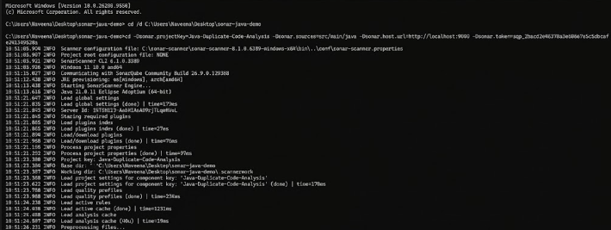

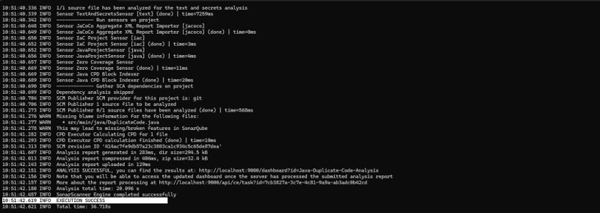

Step 8: Open the dashboard
Open the project dashboard in SonarQube. The project URL used in this project is:
http://localhost:9000/project/dashboards/built-in/project-health?id=Java-Duplicate-Code-Analysis
The initial analysis showed 16 lines of code, Security A with 0 issues, Reliability A with 0 issues, Maintainability B with 5 issues, 0.0% coverage, and 0.0% duplications.
