Data Summarization

Introduction to R for Public Health Researchers

## Data Summarization

* Basic statistical summarization
  + mean(x): takes the mean of x
  + sd(x): takes the standard deviation of x
  + median(x): takes the median of x
  + quantile(x): displays sample quantities of x. Default is min, IQR, max
  + range(x): displays the range. Same as c(min(x), max(x))

## Some examples

We can use the mtcars and Charm City Circulator datasets to explore different ways of summarizing data.

head(mtcars)

mpg cyl disp hp drat wt qsec vs am gear carb  
Mazda RX4 21.0 6 160 110 3.90 2.620 16.46 0 1 4 4  
Mazda RX4 Wag 21.0 6 160 110 3.90 2.875 17.02 0 1 4 4  
Datsun 710 22.8 4 108 93 3.85 2.320 18.61 1 1 4 1  
Hornet 4 Drive 21.4 6 258 110 3.08 3.215 19.44 1 0 3 1  
Hornet Sportabout 18.7 8 360 175 3.15 3.440 17.02 0 0 3 2  
Valiant 18.1 6 225 105 2.76 3.460 20.22 1 0 3 1

## Statistical summarization

mean(mtcars$hp)

[1] 146.6875

quantile(mtcars$hp)

0% 25% 50% 75% 100%   
 52.0 96.5 123.0 180.0 335.0

## Statistical summarization

median(mtcars$wt)

[1] 3.325

quantile(mtcars$wt, probs = 0.6)

60%   
3.44

## Statistical summarization

t.test will be covered more in detail later, gives a 95% CI:

t.test(mtcars$wt)

One Sample t-test  
  
data: mtcars$wt  
t = 18.6, df = 31, p-value < 2.2e-16  
alternative hypothesis: true mean is not equal to 0  
95 percent confidence interval:  
 2.864478 3.570022  
sample estimates:  
mean of x   
 3.21725

## Statistical summarization

Note that many of these functions have additional inputs regarding missing data, typically requiring the na.rm argument.

x = c(1,5,7,NA,4,2, 8,10,45,42)  
mean(x)

[1] NA

mean(x,na.rm=TRUE)

[1] 13.77778

quantile(x,na.rm=TRUE)

0% 25% 50% 75% 100%   
 1 4 7 10 45

## Data Summarization on matrices/data frames

* Basic statistical summarization
  + rowMeans(x): takes the means of each row of x
  + colMeans(x): takes the means of each column of x
  + rowSums(x): takes the sum of each row of x
  + colSums(x): takes the sum of each column of x
  + summary(x): for data frames, displays the quantile information

## Charm City Circulator data

Please download the Charm City Circulator data:

<http://www.aejaffe.com/summerR_2016/data/Charm_City_Circulator_Ridership.csv>

circ = read.csv("http://www.aejaffe.com/summerR_2016/data/Charm_City_Circulator_Ridership.csv",   
 header=TRUE,as.is=TRUE)

## Subsetting to specific columns

Let's just take columns that represent average ridership:

library(dplyr)  
circ2 = select(circ, date, day, ends_with("Average"))  
head(circ2, 4)

date day orangeAverage purpleAverage greenAverage  
1 01/11/2010 Monday 952.0 NA NA  
2 01/12/2010 Tuesday 796.0 NA NA  
3 01/13/2010 Wednesday 1211.5 NA NA  
4 01/14/2010 Thursday 1213.5 NA NA  
 bannerAverage  
1 NA  
2 NA  
3 NA  
4 NA

## column and row means

avgs = select(circ2, ends_with("Average"))  
colMeans(avgs,na.rm = TRUE)

orangeAverage purpleAverage greenAverage bannerAverage   
 3033.1611 4016.9345 1957.7814 827.2685

circ2$daily = rowMeans(avgs,na.rm=TRUE)  
head(circ2$daily)

[1] 952.0 796.0 1211.5 1213.5 1644.0 1490.5

## Summary

summary(circ2)

date day orangeAverage purpleAverage   
 Length:1146 Length:1146 Min. : 0 Min. : 0   
 Class :character Class :character 1st Qu.:2001 1st Qu.:2795   
 Mode :character Mode :character Median :2968 Median :4222   
 Mean :3033 Mean :4017   
 3rd Qu.:4020 3rd Qu.:5147   
 Max. :6926 Max. :8090   
 NA's :10 NA's :153   
 greenAverage bannerAverage daily   
 Min. : 0 Min. : 0.0 Min. : 0   
 1st Qu.:1491 1st Qu.: 632.5 1st Qu.:2097   
 Median :2079 Median : 763.0 Median :2846   
 Mean :1958 Mean : 827.3 Mean :2878   
 3rd Qu.:2340 3rd Qu.: 945.9 3rd Qu.:3646   
 Max. :5094 Max. :4617.0 Max. :6123   
 NA's :661 NA's :876 NA's :10

## Apply statements

You can apply more general functions to the rows or columns of a matrix or data frame, beyond the mean and sum.

apply(X, MARGIN, FUN, ...)

X : an array, including a matrix.

MARGIN : a vector giving the subscripts which the function will be applied over. E.g., for a matrix 1 indicates rows, 2 indicates columns, c(1, 2) indicates rows and columns. Where X has named dimnames, it can be a character vector selecting dimension names.

FUN : the function to be applied: see 'Details'.

... : optional arguments to FUN.

## Apply statements

apply(avgs,2,mean,na.rm=TRUE) # column means

orangeAverage purpleAverage greenAverage bannerAverage   
 3033.1611 4016.9345 1957.7814 827.2685

apply(avgs,2,sd,na.rm=TRUE) # columns sds

orangeAverage purpleAverage greenAverage bannerAverage   
 1227.5779 1406.6544 592.8969 436.0487

apply(avgs,2,max,na.rm=TRUE) # column maxs

orangeAverage purpleAverage greenAverage bannerAverage   
 6926.5 8089.5 5094.0 4617.0

## Other Apply Statements

* tapply(): 'grouping' apply
* lapply(): 'list' apply [tomorrow]
* sapply(): 'simple' apply [tomorrow]
* Other less used ones...

See more details here: <http://nsaunders.wordpress.com/2010/08/20/a-brief-introduction-to-apply-in-r/>

## tapply()

From the help file: "Apply a function to each cell of a ragged array, that is to each (non-empty) group of values given by a unique combination of the levels of certain factors."

tapply(X, INDEX, FUN = NULL, ..., simplify = TRUE)

Simply put, you can apply function FUN to X within each categorical level of INDEX. It is very useful for assessing properties of continuous data by levels of categorical data.

## tapply()

For example, we can estimate the highest average daily ridership for each day of the week in 1 line in the Circulator dataset.

tapply(circ2$daily, circ2$day, max, na.rm = TRUE)

Friday Monday Saturday Sunday Thursday Tuesday Wednesday   
 5600.75 5002.25 6123.00 3980.25 4820.50 4855.25 4985.00

## Data Summarization/Visualization

* Basic summarization plots
  + plot(x,y): scatterplot of x and y
  + boxplot(y~x): boxplot of y against levels of x
  + hist(x): histogram of x
  + density(x): kernel density plot of x

## Basic Plots

Plotting is an important component of exploratory data analysis. We will review some of the more useful and informative plots here. We will go over formatting and making plots look nicer in additional lectures.

## Scatterplot

plot(mtcars$mpg, mtcars$disp)

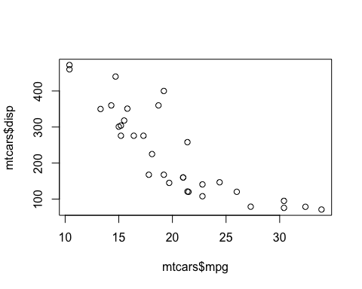

## Histograms

hist(circ2$daily)

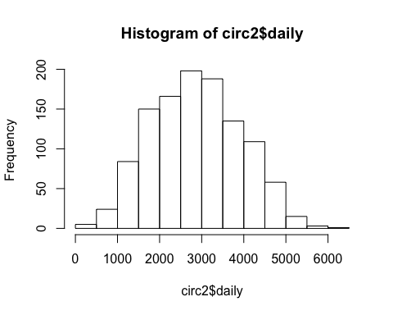

## Plot with a line

type = "l" means a line

library(lubridate)  
circ2$date = mdy(circ2$date)  
plot(circ2$date, circ2$daily, type = "l")

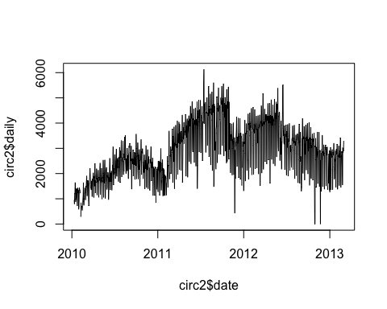

## Density

## plot(density(circ2$daily))  
plot(density(circ2$daily,na.rm=TRUE))

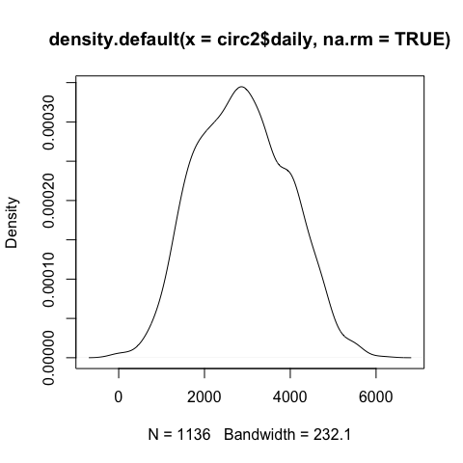

## Boxplots

boxplot(circ2$daily ~ circ2$day)

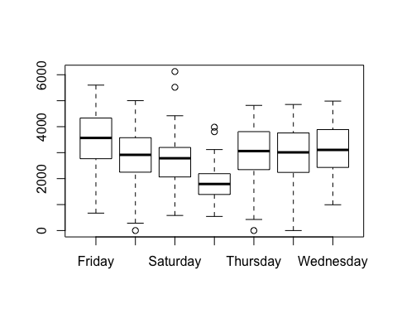

## Boxplots

boxplot(daily ~ day, data=circ2)



## Data Summarization for data.frames

* Basic summarization plots
  + matplot(x,y): scatterplot of two matrices, x and y
  + pairs(x,y): plots pairwise scatter plots of matrices x and y, column by column

## Matrix plot

pairs(avgs)

