Data Visualization

Introduction to R for Public Health Researchers

## Basic Plots

We covered some basic plots previously, but we are going to expand the ability to customize these basic graphics first.

## Read in Data

death = read.csv("http://www.aejaffe.com/summerR_2016/data/indicatordeadkids35.csv",  
 as.is=TRUE,header=TRUE, row.names=1)  
death[1:2, 1:5]

X1760 X1761 X1762 X1763 X1764  
Afghanistan NA NA NA NA NA  
Albania NA NA NA NA NA

We see that the column names were years, and R doesn't necessarily like to read in a column name that starts with a number and puts an X there.  
We'll just take off that X and get the years.

library(stringr)  
year = names(death) %>% str_replace("X","") %>% as.integer  
head(year)

[1] 1760 1761 1762 1763 1764 1765

## Basic Plots

> plot(as.numeric(death["Sweden",]) ~ year)

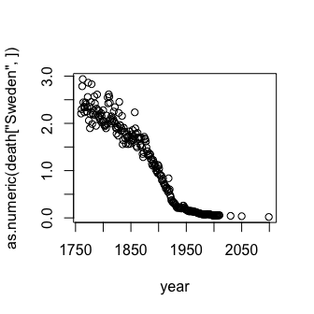

## Basic Plots

The y-axis label isn't informative, and we can change the label of the y-axis using ylab (xlab for x), and main for the main title/label.

> plot(as.numeric(death["Sweden",]) ~ year,  
+ ylab = "# of deaths per family", main = "Sweden")

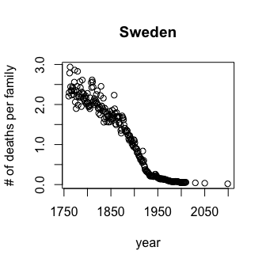

## Basic Plots

Let's drop any of the projections and keep it to year 2012, and change the points to blue.

plot(as.numeric(death["Sweden",])~year,  
 ylab = "# of deaths per family", main = "Sweden",  
 xlim = c(1760,2012), pch = 19, cex=1.2,col="blue")

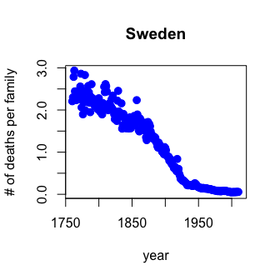

## Basic Plots

You can also use the subset argument in the plot() function, only when using formula notation:

plot(as.numeric(death["Sweden",])~year,  
 ylab = "# of deaths per family", main = "Sweden",  
 subset = year < 2015, pch = 19, cex=1.2,col="blue")

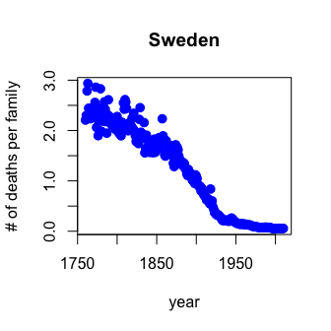

## Basic Plots

Using scatter.smooth plots the points and runs a loess smoother through the data.

> scatter.smooth(as.numeric(death["Sweden",])~year,span=0.2,  
+ ylab="# of deaths per family", main = "Sweden",lwd=3,  
+ subset = year < 2015, pch = 19, cex=0.9,col="grey")

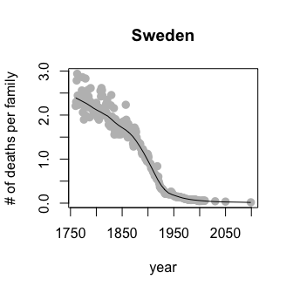

## Basic Plots

par(mfrow=c(1,2)) tells R that we want to set a parameter (par function) named mfrow (number of plots - 1 row, 2 columns) so we can have 2 plots side by side (Sweden and the UK)

> par(mfrow=c(1,2))  
> scatter.smooth(as.numeric(death["Sweden",])~year,span=0.2,  
+ ylab="# of deaths per family", main = "Sweden",lwd=3,  
+ xlim = c(1760,2012), pch = 19, cex=0.9,col="grey")  
> scatter.smooth(as.numeric(death["United Kingdom",])~year,span=0.2,  
+ ylab="# of deaths per family", main = "United Kingdom",lwd=3,  
+ xlim = c(1760,2012), pch = 19, cex=0.9,col="grey")

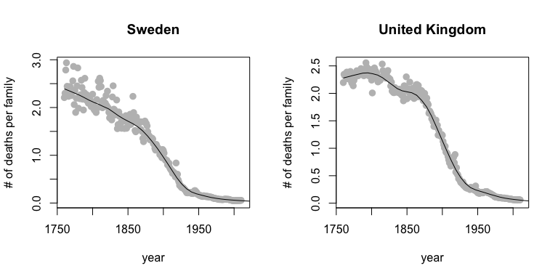

## Basic Plots

We can set the y-axis to be the same.

par(mfrow=c(1,2))  
yl = range(death[c("Sweden","United Kingdom"),])  
scatter.smooth(as.numeric(death["Sweden",])~year,span=0.2,ylim=yl,  
 ylab="# of deaths per family", main = "Sweden",lwd=3,  
 xlim = c(1760,2012), pch = 19, cex=0.9,col="grey")  
scatter.smooth(as.numeric(death["United Kingdom",])~year,span=0.2,  
 ylab="", main = "United Kingdom",lwd=3,ylim=yl,  
 xlim = c(1760,2012), pch = 19, cex=0.9,col="grey")

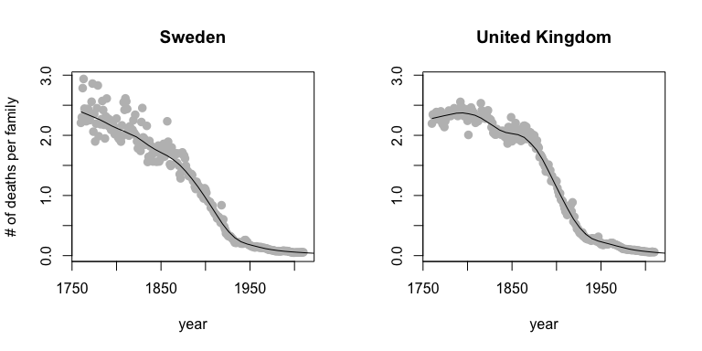

## Bar Plots

* Stacked Bar Charts are sometimes wanted to show distributions of data

## Stacked Bar Charts  
cars = read.csv("http://www.aejaffe.com/summerR_2016/data/kaggleCarAuction.csv",as.is=TRUE)  
counts <- table(cars$IsBadBuy, cars$VehicleAge)  
barplot(counts, main="Car Distribution by Age and Bad Buy Status",  
 xlab="Vehicle Age", col=c("darkblue","red"),  
 legend = rownames(counts))

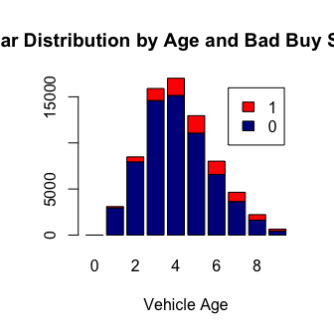

## Bar Plots

prop.table allows you to convert a table to proportions (depends on margin - either row percent or column percent)

## Use percentages (column percentages)  
barplot(prop.table(counts, 2), main="Car Distribution by Age and Bad Buy Status",  
 xlab="Vehicle Age", col=c("darkblue","red"),  
 legend = rownames(counts))

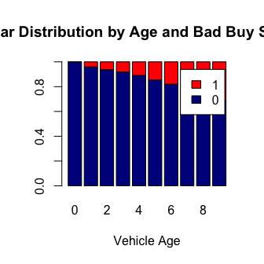

## Bar Plots

Using the beside argument in barplot, you can get side-by-side barplots.

# Stacked Bar Plot with Colors and Legend   
barplot(counts, main="Car Distribution by Age and Bad Buy Status",  
 xlab="Vehicle Age", col=c("darkblue","red"),  
 legend = rownames(counts), beside=TRUE)

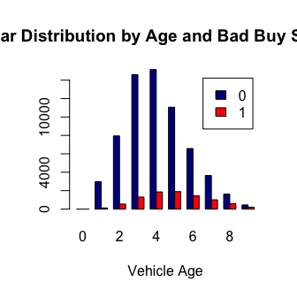

## Graphics parameters

Set within most plots in the base 'graphics' package:

* pch = point shape, <http://voteview.com/symbols_pch.htm>
* cex = size/scale
* xlab, ylab = labels for x and y axes
* main = plot title
* lwd = line density
* col = color
* cex.axis, cex.lab, cex.main = scaling/sizing for axes marks, axes labels, and title

## Devices

By default, R displays plots in a separate panel. From there, you can export the plot to a variety of image file types, or copy it to the clipboard.

However, sometimes its very nice to save many plots made at one time to one pdf file, say, for flipping through. Or being more precise with the plot size in the saved file.

R has 5 additional graphics devices: bmp(), jpeg(), png(), tiff(), and pdf()

## Devices

The syntax is very similar for all of them:

pdf("filename.pdf", width=8, height=8) # inches  
plot() # plot 1  
plot() # plot 2  
# etc  
dev.off()

Basically, you are creating a pdf file, and telling R to write any subsequent plots to that file. Once you are done, you turn the device off. Note that failing to turn the device off will create a pdf file that is corrupt, that you cannot open.

## Boxplots, revisited

These are one of my favorite plots. They are way more informative than the barchart + antenna...

> boxplot(weight ~ Diet, data=ChickWeight, outline=FALSE)  
> points(ChickWeight$weight ~ jitter(as.numeric(ChickWeight$Diet),0.5))

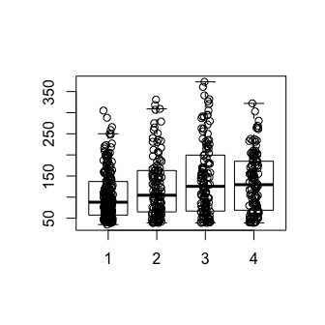

## Formulas

Formulas have the format of y ~ x and functions taking formulas have a data argument where you pass the data.frame. You don't need to use $ or referencing when using formulas:

boxplot(weight ~ Diet, data=ChickWeight, outline=FALSE)

## Colors

R relies on color 'palettes'.

palette("default")  
plot(1:8, 1:8, type="n")  
text(1:8, 1:8, lab = palette(), col = 1:8)

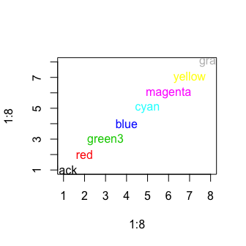

## Colors

The default color palette is pretty bad, so you can try to make your own.

palette(c("darkred","orange","blue"))  
plot(1:3,1:3,col=1:3,pch =19,cex=2)

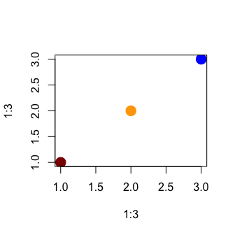

## Colors

It's actually pretty hard to make a good color palette. Luckily, smart and artistic people have spent a lot more time thinking about this. The result is the RColorBrewer package

RColorBrewer::display.brewer.all() will show you all of the palettes available. You can even print it out and keep it next to your monitor for reference.

The help file for brewer.pal() gives you an idea how to use the package.

You can also get a "sneak peek" of these palettes at: <http://colorbrewer2.org/> . You would provide the number of levels or classes of your data, and then the type of data: sequential, diverging, or qualitative. The names of the RColorBrewer palettes are the string after 'pick a color scheme:'

## Colors

palette("default")  
plot(weight ~ Time, data= ChickWeight, pch = 19, col = Diet)

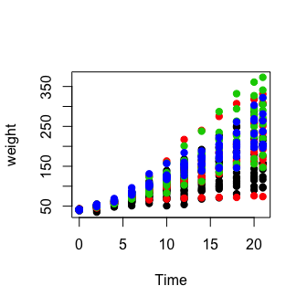

## Colors

library(RColorBrewer)  
palette(brewer.pal(5,"Dark2"))  
plot(weight ~ Time, data=ChickWeight, pch = 19, col = Diet)

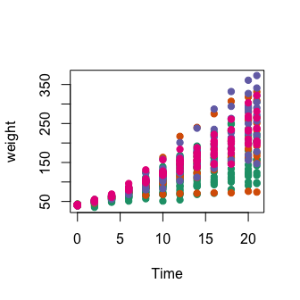

## Colors

library(RColorBrewer)  
palette(brewer.pal(5,"Dark2"))  
plot(weight ~ jitter(Time,amount=0.2),data=ChickWeight,  
 pch = 19, col = Diet,xlab="Time")

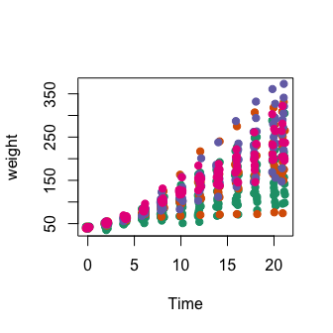

## Adding legends

The legend() command adds a legend to your plot. There are tons of arguments to pass it.

x, y=NULL: this just means you can give (x,y) coordinates, or more commonly just give x, as a character string: "top","bottom","topleft","bottomleft","topright","bottomright".

legend: unique character vector, the levels of a factor

pch, lwd: if you want points in the legend, give a pch value. if you want lines, give a lwd value.

col: give the color for each legend level

## Adding legends

palette(brewer.pal(5,"Dark2"))  
plot(weight ~ jitter(Time,amount=0.2),data=ChickWeight,  
 pch = 19, col = Diet,xlab="Time")  
legend("topleft", paste("Diet",levels(ChickWeight$Diet)),   
 col = 1:length(levels(ChickWeight$Diet)),  
 lwd = 3, ncol = 2)

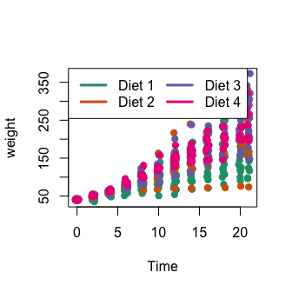

## Coloring by variable

> circ = read.csv("http://www.aejaffe.com/summerR_2016/data/Charm_City_Circulator_Ridership.csv",   
+ header=TRUE,as.is=TRUE)  
> palette(brewer.pal(7,"Dark2"))  
> dd = factor(circ$day)  
> plot(orangeAverage ~ greenAverage, data=circ,   
+ pch=19, col = as.numeric(dd))  
> legend("bottomright", levels(dd), col=1:length(dd), pch = 19)

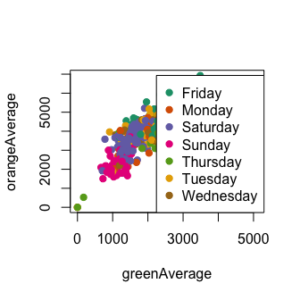

## Coloring by variable

> dd = factor(circ$day, levels=c("Monday","Tuesday","Wednesday",  
+ "Thursday","Friday","Saturday","Sunday"))  
> plot(orangeAverage ~ greenAverage, data=circ,  
+ pch=19, col = as.numeric(dd))  
> legend("bottomright", levels(dd), col=1:length(dd), pch = 19)

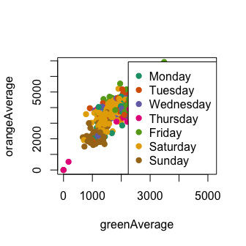

## ggplot2

ggplot2 is a package of plotting that is very popular and powerful. qplot is a short hand for "quick plot". We can simply do a boxplot:

> library(ggplot2)  
> qplot(factor(Diet), y = weight,   
+ data = ChickWeight, geom = "boxplot")

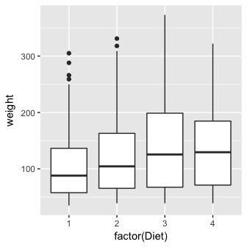

## ggplot2

The generic plotting function is ggplot:

> g = ggplot(aes(x = Diet, y = weight), data = ChickWeight)  
> g + geom_boxplot()

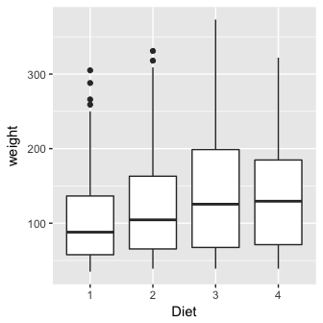

## Boxplots revisited again

We can do the same plot, by just saying we want a boxplot and points (and jitter the points)

> qplot( factor(Diet), y = weight, data = ChickWeight,   
+ geom = c("boxplot", "jitter"))

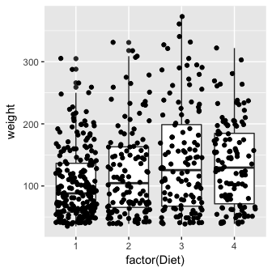

## ggplot2: Adding 2 geoms together

To have multiple geometrics, just "add" them

> g + geom_boxplot() + geom_point(position = "jitter")

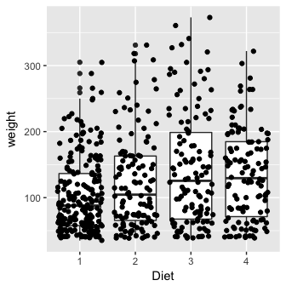

## ggplot2: Adding 2 geoms together

To have multiple geometrics, just "add" them

g + geom_boxplot() + geom_jitter()

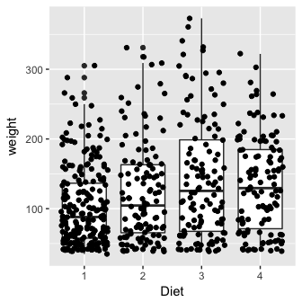

## Histograms again

We can do histograms again using hist. Let's do histograms of weight at all time points for the chick's weights. We reiterate how useful these are to show your data.

> hist(ChickWeight$weight, breaks = 20)

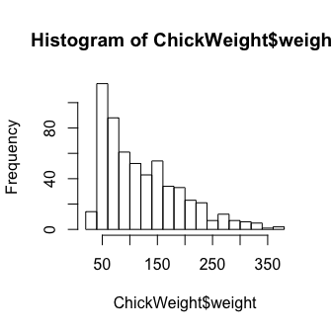

## Multiple Histograms

> qplot(x = weight,   
+ fill = factor(Diet),  
+ data = ChickWeight,   
+ geom = c("histogram"))

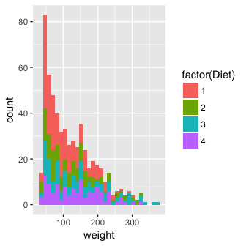

## Multiple Histograms

Alpha refers tot he opacity of the color, less is

> qplot(x = weight, fill = Diet, data = ChickWeight,   
+ geom = c("histogram"), alpha=I(.7))

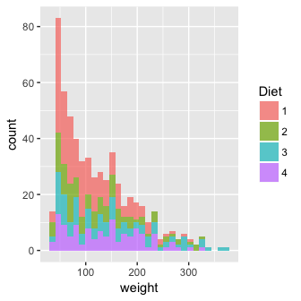

## Multiple Densities

We cold also do densities

> qplot(x= weight, fill = Diet, data = ChickWeight,   
+ geom = c("density"), alpha=I(.7))

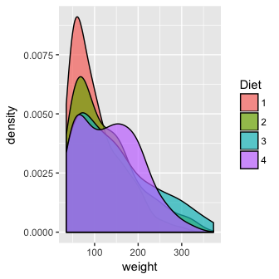

## Multiple Densities

> qplot(x= weight, colour = Diet, data = ChickWeight,   
+ geom = c("density"), alpha=I(.7))

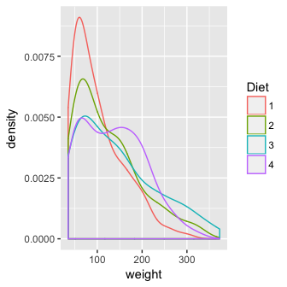

## Multiple Densities

> ggplot(aes(x= weight, colour = Diet),   
+ data = ChickWeight) + geom_density(alpha=I(.7))



## Multiple Densities

You can take off the lines of the bottom like this

> ggplot(aes(x = weight, colour = Diet), data = ChickWeight) +   
+ geom_line(stat = "density")

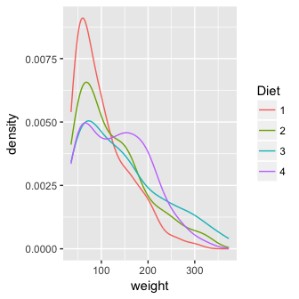

## Spaghetti plot

We can make a spaghetti plot by telling ggplot we want a "line", and each line is colored by Chick.

> qplot(x=Time, y=weight, colour = Chick,   
+ data = ChickWeight, geom = "line")

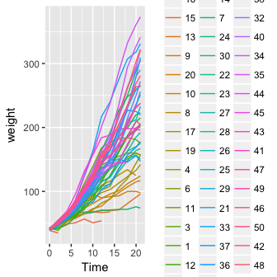

## Spaghetti plot: Facets

In ggplot2, if you want separate plots for something, these are referred to as facets.

> qplot(x = Time, y = weight, colour = Chick,   
+ facets = ~Diet, data = ChickWeight, geom = "line")

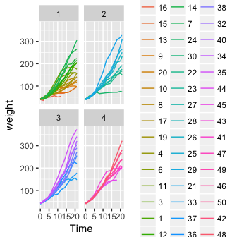

## Spaghetti plot: Facets

We can turn off the legend (referred to a "guide" in ggplot2). (Note - there is different syntax with the +)

> qplot(x=Time, y=weight, colour = Chick,   
+ facets = ~ Diet, data = ChickWeight,   
+ geom = "line") + guides(colour=FALSE)

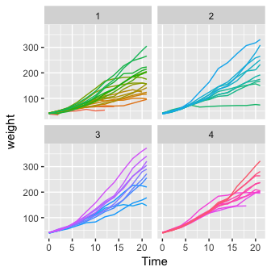

## Spaghetti plot: Facets

> ggplot(aes(x = Time, y = weight, colour = Chick),   
+ data = ChickWeight) + geom_line() +   
+ facet_wrap(facets = ~Diet) + guides(colour = FALSE)



## ggplot2

Let's try this out on the childhood mortality data used above. However, let's do some manipulation first, by using gather on the data to convert to long.

library(tidyr)  
long = death  
long$state = rownames(long)  
long = long %>% gather(year, deaths, -state)  
head(long, 2)

state year deaths  
1 Afghanistan X1760 NA  
2 Albania X1760 NA

## ggplot2

Let's also make the year numeric, as we did above in the stand-alone year variable.

library(stringr)  
library(dplyr)  
long$year = long$year %>% str_replace("^X", "") %>% as.numeric  
long = long %>% filter(!is.na(deaths))

## ggplot2

> qplot(x = year, y = deaths, colour = state,   
+ data = long, geom = "line") + guides(colour = FALSE)

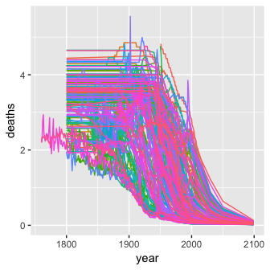

## ggplot2

Let's try to make it different like base R, a bit. We use tile for the geometric unit:

qplot(x = year, y = state, colour = deaths,   
 data = long, geom = "tile") + guides(colour = FALSE)

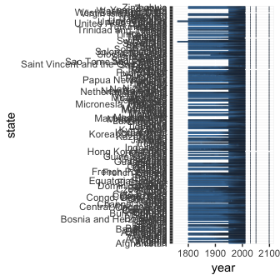

## ggplot2

Useful links:

* <http://docs.ggplot2.org/0.9.3/index.html>
* <http://www.cookbook-r.com/Graphs/>