The three "back ticks" (`) must be followed by curly brackets "{", and then "r" to tell the computer that you are using R code. This line is then closed off by another curly bracket "}".

Anything before three more back ticks "```" are then considered R code (a script).

If any code in the document has just a backtick ` then nothing, then another backtick, then that word is just printed as if it were code, such as hey.

I'm reading in the bike lanes here.

# readin is just a "label" for this code chunk  
## code chunk is just a "chunk" of code, where this code usually  
## does just one thing, aka a module  
### comments are still # here  
### you can do all your reading in there  
### let's say we loaded some packages  
library(stringr)  
library(plyr)  
library(dplyr)  
fname <- "../../data/Bike_Lanes.csv"  
bike = read.csv(fname, as.is = TRUE)

You can write your introduction here.

## Introduction

Bike lanes are in Baltimore. People like them. Why are they so long?

## Exploratory Analysis

Let's look at some plots of bike length. Let's say we wanted to look at what affects bike length.

### Plots of bike length

Note we made the subsection by using three "hashes" (pound signs): ###.

We can turn off R code output by using echo = FALSE on the knitr code chunk. s

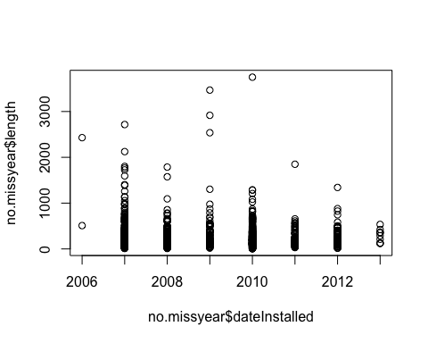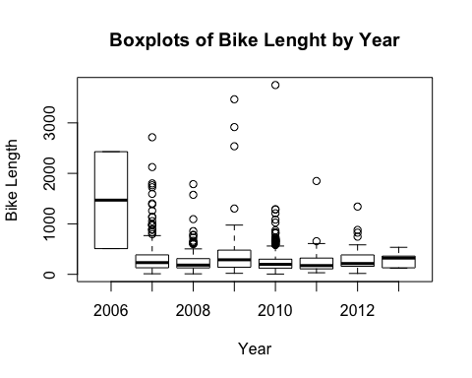

We have a total of 1505 rows.

What does it look like if we took the log (base 10) of the bike length:

no.missyear$log.length <- log10(no.missyear$length)  
### see here that if you specify the data argument, you don't need to do the $   
boxplot(log.length ~ dateInstalled, data=no.missyear, main="Boxplots of Bike Lenght by Year", xlab="Year", ylab="Bike Length")

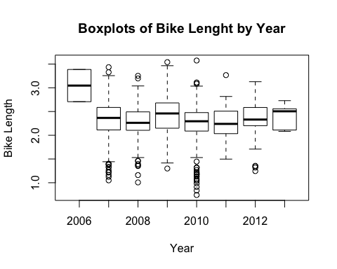

I want my boxplots colored, so I set the col argument.

boxplot(log.length ~ dateInstalled, data=no.missyear, main="Boxplots of Bike Lenght by Year", xlab="Year", ylab="Bike Length", col="red")

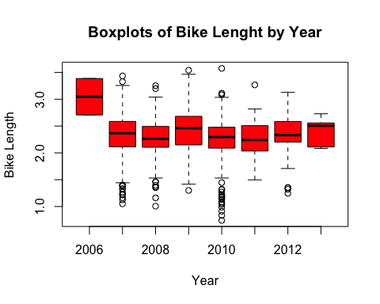

As we can see, 2006 had a much higher bike length. What about for the type of bike path?

### type is a character, but when R sees a "character" in a "formula", then it automatically converts it to factor  
### a formula is something that has a y ~ x, which says I want to plot y against x  
### or if it were a model you would do y ~ x, which meant regress against y  
boxplot(log.length ~ type, data=no.missyear, main="Boxplots of Bike Lenght by Year", xlab="Year", ylab="Bike Length")

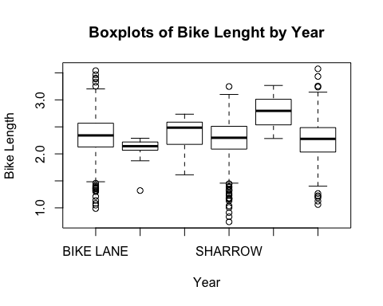

What if we want to extract means by each type?

Let's show a few ways:

### tapply takes in vector 1, then does a function by vector 2, and then you tell what   
### that function is  
tapply(no.missyear$log.length, no.missyear$type, mean)

## BIKE LANE CONTRAFLOW SHARED BUS BIKE SHARROW   
## 2.330611 2.087246 2.363005 2.256425   
## SIDEPATH SIGNED ROUTE   
## 2.781829 2.263746

## aggregate  
aggregate(x=no.missyear$log.length, by=list(no.missyear$type), FUN=mean)

## Group.1 x  
## 1 BIKE LANE 2.330611  
## 2 CONTRAFLOW 2.087246  
## 3 SHARED BUS BIKE 2.363005  
## 4 SHARROW 2.256425  
## 5 SIDEPATH 2.781829  
## 6 SIGNED ROUTE 2.263746

### now let's specify the data argument and use a "formula" - much easier to read and   
## more "intuitive"  
aggregate(log.length ~ type, data=no.missyear, FUN=mean)

## type log.length  
## 1 BIKE LANE 2.330611  
## 2 CONTRAFLOW 2.087246  
## 3 SHARED BUS BIKE 2.363005  
## 4 SHARROW 2.256425  
## 5 SIDEPATH 2.781829  
## 6 SIGNED ROUTE 2.263746

## ddply is from the plyr package  
##takes in a data frame, (the first d refers to data.frame)   
## splits it up by some variables (let's say type)  
## then we'll use summarise to summarize whatever we want  
## then returns a data.frame (the second d) - hence why it's ddply  
## if we wanted to do it on a "list" thne return data.frame, it'd be ldply  
ddply(no.missyear, .(type), plyr::summarise,  
 mean=mean(log.length)  
 )

## type mean  
## 1 BIKE LANE 2.330611  
## 2 CONTRAFLOW 2.087246  
## 3 SHARED BUS BIKE 2.363005  
## 4 SHARROW 2.256425  
## 5 SIDEPATH 2.781829  
## 6 SIGNED ROUTE 2.263746

no.missyear %>% group_by(type) %>%   
 dplyr::summarise(mean=mean(log.length))

## # A tibble: 6 × 2  
## type mean  
## <chr> <dbl>  
## 1 BIKE LANE 2.330611  
## 2 CONTRAFLOW 2.087246  
## 3 SHARED BUS BIKE 2.363005  
## 4 SHARROW 2.256425  
## 5 SIDEPATH 2.781829  
## 6 SIGNED ROUTE 2.263746

ddply (and other functions in the plyr package) is cool because you can do multiple functions really easy.

Let's show a what if we wanted to go over type and dateInstalled:

### For going over 2 variables, we need to do it over a "list" of vectors  
tapply(no.missyear$log.length,   
 list(no.missyear$type, no.missyear$dateInstalled),   
 mean)

## 2006 2007 2008 2009 2010 2011  
## BIKE LANE 3.046261 2.351256 2.365728 2.381418 2.306994 2.242132  
## CONTRAFLOW NA NA NA NA 2.087246 NA  
## SHARED BUS BIKE NA NA NA 2.350759 2.403824 NA  
## SHARROW NA 2.300954 2.220850 2.691814 2.247131 NA  
## SIDEPATH NA NA 2.625486 NA 2.773850 3.266816  
## SIGNED ROUTE NA 2.287593 NA NA 2.239475 2.210112  
## 2012 2013  
## BIKE LANE 2.36151 2.408306  
## CONTRAFLOW NA NA  
## SHARED BUS BIKE NA NA  
## SHARROW 2.23636 NA  
## SIDEPATH NA NA  
## SIGNED ROUTE NA NA

tapply(no.missyear$log.length,   
 list(no.missyear$type, no.missyear$dateInstalled),   
 mean, na.rm=TRUE)

## 2006 2007 2008 2009 2010 2011  
## BIKE LANE 3.046261 2.351256 2.365728 2.381418 2.306994 2.242132  
## CONTRAFLOW NA NA NA NA 2.087246 NA  
## SHARED BUS BIKE NA NA NA 2.350759 2.403824 NA  
## SHARROW NA 2.300954 2.220850 2.691814 2.247131 NA  
## SIDEPATH NA NA 2.625486 NA 2.773850 3.266816  
## SIGNED ROUTE NA 2.287593 NA NA 2.239475 2.210112  
## 2012 2013  
## BIKE LANE 2.36151 2.408306  
## CONTRAFLOW NA NA  
## SHARED BUS BIKE NA NA  
## SHARROW 2.23636 NA  
## SIDEPATH NA NA  
## SIGNED ROUTE NA NA

## aggregate - looks better  
aggregate(log.length ~ type + dateInstalled, data=no.missyear, FUN=mean)

## type dateInstalled log.length  
## 1 BIKE LANE 2006 3.046261  
## 2 BIKE LANE 2007 2.351256  
## 3 SHARROW 2007 2.300954  
## 4 SIGNED ROUTE 2007 2.287593  
## 5 BIKE LANE 2008 2.365728  
## 6 SHARROW 2008 2.220850  
## 7 SIDEPATH 2008 2.625486  
## 8 BIKE LANE 2009 2.381418  
## 9 SHARED BUS BIKE 2009 2.350759  
## 10 SHARROW 2009 2.691814  
## 11 BIKE LANE 2010 2.306994  
## 12 CONTRAFLOW 2010 2.087246  
## 13 SHARED BUS BIKE 2010 2.403824  
## 14 SHARROW 2010 2.247131  
## 15 SIDEPATH 2010 2.773850  
## 16 SIGNED ROUTE 2010 2.239475  
## 17 BIKE LANE 2011 2.242132  
## 18 SIDEPATH 2011 3.266816  
## 19 SIGNED ROUTE 2011 2.210112  
## 20 BIKE LANE 2012 2.361510  
## 21 SHARROW 2012 2.236360  
## 22 BIKE LANE 2013 2.408306

## ddply is from the plyr package  
ddply(no.missyear, .(type, dateInstalled), summarise,  
 mean=mean(log.length),  
 median=median(log.length),  
 Mode=mode(log.length),  
 Std.Dev=sd(log.length)  
 )

## type dateInstalled mean median Mode Std.Dev  
## 1 BIKE LANE 2006 3.046261 3.046261 numeric 0.47973544  
## 2 BIKE LANE 2007 2.351256 2.444042 numeric 0.40662247  
## 3 BIKE LANE 2008 2.365728 2.354641 numeric 0.38916236  
## 4 BIKE LANE 2009 2.381418 2.311393 numeric 0.49447436  
## 5 BIKE LANE 2010 2.306994 2.328486 numeric 0.32075915  
## 6 BIKE LANE 2011 2.242132 2.235462 numeric 0.33397773  
## 7 BIKE LANE 2012 2.361510 2.323863 numeric 0.28528097  
## 8 BIKE LANE 2013 2.408306 2.505012 numeric 0.24040604  
## 9 CONTRAFLOW 2010 2.087246 2.142250 numeric 0.25655109  
## 10 SHARED BUS BIKE 2009 2.350759 2.463997 numeric 0.30609512  
## 11 SHARED BUS BIKE 2010 2.403824 2.586681 numeric 0.27379952  
## 12 SHARROW 2007 2.300954 2.363596 numeric 0.42192796  
## 13 SHARROW 2008 2.220850 2.238021 numeric 0.32664161  
## 14 SHARROW 2009 2.691814 2.707891 numeric 0.06945133  
## 15 SHARROW 2010 2.247131 2.298322 numeric 0.35904709  
## 16 SHARROW 2012 2.236360 2.338508 numeric 0.42924259  
## 17 SIDEPATH 2008 2.625486 2.786834 numeric 0.29583110  
## 18 SIDEPATH 2010 2.773850 2.773850 numeric 0.33479504  
## 19 SIDEPATH 2011 3.266816 3.266816 numeric NA  
## 20 SIGNED ROUTE 2007 2.287593 2.331816 numeric 0.41825297  
## 21 SIGNED ROUTE 2010 2.239475 2.255658 numeric 0.39200947  
## 22 SIGNED ROUTE 2011 2.210112 2.207824 numeric 0.20880213

OK let's do an linear model

### type is a character, but when R sees a "character" in a "formula", then it automatically converts it to factor  
### a formula is something that has a y ~ x, which says I want to plot y against x  
### or if it were a model you would do y ~ x, which meant regress against y  
mod.type = lm(log.length ~ type, data=no.missyear)  
mod.yr = lm(log.length ~ factor(dateInstalled), data=no.missyear)  
mod.yrtype = lm(log.length ~ type + factor(dateInstalled), data=no.missyear)  
summary(mod.type)

##   
## Call:  
## lm(formula = log.length ~ type, data = no.missyear)  
##   
## Residuals:  
## Min 1Q Median 3Q Max   
## -1.51498 -0.19062 0.02915 0.23220 1.31021   
##   
## Coefficients:  
## Estimate Std. Error t value Pr(>|t|)   
## (Intercept) 2.33061 0.01487 156.703 < 2e-16 ***  
## typeCONTRAFLOW -0.24337 0.10288 -2.366 0.018127 *   
## typeSHARED BUS BIKE 0.03239 0.06062 0.534 0.593194   
## typeSHARROW -0.07419 0.02129 -3.484 0.000509 ***  
## typeSIDEPATH 0.45122 0.15058 2.997 0.002775 **   
## typeSIGNED ROUTE -0.06687 0.02726 -2.453 0.014300 *   
## ---  
## Signif. codes: 0 '***' 0.001 '**' 0.01 '*' 0.05 '.' 0.1 ' ' 1  
##   
## Residual standard error: 0.367 on 1499 degrees of freedom  
## Multiple R-squared: 0.01956, Adjusted R-squared: 0.01629   
## F-statistic: 5.98 on 5 and 1499 DF, p-value: 1.74e-05

That's rather UGLY, so let's use a package called xtable and then make this model into an xtable object and then print it out nicely.

### DON'T DO THIS. YOU SHOULD ALWAYS DO library() statements in the FIRST code chunk.  
### this is just to show you the logic of a report/analysis.  
require(xtable)  
# smod <- summary(mod.yr)  
xtab <- xtable(mod.yr)

Well xtable can make html tables, so let's print this. We must tell R that the results is actually an html output, so we say the results should be embedded in the html "asis" (aka just print out whatever R spits out).

print.xtable(xtab, type="html")

Estimate

Std. Error

t value

Pr(>|t|)

(Intercept)

3.0463

0.2600

11.71

0.0000

factor(dateInstalled)2007

-0.7332

0.2608

-2.81

0.0050

factor(dateInstalled)2008

-0.7808

0.2613

-2.99

0.0029

factor(dateInstalled)2009

-0.6394

0.2631

-2.43

0.0152

factor(dateInstalled)2010

-0.7791

0.2605

-2.99

0.0028

factor(dateInstalled)2011

-0.8022

0.2626

-3.05

0.0023

factor(dateInstalled)2012

-0.7152

0.2625

-2.72

0.0065

factor(dateInstalled)2013

-0.6380

0.2849

-2.24

0.0253

OK, that's pretty good, but let's say we have all three models. Another package called stargazer can put models together easily and pritn them out. So xtable is really good when you are trying to print out a table (in html, otherwise make the table and use write.csv to get it in Excel and then format) really quickly and in a report. But it doesn't work so well with *many* models together. So let's use stargazer. Again, you need to use install.packages("stargazer") if you don't have function.

require(stargazer)

OK, so what's the difference here? First off, we said results are "markup", so that it will not try to reformat the output. Also, I didn't want those # for comments, so I just made comment an empty string "".

stargazer(mod.yr, mod.type, mod.yrtype, type="text")

==================================================================================================  
 Dependent variable:   
 ------------------------------------------------------------------------  
 log.length   
 (1) (2) (3)   
--------------------------------------------------------------------------------------------------  
factor(dateInstalled)2007 -0.733*** -0.690***   
 (0.261) (0.259)   
   
factor(dateInstalled)2008 -0.781*** -0.742***   
 (0.261) (0.260)   
   
factor(dateInstalled)2009 -0.639** -0.619**   
 (0.263) (0.262)   
   
factor(dateInstalled)2010 -0.779*** -0.736***   
 (0.260) (0.259)   
   
factor(dateInstalled)2011 -0.802*** -0.790***   
 (0.263) (0.261)   
   
factor(dateInstalled)2012 -0.715*** -0.700***   
 (0.262) (0.261)   
   
factor(dateInstalled)2013 -0.638** -0.638**   
 (0.285) (0.283)   
   
typeCONTRAFLOW -0.243** -0.224**   
 (0.103) (0.103)   
   
typeSHARED BUS BIKE 0.032 -0.037   
 (0.061) (0.069)   
   
typeSHARROW -0.074*** -0.064***   
 (0.021) (0.023)   
   
typeSIDEPATH 0.451*** 0.483***   
 (0.151) (0.150)   
   
typeSIGNED ROUTE -0.067** -0.067**   
 (0.027) (0.029)   
   
Constant 3.046*** 2.331*** 3.046***   
 (0.260) (0.015) (0.258)   
   
--------------------------------------------------------------------------------------------------  
Observations 1,505 1,505 1,505   
R2 0.017 0.020 0.033   
Adjusted R2 0.012 0.016 0.026   
Residual Std. Error 0.368 (df = 1497) 0.367 (df = 1499) 0.365 (df = 1492)   
F Statistic 3.691*** (df = 7; 1497) 5.980*** (df = 5; 1499) 4.285*** (df = 12; 1492)  
==================================================================================================  
Note: *p<0.1; **p<0.05; ***p<0.01

If we use

stargazer(mod.yr, mod.type, mod.yrtype, type="html")

Dependent variable:

log.length

(1)

(2)

(3)

factor(dateInstalled)2007

-0.733***

-0.690***

(0.261)

(0.259)

factor(dateInstalled)2008

-0.781***

-0.742***

(0.261)

(0.260)

factor(dateInstalled)2009

-0.639**

-0.619**

(0.263)

(0.262)

factor(dateInstalled)2010

-0.779***

-0.736***

(0.260)

(0.259)

factor(dateInstalled)2011

-0.802***

-0.790***

(0.263)

(0.261)

factor(dateInstalled)2012

-0.715***

-0.700***

(0.262)

(0.261)

factor(dateInstalled)2013

-0.638**

-0.638**

(0.285)

(0.283)

typeCONTRAFLOW

-0.243**

-0.224**

(0.103)

(0.103)

typeSHARED BUS BIKE

0.032

-0.037

(0.061)

(0.069)

typeSHARROW

-0.074***

-0.064***

(0.021)

(0.023)

typeSIDEPATH

0.451***

0.483***

(0.151)

(0.150)

typeSIGNED ROUTE

-0.067**

-0.067**

(0.027)

(0.029)

Constant

3.046***

2.331***

3.046***

(0.260)

(0.015)

(0.258)

Observations

1,505

1,505

1,505

R2

0.017

0.020

0.033

Adjusted R2

0.012

0.016

0.026

Residual Std. Error

0.368 (df = 1497)

0.367 (df = 1499)

0.365 (df = 1492)

F Statistic

3.691*** (df = 7; 1497)

5.980*** (df = 5; 1499)

4.285*** (df = 12; 1492)

Note:

*p<0.1;* ***p<0.05;*** p<0.01

## Data Extraction

Let's say I want to get data INTO my text. Like there are N number of bike lanes with a date installed that isn't zero. There are 1505 bike lanes with a date installed after 2006. So you use one backtick ` and then you say "r" to tell that it's R code. And then you run R code that gets evaulated and then returns the value. Let's say you want to compute a bunch of things:

### let's get number of bike lanes installed by year  
n.lanes = ddply(no.missyear, .(dateInstalled), nrow)  
names(n.lanes) <- c("date", "nlanes")  
n2009 <- n.lanes$nlanes[ n.lanes$date == 2009]  
n2010 <- n.lanes$nlanes[ n.lanes$date == 2010]  
getwd()

## [1] "/Users/johnmuschelli/Dropbox/Teaching/winterR_2017/Knitr/lecture"

Now I can just say there are 86 lanes in 2009 and 625 in 2010.

fname <- "../../data/Charm_City_Circulator_Ridership.csv"  
# fname <- file.path(data.dir, "Charm_City_Circulator_Ridership.csv")  
## file.path takes a directory and makes a full name with a full file path  
charm = read.csv(fname, as.is=TRUE)  
  
library(chron)  
days = levels(weekdays(1, abbreviate=FALSE))  
charm$day <- factor(charm$day, levels=days)  
charm$date <- as.Date(charm$date, format="%m/%d/%Y")  
cn <- colnames(charm)  
daily <- charm[, c("day", "date", "daily")]

charm$daily <- NULL  
require(reshape)  
long.charm <- melt(charm, id.vars = c("day", "date"))  
long.charm$type <- "Boardings"  
long.charm$type[ grepl("Alightings", long.charm$variable)] <- "Alightings"  
long.charm$type[ grepl("Average", long.charm$variable)] <- "Average"  
  
long.charm$line <- "orange"  
long.charm$line[ grepl("purple", long.charm$variable)] <- "purple"  
long.charm$line[ grepl("green", long.charm$variable)] <- "green"  
long.charm$line[ grepl("banner", long.charm$variable)] <- "banner"  
long.charm$variable <- NULL  
  
long.charm$line <-factor(long.charm$line, levels=c("orange", "purple",   
 "green", "banner"))  
  
head(long.charm)

## day date value type line  
## 1 Monday 2010-01-11 877 Boardings orange  
## 2 Tuesday 2010-01-12 777 Boardings orange  
## 3 Wednesday 2010-01-13 1203 Boardings orange  
## 4 Thursday 2010-01-14 1194 Boardings orange  
## 5 Friday 2010-01-15 1645 Boardings orange  
## 6 Saturday 2010-01-16 1457 Boardings orange

### NOW R has a column of day, the date, a "value", the type of value and the   
### circulator line that corresponds to it  
### value is now either the Alightings, Boardings, or Average from the charm dataset

Let's do some plotting now!

require(ggplot2)  
### let's make a "ggplot"  
### the format is ggplot(dataframe, aes(x=COLNAME, y=COLNAME))  
### where COLNAME are colnames of the dataframe  
### you can also set color to a different factor  
### other options in AES (fill, alpha level -which is the "transparency" of points)  
g <- ggplot(long.charm, aes(x=date, y=value, color=line))   
### let's change the colors to what we want- doing this manually, not letting it choose  
### for me  
g <- g + scale_color_manual(values=c("orange", "purple", "green", "blue"))  
### plotting points  
g + geom_point()

## Warning: Removed 5328 rows containing missing values (geom_point).

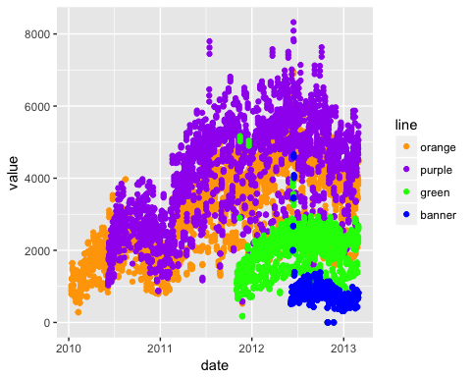

### Let's make Lines!  
g + geom_line()

## Warning: Removed 5043 rows containing missing values (geom_path).

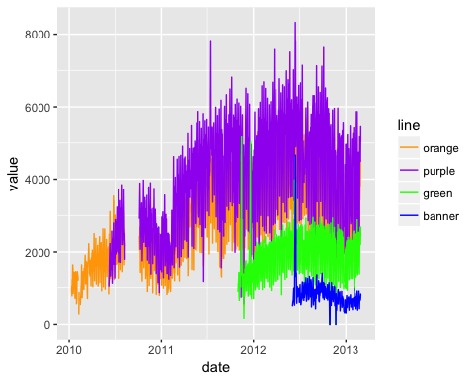

### let's make a new plot of poitns  
gpoint <- g + geom_point()  
### let's plot the value by the type of value - boardings/average, etc  
gpoint + facet_wrap(~ type)

## Warning: Removed 5328 rows containing missing values (geom_point).

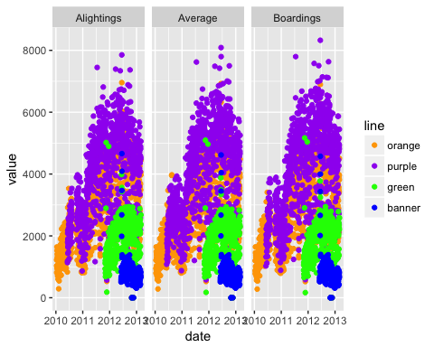

OK let's turn off some warnings - making warning=FALSE (in knitr) as an option.

## let's compare vertically   
gpoint + facet_wrap(~ type, ncol=1)

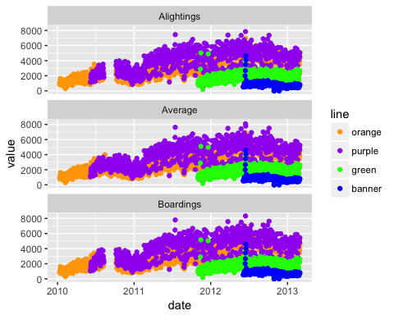

gfacet = g + facet_wrap(~ type, ncol=1)

We can also smooth the data to give us a overall idea of how the average changes over time. I don't want to do a standard error (se).

## let's smooth this - get a rough estimate of what's going on  
gfacet + geom_smooth(se=FALSE)

## `geom_smooth()` using method = 'gam'

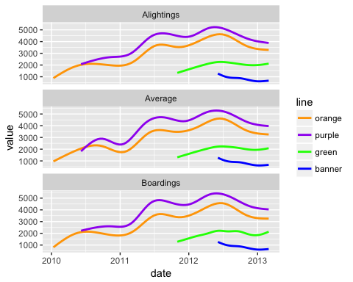

OK, I've seen enough code, let's turn that off, using echo=FALSE.

## `geom_smooth()` using method = 'gam'

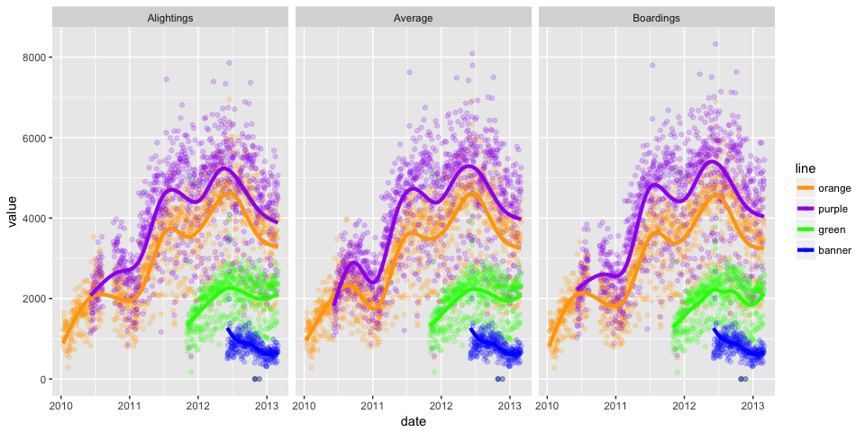

There are still messages, but we can turn these off with message = FALSE

