Knitr

Introduction to R for Public Health Researchers

Table of Contents

The three "back ticks" (`) must be followed by curly brackets "{", and then "r" to tell the computer that you are using R code. This line is then closed off by another curly bracket "}".

Anything before three more back ticks "```" are then considered R code (a script).

If any code in the document has just a backtick ` then nothing, then another backtick, then that word is just printed as if it were code, such as hey.

I'm reading in the bike lanes here.

# readin is just a "label" for this code chunk  
## code chunk is just a "chunk" of code, where this code usually  
## does just one thing, aka a module  
### comments are still # here  
### you can do all your reading in there  
### let's say we loaded some packages  
library(stringr)  
library(dplyr)  
library(tidyr)  
library(readr)  
fname <- "http://www.aejaffe.com/winterR_2017/data/Bike_Lanes.csv"  
bike = read_csv(fname)

You can write your introduction here.

## Introduction

Bike lanes are in Baltimore. People like them. Why are they so long?

## Exploratory Analysis

Let's look at some plots of bike length. Let's say we wanted to look at what affects bike length.

### Plots of bike length

Note we made the subsection by using three "hashes" (pound signs): ###.

We can turn off R code output by using echo = FALSE on the knitr code chunks.

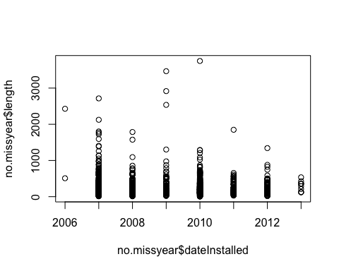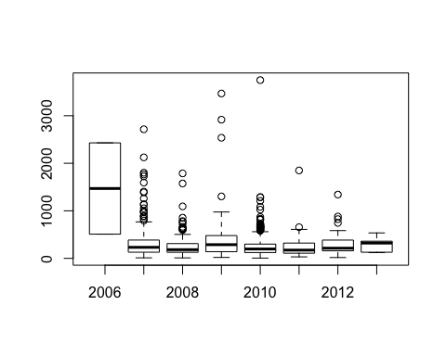

no.missyear = no.missyear %>% mutate(dateInstalled = factor(dateInstalled))   
library(ggplot2)  
gbox = no.missyear %>% ggplot(aes(x = dateInstalled, y = length)) + geom_boxplot()  
print(gbox)

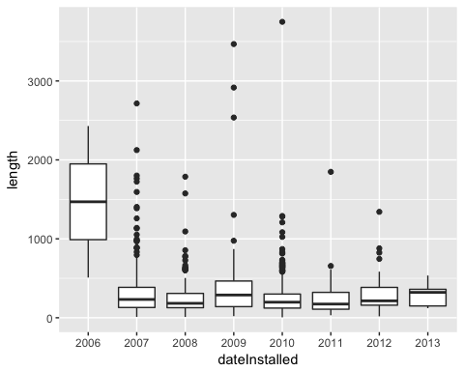

We have a total of 1505 rows.

What does it look like if we took the log (base 10) of the bike length:

no.missyear <- no.missyear %>% mutate(log.length = log10(length))  
### see here that if you specify the data argument, you don't need to do the $   
boxplot(log.length ~ dateInstalled, data = no.missyear,   
 main = "Boxplots of Bike Lenght by Year",   
 xlab="Year",   
 ylab="Bike Length")

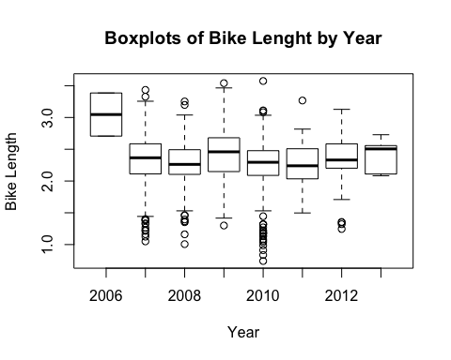

glogbox = no.missyear %>% ggplot(aes(x = dateInstalled, y = log.length)) + geom_boxplot() +   
 ggtitle("Boxplots of Bike Lenght by Year") +   
 xlab("Year") +   
 ylab("Bike Length")  
print(glogbox)

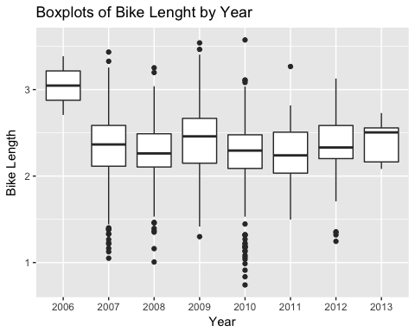

I want my boxplots colored, so I set the col argument.

boxplot(log.length ~ dateInstalled,   
 data=no.missyear,   
 main="Boxplots of Bike Lenght by Year",  
 xlab="Year",   
 ylab="Bike Length",   
 col="red")

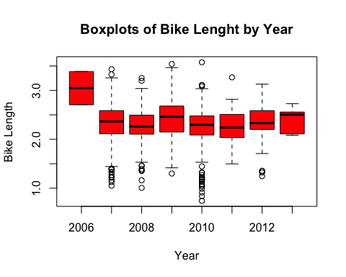

glogbox + geom_boxplot(fill = "red")

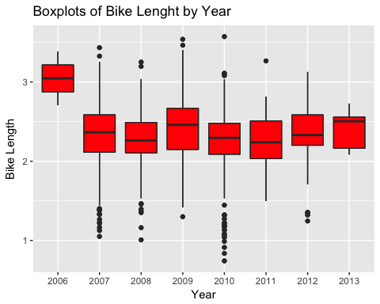

As we can see, 2006 had a much higher bike length. What about for the type of bike path?

### type is a character, but when R sees a "character" in a "formula", then it automatically converts it to factor  
### a formula is something that has a y ~ x, which says I want to plot y against x  
### or if it were a model you would do y ~ x, which meant regress against y  
boxplot(log.length ~ type, data=no.missyear, main="Boxplots of Bike Lenght by Year", xlab="Year", ylab="Bike Length")

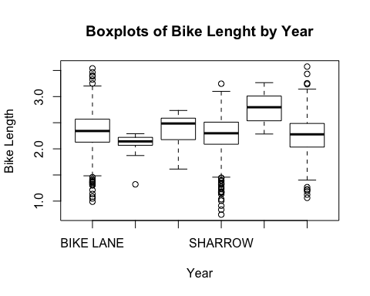

## Multiple Facets

We can do the plot with different panels for each type.

glogbox + facet_wrap(~ type)

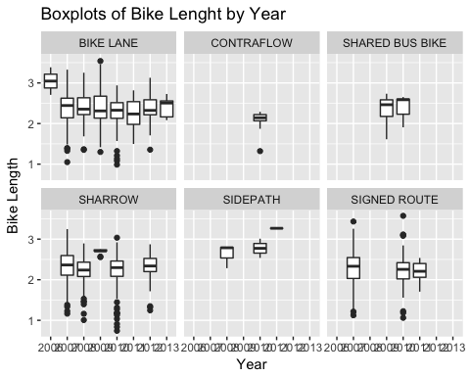

NOTE, this is different than if we colored on type:

glogbox + aes(colour = type)

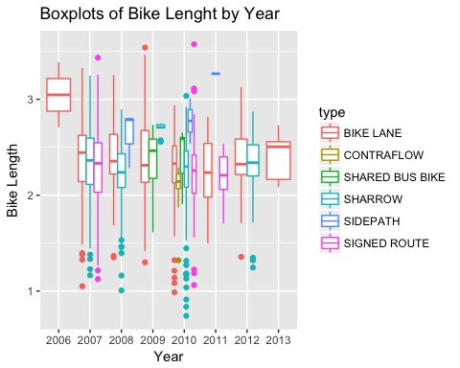

### Means by type

What if we want to extract means by each type?

Let's show a few ways:

no.missyear %>% group_by(type) %>%   
 dplyr::summarise(mean = mean(log.length))

## # A tibble: 6 × 2  
## type mean  
## <chr> <dbl>  
## 1 BIKE LANE 2.330611  
## 2 CONTRAFLOW 2.087246  
## 3 SHARED BUS BIKE 2.363005  
## 4 SHARROW 2.256425  
## 5 SIDEPATH 2.781829  
## 6 SIGNED ROUTE 2.263746

Let's show a what if we wanted to go over type and dateInstalled:

no.missyear %>% group_by(type, dateInstalled) %>%   
 dplyr::summarise(mean = mean(log.length),  
 median = median(log.length),  
 Std.Dev = sd(log.length))

## Source: local data frame [22 x 5]  
## Groups: type [?]  
##   
## type dateInstalled mean median Std.Dev  
## <chr> <fctr> <dbl> <dbl> <dbl>  
## 1 BIKE LANE 2006 3.046261 3.046261 0.4797354  
## 2 BIKE LANE 2007 2.351256 2.444042 0.4066225  
## 3 BIKE LANE 2008 2.365728 2.354641 0.3891624  
## 4 BIKE LANE 2009 2.381418 2.311393 0.4944744  
## 5 BIKE LANE 2010 2.306994 2.328486 0.3207591  
## 6 BIKE LANE 2011 2.242132 2.235462 0.3339777  
## 7 BIKE LANE 2012 2.361510 2.323863 0.2852810  
## 8 BIKE LANE 2013 2.408306 2.505012 0.2404060  
## 9 CONTRAFLOW 2010 2.087246 2.142250 0.2565511  
## 10 SHARED BUS BIKE 2009 2.350759 2.463997 0.3060951  
## # ... with 12 more rows

## Linear Models

OK let's do some linear model

### type is a character, but when R sees a "character" in a "formula", then it automatically converts it to factor  
### a formula is something that has a y ~ x, which says I want to plot y against x  
### or if it were a model you would do y ~ x, which meant regress against y  
mod.type = lm(log.length ~ type, data = no.missyear)  
mod.yr = lm(log.length ~ factor(dateInstalled), data = no.missyear)  
mod.yrtype = lm(log.length ~ type + factor(dateInstalled), data = no.missyear)  
summary(mod.type)

##   
## Call:  
## lm(formula = log.length ~ type, data = no.missyear)  
##   
## Residuals:  
## Min 1Q Median 3Q Max   
## -1.51498 -0.19062 0.02915 0.23220 1.31021   
##   
## Coefficients:  
## Estimate Std. Error t value Pr(>|t|)   
## (Intercept) 2.33061 0.01487 156.703 < 2e-16 ***  
## typeCONTRAFLOW -0.24337 0.10288 -2.366 0.018127 *   
## typeSHARED BUS BIKE 0.03239 0.06062 0.534 0.593194   
## typeSHARROW -0.07419 0.02129 -3.484 0.000509 ***  
## typeSIDEPATH 0.45122 0.15058 2.997 0.002775 **   
## typeSIGNED ROUTE -0.06687 0.02726 -2.453 0.014300 *   
## ---  
## Signif. codes: 0 '***' 0.001 '**' 0.01 '*' 0.05 '.' 0.1 ' ' 1  
##   
## Residual standard error: 0.367 on 1499 degrees of freedom  
## Multiple R-squared: 0.01956, Adjusted R-squared: 0.01629   
## F-statistic: 5.98 on 5 and 1499 DF, p-value: 1.74e-05

That's rather UGLY, so let's use a package called pander and then make this model into an pander object and then print it out nicely.

## Grabbing coefficients

We can use the coef function on a summary, or do smod$coef to get the coefficients. But they are in a matrix:

smod = summary(mod.type)  
coef(smod)

## Estimate Std. Error t value Pr(>|t|)  
## (Intercept) 2.33061129 0.01487281 156.7027729 0.0000000000  
## typeCONTRAFLOW -0.24336564 0.10287662 -2.3656069 0.0181272020  
## typeSHARED BUS BIKE 0.03239334 0.06062453 0.5343274 0.5931943055  
## typeSHARROW -0.07418617 0.02129463 -3.4837969 0.0005085795  
## typeSIDEPATH 0.45121749 0.15057577 2.9966142 0.0027748128  
## typeSIGNED ROUTE -0.06686556 0.02726421 -2.4525034 0.0142999055

class(coef(smod))

## [1] "matrix"

### Broom package

The broom package can "tidy" up the output to actually put the terms into a column of a data.frame that you can grab values from:

library(broom)  
smod2 = tidy(mod.type)  
class(smod2)

## [1] "data.frame"

better = smod2 %>% mutate(term = str_replace(term, "^type", ""))  
better

## term estimate std.error statistic p.value  
## 1 (Intercept) 2.33061129 0.01487281 156.7027729 0.0000000000  
## 2 CONTRAFLOW -0.24336564 0.10287662 -2.3656069 0.0181272020  
## 3 SHARED BUS BIKE 0.03239334 0.06062453 0.5343274 0.5931943055  
## 4 SHARROW -0.07418617 0.02129463 -3.4837969 0.0005085795  
## 5 SIDEPATH 0.45121749 0.15057577 2.9966142 0.0027748128  
## 6 SIGNED ROUTE -0.06686556 0.02726421 -2.4525034 0.0142999055

better %>% filter(term == "SIDEPATH")

## term estimate std.error statistic p.value  
## 1 SIDEPATH 0.4512175 0.1505758 2.996614 0.002774813

write.csv(better, file = "Best_Model_Coefficients.csv")

BUT I NEEEEEED an XLSX! The xlsx package can do it, but I still tend to use CSVs.

library(xlsx)  
write.xlsx(better, file = "Best_Model_Coefficients.xlsx")

### Testing Nested Models

The anova command will test nested models and give you a table of results:

my_lrtest = anova(mod.yrtype, mod.yr)  
print(my_lrtest)

## Analysis of Variance Table  
##   
## Model 1: log.length ~ type + factor(dateInstalled)  
## Model 2: log.length ~ factor(dateInstalled)  
## Res.Df RSS Df Sum of Sq F Pr(>F)   
## 1 1492 199.10   
## 2 1497 202.47 -5 -3.3681 5.048 0.000136 ***  
## ---  
## Signif. codes: 0 '***' 0.001 '**' 0.01 '*' 0.05 '.' 0.1 ' ' 1

print(tidy(my_lrtest))

## res.df rss df sumsq statistic p.value  
## 1 1492 199.0977 NA NA NA NA  
## 2 1497 202.4658 -5 -3.368136 5.048034 0.0001360178

Similarly with year:

my_lrtest = anova(mod.yrtype, mod.type)  
print(tidy(my_lrtest))

## res.df rss df sumsq statistic p.value  
## 1 1492 199.0977 NA NA NA NA  
## 2 1499 201.9321 -7 -2.834384 3.034333 0.003588298

ASIDE: the aov function fits what you think of when you think ANOVA.

## Pander

Pander can output tables (as well as other things such as models), so let's print this using the pander command from the pander package. So pander is really good when you are trying to print out a table (in html, otherwise make the table and use write.csv to get it in Excel and then format) really quickly and in a report.

# devtools::install_github('Rapporter/pander') # need this version!  
library(pander)  
pander(mod.yr)

Fitting linear model: log.length ~ factor(dateInstalled)

|  |  |  |  |  |
| --- | --- | --- | --- | --- |
|  | Estimate | Std. Error | t value | Pr(>|t|) |
| **(Intercept)** | 3.046 | 0.26 | 11.71 | 2.181e-30 |
| **factor(dateInstalled)2007** | -0.7332 | 0.2608 | -2.812 | 0.004987 |
| **factor(dateInstalled)2008** | -0.7808 | 0.2613 | -2.988 | 0.002852 |
| **factor(dateInstalled)2009** | -0.6394 | 0.2631 | -2.431 | 0.01518 |
| **factor(dateInstalled)2010** | -0.7791 | 0.2605 | -2.991 | 0.002825 |
| **factor(dateInstalled)2011** | -0.8022 | 0.2626 | -3.055 | 0.002292 |
| **factor(dateInstalled)2012** | -0.7152 | 0.2625 | -2.725 | 0.006509 |
| **factor(dateInstalled)2013** | -0.638 | 0.2849 | -2.239 | 0.02527 |

It is the same if we write out the summary, but more information is in the **footer**.

pander(summary(mod.yr))

|  |  |  |  |  |
| --- | --- | --- | --- | --- |
|  | Estimate | Std. Error | t value | Pr(>|t|) |
| **(Intercept)** | 3.046 | 0.26 | 11.71 | 2.181e-30 |
| **factor(dateInstalled)2007** | -0.7332 | 0.2608 | -2.812 | 0.004987 |
| **factor(dateInstalled)2008** | -0.7808 | 0.2613 | -2.988 | 0.002852 |
| **factor(dateInstalled)2009** | -0.6394 | 0.2631 | -2.431 | 0.01518 |
| **factor(dateInstalled)2010** | -0.7791 | 0.2605 | -2.991 | 0.002825 |
| **factor(dateInstalled)2011** | -0.8022 | 0.2626 | -3.055 | 0.002292 |
| **factor(dateInstalled)2012** | -0.7152 | 0.2625 | -2.725 | 0.006509 |
| **factor(dateInstalled)2013** | -0.638 | 0.2849 | -2.239 | 0.02527 |

Fitting linear model: log.length ~ factor(dateInstalled)

|  |  |  |  |
| --- | --- | --- | --- |
| Observations | Residual Std. Error |  | Adjusted |
| 1505 | 0.3678 | 0.01697 | 0.01237 |

### Formatting

Let's format the rows and the column names a bit better:

#### Changing the terms

ptable = tidy(mod.yr)  
ptable$term = ptable$term %>%   
 str_replace(fixed("factor(dateInstalled)"), "") %>%  
 str_replace(fixed("(Intercept)"), "Intercept")

#### Column Names

Now we can reset the column names if we didn't like them before:

colnames(ptable) = c("Variable", "Beta", "SE", "tstatistic", "p.value")  
pander(ptable)

|  |  |  |  |  |
| --- | --- | --- | --- | --- |
| Variable | Beta | SE | tstatistic | p.value |
| Intercept | 3.046 | 0.26 | 11.71 | 2.181e-30 |
| 2007 | -0.7332 | 0.2608 | -2.812 | 0.004987 |
| 2008 | -0.7808 | 0.2613 | -2.988 | 0.002852 |
| 2009 | -0.6394 | 0.2631 | -2.431 | 0.01518 |
| 2010 | -0.7791 | 0.2605 | -2.991 | 0.002825 |
| 2011 | -0.8022 | 0.2626 | -3.055 | 0.002292 |
| 2012 | -0.7152 | 0.2625 | -2.725 | 0.006509 |
| 2013 | -0.638 | 0.2849 | -2.239 | 0.02527 |

#### Confidence Intervals

Let's say we want the beta, the 95% CI. We can use confint on the model, merge it to ptable and then paste the columns together (after rounding) with a comma and bound them in parentheses.

cint = confint(mod.yr)  
print(cint)

## 2.5 % 97.5 %  
## (Intercept) 2.536168 3.55635353  
## factor(dateInstalled)2007 -1.244725 -0.22177042  
## factor(dateInstalled)2008 -1.293400 -0.26827336  
## factor(dateInstalled)2009 -1.155435 -0.12345504  
## factor(dateInstalled)2010 -1.289978 -0.26816090  
## factor(dateInstalled)2011 -1.317344 -0.28710724  
## factor(dateInstalled)2012 -1.229999 -0.20032262  
## factor(dateInstalled)2013 -1.196733 -0.07917559

print(class(cint))

## [1] "matrix"

Tidying it up

cint = tidy(cint)  
colnames(cint) = c("Variable", "lower", "upper")  
cint$Variable = cint$Variable %>%   
 str_replace(fixed("factor(dateInstalled)"), "") %>%  
 str_replace(fixed("(Intercept)"), "Intercept")  
ptable = left_join(ptable, cint, by = "Variable")  
ptable = ptable %>% mutate(lower = round(lower, 2),  
 upper = round(lower, 2),  
 Beta = round(Beta, 2),  
 p.value = ifelse(p.value < 0.01, "< 0.01",   
 round(p.value,2)))  
ptable = ptable %>% mutate(ci = paste0("(", lower, ", ", upper, ")"))  
ptable = dplyr::select(ptable, Beta, ci, p.value)  
pander(ptable)

|  |  |  |
| --- | --- | --- |
| Beta | ci | p.value |
| 3.05 | (2.54, 2.54) | < 0.01 |
| -0.73 | (-1.24, -1.24) | < 0.01 |
| -0.78 | (-1.29, -1.29) | < 0.01 |
| -0.64 | (-1.16, -1.16) | 0.02 |
| -0.78 | (-1.29, -1.29) | < 0.01 |
| -0.8 | (-1.32, -1.32) | < 0.01 |
| -0.72 | (-1.23, -1.23) | < 0.01 |
| -0.64 | (-1.2, -1.2) | 0.03 |

## Multiple Models

OK, that's pretty good, but let's say we have all three models. You can't put doesn't work so well with *many* models together.

# pander(mod.yr, mod.yrtype) does not work  
# pander(list(mod.yr, mod.yrtype)) # will give 2 separate tables

If we use the memisc package, we can combine the models:

library(memisc)  
mtab_all <- mtable("Model Year" = mod.yr,  
 "Model Type" = mod.type,  
 "Model Both" = mod.yrtype,   
 summary.stats = c("sigma","R-squared","F","p","N"))  
print(mtab_all)

##   
## Calls:  
## Model Year: lm(formula = log.length ~ factor(dateInstalled), data = no.missyear)  
## Model Type: lm(formula = log.length ~ type, data = no.missyear)  
## Model Both: lm(formula = log.length ~ type + factor(dateInstalled), data = no.missyear)  
##   
## ========================================================================  
## Model Year Model Type Model Both   
## ------------------------------------------------------------------------  
## (Intercept) 3.046*** 2.331*** 3.046***   
## (0.260) (0.015) (0.258)   
## factor(dateInstalled): 2007/2006 -0.733** -0.690**   
## (0.261) (0.259)   
## factor(dateInstalled): 2008/2006 -0.781** -0.742**   
## (0.261) (0.260)   
## factor(dateInstalled): 2009/2006 -0.639* -0.619*   
## (0.263) (0.262)   
## factor(dateInstalled): 2010/2006 -0.779** -0.736**   
## (0.260) (0.259)   
## factor(dateInstalled): 2011/2006 -0.802** -0.790**   
## (0.263) (0.261)   
## factor(dateInstalled): 2012/2006 -0.715** -0.700**   
## (0.262) (0.261)   
## factor(dateInstalled): 2013/2006 -0.638* -0.638*   
## (0.285) (0.283)   
## type: CONTRAFLOW/BIKE LANE -0.243* -0.224*   
## (0.103) (0.103)   
## type: SHARED BUS BIKE/BIKE LANE 0.032 -0.037   
## (0.061) (0.069)   
## type: SHARROW/BIKE LANE -0.074*** -0.064**   
## (0.021) (0.023)   
## type: SIDEPATH/BIKE LANE 0.451** 0.483**   
## (0.151) (0.150)   
## type: SIGNED ROUTE/BIKE LANE -0.067* -0.067*   
## (0.027) (0.029)   
## ------------------------------------------------------------------------  
## sigma 0.4 0.4 0.4   
## R-squared 0.0 0.0 0.0   
## F 3.7 6.0 4.3   
## p 0.0 0.0 0.0   
## N 1505 1505 1505   
## ========================================================================

If you want to write it out (for Excel), it is tab delimited:

write.mtable(mtab_all, file = "my_tab.txt")

pander(mtab_all)

|  |  |  |  |
| --- | --- | --- | --- |
|  | Model Year | Model Type | Model Both |
| **(Intercept)** | 3.046*** (0.260) | 2.331*** (0.015) | 3.046*** (0.258) |
| **factor(dateInstalled): 2007/2006** | -0.733** (0.261) |  | -0.690** (0.259) |
| **factor(dateInstalled): 2008/2006** | -0.781** (0.261) |  | -0.742** (0.260) |
| **factor(dateInstalled): 2009/2006** | -0.639* (0.263) |  | -0.619* (0.262) |
| **factor(dateInstalled): 2010/2006** | -0.779** (0.260) |  | -0.736** (0.259) |
| **factor(dateInstalled): 2011/2006** | -0.802** (0.263) |  | -0.790** (0.261) |
| **factor(dateInstalled): 2012/2006** | -0.715** (0.262) |  | -0.700** (0.261) |
| **factor(dateInstalled): 2013/2006** | -0.638* (0.285) |  | -0.638* (0.283) |
| **type: CONTRAFLOW/BIKE LANE** |  | -0.243* (0.103) | -0.224* (0.103) |
| **type: SHARED BUS BIKE/BIKE LANE** |  | 0.032 (0.061) | -0.037 (0.069) |
| **type: SHARROW/BIKE LANE** |  | -0.074*** (0.021) | -0.064** (0.023) |
| **type: SIDEPATH/BIKE LANE** |  | 0.451** (0.151) | 0.483** (0.150) |
| **type: SIGNED ROUTE/BIKE LANE** |  | -0.067* (0.027) | -0.067* (0.029) |
| **sigma** | 0.4 | 0.4 | 0.4 |
| **R-squared** | 0.0 | 0.0 | 0.0 |
| **F** | 3.7 | 6.0 | 4.3 |
| **p** | 0.0 | 0.0 | 0.0 |
| **N** | 1505 | 1505 | 1505 |

### Not covered - making mtable better:

renamer = function(model) {  
 names(model$coefficients) = names(model$coefficients) %>%   
 str_replace(fixed("factor(dateInstalled)"), "") %>%  
 str_replace(fixed("(Intercept)"), "Intercept")  
 names(model$contrasts) = names(model$contrasts) %>%   
 str_replace(fixed("factor(dateInstalled)"), "") %>%  
 str_replace(fixed("(Intercept)"), "Intercept")  
 return(model)  
}  
mod.yr = renamer(mod.yr)  
mod.yrtype = renamer(mod.yrtype)  
mod.type = renamer(mod.type)  
  
mtab_all_better <- mtable("Model Year" = mod.yr,  
 "Model Type" = mod.type,  
 "Model Both" = mod.yrtype,   
 summary.stats = c("sigma","R-squared","F","p","N"))  
pander(mtab_all_better)

|  |  |  |  |
| --- | --- | --- | --- |
|  | Model Year | Model Type | Model Both |
| **Intercept** | 3.046*** (0.260) | 2.331*** (0.015) | 3.046*** (0.258) |
| **2007** | -0.733** (0.261) |  | -0.690** (0.259) |
| **2008** | -0.781** (0.261) |  | -0.742** (0.260) |
| **2009** | -0.639* (0.263) |  | -0.619* (0.262) |
| **2010** | -0.779** (0.260) |  | -0.736** (0.259) |
| **2011** | -0.802** (0.263) |  | -0.790** (0.261) |
| **2012** | -0.715** (0.262) |  | -0.700** (0.261) |
| **2013** | -0.638* (0.285) |  | -0.638* (0.283) |
| **type: CONTRAFLOW/BIKE LANE** |  | -0.243* (0.103) | -0.224* (0.103) |
| **type: SHARED BUS BIKE/BIKE LANE** |  | 0.032 (0.061) | -0.037 (0.069) |
| **type: SHARROW/BIKE LANE** |  | -0.074*** (0.021) | -0.064** (0.023) |
| **type: SIDEPATH/BIKE LANE** |  | 0.451** (0.151) | 0.483** (0.150) |
| **type: SIGNED ROUTE/BIKE LANE** |  | -0.067* (0.027) | -0.067* (0.029) |
| **sigma** | 0.4 | 0.4 | 0.4 |
| **R-squared** | 0.0 | 0.0 | 0.0 |
| **F** | 3.7 | 6.0 | 4.3 |
| **p** | 0.0 | 0.0 | 0.0 |
| **N** | 1505 | 1505 | 1505 |

Another package called stargazer can put models together easily and print them out. So let's use stargazer. Again, you need to use install.packages("stargazer") if you don't have function.

require(stargazer)

OK, so what's the difference here? First off, we said results are "markup", so that it will not try to reformat the output. Also, I didn't want those # for comments, so I just made comment an empty string "".

stargazer(mod.yr, mod.type, mod.yrtype, type = "text")

============================================================================================  
 Dependent variable:   
 ------------------------------------------------------------------------  
 log.length   
 (1) (2) (3)   
--------------------------------------------------------------------------------------------  
2007 -0.733*** -0.690***   
 (0.261) (0.259)   
   
2008 -0.781*** -0.742***   
 (0.261) (0.260)   
   
2009 -0.639** -0.619**   
 (0.263) (0.262)   
   
2010 -0.779*** -0.736***   
 (0.260) (0.259)   
   
2011 -0.802*** -0.790***   
 (0.263) (0.261)   
   
2012 -0.715*** -0.700***   
 (0.262) (0.261)   
   
2013 -0.638** -0.638**   
 (0.285) (0.283)   
   
typeCONTRAFLOW -0.243** -0.224**   
 (0.103) (0.103)   
   
typeSHARED BUS BIKE 0.032 -0.037   
 (0.061) (0.069)   
   
typeSHARROW -0.074*** -0.064***   
 (0.021) (0.023)   
   
typeSIDEPATH 0.451*** 0.483***   
 (0.151) (0.150)   
   
typeSIGNED ROUTE -0.067** -0.067**   
 (0.027) (0.029)   
   
Constant 3.046*** 2.331*** 3.046***   
 (0.260) (0.015) (0.258)   
   
--------------------------------------------------------------------------------------------  
Observations 1,505 1,505 1,505   
R2 0.017 0.020 0.033   
Adjusted R2 0.012 0.016 0.026   
Residual Std. Error 0.368 (df = 1497) 0.367 (df = 1499) 0.365 (df = 1492)   
F Statistic 3.691*** (df = 7; 1497) 5.980*** (df = 5; 1499) 4.285*** (df = 12; 1492)  
============================================================================================  
Note: *p<0.1; **p<0.05; ***p<0.01

If we use

stargazer(mod.yr, mod.type, mod.yrtype, type="html")

Dependent variable:

log.length

(1)

(2)

(3)

2007

-0.733***

-0.690***

(0.261)

(0.259)

2008

-0.781***

-0.742***

(0.261)

(0.260)

2009

-0.639**

-0.619**

(0.263)

(0.262)

2010

-0.779***

-0.736***

(0.260)

(0.259)

2011

-0.802***

-0.790***

(0.263)

(0.261)

2012

-0.715***

-0.700***

(0.262)

(0.261)

2013

-0.638**

-0.638**

(0.285)

(0.283)

typeCONTRAFLOW

-0.243**

-0.224**

(0.103)

(0.103)

typeSHARED BUS BIKE

0.032

-0.037

(0.061)

(0.069)

typeSHARROW

-0.074***

-0.064***

(0.021)

(0.023)

typeSIDEPATH

0.451***

0.483***

(0.151)

(0.150)

typeSIGNED ROUTE

-0.067**

-0.067**

(0.027)

(0.029)

Constant

3.046***

2.331***

3.046***

(0.260)

(0.015)

(0.258)

Observations

1,505

1,505

1,505

R2

0.017

0.020

0.033

Adjusted R2

0.012

0.016

0.026

Residual Std. Error

0.368 (df = 1497)

0.367 (df = 1499)

0.365 (df = 1492)

F Statistic

3.691*** (df = 7; 1497)

5.980*** (df = 5; 1499)

4.285*** (df = 12; 1492)

Note:

*p<0.1;* ***p<0.05;*** p<0.01

## Data Extraction

Let's say I want to get data INTO my text. Like there are N number of bike lanes with a date installed that isn't zero. There are 1505 bike lanes with a date installed after 2006. So you use one backtick ` and then you say "r" to tell that it's R code. And then you run R code that gets evaulated and then returns the value. Let's say you want to compute a bunch of things:

### let's get number of bike lanes installed by year  
n.lanes = no.missyear %>% group_by(dateInstalled) %>% dplyr::summarize(n())  
class(n.lanes)

## [1] "tbl_df" "tbl" "data.frame"

print(n.lanes)

## # A tibble: 8 × 2  
## dateInstalled `n()`  
## <fctr> <int>  
## 1 2006 2  
## 2 2007 368  
## 3 2008 206  
## 4 2009 86  
## 5 2010 625  
## 6 2011 101  
## 7 2012 107  
## 8 2013 10

n.lanes = as.data.frame(n.lanes)  
print(n.lanes)

## dateInstalled n()  
## 1 2006 2  
## 2 2007 368  
## 3 2008 206  
## 4 2009 86  
## 5 2010 625  
## 6 2011 101  
## 7 2012 107  
## 8 2013 10

colnames(n.lanes) <- c("date", "nlanes")  
n2009 <- filter(n.lanes, date == 2009)  
n2010 <- filter(n.lanes, date == 2010)  
getwd()

## [1] "/Users/johnmuschelli/Dropbox/Teaching/winterR_2017/Knitr/lecture"

Now I can just say there are 2009, 86 lanes in 2009 and 2010, 625 in 2010.

fname <- "http://www.aejaffe.com/summerR_2016/data/Charm_City_Circulator_Ridership.csv"  
## file.path takes a directory and makes a full name with a full file path  
charm = read.csv(fname, as.is=TRUE)  
  
library(chron)  
days = levels(weekdays(1, abbreviate=FALSE))  
charm$day <- factor(charm$day, levels=days)  
charm$date <- as.Date(charm$date, format="%m/%d/%Y")  
cn <- colnames(charm)  
daily <- charm[, c("day", "date", "daily")]

charm$daily <- NULL  
require(reshape)  
long.charm <- melt(charm, id.vars = c("day", "date"))  
long.charm$type <- "Boardings"  
long.charm$type[ grepl("Alightings", long.charm$variable)] <- "Alightings"  
long.charm$type[ grepl("Average", long.charm$variable)] <- "Average"  
  
long.charm$line <- "orange"  
long.charm$line[ grepl("purple", long.charm$variable)] <- "purple"  
long.charm$line[ grepl("green", long.charm$variable)] <- "green"  
long.charm$line[ grepl("banner", long.charm$variable)] <- "banner"  
long.charm$variable <- NULL  
  
long.charm$line <-factor(long.charm$line, levels=c("orange", "purple",   
 "green", "banner"))  
  
head(long.charm)

## day date value type line  
## 1 Monday 2010-01-11 877 Boardings orange  
## 2 Tuesday 2010-01-12 777 Boardings orange  
## 3 Wednesday 2010-01-13 1203 Boardings orange  
## 4 Thursday 2010-01-14 1194 Boardings orange  
## 5 Friday 2010-01-15 1645 Boardings orange  
## 6 Saturday 2010-01-16 1457 Boardings orange

### NOW R has a column of day, the date, a "value", the type of value and the   
### circulator line that corresponds to it  
### value is now either the Alightings, Boardings, or Average from the charm dataset

Let's do some plotting now!

require(ggplot2)  
### let's make a "ggplot"  
### the format is ggplot(dataframe, aes(x=COLNAME, y=COLNAME))  
### where COLNAME are colnames of the dataframe  
### you can also set color to a different factor  
### other options in AES (fill, alpha level -which is the "transparency" of points)  
g <- ggplot(long.charm, aes(x=date, y=value, color=line))   
### let's change the colors to what we want- doing this manually, not letting it choose  
### for me  
g <- g + scale_color_manual(values=c("orange", "purple", "green", "blue"))  
### plotting points  
g + geom_point()

## Warning: Removed 5328 rows containing missing values (geom_point).

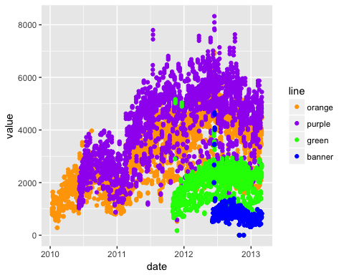

### Let's make Lines!  
g + geom_line()

## Warning: Removed 5043 rows containing missing values (geom_path).

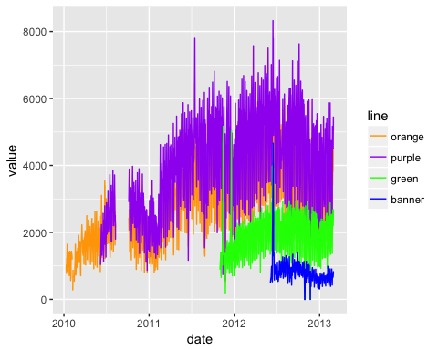

### let's make a new plot of poitns  
gpoint <- g + geom_point()  
### let's plot the value by the type of value - boardings/average, etc  
gpoint + facet_wrap(~ type)

## Warning: Removed 5328 rows containing missing values (geom_point).

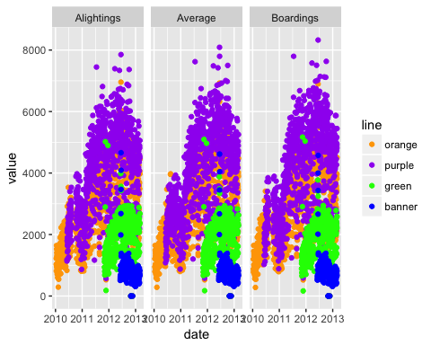

OK let's turn off some warnings - making warning=FALSE (in knitr) as an option.

## let's compare vertically   
gpoint + facet_wrap(~ type, ncol=1)

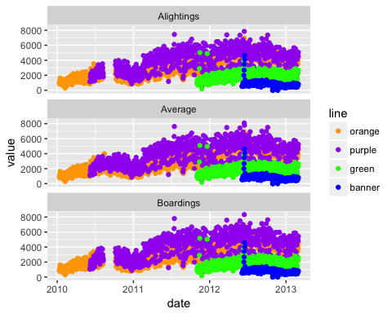

gfacet = g + facet_wrap(~ type, ncol=1)

We can also smooth the data to give us a overall idea of how the average changes over time. I don't want to do a standard error (se).

## let's smooth this - get a rough estimate of what's going on  
gfacet + geom_smooth(se=FALSE)

## `geom_smooth()` using method = 'gam'

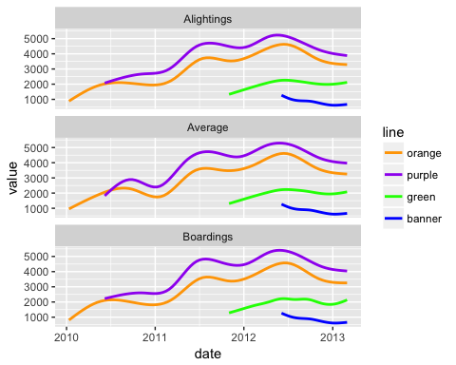

OK, I've seen enough code, let's turn that off, using echo=FALSE.

## `geom_smooth()` using method = 'gam'

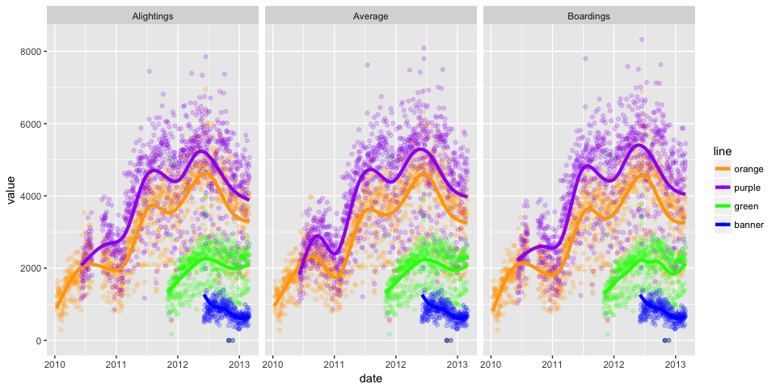

There are still messages, but we can turn these off with message = FALSE

