Manipulating Data in R

Introduction to R for Public Health Researchers

## Reshaping Data

In this module, we will show you how to:

1. Reshaping data from long (tall) to wide (fat)
2. Reshaping data from wide (fat) to long (tall)
3. Merging Data
4. Perform operations by a grouping variable

## Setup

We will show you how to do each operation in base R then show you how to use the dplyr or tidyr package to do the same operation (if applicable).

See the "Data Wrangling Cheat Sheet using dplyr and tidyr":

* <https://www.rstudio.com/wp-content/uploads/2015/02/data-wrangling-cheatsheet.pdf>

## Data used: Charm City Circulator

<http://www.aejaffe.com/summerR_2016/data/Charm_City_Circulator_Ridership.csv>

circ = read.csv("http://www.aejaffe.com/summerR_2016/data/Charm_City_Circulator_Ridership.csv", as.is = TRUE)  
head(circ, 2)

day date orangeBoardings orangeAlightings orangeAverage  
1 Monday 01/11/2010 877 1027 952  
2 Tuesday 01/12/2010 777 815 796  
 purpleBoardings purpleAlightings purpleAverage greenBoardings  
1 NA NA NA NA  
2 NA NA NA NA  
 greenAlightings greenAverage bannerBoardings bannerAlightings  
1 NA NA NA NA  
2 NA NA NA NA  
 bannerAverage daily  
1 NA 952  
2 NA 796

## Creating a Date class from a character date

library(lubridate) # great for dates!  
library(dplyr) # mutate/summarise functions  
circ = mutate(circ, date = mdy(date))  
sum( is.na(circ$date) ) # all converted correctly

[1] 0

head(circ$date)

[1] "2010-01-11" "2010-01-12" "2010-01-13" "2010-01-14" "2010-01-15"  
[6] "2010-01-16"

class(circ$date)

[1] "Date"

## Making column names a little more separated

We will use str_replace from stringr to put periods in the column names.

library(stringr)  
cn = colnames(circ)  
cn = cn %>%   
 str_replace("Board", ".Board") %>%   
 str_replace("Alight", ".Alight") %>%   
 str_replace("Average", ".Average")   
colnames(circ) = cn  
cn

[1] "day" "date" "orange.Boardings"   
 [4] "orange.Alightings" "orange.Average" "purple.Boardings"   
 [7] "purple.Alightings" "purple.Average" "green.Boardings"   
[10] "green.Alightings" "green.Average" "banner.Boardings"   
[13] "banner.Alightings" "banner.Average" "daily"

## Removing the daily ridership

We want to look at each ridership, and will remove the daily column:

circ$daily = NULL

## Reshaping data from wide (fat) to long (tall)

See <http://www.cookbook-r.com/Manipulating_data/Converting_data_between_wide_and_long_format/>

* Wide - multiple columns per observation
  + e.g. visit1, visit2, visit3

id visit1 visit2 visit3  
1 1 10 4 3  
2 2 5 6 NA

* Long - multiple rows per observation

id visit value  
1 1 1 10  
2 1 2 4  
3 1 3 3  
4 2 1 5  
5 2 2 6

## Reshaping data from wide (fat) to long (tall): base R

The reshape command exists. It is a **confusing** function. Don't use it.

## Reshaping data from wide (fat) to long (tall): tidyr

tidyr::gather - puts column data into rows.

We want the column names into "var" variable in the output dataset and the value in "number" variable. We then describe which columns we want to "gather:"

library(tidyr)  
long = gather(circ, key = "var", value = "number",   
 starts_with("orange"),  
 starts_with("purple"),   
 starts_with("green"),  
 starts_with("banner"))  
head(long, 2)

day date var number  
1 Monday 2010-01-11 orange.Boardings 877  
2 Tuesday 2010-01-12 orange.Boardings 777

table(long$var)

banner.Alightings banner.Average banner.Boardings green.Alightings   
 1146 1146 1146 1146   
 green.Average green.Boardings orange.Alightings orange.Average   
 1146 1146 1146 1146   
 orange.Boardings purple.Alightings purple.Average purple.Boardings   
 1146 1146 1146 1146

## Reshaping data from wide (fat) to long (tall): tidyr

Now each var is boardings, averages, or alightings. We want to separate these so we can have these by line.

long = separate_(long, "var",   
 into = c("line", "type"),   
 sep = "[.]")  
head(long, 3)

day date line type number  
1 Monday 2010-01-11 orange Boardings 877  
2 Tuesday 2010-01-12 orange Boardings 777  
3 Wednesday 2010-01-13 orange Boardings 1203

unique(long$line)

[1] "orange" "purple" "green" "banner"

unique(long$type)

[1] "Boardings" "Alightings" "Average"

## Finding the First (or Last) record

long = long %>% filter(!is.na(number) & number > 0)  
first_and_last = long %>% arrange(date) %>% # arrange by date  
 filter(type %in% "Boardings") %>% # keep boardings only  
 group_by(line) %>% # group by line  
 slice( c(1, n())) # select ("slice") first and last (n() command) lines  
first_and_last %>% head(4)

Source: local data frame [4 x 5]  
Groups: line [2]  
  
 day date line type number  
 <chr> <date> <chr> <chr> <dbl>  
1 Monday 2012-06-04 banner Boardings 520  
2 Friday 2013-03-01 banner Boardings 817  
3 Tuesday 2011-11-01 green Boardings 887  
4 Friday 2013-03-01 green Boardings 2592

## Reshaping data from long (tall) to wide (fat): tidyr

In tidyr, the spread function spreads rows into columns. Now we have a long data set, but we want to separate the Average, Alightings and Boardings into different columns:

# have to remove missing days  
wide = filter(long, !is.na(date))  
wide = spread(wide, type, number)  
head(wide)

day date line Alightings Average Boardings  
1 Friday 2010-01-15 orange 1643 1644.0 1645  
2 Friday 2010-01-22 orange 1388 1394.5 1401  
3 Friday 2010-01-29 orange 1322 1332.0 1342  
4 Friday 2010-02-05 orange 1204 1217.5 1231  
5 Friday 2010-02-12 orange 678 671.0 664  
6 Friday 2010-02-19 orange 1647 1642.0 1637

## Reshaping data from long (tall) to wide (fat): tidyr

We can use rowSums to see if any values in the row is NA and keep if the row, which is a combination of date and line type has any non-missing data.

# wide = wide %>%  
# select(Alightings, Average, Boardings) %>%  
# mutate(good = rowSums(is.na(.)) > 0)  
namat = !is.na(select(wide, Alightings, Average, Boardings))  
head(namat)

Alightings Average Boardings  
1 TRUE TRUE TRUE  
2 TRUE TRUE TRUE  
3 TRUE TRUE TRUE  
4 TRUE TRUE TRUE  
5 TRUE TRUE TRUE  
6 TRUE TRUE TRUE

wide$good = rowSums(namat) > 0  
head(wide, 3)

day date line Alightings Average Boardings good  
1 Friday 2010-01-15 orange 1643 1644.0 1645 TRUE  
2 Friday 2010-01-22 orange 1388 1394.5 1401 TRUE  
3 Friday 2010-01-29 orange 1322 1332.0 1342 TRUE

## Reshaping data from long (tall) to wide (fat): tidyr

Now we can filter only the good rows and delete the good column.

wide = filter(wide, good) %>% select(-good)  
head(wide)

day date line Alightings Average Boardings  
1 Friday 2010-01-15 orange 1643 1644.0 1645  
2 Friday 2010-01-22 orange 1388 1394.5 1401  
3 Friday 2010-01-29 orange 1322 1332.0 1342  
4 Friday 2010-02-05 orange 1204 1217.5 1231  
5 Friday 2010-02-12 orange 678 671.0 664  
6 Friday 2010-02-19 orange 1647 1642.0 1637

## Data Merging/Append in Base R

* Merging - joining data sets together - usually on key variables, usually "id"
* merge() is the most common way to do this with data sets
* rbind/cbind - row/column bind, respectively
  + rbind is the equivalent of "appending" in Stata or "setting" in SAS
  + cbind allows you to add columns in addition to the previous ways
* t() is a function that will transpose the data

## Merging

base <- data.frame(id = 1:10, Age= seq(55,60, length=10))  
base[1:2,]

id Age  
1 1 55.00000  
2 2 55.55556

visits <- data.frame(id = rep(1:8, 3), visit= rep(1:3, 8),  
 Outcome = seq(10,50, length=24))  
visits[1:2,]

id visit Outcome  
1 1 1 10.00000  
2 2 2 11.73913

## Merging

merged.data <- merge(base, visits, by="id")  
merged.data[1:5,]

id Age visit Outcome  
1 1 55.00000 1 10.00000  
2 1 55.00000 3 23.91304  
3 1 55.00000 2 37.82609  
4 2 55.55556 2 11.73913  
5 2 55.55556 1 25.65217

dim(merged.data)

[1] 24 4

## Merging

all.data <- merge(base, visits, by="id", all=TRUE)  
tail(all.data)

id Age visit Outcome  
21 7 58.33333 2 48.26087  
22 8 58.88889 2 22.17391  
23 8 58.88889 1 36.08696  
24 8 58.88889 3 50.00000  
25 9 59.44444 NA NA  
26 10 60.00000 NA NA

dim(all.data)

[1] 26 4

## Joining in dplyr

* ?join - see different types of joining for dplyr
* Let's look at <https://www.rstudio.com/wp-content/uploads/2015/02/data-wrangling-cheatsheet.pdf>

## Left Join

lj = left_join(base, visits)

Joining, by = "id"

dim(lj)

[1] 26 4

tail(lj)

id Age visit Outcome  
21 7 58.33333 2 48.26087  
22 8 58.88889 2 22.17391  
23 8 58.88889 1 36.08696  
24 8 58.88889 3 50.00000  
25 9 59.44444 NA NA  
26 10 60.00000 NA NA

## Right Join

rj = right_join(base, visits)

Joining, by = "id"

dim(rj)

[1] 24 4

tail(rj)

id Age visit Outcome  
19 3 56.11111 1 41.30435  
20 4 56.66667 2 43.04348  
21 5 57.22222 3 44.78261  
22 6 57.77778 1 46.52174  
23 7 58.33333 2 48.26087  
24 8 58.88889 3 50.00000

## Full Join

fj = full_join(base, visits)

Joining, by = "id"

dim(fj)

[1] 26 4

tail(fj)

id Age visit Outcome  
21 7 58.33333 2 48.26087  
22 8 58.88889 2 22.17391  
23 8 58.88889 1 36.08696  
24 8 58.88889 3 50.00000  
25 9 59.44444 NA NA  
26 10 60.00000 NA NA

## Perform Operations By Groups: dplyr

group_by is a form of replacement for tapply (not a complete replacement).

We will use group_by to group the data by line, then use summarize (or summarise) to get the mean Average ridership:

gb = group_by(wide, line)  
summarize(gb, mean_avg = mean(Average))

# A tibble: 4 × 2  
 line mean_avg  
 <chr> <dbl>  
1 banner 836.5637  
2 green 1969.9668  
3 orange 3041.1924  
4 purple 4029.1071

## Perform Operations By Groups: dplyr with piping

Using piping, this is:

wide %>%   
 group_by(line) %>%  
 summarise(mean_avg = mean(Average))

# A tibble: 4 × 2  
 line mean_avg  
 <chr> <dbl>  
1 banner 836.5637  
2 green 1969.9668  
3 orange 3041.1924  
4 purple 4029.1071

## Perform Operations By Multiple Groups: dplyr

This can easily be extended using group_by with multiple groups. Let's define the year of riding:

wide = wide %>% mutate(year = year(date),  
 month = month(date))  
wide %>%   
 group_by(line, year) %>%  
 summarise(mean_avg = mean(Average))

Source: local data frame [13 x 3]  
Groups: line [?]  
  
 line year mean_avg  
 <chr> <dbl> <dbl>  
1 banner 2012 894.8768  
2 banner 2013 635.3833  
3 green 2011 1455.1667  
4 green 2012 2045.5870  
5 green 2013 2028.5250  
6 orange 2010 1890.7859  
7 orange 2011 3061.6556  
8 orange 2012 4079.9420  
9 orange 2013 3322.6250  
10 purple 2010 2577.1000  
11 purple 2011 4026.9146  
12 purple 2012 4850.8771  
13 purple 2013 4045.3833

# Bonus slides - explore after visualization!

## Perform Operations By Multiple Groups: dplyr

We can then easily plot each day over time:

library(ggplot2)  
ggplot(aes(x = date, y = Average,   
 colour = line), data = wide) + geom_line()

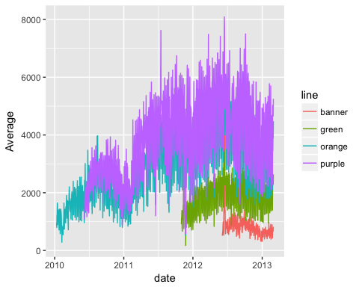

## Perform Operations By Multiple Groups: dplyr

Let's create the middle of the month (the 15th for example), and name it mon.

mon = wide %>%   
 dplyr::group_by(line, month, year) %>%  
 dplyr::summarise(mean_avg = mean(Average))  
mon = mutate(mon,   
 mid_month = dmy(paste0("15-", month, "-", year)))  
head(mon)

Source: local data frame [6 x 5]  
Groups: line, month [6]  
  
 line month year mean_avg mid_month  
 <chr> <dbl> <dbl> <dbl> <date>  
1 banner 1 2013 610.3226 2013-01-15  
2 banner 2 2013 656.4643 2013-02-15  
3 banner 3 2013 822.0000 2013-03-15  
4 banner 6 2012 1288.1296 2012-06-15  
5 banner 7 2012 874.4839 2012-07-15  
6 banner 8 2012 929.4355 2012-08-15

## Perform Operations By Multiple Groups: dplyr

We can then easily plot the mean of each month to see a smoother output:

ggplot(aes(x = mid_month,  
 y = mean_avg,   
 colour = line), data = mon) + geom_line()

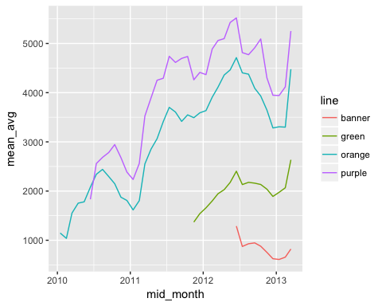

## Bonus! Points with a smoother!

ggplot(aes(x = date, y = Average, colour = line),   
 data = wide) + geom_smooth(se = FALSE) +   
 geom_point(size = .5)

`geom_smooth()` using method = 'gam'

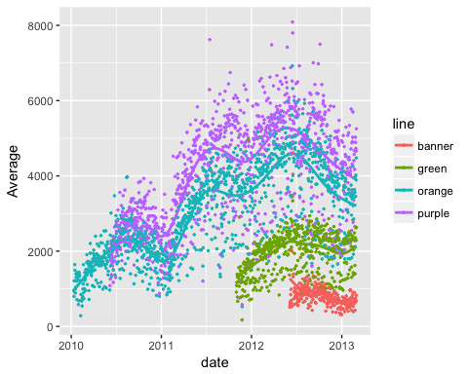

# Extra group_by examples

## group_by

group_by is a form of replacement for tapply (not a complete replacement).

Example using Bike Lanes: <http://www.aejaffe.com/summerR_2016/data/Bike_Lanes.csv>

bike = read.csv(  
 "http://www.aejaffe.com/summerR_2016/data/Bike_Lanes.csv",  
 as.is = TRUE)

## Summarizing data with group_by and summarize

Average bike length BY project:

bike %>%   
 group_by(project) %>%   
 summarise(mean(length)) # get the average length

# A tibble: 13 × 2  
 project `mean(length)`  
 <chr> <dbl>  
1 214.3288  
2 CHARM CITY CIRCULATOR 276.6658  
3 COLLEGETOWN 320.6836  
4 COLLEGETOWN NETWORK 213.6373  
5 ENGINEERING CONSTRUCTION 512.0976  
6 GUILFORD AVE BIKE BLVD 197.2782  
7 MAINTENANCE 1942.1523  
8 OPERATION ORANGE CONE 250.0784  
9 PARK HEIGHTS BIKE NETWORK 283.2252  
10 PLANNING TRAFFIC 209.4289  
11 SOUTHEAST BIKE NETWORK 210.8283  
12 TRAFFIC 419.5288  
13 TRAFFIC CALMING 268.5314

## Naming columns in output in summarize

Using summarise/summarize(my_new_column_name = output ) allows you to name the column in the output:

bike %>%   
 group_by(project) %>%   
 summarize(mean_length = mean(length)) %>%   
 head(4) # head ONLY for slide printing

# A tibble: 4 × 2  
 project mean_length  
 <chr> <dbl>  
1 214.3288  
2 CHARM CITY CIRCULATOR 276.6658  
3 COLLEGETOWN 320.6836  
4 COLLEGETOWN NETWORK 213.6373