Statistics

Introduction to R for Public Health Researchers

## Statistics

Now we are going to cover how to perform a variety of basic statistical tests in R.

* Correlation
* T-tests
* Linear Regression
* Logistic Regression
* Proportion tests
* Chi-squared
* Fisher's Exact Test

Note: We will be glossing over the statistical theory and "formulas" for these tests. There are plenty of resources online for learning more about these tests, as well as dedicated Biostatistics series at the School of Public Health

## Correlation

cor() performs correlation in R

cor(x, y = NULL, use = "everything",  
 method = c("pearson", "kendall", "spearman"))

Like other functions, if there are NAs, you get NA as the result. But if you specify use only the complete observations, then it will give you correlation on the non-missing data.

> circ = read.csv("http://www.aejaffe.com/summerR_2016/data/Charm_City_Circulator_Ridership.csv",   
+ header=TRUE,as.is=TRUE)  
> cor(circ$orangeAverage, circ$purpleAverage)

[1] NA

> cor(circ$orangeAverage, circ$purpleAverage, use="complete.obs")

[1] 0.9195356

## Correlation

You can also get the correlation between matrix columns

> signif(cor(circ[,grep("Average",names(circ))],   
+ use="complete.obs"),3)

orangeAverage purpleAverage greenAverage bannerAverage  
orangeAverage 1.000 0.908 0.840 0.545  
purpleAverage 0.908 1.000 0.867 0.521  
greenAverage 0.840 0.867 1.000 0.453  
bannerAverage 0.545 0.521 0.453 1.000

## Correlation

You can also get the correlation between matrix columns

Or between columns of two matrices, column by column.

> signif(cor(circ[,3:4],circ[,5:6], use="complete.obs"),3)

orangeAverage purpleBoardings  
orangeBoardings 0.998 0.922  
orangeAlightings 0.998 0.926

## Correlation

You can also use cor.test() to test for whether correlation is significant (ie non-zero). Note that linear regression may be better, especially if you want to regress out other confounders.

> ct= cor.test(circ$orangeAverage,  
+ circ$purpleAverage, use="complete.obs")  
> ct

Pearson's product-moment correlation  
  
data: circ$orangeAverage and circ$purpleAverage  
t = 73.656, df = 991, p-value < 2.2e-16  
alternative hypothesis: true correlation is not equal to 0  
95 percent confidence interval:  
 0.9093438 0.9286245  
sample estimates:  
 cor   
0.9195356

## Correlation

Note that you can add the correlation to a plot, via the legend() function.

> plot(circ$orangeAverage, circ$purpleAverage,  
+ xlab="Orange Line", ylab="Purple Line",  
+ main="Average Ridership",cex.axis=1.5,  
+ cex.lab=1.5,cex.main=2)  
> legend("topleft", paste0("r=", signif(ct$estimate,3)),   
+ bty="n",cex=1.5)

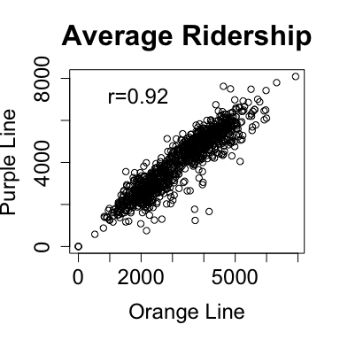

## Correlation

For many of these testing result objects, you can extract specific slots/results as numbers, as the ct object is just a list.

> # str(ct)  
> names(ct)

[1] "statistic" "parameter" "p.value" "estimate" "null.value"   
[6] "alternative" "method" "data.name" "conf.int"

> ct$statistic

t   
73.65553

> ct$p.value

[1] 0

## T-tests

The T-test is performed using the t.test() function, which essentially tests for the difference in means of a variable between two groups.

In this syntax, x and y are the column of data for each group.

> tt = t.test(circ$orangeAverage, circ$purpleAverage)  
> tt

Welch Two Sample t-test  
  
data: circ$orangeAverage and circ$purpleAverage  
t = -17.076, df = 1984, p-value < 2.2e-16  
alternative hypothesis: true difference in means is not equal to 0  
95 percent confidence interval:  
 -1096.7602 -870.7867  
sample estimates:  
mean of x mean of y   
 3033.161 4016.935

## T-tests

t.test saves a lot of information: the difference in means estimate, confidence interval for the difference conf.int, the p-value p.value, etc.

> names(tt)

[1] "statistic" "parameter" "p.value" "conf.int" "estimate"   
[6] "null.value" "alternative" "method" "data.name"

## T-tests

You can also use the 'formula' notation. In this syntax, it is y ~ x, where x is a factor with 2 levels or a binary variable and y is a vector of the same length.

> http_data_dir = "http://www.aejaffe.com/summerR_2016/data/"  
> cars = read.csv(paste0(http_data_dir, "kaggleCarAuction.csv"),  
+ as.is=TRUE)  
> tt2 = t.test(VehBCost~IsBadBuy, data=cars)  
> tt2$estimate

mean in group 0 mean in group 1   
 6797.077 6259.274

## T-tests

You can add the t-statistic and p-value to a boxplot.

> boxplot(VehBCost~IsBadBuy, data=cars,   
+ xlab="Bad Buy",ylab="Value")  
> leg = paste("t=", signif(tt$statistic,3),   
+ " (p=",signif(tt$p.value,3),")",sep="")  
> legend("topleft", leg, cex=1.2, bty="n")

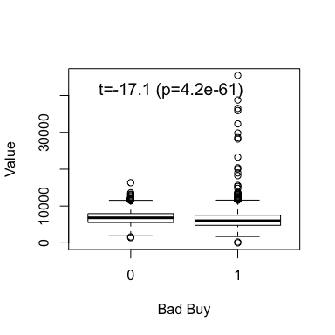

## Linear Regression

Now we will briefly cover linear regression. I will use a little notation here so some of the commands are easier to put in the proper context.

$$y_{i}=α+βx_{i}+ε_{i}$$

where:

* $y_{i}$ is the outcome for person i
* $α$ is the intercept
* $β$ is the slope
* $x_{i}$ is the predictor for person i
* $ε_{i}$ is the residual variation for person i

## Linear Regression

The R version of the regression model is:

y ~ x

where:

* y is your outcome
* x is/are your predictor(s)

## Linear Regression

For a linear regression, when the predictor is binary this is the same as a t-test:

> fit = lm(VehBCost~IsBadBuy, data=cars)  
> fit

Call:  
lm(formula = VehBCost ~ IsBadBuy, data = cars)  
  
Coefficients:  
(Intercept) IsBadBuy   
 6797.1 -537.8

'(Intercept)' is $α$

'IsBadBuy' is $β$

## Linear Regression

The summary command gets all the additional information (p-values, t-statistics, r-square) that you usually want from a regression.

> sfit = summary(fit)  
> print(sfit)

Call:  
lm(formula = VehBCost ~ IsBadBuy, data = cars)  
  
Residuals:  
 Min 1Q Median 3Q Max   
 -6258 -1297 -27 1153 39210   
  
Coefficients:  
 Estimate Std. Error t value Pr(>|t|)   
(Intercept) 6797.077 6.953 977.61 <2e-16 ***  
IsBadBuy -537.803 19.826 -27.13 <2e-16 ***  
---  
Signif. codes: 0 '***' 0.001 '**' 0.01 '*' 0.05 '.' 0.1 ' ' 1  
  
Residual standard error: 1759 on 72981 degrees of freedom  
Multiple R-squared: 0.009982, Adjusted R-squared: 0.009969   
F-statistic: 735.9 on 1 and 72981 DF, p-value: < 2.2e-16

## Linear Regression

The coefficients from a summary are the coefficients, standard errors, t-statistcs, and p-values for all the estimates.

> names(sfit)

[1] "call" "terms" "residuals" "coefficients"   
 [5] "aliased" "sigma" "df" "r.squared"   
 [9] "adj.r.squared" "fstatistic" "cov.unscaled"

> sfit$coef

Estimate Std. Error t value Pr(>|t|)  
(Intercept) 6797.0774 6.952728 977.61299 0.00000e+00  
IsBadBuy -537.8033 19.825525 -27.12681 3.01661e-161

## Linear Regression

We'll look at vehicle odometer value by vehicle age:

fit = lm(VehOdo~VehicleAge, data=cars)  
print(fit)

##   
## Call:  
## lm(formula = VehOdo ~ VehicleAge, data = cars)  
##   
## Coefficients:  
## (Intercept) VehicleAge   
## 60127 2723

## Linear Regression

We can visualize the vehicle age/odometer relationshp using scatter plots or box plots (with regression lines). The function abline will plot the regresion line on the plot.

## Linear Regression

> library(scales) # we need this for the alpha command - make points transparent  
> par(mfrow=c(1,2))  
> plot(VehOdo ~ jitter(VehicleAge,amount=0.2), data=cars, pch = 19,  
+ col = alpha("black",0.05), xlab="Vehicle Age (Yrs)")  
> abline(fit, col="red",lwd=2)  
> legend("topleft", paste("p =",summary(fit)$coef[2,4]))  
> boxplot(VehOdo ~ VehicleAge, data=cars, varwidth=TRUE)  
> abline(fit, col="red",lwd=2)

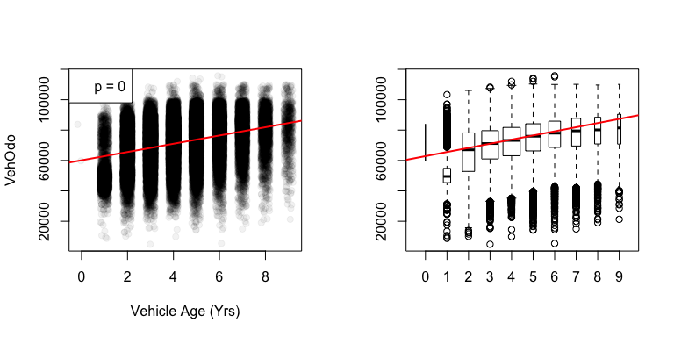

## Linear Regression

Note that you can have more than 1 predictor in regression models.The interpretation for each slope is change in the predictor corresponding to a one-unit change in the outcome, holding all other predictors constant.

> fit2 = lm(VehOdo ~ IsBadBuy + VehicleAge, data=cars)  
> summary(fit2)

Call:  
lm(formula = VehOdo ~ IsBadBuy + VehicleAge, data = cars)  
  
Residuals:  
 Min 1Q Median 3Q Max   
-70856 -9490 1390 10311 41193   
  
Coefficients:  
 Estimate Std. Error t value Pr(>|t|)   
(Intercept) 60141.77 134.75 446.33 <2e-16 ***  
IsBadBuy 1329.00 157.84 8.42 <2e-16 ***  
VehicleAge 2680.33 30.27 88.53 <2e-16 ***  
---  
Signif. codes: 0 '***' 0.001 '**' 0.01 '*' 0.05 '.' 0.1 ' ' 1  
  
Residual standard error: 13810 on 72980 degrees of freedom  
Multiple R-squared: 0.1031, Adjusted R-squared: 0.1031   
F-statistic: 4196 on 2 and 72980 DF, p-value: < 2.2e-16

## Linear Regression

Added-Variable plots can show you the relationship between a variable and outcome after adjusting for other variables. The function avPlots from the car package can do this:

> library(car)  
> avPlots(fit2)

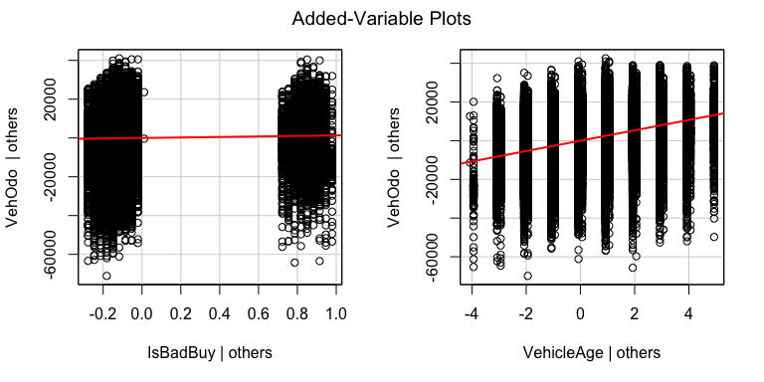

## Linear Regression

Plot on an lm object will do diagnostic plots. Residuals vs. Fitted should have no discernable shape (the red line is the smoother), the qqplot shows how well the residuals fit a normal distribution, and Cook's distance measures the influence of individual points.

> par(mfrow=c(2,2))  
> plot(fit2, ask= FALSE)

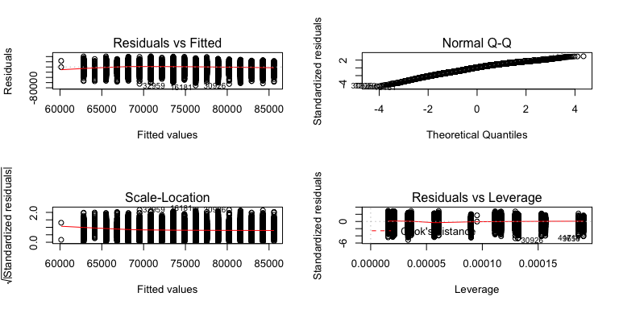

## Linear Regression

Factors get special treatment in regression models - lowest level of the factor is the comparison group, and all other factors are relative to its values.

> fit3 = lm(VehOdo ~ factor(TopThreeAmericanName), data=cars)  
> summary(fit3)

Call:  
lm(formula = VehOdo ~ factor(TopThreeAmericanName), data = cars)  
  
Residuals:  
 Min 1Q Median 3Q Max   
-71947 -9634 1532 10472 45936   
  
Coefficients:  
 Estimate Std. Error t value Pr(>|t|)   
(Intercept) 68248.48 92.98 733.984 < 2e-16 ***  
factor(TopThreeAmericanName)FORD 8523.49 158.35 53.828 < 2e-16 ***  
factor(TopThreeAmericanName)GM 4952.18 128.99 38.393 < 2e-16 ***  
factor(TopThreeAmericanName)NULL -2004.68 6361.60 -0.315 0.752670   
factor(TopThreeAmericanName)OTHER 584.87 159.92 3.657 0.000255 ***  
---  
Signif. codes: 0 '***' 0.001 '**' 0.01 '*' 0.05 '.' 0.1 ' ' 1  
  
Residual standard error: 14220 on 72978 degrees of freedom  
Multiple R-squared: 0.04822, Adjusted R-squared: 0.04817   
F-statistic: 924.3 on 4 and 72978 DF, p-value: < 2.2e-16

## Logistic Regression and GLMs

Generalized Linear Models (GLMs) allow for fitting regressions for non-continous/normal outcomes. The glm has similar syntax to the lm command. Logistic regression is one example.

> glmfit = glm(IsBadBuy ~ VehOdo + VehicleAge, data=cars, family=binomial())  
> summary(glmfit)

Call:  
glm(formula = IsBadBuy ~ VehOdo + VehicleAge, family = binomial(),   
 data = cars)  
  
Deviance Residuals:   
 Min 1Q Median 3Q Max   
-0.9943 -0.5481 -0.4534 -0.3783 2.6318   
  
Coefficients:  
 Estimate Std. Error z value Pr(>|z|)   
(Intercept) -3.778e+00 6.381e-02 -59.211 <2e-16 ***  
VehOdo 8.341e-06 8.526e-07 9.783 <2e-16 ***  
VehicleAge 2.681e-01 6.772e-03 39.589 <2e-16 ***  
---  
Signif. codes: 0 '***' 0.001 '**' 0.01 '*' 0.05 '.' 0.1 ' ' 1  
  
(Dispersion parameter for binomial family taken to be 1)  
  
 Null deviance: 54421 on 72982 degrees of freedom  
Residual deviance: 52346 on 72980 degrees of freedom  
AIC: 52352  
  
Number of Fisher Scoring iterations: 5

## Logistic Regression

Note the coefficients are on the original scale, we must exponentiate them for odds ratios:

> exp(coef(glmfit))

(Intercept) VehOdo VehicleAge   
 0.02286316 1.00000834 1.30748911

## Proportion tests

prop.test() can be used for testing the null that the proportions (probabilities of success) in several groups are the same, or that they equal certain given values.

prop.test(x, n, p = NULL,  
 alternative = c("two.sided", "less", "greater"),  
 conf.level = 0.95, correct = TRUE)

> prop.test(x=15, n =32)

1-sample proportions test with continuity correction  
  
data: 15 out of 32, null probability 0.5  
X-squared = 0.03125, df = 1, p-value = 0.8597  
alternative hypothesis: true p is not equal to 0.5  
95 percent confidence interval:  
 0.2951014 0.6496695  
sample estimates:  
 p   
0.46875

## Chi-squared tests

chisq.test() performs chi-squared contingency table tests and goodness-of-fit tests.

chisq.test(x, y = NULL, correct = TRUE,  
 p = rep(1/length(x), length(x)), rescale.p = FALSE,  
 simulate.p.value = FALSE, B = 2000)

> tab = table(cars$IsBadBuy, cars$IsOnlineSale)  
> tab

0 1  
 0 62375 1632  
 1 8763 213

## Chi-squared tests

You can also pass in a table object (such as tab here)

> cq=chisq.test(tab)  
> cq

Pearson's Chi-squared test with Yates' continuity correction  
  
data: tab  
X-squared = 0.92735, df = 1, p-value = 0.3356

> names(cq)

[1] "statistic" "parameter" "p.value" "method" "data.name" "observed"   
[7] "expected" "residuals" "stdres"

> cq$p.value

[1] 0.3355516

## Chi-squared tests

Note that does the same test as prop.test, for a 2x2 table.

> chisq.test(tab)

Pearson's Chi-squared test with Yates' continuity correction  
  
data: tab  
X-squared = 0.92735, df = 1, p-value = 0.3356

> prop.test(tab)

2-sample test for equality of proportions with continuity  
 correction  
  
data: tab  
X-squared = 0.92735, df = 1, p-value = 0.3356  
alternative hypothesis: two.sided  
95 percent confidence interval:  
 -0.005208049 0.001673519  
sample estimates:  
 prop 1 prop 2   
0.9745028 0.9762701

## Fisher's Exact test

fisher.test() performs contingency table test using the hypogeometric distribution (used for small sample sizes).

fisher.test(x, y = NULL, workspace = 200000, hybrid = FALSE,  
 control = list(), or = 1, alternative = "two.sided",  
 conf.int = TRUE, conf.level = 0.95,  
 simulate.p.value = FALSE, B = 2000)

> fisher.test(tab)

Fisher's Exact Test for Count Data  
  
data: tab  
p-value = 0.3324  
alternative hypothesis: true odds ratio is not equal to 1  
95 percent confidence interval:  
 0.8001727 1.0742114  
sample estimates:  
odds ratio   
 0.9289923

## Probability Distributions

Sometimes you want to generate data from a distribution (such as normal), or want to see where a value falls in a known distribution. R has these distibutions built in:

* Normal
* Binomial
* Beta
* Exponential
* Gamma
* Hypergeometric
* etc

## Probability Distributions

Each has 4 options:

* r for random number generation [e.g. rnorm()]
* d for density [e.g. dnorm()]
* p for probability [e.g. pnorm()]
* q for quantile [e.g. qnorm()]

> rnorm(5)

[1] 0.39811160 -0.06253553 -0.42188248 0.30280643 -1.21367561

## Sampling

The sample() function is pretty useful for permutations

> sample(1:10, 5, replace=FALSE)

[1] 6 7 3 9 2

## Sampling

Also, if you want to only plot a subset of the data (for speed/time or overplotting)

> samp.cars <- cars[ sample(nrow(cars), 10000), ]  
> plot(VehOdo ~ jitter(VehBCost,amount=0.3), data= samp.cars)

