## A description of the problem and a discussion of the background. (15 marks)

Should you start a business form scratch or simply buy a franchise? If you opt to NOT start a business from scratch and choose a franchise;

What’s involved?

Where do you start?

What’s the competitive landscape?

That’s the biggest problem when choosing this career path. Evaluating the competitive landscape and it’s this problem that we will look to address in more detail; as well as provide you further insights into more of the background of exactly where you should setup your franchise.

Let’s start at the beginning by discussing the background and specifically answer What’s involved?

Well these are the 7 things you need to consider when choosing to franchise.

1. Start with learning everything you can and get professional advice before you sign up to buy a franchise. Begin with free online courses, and it’s important to ask questions and make sure you understand how the franchise model could affect the way you do business.
2. Agreements. The first could be the franchise agreement which is the contract you agree to for a set amount of time, which on average can be five years. It covers exactly where and how you will run your franchise and worth consulting a professional to make sure you understand your rights and responsibilities under every clause.
3. Disclosure statement. Franchising in Australia is regulated by the Franchising Code of Conduct. Before entering a franchising arrangement, you should be given certain documents including your franchise agreement, code of conduct and disclosure statement. It’s worth contacting more than one franchisee and even past franchisees for their experiences.
4. Finances. Running a business will always come with risks, especially in relation to factors out of your control, such as competition and the economy.
5. Restraint of trade clause. This stops you competing with the franchise itself during the term of your franchise agreement and after the agreement ends.
6. Fees. In most franchise business arrangements, the franchisee could have to pay a royalty fee to the franchisor on a weekly, monthly or yearly basis. You need to know how this royalty fee works as well as other fees on top of these.
7. Understanding your territory. Is last but not least important because your territory is the area you’re allowed to serve customers within. Increased competition might result if you haven’t selected your target territory well.

## A description of the data and how it will be used to solve the problem. (15 marks)

Addressing the competitive landscape proves to be the hardest thing to address because there isn’t the ability to simply search for the 50 of a whatever it is you want to search for in a given area. Even Google maps can’t easily achieve this. However, with this tool you can define the area, search criteria, and radius in meters around the given area.

The data requirements to achieve this include:

Inputs from the user:

1. Area anywhere on the map
2. Search term in the case of the default notebook it uses Mc Donald’s
3. Radius in meters around the area up to 100, 000 meters

The outputs as a result are those the Foursquare API which include:

{ "meta":

{ "code": 200, "requestId": "5ac51d7e6a607143d811cecb" },

"response":

{ "venues": [

{ "id": "5642aef9498e51025cf4a7a5", "name": "Mr. Purple", "location": { "address": "180 Orchard St", "crossStreet": "btwn Houston & Stanton St", "lat": 40.72173744277209, "lng": -73.98800687282996, "labeledLatLngs": [ { "label": "display", "lat": 40.72173744277209, "lng": -73.98800687282996 } ], "distance": 8, "postalCode": "10002", "cc": "US", "city": "New York", "state": "NY", "country": "United States", "formattedAddress": [ "180 Orchard St (btwn Houston & Stanton St)", "New York, NY 10002", "United States" ] }, "categories": [ { "id": "4bf58dd8d48988d1d5941735", "name": "Hotel Bar", "pluralName": "Hotel Bars", "shortName": "Hotel Bar", "icon": { "prefix": "https://ss3.4sqi.net/img/categories_v2/travel/hotel_bar_", "suffix": ".png" }, "primary": **true** } ], "venuePage": { "id": "150747252" } } ] } }

The result of which are combined into producing the final interactive map and machine learning analytics.

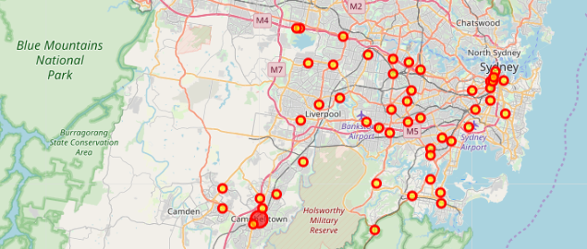

For the second week, the final deliverables of the project will be:

1. A link to your Notebook on your Github repository, showing your code. (15 marks)

2. A full report consisting of all of the following components (15 marks):

• Introduction where you discuss the business problem and who would be interested in this project.

Let's take a look at some of these franchises and see how they stack up. I'll review what each franchise requires in terms of the franchise fee and the initial investment you'll need to make. A franchise fee is a cost a potential franchisee pays up front to operate the franchise. And the initial investment amount includes expenses such as royalty fees, real estate, and inventory costs.

• Data where you describe the data that will be used to solve the problem and the source of the data.

• Methodology section which represents the main component of the report where you discuss and describe any exploratory data analysis that you did, any inferential statistical testing that you performed, if any, and what machine learnings were used and why.

• Results section where you discuss the results.

• Discussion section where you discuss any observations you noted and any recommendations you can make based on the results.

• Conclusion section where you conclude the report.

3. Your choice of a presentation or blogpost. (10 marks)