# Aufgabe 2

* Search «woman friend cat» with 30 repetitions

3306.4

2107.7

2220.0

2261.7

2130.2

2148.3

2138.9

2068.6

2065.6

2052.1

2021.6

2003.9

2034.4

2048.6

2084.8

2408.7

2035.3

2360.9

2083.5

2021.0

2042.2

2252.9

2000.7

2060.7

1998.3

2184.2

2235.2

2265.0

2152.3

2082.6

Average: 2162.5 ms

Min: 1998.3 ms

Max: 3306.4 ms

2. Durchlauf

Average: 1987.7 ms

Min: 1921.0 ms

Max: 2875.7 ms

Process finished with exit code 0

* Search «woman friend cat» With 60 repetetions

10/60 repetitions

20/60 repetitions

30/60 repetitions

40/60 repetitions

50/60 repetitions

60/60 repetitions

2796.6

1721.5

1659.5

1636.0

1650.4

1640.7

1625.5

1632.5

1622.0

1640.0

1631.5

2052.7

2365.6

2308.7

1714.9

1684.5

1636.0

1650.4

1616.5

1610.3

1638.0

1623.6

1788.5

1650.6

1892.3

1868.1

1825.5

1659.5

1845.2

1648.8

1650.8

1618.1

1612.5

1612.7

1618.3

1637.4

1635.9

1658.0

1682.9

1626.8

1646.4

1656.8

1702.8

1631.2

1640.2

1622.9

1629.9

1627.7

1625.2

1620.6

1621.2

1629.9

1624.7

1817.0

1606.6

1601.1

1612.3

1606.3

1609.1

1620.1

Average: 1707.4 ms

Min: 1601.1 ms

Max: 2796.6 ms

* Search «woman friend cat» with 120 repetitions

2604.7

2083.4

2427.8

2082.4

2125.9

2114.9

2024.7

2137.1

2162.3

2048.1

2174.5

2399.1

3375.0

2122.1

2822.2

1966.4

2119.5

2199.8

1955.6

1934.4

1982.7

1979.5

1944.0

1945.7

1966.2

1924.8

1921.6

1958.8

1935.9

1917.2

1934.8

1959.2

1932.3

1930.8

1930.4

1914.1

1931.2

1921.7

2359.0

4372.6

3627.9

2967.4

2017.4

1940.6

2023.4

2012.3

1962.1

2377.3

2519.4

2268.3

1996.1

2089.3

1953.8

1957.7

1934.5

1945.6

1985.2

1978.2

1921.7

2060.4

1940.5

1960.1

1970.2

1981.8

1916.1

2056.5

2175.5

1952.1

2021.1

2054.4

1956.0

1979.5

1950.3

1964.1

1943.5

1908.7

1929.5

1905.6

1998.9

1912.5

1932.9

1980.4

2086.0

1933.8

1942.7

1920.6

1971.0

1938.8

1914.4

1909.5

1917.0

1943.9

1923.7

1922.5

1931.3

1923.2

1939.9

2099.0

1940.0

1928.7

1930.1

1940.4

1922.6

1907.8

1945.7

1971.5

1892.6

1947.6

1947.9

1948.7

1916.7

1913.3

2052.8

1935.6

1917.8

1913.2

1901.8

1913.7

1939.7

1955.5

Average: 2060.6 ms

Min: 1892.6 ms

Max: 4372.6 ms

Process finished with exit code 0

* Search woman friend cat “and history ” with 30

Average: 1845.4 ms

Min: 1701.3 ms

Max: 2897.4 ms

# Durchsatz berechnen

* Druchsatz: 1=1987.7 ms

0.5030940282738844 = 1s

Hohe Auslastung CPU und RAM

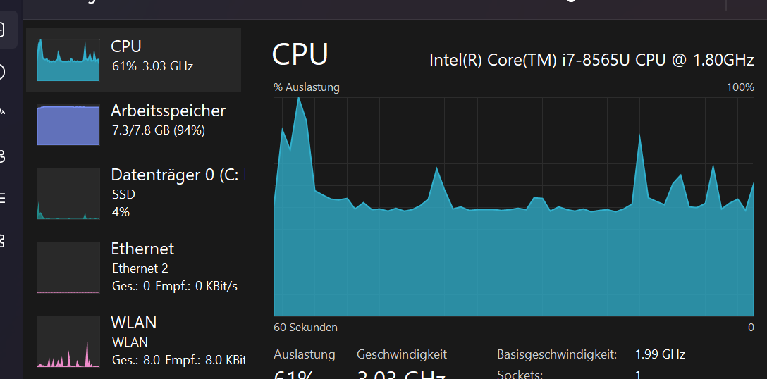

## NAch paralellisierung

Average: 851.5 ms

Min: 670.6 ms

Max: 1365.9 ms