Abstract:

The following paper provides the fundamental concepts required for understanding and implementing your own operating system based on the x86 architecture. MyOS is an operating system that will serve as an example for the concepts covered.
This project serves as a starting point for anyone wishing to expand their understanding of what modern operating systems are, how they work.

Chapter 1

1.1 Introduction

From the very first operating systems, the GMOS[11], their purpose was to abstract the task of queuing jobs, a function still prevalent in all modern operating systems.

Modern operating systems are a lot more complex, however, their role has stayed the same, to provide a layer of abstraction that manages computer hardware. Operating systems are treated as black boxes. Millions of people use them every single day, sometimes without even know it. Even technology enthusiasts tend to know very little of what actually goes on in the operating system. This is a good thing. The point of an operating system is to abstract away the complexity and diversity of hardware devices. However

1.2 Aims

The aim of this project is to provide an easy-to-understand guide which unifies both theoretical concepts and a practical implementation, specifically for the x86 architecture. Explaining and justifying modern operating system design approaches whilst removing their ambiguity with practical examples. The main OS features that will be explored are kernel design, I/O, memory management, and interrupts.

- Discuss the rationale behind the tools and architecture chosen.
- Discuss various design approaches when writing an x86 operating system.
- Create an operating system with basic capabilities.
- Produce an easy-to-follow guide to writing some of the highlighted x86 features.

Chapter 2

2.1 Background

When it comes to operating systems, there are many
2.2 Related work

2.3 Tools and setup

This section is dedicated to explaining what tools are required for running MyOS, and how to set those up. For this project I decided to use the C programming language. There are other popular options for building operating systems, like the recent interest in Rust [12]. Firstly, I have never used Rust previously, and learning a new language would severely reduce the scope of the project. Secondly, one of the main goals of this project is to reduce the lack of tangible examples to go along side theoretical explanations, therefore,

Setup
This is only verified to work on Ubuntu 21.10, however most newer Ubuntu versions should also work. Firstly, let’s set up the C compiler, namely GCC.
The tool required are, QEMU, GNU GRUB, GCC,

Booting and setup:

The very first thing the computer does when turned on is go through the boot sequence.

Chapter 3

3.1 Kernel Design

When designing an operating system, one of the key design choices to consider is the kernel design.

Monolithic
A monolithic kernel is one which includes most of it’s services in the kernel proper. This is the model that most early PCs adopted. This model generally has little distinction between user and kernel space. Essentially resulting in two protection levels, application (user) and kernel. This interconnection of the different kernel services has some interesting consequences.

Advantages:
→ Faster as the different elements are able to directly communicate with each other and share resources more efficiently.
→ Results in a single static binary file.

Disadvantages:
→ Due to the tight coupling and interdependency of kernel services, one error can crash the whole operating system.
→ Difficult to maintain.

There are a few ways to minimize the drawbacks, such as hardware imposed protection levels. Another common way, introduced by the x86 architecture was ring levels. The architecture support 4 distinct ring levels.

Micro kernel
A micro kernel design takes the opposite approach, trying to minimalize the kernel.
It attempts to run kernel services as user space applications, in separate address spaces, keeping the kernel code small. The separated services use interprocess communication to transfer data between each other and the kernel.

Advantages:
→ Tends to be more secure and reliable, because erroneous services, like device drivers, have user space permissions.
→ Micro kernels are more modular. Services may be swapped and modified without affecting the kernel.
→ The use of APIs make the kernel more extensible and less system dependent.

Disadvantages:
→ Slower because services don’t have permissions to access data directly, and rely on message passing.
→ Function calls needed when drivers are implemented as processes.

There are clear differences in the two approaches.

Approach for MyOS

In practice, most operating systems rarely go with a pure monolithic or micro kernel approach. The reality is that a hybrid approach seems to work best. This is the approach that window NT took [8].

3.2 Hello World

As any good beginner tutorial, let’s start off by learning how to print ‘Hello world’ to the screen.
The code shows a simple example of how this can be achieved:

// x and y position of the cursor
static int x = 0;
static int y = 0;
// Integer used to store the current position in the string
int pos = 0;

// String to print out
char * str = "Hello world";

// While the terminating character is not reached
// print the character.
while ( *(str+pos) != '\0' )
putchar(*(str+pos++));

void
putchar ( char c ) {
uint16_t * screenp = (uint16_t *) 0xb8000;
// Store character value (with colour information) at memory location
// of current x,y screen position and update x and y ready to move
// the cursor.
*(screenp+x) = c | 0xf00 | 0x0;
x++;

// Update the position of the cursor (Not necessary at this stage).
x = 0; y = 0;
setcursor (x, y);
}

At this stage, it is not supposed to make sense, so don’t worry, the important thing for now is that we have our desired output:
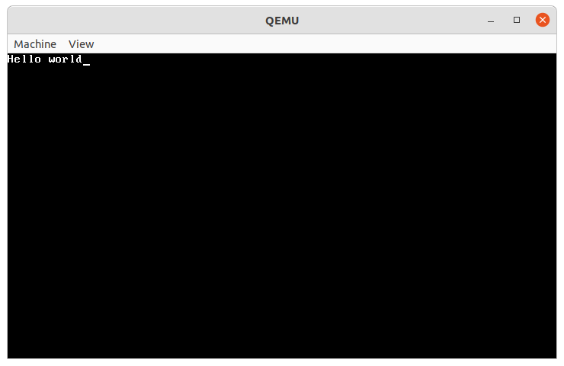
Now, let’s try to actually understand what is going here. Hopefully, the simple C code is not a problem as I’m expecting a decent level of understanding for this paper. So let us focus on the important bit, the ‘putchar’ function.

The first line of code is setting the ‘screenp’ pointer variable the location ‘0xb8000’. This is the location of the VGA. The Video Graphics Array (VGA) is a graphics standard for the video display controller, first introduced with the IBM PS/2 line of computers in 1987 [1]. Shortly after, became a standard in the industry. This, amongst others, is the reason why still to this day, computers boot in a simple VGA colour text mode with 80x25 dimensions. In text mode, the programmer does not need to render individual pixels to describe specific characters, since a simple font is already defined in the internal memory of the VGA display device. This provides us with a simple interface which consists of two bytes per character we want to display: the first byte is the ASCII code representing the character (for details, console the ASCII table [3]), and the second byte stores the characters attributes[2]. This is what we see on the following line:
‘*(screenp+x) = c | 0xf00 | 0x0’
‘c’ is the character we want written to the VGA memory address. The following two bytes represent the attributes of the character, namely, it’s foreground colour and its background colour which are inserted into the resulting byte with bitwise OR operations [4].

What we really want, is a function like printf, which would allow us to print any string, with formatted variables of different types. My implementation can be viewed in the source code, in the ‘kprintf.c’ file.

3.3 Interrupts
Theory

“An interrupt is a signal emitted by hardware or software when a process or an event needs immediate attention. It alerts the processor to a high-priority process requiring interruption of the current working process” [5] Interrupts are a core functionality of any modern operating system. EXPAND…
Programs are made up of two segments, data and code. A data segment is a portion of an object file that contains, well, data, like variables. In assembly, this is typically represented as ‘.data’. The code segment, as you can imagine, contains code that is translated into executable instruction, represented as ‘.text’. The reason for this clear distinction is because some of the early systems had a major security flaw where it was possible to jump to and execute a section of data.
EXPAND...
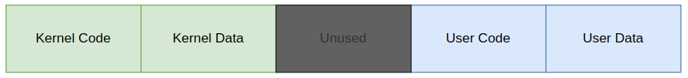
Therefore, memory is laid out as a contiguous segment of code, and their corresponding data an example is show here:

Great! We now have a separation of code and data, meaning that malicious users cannot execute injected code. We now also have a way of preventing a user level application, which could potentially be a virus, from accessing code and data that it shouldn’t have access to.
Now, however, we have a different problem. Most non-trivial user level applications will need to access sections of kernel data and code. Finally, here is where the title of this section comes in, interrupts.

Practice

With all that out of the way, let’s look at how to actually implement interrupts. From the theory section, we know that we need to first create a GDT. This is the structure of the GDT[7]:
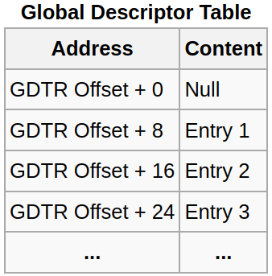

Each segment descriptor looks like so:

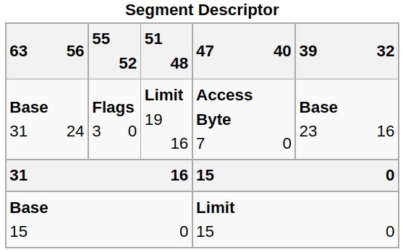

Let’s start off with some definitions in descriptor_tables.h[6]:
struct gdt_entry_struct
{
uint16_t limit_low; // The lower 16 bits of the limit.
uint16_t base_low; // The lower 16 bits of the base.
uint8_t base_middle; // The next 8 bits of the base.
uint8_t access; // Access flags, determine what ring this segment can be used in.
uint8_t flags_lim;
uint8_t base_high; // The last 8 bits of the base.
} __attribute__((packed));
typedef struct gdt_entry_struct gdt_entry_t;

// Special pointer used to point to the GDT.
// This is what will be later loaded using lgdt
struct gdt_ptr_struct
{
uint16_t limit; // The upper 16 bits of all selector limits.
uint32_t base; // The address of the first gdt_entry_t struct.
}
__attribute__((packed));
typedef struct gdt_ptr_struct gdt_ptr_t;

‘gdt_entry_struct’ defines an entry into the GDT

With everything set up, now it’s just a case of actually implementing the interrupt handlers stub. Just to quickly demonstrate that the interrupts are indeed working, we can write a simple keyboard driver. Make a new file called ‘keyboard.h’ and define a new function ‘init_keyboard()’:
#include "globals.h"
void init_keyboard();

Then, in keyboard.c, we can implement a callback function for the interrupt request which corresponds to the keyboard (IRQ1 corresponds to keyboard interrupt, the full list of IRQs can be found here[9]):
static void keyboard_callback(registers_t regs) {
char c = inb(0x60);
if ((int) c > 0) // Ignore key release
kprintf("%c", keyboard_to_ascii(c));
}

void init_keyboard() {
register_interrupt_handler(IRQ1, &keyboard_callback);
}

The keyboard_to_ascii function converts scancode values into the corresponding ascii character. For more about scancodes, see this[10]
Simple I/O:

Chapter 4

4.1 Testing

There are many unavoidable inaccuracies in the testing methods used that need to be acknowledged. For example,

[1] https://videocide.com/glossary/video-graphics-array/
[2] https://www.cs.bham.ac.uk/~exr/lectures/opsys/10_11/lectures/os-dev.pdf
[3] https://www.asciitable.com/
[4] https://intermezzos.github.io/book/second-edition/vga/understanding-text-mode.html
[5] https://www.javatpoint.com/what-is-interrupt-in-os
[6] http://www.jamesmolloy.co.uk/tutorial_html/4.-The%20GDT%20and%20IDT.html
[7] https://wiki.osdev.org/GDT
[8] https://www.roadlesstraveledstore.com/is-windows-a-microkernel-or-monolithic-kernel/
[9] https://www.computerhope.com/jargon/i/irq.htm
[10] https://www.win.tue.nl/~aeb/linux/kbd/scancodes-1.html
[11] https://www.informit.com/articles/article.aspx?p=24972
[12] https://serokell.io/blog/rust-guide

