**MongoDB Task**

**Design database for Zen class programme**

users

codekata

attendance

topics

tasks

company_drives

mentors

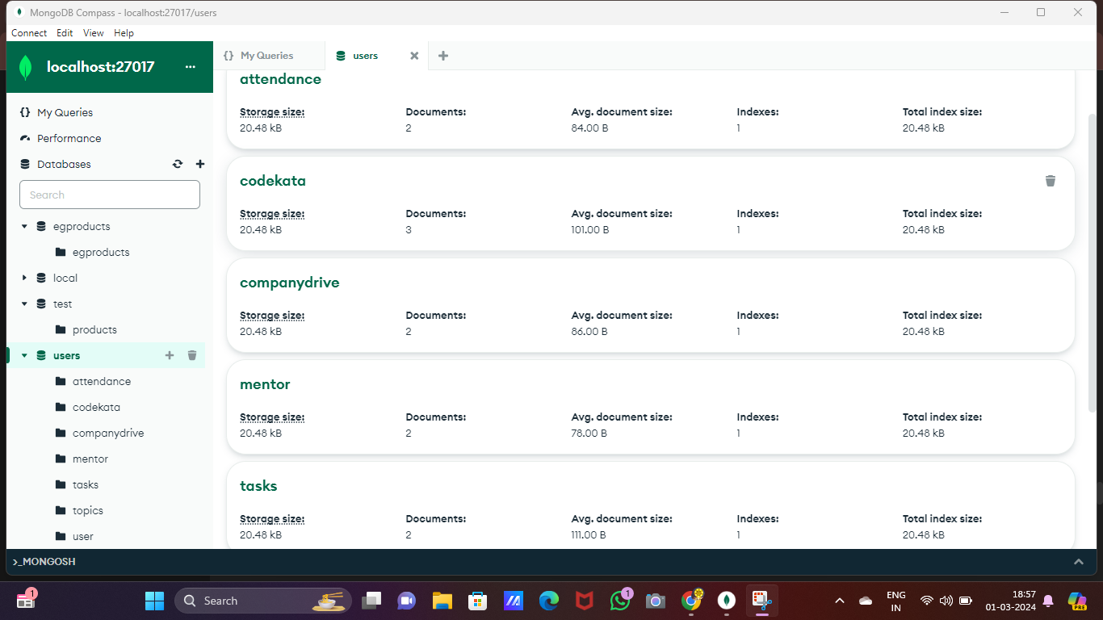

1. Find all the topics and tasks which are thought in the month of October

db.topics.aggregate([

{

$lookup: {

from: "tasks",

localField: "topic_id",

foreignField: "topic_id",

as: "tasks"

}

},

{

$match: {

$or: [

{ created_at: { $gte: ISODate("2020-10-01"), $lt: ISODate("2020-11-01") } },

{ "tasks.deadline": { $gte: ISODate("2020-10-01"), $lt: ISODate("2020-11-01") } }

]

}

}

]);

1. Find all the company drives which appeared between 15 oct-2020 and 31-oct-2020

db.company_drives.aggregate([

{

$match: {

date: { $gte: ISODate("2020-10-15"), $lte: ISODate("2020-10-31") }

}

}

]);

1. Find all the company drives and students who are appeared for the placement.

db.company_drives.aggregate([

{

$lookup: {

from: "attendance",

localField: "date",

foreignField: "date_attended",

as: "attendance_details"

}

},

{

$lookup: {

from: "users",

localField: "attendance_details.user_id",

foreignField: "user_id",

as: "students"

}

},

{

$match: { "students.role": "student" }

}

]);

1. Find the number of problems solved by the user in codekata

db.codekata.aggregate([

{

$group: {

_id: "$user_id",

problems_solved: { $sum: 1 }

}

}

]);

1. Find all the mentors with who has the mentee's count more than 15

db.mentors.aggregate([

{

$match: {

mentee_count: { $gt: 15 }

}

}

]);

1. Find the number of users who are absent and task is not submitted  between 15 oct-2020 and 31-oct-2020

db.users.aggregate([

{

$lookup: {

from: "attendance",

localField: "user_id",

foreignField: "user_id",

as: "attendance"

}

},

{

$lookup: {

from: "codekata",

localField: "user_id",

foreignField: "user_id",

as: "codekata"

}

},

{

$match: {

"attendance.date_attended": { $lt: ISODate("2020-10-15") },

"codekata.date_submitted": { $not: { $gte: ISODate("2020-10-15"), $lte: ISODate("2020-10-31") } }

}

},

{

$count: "num_users"

}

]);