Create a script which scrapes player data for the college hockey ECAC teams:
http://www.collegehockeystats.net/1920/teamstats/ecachm
Your script should scrape the following data for all teams in the ECAC for the 2019/2020 season:
- team name
- team home wins
- team home losses
- team home ties
- player name
- player number
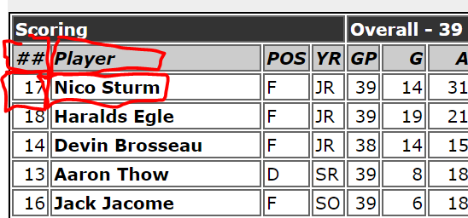
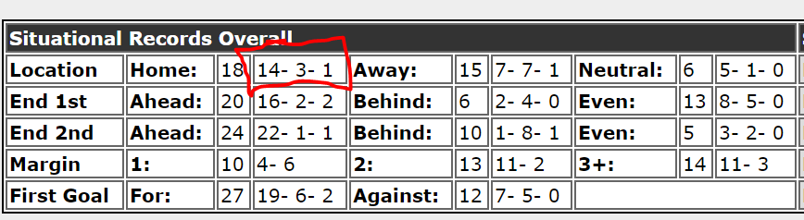

- What is your JSON data schema? (in class)
  - Your schema should be nested to normalize the data.
  - Draw the node tree for the data as a comment to your python code.
- Submit your .py file. (assignment)
  - Your python script should print one single data structure as json

[
{
"players": [
{
"games_played": 38,
"assists": 31,
"name": "Nico Sturm",
"goals": 13
} ],
"name": "Clarkson"
}
]

https://docs.google.com/document/d/1Qg2mxTOVkkbRD586pftxyMdHdhhAFhfVza3WYWhKb8I/edit

