
Comparative Financial Statement Analysis of Engro Fertilizers Limited
Names & Registration No
Name | Registration No
MUHAMMAD QAIS | SP25-BBD-104
MUHAMMAD SAAD HABIB | SP25-BBD-106
MUHAMMAD SHAHEER REHAN | SP25-BBD-107
MUHAMMAD SHAH ZAIB | SP25-BBD-109
MUHAMMAD TAYYAB | SP25-BBD-112

Subject: Business Finance
Semester: 3
Section: C
Instructor Name: Muhammad Ather Yaqoob

Table of Contents
Chapter 1: Introduction 3
Company’s overview: 3
Industry Overview: 3
Chapter 2: Trend Analysis 3
2.1 Introduction 3
2.2 Liquidity Ratios 4
2.3 Leverage / Debt Ratios 4
2.4 Coverage Ratio 5
2.5 Activity / Efficiency Ratios 6
2.6 Profitability Ratios 8
2.7 Chapter Discussion 9
Chapter 3: Common Size Analysis Report 9
Chapter 4: Horizontal (Index) Analysis 12
Chapter 5: Risk and Return Assessment Report 15
1. Overview 15
2. Performance Metrics Comparison 15
3. Risk-Adjusted Return Analysis (CV) 15
4. Qualitative Risk Factors 16
5. Conclusion 16
Chapter 6: Conclusion 16
6.1 Summary of Findings 16
6.2 EFERT vs. FFC 17
6.3 Recommendations 17
References 18

List of Tables
Table 1 Liquidity Ratios 4
Table 2 Financial leverage / Debt Ratios 5
Table 3 Coverage Ratios 6
Table 4 Activity Ratios 6
Table 5 Activity Ratios(Days) 7
Table 6 Profitability Ratios 8
Table 7 Horizontal Analysis 12

List of Figures
Figure 1 Liquidity Ratios 4
Figure 2 Leverage Ratios 5
Figure 3 Coverage Ratios 6
Figure 4 Activity Ratios 7
Figure 5 Activity Ratios (Days) 8
Figure 6 Profitability Ratios 9
Figure 7 Common Size / Vertical Analysis(Balance Sheet) 11
Figure 8 Common Size / Vertical Analysis(Income Statement) 11
Figure 9 Horizontal (Index) Analysis 14

Chapter 1: Introduction
To evaluate a company’s future prospects, performance and financial position financial analysis is done. It considers both income statement and balance sheet to get insights through different trends. In this project, financial analysis is conducted on Engro Fertilizers Limited using ratio analysis, trend analysis, and risk-return measures. The focus is to assess the company’s liquidity, profitability, efficiency, and financial stability over past few years.

Company’s overview:
Engro Fertilizers Limited is one of Pakistan’s biggest fertilizer manufacturing companies and operates as a subsidiary of Engro Corporation. Engro Fertilizers was incorporated in 2009 after being separated from engro chemical Pakistan. Its Headquarter is in Karachi, Pakistan Engro fertilizer is a big contributor to Pakistan’s agricultural sector

Industry Overview:
Pakistan is a big agricultural country and its economy depends on it, so fertilizer industry plays a big role in economic cycle. Fertilizers betters crop yield and ensure food security. This industry highly depends on natural gas availability, as this sector is big and contributes hugely to the economy so there are government regulations implemented, these factors may affect on industry performance too as increase in tax or gas prices also affect company net profit.
Despite these challenges, the industry remains profitable due to consistent demand for agricultural inputs.

Chapter 2: Trend Analysis

2.1 Introduction
This chapter is all about EFERT’s financial performance from financial year 2023 to financial year 2025 across five ratio categories: liquidity, leverage, coverage, activity, and profitability. FFC's financial year 2025 figures help in comparing the performance of our chosen industry. Ratios are computed from audited annual reports.

2.2 Liquidity Ratios

Table 1 Liquidity Ratios
Ratio | ENGRO 2023 | ENGRO 2024 | ENGRO 2025 | FFC 2025
A. LIQUIDITY RATIOS
Current Ratio | 0.78 | 0.76 | 0.77 | 1.27
Acid Test (Quick) Ratio | 0.63 | 0.50 | 0.56 | 1.10

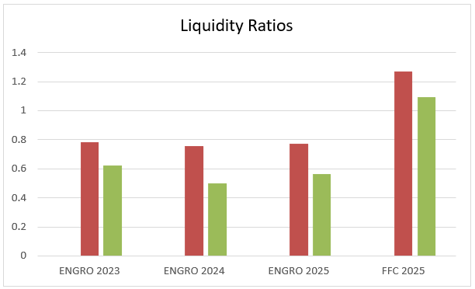
Figure 1 Liquidity Ratios

Interpretation
EFERT's current ratio stayed below 1.0 in all three years (0.78, 0.76, 0.77) mainly because of a PKR 19,558 million GIDC provision in current liabilities that is stuck in court. If we remove this amount, the 2025 ratio adjusts to 0.93, which is more realistic. FFC's higher ratios of 1.27 and 1.10 are mostly because it holds PKR 199,034 million in short-term investments.
2.3 Leverage / Debt Ratios

Table 2 Financial leverage / Debt Ratios
B. FINANCIAL LEVERAGE / DEBT RATIOS
Ratio | ENGRO 2023 | ENGRO 2024 | ENGRO 2025 | FFC 2025
Total Debt to Equity | 2.36 | 2.59 | 3.45 | 1.32
Total Debt to Total Assets | 0.70 | 0.72 | 0.78 | 0.57
Long-term Debt to Total Capital | 0.06 | 0.28 | 0.40 | 0.16

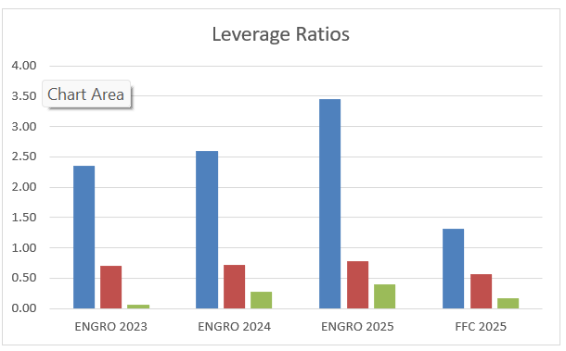
Figure 2 Leverage Ratios

Interpretation
EFERT's debt grew very fast D/E went from 2.36x to 3.45x as short-term borrowings rose 43 times and long-term borrowings rose nine times in just three years. By 2025, only 22.5% of assets are funded by equity, which means the company is heavily dependent on borrowed money. FFC is much more conservative with a D/E of 1.32x and debt-to-assets of 56.8% (Engro Fertilizers Limited, 2025).
2.4 Coverage Ratio
Table 3 Coverage Ratios
C. COVERAGE RATIO
Ratio | ENGRO 2023 | ENGRO 2024 | ENGRO 2025 | FFC 2025
Times Interest Earned (TIE / ICR) | 40.83 | 12.03 | 7.72 | 15.57
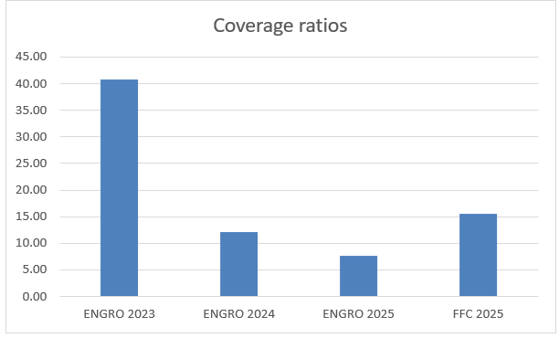
Figure 3 Coverage Ratios

Interpretation
TIE fell from 40.83x in 2023 to 7.72x in 2025, an 81% drop, mainly because EFERT borrowed heavily when Pakistan's policy rate was at 22% and EBIT also declined (Engro Fertilizers Limited, 2025). EFERT is still above the 3.0x safety level, but the direction is concerning. FFC's 15.57x shows it is in a much safer position.

2.5 Activity / Efficiency Ratios
Table 4 Activity Ratios
D. ACTIVITY / EFFICIENCY RATIOS
 | ENGRO |  |  | FFC
Ratio | 2023 | 2024 | 2025 | 2025
Receivable Turnover | 76.81x | 31.10x | 14.08x | 14.27x
Payable Turnover (PTO) | 2.04x | 2.77x | 2.51x | 1.62x
Inventory Turnover (ITO) | 9.86x | 6.90x | 6.41x | 7.39x
Total Asset Turnover | 1.39x | 1.50x | 1.19x | 0.79x

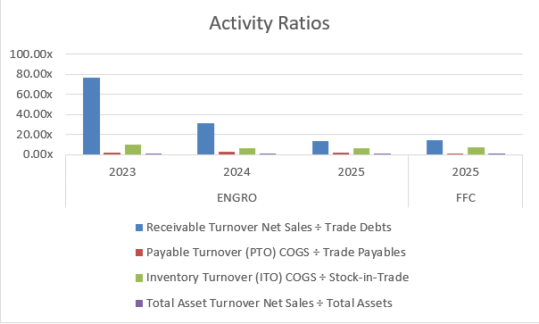
Figure 4 Activity Ratios
Table 5 Activity Ratios(Days)
D. ACTIVITY / EFFICIENCY RATIOS(Days)
 | ENGRO |  |  | FFC
Ratio | ENGRO 2023 | ENGRO 2024 | ENGRO 2025 | FFC 2025
Average Collection Period (ACP) | 4.8 days | 11.7 days | 25.9 days | 25.6 days
Payable Turnover in Days (PTO days) | 178.6 days | 131.8 days | 145.7 days | 225.5 days
Inventory Turnover in Days (ITO days) | 37.0 days | 52.9 days | 57.0 days | 49.4 days
Operating Cycle | 41.8 days | 64.6 days | 82.9 days | 75.0 days
Cash Conversion Cycle | -136.9 days | -67.2 days | -62.8 days | -150.5 days

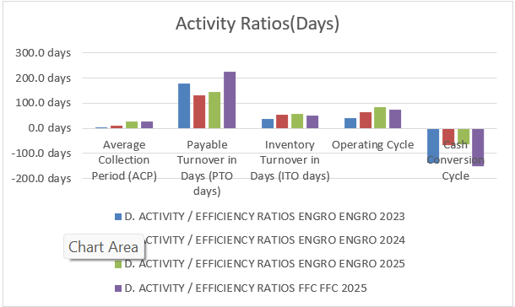
Figure 5 Activity Ratios (Days)

Interpretation
EFERT's average collection period grew from 4.75 to 25.93 days as trade debts rose sharply, and the operating cycle nearly doubled from 41.8 to 82.9 days. Despite this, both companies maintain negative cash conversion cycles — EFERT at −62.8 days and FFC at −150.5 days — because large government-linked payables act as free financing (Engro Fertilizers Limited, 2025). EFERT's asset turnover of 1.19x is still better than FFC's 0.79x.
2.6 Profitability Ratios
Table 6 Profitability Ratios
E. PROFITABILITY RATIOS
Ratio | ENGRO 2023 | ENGRO 2024 | ENGRO 2025 | FFC 2025
Gross Profit (GP) Margin | 32.3% | 28.2% | 30.6% | 30.8%
Net Profit (NP) Margin | 11.7% | 11.0% | 9.5% | 17.6%
Return on Investment / ROA | 16.3% | 16.6% | 11.4% | 13.9%
Return on Equity (ROE) | 54.7% | 59.5% | 50.6% | 32.1%

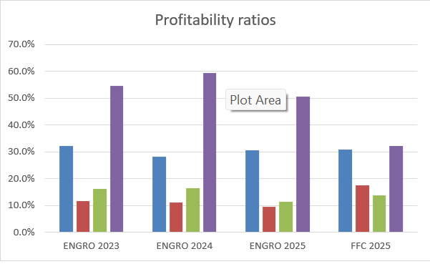
Figure 6 Profitability Ratios

Interpretation
Gross profit stayed stable at around PKR 72.3 billion across all three years, which shows good cost control, and the GP margin recovered to 30.6% in 2025, almost matching FFC's 30.8%. Net margin fell from 11.7% to 9.5% because selling expenses doubled and finance costs rose five times. ROE stayed strong at 50.6% against FFC's 32.1% because EFERT's smaller equity base boosts returns through leverage.
2.7 Chapter Discussion
EFERT's real strengths are stable gross profit, good asset turnover, and a negative cash conversion cycle throughout all three years. The main concerns are D/E rising from 2.36x to 3.45x, TIE falling 81%, collection period growing five times, and net margin shrinking from 11.7% to 9.5%. Given rising energy prices from the ongoing Middle East conflict, EFERT's aggressive borrowing strategy may not be sustainable going into financial year 2026.

Chapter 3: Common Size Analysis Report
This report provides the Vertical Analysis (Common-Size) of Engro Fertilizers Limited for
the years 2023, 2024, and 2025. In the vertical analysis of the Balance Sheet, all items
are calculated as percentages of Total Assets, while in the vertical analysis of the Income
Statement, all items are computed as percentages of Net Sales.
First, in 2023, the company exhibited good financial performance. Current assets to total assets ratio was appropriate, demonstrating sufficient short-term assets that could be used to cover the expenses. Costs were controlled well, making the company profitable.
Second, 2024 can be regarded as a year in which there was significant progress in various fields. First of all, revenue was higher than before, and operating efficiency was also increased significantly. The ratio of liabilities to total assets demonstrates that there were no major risks related to debts since their amount remained acceptable. Finally, profit margin improved due to cost management.
Third, the 2025 year was characterized by continuing growth and good financial condition of the firm. From the balance sheet, we can see better asset management and equity position. Income statement also shows good net income considering sales.
Comparing those years, it is easy to observe that there was steady and continuous growth and sound financial condition demonstrated by the company.
Common size analysis helps investors, students, and managers understand how each part of financial statements affects the performance of the firm.
Common Size Financial Statements
Vertical analysis of balance sheet.
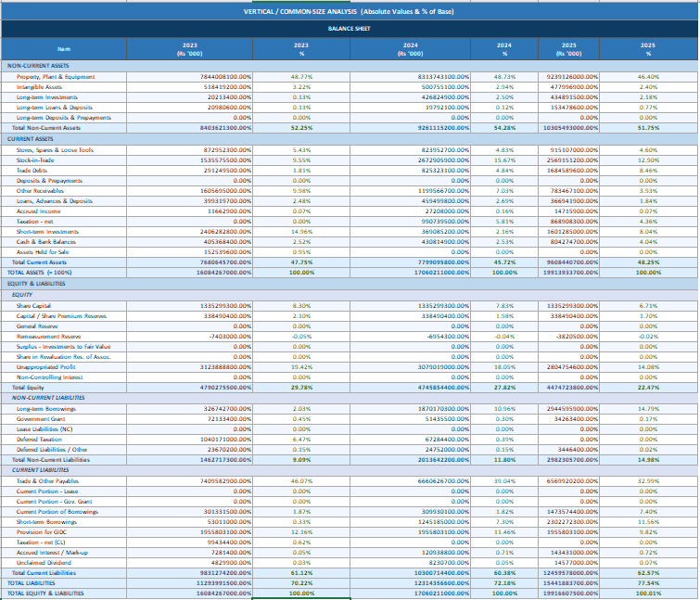
Figure 7 Common Size / Vertical Analysis(Balance Sheet)

Vertical analysis on income statement.
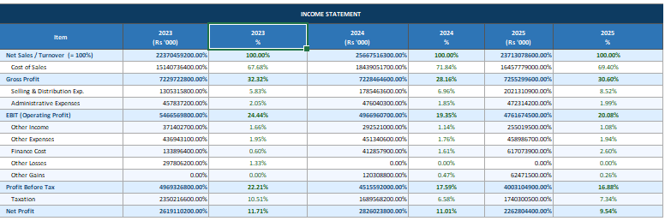
Figure 8 Common Size / Vertical Analysis(Income Statement)

Key Observations
• Non-current Assets: Non-Current Assets have remained constant throughout the three-year period, and have accounted for around 46-48% of total assets.
• Liquidity Ratio: It is clear from the common-size analysis that the current liabilities are an important element of the capital structure, and include trade payables and GIDC payables as the two major elements.
• Inventory: An important point to be observed from the vertical analysis is that the stock in trade as a percentage of total assets has come down significantly in 2025, meaning good stock clearance or production/sale policy of the company.
• Profitability: The lower part of the table depicts the analysis of Profitability, wherein margins are shown using vertical analysis of Income Statement.

Chapter 4: Horizontal (Index) Analysis
4.1 Introduction
Horizontal analysis is simply a way of tracking how much each number in the financial statements has changed over time. We pick a starting year — in this case FY 2023 — assign it a value of 1.00, and then see where everything stands relative to that point in the years that follow. Anything above 1.00 has grown; anything below has shrunk. It is a straightforward technique, but it is surprisingly effective at exposing trends that raw numbers can mask, especially when one item is growing far faster than everything else (Engro Fertilizers Limited, 2025).
4.2 Horizontal Analysis Results
Table 7 Horizontal Analysis
Item | FY 2023 (Base) | FY 2024 Index | % Change | FY 2025 Index | % Change | FFC 2025
Net Sales | 1.00 | 1.147 | +14.7% | 1.060 | +6.0% | 2.163
Cost of Sales | 1.00 | 1.218 | +21.8% | 1.087 | +8.7% | 2.212
Gross Profit | 1.00 | 1.000 | 0.0% | 1.004 | +0.4% | 2.059
EBIT | 1.00 | 0.909 | −9.1% | 0.871 | −12.9% | 2.027
Finance Cost | 1.00 | 3.083 | +208.3% | 4.609 | +360.9% | 5.314
Net Profit | 1.00 | 1.079 | +7.9% | 0.864 | −13.6% | 3.248
Total Assets | 1.00 | 1.061 | +6.1% | 1.238 | +23.8% | 3.813
Total Equity | 1.00 | 0.991 | −0.9% | 0.934 | −6.6% | 5.528
Total Liabilities | 1.00 | 1.090 | +9.0% | 1.367 | +36.7% | 3.086
LT Borrowings | 1.00 | 5.724 | +472.4% | 9.012 | +801.2% | 15.553
Trade Debts | 1.00 | 2.834 | +183.4% | 5.784 | +478.4% | 11.640
Stock-in-Trade | 1.00 | 1.741 | +74.1% | 1.673 | +67.3% | 2.953
Trade & Other Payables | 1.00 | 0.899 | −10.1% | 0.887 | −11.3% | 2.792
Short-term Borrowings | 1.00 | 23.49 | +2249% | 43.43 | +4243% | 41.52
Cash & Bank Balances | 1.00 | 1.063 | +6.3% | 1.984 | +98.4% | 3.445
Source: Base year FY 2023 = 1.00. * FFC 2025 index computed relative to EFERT FY 2023 as a scale reference. Source: Excel workbook Sheet: Vertical + Horizontal. 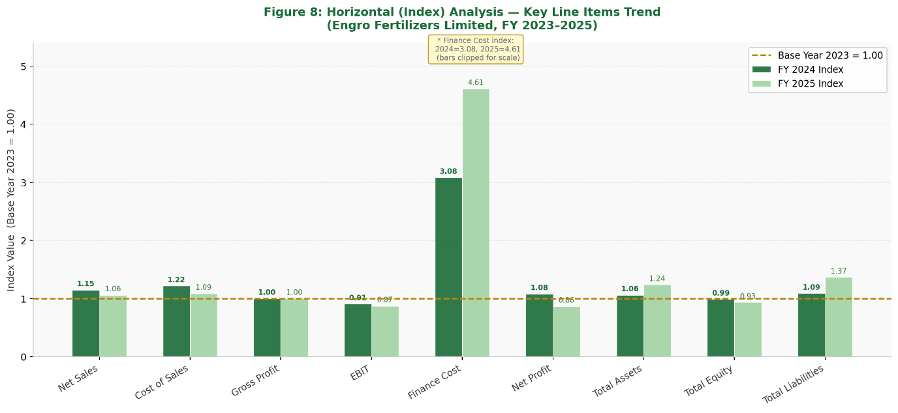
Figure 9 Horizontal (Index) Analysis

4.3 Discussion
The revenue picture is more reassuring than it first appears. While sales did fall from the FY 2024 peak, FY 2025 revenues of PKR 237.1 billion were still 6.0 percent above the FY 2023 base — so the decline was a correction from an exceptional year, not a collapse. Net profit, however, did not hold up as well. It was 7.9 percent above base in FY 2024, then fell to 86.4 percent of the FY 2023 level in FY 2025, landing at PKR 22,628 million. Revenue held; profit did not — which points directly at what is happening below the gross margin line.
The debt numbers are where this analysis gets uncomfortable. Long-term borrowings multiplied 9.01 times in three years, rising from PKR 3,267 million to PKR 29,446 million. Short-term borrowings went from PKR 530 million to PKR 23,023 million — that is a 43-fold increase. Finance cost followed accordingly, growing 4.61 times from PKR 1,339 million to PKR 6,171 million, and that is precisely what has been compressing net profit despite stable revenues.
Trade debts nearly sextupled (index 5.784), which tells us EFERT has been selling more on credit. That is not automatically a bad thing, but combined with the debt build-up it does add pressure on the cash flow side.
On the brighter side, gross profit barely moved in absolute terms (index 1.004) — meaning EFERT managed its production costs well enough to absorb the revenue swings without losing much at the gross level. Cash balances also nearly doubled (index 1.984), growing from PKR 4,054 million to PKR 8,043 million, which shows the core business is still generating healthy operating cash (Engro Fertilizers Limited, 2025).

4.4 Conclusion
The FFC comparison puts things in perspective. FFC's assets are 3.81 times EFERT's FY 2023 base and its profits 3.25 times — a reminder of the scale gap between the two companies. More telling is the equity comparison: FFC's equity index stands at 5.528 while EFERT's has slipped to 0.934. One company is building its equity base strongly; the other is slowly eroding it. That divergence will matter when either company faces tougher market conditions. Overall, the index analysis confirms that while EFERT's revenue and gross profit have remained largely stable, the rapid accumulation of debt and its associated costs represent the most significant financial challenge the company faces going into the future.

Chapter 5: Risk and Return Assessment Report

1. Overview
This report provides risk and return analysis for Engro Fertilizers (EFERT) compared against its primary competitor, Fauji Fertilizer Company (FFC). The data and calculation is based on historical daily returns from the Pakistan Stock Exchange over last 3 months of year 2025.

2. Performance Metrics Comparison
Metric | Engro (EFERT) | FFC (Competitor)
Average Daily Return | 0.0106 | 0.0087
Standard Deviation (Risk) | 0.0138 | 0.0115
Coefficient of Variation (CV) | 1.3028 | 1.3245
Skewness | -0.5812 | -0.5992
Kurtosis | -1.4261 | -1.4304

3. Risk-Adjusted Return Analysis (CV)
The Coefficient of Variation is a critical metric for investors as it measures the risk per unit of return. In this analysis, Engro has a CV of 1.3028, while FFC has a CV of 1.3245.
A lower CV represents a more efficiency, minimizing risk while maximizing return, Engro fertilizers demonstrates slightly better risk-adjusted performance during this period, despite having higher overall volatility (Standard Deviation) than FFC.

4. Qualitative Risk Factors
- GIDC Provision: The company maintains a supplies of Rs. 19.6 billion for Gas Infrastructure Development Cess, this remains a significant potential cash outflow risk.
- Rising Debt Levels: Debt-to-Equity has increased to 3.4x, indicating higher financial leverage and sensitivity to interest rate fluctuations.
- Revenue Volatility: A 25% drop in net sales (2025 vs 2024) highlights exposure to market pricing and volume fluctuations.

5. Conclusion
While Engro Fertilizers exhibits higher volatility, its higher average returns result in a superior Coefficient of Variation compared to FFC. Investors should remain cautious of the increasing leverage factor and the unresolved GIDC provision which could impact future liquidity.

Chapter 6: Conclusion

6.1 Summary of Findings
This report covered EFERT across FY 2023 to FY 2025 using five analytical frameworks: liquidity, leverage, coverage, activity and efficiency, and profitability, plus a risk and return comparison with FFC. Liquidity ratios stayed below 1.0 in all three years, mostly because a PKR 19,558 million GIDC provision sits in current liabilities but has not been paid due to a court case. Adjusting for this lifts the 2025 current ratio to around 0.93. Leverage changed the most: D/E went from 2.36x to 3.45x, debt-to-assets from 70.2% to 77.5%, and long-term debt to capital from 6.4% to 39.7%, driven by borrowings rising nine times on the long-term side and 43 times on the short-term side (Engro Fertilizers Limited, 2025).
The TIE ratio fell from 40.83x in 2023 to 7.72x in 2025, still above the 3.0x safety floor but declining fast as finance costs nearly tripled. Common size analysis showed gross profit was stable at about 30.6% of sales in 2025, almost matching FFC’s 30.8%, though the net margin fell from 11.7% to 9.5% as selling expenses doubled and finance costs rose. The index analysis confirmed that while revenues stayed 6% above the 2023 base in 2025, net profit fell to 86.4% of the base due to ballooning interest costs. ROA declined from 16.6% to 11.4%, falling below FFC’s 13.9% for the first time.
Activity ratios worsened: the average collection period grew from 4.75 days to 25.93 days and inventory days rose from 37 to 57, pushing the operating cycle from 41.8 to 82.9 days. Despite this, the cash conversion cycle stayed deeply negative at −62.8 days because EFERT defers large payables to government-owned gas utilities, effectively using supplier credit as free financing. The risk and return analysis showed EFERT shares delivered a higher daily return of 1.06% but with higher volatility (SD 1.381%) compared to FFC (0.87%, SD 1.152%). EFERT’s Coefficient of Variation of 1.3028 was marginally better than FFC’s 1.3245, meaning slightly better risk-adjusted returns (Pakistan Stock Exchange, 2025).

6.2 EFERT vs. FFC
Compared to FFC, EFERT offered higher shareholder returns but also carried more financial risk. FFC appeared more stable and conservative, while EFERT grew by taking on more debt.

6.3 Recommendations
First, EFERT needs to resolve the GIDC case. The PKR 19,558 million provision has been sitting in current liabilities for years without being paid and it is making liquidity ratios look worse than they are. Second, the average collection period has gone from under 5 days in 2023 to almost 26 days in 2025. With PKR 16,846 million in receivables, any defaults hit net profit directly, so tighter credit limits and faster follow-up are needed. Third, borrowing has grown too fast. Long-term borrowings went up nine times and short-term borrowings went up 43 times in three years. No new debt should be taken unless the return on it clearly exceeds the cost. Management should also set a clear D/E target and not go beyond it (Engro Fertilizers Limited, 2025).

References
Engro Fertilizers Limited. (2023). Annual report 2023. https://www.engrofertilizers.com/investor-relations/annual-reports/
Engro Fertilizers Limited. (2024). Annual report 2024. https://www.engrofertilizers.com/investor-relations/annual-reports/
Engro Fertilizers Limited. (2025). Annual report 2025. https://www.engrofertilizers.com/investor-relations/annual-reports/
Fauji Fertilizer Company Limited. (2025). Annual report 2025. https://www.ffc.com.pk/investor-relations/
Pakistan Stock Exchange. (2025). Historical daily stock price data: EFERT & FFC [Data set]. https://www.psx.com.pk
Van Horne, J. C., & Wachowicz, J. M. (2008). Fundamentals of financial management (13th ed.). Prentice Hall.
Brigham, E. F., & Houston, J. F. (2019). Fundamentals of financial management (15th ed.). Cengage Learning.

