**National Vocational & Technical Training Commission (NAVTTC)**

**Name: Muhammad Saad**

**CNIC: 11201-3611172-5**

**Trade: Mobile App Development**

**Test Date: 10/06/2024**

**Test Center: University of Engineering and Technology Peshawar**

**Examiner Name: Tiham Khan / Muhammad Nouman**

_____________________________________________________________________________________

Q1: **Shape Hierarchy Define an abstract class “Shape” with an abstract method “calculateArea”. Create subclass “Circle” and “Rectangle” that inherits from “Shape” and implements the method to calculate area.**

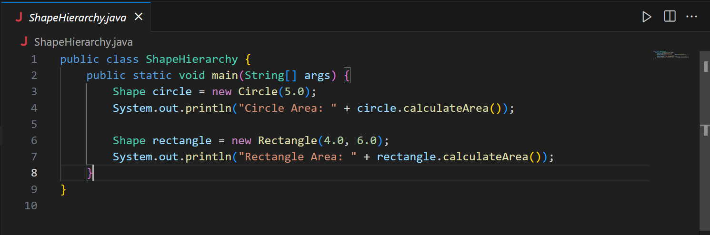

Fig 01: ShapeHierarchy class

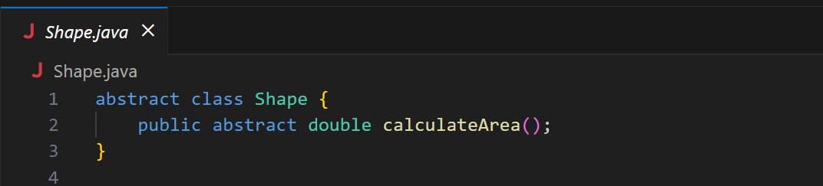

Fig 02: Abstract class Shape

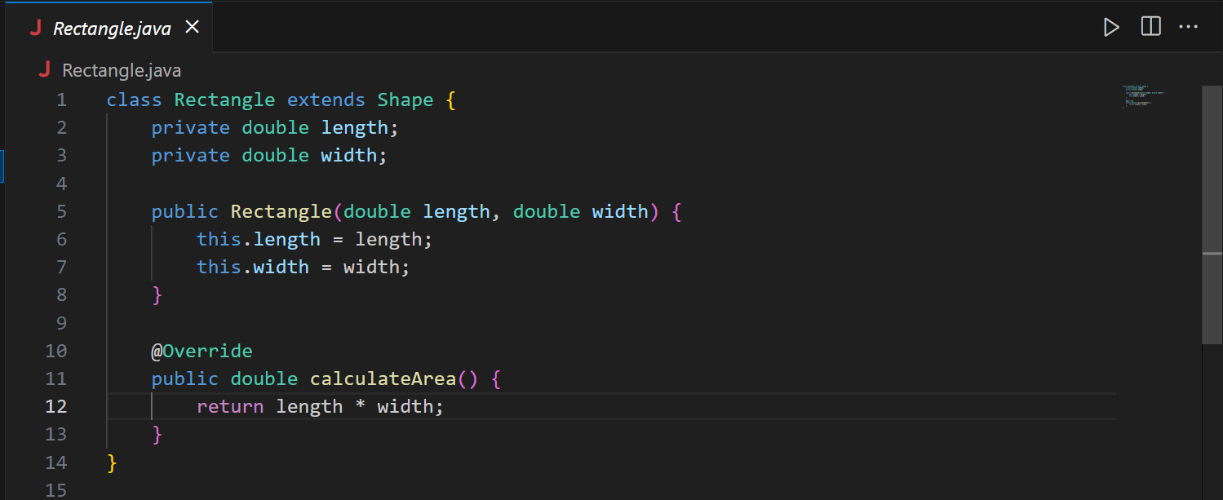

Fig 03: Rectangle class

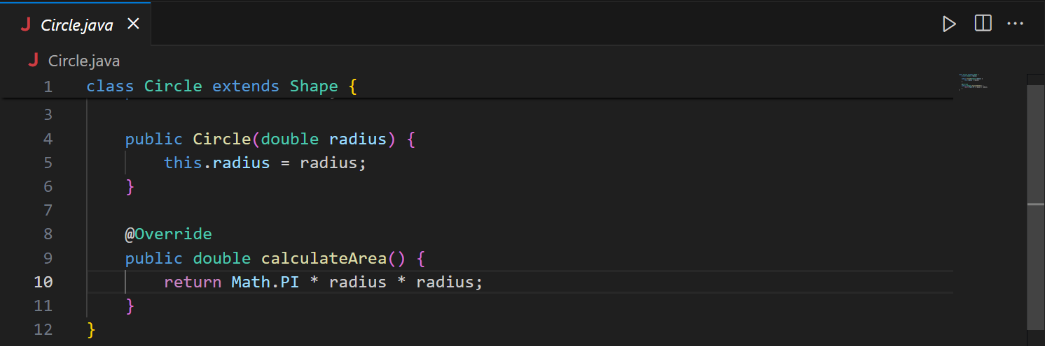

Fig 04: Circle class

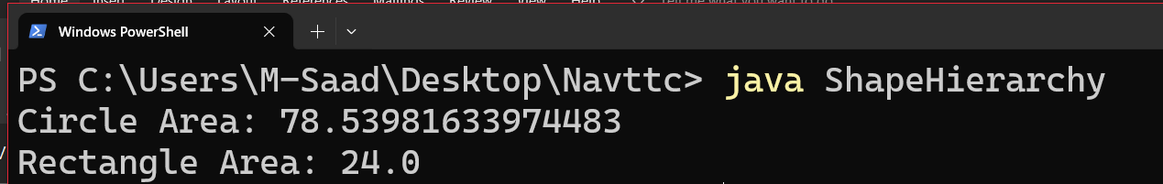

Fig 05: Output Screen Shot

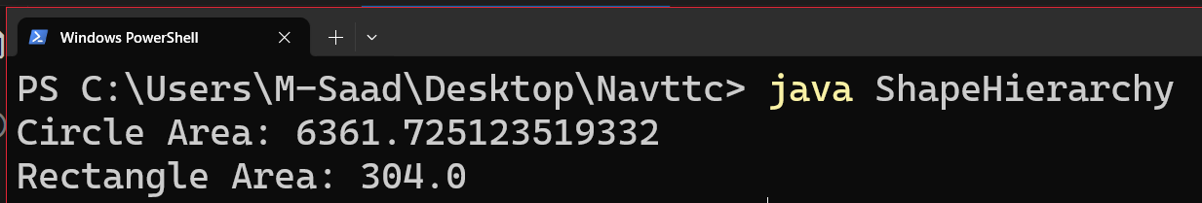

Fig 06: Output with different values

_____________________________________________________________________________________