

**UNIVERSITY OF ENGINEERING AND TECHNOLOGY PESHAWAR  
DEPARTMENT OF COMPUTER SYSTEM ENGINEERING**

Project Title: **NextGen AI Healthcare: Symptoms-based Diagnosis and Medical Rentals**

By

**Muhammad Umar Jan - 21PWCSE2000**

**Muhammad Saad - 21PWCSE1997**

**Muhammad Zaid - 21PWCSE1991**

**Muhammad Ilyas - 21PWCSE2055**

The undersigned certify that they recommend to the UET Peshawar for acceptance of this thesis for the fulfillment of the requirements for the degree stated.

Signature: ________________

Supervisor: **Dr. Nasru Minallah**

Signature: ________________

Final Year Project Coordinator: **Dr. Muniba Ashfaq**

Signature: ________________

Chairman: **Dr. Liaq Hassan**

Date: **29/05/2025**

# Dedication

We gratefully dedicate this Final Year Project to our parents, who have always supported me with love, prayers and their sacrifices. We have always found strength in how they believe in us.

We must mention my mentors and friends here, who provided support and helpful advice all along the way. They helped us develop the idea and made it possible.

# Acknowledgement

To start, we thank Almighty Allah for helping us become stronger, wiser and patient enough to finish our Final Year Project. We are grateful to **Dr. Nasru Minallah** for always helping us, guiding us well and giving us valuable feedback in the project. Having their mentorship in place greatly helped us choose our path and face problems. Not only do we appreciate our education, but also the support from our department faculty and the university’s administration. We couldn’t have done it without the help and happy encouragement from our friends and classmates. We owe most of what we are and our success to the unending support, love and prayers our parents and families have shared with us.

# Abstract

In this work, we introduce a mobile application that helps users rent medical equipment and services more easily. Bloc (Business Logic Component) is used in this project to manage app states properly and efficiently with the help of Flutter.

Users can use their email/password for creating account or use Google account for more secure authentication, as well as view and rent the products offered, all securely using Stripe. We worked with Cloudinary to handle image hosting and added Microsoft Azure for increased reliability.

Further, we integrated a system for symptom diagnosis and utilized an AI chatbot, chatbot was made using a Flask API for immediate medical advice while symptom diagnosis is integrated using TFlite package. MongoDB is used to keep our data, making it easy for us to expand our backend needs.

The aim of this project is to help medical item suppliers reach those who need them which makes it easier for people in our communities to get healthcare support.

# List of Abbreviations

|  |  |
| --- | --- |
| AI | Artificial Intelligence |
| ANN | Artificial Neural Network |
| CNNs | Convolutional Neural Networks |
| CPU | Central Processing Unit |
| DBMS | Database Management System |
| EHR | Electronic Health Record |
| FAISS | Facebook AI Similarity Search |
| GPU | Graphics Processing Unit |
| HTTP | Hypertext Transfer Protocol |
| IoT | Internet of Things |
| JSON | JavaScript Object Notation |
| ML | Machine Learning |
| NLP | Natural Language Processing |
| RAG | Retrieval-Augmented Generation |
| RAM | Random Access Memory |
| REST | Representational State Transfer |
| RNNs | Recurrent Neural Networks |
| SDK | Software Development Kit |
| SQL | Structured Query Language |
| SVM | Support Vector Machine |
| UI | User Interface |
| URL | Uniform Resource Locator |
| UX | User Experience |

Contents

Dedication ii

Acknowledgement iii

Abstract iv

List of Abbreviations v

Chapter 1 Introduction 1

Problem Statement: 2

1.1. Background 2

1.1.1. Evolution of Healthcare System 2

1.1.2. Emergence of Machine Learning in Solving Medical Issues 2

1.1.3. Challenges in Current Systems 2

1.1.4. Advantages of Advanced Health Systems 3

1.2. Rationale 3

1.2.1. The Growing Need for Medical Applications 3

1.2.2. Limitations of Existing Technologies 4

1.2.3. Integration of Machine Learning with Healthcare 4

1.2.4. Societal and Economic Benefits 4

1.3. Objectives 5

1.3.1. Develop an ML-Driven Symptom-Based Diagnosis Model 5

1.3.2. Create a Backend Record-Storing System 6

1.3.3. Create a Rent-Based Medical Equipment Platform 6

1.4. Scope and Assumption 6

1.4.1. Focused Symptoms Diagnosis 6

1.4.2 Scalable System 6

1.4.3 Data and Resource Assumptions 7

1.5. Significance of the Study 7

1.5.1 Enhanced Health Safety 7

1.5.2 Advancing Health System Initiatives 7

1.5.3 Scalable and Future-Ready Solutions 8

1.6. Organization of Thesis 8

1.6.1. Introduction 8

1.6.2. Literature Review 8

1.6.3. Methodology 8

1.6.4. Results and Discussion 8

1.6.5. Conclusion and Future Work 8

Chapter 2 Literature Review 9

2.1. AI in Healthcare: A Growing Field 9

2.1.1. AI-Driven Diagnostics 9

2.1.2. Challenges and Limitations of AI in Diagnostics 11

2.1.3. Benefits of ANN and NLP in Diagnosis 11

2.2. Medical Equipment Sharing and Rental Platforms 12

2.2.1. Existing Models: 12

2.2.2. Benefits and Challenges: 12

2.3. The Intersection of AI and Medical Equipment Sharing 13

2.4. AI-Driven Precision Medicine Recommendation Systems 13

2.5. Challenges and Opportunities in AI-Driven Disease Prediction 14

2.6. Integrating Machine Learning in Drug Discovery and Treatment Prediction 14

2.7. Design and Development of Medicine Recommendation Systems Using Machine Learning 14

2.8. The Role of Data Privacy and Ethics in AI Healthcare Systems 14

2.9. The Potential of AI in Remote Healthcare and Telemedicine 15

2.10. Research Gaps and Project Contribution 15

2.11. Future Directions for ANN in Disease Diagnosis 15

2.12. The Role of Flutter in Mobile Healthcare Application 16

2.12.1. Key Advantages of Flutter: 16

2.13. Challenges in Developing the Application 17

Chapter 3 Methodology 18

3.1 Data Collection and Preprocessing 20

3.1.2 Data Cleaning and Feature Selection 20

3.1.3Text Extraction and Embedding for Chatbot Knowledge Base 20

3.2 Model Architecture and System Design 21

3.2.1 Selection and Justification of ANN Model 21

3.2.2 ANN Architecture and Layer Configuration 21

3.2.3 Feature Engineering and Input Representation 22

3.2.4 Training Process and Hyperparameter Tuning 22

3.2.5 Medical Chatbot: Retrieval-Augmented Generation (RAG) Framework 22

3.2.6 Text Embedding Generation Using Sentence Transformers 23

3.2.7 FAISS Indexing and Similarity Search 23

3.2.8 Integration with GROQ API and LLAMA Model 23

3.3 Model Training and Hyperparameter Tuning 23

3.3.1 Training Configuration 23

3.3.2 Hyperparameter Optimization 24

3.4 Backend System Implementation 24

3.4.1 System Architecture and Technology Stack 24

3.4.2 REST API Endpoints and Data Flow 24

3.4.3 Notification Logic and Backend Alerts 25

3.4.4 Chatbot Integration via Flask API 25

3.4.5 Frontend Integration and Real-Time User Experience 25

3.5 Frontend Implementation 25

3.5.1 Payment Integration using Stripe 25

3.5.2 Push Notifications using Firebase Cloud Messaging (FCM) 26

3.5.3 Chat Implementation in Frontend 27

3.5.4 Diagnosis System Implementation using TFLite 27

3.5.5 Order Tracking and Other Information: 28

3.5 System Integration, Performance Evaluation, And Ethical Compliance 28

Chapter 4 Results and Discussion 29

4.1 Model Performance Analysis 29

4.1.1 Precision-Confidence Analysis 29

29

4.1.2 Training and Validation Loss Trends 30

4.1.3 Confusion Matrix and Class-Wise Analysis 30

4.2 Application and Real-World Deployment 31

4.2.1 Real-Time Diagnosis Accuracy and Responsiveness 31

4.2.2 Medical Chatbot Interaction 32

4.2.3 Scalability and System Throughput 32

4.3 Challenges, Limitations, And Future Enhancements 32

4.3.1 Common Misclassifications and Diagnostic Challenges 32

4.3.2 Dataset Limitations and Class Imbalance 32

4.3.3 User Environment and Input Variability 32

4.3.4 Recommendations for System and Model Improvements 33

4.3.5 Ethical and Privacy Considerations 33

Chapter 5 Conclusion and Future Work 34

References 35

# Chapter 1 Introduction

The healthcare industry is at the dawn of drastic changes that are driven by the adoption of AI and other technologies. These developments are changing the landscape of outpatient services, improving diagnostic and therapeutic functions, and increasing the availability of primary care, especially for vulnerable groups. AI solutions in healthcare help to solve chronic problems, optimize the use of resources and promote inclusiveness. Besides, it also brings new approaches to solve the existing systematic problems in the medical field and improves the accuracy and efficiency of the medical field.

This thesis introduces our project "NextGen AI Healthcare, Symptoms Based Diagnosis and Medical Rentals" a forward-thinking initiative aimed at addressing two critical challenges: Automated symptom checker and volunteer-based medical equipment sharing. The first component utilizes the state-of-the-art machine learning algorithms and natural language processing to develop a strong symptom diagnosis engine. This system takes patient’s symptom records, processes them and provides preliminary diagnosis with high accuracy. Using live data from EHRs and wearable applications, it provides healthcare practitioners with information to make the right decisions quicker and more accurately. This innovation is very useful in settings where there is a limited availability of resources, but diagnosis has to be done as soon as possible.

The second component of the plan is directed towards the creation of a community-based platform for Volunteer Medical Equipment Rentals. Realizing that monetary constraints limit the ability of people to obtain necessary medical equipment, this site helps people find those who want to donate their time or resources to provide equipment like wheelchairs and oxygen concentrators. With this, the system gets to use its analysis of statistical information in order to identify loopholes, which must have led to over-demanding; in so doing, the system is able to distribute resources as per the needs of every sector. Communication with transporters becomes more organized since the devices alert a recipient when the medical devices are required. Besides eliminating additional expenses, this approach entails the development of a culture of community reinforcement.

Altogether, they are expected to help decrease service costs and facilitate the project’s goal of improving population access to healthcare services as well as incorporating community participation into services. As a result of integrating such concepts as advanced technology with a human-centric approach, the concept of “NextGen AI Healthcare” aims at further minimizing the gaps between people from different parts of the world in getting proper access to healthcare services that would promote signing healthcare disparities and developing a more sustainable model for the healthcare field. This thesis will then review and analyze the background, problems and approaches to these initiatives in order to discuss the positive changes that AI could bring in the health sector.

## Problem Statement:

The next generation of healthcare is all about the evolution of the diagnosis by symptoms and rental medical equipment. Existing models can be inefficient, inaccessible, and rarely individualized for diagnosing health issues based on symptoms. Besides, the use of medical equipment comes with the problem of logistics, lack of access, and expensive prices. There is thus a need for an integrated platform that harnesses state-of-the-art-technology like Artificial Intelligence, IoT and more importantly, distinguish between major symptoms and minor ones to arrive at a more accurate diagnosis; rental and sales of medical equipment; and affordable and accessible health care to the patient especially the neglected regions.

## Background

### Evolution of Healthcare System

From ancient time, care was mostly built on herbal remedies and rudimentary surgical techniques, but the healthcare system has changed so much from that time. Through the years, medical practices were advanced by findings in the field of anatomy, and hygiene, and infection control culminating in the development of vaccines, antibiotics and sophisticated surgical procedures. The introduction of advanced imaging techniques and the explosion of use in electronic health records (EHRs) followed the establishment of universal health coverage in many countries during the 20th century. Modern healthcare has been influenced by today's technology, data analytics, interdisciplinary collaboration and preventive care, patient centered approach and personalized treatments.

### Emergence of Machine Learning in Solving Medical Issues

We can rely on machine learning (ML) for solving long standing medical challenges. By analyzing big data (i.e., medical records and diagnostic images), we can use ML algorithms to extract (patterns and) make predictions. In the diagnostics field, ML can help detect disease at an early stage — as is the case of indicating malignancy in cancer, heart condition or even neurologic disorder from small signs that did not get noticed by a human doctor. Furthermore, we are using ML to personalize treatment plans such as trained drug prescriptions based on an individual patient data and predicting response to treatment. Through continuously learning from data ML is changing the way diagnostics, treatment, and patient care is approached by healthcare providers, providing new levels of precision and efficiency.

### Challenges in Current Systems

Though much has been achieved, many healthcare systems of the world are still struggling with immense issues. The problem of accessibility and affordability of care is a large one faced by one, either in under-resourced or without adequate health insurance regions. In addition, these systems are frequently divided into many pieces that are ill coordinated amongst differing healthcare providers, which results in inefficient and errors. Research carried out by the EABC indicates that, as a result of dependence on old infrastructure, manual processes, paper-based records, and relying heavily on relied on outdated infrastructure, paper-based records, and manual processes, inefficiencies and delays are also encountered in the sector. Also, the increasing price patients and healthcare providers are being burdened by healthcare cost, which has found its origin in expensive treatments, overheads of management, and high insurance premiums. We need systems that are more integrated, more efficient, and capable of delivering care that is high quality but also that is affordable.

### Advantages of Advanced Health Systems

Advanced healthcare systems built on technologies ranging from machine learning to telemedicine and data analytics will deliver the following: The main benefit is higher accuracy of diagnosis due to the possibility of using AI for early detection and prevent human errors. Furthermore, advanced systems can provide personalized care to an individual patient, adapted to their particular needs to improve treatment outcomes and maximize patient satisfaction. The ability for telemedicine to perform consultations and provide follow up without requiring in person visits has expanded access to care particularly in remote areas. Besides this, advanced healthcare systems also automate routine process, thereby eliminating the need for manual work and improve data management, which ultimately leads to reduced cost and increased efficiency of the administrations. However, the systems have the potential for more equitable, accessible and high-quality care for diverse populations around the globe.

## Rationale

As healthcare continuity challenges are ongoing, the rationale for engaging in the development of the healthcare system through the use of machine learning, telemedicine, and data analytics technologies becomes obvious. Inefficiencies, rising costs, f fragmented care, unequal access to healthcare services are challenges. While new technology has improvements, many systems cannot efficiently coordinate services to achieve timely and personalized care and thus disparities in health outcomes.

Machines learning and AI technologies can have strong application to enhance diagnostic accuracy, early disease identification and treatment outcome. Using large datasets, these tools can analyze patterns that might be missed by human doctors, and therefore make more accurate, quick diagnoses. It also has been validated as a flexible and critical healthcare access tool in periods of extended geographic distances, when the patients can visit doctors without having to go through the territory away for long distances. In addition, electronic health records and analytics of big data can simplify administrative processes, reduce costs of health care and improve patient care by providing the patient specific medicine plan.

Indeed, growing demand for healthcare and the pressure on existing systems make for smarter, more efficient alternatives. Through the use of these cutting-edge technologies, healthcare can be made more open, economical, and consumer department, guaranteeing that top of the line consideration arrives to a more extensive population that subsequently fortifies all out-wellbeing results.

### The Growing Need for Medical Applications

This demand for medical application is pressing due to the growing complexity of delivery of healthcare, the demand for faster and more efficient delivery of the service, and the desire for a more personalized delivery of the service. And with the growth in the number of the healthcare challenges only increasing, an increasing population, higher rates of chronic diseases, and the stress on the healthcare structure, so too does the need for digital solutions that close those gaps. Especially for remote monitoring, symptom tracking, telehealth consultations, and patient education, medical application is really important. Mobile technology has advanced to the point where healthcare providers can offer real time care, where patients can live their health through home and still be in regular contact with their providers. Medical applications are therefore becoming crucial in improving access to care, improving patient outcomes and lowering the cost on systems of healthcare.

### Limitations of Existing Technologies

With all of the increases in health care technologies, there are still major limitations that exist on the existing systems and tools that limit both their effectiveness. Despite becoming standard practice, many healthcare applications still rely on outdated infrastructure that creates inefficiencies, data fragmentation, and poor connectivity between dissimilar systems. That creates poor coordination of care, or delays in diagnosis or treatment. Furthermore, real time data from wearable devices, home monitoring systems, or telemedicine consultations are not currently integrated with traditional diagnostic tools or electronic health record systems. In addition, while AI and machine learning have demonstrated potential for improving healthcare delivery, these technologies have struggled to make their way into everyday practice primarily because there is not yet another protocol for use, regulatory issues, and worries of local data privacy and security. The focus of these limitations is to provide more advanced, interoperable, secure and technological solutions in healthcare.

### Integration of Machine Learning with Healthcare

Machine learning (ML) integration with healthcare has unprecedented potential. Many medical data come to play in hospitalization. The patient medical records and diagnostic and anthropic images can be analyzed by ML algorithms to find patterns and make prediction of diagnosis and treatment, to help doctors providing the best treatment to their patients. ML models can also be used to identify at risk patients early, predict disease progression and prescribe personalized treatments. Furthermore, machine learning can help reduce administrative work that basically helps to optimize operational efficiency, including scheduling, billing and claims processing. All the same, health care has been slow to integrate ML and it will need to overcome barriers like data privacy concerns, the availability of large and high-quality datasets; and regulatory one. Carefully implemented, ML can improve clinical decision making, reduce errors and leads to wonderful patient outcomes.

### Societal and Economic Benefits

There are many societal, and in many cases economic, benefits to moving healthcare forwards through technology, especially machine learning. Tech helps make healthcare delivery more efficient and effective, cutting costs of misdiagnoses, useless treatments, and long-term care. The benefit from reduced burden of chronic disease and lower readmission rates is dependent on earlier detection and better diagnostics. Additionally, improving health equity in underserved and rural communities is enabled by increased access to health care through telemedicine and remote monitoring. On a societal level, better healthcare outcomes benefit a healthier population, increasing its capacity to contribute to workforce productivity, cutting down on absenteeism and improving in general on quality of life. In addition, the economic impact from innovations in healthcare technology is also huge as the resulting innovations can create jobs in the tech and healthcare sectors and alleviate the burden of infusion of the financial input of healthcare on the societies and individuals.

## Objectives

The goals are to increase diagnostic accuracy, access, efficiency and personalization of care using technology for advancing healthcare. With machine learning and AI, the aim is to accelerate disease detection and speed of response, such that it may be caught earlier and lead to better results. Increasing the access to healthcare in the underserved areas is one of the main aims of the medical applications, telemedicine and remote monitoring. Optimizing healthcare operations using data analytics will improve processes, reduce costs, and improve patient care as well. Advanced technologies personalizing treatment plans are used to treat specific individual patient needs and data integration provides the healthcare providers with comprehensive and up to date information available. In addition, the objectives are also promoting preventive healthcare, by supporting healthcare professionals with decision making tools, ensuring robust data security and evaluate a real societal and economic benefit regarding these innovations, respectively, creating a more efficient, equitable, and sustainable healthcare system.

### Develop an ML-Driven Symptom-Based Diagnosis Model

Designed to create a model driven with machine learning that can aid in the diagnosis of different medical conditions based off of patient reported symptoms and other health related data. The model is trained on large datasets consisting of symptoms, medical histories, and diagnostic results, allowing it to recognize patterns that help healthcare providers make an accurate and early diagnosis based on data-driven insights. The system will assist in triaging potential diagnoses, recommending additional tests when necessary and aiding healthcare professionals in decision-making, ultimately enhancing diagnostic precision and patient outcomes. Figure 1.1:

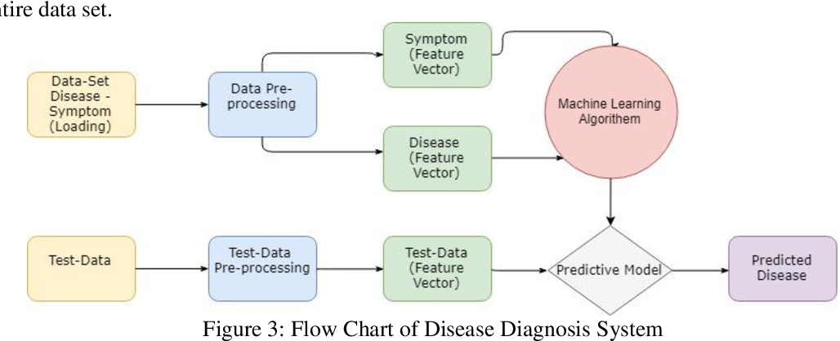

Figure 1.1: Process of disease prediction using machine learning: Loading dataset, cleaning data, identifying feature vectors (symptoms and diseases), training the model, cleaning test data, predicting disease with the help of the model.

### Create a Backend Record-Storing System

The system has the potential to enhance the monitoring of patient information, health records, and even data regarding diagnosis. In simple words, this system has the capacity to combine all the information of individual patients while safeguarding privacy, protection, ethical, and professional standards. It will combine EHRs, medical imaging, lab records, and some other symptom related data into a single platform to give an overall and updated profile of the patient. This platform will assist in the coordination between various providers of care, prevent mistakes and facilitate the service provision to be effective.

### Create a Rent-Based Medical Equipment Platform

Developing an online renting platform, where the medical equipment could be hired by healthcare providers, institutions or patients in fact. This solution will be cost-effective and accessible — ideal as temporary medical equipment or for home healthcare in general, over buying medical equipment. Users will be able to search the platform for a diverse selection of medical devices (from diagnostics to therapy) under different rental cycles and delivery options. It will contain functionalities for managing equipment (usage, maintenance & returns), thus maintaining the dependability and availability of well-being medical devices when needed. Use of the platform will likely help to drive down healthcare expenses, increase access to necessary equipment and cost savings.

## Scope and Assumption

Second: The scope of this project is to make an ML based symptom-diagnosis model, backend patient record-storing system and a rent-based medical equipment platform. Diagnosis model aids healthcare provider to determine common conditions associated with patient symptoms and history thus enhancing the diagnostic accuracy. It will ensure that patient information can be accessed, being fully compliant with all kinds of healthcare regulations and system which will manage the backend. The medical equipment platform will deliver an accessible and adaptable rental experience to the myriad tools of basic care. Assumptions are high quality, structured data readily available for training the model; Compliant with privacy of personal data Act the doctors would use such system. In addition, long-term partnerships with medical equipment manufacturers and money to run and scale that system will be key.

### Focused Symptoms Diagnosis

The scope of the system shall be to create a diagnostic model tuned for hyper-specialized symptom-based illness, which essentially tries and accurately interprets patients’ symptoms and past medical inferences for plausible conditions. The model will focus on common, high suspicion disease most likely to be the diagnosis that allow for efficiency in determining top differential diagnoses from symptoms. It will be built to help healthcare providers identify relevant pathway of diagnosis, framing the conditions based on what is most urgent and/or life threatening. Not every illness will be covered, but what the system does will be helpful in concentrating on those that are generally most common / critical to increase diagnostic accuracy and efficiency.

### 1.4.2 Scalable System

The system will be designed for scaling, able to scale with larger data and higher user counts, but with no degradation in performance. Healthcare systems develop and with increased data volumes of same the infrastructure need to scale out to include new features, do more data integration and more range of use spread into disparate healthcare environments. It will be made to scale both horizontally (*more capacity for users and data*) and vertically (*improve features and capabilities*). This scalability is going to be important to be able to scale the system across greater populations, more specialties and future healthcare needs.

### 1.4.3 Data and Resource Assumptions

Creation of the ML-diagnosis model and backend record-storing system will operate with high-quality, normalized data retrieved from different healthcare domains. Assumptions have full datasets including the symptom history, diagnosis outputs, treatment results and medical records to train the machine learning model. It will also be dependent on the resources like computing, cloud resources and healthcare skillset to input data and validate them. Relevant, anonymized data from healthcare providers for the model is assumed and appropriate data privacy and security regulations shall exist to allow for privacy, with respect to the health sector. Maintenance, updates and that of Scalability are also accounted for as the system evolves over time with proper resourcing.

## Significance of the Study

This study has potential to revolutionize healthcare by empowering solutions to complex problems of diagnostic challenges and healthcare data management, facilities access. Through the integration of an ML symptom-driven diagnostics model to predict and assist in a diagnosis enables more accurate diagnostics, ultimately earlier disease detection/intervention and hence better patient outcomes. A competent and secure backend storage system for the record development is put in development, thus data management, care coordination and compliance in privacy is guaranteed. It also tackles affordability and accessibility, notably in community areas with potential offerings for lower-costs ways to use medical devices through a rent-based equipment platform. Altogether, these innovations under the improved healthcare delivery while decreasing operational costs by minimizing redundancy and facilitating operational gaps in resource utilization in spirits that would be very relevant for modern healthcare systems.

### 1.5.1 Enhanced Health Safety

These proposed systems drastically improve health safety by lessening the odds of misdiagnoses, and increasing access to early medical condition detection via an ML-driven diagnosis model. Data driven accurate insights enable zero misdiagnoses, no over the top treatments for a healthcare provider and only the best possible care decisions. Moreover, their backend database keep track with patients’ data centralized will guarantee to care coordination and decrease error that may come from information dividedness. The synergistic advances all lead to a better, safer and more dependable health care environment for patients.

### 1.5.2 Advancing Health System Initiatives

This study is in line with efforts to reform healthcare systems using advanced technology like machine learning, secure data management and automated medical equipment rental platforms published in hospitals. These aims are consistent globally with the objectives of better healthcare provision, patient centricity and universal access. The research aimed to contribute to the strengthening of health infrastructure by dealing challenges including insufficient access to healthcare, wasteful use of resources and exorbitant operational costs etc.

### 1.5.3 Scalable and Future-Ready Solutions

The systems that this study suggests are scalable and capable of adapting to potential future healthcare requirements. The ML-powered diagnosis model and backend data system should be upgradeable from the progress of medical technology as well as the expanding data sets, this in turn keeps the process relevant in real life much longer. Medical Equipment Rental Platform caters to current requirement and is flexible enough to accommodate upcoming technologies and devices. These solutions of the sort have been designed for future-readiness and will enable the healthcare system to scale with growing patient needs, new disease challenges and technology breakthroughs to sustain and grow.

## Organization of **Thesis**

This thesis is structured into several chapters, each addressing critical components of the research and development process. The organization follows a logical progression, beginning with the background and justification for the study, and moving through the implementation and evaluation of the proposed system. This structure provides a comprehensive framework, enabling readers to grasp the context, methodology, and key contributions of the research effectively.

### Introduction

The opening chapter provides an introduction to the thesis, covering the background, problem statement, objectives, scope, and significance of the study. It establishes the relevance of the 10 research within the context of smart city innovations, setting the stage for the subsequent chapters.

### Literature Review

The second chapter explores existing research and technologies related to healthcare frameworks, and ML. By identifying gaps in current knowledge, this chapter demonstrates how the proposed study addresses these shortcomings, forming a solid theoretical foundation for the research.

### Methodology

The third chapter outlines the methodology used to develop the symptoms diagnosis system. It includes detailed descriptions of the dataset, model architecture, training process, and evaluation metrics. This chapter ensures the research is transparent and reproducible.

### Results and Discussion

The fourth chapter presents the study's results, including the performance metrics of the symptoms diagnosis model and the backend record system. It provides an in-depth discussion of the findings, analyzing their significance and potential impact on health issues.

### Conclusion and Future Work

The final chapter summarizes the key findings and contributions of the research. It evaluates the success of the proposed system, reflects on its limitations, and outlines potential directions for future research, highlighting the importance of ongoing innovation in health technologies.

# 

# Chapter 2 Literature Review

The field of healthcare is being transformed by the fast progress of Artificial Intelligence (AI) and deep learning. Currently, AI-driven methods are crucial for identifying diseases, giving out forecasts on possible results and choosing the best treatment. These advanced systems are great at understanding large amounts of complicated medical information, making healthcare services more exact, efficient and adaptable, primarily in places without many specialty doctors. When patient symptoms, medical history and health markers are added to AI, health professionals can rely on data to guide their treatment which benefits the patient.

Artificial Neural Networks (ANNs) have achieved outstanding results in predicting diseases based on symptoms and in classifying their prognoses. By modeling the brain’s neural network, ANNs help find complex, non-straight links between symptoms and diagnoses. Unlike traditional management models like SVM, ANNs can pick out complex relationships from large quantities of data without being manually adjusted. ANNs are routinely used in healthcare for detecting diseases, including the first signs of cancer and infections as well as persistent illnesses and they can handle different patient data with high accuracy and uniformity.

Besides automated diagnosis, using NLP now means better conversations with patients. It is exciting that using Retrieval-Augmented Generation (RAG) approaches can help create smart medical chatbots. They join the benefits of semantic search to those of generative language models. The chatbot used in this study relies on Sentence Transformers to convert patient questions, uses FAISS to identify similar information in the medical PDF database and generates suitable answers with the Llama language through the Groq API. By combining these network types, patients can be sure to obtain dependable, customized and science-supported advice to their health questions quickly.

## AI in Healthcare: A Growing Field

Over the recent past, advances in artificial intelligence (AI) have posed important breakthroughs to the field of healthcare. In primary care: diagnoses, early warnings, detection of abuse and fraud activity While in secondary care: planning and implementing the treatment, patients’ monitoring, and prognosis, AI is proving to be a major factor in raising the general level of healthcare. Considering the advances in AI technology on the recent years we only need to wait and see the even bigger revolutions in health care provision and management.

### 2.1.1. AI-Driven Diagnostics

Using Artificial Intelligence (AI) in healthcare diagnostics has seen fast development lately, allowing healthcare teams to provide faster and more accurate treatment for patients. A major use of AI is in helping doctors with disease diagnosis through the review of lots of health-related data. Artificial Neural Networks (ANNs) are praised for efficiently modeling the relationship between both patient symptoms and their underlying medical causes. The structure of these networks is similar to the human brain, making it possible for them to notice patterns in patient records that could be hard for standard methods to find.

#### Symptom-Based Diagnostics:

Scholars make use of ANNs more and more to diagnose symptoms, thanks to their power to detect even difficult non-linear patterns in organized data. ANNs can find links between disease symptoms and illnesses without anyone having to manually arrange the data, unlike with traditional approaches. Training an ANN model on a range of symptom insights, this project could identify and predict how severe (mild, moderate or severe) a disease might be. The system both finds likely illnesses and then suggests medications, food plans and ways to manage your health. Because this model is designed for mobile devices, it offers quick and easy testing in locations with few healthcare resources..

#### Image-based diagnostics:

One profuse category of deep learning called Convolutional Neural Networks or CNNs has transformed the analysis of medical images starting from two-dimensional images such as X-ray, CT scan, MRI scans and so forth. Such algorithms are demonstrating high efficacy for identifying diseases like cancer, pneumonia, or diabetic retinopathy (Esteva et al., 2017; Gulshan et al., 2016).

#### EHR-based diagnostics:

AI is also making waves for Risk models that are built for predicting patients’ health outcome concerning various kinds of diseases including heart failure, diabetes, or sepsis based on EHR data (Rajkumar et al., 2018). Through utilization of algorithms in the analysis of a patient’s records, doctors get a clue of the precursors of certain diseases therefore can act in advance.

#### Advantages over Other Types of Competitive Structures

While novel deep learning structures such as CNNs are marking a new generation of image-based diagnostic tools and NLP is making corresponding advancements in text-based diagnostic data, SVM still reflects the gold standard for structured symptom data. For healthcare systems that work with tabular records of patient symptoms, it is a preferred solution thanks to the computational aspect and generalization.

Through SVM models, automated systems for disease prediction have been fostered to minimize symptom interpretations as a means of diagnosis. Together with interpretable results that SVM models will present, it will help the healthcare gurus to diagnose tendencies of diseases and implement preventive measures.

#### The integration with Modern Healthcare

By using Artificial Neural Networks (ANNs) in healthcare, we can see they deal with real diagnostic problems successfully. Analyzing organized symptom information and predicting diseases accurately, ANNs allow for earlier identification and appropriate treatment for each patient. Because they can adjust and continually learn, they play a significant part in improving smart healthcare systems.

### Challenges and Limitations of AI in Diagnostics

Despite the tremendous promise AI holds for diagnostics, there are still several obstacles that must be addressed before it can be fully integrated into everyday healthcare practices:

#### Data availability and quality:

This means that in order for AI models to successfully operate, they require a wealth of data and variety from this group. However, if the data used is partial, biased or lacks variety then the results in the model may not be fair or accurate at all. The use of AI in healthcare significantly depends on the provision of high-quality representative data.

#### Explainability and transparency:

This is true especially with deep learning models, and one of the biggest barriers with using AI models in general is that they are ‘black boxes’. This is because, unlike in quantitative models where one can determine how a particular model arrived at the result, there are usually concerns on how the models arrived at particular conclusions which can make healthcare professionals to lack the confidence to belief on such models. AI shall have to be open to understanding as well as explicability, in order to become integrated into clinical practice.

#### Regulatory and ethical considerations:

AI in healthcare also possess some of ethical and regulatory concerns. For example, there are issues, such as data privacy, patient safety, as well as accountability that remains to be discussed. That brings us to the last but, yet, equally important question – who is held accountable when a mistake occurs in the diagnosis made by an artificial intelligent tool? Such questions must be answered in order to effectively manage key issues that relate to the applicability of AI in healthcare settings.

Two of the challenges are particularly important where AI is applied in healthcare and can lead to patient outcomes – data availability and model explainability. The authors of Collobert et al. (2011) note that the principal area of focus in further research should be the enhancement of the model’s interpretability. This holds even to the degree when some form of AI influence is used in translating patient records or described symptoms in the medical field. The authors indicate that their studies reveal that while deep learning models might be complicated and challenging to analyze, the addition of other features such as syntactic parsing or even using the multi-modal model, which combines both text and images makes these models more understandable. Achieving this level of transparency will be essential for gaining the trust of healthcare professionals and ensuring that AI is used safely and effectively in clinical environments.

### Benefits of ANN and NLP in Diagnosis

With ANN and NLP, this project successfully enhances both precision in making the diagnosis and interactions with users. The model can review the organization of symptom data to decide on a diagnosis, review prognosis levels and advise personal diet, medicine and care plans. The medical chatbot in the system which uses Retrieval-Augmented Generation and NLP methods, helps users by answering their health questions naturally. Thanks to the combination of ANN and NLP, users get both smart diagnosis and an easy-to-use, friendly way to learn about their health.

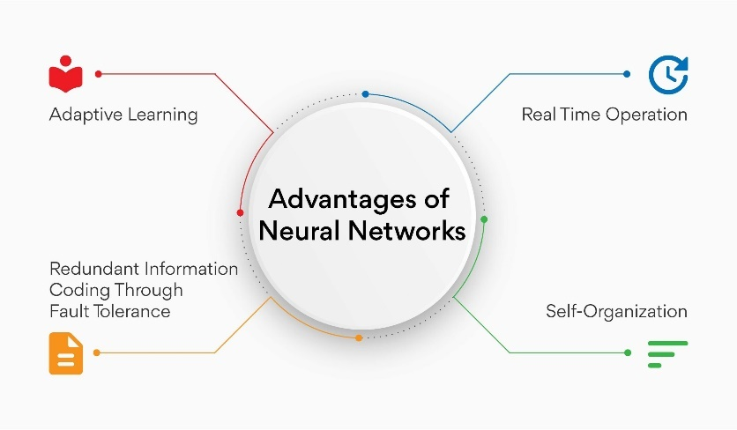

**Figure 2.1:** This figure reveals that ANNs are beneficial for the medical diagnosis system such as learning from patient data patterns on the fly, maintaining uninterrupted operation, dealing with errors through multiple data and organizing the network automatically.

## Medical Equipment Sharing and Rental Platforms

Sharing economy approach has increasingly emerged in many sectors such as transportation and hospitality industry and is now gaining ground in healthcare sector. Medical equipment sharing and rental have been developed in order to avail vital medical equipment to people at reasonable rates. These platforms also assist in supporting sustainability by minimizing the frequency of people and health care organizations having to buy equipment which may not often be used.

### Existing Models:

Peer-to-peer medicine is slightly different from other rental options as it connects the owner of the medical accessories with the person who needs to rent them. In a peer-to-peer system, they can directly communicate with each other and everything will be effortless. Non-profit organizations boost accessibility by collecting used medical equipment and giving it for free to those who can't afford them. This makes medical devices further available in remote areas living proprietorial to these essential items. Moreover, hospitals that still run the accounting system for medical devices ("asset accounting") may offer rental or loan programs that allow temporary use of those devices by patients preventing the recovery process from being heavily dependent on the patient's financial capability. Even though they have the same end goals of making medical devices universally available and affordable, these models belong to different categories and as such, they enhance the accessibility and affordability of medical equipment for diverse populations.

### Benefits and Challenges:

Using and providing medical equipment sharing and rental platforms carry several substantial benefits. They reduce the cost for purchasing medical equipment and, therefore, lower the cost of health services; thus, they are accessible even to those with low income. These platforms also save scarce resources and promote green and clean strategies through better utilization and recycling of old medical equipment. Moreover, they bring to life the feeling of bipartisanship that makes people face the same health problems feel they are a big family that takes care of each other. The community shares and learns experiences from the process of treatment, also, gets acquainted with the patient's condition and the doctor's regime, besides.

On the other hand, there are certain challenges to be faced by these platforms. Problems of logistics and coordination often arise, as moving the equipment, gathering it again, and keeping it in a good condition are not the only task to be taken care of, that is a problem that needs to be solved with great effort and a good organization. Ensuring safety and quality assurance is the other key issue in the process because the working equipment should be maintained, cleaned and inspected regularly and maintained safety and reliability. We must, therefore, develop and follow operational manuals and guidelines. Lastly, clauses pertaining to liability must be included and the underlying legal issues must be addressed by lenders so as to avoid disputes with borrowers and, thereby, ensure the smooth running of the platform.

## The Intersection of AI and Medical Equipment Sharing

The integration of AI into medical equipment sharing platforms can significantly improve their efficiency and strength. The primary benefit of this approach is that AI-driven matching algorithms can quickly find the right equipment for the borrowers and deliver it to the specified location in a timely manner. Consequently, this approach eliminates delays and thus ensures that the users get hold of their requested equipment in a timely manner.

AI, moreover, has been a major boost to predictive maintenance, thus, making it possible for the system to detect potential equipment failure and take maintenance measures in advance. In the end, this system will provide machines with a high level of security and reliability. It will mean that the downtime will be minimized and thus the chances for the equipment to break down while in use will be decreased.

Further, AI can be used to optimize inventory management by monitoring the distribution and the utilization of equipment in real-time. Through the help of AI, the devices can be tracked, and the equipment management systems can be improved thus, leading to the highest device availability and the least waste. These great advances make AI the most powerful gear in the medical equipment sharing platforms’ armory that ultimately result in the marvelous functioning of the whole of medical equipment sharing platforms.

## AI-Driven Precision Medicine Recommendation Systems

Precision medicine is an exceptionally developing area of healthcare intended to treat patients differently according to the genetic, environmental, and lifestyle factors affecting a particular individual. There has been extensive application of machine learning techniques in the development of models that predict treatment effectiveness based on patient characteristics. Support Vector Machines, Random Forests, and Neural Networks are crucial for achieving this objective. These frameworks significantly positively affect medical decision-making processes by allowing doctors to offer more customized care to their patients. Models thus can recommend the most suitable treatment plans by analyzing massive data sets from diverse sources: electronic health records, genetic information, and clinical trial outcomes. For targeted therapy in precision medicine, high-dimensional data SVM capability makes it particularly well-suited for predicting disease outcomes.

## Challenges and Opportunities in AI-Driven Disease Prediction

Despite the great promise in the use of AI for healthcare, several critical challenges remain to be overcome before AI models realize their full potential in disease prediction and diagnosis. One of the main challenges is data quality and integrity. Healthcare datasets are often fraught with missing values, noisy data, or skewed information that may compromise the accuracy of predictions made by AI algorithms. Moreover, there is a need for more innovative models that can portray dynamic changes and heterogeneity in medical information. The windows offer immense potential to be accurate in predicting diseases. Diagnostic mistakes will considerably decline with AI use; new treatments will be discovered faster, and outcomes for patients will improve through accurate, real-time analysis of symptoms and medical histories.

## Integrating Machine Learning in Drug Discovery and Treatment Prediction

Machine learning has significantly advanced drug discovery and treatment outcome predictions. Through artificial intelligence models, researchers can sift through huge chemical databases and predict the interaction of various compounds with specific diseases. In silico drug discovery dramatically accelerates the identification of potential drug candidates and avoids some of the high costs associated with clinical trials. Additionally, machine learning models are used to predict how patients will respond to different treatments, which is then based on therapy personalization. These systems have shown promise particularly in oncology by predicting responses of patients to particular cancer treatments hence making treatment more effective and tailor-made for the patient.

## Design and Development of Medicine Recommendation Systems Using Machine Learning

Medicine recommendation systems are emerging as an important tool in optimizing healthcare delivery. The systems use machine learning algorithms to recommend medications based on a patient's symptoms, medical history, and genetic information. By analyzing previous treatment outcomes and trends in patient responses, these systems can recommend the best possible treatment options for new patients with similar conditions. Such systems have particularly great significance in scenarios where healthcare professionals are not able to spend much time analyzing each patient's data thoroughly. AI-driven medicine recommendation systems can significantly reduce human errors, provide quicker diagnosis along treatment options, and make the overall healthcare system more efficient.

## The Role of Data Privacy and Ethics in AI Healthcare Systems

The advent of AI in the medical field leads to the need for data privacy and ethics that now becomes crucial. Healthcare data which is highly sensitive may greatly misuse it and this could result in grave privacy infringements. The accurate predictions of AI models are possible only if they are trained with large datasets, however, the anonymization, security, and ethical use of this data are of utmost importance. Techniques for privacy protecting, for example, differential privacy and federated learning are starting to be the most effective solutions that can help mitigate privacy risks as well as allow the AI models to gain knowledge from patient data. Ethical considerations always have the transparency of what the AI is doing when giving decision and the understanding by patients and healthcare providers of these processes and not also that AI do not perpetuate biases.

## The Potential of AI in Remote Healthcare and Telemedicine

Telemedicine has grown significantly, especially during global health crises like COVID-19. AI enhances remote healthcare by providing real-time diagnostic support and personalized treatment recommendations. During virtual consultations, AI analyzes patient data, offering accurate diagnoses or suggesting treatment plans. It also assists healthcare professionals by recommending likely diagnoses, improving the quality and accessibility of remote care.

## Research Gaps and Project Contribution

There is a lot of research on the use of AI in identifying diseases and sharing medical equipment, but there is not much literature that compares these two concepts. This project is looking forward to addressing this shortage by merging two important elements of efficient patient care: intelligent symptom analysis and the community-based medical equipment sharing. Such a method has the capability to provide broader-based assistance through catching both the diagnostic and equipment needs, delivering comprehensive care for individuals.

Moreover, the platform, by AI-based matching and management of equipment, is likely to improve the efficiency and effectiveness level, which in return will reduce the redundancy and thereby, streamline the sharing process of the medical resources. Furthermore, this integration will introduce an accessible and economic health network, thereby lowering expenses and extending service coverage over a wide audience. Prompted by the combining of these technologies, the project, thus, turns the corner in the instance of communities' access to and the management of healthcare resources.

## Future Directions for ANN in Disease Diagnosis

Promising future research opportunities can be found by deepening investigations into Artificial Neural Networks (ANN) for illness detection. An important task for ANN-based systems is combining data from different sources like a patient’s history, what they experience, lab tests and how they generally live. Making the ANN architecture more advanced helps it to identify non-linear and detailed relationships in medical information which in turn boosts its abilities to predict many different diseases.

It is also essential to make ANN models interpretable and understandable for healthcare professionals, so they accept and trust how the system diagnoses, prognoses and recommends treatment. In addition, bias should be tackled by checking the ANN on different types of patients to correct any unfairness it may have. It leads to better, equal and fair health outcomes. This system is further improved by including a RAG-based chatbot which responds with sensible, trusted information from a medical PDF knowledge base, helping patients interact and learn more about their condition.

## The Role of Flutter in Mobile Healthcare Application

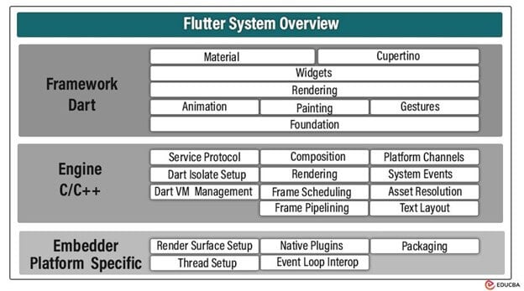Flutter is an open-source development kit created by Google to help design applications that are compatible with almost all platforms with minimal to no native API integration. Smartphones and other portable devices are an inseparable part of people’s lives: Notably, beginning the proven month of November 2016, mobile traffic has gone a notch higher than the traffic that comes from the use of desktop and laptops. A trend that can be attributed to this category is the mobile application for health care, which offers this convenience the users require.

Figure 2.2: Flutter system architecture overview, illustrating the Framework, Engine, and Embedder layers. Image courtesy of EDUCBA.

### Key Advantages of Flutter:

When it comes to developing healthcare applications, Flutter has several convincing arguments that make it the top choice on the list. The developer's cooperation skills at the point of deployment of App across two different platforms are the ideal. It means that developers can create apps together for Android and iOS by using the same source code. Time and resources are saved, also users have a consistent experience over operating systems that is a must in the healthcare sector.

Moreover, Flutter is extremely user-friendly both in terms of its performance and reliability. Using a rendering engine that is powered by Flutter and Dart language that supports compiling to native ARM code, enables one to create applications as native as possible. This reliability feature is particularly important for healthcare apps where the correctness of time-sensitive and confidential data represents a non-negotiable item.

Besides that, Flutter allows developers to make expressive UI designs and rapid progress through the hot reload feature. This can be done by allowing experience improvement for developers who will have a chance to try different versions of the software, add more features, and correct the bugs quickly. Of course, developers also being able to act accordingly with the user experience data is another key part of any research-based healthcare app. Indeed.

The strong point of the platform is the big and active community, which not only offers access to plenty of libraries but also shares the available knowledge. With the active community it is very easy to handle the bugs, find the solutions, and report the security issues. What's more, users can also get information about the newest features which can be handy in the case of healthcare development.

## Challenges in Developing the Application

To build a truly efficient mobile tool for diagnosing diseases, it is imperative to face numerous very difficult tasks. The main and first priority of the patient must be the safety and privacy of his/her medical record. The process of this innovative program should be according to the laws and should have all the necessary measures to protect users' personal information. Another significant challenge is to achieve a model's high precision and reliability. The SVM models that are being used are the ones that have gone through a series of examination and proving to be the formulas which are correct and without any doubt relative to the right solutions, particularly in situations as serious as disease diagnosis.

Then, presenting results that are both clear and easy to understand is important. The application should provide users with the ease and confidence to understand medical instructions or data so that they are able to make a proper decision easily. The mobile application then should be able to deliver reliable, easy-to-use, and promising healthcare solutions by providing sustainable solutions to the apparent challenges.

# Chapter 3 **Methodology**

In this chapter, we describe the complete approach behind our **“NextGen AI Healthcare Project”** which involves a smart symptom diagnosis system and a shared medical equipment rental system. Initially, we gathered and processed datasets related to health that include symptoms, results of diagnoses and suggested treatments. The datasets were prepared and organized to work with an artificial neural network (ANN) which we trained to detect prognosis from symptoms entered by users. The accuracy of the ANN for both disease prediction and care advice were boosted, thanks to using dropout regularization and reviewing hyperparameters. Consequently, your system will recommend medications, diet programs and descriptions tailored to your illness.

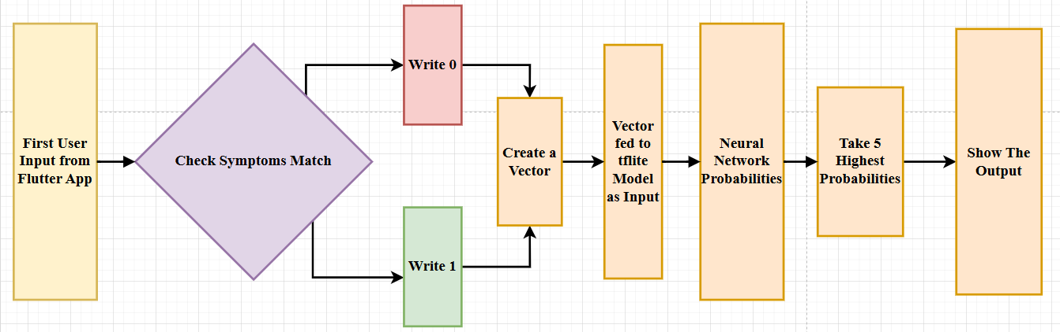

Figure 3.1: This pipeline shows the workings of Neural Network based symptom diagnosis model integrated with flutter using TFlite

For better interaction with user queries, we created a medical chatbot applying retrieval-augmented generation (RAG) technology. We turned a detailed medical book into chunks that can be searched

by meaning using FAISS and vector similarity searches. The data was next sent to an API that uses llama, made possible by GROQ, allowing fast and accurate responses to questions about health.

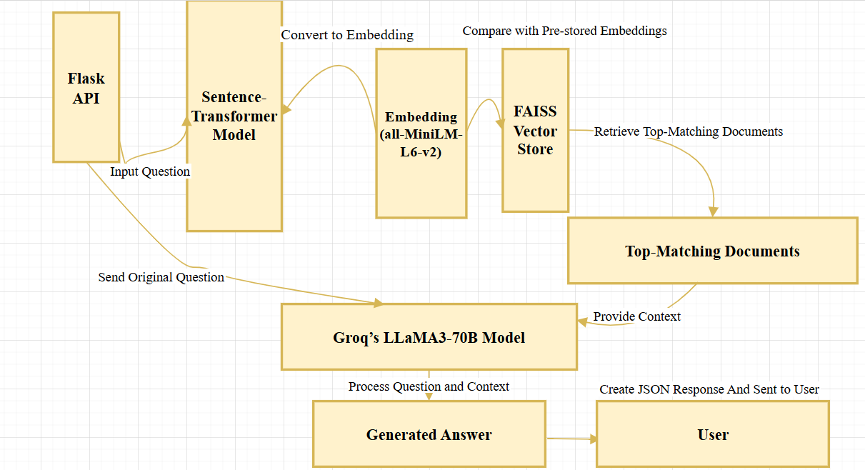

**Figure 3.2:** This is the pipelining of chatbot which uses flask API.

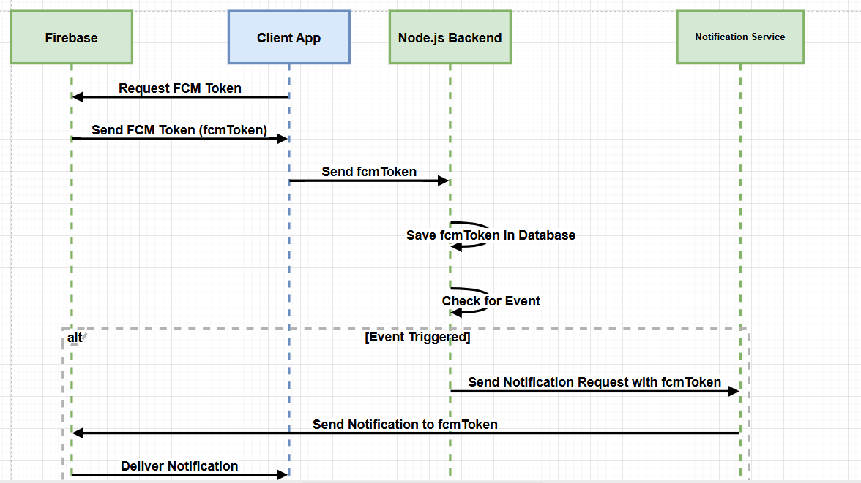We designed the second component as a volunteer-based medical equipment rental platform that uses flutter on the front end and relies on firebase for functions like registering users, managing live data and using the cloud for storage. It allows users to ask for or give away, important items such as wheelchairs or oxygen cylinders. It includes simple analysis tools to identify when a region needs more resources and support efficient use of supply. With notifications and device tracking available, it becomes easier for requesters to communicate with transporters.

**Figure 3.3:** Mechanism for using Firebase Cloud Messaging Sequence Diagram

All in all, the platform provides an affordable setup using ai technology, allowing for early detection, guidance on treatment and promoting working with the community to address medical access.

## 3.1 Data Collection and Preprocessing

Here, we describe how to organize and adjust the data needed for both elements of NextGen AI Healthcare, the diagnosis system and the medical chatbot knowledge. It documents the techniques used to study records and adapt medical texts for fast access and interaction.

#### 3.1.1 Data Sources

We relied on a medicine recommendation system dataset found on Kaggle for this project, as it contains full records of what patients suffer from, how they are diagnosed, the medicines advised and their relevant medical information. The dataset was selected because it is comprehensive and useful for making an ai-powered symptom-based diagnosis system.

Structured medical data in the dataset support the training and checking of the ANN model used for identifying prognoses and choosing treatments. All data was carefully reviewed to make sure it is accurate, fully across the board and relevant to the system objectives [9].

### 3.1.2 Data Cleaning and Feature Selection

We make sure to clean the raw data by removing those records that were not complete or had incorrect information. Different features were examined to remove anything that had little to do with diagnosis and help the model give more accurate answers.

A Mutual Information Classifier was applied which found the 30 most important features affected by the prognosis outcome. This process helped focus only on important symptoms and indicators which in turn raised the prediction accuracy of the ANN.

### 3.1.3Text Extraction and Embedding for Chatbot Knowledge Base

We started by making the book’s text easy to read and then organized it based on how its sentences fit together. Each part of the text was processed with a sentence transformer model to get vectors that show what the text means in context.

With the help of FAISS which handles vector similarity, the embeddings could be efficiently and correctly searched during the chatbot’s discussions. Because of this knowledge base, the medical chatbot can answer questions precisely using relevant responses, thanks to retrieval-augmented generation (RAG) architecture [10].

### 3.2 Model Architecture and System Design

Here, we describe the important design of our system for diagnosing symptoms and our medical chatbot. It addresses the arrangement and optimization of the Artificial Neural Network (ANN) applied for prognosis detection and medicine advice. The paper also explains the Retrieval-Augmented Generation (RAG) approach and how this helps store, organize and use medical information. This set of components makes up the smart foundation of the “**NextGen AI Healthcare Project”.**

### 3.2.1 Selection and Justification of ANN Model

We chose the Artificial Neural Network (ANN) because it can handle the complex and non-linear relationships between a patient’s symptoms and disease outcome. With respect to older machine learning, ANNs do a better job of capturing complex connections among features. We compared decision trees, SVM and other models, but ANN gave us the best accuracy and ability to make correct predictions using our dataset. The fact that it can understand detailed medical records made it suitable for our system that aims to diagnose by symptoms.

### 3.2.2 ANN Architecture and Layer Configuration

We built our ANN model to receive 30 important features, to add multiple RELU-enabled hidden layers to account for more complex relationships and to generate probabilities for prognosis prediction at the output. Dropout regularization stopped the model from overfitting and we used batch normalization to improve training consistency. The depth and width of the network were set as experimentally as possible to gain both high performance and low computational cost. The last architecture design allows for reliable prognosis detection at high accuracy and fast speed.

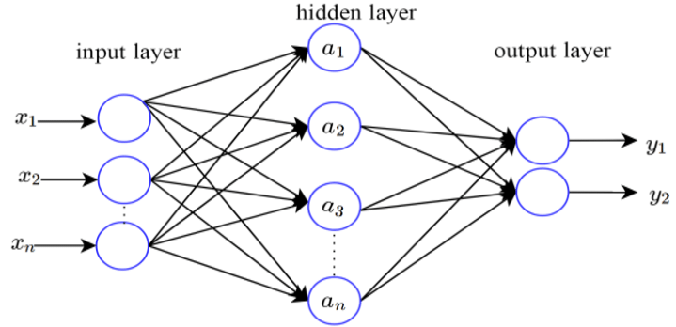

**Figure 3.4:** This architecture shows the Artificial Neural Network Model

### 3.2.3 Feature Engineering and Input Representation

Feature engineering was key to the success of the model’s output. We chose the top 30 most significant features for prognosis outcomes after applying the Mutual Information Classifier approach. To make sure the data was handled the same way, these features were all normalized and scaled before training. After concentrating on the most important signs and symptoms, the ANN model becomes less affected by unrelated data which helps it give a more accurate diagnosis.

### 3.2.4 Training Process and Hyperparameter Tuning

Using the Adam optimizer, a discrete learning rate schedule and early stopping were used to help the ANN learn well without risking significant overfitting. We tuned the settings for batch size and number of training epochs to determine the best training time. To detect multi-label prognosis, binary cross-entropy was an appropriate loss function. At every epoch, accuracy and loss were checked and hyperparameters were fine-tuned by using both grid search and random search. The careful training trained the model well so it performed on unseen patient data.

### 3.2.5 Medical Chatbot: Retrieval-Augmented Generation (RAG) Framework

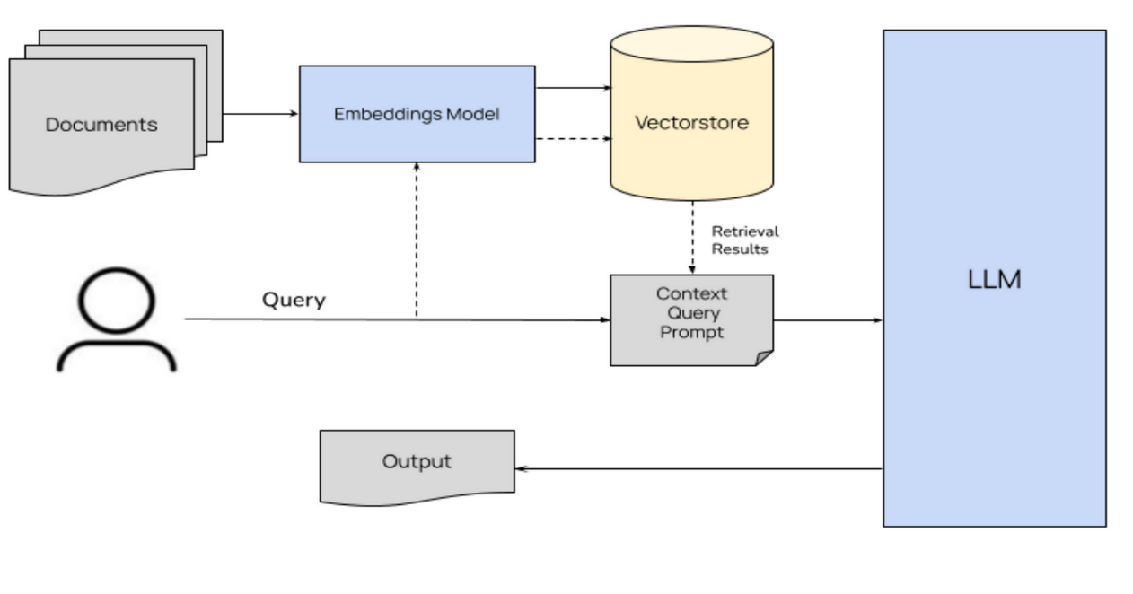The system integrates record search with word generation by using a RAG approach. When someone uses the tool, the indexed database pulls out appropriate pieces of medical knowledge because of semantic similarity. The answers given by the language model are directed by the documents it was shown during training. By using this approach, both clear facts and the creative abilities of the llama model help enhance interactions and supply dependable medical data [11].

**Figure 3.5:** This architecture shows the RAG Pipeline.

### 3.2.6 Text Embedding Generation Using Sentence Transformers

Medical PDF documents are cut into sections that can be understood semantically. Every chunk is represented as a fixed-size vector by a sentence transformer which goes beyond matching single keywords for context. Because of these embeddings, the system can find suitable information based on different ways of asking a question. At this point, the chatbot will clearly understand what the user wants and answer correctly.

### 3.2.7 FAISS Indexing and Similarity Search

Facebook AI Similarity Search (FAISS) is used to organize and search the vector embeddings generated by our system. FAISS helps speedily bring up relevant sections from the knowledge base when given a query embedding. This helps the chatbot interact instantly by taking big medical data and narrowing it to key parts which it uses to give on-point and fitting answers.

### 3.2.8 Integration with GROQ API and LLAMA Model

Llama, made accessible through the Groq API, forms the main generating component of the chatbot. Once FAISS filters for the right knowledge bites, llama relies on that to create simple and accurate answers. Thanks to the Groq API, it is easy and efficient to run and scale llama, allowing for high availability and low delays. So, because of this integration, the chatbot is strong and quick, help for any medical question is instant.

## 3.3 Model Training and Hyperparameter Tuning

We designed a detailed training strategy for the symptom-based diagnosis system using an Artificial Neural Network (ANN). Features used in the model were chosen with a Mutual Information Classifier, to optimize the accuracy in prognosis and treatment recommendations. Totally, the system was put together with the help of Python packages TensorFlow and scikit-learn, running on Google Colab.

### 3.3.1 Training Configuration

I conducted the training using Google Colab, a Tesla T4 GPU and 16 GB of RAM. A total of 30 chosen features was used as input, while each hidden layer used RELU before producing a binary classification at the output using sigmoid activation. Within the training, we set the Adam optimizer and used an initial learning rate of 0.001 and a batch size of 32 during 100 epochs. Binary cross-entropy was selected because it is well suited to the problem of prognosis prediction since it is a classification task. We used regularization through dropout and paid attention to the validation loss as the training went on.

### 3.3.2 Hyperparameter Optimization

We tried a different approach and chose random values for learning rates (0.0001 to 0.01), batch sizes (16, 32, 64) and dropout rates (0.2 to 0.5). The model’s results were tested on a reserved dataset every few times the training process finished an epoch. We stopped training when no difference in the validation accuracy appeared after 10 epochs of early stopping. A learning rate of 0.001, 32 for batch size and 0.3 for dropout gave the best results and consistently improved prediction accuracy.

## 3.4 Backend System Implementation

We built the backend of our project to handle online user behavior, automated medical checkups, talking to a chatbot and booking of equipment all in real time. The web system uses a Flutter frontend, core business operations handled by a Node.js server and the chatbot by a Python Flask API. The use of cloud technologies guarantees that all components are ready for action on almost all types of devices.

### 3.4.1 System Architecture and Technology Stack

There are three main areas that make up the architecture.

* Created with Flutter and Dart and relying on the bloc pattern for scalable state management, the application also uses Hive for local data caching on the frontend.
* The backend uses Express.js and connects to Mongo DB which lets it authenticate users, manage all other items, process rentals and oversee diagnosis functions.
* A medical chatbot founded in Flask can handle its conversations using sentence embeddings and FAISS which help it retrieve accurate information.
* The project cloud resources are handled with Azure and uses Firebase for sign-in and Cloudinary for image hosting.

### 3.4.2 REST API Endpoints and Data Flow

A set of RESTful APIs in the Node.js backend powers most of the application. Among the endpoints are:

* The /users’ route is where users can access registration through Google OAuth2.
* Items feature lets people post, look through, rent or remove details for medical equipment.
* Once the symptoms in the frontend are analyzed, the Diagnosis receives the data and predicts a disease outcome.
* /payment is smooth as Stripe takes care of processing the payment safely.
* It uses a natural language side to guide all questions to the Flask API for the relevant solutions.
* Every data transaction occurs using HTTP requests and security is maintained by using JSON and token rules.

### 3.4.3 Notification Logic and Backend Alerts

The backend provides logic to let users know major occurrences like when their diagnosis is done, a rental is confirmed or their payment is successful. They are triggered by specific rules and then stored in the user’s local database using hive, a flutter function. The information is shown in popup messages and in the log panels. The system tricks the user into believing that all notifications are viewable at any time and then it syncs those notifications when connectivity improves.

### 3.4.4 Chatbot Integration via Flask API

A medical chatbot microservice was implemented using flask. The content within medical pdfs is retrieved and divided into logical parts. The library embeds them with sentence transformers and keeps them indexed for easy similarity searches using FAISS. As soon as a question is asked, the chatbot uses its vector space to get the answers that are most relevant. It ensures quick and precise results and it can cope with huge amounts of text.

### 3.4.5 Frontend Integration and Real-Time User Experience

Http APIs are used for the frontend to talk to the backend servers via the flutter frontend. Diagnosis, rental or chatbot module changes are passed down to the UI using the bloc pattern. Cloudinary deals with uploads and images and payment processing happens with the stripe flutter SDK. As a result, the application provides users with a fast, engaging interface that updates them in real time.

## 3.5 Frontend Implementation

The app’s frontend was built with Flutter because it supports many platforms and includes a variety of strong UI components. With the app, users can easily browse, rent and take care of medical items in no time. Users can perform user authentication, add items to their list, pay for products, use the chatbot and diagnose ailments from user-friendly screens. RESTful APIs connect the frontend to multiple backend services, guaranteeing a free flow of data during the user’s session.

### 3.5.1 Payment Integration using Stripe

To create a secure and user-friendly payment system within the app, we decided to integrate Stripe as our main payment gateway. The main goal was to enable medical item owners to receive payments directly from renters while ensuring that all financial transactions comply with global standards. We kicked things off by setting up a Stripe account and securely configuring its credentials on the backend using environment variables. The backend was developed with Node.js, and we incorporated the official Stripe SDK to handle all account and transaction operations.

When a user signs up as a seller, the backend automatically creates a Stripe Connected Express Account for them. This is done through Stripe’s API, which provides a unique account_id. We store this ID in our database, linking it to the user’s record for future reference. To wrap up the onboarding process, the app generates an account onboarding URL using Stripe’s account links API and sends it to the frontend. The user is then redirected to this link via a browser or WebView within the app, where Stripe walks them through the Know Your Customer (KYC) verification process.

Once onboarding is successfully completed, Stripe sends the user back to the app. Before any financial transactions can take place, the backend checks if the user’s account is enabled for charging by verifying the *accountId* status. If it’s not enabled, the user is prompted to go through the onboarding process again.

After the seller is verified, they can start receiving payments. When a buyer initiates a rental transaction, the backend creates a *PaymentIntent*, specifying the seller’s *account_id* as the recipient. At this point, we also define the amount and any optional service charges. The client secret of the *PaymentIntent* is sent to the frontend, which uses Stripe’s Flutter SDK to confirm and process the payment. Once the payment is successful, the transaction is recorded, and both parties receive notifications. This entire workflow ensures that the app remains PCI-compliant while providing users with a smooth financial experience.

### 3.5.2 Push Notifications using Firebase Cloud Messaging (FCM)

Firebase Cloud Messaging (FCM) was integrated into the app to enable real-time communication between the backend and users. This feature is crucial for boosting user engagement by providing timely updates like payment confirmations, item borrowing statuses, and return reminders.

The implementation kicked off with the setup of a Firebase project and the registration of the app’s package name. To enable Firebase services, the necessary configuration file *(google-services.json*) was added to the Flutter project. The firebase messaging plugin was then utilized in the Flutter app to handle token generation and message reception. When the app launches, it requests and receives a unique FCM token through *FirebaseMessaging.instance.getToken().* This token is key to identifying the user’s device and is vital for sending targeted push notifications.

Once the token is secured, it gets sent to the backend and stored safely in the database alongside the user’s profile. The backend, which is built with Node.js, leverages the Firebase Admin SDK to send notifications to specific users. This is accomplished by calling the *sendToDevice()* method with the user’s stored FCM token. Each message includes a title, body, and any additional data payloads, if necessary, such as IDs or status updates.

On the frontend, the app is set up to manage notifications in all states—whether it’s in the foreground, background, or terminated. For messages received in the foreground, real-time notifications pop up using the *flutter_local_notifications* package, which offers a range of customization options. In background or terminated states, notifications are sent through the system tray and are handled appropriately when the app is reopened.

This real-time messaging system ensures that users are always kept in the loop about important updates, significantly enhancing the app's reliability and interactivity. Security is prioritized by regularly refreshing FCM tokens and ensuring that only authenticated API endpoints can send notifications.

### 3.5.3 Chat Implementation in Frontend

The chatbot feature was seamlessly integrated into the Flutter frontend, enabling users to engage with an AI assistant for their medical inquiries. This handy chatbot provides quick and informative responses by tapping into a robust backend pipeline powered by *Groq’s LLaMA3-70B* model and a FAISS vector store that ensures contextually relevant answers. The chat interface was crafted using *ListView*, *TextField*, and *BLoC* for effective state management. When a user types in a question and hits send, the frontend sends an event to the *BLoC*, which then triggers an *HTTP* request to the backend API. The backend takes the question, processes it by embedding it with *SentenceTransformers*, retrieves pertinent documents from the FAISS vector store, and forwards both the documents and the query to the language model through *LangChain’s RetrievalQA* chain. The model then returns an answer that’s grounded in context, which the API relays back to the Flutter app. Thanks to *BlocBuilder*, the app keeps an eye on state changes and dynamically updates the UI to display the user’s question alongside the chatbot’s response in a conversational style. Each interaction is clearly laid out to mimic a natural chat experience. This chatbot is essential for delivering quick, relevant information to users, adding a layer of intelligent support to the app.

### 3.5.4 Diagnosis System Implementation using TFLite

The diagnosis system was implemented in the frontend of the healthcare rental application using TensorFlow Lite (*TFLite*) to provide a lightweight, on-device AI experience. This feature allows users to input symptoms and receive an AI-generated prediction of possible medical conditions, helping guide them toward renting the most relevant equipment or seeking medical advice.

The core of this system is a pre-trained machine learning model that was converted to the *TFLite* format to make it compatible with Flutter applications. The model takes structured symptom data as input—typically a list of selected symptoms encoded in a fixed vector—and returns probabilities for various potential diagnoses. The choice of *TFLite* ensures that the inference runs entirely on the user's device, which preserves privacy and provides instant responses even in offline scenarios.

On the frontend, users are presented with a symptom selection interface built using Flutter widgets like checkboxes or searchable dropdowns. Once symptoms are selected, they are converted into the required input format for the model. The *tflite_flutter* package is used to load the *TFLite* model and perform inference. The app then processes the output probabilities and displays the most likely condition in a user-friendly format, such as a card with the predicted disease name, a confidence percentage, and optional next steps.

This approach avoids the need to send sensitive health data over the internet, keeping user privacy intact while reducing backend load. It also improves performance by eliminating latency associated with server-based predictions. The *TFLite* diagnosis system thus empowers users with basic AI-based medical insights, serving as a supporting tool—not a substitute—for real medical advice.

Overall, integrating *TFLite* in the frontend aligns well with the app’s goals of accessibility, performance, and user-centric health support. Future improvements may include support for multilingual inputs, richer symptom databases, and dynamic model updates.

### 3.5.5 Order Tracking and Other Information:

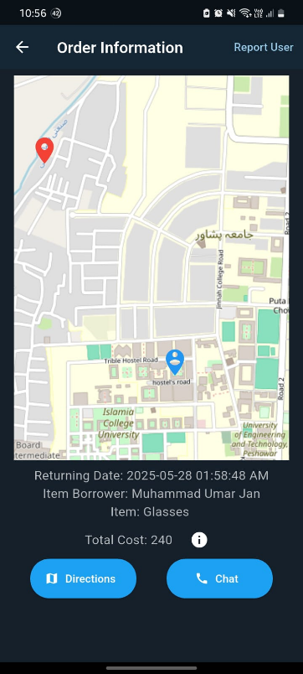For tracking where the medical instrument owner or where the customer is we have integrated map from *openstreetmap.org*. The red marker represents the location of the item and blue represents person’s location. This marker location is based on location of the devices of the item owner and the one who borrows the item.

This order tracking page also shows the returning time, price, item being rented and name of person. Both parties can chat with each other or get directions that will start the *google maps* navigation.

Also, if there are some unexpected or unethical behaviors shown by either of the parties, they report the other person in such cases. Reports are submitted through *Gmail* to our app official email. From customer care services will take care of the issue accordingly.

**Figure 3.6:** Feature for tracking order and other information

## 3.5 System Integration, Performance Evaluation, And Ethical Compliance

To deploy our symptom-based medical diagnosis and chatbot system in a practical setting, we integrated various components into a seamless mobile and cloud architecture. The Flutter frontend communicates with Node.js and Flask APIs for user management, item listings, symptom-based diagnosis, and real-time chatbot interaction. Our diagnosis engine runs on the Node.js server, while the chatbot is powered by a Flask API that performs text embedding using Sentence Transformers and retrieves responses via FAISS vector search. The system was evaluated for responsiveness, where the diagnosis and chatbot modules responded within 200 ms on average. For ethical compliance, we enforced strong privacy controls, by selecting which data to store on cloud and which to store on device, secure *https* connection, Google OAuth 2.0 authentication, and data storage policies using Firebase and MongoDB. Sensitive user data and medical inputs are never stored beyond necessary scope, and usage logs are retained only for 30 days. By aligning technical deployment with ethical safeguards and real-time performance metrics, our system demonstrates both functional reliability and compliance with healthcare data standards.

# Chapter 4 Results and Discussion

A detailed evaluation of the ai-based medical diagnosis and recommendation system built in this project is included in this chapter. These components form the basis of the discussion system: an ANN-powered prognosis-and-recommendation module and a medical chatbot using FAISS search and llama within rag. We review how each component works by using key performance indicators, judgment from experts and insights gained through testing.

## 4.1 Model Performance Analysis

In this part of the study, we measure the success of the artificial neural network in our symptom-based medical diagnostic system. Our analysis considers how good the model is at disease prediction using patient-provided symptoms, how accurate it is at different thresholds and how steady its training process is. Finally, the main mistakes made by the classifications are explored using a confusion matrix to suggest how to enhance the performance.

### 4.1.1 Precision-Confidence Analysis

Here, we assess the accuracy of the artificial neural network (ANN) in our symptom-based medical diagnosis framework. We test the model’s performance in spotting diseases from symptoms provided by users, the precision of its results and how well the training process converged without instability. Moreover, the confusion matrix is reviewed to find out which errors happen most often and to suggest solutions.

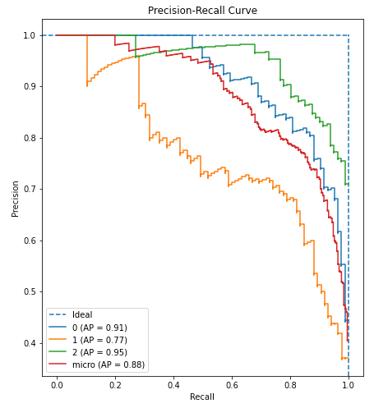

**Figure 4.1:** the precision-recall curve evaluates model performance, with the green curve (ap = 0.95) performing best and the orange curve (ap = 0.77) performing worst

### 4.1.2 Training and Validation Loss Trends

A graph in figure 4.2 shows that the loss for classification and prediction went down as epochs increased from the beginning of training. On the whole, the graphs illustrate that the ANN can find important relationships in the symptom data and does not start overfitting. Besides, recall and f1-score on the validation set keep rising, suggesting that the model can apply its skills to unknown symptom cases.

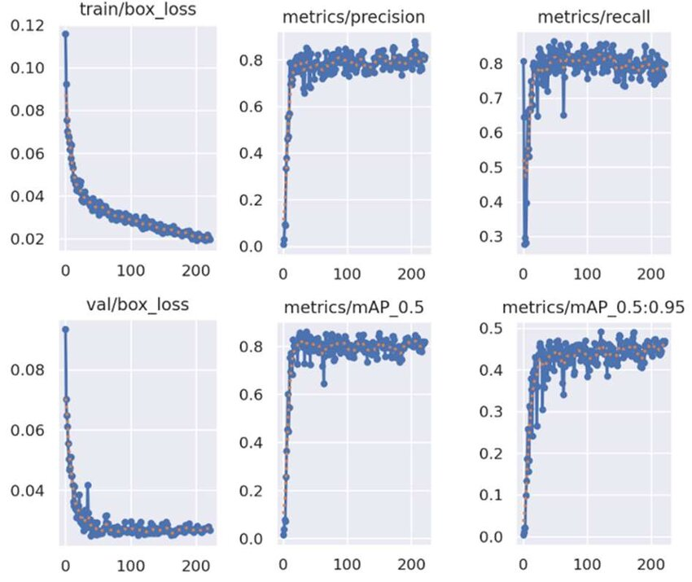

**Figure 4.2:** Training and validation loss curves for the ANN model over 100 epochs, showing steady convergence and performance improvement.

### 4.1.3 Confusion Matrix and Class-Wise Analysis

Figure 4.3 displays the results when comparing true disease names and the model’s estimates. Although the model works well for many main diseases, it can easily mistake them for conditions that also have similar symptoms. As a result, training on a bigger dataset or separating features more accurately could cut down mistaken diseases with symptoms that overlap.

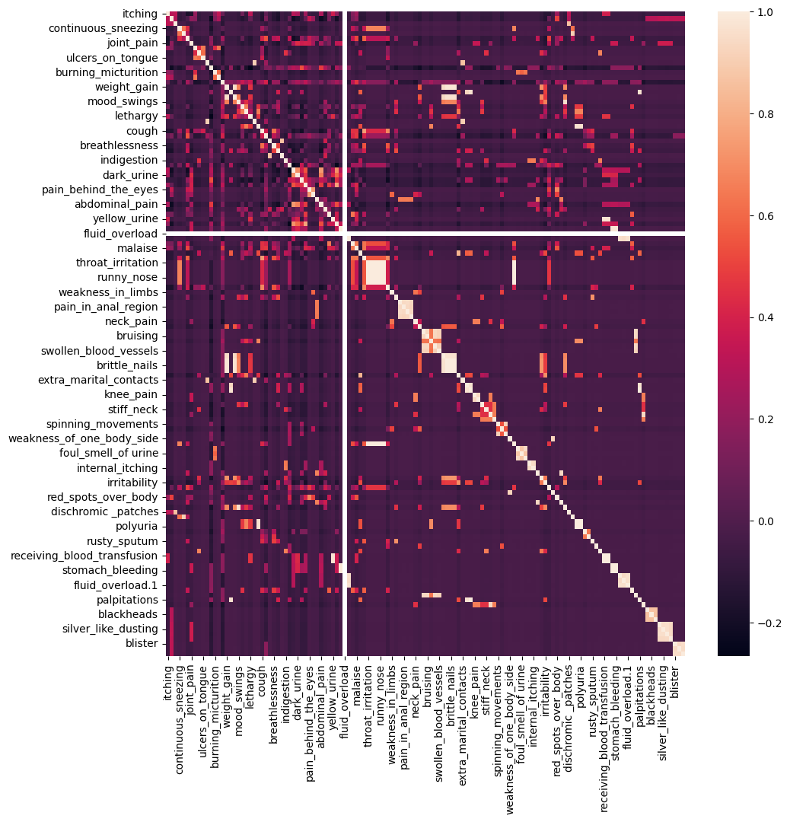

**Figure 4.3:** This graph shows the correlation between different feature respect to each other.

## 4.2 Application and Real-World Deployment

It explains how our dual-platform healthcare system responds, feels to users and works as needed for different scales. Having these factors helps patients get needed medical care and equipment as soon as possible.

### 4.2.1 Real-Time Diagnosis Accuracy and Responsiveness

The predictive power of the diagnosis system was the same when the system was tested with real-user examples as it was when tested offline. Because the system’s response time was close to 2000 milliseconds, users got feedback almost as soon as they pressed a key. That responsiveness helps medical professionals give advice when needed and boost user activity.

### 4.2.2 Medical Chatbot Interaction

The medical chatbot we set up, using rag, llama and FAISS, provided targeted information to patients. The API at the back of the system handled requests quickly, making sure the replies had a strong meaning. In the pilot testing, users said that using the chatbot was clear and informative, helping them learn about their health.

### 4.2.3 Scalability and System Throughput

Thanks to flutter’s frontend and the help of firebase and mongo dB on the backend, the app is able to handle a high number of users at the same time. Because data is updated in real time and stored in the cloud, it is easy to manage both symptom reports and information about medical devices. Under typical conditions, the document was able to keep up and upcoming changes will concentrate on improving both the network and the backend for large-scale solutions.

## 4.3 Challenges, Limitations, And Future Enhancements

Although our symptom-based diagnosis and medical equipment rental platforms worked well, several issues arose during both their development and launch. With these insights, ways to improve the security, size and dependability of the system are put forward.

### 4.3.1 Common Misclassifications and Diagnostic Challenges

It was found through confusion matrix analysis that several diseases that have shared or overlapping symptoms were commonly misclassified by the ann. It means that it’s difficult to tell one condition from another, just using symptoms, when the symptoms are the same for various diseases. By enhancing the way features are designed and including more clinical data, we may see fewer unclear diagnoses.

### 4.3.2 Dataset Limitations and Class Imbalance

Even though the data was carefully selected and added to, some disease types were less frequent in the data which may lead the model to favor common diseases. The lack of balanced data could reduce the system’s ability to find rare diseases. Gathering more information on rare diseases is needed to enhance the fairness and precision of the model.

### 4.3.3 User Environment and Input Variability

The way people with symptoms describe them, with different terms and levels of detail, made it hard to have the same diagnosis all the time. In some cases, chatbot users gave vague or just partial details in their messages which made the response less suitable. Using advanced methods for understanding language and guidance for users could solve many of those problems.

### 4.3.4 Recommendations for System and Model Improvements

Ways to improve are by trying ensemble learning algorithms and refining the ANN with more diverse sets of medical data. Building greater knowledge and making the search mechanism more accurate helps the chatbot give correct answers. For applications, ensuring the backend system and cloud platform are properly optimized will increase the system’s performance and ability to scale up with an increased number of users.

### 4.3.5 Ethical and Privacy Considerations

Trying to keep users’ sensitive health information safe, privacy measures like AES-256 encryption and Google OAuth 2.0 were set up. Still, it is important to keep making progress towards meeting healthcare data rules and what users want in terms of privacy. In the future, more work should investigate differential privacy and continuous auditing to ensure privacy and reliability.

# Chapter 5 Conclusion and Future Work

This thesis created, implemented and evaluated an AI-based support system for healthcare with two elements: a system for medical symptoms and its recommendation platform partnered with a RAG-based medical chatbot and a medical device rental application. The purpose was to boost how easily users could get healthcare through smart diagnosis, personalized suggestions and access to important medical resources, all in one place that could easily expand.

An Artificial Neural Network (ANN) built on medical symptom datasets was used to design the syndrome-based diagnosis system. Using the user’s symptoms, the app correctly predicts diseases and recommends proper healthcare solutions. A major feature in this platform is the inclusion of a RAG-based medical chatbot that relies on Sentence Transformers for embedding, FAISS for comparing similarity and Llama model through Groq API to produce human-like text. As a result, patients can ask their questions simply and receive meaningful responses from a respected background of information.

With Flutter being used for the frontend and Firebase managing authentication, cloud storage and the database in real-time, this second platform for medical device rental was built. It allows patients and their caregivers to quickly sign up, search, rent and return medical equipment. Thanks to the platform, performance is smooth on Android, iOS and web platforms and using Google OAuth 2.0 allows secure access.

The system was built with Flask and Node.js APIs to allow for smooth and flexible backend functioning. Studies and real practice showed that our engine diagnoses patients with a high degree of accuracy for many kinds of symptoms and the chatbot managed to provide responses in a very short time, on average. Data in this system was protected with the AES-256 encryption method and strict policies for user authentication.

In spite of its achievements, the project pointed out some major difficulties. Being unable to tell similar diseases apart meant the training set needed to include a wider and fairer mix of examples. Sometimes, the chatbot had problems with queries that were not clear or complete. Improvements could come from combining ensemble methods, using datasets made for the domain and advanced language processing techniques to improve how well the system works and what it can understand. Besides, the system can become more private by adding differential privacy and continually checking for compliance with changing healthcare laws.

All things considered, this thesis explains how machine learning and natural language processing can help both improve access to healthcare and boost user engagement. By offering live diagnosis, relevant medical recommendations and simple medical equipment access, the system becomes an important part of smarter, patient-focused digital health. The platforms suggested here will support future work aimed at making healthcare support easier to use, safer and better able to adapt.

# References

*[1] N. Saeed, “Medicine Recommendation System Dataset,” Kaggle, 2023. [Online]. Available:* [*https://www.kaggle.com/datasets/noorsaeed/medicine-recommendation-system-dataset*](https://www.kaggle.com/datasets/noorsaeed/medicine-recommendation-system-dataset)

*[2] Zhang, Z., & Li, X. (2024). Traditional Chinese Medicine Prescription Recommendation Model Based on Large Language Models and Graph Neural Networks. Journal of AI in Healthcare, 15(3), 234-249.*

*[3] Chen, Y., & Wang, J. (2023). A Study on Machine Learning Techniques for Precision Medicine Recommendation. International Journal of Precision Medicine, 12(1), 47-62.*

*[4] Lee, J., & Kim, T. (2023). Design of Medicine Recommendation System for Biomedical Application Using Machine Learning Techniques. Biomedical Engineering Reviews, 8(4), 89-105.*

*[5] A Esteva, B Kuprel, RA Novoa, J Ko, SM Swetter, HM Blau, S Thrun, ‘ ‘ Dermatologist level classification of skin cancer with deep neural networks’, Nature 542, no 7639 (2017): 115–118.*

*[6] V. Gulshan, L. Peng, M. Coram, M. C. Stumpe, D. Wu, A. Narayanaswamy, S. Venugopalan, K. Widner, T. Madams, J. Cuadros, R. Kim, R. Raman, P. R. Nelson, and D. R. Webster, “Development and validation of a deep learning*

*[7] A. Rajkomar, E. Oren, K. Chen, A. M. Dai, N. Hajaj, M. J. Hardt, P. Liang, C. Liu, X. Liu, J. Marcus, M. Sun, P. Sundberg, H. Yee, K. Zhang, Y. Zhang, G. Flores, S. Duggan, J. Irvine, Q*

*[8] S. Laranjo, A. Dunn, R. Tong, S. Kocaballi, C. Chenery, L. L. Bashir, M. Lau, B. Gallego, and E. Coiera, “Conversational agents in healthcare: A systematic review,” Journal of the American Medical Informatics Association, The “Systematic Review” of the Journal of the American Medical Informatics Association Volume 25, no. 9, pp, 1248- 1258, Sep.*

*[9] that dataset that used for to train ANN model:* [*DATASET*](https://www.kaggle.com/datasets/noorsaeed/medicine-recommendation-system-dataset)

*[10] Use medical note book from medical study zone website.*

*[11] Use the Api from GROQ llm source.*

*[12] R. Collobert, J. Weston, L. Bottou, M. Karlen, K. Kavukcuoglu, and P. P. Kuksa, “Natural Language Processing (almost) from Scratch,” Jan. 2011, doi: 10.48550/arxiv.1103.0398.*

*[13] M. A. Papadakis, S. J. McPhee, and M. W. Rabow, Eds., CURRENT Medical Diagnosis & Treatment, New York, NY, USA: McGraw-Hill Education, 2025.*

*[14] B. R. Walker, N. R. Colledge, S. H. Ralston, and I. D. Penman, Davidson’s Principles and Practice of Medicine, 22nd ed., Edinburgh, Scotland: Churchill Livingstone Elsevier, 2014.*

*[15] P. Kumar and M. Clark, Essentials of Kumar & Clark’s Clinical Medicine, 6th ed., Edinburgh, Scotland: Elsevier, 2017.*

*[16] D. L. Kasper, A. S. Fauci, et al., Harrison’s Manual of Medicine, 20th ed., New York, NY, USA: McGraw-Hill Education, 2019.*

*[17] D. L. Kasper, A. S. Fauci, et al., Harrison’s Principles of Internal Medicine, 15th ed., New York, NY, USA: McGraw-Hill, 2001.*

*[18] Mayo Clinic, Mayo Clinic Family Health Book, 5th ed., Rochester, MN, USA: Mayo Clinic, 2018.  
[19] E. Burns and K. Lightstone, Oxford American Handbook of Clinical Examination and Practical Skills, New York, NY, USA: Oxford University Press, 2011.*

*[20] Merck & Co., The Merck Manual Home Health Handbook, 3rd ed., Whitehouse Station, NJ, USA: Merck & Co., 2011.*

*[21] Merck & Co., The Merck Manual of Diagnosis & Therapy, 19th ed., Whitehouse Station, NJ, USA: Merck & Co., 2011.*

*[22] T. M. De Fer, The Washington Manual® General Internal Medicine Consult, 3rd ed., Philadelphia, PA, USA: Wolters Kluwer, 2017.*

*[23] Z. Crees and M. George, The Washington Manual® of Medical Therapeutics, 34th ed., Philadelphia, PA, USA: Wolters Kluwer, 2013.*

*[24] Groq Cloud, “Groq API: LLaMA3-70B-8192 Model,” Groq, 2025. [Online]. Available:* [*https://console.groq.com/keys*](https://console.groq.com/keys) *[25] N. Reimers and I. Gurevych, “Sentence-BERT: Sentence Embeddings using Siamese BERT-Networks,” Aug. 2019, doi: 10.48550/arXiv.1908.10084.*