PurposeMint
Product Roadmap & Build Plan
React Native Mobile App + NestJS Backend + AWS Cloud Deployment

RN + NestJS + AWS  Production stack | 14-26 weeks  MVP roadmap | Updated Proposal v1.1  Primary source

Prepared as a Google Docs-ready roadmap document for sequencing discovery, foundations, authentication, core product workflows, payments, notifications, admin tooling, QA, and app store launch.
Generated: June 28, 2026

Creative Visual Roadmap Layer
The following visual dashboard and infographics were added to make the roadmap easier to scan, present, and defend in a university or client review setting while keeping the original technical material intact.
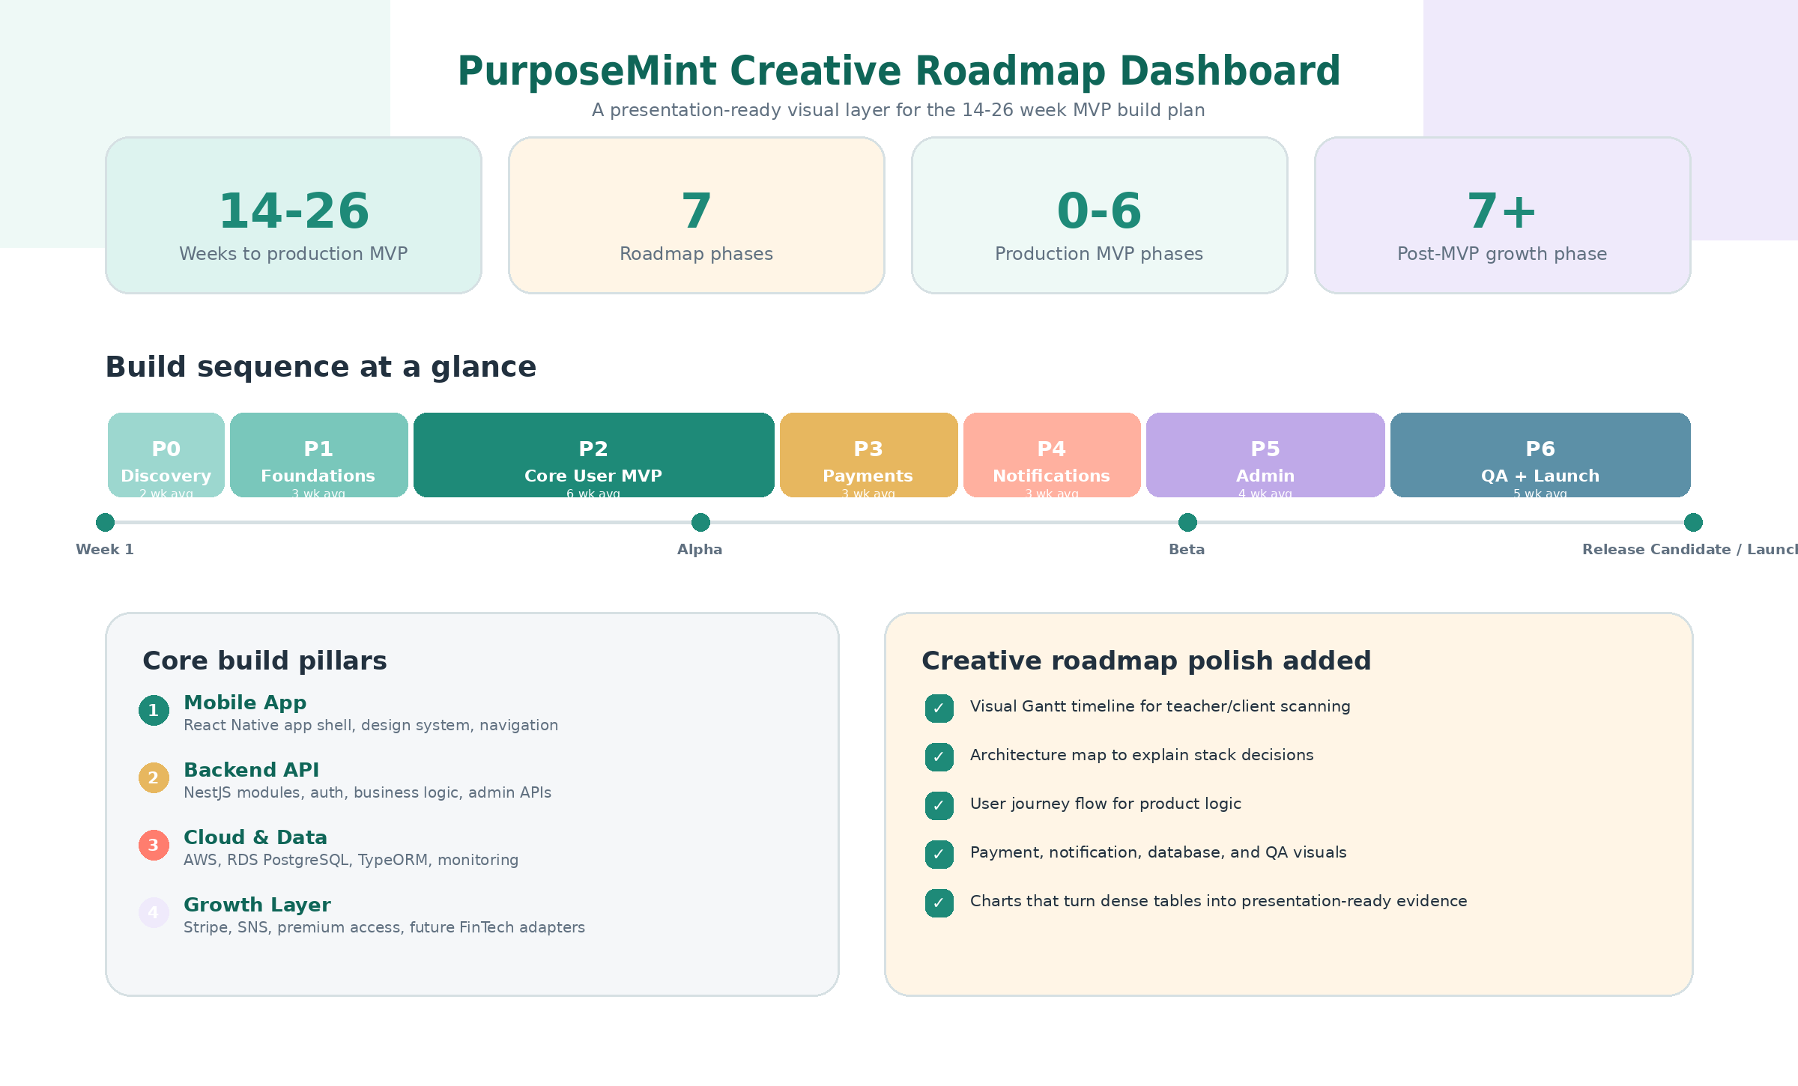
Figure 1. Executive visual dashboard summarizing timeline, phases, stack, and presentation polish.

1. Roadmap Purpose & Source Alignment
Primary Source Note
This roadmap uses PurposeMint_Technical_Prospectus_Proposal_Updated.docx as the controlling technical direction. Older no-code/prototype documents are used only as product-flow and design references. The production roadmap is therefore based on React Native, NestJS, PostgreSQL/TypeORM, AWS, Stripe, and Amazon SNS.

The goal of this roadmap is to turn the technical proposal, prototype workflow, design-screen direction, and data requirements into a clear build sequence. It explains what should be built first, what depends on it, how authentication and core modules should be ordered, and what should be included in MVP versus post-MVP expansion.

Source Documents Used
Priority | Document | How It Informs This Roadmap
Primary / correct | PurposeMint_Technical_Prospectus_Proposal_Updated.docx | Production architecture, timeline, stack, backend modules, database design, security, deliverables, QA, app store plan.
Reference | PurposeMint Prototype Development & Alignment Document.pdf | Original no-code MVP user journeys: onboarding, PurposeMap, goal/habit setup, micro-wins, journaling, upgrade, premium content, badges, admin.
Reference | PurposeMint Screen Design Draft / Product Content Reference | Design tone and product content: warm, affirming, culturally relevant, trauma-informed, beginner-friendly, pricing tiers, real-life goals, user pain points.
Reference | PurposeMint_Data_Requirements.pdf | Future data partner needs: open banking, payroll/income, credit attributes, macro/reference data, and financial education feeds.
Older / superseded | PurposeMint_Technical_Prospectus_Proposal.pdf | Earlier version of the technical proposal; superseded by the updated DOCX.

Roadmap Summary
PurposeMint should be built in a phased sequence: first finalize requirements and app store/payment decisions; then build the technical foundation; then implement authentication and the core behavior-change flow; then add payments, premium access, notifications, admin reporting, QA, and release operations. Advanced FinTech data integrations should be treated as post-MVP unless the client explicitly funds and approves compliance work early.
0-7  Phase count | Phases 0-6  Production MVP | Phase 7  Post-MVP growth

2. Product Vision & MVP Definition
PurposeMint is a values-led financial wellness and behavior-change product. It is not positioned as a traditional budgeting app only. The experience should help underserved users connect personal values, realistic goals, daily habits, reflections, encouragement, and premium support into one mobile-first journey.
Area | Roadmap Interpretation
Mission | Help underserved individuals align goals, values, and daily habits through financial literacy, personal development, behavior change, and culturally relevant design.
Experience tone | Warm, affirming, minimalistic, beginner-friendly, trauma-informed, non-judgmental, and visually simple.
Core user need | Users may feel overwhelmed, excluded, or judged by traditional finance tools. PurposeMint should make small wins feel achievable.
Core value | Turn values into realistic savings and habit goals, then reinforce progress through micro-actions, reflection, badges, and supportive nudges.

MVP Should Include
- Secure account creation, login, password reset or passwordless access, onboarding status, and user profile.
- Values quiz and PurposeMap(TM) output that maps selected values into suggested goals and habits.
- Goal templates, custom goal creation, real-life savings categories, habit setup, completion tracking, streaks, and progress bars.
- Reflection/journaling with mood score, history, emotionally intelligent prompts, and dashboard summaries.
- Badge system for first goal set, habit completions, streak milestones, challenge milestones, and premium-related achievements.
- Pricing screen for Free, Growth, and Elevate tiers, with Stripe subscription flow and backend entitlement enforcement.
- Premium content visibility rules for downloads, reports, challenge board access, coaching links, and gated tools.
- Push notification preferences, device registration, reminder nudges, quiet hours, badge unlock notices, and delivery logs.
- Admin dashboard for operational metrics, subscription states, support workflows, audit logs, and notification visibility.
- Store-ready Android and iOS builds, app privacy disclosures, account deletion/export flow, and release documentation.

MVP Should Not Depend On Unless Confirmed
- Open banking, payroll, credit, macro/reference, and news feed integrations unless client approves partner contracts, consent flow, compliance, and data-retention rules.
- FDIC-insured account functionality unless the banking/embedded-finance partner and product rules are finalized.
- Voice note reflections unless included as a paid scope item; text reflections and mood scale are enough for initial MVP.
- Advanced coaching/community operations unless content, moderation, scheduling, and admin workflows are defined.

3. Technical Stack & System Architecture

Architecture Diagram
This system map turns the technical stack into a simple visual architecture so non-technical reviewers can understand how the mobile app, backend, database, cloud, payments, notifications, and future integrations connect.
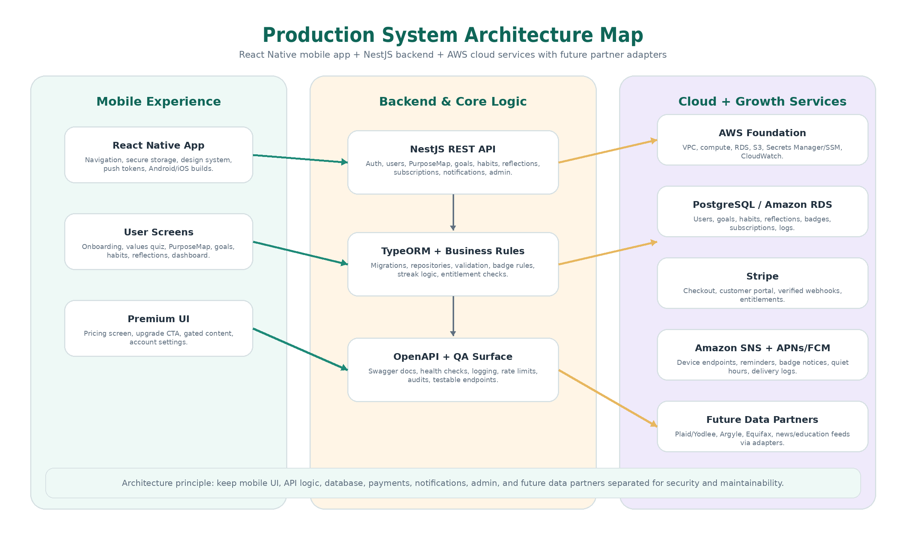
Figure 2. Production architecture map for React Native, NestJS, PostgreSQL/AWS, Stripe, SNS, admin, and future partner adapters.

Architecture Principle
Keep the mobile client, backend API, database, payments, notifications, admin functions, and future data partners separated. This makes the platform secure, maintainable, testable, and ready for future integrations.

Layer | Technology | Roadmap Responsibility
Mobile app | React Native | Cross-platform Android/iOS app, reusable design system, secure storage, navigation, push token registration, analytics hooks, store release builds.
Backend API | NestJS | REST APIs, authentication, authorization, profile, PurposeMap, goals, habits, journaling, subscriptions, notifications, admin, provider adapters.
ORM | TypeORM | Entities, repositories, migrations, transactions, seed data, database access patterns.
Database | PostgreSQL on Amazon RDS | System of record for users, values, goals, habits, reflections, badges, subscriptions, events, audit logs, notification tokens.
Cloud hosting | AWS | VPC, compute, RDS, S3, Secrets Manager/SSM, CloudWatch, alarms, CI/CD, optional CloudFront/WAF.
Payments | Stripe | Checkout, customer portal, subscription plans, invoices, webhooks, entitlement updates, payment audit trail.
Push notifications | Amazon SNS + APNs/FCM | Device endpoint registration, reminders, habit nudges, badge unlocks, subscription messages, delivery logs.
Distribution | Google Play + Apple App Store | Signing, metadata, privacy declarations, app review, TestFlight/testing tracks, staged rollout.

Production Architecture Build Order
- Create repositories and branch strategy for mobile app, backend API, infrastructure scripts, and documentation.
- Build AWS development/staging foundation first: networking, secrets, logs, RDS, backend compute target, and deployment pipeline.
- Create NestJS application skeleton with modules, configuration, validation, OpenAPI docs, logging, error handling, and health checks.
- Create PostgreSQL schema with TypeORM entities and migrations for users/auth first, then values/goals/habits/reflections/badges/subscriptions/notifications/admin logs.
- Create React Native app shell with navigation, environment configuration, design system, reusable components, secure storage, and API client.
- Implement authentication and user profile before core product modules so every feature has a reliable user identity and permissions model.
- Implement core MVP workflows in user journey order: onboarding, PurposeMap, goal setup, habit tracking, reflections, dashboard, badges.
- Add monetization and engagement after core flows: Stripe entitlements, premium gating, push notifications, and admin visibility.
- Complete QA, security hardening, release builds, privacy/legal assets, app store preparation, and staged launch.

4. Roadmap at a Glance

Timeline Gantt View
The Gantt-style visual makes the delivery sequence easier to understand than a table alone and highlights release milestones across the 14-26 week production path.
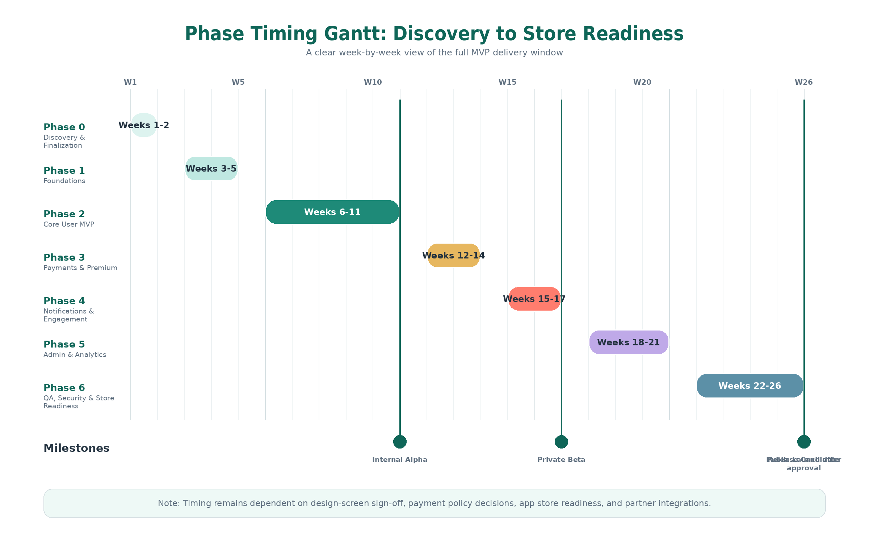
Figure 3. Phase timing Gantt view from discovery through release candidate.

Effort Distribution Chart
This chart converts the duration ranges into a visual planning view, showing which phases carry the most work and where the roadmap effort is concentrated.
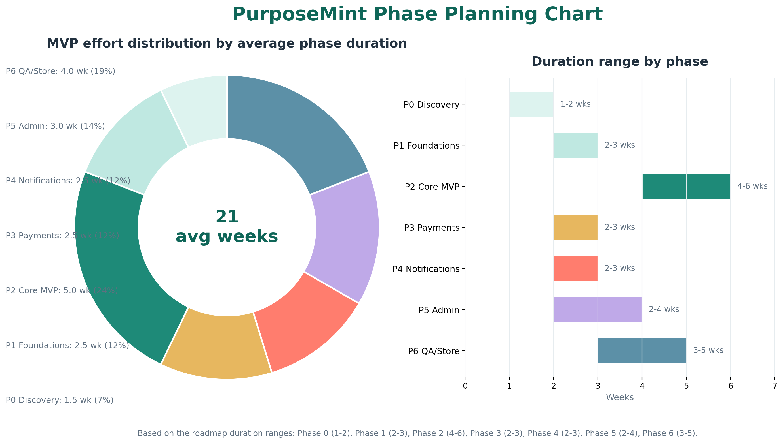
Figure 4. MVP phase effort distribution and duration ranges based on average proposed weeks.

The updated proposal estimates the production release in phases. Sequential planning below uses the full range from discovery through store readiness. Actual duration depends on team size, design-screen completion, payment policy decisions, app store readiness, and whether any partner integrations are pulled into MVP.
Phase | Timing | Focus | Main Outcome
Phase 0 | Weeks 1-2 | Discovery & Finalization | Final requirements, design screens without API integration, pricing, payment approach, compliance assumptions, release scope.
Phase 1 | Weeks 3-5 | Foundations | Repositories, CI/CD, AWS base infrastructure, NestJS skeleton, database schema, auth foundation, React Native setup.
Phase 2 | Weeks 6-11 | Core User MVP | Onboarding, PurposeMap, goals, habits, progress, journaling, dashboard, badges, user profile.
Phase 3 | Weeks 12-14 | Payments & Premium Access | Stripe checkout, customer portal, webhooks, entitlements, premium content gating, payment audit logs.
Phase 4 | Weeks 15-17 | Notifications & Engagement | SNS, device tokens, reminder preferences, habit nudges, badge notifications, quiet hours.
Phase 5 | Weeks 18-21 | Admin & Analytics | Admin dashboard, metrics, support workflows, notification/payment visibility, audit logs.
Phase 6 | Weeks 22-26 | QA, Security & Store Readiness | Testing, accessibility, performance, security hardening, release builds, App Store/Play Store submission.
Phase 7 | Post-MVP | Future FinTech Integrations | Plaid/Yodlee, Argyle, Equifax, macro/reference data, financial education/news feeds via adapter services.

Release Strategy
Milestone | Target Window | Definition
Internal Alpha | End of Phase 2 or early Phase 3 | Core app journey works on test devices with seeded data, but payments/notifications may still be in progress.
Private Beta | End of Phase 4 | Core journey, Stripe test mode, premium gating, and push notifications work in staging for a closed test group.
Release Candidate | End of Phase 6 | Production-like build passes QA, store metadata is ready, privacy/legal checks complete, monitoring and rollback plan are prepared.
Public Launch | After store approval | Staged rollout with crash monitoring, support process, analytics review, and launch issue triage.

5. Detailed Phase-by-Phase Product Roadmap

Phase 0 - Discovery & Finalization | 1-2 weeks
Objective
Convert the proposal, design-screen direction, prototype flow, and data requirements into final build requirements and a locked MVP backlog before engineering starts.

Workstream | Detailed Build Activities
Product scope | - Confirm MVP screens, user stories, feature priorities, and scope boundaries.  - Map the old no-code prototype flows into production modules without carrying over Glide/Airtable/Zapier as the production stack.  - Confirm Free, Growth, and Elevate tier benefits and entitlement rules.  - Define what is MVP versus post-MVP: banking, payroll, credit, macro/reference, and news feeds.
Design | - Create and finalize design screens for onboarding, values quiz, PurposeMap, goals, habits, dashboard, reflections, pricing, premium, notifications, settings, and admin basics as screen design only, without API integration.  - Lock visual direction: mint/cream/lavender/coral accents, rounded components, clear typography, trauma-informed messaging.  - Create empty/loading/error states and accessible copy for beginner users.
Technical decisions | - Confirm auth method: email/password, passwordless, or hybrid.  - Confirm backend hosting preference: ECS Fargate recommended, EC2 or Elastic Beanstalk possible if budget requires.  - Confirm mobile payment approach against Apple/Google rules before building the final subscription flow.  - Confirm Stripe products/prices, trial/coupon logic, cancellation rules, and customer portal needs.
Compliance / operations | - Define privacy policy, terms, user data export/deletion expectations, and consent language.  - Confirm AWS account ownership, Apple Developer account, Google Play Console account, Stripe account, APNs/FCM setup, and support email.  - Create risk log for financial-data integrations and app store subscription review.

Deliverables
- Final MVP backlog with priorities and acceptance criteria.
- Signed-off design screen list and design system direction, covering screens only without API integration.
- Final stack confirmation and environment plan.
- Stripe/app store payment decision note.
- Open decisions tracker for data partners and compliance items.

Exit Criteria / Sign-off Gate
- No major screen or feature ambiguity remains for MVP.
- Pricing model and entitlement rules are approved.
- Payment and subscription approach is understood before production build starts.
- Team agrees on the first release excluding advanced data integrations unless separately approved.

Dependencies / Risks to Confirm
- Design screens must be finalized before full React Native development accelerates.
- If subscriptions unlock digital-only content, app store payment rules may affect Stripe-only flow.
- If open banking or payroll is pulled into MVP, timeline and compliance scope will expand.

Phase 1 - Foundations | 2-3 weeks
Objective
Build the technical base that every later feature depends on: repositories, environments, CI/CD, cloud foundation, backend skeleton, database schema, authentication foundation, and mobile app shell.

Workstream | Detailed Build Activities
Repositories & CI/CD | - Create backend, mobile, and documentation repositories or a structured monorepo if preferred.  - Set branch strategy, pull request checks, linting, formatting, unit test commands, build commands, and environment variable templates.  - Create GitHub Actions pipeline for linting, tests, Docker image build, migrations policy, and staging deployment.
AWS foundation | - Create development/staging/prod separation plan.  - Set up VPC/subnets/security groups, RDS PostgreSQL, Secrets Manager or SSM Parameter Store, CloudWatch logs, alarms, and storage buckets if required.  - Prepare backend compute target: ECS Fargate preferred for cleaner scaling and reduced server maintenance.
Backend foundation | - Create NestJS app with modular folder structure, config module, environment validation, REST API versioning, health check, Swagger/OpenAPI, global validation pipes, logging, exception filters, rate limiting, and CORS allowlist.  - Create TypeORM connection, migration workflow, seed-data workflow, repositories, and base service patterns.
Database foundation | - Create initial schemas/entities: users, auth/session/refresh tokens, roles, user profile, onboarding status, audit logs.  - Prepare entity patterns for user_values, goal_templates, user_goals, habit_templates, user_habits, habit_completions, reflections, badges, subscriptions, payment_events, notification_devices, notification_logs.  - Add indexes for userId, status fields, goalId, habit completion dates, Stripe event IDs, and admin audit lookup.
Mobile foundation | - Create React Native app shell with navigation, environment configuration, reusable component library, typography, spacing, rounded cards, accessible buttons, and API client.  - Implement secure token storage plan using iOS Keychain and Android Keystore-backed storage.  - Create development/staging API switching and base error/loading/empty states.
Auth foundation | - Create auth module skeleton, user registration/login endpoints, JWT or secure session strategy, refresh-token rotation design, password reset/email verification design, and RBAC rules.  - Create auth screens: welcome, sign up, login, forgot password, verification, and first-run profile setup shell.

Deliverables
- Working React Native app shell with navigation and design system components.
- Working NestJS API skeleton with Swagger, validation, logging, health check, and environment configuration.
- PostgreSQL/RDS database connected through TypeORM with migrations.
- Development/staging CI/CD pipeline skeleton.
- Authentication foundation ready for Phase 2 user flows.

Exit Criteria / Sign-off Gate
- Backend can deploy to staging successfully.
- Mobile app can connect to staging API.
- Initial migrations run safely and can be rolled back in development.
- Auth screens and API foundation are ready for full registration/login implementation.

Dependencies / Risks to Confirm
- AWS access, Stripe test keys, Apple/Google accounts, and APNs/FCM prerequisites should be available early to avoid delays.

Phase 2 - Core User MVP | 4-6 weeks
Objective
Build the complete non-paid user journey from account creation through values, goals, habits, reflections, dashboard, badges, and profile. This is the heart of the PurposeMint experience.

Workstream | Detailed Build Activities
Authentication & profile | - Complete account creation, login, refresh token/session handling, logout, password reset or passwordless flow, email verification, and protected routes.  - Create user profile, onboarding status, tier field, notification preferences shell, account deletion/export placeholders, and user settings screen.
Onboarding & values quiz | - Build welcome flow, consent notices, beginner-friendly education, values quiz, selected values review, and onboarding completion tracking.  - Store selected values in user_values with quiz version and source metadata.
PurposeMap(TM) | - Map selected values to goal suggestions and habit templates.  - Display a personalized blueprint of values, suggested goals, and first micro-actions.  - Support editable selections so users can choose suggested or custom paths.
Goals | - Create goal templates for real-life savings and support goals: emergency cushion, groceries, back-to-school supplies, therapy session fund, bill buffer, self-care, kids birthday fund, and custom goals.  - Build goal creation/edit/archive, target amount, due date, category/tag, current progress, and goal status.
Habits & micro-wins | - Create habit templates and user habit creation tied to goals.  - Implement daily/weekly checklist, status, schedule/frequency, completion records, streak logic, progress percentage, and lightweight history.  - Create micro-win messages that celebrate progress without shaming missed days.
Reflections & mood tracking | - Build journal prompt, text reflection, mood scale, reflection history, privacy-aware storage, and dashboard mood trend.  - Prepare the data model for optional future voice notes without blocking MVP.
Dashboard | - Build personalized home screen with active goals, savings/progress bars, completed habits, badges, mood trend, and encouraging nudges.  - Add loading states, empty states, and beginner-friendly explanation cards.
Badges & rewards | - Create badge catalog and trigger rules for first goal set, 3 habits completed, 7-day streak, challenge milestones, and other early wins.  - Store user_badges with unlock timestamp and metadata; trigger in-app confirmation states.
QA within phase | - Write unit tests for calculation logic, badge rules, streaks, goal progress, validations, and core services.  - Run mobile testing across common device sizes and poor-network scenarios.

Deliverables
- End-to-end core journey from signup to dashboard.
- PurposeMap(TM), goal templates, habit tracking, reflection/mood, dashboard, and badges working in staging.
- Seed data for demo users, goals, habits, prompts, and badge definitions.
- Initial internal alpha build for product review.

Exit Criteria / Sign-off Gate
- A new user can register, complete onboarding, see PurposeMap(TM), select a goal, create habits, complete habits, see progress, journal, earn a badge, and return to the dashboard.
- Core MVP data is persisted in PostgreSQL with user-specific authorization.
- No paid access is granted from the client side; tier field remains backend-controlled for later Stripe integration.

Dependencies / Risks to Confirm
- If design screens change during Phase 2, timeline may expand because core screens are being implemented here.

Phase 3 - Payments & Premium Access | 2-3 weeks
Objective
Add monetization through Stripe, subscription lifecycle management, tier-based entitlements, premium content visibility, and billing support views.

Workstream | Detailed Build Activities
Stripe setup | - Create Stripe products/prices for Free, Growth, and Elevate according to final pricing rules.  - Configure checkout sessions, success/cancel return flow, customer portal, and staging webhooks.  - Use Stripe-hosted payment collection to avoid storing raw card data on PurposeMint servers.
Backend billing module | - Create subscription module with Stripe customer ID, subscription ID, plan, status, current period end, cancellation/renewal state, and entitlement mapping.  - Verify every webhook signature before processing.  - Process webhooks idempotently through payment_events table and guard against duplicate/out-of-order events.
Mobile upgrade flow | - Build pricing comparison screen for Free, Growth, and Elevate.  - Add upgrade CTA, checkout redirect/webview handling as approved, return/deep-link validation, and entitlement-aware UI states.  - Show plan status, manage billing link, upgrade/downgrade messaging, and friendly error states.
Premium access | - Gate premium content such as digital planner downloads, premium reports, challenge board, group coaching links, partner discounts, and advanced tools based on backend entitlements.  - Never rely on mobile-only tier flags to unlock premium access.
Admin/payment visibility | - Expose subscription state and failed payment visibility to admin API or dashboard backlog.  - Create payment audit logs and reconciliation checks for webhook failures.

Deliverables
- Stripe checkout and customer portal working in test mode.
- Backend subscription and entitlement module with webhook verification and audit logs.
- Premium content gating in mobile app.
- Payment test plan and staging billing checklist.

Exit Criteria / Sign-off Gate
- Users can upgrade in staging and see backend-confirmed entitlement changes reflected in the app.
- Duplicate Stripe webhooks do not double-process subscription events.
- Free users cannot access premium endpoints or screens without proper entitlement.

Dependencies / Risks to Confirm
- Apple/Google payment policy must be confirmed before final store submission if subscriptions unlock digital-only content.

Phase 4 - Notifications & Engagement | 2-3 weeks
Objective
Add push notification infrastructure and user-controlled reminders that support habit consistency, badge celebration, subscription messaging, and non-shaming engagement.

Workstream | Detailed Build Activities
Mobile push setup | - Set up APNs/FCM configuration for iOS and Android.  - Request notification permission with clear, supportive wording.  - Register platform token from the mobile app and send it to the backend.
Amazon SNS backend | - Create or update SNS platform endpoints for device tokens.  - Store endpoint ARN and hashed device token in notification_devices.  - Handle disabled endpoints, token refresh, platform differences, and delivery failures.
Preferences & quiet hours | - Build user notification preference screen.  - Support opt-out, reminder categories, habit reminder times, quiet hours, and relevance checks before sending.
Engagement templates | - Create templates for habit reminder, badge unlock, payment notice, weekly summary, and gentle re-engagement nudges.  - Keep copy warm, short, culturally aware, and non-judgmental; avoid bulk/junky notification behavior.
Delivery logging | - Store notification type, status, sent time, provider message ID, failure reason, retry/disable decisions, and user preference enforcement.

Deliverables
- SNS platform setup and backend device registration APIs.
- User notification preferences and quiet-hour controls.
- Habit, badge, payment, and weekly summary notification templates.
- Notification logs for admin/support review.

Exit Criteria / Sign-off Gate
- Test devices receive staging notifications reliably.
- Quiet hours and opt-out preferences are respected.
- Notification delivery events are logged and failures can be diagnosed.

Dependencies / Risks to Confirm
- App notification permission copy should be finalized with product/design to avoid user distrust.

Phase 5 - Admin & Analytics | 2-4 weeks
Objective
Build operational visibility and support workflows so the team can monitor product usage, subscriptions, goal/habit/reflection activity, notifications, and user support needs.

Workstream | Detailed Build Activities
Admin auth & access | - Create admin role and protected admin-only endpoints or a secured internal web dashboard.  - Require separate admin permissions and log every sensitive admin action.
Metrics dashboard | - Show total users, users by tier, onboarding completion, active goals, completed habits, badge unlock rate, reflection count, average mood trend, and notification engagement.  - Add filters for date range, tier, onboarding status, and activity status if needed.
Support tools | - Find user by email, review account/profile/onboarding state, subscription state, failed payment state, and notification delivery logs.  - Resend verification links or trigger support-safe workflows if approved.
Content management basics | - Manage or seed goal templates, habit templates, reflection prompts, badge definitions, and premium content links.  - Keep destructive edits restricted or migration-backed for early versions.
Audit logs | - Record admin action, entity type, entity ID, timestamp, admin user ID, and outcome.

Deliverables
- Admin dashboard or secured admin route with core operational metrics.
- Support lookup tools and subscription/notification visibility.
- Template/content management basics where needed.
- Admin audit logging and permission enforcement.

Exit Criteria / Sign-off Gate
- Admin users can review high-level product health without direct database access.
- Sensitive admin actions are restricted and audited.
- Metrics match backend data and can support launch operations.

Dependencies / Risks to Confirm
- Admin dashboard scope can grow quickly; keep launch version focused on operational essentials.

Phase 6 - QA, Security & Store Readiness | 3-5 weeks
Objective
Harden the platform, test the complete user journey, prepare store submissions, and move from staging to production-ready release builds.

Workstream | Detailed Build Activities
Functional QA | - Test all critical flows: signup, login, verification/password reset, onboarding, PurposeMap, goal creation, habit completion, badge unlock, reflection, dashboard, upgrade, premium access, notifications, admin support.  - Create regression checklist for every release candidate.
Backend/API QA | - Unit tests for services, validators, repositories, calculations, badge rules, entitlements.  - Integration tests for auth, TypeORM operations, Stripe webhook simulation, SNS token registration, and admin actions.  - OpenAPI/Swagger review for QA and handoff.
Mobile QA | - Test Android and iOS devices, screen responsiveness, navigation, secure storage, deep links, offline/poor network behavior, and release builds.  - Strip debug logs, confirm environment separation, and validate release configuration.
Security hardening | - HTTPS/TLS, security headers, CORS allowlists, request validation, rate limiting, JWT/session security, password hashing, RBAC, secrets management, logging without sensitive data.  - Verify Stripe webhooks, secure database access, RDS private subnet, encryption at rest/in transit, backup/restore plan, dependency scans, and rollback strategy.
Accessibility & inclusive UX | - Check text size, contrast, screen reader labels, tap targets, readable consent screens, understandable errors, and non-shaming copy.
Store readiness | - Generate signed Android App Bundle and iOS archive/TestFlight build.  - Prepare app metadata, screenshots, privacy policy URL, terms, account deletion process, data-use declarations, subscription explanation, notification permission wording, staged rollout plan.
Production operations | - Configure production AWS/RDS/Stripe/SNS/APNs/FCM, CloudWatch alarms, incident checklist, crash monitoring, release notes, and hotfix/rollback process.

Deliverables
- Release candidate Android and iOS builds.
- QA report and defect closure list.
- Security hardening checklist and app store readiness checklist.
- Production deployment guide and rollback plan.
- Store listing guidance and submission package.

Exit Criteria / Sign-off Gate
- Critical and high-severity defects are closed or explicitly accepted.
- Payment, notification, auth, account deletion/export, privacy, and admin flows pass release QA.
- Production environment is configured, monitored, and backed up.
- Store assets and privacy declarations are ready for review.

Dependencies / Risks to Confirm
- App review timelines are outside the engineering team’s direct control.
- Policy issues around subscriptions may require adjustments before approval.

Phase 7 - Future FinTech Integrations | Post-MVP
Objective
After the core app is stable, add partner-powered financial data integrations through secure backend adapters. These integrations can make PurposeMint more automated and insight-driven, but they require compliance, consent, contracts, security, and support planning.

Workstream | Detailed Build Activities
Open banking | - Integrate Plaid or Yodlee for accounts, transactions, balances, categorization, goal tracking, spending insights, and potential micro-save logic.  - Add explicit consent, token management, data minimization, account unlinking, and data deletion logic.
Payroll / income | - Integrate Argyle for pay cycle detection, paycheck-linked saving rules, employer challenges, and income-aware recommendations.
Credit attributes | - Integrate Equifax or similar provider for lightweight wellness signals while avoiding lending positioning.
Macro/reference data | - Use Nasdaq Data Link, S&P, or FactSet for contextual education such as inflation trends, deposit rates, and savings guidance.
News & education feeds | - Use AP, MT Newswires, Dow Jones, or curated feeds for Money Moments and timely financial education content.
Adapter architecture | - Keep each provider isolated behind integration adapters so the product can swap providers without changing core app logic.

Deliverables
- Partner integration discovery and compliance plan.
- Secure provider adapter modules and consent flows.
- Data retention/deletion policy for financial data.
- Enhanced dashboard insights, education content, and automated savings recommendations.

Exit Criteria / Sign-off Gate
- Provider contracts and sandbox access are approved.
- Consent, data minimization, deletion, and support flows are reviewed.
- Integrations do not compromise the warm, beginner-friendly user experience.

Dependencies / Risks to Confirm
- Do not start production financial-data integrations until legal/compliance, partner contracts, and data handling rules are clear.

6. Feature Build Sequence by User Journey

User Journey Flow Diagram
This flow diagram shows how the user experience and engineering sequence connect, from first open through admin visibility.
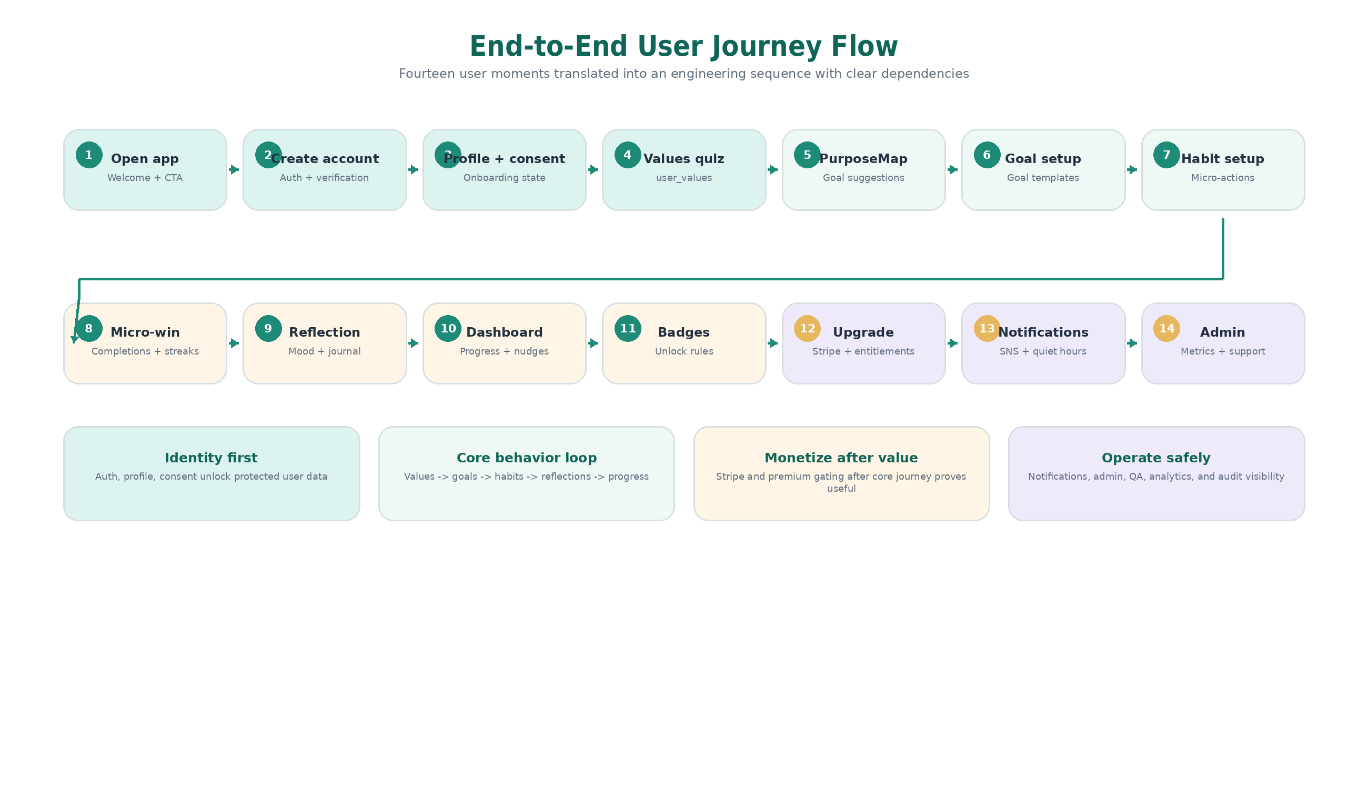
Figure 5. End-to-end user journey and engineering dependency flow.

This section converts the user journey into an engineering sequence. It is useful for sprint planning because it shows what should be built first and which modules depend on earlier work.

Steps 1-7: Account, Values & Goal Setup
Step | User Moment | Build Items | Dependency
1 | Open app / welcome | React Native navigation, design system, welcome screen, copy, CTA routing. | No dependency beyond app shell.
2 | Create account / login | Auth screens, NestJS Auth Module, Users Module, token storage, verification/reset flow. | Must be completed before protected user data flows.
3 | Profile + consent | Profile fields, onboarding status, consent notices, notification preference shell. | Requires Auth + Users tables.
4 | Values quiz | Values selection screens, validation, user_values table, quiz versioning. | Requires logged-in user and onboarding state.
5 | PurposeMap(TM) | Map selected values to goals and habits; display personalized blueprint. | Requires values + goal templates.
6 | Goal setup | Goal templates, custom goals, target amount/due date/status, user_goals table. | Requires PurposeMap or manual goal entry.
7 | Habit setup | Habit templates, user_habits, schedule/frequency, micro-actions. | Requires a selected goal.

Steps 8-14: Tracking, Monetization, Engagement & Admin
Step | User Moment | Build Items | Dependency
8 | Micro-win tracking | Completion records, streaks, progress calculations, supportive messages. | Requires habits and completion data model.
9 | Reflection / mood | Journal prompt, mood score, history, privacy-aware storage. | Can run parallel after auth/profile.
10 | Dashboard | Progress bars, active goals, completed habits, badges, mood trend, nudges. | Requires goals, habits, reflections, badges.
11 | Badges | Badge rules, unlock events, achievements screen. | Requires goals/habits/completions.
12 | Upgrade / premium | Pricing, Stripe checkout, entitlements, premium gating. | Requires auth and tier model.
13 | Notifications | Device tokens, SNS endpoints, reminders, quiet hours, delivery logs. | Requires authenticated device and preferences.
14 | Admin | Metrics, support tools, subscription status, notification logs, audit trail. | Requires reliable production data.

7. Backend Module Roadmap

Backend Module Heatmap
The heatmap makes module ownership and phase targeting clear, especially for explaining why QA/security touches multiple modules before launch.
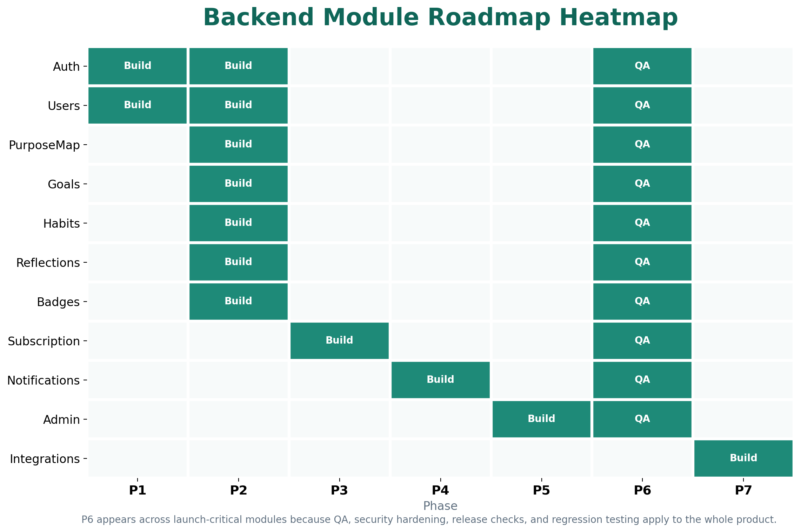
Figure 6. Backend module roadmap heatmap by implementation and QA phase.

Module | Target Phase | Responsibilities | Acceptance Focus
Auth Module | Phase 1-2 | Email/password or passwordless login, JWT/session strategy, refresh tokens, RBAC, password reset, email verification, future social login. | Protected routes work; tokens refresh securely; role checks block unauthorized access.
Users Module | Phase 1-2 | Profile, onboarding status, tier, notification preferences, account deletion/export workflows. | User data is isolated by userId; profile and onboarding state update reliably.
PurposeMap Module | Phase 2 | Values quiz storage, value profile, recommended goals, goal templates, onboarding logic. | Selected values produce repeatable suggested goals and habits.
Goals Module | Phase 2 | Create/edit/archive goals, custom goals, target amounts, due dates, tags, progress calculations. | Goal CRUD and progress calculations are tested and secure.
Habits Module | Phase 2 | Habit templates, user habits, completion records, streaks, schedule/frequency, micro-task tracking. | Completion history and streaks calculate correctly.
Reflections Module | Phase 2 | Journal entries, mood scores, prompts, history, privacy-aware storage rules. | Users can create/view own entries; admin access is restricted.
Badges Module | Phase 2 | Badge definitions, achievement rules, unlock events, user badge assignments, reward triggers. | Badge unlocks are idempotent and logged.
Subscription Module | Phase 3 | Stripe customers, checkout sessions, entitlements, webhook verification, renewal/cancellation, audit trail. | Webhook simulation passes; paid access only unlocks through verified events.
Notifications Module | Phase 4 | Device tokens, SNS endpoints, reminder scheduling, push templates, preferences, delivery logs. | Opt-outs and quiet hours are enforced.
Admin Module | Phase 5 | Admin login, metrics, user counts by tier, reflection counts, badge unlock rates, support tools. | Admin role required; audit logs capture actions.
Integrations Module | Phase 7 | Plaid/Yodlee, Argyle, Equifax, Nasdaq Data Link, AP/Dow Jones through isolated adapters. | Provider adapters can be added without changing core user flows.

8. Database & Data Model Roadmap

Database Visual Map
This visual groups the core entities into clear data domains so the data model looks less like a list and more like a product system.
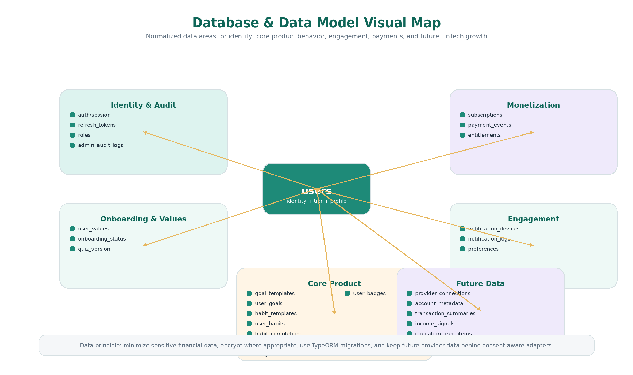
Figure 7. Database and data model map showing core entity groups and future data boundaries.

Database Principle
The database should be normalized around users, goals, habits, reflections, subscriptions, badges, and notification records. Sensitive financial data should be minimized, encrypted where appropriate, and stored only when required.

Area | Tables / Entities | Phase | Purpose
Foundation | users, auth/session/refresh token records, roles, admin audit logs | Phase 1 | Identity, access, auditability.
Onboarding | user_values, onboarding status fields, quiz version | Phase 2 | Values selected during onboarding and PurposeMap generation.
Goals | goal_templates, user_goals | Phase 2 | Predefined real-life goals and user-created goals.
Habits | habit_templates, user_habits, habit_completions | Phase 2 | Micro-actions, completion history, streaks, progress.
Reflections | reflections, reflection prompts | Phase 2 | Journal entries and mood tracking.
Badges | badges, user_badges | Phase 2 | Badge catalog, rules, user achievements.
Payments | subscriptions, payment_events | Phase 3 | Billing state, entitlements, webhook audit and idempotency.
Notifications | notification_devices, notification_logs | Phase 4 | Push registration, delivery status, opt-out evidence.
Admin analytics | read models/views or reporting queries | Phase 5 | Dashboard metrics and support operations.
Future data | provider connections, account metadata, transaction summaries, income signals, education feed items | Phase 7 | Only after compliance, partner, and consent decisions are finalized.

Database Implementation Notes
- Use TypeORM migrations for schema changes and avoid destructive migrations without backup and rollback plans.
- Add indexes on userId, status fields, subscription status, goalId, habit completion dates, and Stripe event IDs.
- Keep raw banking credentials out of the database. Store only provider tokens or references where required and encrypt sensitive columns if future integrations are added.
- Use separate credentials for application runtime, migrations, and read-only analytics when practical.
- Use RDS automated backups, point-in-time recovery, maintenance windows, CloudWatch alarms, and private networking.

9. Payment, Premium & Subscription Roadmap

Subscription & Entitlement Flow
This diagram clarifies that Stripe handles payment collection while the backend remains the source of truth for premium access.
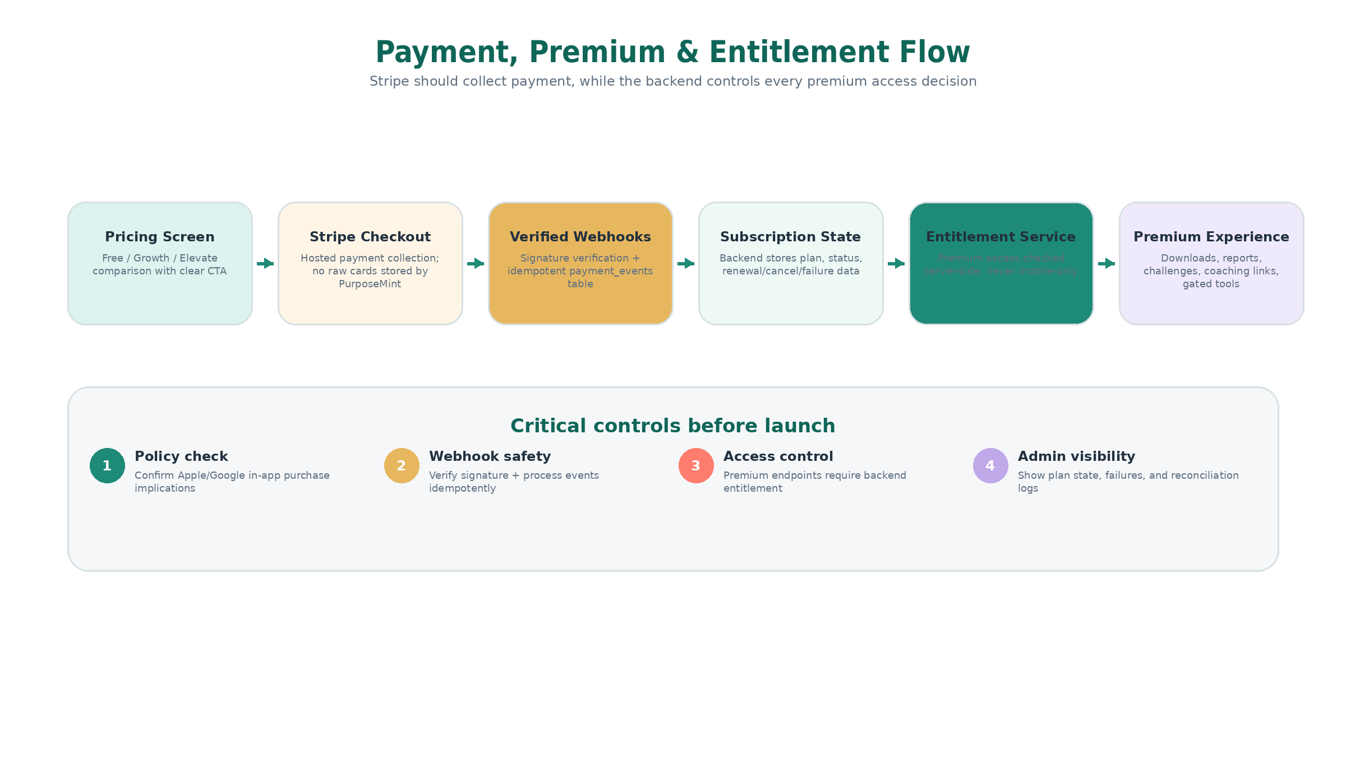
Figure 8. Payment, webhook, subscription, entitlement, and premium access control flow.

Step | Phase | Implementation Detail | Completion Signal
Decision checkpoint | Phase 0 | Confirm Free/Growth/Elevate rules, app store payment policy, Stripe product setup, cancellation/renewal behavior, customer portal needs. | Approved pricing and payment decision note.
Data foundation | Phase 1 | Prepare users.tier, subscriptions table, payment_events table, entitlement model. | Backend can represent a user plan without client trust.
Checkout | Phase 3 | Create Stripe checkout sessions, customer creation, success/cancel return handling, deep-link validation. | Users can start checkout from app in staging.
Webhooks | Phase 3 | Verify signatures, idempotent payment_events, update subscription state, handle renewals/cancellations/failures. | Stripe test events update entitlements correctly.
Premium gating | Phase 3 | Backend-protected premium APIs and mobile premium UI states for content/downloads/challenges/coaching links. | Free users blocked; paid users allowed.
Admin visibility | Phase 5 | Show subscription state, failed payment state, and basic support data. | Support can review payment status without Stripe dashboard-only dependence.
Release checks | Phase 6 | Test cards, failed payments, cancellation, renewal, webhook retry, production keys, store review requirements. | Payment checklist passes before launch.

Payment Policy Risk
Before final App Store submission, confirm whether Stripe alone is acceptable for the exact paid offering. If subscriptions unlock digital-only content, Apple/Google in-app purchase rules may apply. This decision should be closed in Phase 0 and rechecked in Phase 6.

10. Notifications & Engagement Roadmap

Notification Engagement Loop
The engagement loop visual reinforces the product tone: supportive nudges, user controls, quiet hours, delivery logging, and admin visibility.
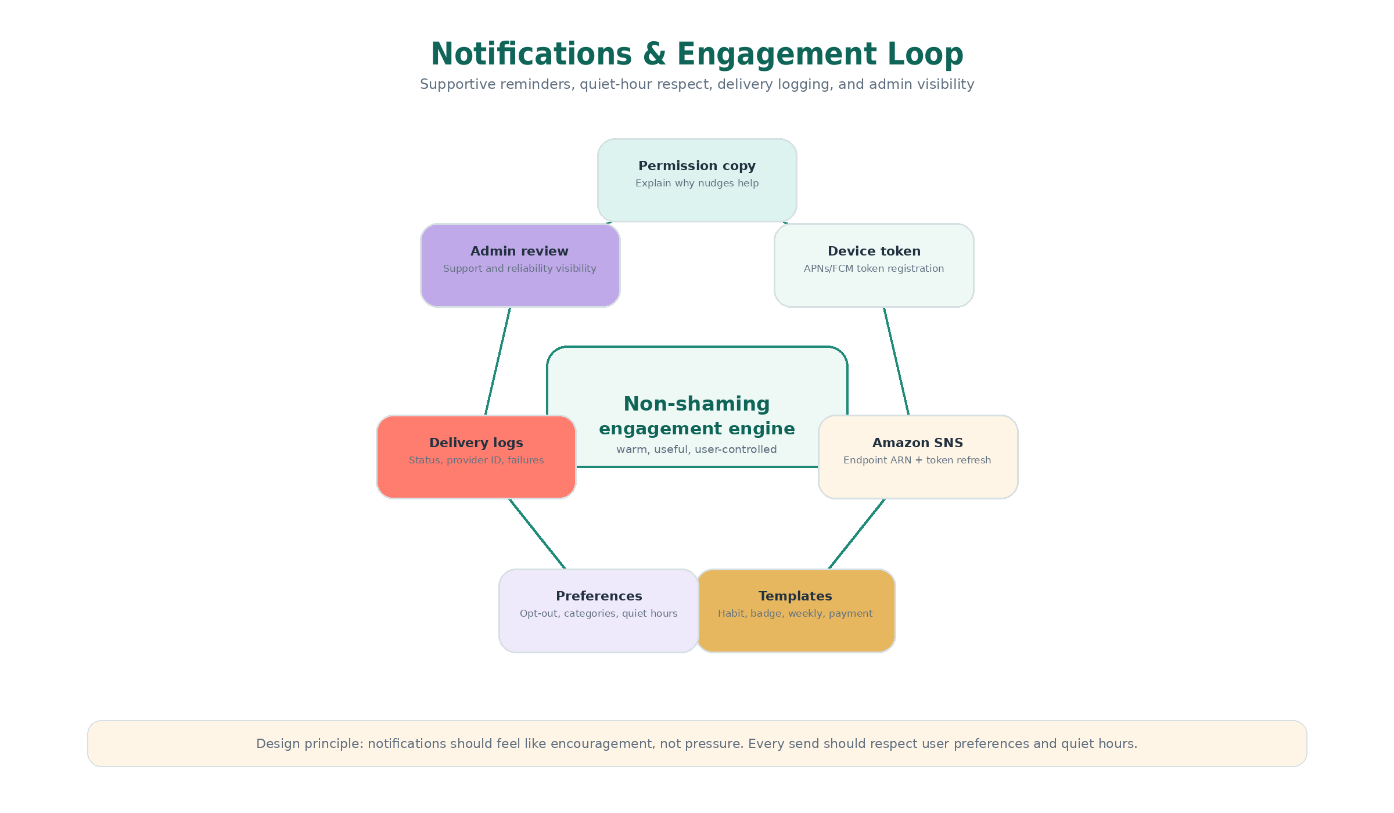
Figure 9. Notifications and engagement loop with preference enforcement and delivery logs.

Area | Phase | Build Detail | Acceptance Signal
Permission strategy | Phase 0-4 | Define why notifications matter, how often they send, and what copy respects user trust. | Short, supportive notification copy approved.
Device registration | Phase 4 | Mobile gets APNs/FCM token; backend stores hashed token and SNS endpoint ARN. | Token refresh and multiple devices handled.
Preferences | Phase 4 | Reminder categories, quiet hours, opt-out, frequency, channel settings. | Backend checks preferences before sending.
Templates | Phase 4 | Habit reminder, badge unlock, weekly summary, subscription notice, re-engagement nudge. | Templates are concise and non-shaming.
Delivery logs | Phase 4-5 | Status, sentAt, provider ID, failure reason, disabled endpoint handling. | Admin can diagnose delivery issues.
Release QA | Phase 6 | Android/iOS push tests, background/foreground behavior, opt-out behavior, permission denied behavior. | Push works in release builds.

11. Design & Content Roadmap

UI Style & Component Direction
This mockup-style visual makes the design direction tangible with colors, rounded cards, progress components, badges, and warm copy examples.
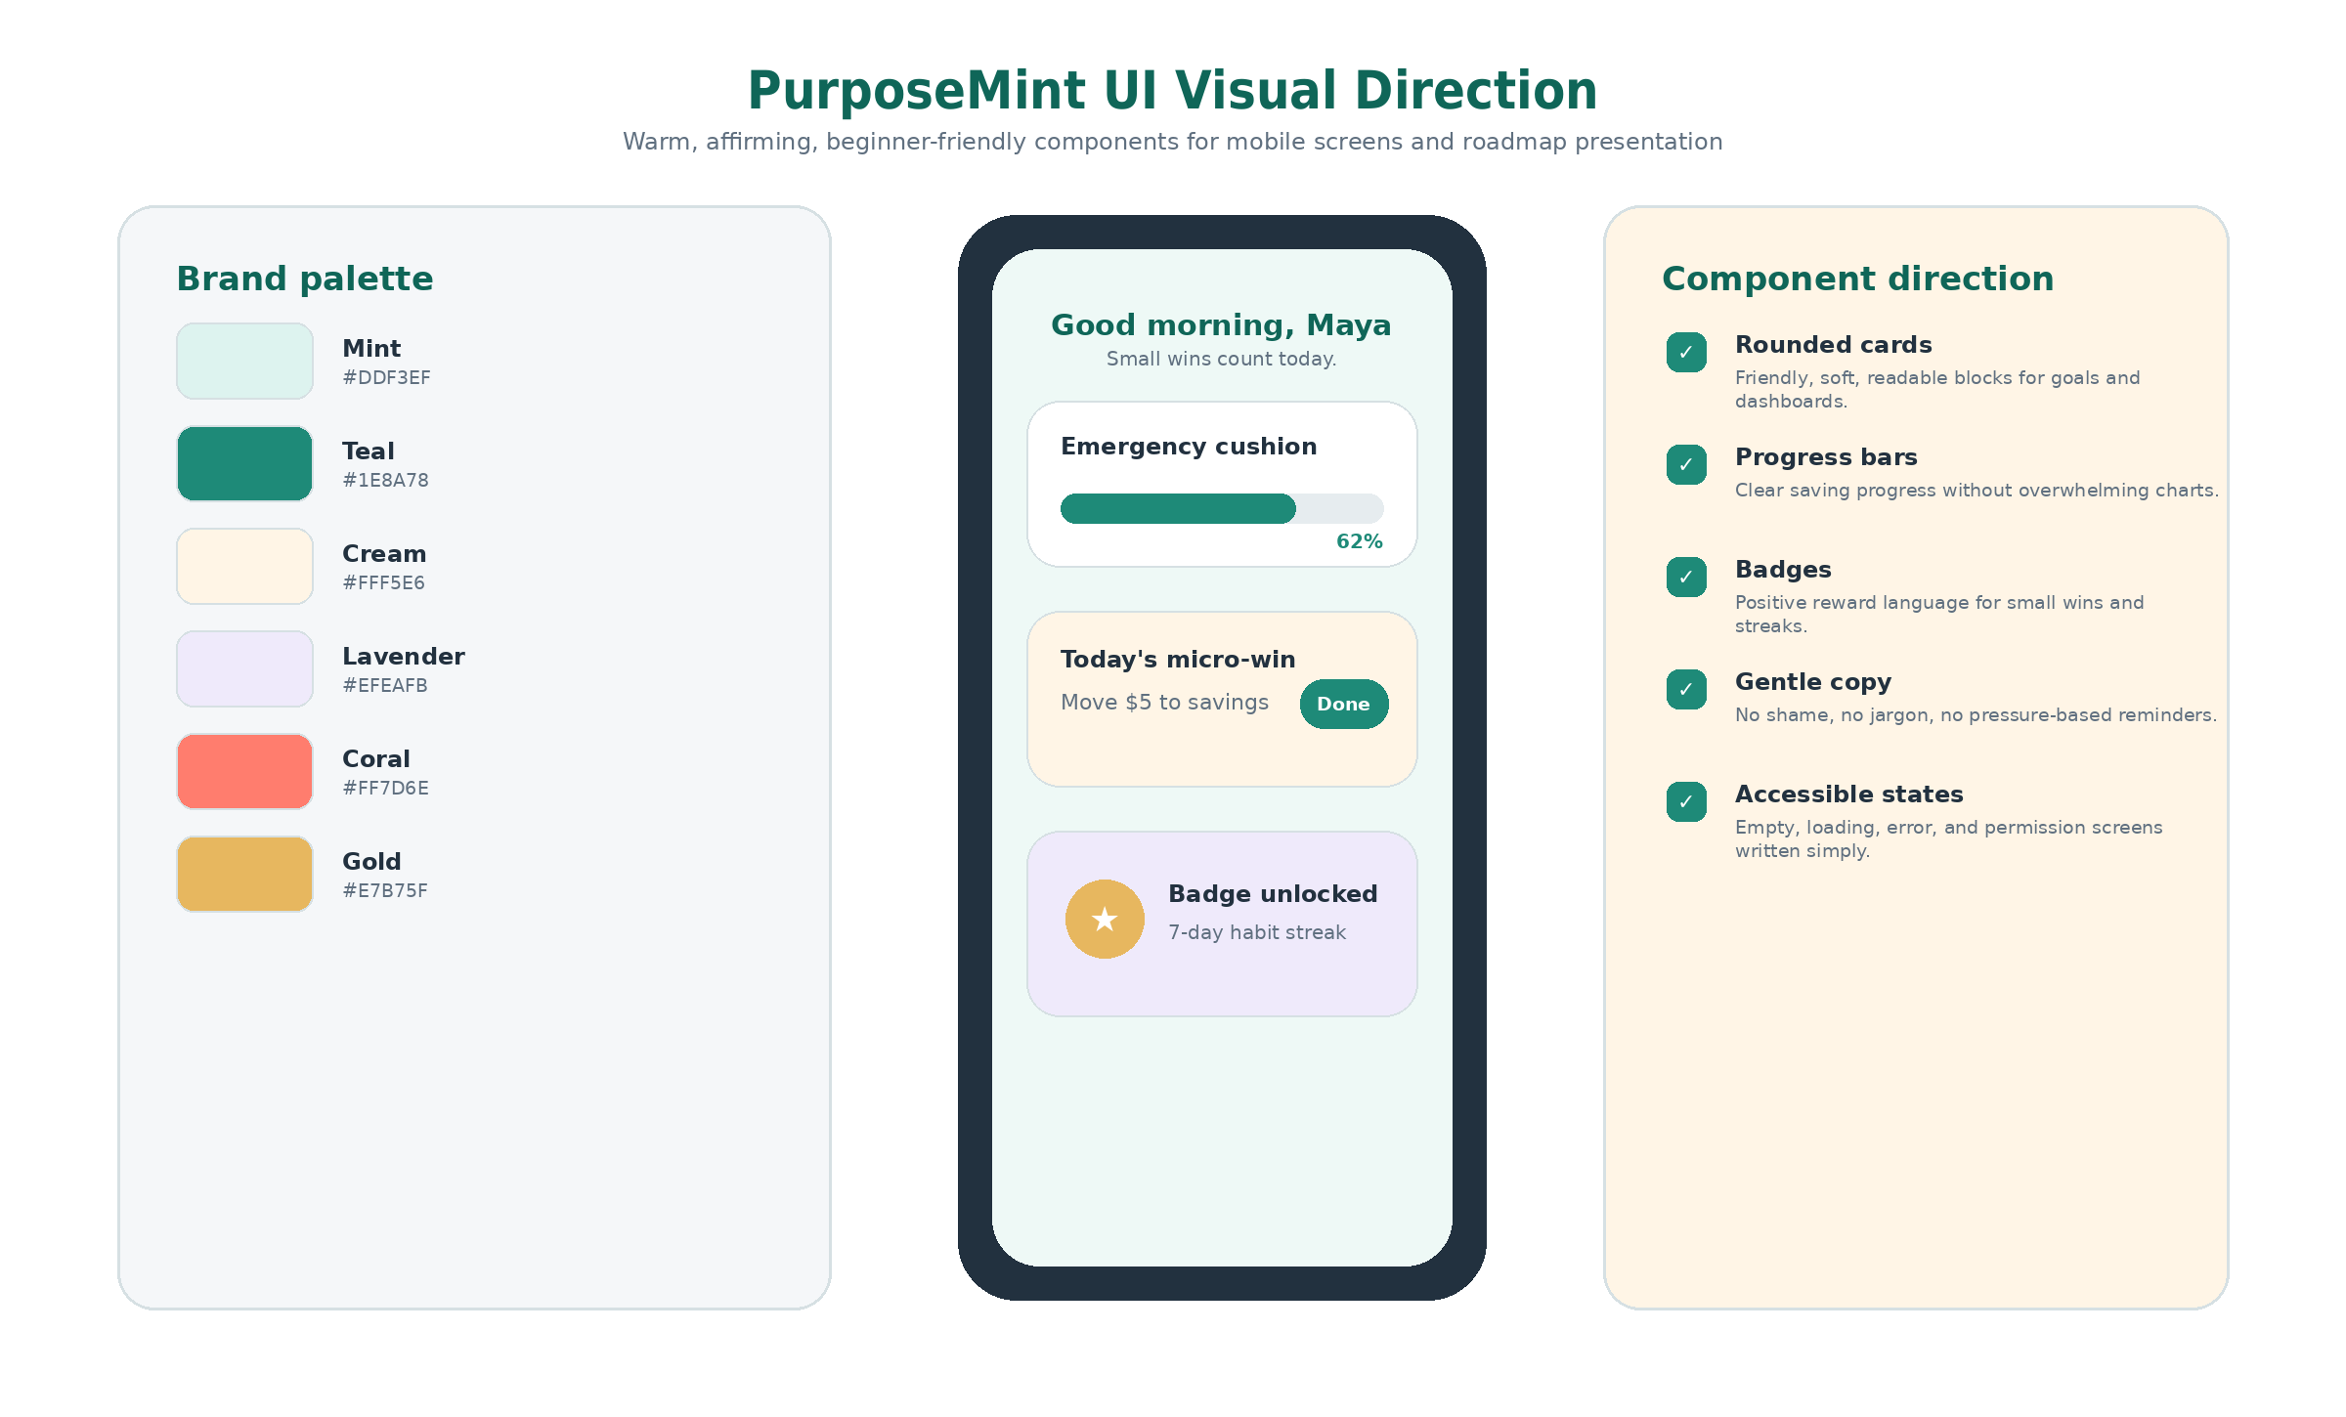
Figure 10. PurposeMint UI style direction for colors, components, tone, and mobile dashboard patterns.

The screen design direction should guide both mobile UI and product messaging. The roadmap should preserve the product tone: warm, affirming, culturally relevant, trauma-informed, beginner-friendly, and visually simple.
Design/Input Area | Roadmap Use | Phase
Brand tone | Warm, affirming, non-judgmental, culturally relevant, clear, encouraging. | Phase 0-2
Design system | Typography, spacing, buttons, cards, forms, progress bars, badges, charts, empty/error states. | Phase 1
User pain points | No emergency savings, paycheck-to-paycheck stress, financial trauma, jargon overwhelm, distrust of traditional tools. | Phase 0-2
Journey content | Open account, set real-life goals, automate your way, track progress visually, pause without shame, celebrate small wins. | Phase 2
Pricing tiers | Free at $0/month, Growth at $19/month, Elevate at $49/month, with benefit comparison and clear upgrade CTA. | Phase 3
Real-life goal library | Fresh haircut fund, back-to-school supplies, groceries, bill buffer, therapy session fund, kids birthday fund, self-care, coffee joy runs. | Phase 2
Testimonials/focus-group insight | Users want a tool that understands real life, is not culturally irrelevant, and does not send junky notifications. | Phase 0-4

12. QA, Security & Release Gates

QA & Launch Gate Diagram
This release-gate visual helps reviewers quickly understand how the product moves from alpha to beta, release candidate, and public launch.
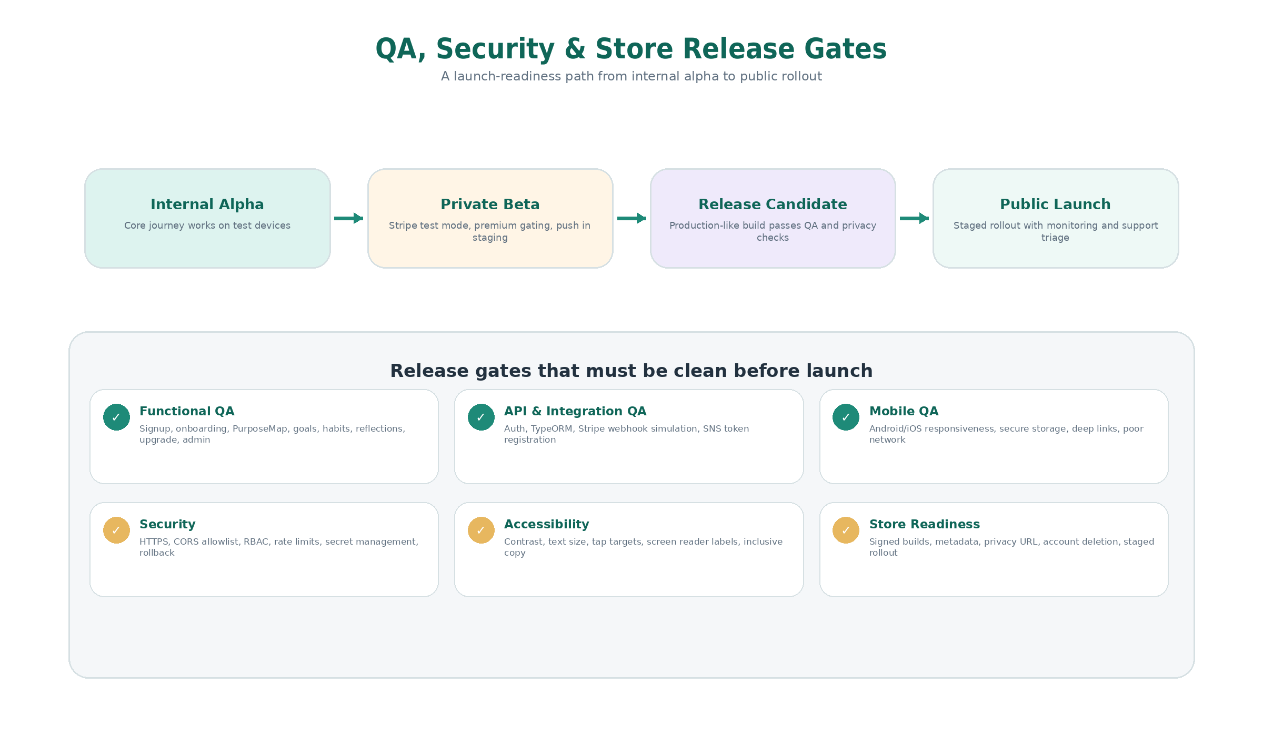
Figure 11. QA, security, accessibility, store-readiness, and launch gates.

Testing Area | Coverage | When It Must Pass
Unit testing | Backend services, validators, repositories, calculations, badge rules, entitlement rules. | Every pull request and Phase 6 regression.
Integration testing | Auth flows, TypeORM operations, Stripe webhook simulation, SNS token registration, admin operations. | Before staging sign-off and release candidate.
Mobile testing | Android/iOS devices, screen responsiveness, poor network, secure storage, deep links, push behavior. | Alpha, beta, and release candidate.
E2E testing | Onboarding -> PurposeMap -> goal setup -> habit completion -> badge unlock -> upgrade flow. | Before private beta and before launch.
Security testing | Rate limits, API validation, token handling, RBAC, webhook forgery attempts, secrets review, dependency scanning. | Before production launch.
Performance testing | API response times, dashboard load, database query performance, notification dispatch, scaling checks. | Before launch and after major changes.
Accessibility testing | Contrast, text size, screen reader labels, tap targets, consent screens, non-shaming copy. | Design sign-off and Phase 6.
Store QA | Android App Bundle, iOS archive, signing, metadata, screenshots, privacy disclosures, staged rollout readiness. | Phase 6 release gate.

Security Gates by Area
Area | Required Security Gate
Backend/API | HTTPS, validation pipes, strict DTOs, rate limiting, CORS allowlist, security headers, safe errors, short token expiry or secure sessions, refresh rotation, RBAC.
Database | RDS private subnet, encryption at rest/in transit, least-privilege credentials, backups, migration safety, indexes, audit logs.
Mobile | Secure storage, no hard-coded secrets, release obfuscation where practical, deep-link validation, screenshot protection if financial account details are added.
Payments | Stripe-hosted or official SDK flows, webhook signatures, idempotency, backend-only entitlement updates, separate dev/staging/prod keys.
Cloud/DevOps | IAM least privilege, MFA, secrets in AWS services, separate environments, CI tests/scans, rollback strategy, CloudWatch alarms.

13. MVP Deliverables
Deliverable | Description
React Native Mobile App | Android and iOS app with production-ready screens, navigation, secure auth, PurposeMap, goals, habits, dashboard, reflections, badges, subscriptions, notifications.
NestJS Backend API | REST API, OpenAPI docs, auth, business logic, Stripe webhooks, SNS push service, admin APIs, and future adapter structure.
PostgreSQL Database | Schema, TypeORM entities, migrations, indexes, seed data, backup plan, and environment-specific configuration.
AWS Deployment | Backend hosting, RDS, networking, secrets, logs, monitoring, alarms, and deployment documentation.
Stripe Integration | Checkout, customer portal, webhooks, subscription records, entitlement logic, test checklist.
Push Notification System | SNS setup, device registration APIs, templates, delivery logs, preferences.
Admin Dashboard | Operational metrics, user tier counts, goal/habit/reflection metrics, payment state visibility, audit logging.
Deployment Package | Google Play and Apple App Store build artifacts, release notes, store metadata guidance, staging/production deployment guide.

14. Client Decisions Needed Before Build Lock
- Finalize all MVP design screens and confirm no major screen additions during Phase 2.
- Confirm login approach: email/password, passwordless, or hybrid.
- Approve Free, Growth, and Elevate benefits, prices, trials, discounts, and cancellation/downgrade rules.
- Confirm Stripe-only payment approach or app-store in-app purchase requirement for subscriptions.
- Confirm whether open banking, payroll, credit, macro/reference data, and education/news feeds are post-MVP or included in MVP.
- Provide AWS, Stripe, Apple Developer, Google Play Console, APNs/FCM, and domain/DNS access or invite the engineering team with limited permissions.
- Approve privacy policy, terms of service, account deletion/export process, support email, and app store data-use declarations.
- Approve notification categories, quiet-hour defaults, frequency limits, and sample copy.
- Confirm admin users, roles, support workflows, and what data admins may view.
- Confirm launch region, target devices, accessibility expectations, analytics/crash monitoring tools, and beta testing group.

15. Recommended Sprint Structure
Sprint | Timing | Main Focus
Sprint 0 | Week 1-2 | Discovery, final requirements, backlog, acceptance criteria, design-screen freeze, payment/app store decision.
Sprint 1 | Week 3 | Repositories, CI/CD, NestJS skeleton, React Native shell, AWS/RDS planning.
Sprint 2 | Week 4 | Database migrations, auth backend, auth screens, profile model, design system components.
Sprint 3 | Week 5 | Auth completion, secure storage, environment switching, onboarding shell.
Sprint 4 | Week 6-7 | Values quiz, PurposeMap(TM), goal templates, user values and goal suggestion logic.
Sprint 5 | Week 8-9 | Goal setup, habit setup, habit completion, progress and streak logic.
Sprint 6 | Week 10-11 | Reflections, mood, dashboard, badges, internal alpha stabilization.
Sprint 7 | Week 12-14 | Stripe checkout, customer portal, webhooks, entitlements, premium gating.
Sprint 8 | Week 15-17 | SNS, push tokens, preferences, reminder templates, quiet hours, notification logs.
Sprint 9 | Week 18-21 | Admin dashboard, metrics, support workflows, audit logs, reporting polish.
Sprint 10 | Week 22-26 | Full QA, security hardening, release builds, store metadata, launch readiness.

16. Final Roadmap Summary
Recommended Build Path
Start with Phase 0 decisions, then engineering foundations and authentication. Build the core PurposeMint journey before payments and notifications. Only after the user flow is stable should the team add Stripe, premium gating, push notifications, admin analytics, and full store readiness. Keep advanced FinTech data integrations as post-MVP unless the client approves the extra compliance and integration scope.

Priority | Roadmap Focus
First priority | Finalize design screens, scope, pricing, payment policy, and compliance assumptions.
Second priority | Build technical foundation: React Native, NestJS, PostgreSQL/RDS, TypeORM, AWS, CI/CD.
Third priority | Build auth, profile, onboarding, PurposeMap(TM), goals, habits, reflection, dashboard, and badges.
Fourth priority | Add Stripe subscriptions, backend entitlements, and premium content gating.
Fifth priority | Add Amazon SNS push notifications, reminders, quiet hours, and delivery logs.
Sixth priority | Add admin dashboard, operational analytics, support tools, audit logs.
Launch priority | Complete QA, security, accessibility, app store assets, privacy/legal items, and staged rollout.
Growth priority | Add Plaid/Yodlee, Argyle, Equifax, macro/reference data, and education/news feeds after MVP.

Appendix A - MVP Checklist
[ ] Account creation and secure login
[ ] Password reset or passwordless recovery
[ ] Email verification or equivalent account verification
[ ] User profile and onboarding status
[ ] Values quiz and PurposeMap(TM) display
[ ] Goal templates and custom goal creation
[ ] Habit setup and completion tracking
[ ] Progress bar and dashboard
[ ] Reflection/journal entry and mood score
[ ] Badge unlock system
[ ] Stripe plan upgrade flow
[ ] Backend entitlement rules
[ ] Premium content visibility rules
[ ] Push notification registration and reminders
[ ] Notification preferences and quiet hours
[ ] Admin metrics dashboard
[ ] Audit logs for admin/payment/subscription actions
[ ] Store-ready Android and iOS builds
[ ] Privacy policy, terms, account deletion/export process

Appendix B - Environment Separation
Environment | Purpose
Development | Local developer machines, mock providers, local/staging database, non-production Stripe keys, debugging enabled.
Staging | AWS-hosted test environment, staging RDS, Stripe test mode, SNS sandbox/test devices, QA builds, seeded data.
Production | Production AWS environment, RDS backups, production Stripe keys, production SNS/APNs/FCM setup, release builds, monitoring and alarms.

