

**REPORT**

**Free Coaching &Guidance Centre**

**Mohalla Quazi, Saharanpur**

**Supported by**

**Indian Minority Education Society of Australia**

**&**

**Hamrah Foundation, Delhi**

**WORKING COMMETTEE**

* Mr Irfan Ahmad Ansari - Project In Charge
* Prof Majid Jamil - Project Coordinator (Hon.)
* Mr Zia Ahmad -Adviser (Hon)
* Mr Rashid Jamil Advocate - Adviser (Hon)

Payee Staff-

* Mr Mohammad Saleem - (Teacher)
* Mr. Mohd. Irfan Ansari - (Supervisor)

1. **Aims and objectives of the project**

* Creating and establishing educational environment among poor and educationally backward people in the neighboring localities of the premises.
* Bringing awareness about importance of education in human society.
* Restricting children to play in streets, watching excessive TV and wasting time without knowing their aims in life.
* Creating moral values among youth.
* Encouraging people to participate in social activities that benefit masses.

1. **Number of beneficiaries**

The project commenced in July 2019 with approx. 40 students. As the word spread in neighborhoods, the number of students grew rapidly.

Currently, there are more than 120 needy students from Nursery to 10th class, who are attending the Centre to do homework, exam preparation and general help.

They study in reading rooms and get guidance from teacher and visiting academic volunteers in different batches at the Centre.

1. **Capacity of beneficiaries before the project:**

Young children of class nursery to 8th standard belonging to more than 50 educationally backward and financially poor families were targeted. These children were not having any guidance at home as parents were not educated. General atmosphere in these localities lack discipline and unless the children are given proper guidance, they fail in early classes and generally drop out of schools.

1. **Brief Methodology**

Free Coaching & guidance Centre was setup in the month of June 2019 in the house offered by Jamil family of Late Jamil Ahmad Advocate, an honourable personality of Muslim community in Saharanpur.All necessary furniture, white boards were bought

to equip classes adequately.

Students are asked to attend the library cum reading room facility after school hours. They do their homework, learning work and self- study successfully under the supervision of one teacher and one supervisor. Students study in different batches as below.

Batch 1 : Nursery to 5th standard – 40

Batch 2 : 6th standard to 8th standard – 58

Batch 3 : 9th standard to 10th standard – 08

Batch 4 :Madarsa students -12

The project helped in creating a positive atmosphere among students, very importantly of higher classes (9th-10th). Local retired Academic Mr. Zia Ansari, former retired Principal of an intermediate schools poke to students regularly to define the main goals and do efforts to achieve them. We wish to extend all support to promising students.

Mr. Rashid Jamil advocate, who lives in the other section on the Jamil family home, takes deep interest in the operation of the Centre to ensure that all the needs of teachers and students are met.

1. **Capacities developed in beneficiaries after the project**

By providing free reading room library with all facilities like proper sitting arrangement, power backup and a small collection of important books to all class students, improvement in the results is observed. Students of higher classes received support from volunteering local academics.

One teacher along with a support staff is available for 4 hrs daily from 4 pm to 8 pm to assist the young boys and girls in completing the day to day homework.

Students are well behaved and confident with improvement not in academics but in cultural activities also.

Time to time the parents are requested to attend the motivating lectures to know how better environment may be created at home to uplift the children in the right direction.

1. **Further need for project**

Result of students who are attending the centre has improved significantly. By starting this reading free coaching centre, we have noticed that most of the students have benefited with this project not only academically but behaviorally also. Students are showing their interest in academics as well as in extracurricular activities.

It is vital that the project continues and students continue to get the support. Without such support, students’ performance will deteriorate sharply affecting their results. Some of them may thus drop out.

Therefore the above coaching centre is essential to provide students support with their homework and exam preparation.

Indian Minority Education Society of Australia Inc. is convinced and is willing to offer ongoing support for the project.

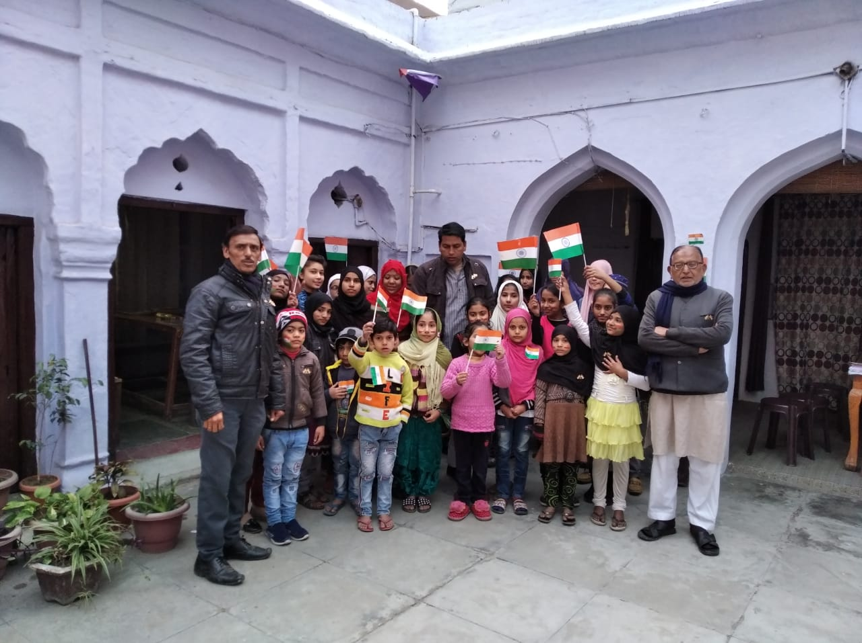

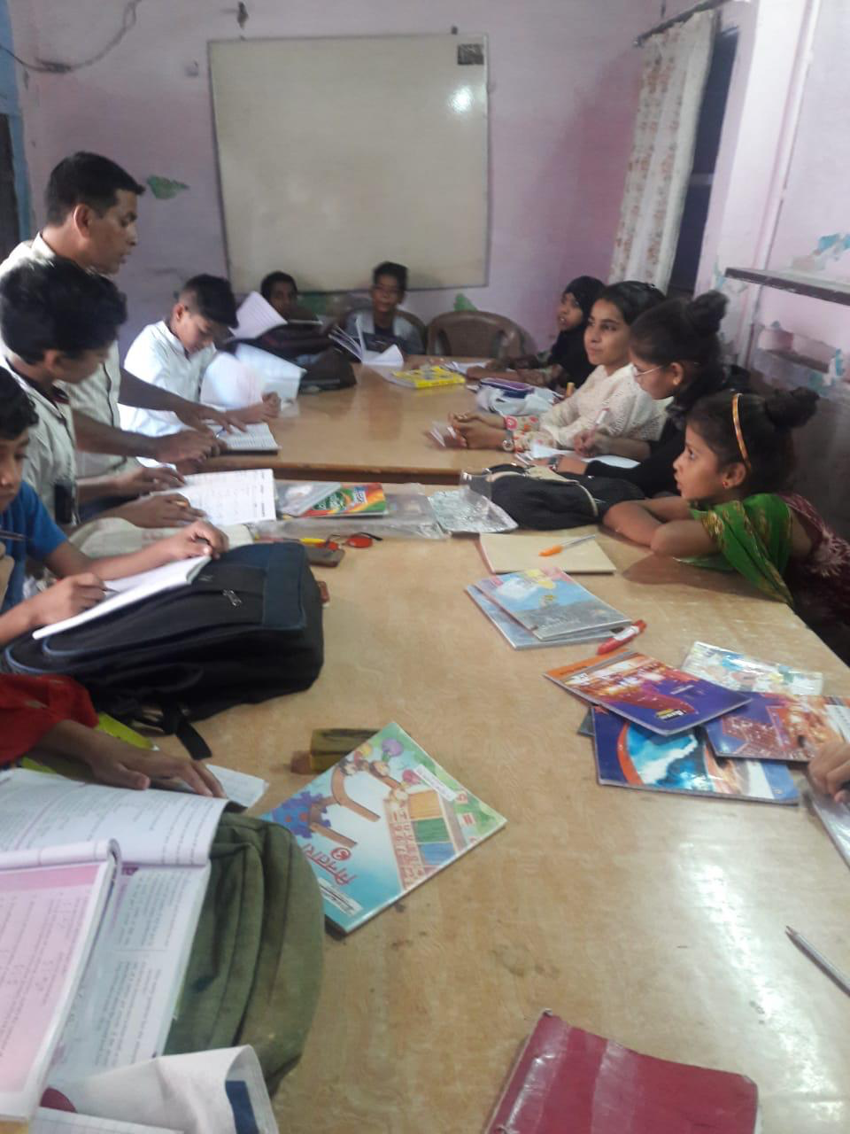

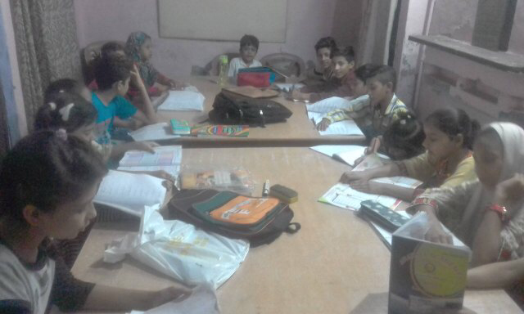

**A CULTURAL EVENT**

