**1.AIM**: **Program to Create text file which contains all your friends names, display the count of each alphabet present in file.**

**DESCRIPTION:**

**In this program we will first create a file named lab_internal_2 and I included some names in the file. Then I read the data from the file and crated a function named count_letters. In that function I created the logic of counting all the letters of one name. Like wise it will count the no.of letters present in each name and return in the form of dictionary.**

**CODE:**

f=open("lab_internal_2.txt","w")  
f.write("Marepally Saiteja\nTeja sai\nNikhil Krishna")  
f.close()  
def count_letters(text):  
 result={}  
 for letter in text:  
 if letter not in result:  
 result[letter]=0  
 result[letter]+=1  
 return result  
  
f=open("lab_internal_2.txt",'r')  
for i in f:  
 s=i[:len(i)+1]  
 print(s,':',count_letters(s))  
f.close()

**FILE USED:**

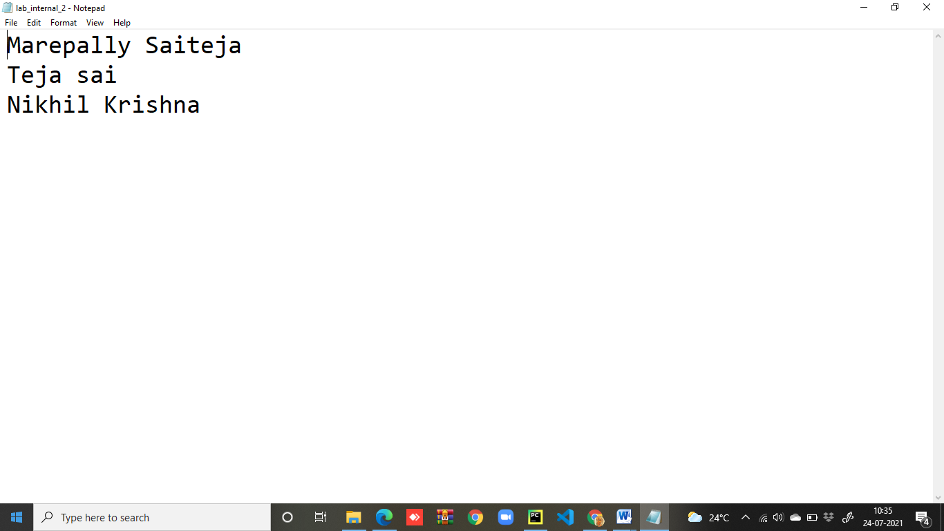

**RESULT:**

