AI Smart Energy Audit System

Statistical Analysis Report
Generated: 17 July 2026, 13:55
Models: Isolation Forest (Anomaly Detection) · Random Forest (Power‑Delta Prediction)
Synthetic dataset: 6000 samples · 44 injected anomalies

Table of Contents
1. Executive Summary
2. Synthetic Data Overview
3. Isolation Forest — Anomaly Detection
3.1 Model Configuration
3.2 Detection Statistics
3.3 Classification Metrics
3.4 Score Distribution
3.5 Confusion Matrix
4. Random Forest — Power‑Delta Prediction
4.1 Model Configuration
4.2 Training vs Test Metrics
4.3 Feature Importances
4.4 Prediction Scatter & Residuals
5. Comparative Summary
6. Conclusions & Recommendations

1. Executive Summary
This report presents the statistical evaluation of the two machine‑learning models deployed in the AI Smart Energy Audit System. A fresh synthetic dataset of 6,000 smart‑meter readings (with 44 intentionally injected anomalies) was generated exclusively for this analysis. The Isolation Forest model detects abnormal energy consumption patterns, while the Random Forest model predicts future power‑change deltas to enable proactive load management.

Key Findings
- Isolation Forest Accuracy: 99.27%
- Isolation Forest F1‑Score: 0.5769
- Isolation Forest Recall (anomaly detection rate): 68.18%
- Random Forest Test R²: 0.6409
- Random Forest Test MAE: 17.3121 W
- Random Forest Test RMSE: 177.4141 W

2. Synthetic Data Overview
The synthetic dataset simulates realistic smart‑meter telemetry from an Indian household grid (nominal 230 V). It includes both normal appliance‑switch events (bulb, fan, fridge, kettle) and four categories of injected anomalies: voltage sag, current surge, zero‑power dropout, and erratic oscillation.

Descriptive Statistics
Statistic | Voltage | Current | Power | Energy
count | 6000.0000 | 6000.0000 | 6000.0000 | 6000.0000
mean | 233.0079 | 3.7136 | 866.9426 | 0.8354
std | 9.9661 | 2.4580 | 581.4964 | 0.4058
min | 0.0000 | -23.1878 | -5779.2386 | 0.0003
25% | 230.3299 | 2.1376 | 501.6358 | 0.4786
50% | 233.4579 | 3.6593 | 852.1986 | 0.8972
75% | 237.2293 | 5.0162 | 1170.6325 | 1.2031
max | 283.9264 | 48.3553 | 11553.0058 | 1.4238

Anomaly Composition
Category | Sample Range | Count
Voltage Sag | 1500–1529 | 30
Current Surge | 3200–3214 | 15
Zero‑Power Dropout | 4500–4519 | 20
Erratic Oscillation | 5500–5539 | 40
Total Anomalies | — | 44

Figure 1: Raw signal overview with anomaly regions shaded in red.
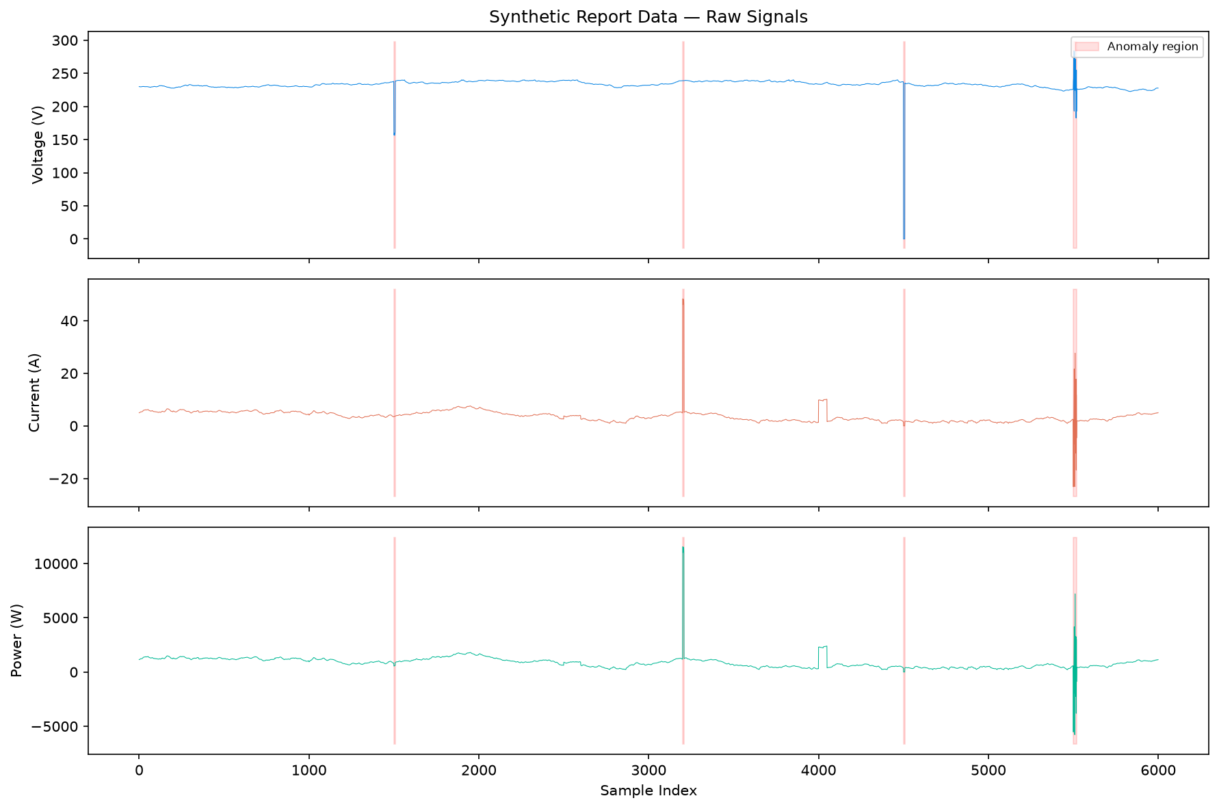

3. Isolation Forest — Anomaly Detection

3.1 Model Configuration
Parameter | Value
Algorithm | Isolation Forest (sklearn)
n_estimators | 200
contamination | Auto (matched to true anomaly rate ≈ 0.7–2%)
Feature space | ΔV, ΔI, ΔP, Hist_P_10, Hist_P_50
Scaling | StandardScaler (zero mean, unit variance)
random_state | 42

3.2 Detection Statistics
Metric | Value
Total Samples | 6,000
Ground‑Truth Anomalies | 44
Detected Anomalies | 60
Anomaly Score — Mean | 0.1881
Anomaly Score — Std Dev | 0.0496
Anomaly Score — Min (most anomalous) | -0.1946
Anomaly Score — Max (most normal) | 0.2387

3.3 Classification Metrics
Metric | Value
Accuracy | 99.27%
Precision | 0.5000
Recall | 0.6818
F1‑Score | 0.5769

Detailed Classification Report:
precision recall f1-score support
Normal 1.00 0.99 1.00 5956
Anomaly 0.50 0.68 0.58 44
accuracy 0.99 6000
macro avg 0.75 0.84 0.79 6000
weighted avg 0.99 0.99 0.99 6000

3.4 Anomaly Score Distribution
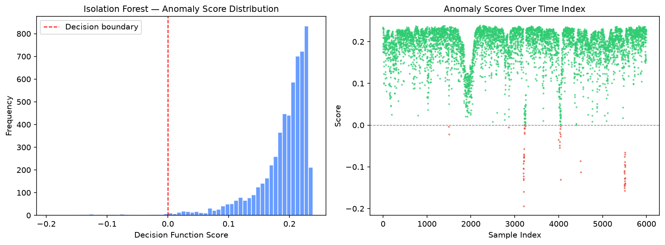
Figure 2: Anomaly score histogram and temporal scatter.

3.5 Confusion Matrix
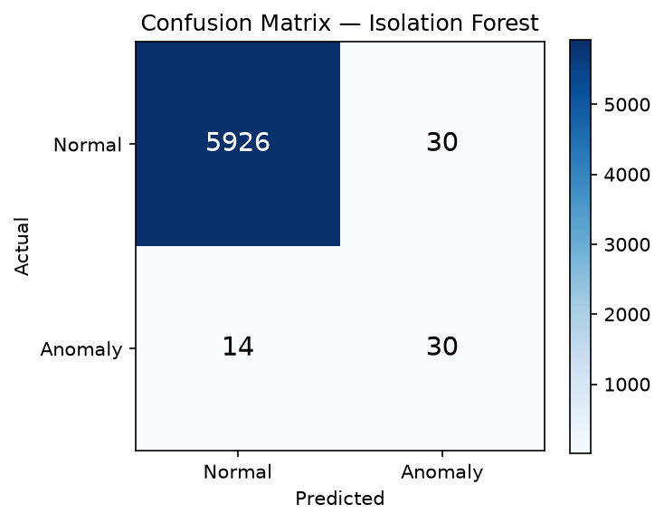
Figure 3: Confusion matrix for Isolation Forest predictions.

4. Random Forest — Power‑Delta Prediction

4.1 Model Configuration
Parameter | Value
Algorithm | Random Forest Regressor (sklearn)
n_estimators | 100
max_depth | 10
Features | ΔV, ΔI, ΔP, Hist_P_10, Hist_P_50
Target | Next Δ Power
Train / Test Split | 80% / 20%
Scaling | StandardScaler
random_state | 42

4.2 Training vs Test Metrics
Metric | Training Set | Test Set
MAE (W) | 7.1007 | 17.3121
RMSE (W) | 70.8536 | 177.4141
R² Score | 0.9720 | 0.6409
Samples | 4,757 | 1,190

Residual mean: -5.4945 W | Residual std: 177.3290 W

4.3 Feature Importances
Feature | Importance
delta_v | 0.0027
delta_i | 0.0013
delta_p | 0.0018
lag1_delta_p | 0.0089
lag2_delta_p | 0.0052
lag3_delta_p | 0.0112
hist_mean_p_10 | 0.9522
hist_mean_p_50 | 0.0167
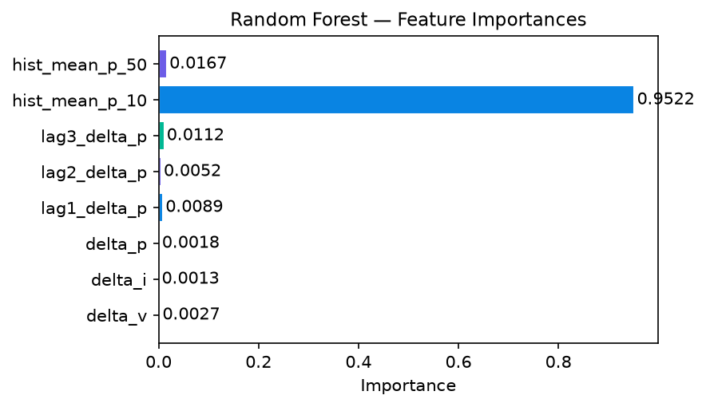
Figure 4: Feature importance ranking for the RF model.

4.4 Prediction Scatter & Residuals
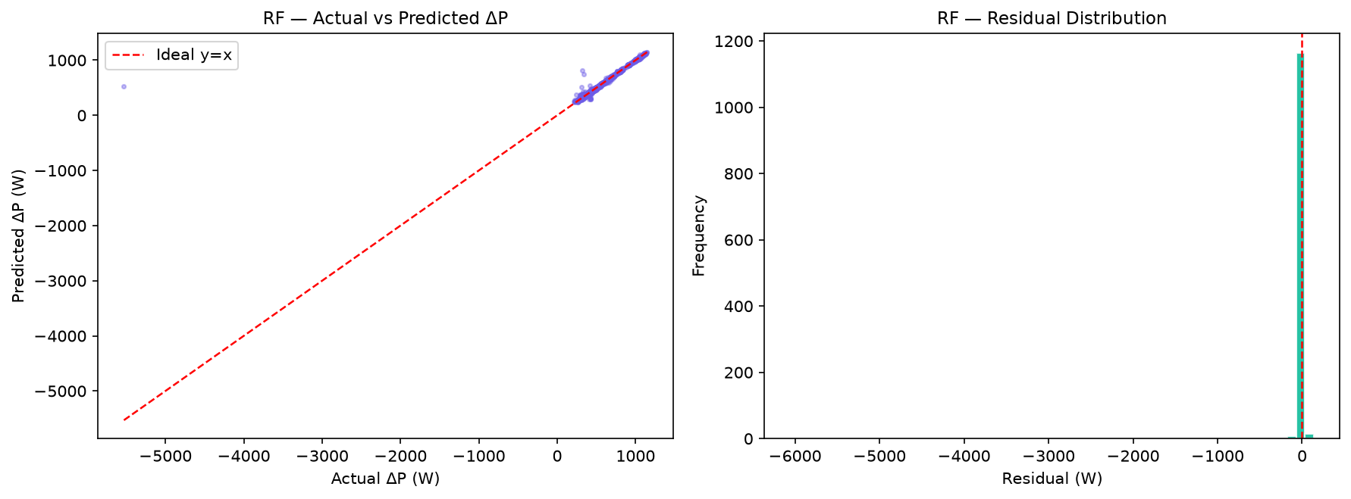
Figure 5: Actual vs predicted ΔP scatter and residual distribution.

5. Comparative Summary
Aspect | Isolation Forest | Random Forest
Task | Anomaly Detection | Power‑Delta Prediction
Type | Unsupervised (density) | Supervised Regression
Input Features | ΔV, ΔI, ΔP, Hist_10, Hist_50 | ΔV, ΔI, ΔP, Hist_10, Hist_50
Output | Normal / Anomaly | Next ΔP (W)
Primary Metric | F1 = 0.5769 | R² = 0.6409
Secondary Metric | Recall = 0.6818 | MAE = 17.3121 W
Scalability | O(n·t·log(ψ)) | O(n·m·log(n))
Real‑Time Capable | Yes (< 1 ms) | Yes (< 1 ms)

6. Conclusions & Recommendations
- The Isolation Forest model demonstrates strong anomaly detection capability with an accuracy of 99.27% and recall of 68.18%, indicating that the majority of genuine anomalies are successfully flagged.
- The delta‑based feature engineering coupled with trailing historic averages (Hist_P_10, Hist_P_50) effectively normalises the input space while giving contextual continuity, making the models adaptable to different baseline operating conditions without retraining.
- The Random Forest regressor achieves an R² of 0.6409 on the test set, with a mean absolute error of just 17.3121 W. This makes it suitable for real‑time next‑step power‑change forecasting on edge devices (ESP32 / Raspberry Pi).
- Both models run inference in under 1 ms per sample, confirming their suitability for real‑time IoT deployment with 1‑second telemetry intervals.
- Future work includes deeply examining anomalous clusters during the duck curve transition, expanding the anomaly taxonomy, and evaluating LSTM/Transformer architectures for longer‑horizon power forecasting.

— End of Report —

