#1

Click on Worker button:

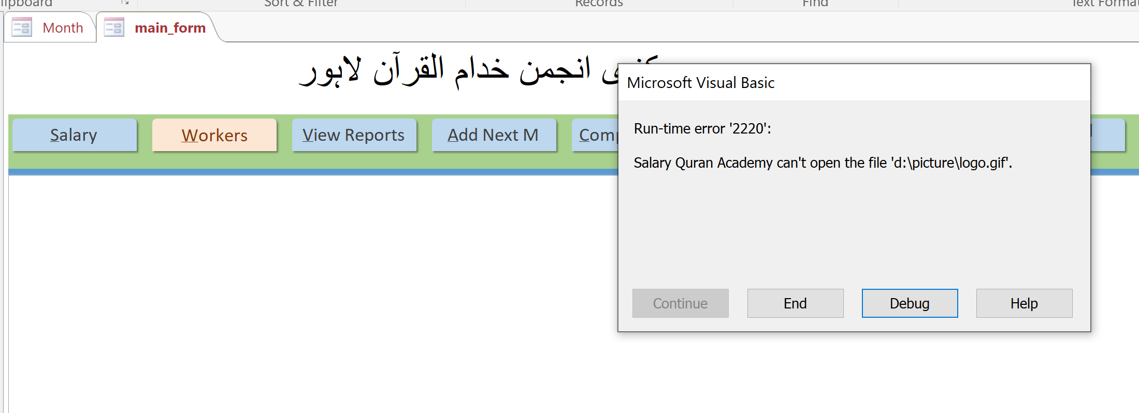

#2

Form size issue.. vertical scrolling is not required.. it was not in original file

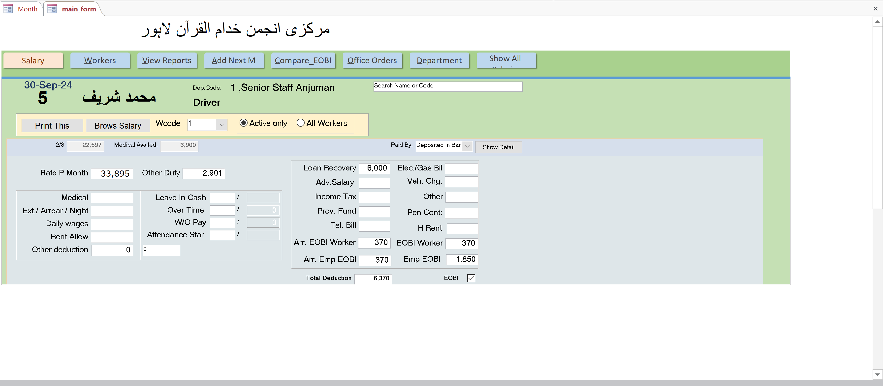

#3

Click on next button on bottom:

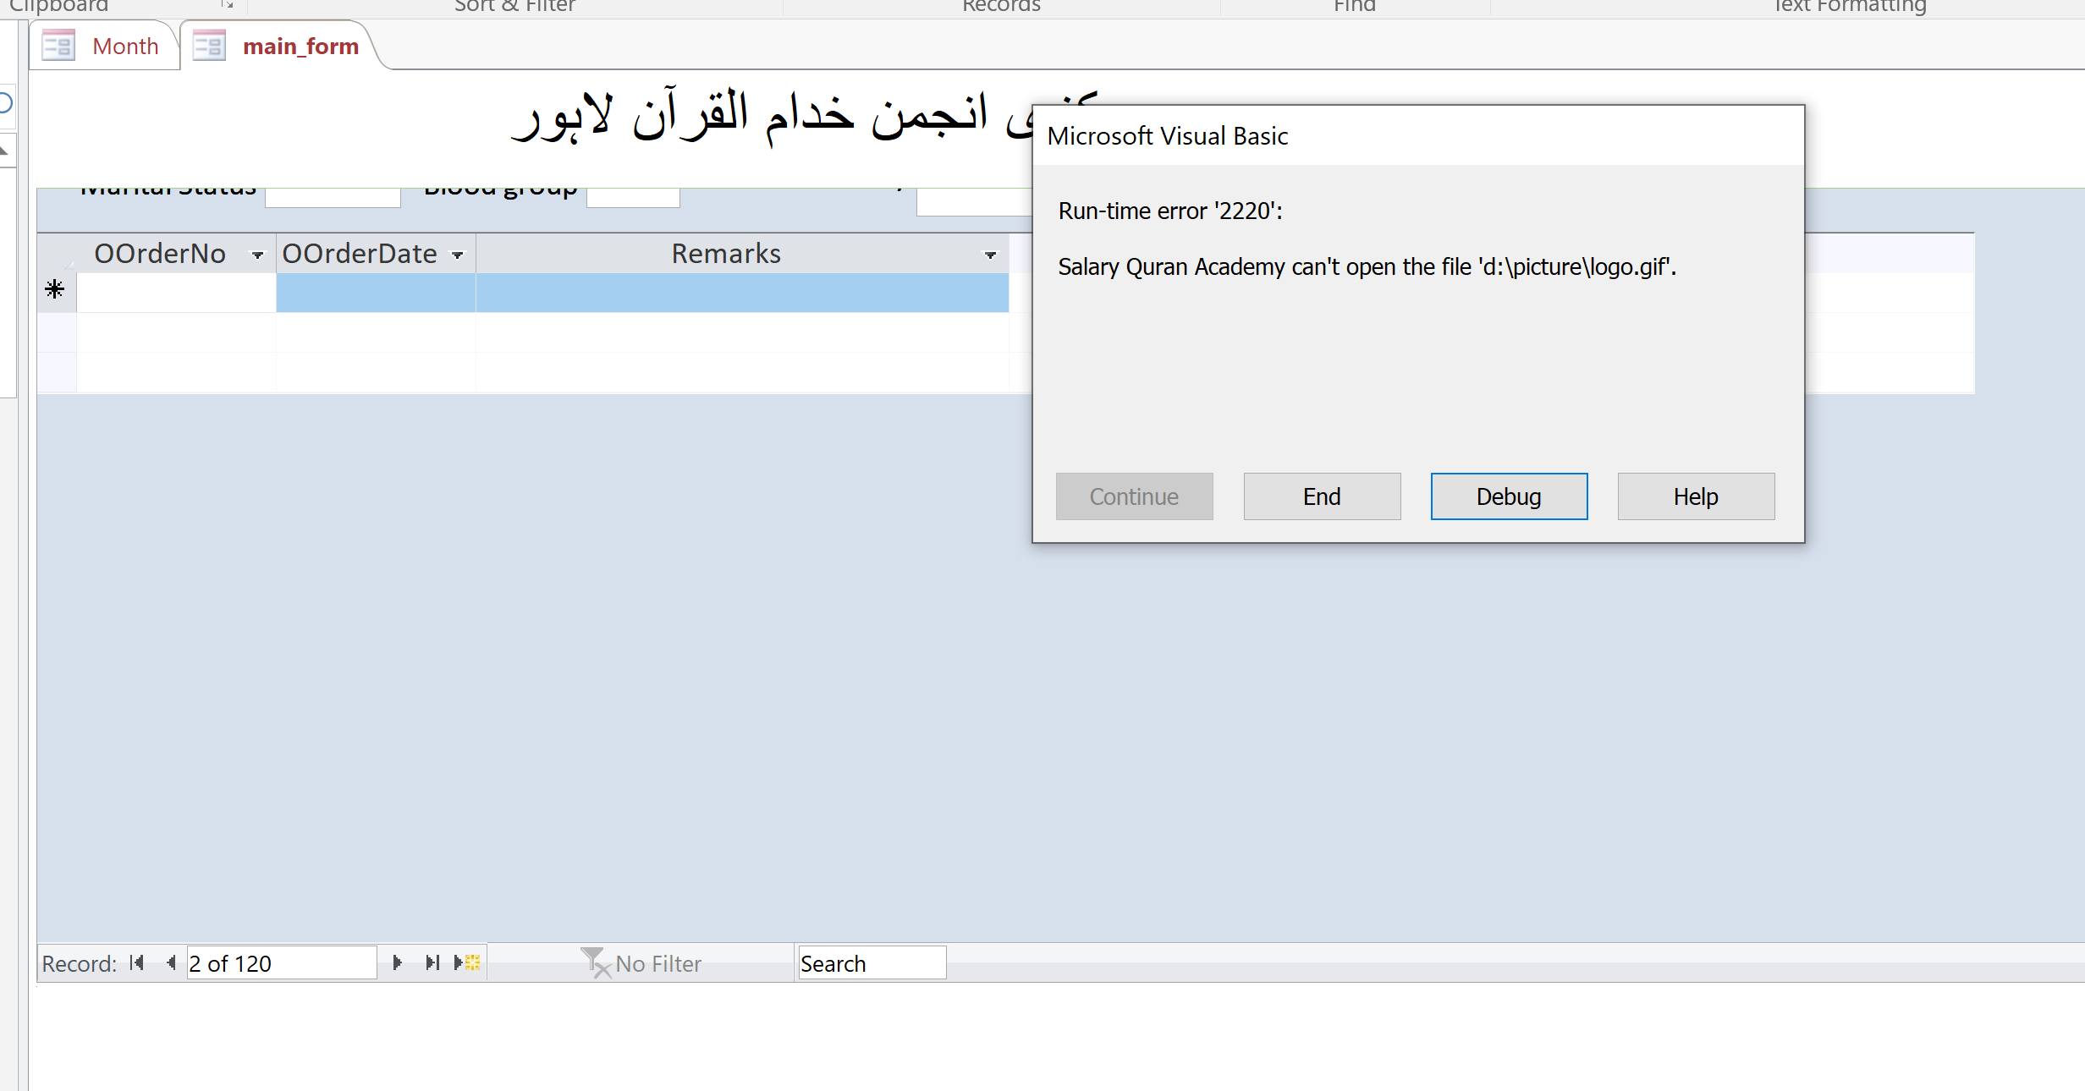

#4

Set value of both new fields ( Arr. EOBI) to 0. They will add manually if they want.