Lab 2 - Implementing Decision Instructions in RISC V Assembly Language

Name:M. Shees Abbas | Student ID: ma11212

Task 1a:

Code:
Listing 3
.text
.globl main
main:
li x20, 0x6
li x21, 0x3
li x22, 0x7
li x23, 0x5

bne x22,x23,Else
add x19, x20, x21
beq x0,x0,Exit
Else: sub x19, x20, x21
Exit:

end:
j end

listing 4
.text
.globl main
main:
li x24, 2
li x25, 0x100
li x22, 0
li x5, 2
sw x5, 0(x25)
li x5, 2
sw x5, 4(x25)
li x5, 4
sw x5, 8(x25)
li x5, 2
sw x5, 12(x25)
Loop: slli x10,x22,2
add x10, x10, x25
lw x9, 0(x10)
bne x9,x24,Exit
addi x22,x22,1
beq x0,x0,Loop
Exit:

end:
j end

Results:

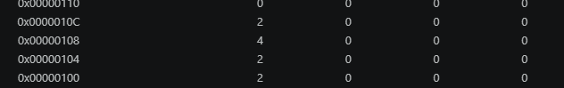
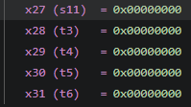
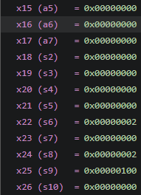
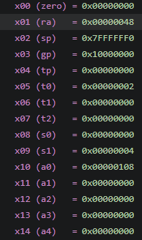
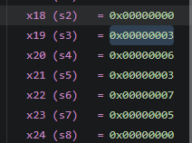
For listing 3
Before jump after jump registers at the end


For listing 4
Array save[i] = [2,2,4,2] stored in memory

PC before unconditional jump PC after unconditional jump

PC before conditional jump PC after conditional jump

Registers final values
Task 2:

Code:
.text
.globl main
main:
li x20, 4
li x21, 2
li x22, 3
li x23, 4
li x5, 1

bne x20, x5, Case2
add x21, x22, x23
j done
Case2: li x5, 2
bne x20, x5, Case3
sub x21, x22, x23
j done
Case3: li x5, 3
bne x20, x5 ,Case4
slli x21, x22, 1
j done
Case4: li x5, 4
bne x20, x5, default
srli x21, x22, 1
j done
default: li x21, 0

done:

end:
j end

Results:
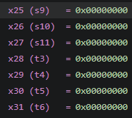
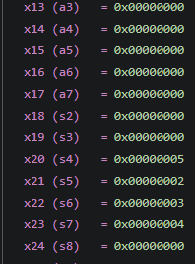
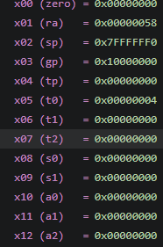
Taking x = 5
Case 1-2 PC before after Case 2-3 PC before after

Case 3-4 PC before after Case 4-default PC before after

Registers final values

Task 3:

Code:
.text
.globl main
main:
li x22, 0
li x23, 0
li x5, 10
li x6, 0x200

FOR1: bge x22, x5, EXIT1
slli x7, x22, 2
add x7, x7, x6
sw x22, 0(x7)
addi x22,x22,1
j FOR1
EXIT1:
li x22, 0
FOR2:bge x22,x5,EXIT2
slli x7,x22,2
add x7, x7, x6
lw x8, 0(x7)
add x23, x23,x8
addi x22,x22,1
j FOR2
EXIT2:

end:
j end

Results:

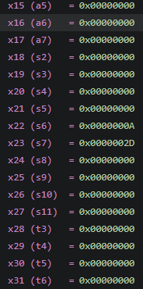
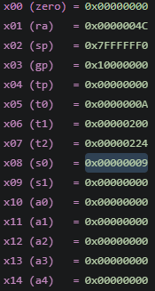
PC of loop 1 Before After PC of loop 2 Before After

Memory of array
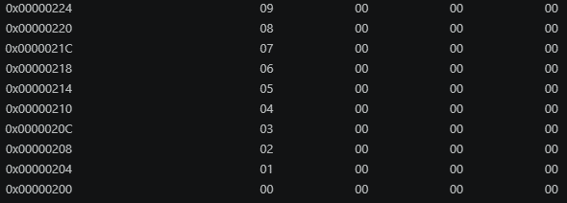
Final register

Task 4:

Code:
.text
.globl main
main:
li x7, 0
li x5, 5
li x6, 5
li x10, 0x100
FOR2:
bge x7, x5, Exit2
li x29, 0
FOR1:
bge x29, x6, EXIT1
slli x8, x29, 2
add x8, x8, x10
add x9, x7,x29
sw x9, 0(x8)
addi x29,x29,1
j FOR1
EXIT1:
addi x7, x7,1
j FOR2
Exit2:

end:
j end

Results:
PC of inner loop jump before and after: PC of outer loop jump before and after:

Final memory value
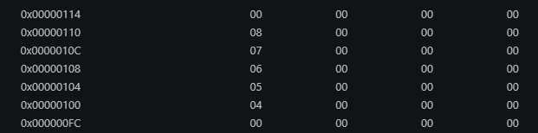
Final register values
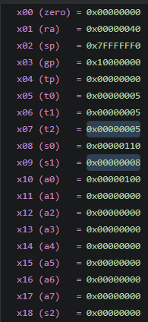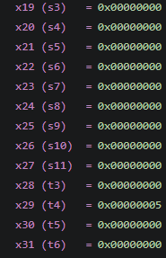

Assessment Rubric
Lab 2 - Implementing Decision Instructions in RISC V Assembly Language

Name | Student ID: | Section:

Points Distribution:

 | Task No. | LR 2 (Code) | LR 5 (Results)
In-Lab | Task 1 | - | /5
In-Lab | Task 2 | /10 | /10
In-Lab | Task 3 | /15 | /10
In-Lab | Task 4 | /20 | /10
Total Points: 100 |  | /45 | /35
CLO Mapped |  | CLO 2

Affective Domain Rubric |  | Points | CLO Mapped
AR7 | Report Submission & Git Upload | /10 & /10 | CLO 2

CLO | Total Points | Points Obtained
2 | 100
Total | 100

GitHub Repo link: https://github.com/M-Shees-Abbas/CA-labs.git

