Lab 1 - Getting Started with RISC-V (Assembly Language) in VS Code

Name: Muhammad Shees Abbas | Student ID: ma11212

Task 3:

Code:
.text
.globl main
main:
li x20, 5
li x21, 0

addi x20, x21, 32

add x22, x20, x21 # a = x20 , b =x21, temp(a+b) = x22
addi x23, x22, -5 #d = x23
sub x22, x20, x23 # temp(a-d) = x22
sub x5, x21, x20 # temp(b-a) = x5
add x6, x22, x5 # temp((a-d)+(b-a)) = x6
add x7, x6, x23 # e = x7

add x22, x20, x21 # temp(a+b) = x22
add x5, x23, x7 # temp(d+e) = x5
add x7, x22, x5

end:
j end

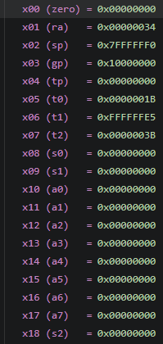
Results:
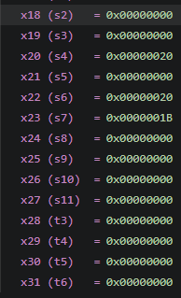

Task 4a:
.text
.globl main
main:
li x10, 0x78786464
li x11, 0xA8A81919
li x5, 0x100
li x6, 0x1F0

sw x10, 0(x5)
sw x11, 0(x6)

lh x12, 0(x5)
lh x13, 0(x6)

lb x14, 0(x6)

end:
j end

- Store x10 as unsigned integer at address 0x100.
Memory 0x100 will become 0x787876464

- Store x11 as unsigned integer at address 0x1F0.
Memory 0x1F0 will become 0x787876464

- Load an unsigned short integer (two bytes) from address 0x100 in x12.
X12 register will become 0x00006464

- Load a short integer from address 0x1F0 in register x13.
X13 register will become 0x00001919

- Load a singed character from address 0x1F0 in register x14.
X14 register will become 0x00000019

Task 4b:

Code:
.text
.globl main
main:
li x5, 0x100
li x6, 0x200
li x7, 0x300

lb x21, 0(x5)
lh x22, 0(x6)
add x23, x21, x22
sw x23, 0(x7)

lb x21, 1(x5)
lh x22, 2(x6)
add x23, x21, x22
sw x23, 4(x7)

lb x21, 2(x5)
lh x22, 4(x6)
add x23, x21, x22
sw x23, 8(x7)

lb x21, 3(x5)
lh x22, 6(x6)
add x23, x21, x22
sw x23, 12(x7)

end:
j end

Results:
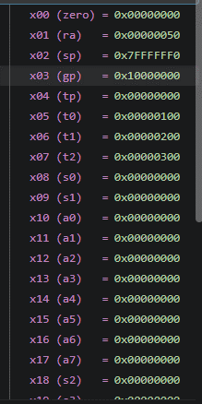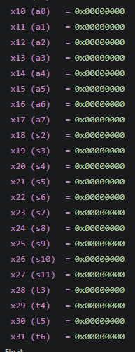

Github repo link: https://github.com/M-Shees-Abbas/CA-labs.git

Assessment Rubric
Lab 1: Getting Started with RISC-V (Assembly Language) n VS Code

Name | Student ID: | Section:

Points Distribution:

 | Task No. | LR 2 (Code) | LR 5 (Results)
In-Lab | Task 1 | - | /15
In-Lab | Task 2 | - | /15
In-Lab | Task 3 | /10 | /5
In-Lab | Task 4a | /10 | /5
In-Lab | Task 4b | /10 | /10
Total Points: 100 |  | /30 | /50
CLO Mapped |  | CLO 2

Affective Domain Rubric |  | Points | CLO Mapped
AR7 | Report Submission & Git Upload | /10 & /10 | CLO 2

CLO | Total Points | Points Obtained
2 | 100
Total | 100

