Born in the wrong place, living 16 years less
A visual story for a ministry of health planning where to focus health spending. Data: World Bank WDI, 208 countries, latest year 2022.
Question: does where a person is born still decide how long they live? Short answer: largely yes, and income explains much of it, but not all.

Figure 1. Where is life expectancy lowest?
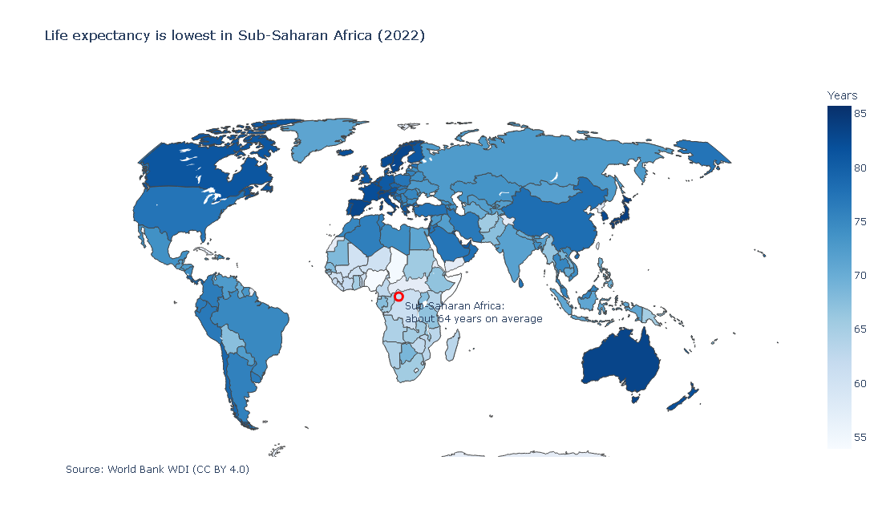 | Question: Which parts of the world have the lowest life expectancy?  What it shows: The lowest values cluster in Sub-Saharan Africa (average 64.1 years). The highest are in Europe, North America and parts of East Asia.  Design choices: Choropleth with a sequential Blues palette: lightness carries the value, so it still reads in colour-blindness simulation and grayscale. Continuous scale, because classes would hide differences. Natural Earth projection limits area distortion. One callout on the map itself.  So what: The low values are concentrated in one region, so this is a regional problem, not scattered cases.

Figure 2. How big is the gap?
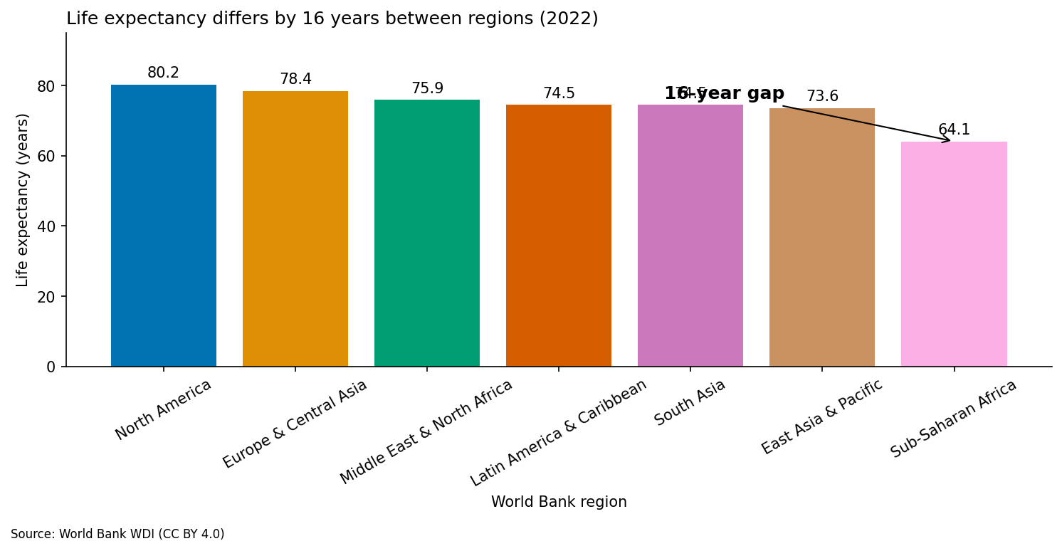 | Question: How far apart are the regions?  What it shows: North America averages 80.2 years and Sub-Saharan Africa 64.1, a gap of 16 years.  Design choices: Bars sorted high to low with the axis starting at zero, so lengths are honest. Values printed on the bars and a colourblind-safe palette, so no one depends on colour alone.  So what: Region of birth is associated with about 16 years of life, a very large difference.

Figure 3. Is the gap closing?
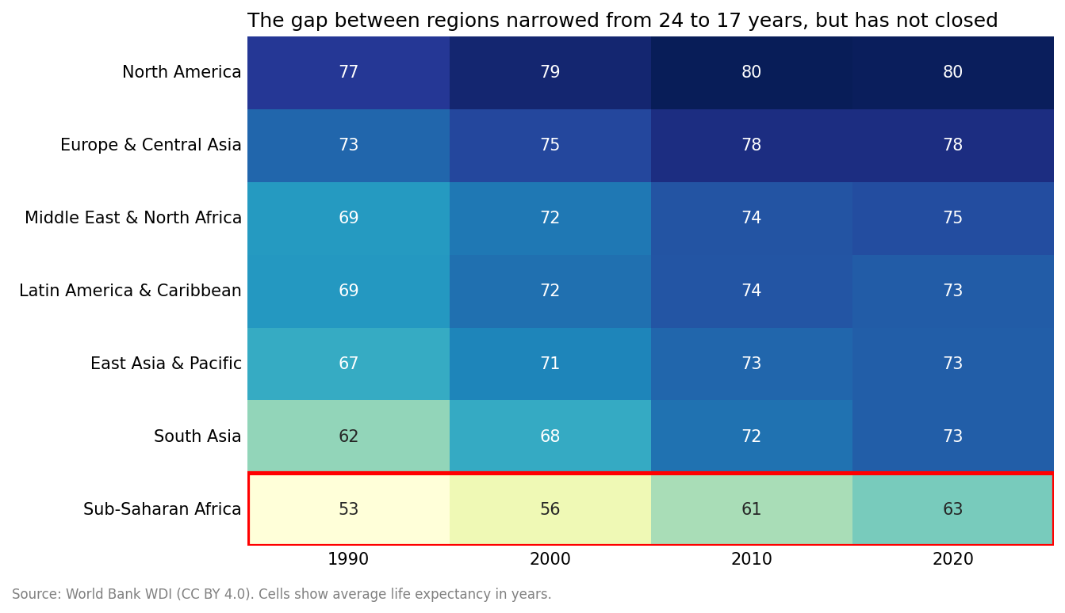 | Question: Has the gap between regions changed since 1990?  What it shows: The gap between the highest and lowest region fell from 24 years (1990s) to 17 (2020s). Every region improved. South Asia gained most (+11 years); Sub-Saharan Africa gained 11.  Design choices: Heatmap with a sequential palette, rows sorted by latest value, whole-number cells for exact values, no colour bar or grid lines (they repeat the numbers). One outline marks the lowest region. The 2020s column covers 2020 to 2022 only.  So what: Progress is real but incomplete: the gap is narrower, not closed.

Figure 4. Is it income?
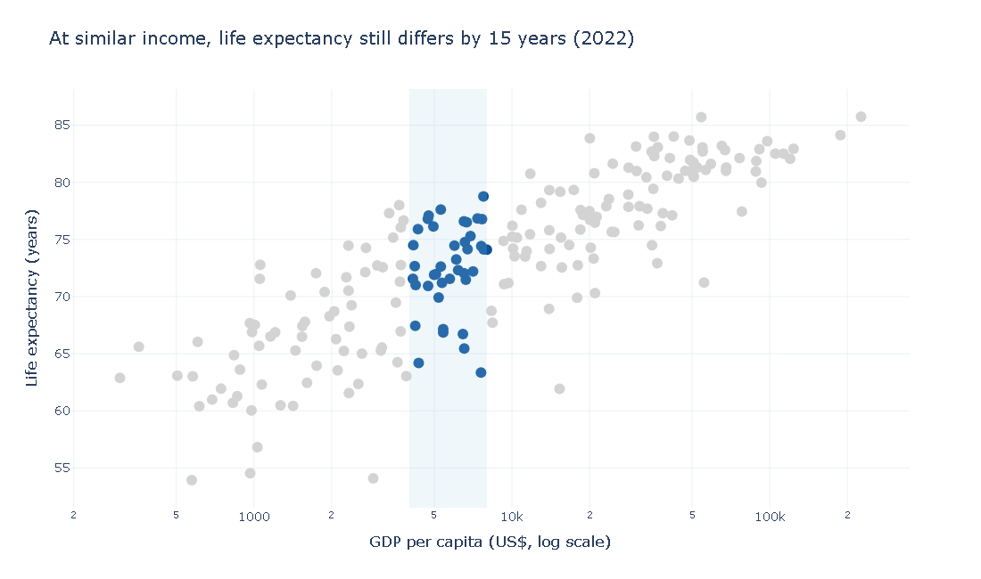 | Question: Does income explain the differences?  What it shows: Log GDP per capita and life expectancy correlate at r = 0.83, so income accounts for about 70% of the variation. But 40 countries with similar income (US$4,000 to 8,000) still span 15 years, from Equatorial Guinea to Albania.  Design choices: GDP on a log axis because it is heavily skewed. Everything outside the income band is grey and the band is one dark colour with a shaded stripe, so the eye goes to the point.  So what: Income matters, but countries with the same income reach very different outcomes. This is an association, not proof of cause.

Figure 5. Is it the region?
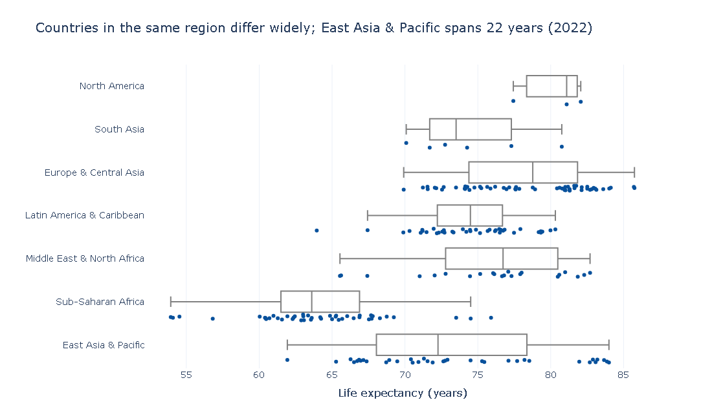 | Question: How much do countries differ inside one region?  What it shows: East Asia & Pacific spans 22 years between its lowest and highest country, while North America spans only 5.  Design choices: Box plot with a dot for every country, so the box cannot hide individuals. Regions sorted by spread.  So what: Regional averages hide large differences, so targeting by region alone would miss countries.

Takeaway for the ministry
Income and region explain much of the gap in life expectancy, but not all of it. Three implications:
- Prioritise the countries in Sub-Saharan Africa, where the lowest values cluster.
- Do not use income alone to target spending: countries at the same income differ by many years.
- Study the best performers within each income band to see which policies they share.

Methods note and limitations
Data: World Bank World Development Indicators (CC BY 4.0), 1990 to 2022; latest year 2022 because it still covers at least 179 countries in every column. Cleaning: aggregates such as World removed; 350 rows missing life expectancy, GDP or population dropped; Central African Republic removed because its life expectancy swings implausibly between years; missing CO2 and internet values left missing, not filled with zero. Limitations: regional averages are simple country averages, not population-weighted; correlations show association, not causation; the network and Sankey in Part 8 use derived relationships, not real migration flows; very small countries such as Monaco and San Marino have less stable values.

