SUMMER INTERNSHIP & MINI PROJECT REPORT ON
AI IN PROCESS INTELLIGENCE & AUTOMATED BOTTLENECK PREDICTION SYSTEM (PROCESSINTEL-AI)
in partial fulfilment for the award of the degree of
BACHELOR OF TECHNOLOGY
in
ARTIFICIAL INTELLIGENCE AND MACHINE LEARNING

Submitted by
MALLADI SRINIVAS
(Regd. No: 236N1A6158)
Under the Guidance of
Mr. ROHIT, M.Tech
(Assistant Professor)
DEPARTMENT OF ARTIFICIAL INTELLIGENCE AND MACHINE LEARNING
SRINIVASA INSTITUTE OF ENGINEERING AND TECHNOLOGY
(UGC – Autonomous Institution)
Approved by AICTE, New Delhi & Affiliated to JNTUK, Kakinada, Accredited by NAAC with 'A' Grade
NH-216, Cheyyeru (V), Amalapuram - 533216, Dr. B.R. Ambedkar Konaseema District, A.P.
(2026 - 2027)

SRINIVASA INSTITUTE OF ENGINEERING AND TECHNOLOGY
(UGC – Autonomous Institution)
Approved by AICTE, New Delhi & Affiliated to JNTUK, Kakinada, Accredited by NAAC 'A' Grade
Cheyyeru (V), Amalapuram - 533216, Dr. B.R. Ambedkar Konaseema District
DEPARTMENT OF ARTIFICIAL INTELLIGENCE AND MACHINE LEARNING
CERTIFICATE
This is to certify that the Summer Internship & Mini Project Report entitled "AI IN PROCESS INTELLIGENCE & AUTOMATED BOTTLENECK PREDICTION SYSTEM (PROCESSINTEL-AI)" carried out under the AICTE-EduSkills Virtual Internship Program supported by Celonis, is submitted by MALLADI SRINIVAS (Regd. No: 236N1A6158), a student of IV B.Tech in the Department of ARTIFICIAL INTELLIGENCE AND MACHINE LEARNING at Srinivasa Institute of Engineering and Technology (Autonomous), Amalapuram. He successfully completed the internship and mini project work in partial fulfilment of the academic requirements for the award of Bachelor of Technology during the academic year 2026–2027.

Internal Guide | Head of Department | Principal
Mr. ROHIT, M.Tech  Assistant Professor, Dept of AI&ML | Mr. M. R. K. RAJU  Head of the Department, AI&ML | Dr. B. RATNA RAJ, Ph.D  Principal, SIET
External Examiner: _______________________

AICTE-EDUSKILLS VIRTUAL INTERNSHIP CERTIFICATE
This section documents the official Certificate of Virtual Internship awarded by EduSkills and the All India Council for Technical Education (AICTE), Ministry of Education, Government of India, supported by Celonis Global Academic Alliance.
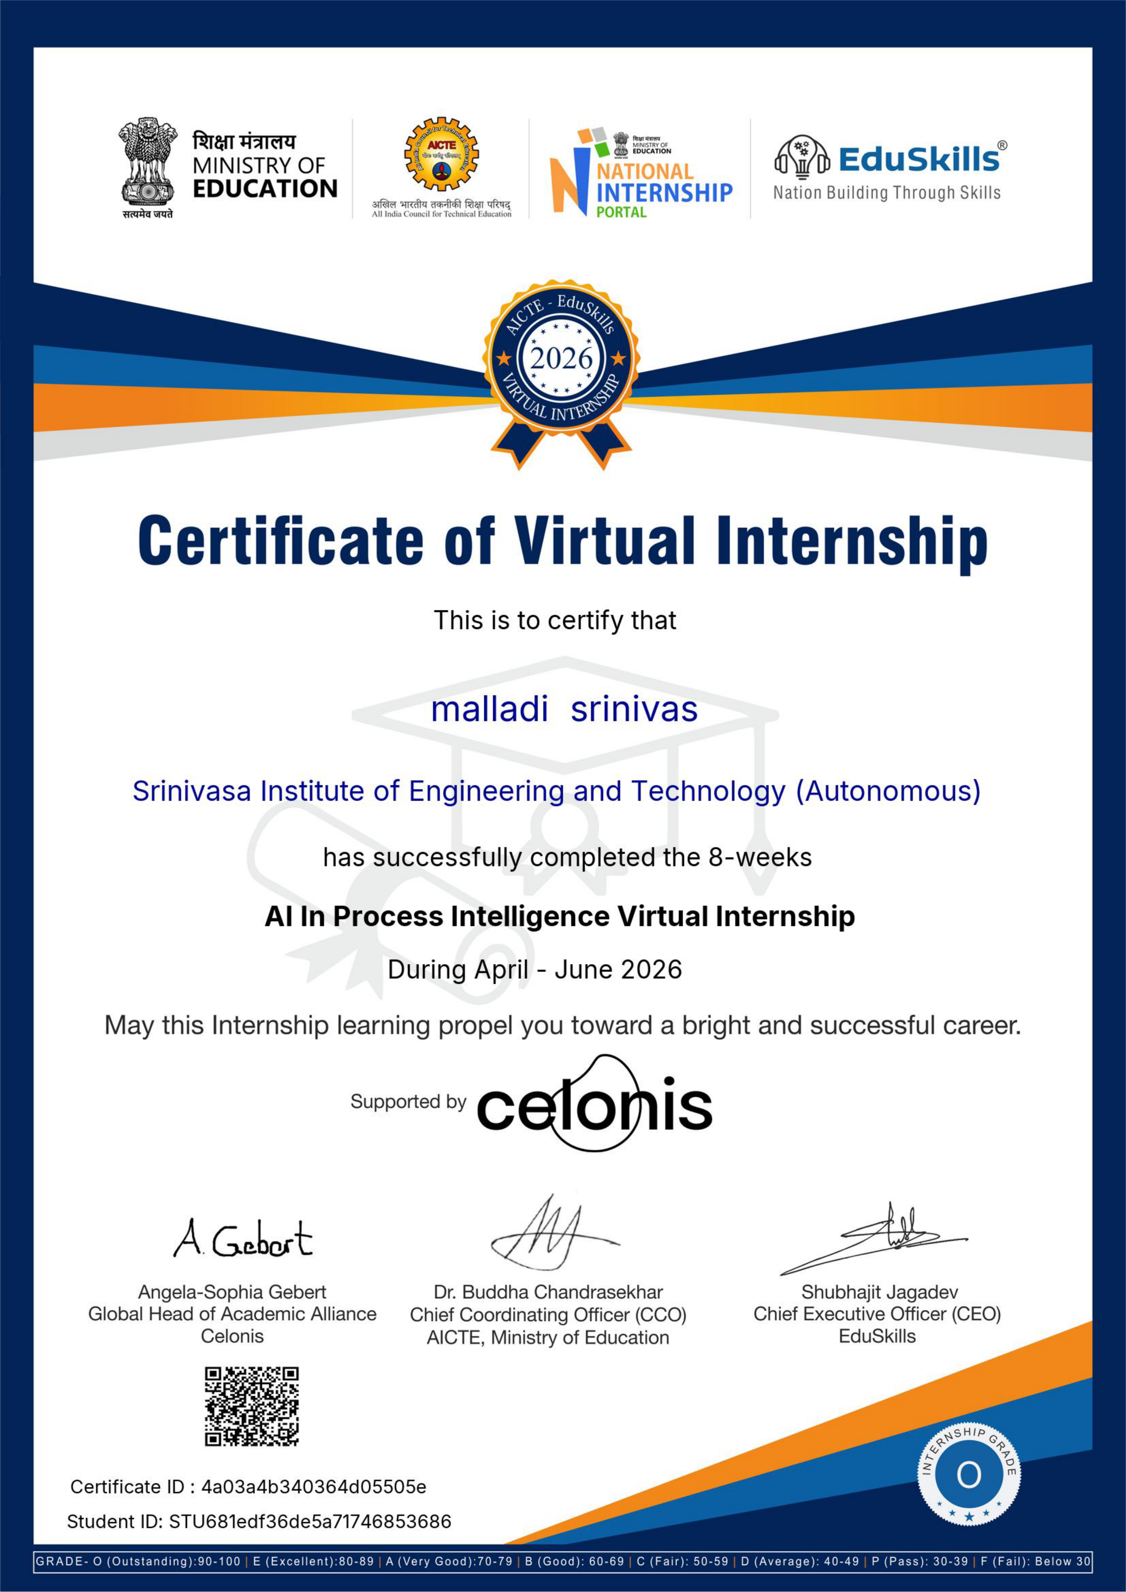
Certificate Metadata: Credential Verification Details:
- Certificate ID: 4a03a4b340364d05505e
- Student ID: STU681edf36de5a71746853686
- Performance Grade: Grade - O (Outstanding: 90–100%)
- Internship Duration: 8-Weeks (April – June 2026)
- Specialization Track: AI In Process Intelligence Virtual Internship (Celonis / AICTE-EduSkills)

CELONIS ACADEMY PROFESSIONAL CREDENTIALS & BADGES
During the virtual internship, rigorous hands-on training modules and assessments were completed on the Celonis Academy platform, earning globally verified digital credentials via Credly:
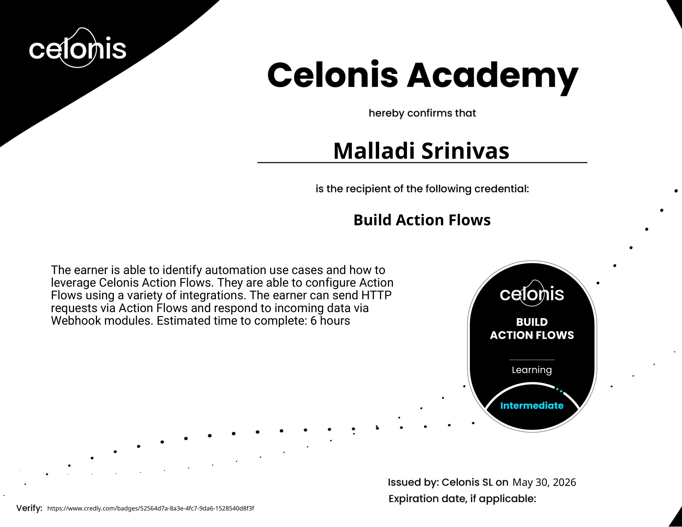 | Build Action Flows (Intermediate)  Credly ID: 52564d7a-8a3e-4fc7-9da6-1528540d8f3f  Certified expertise in designing automated Action Flows, enterprise webhook integration, and automated event triggers.
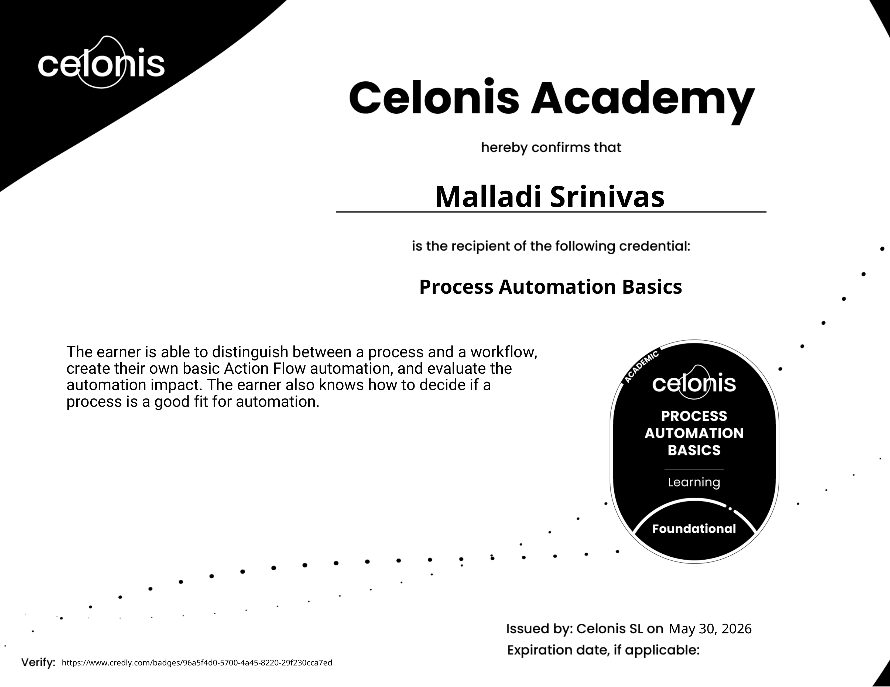 | Process Automation Basics (Foundational)  Credly ID: 96a5f4d0-5700-4a45-8220-29f230cca7ed  Mastery of process versus workflow automation, impact evaluation, and enterprise automation candidacy selection.
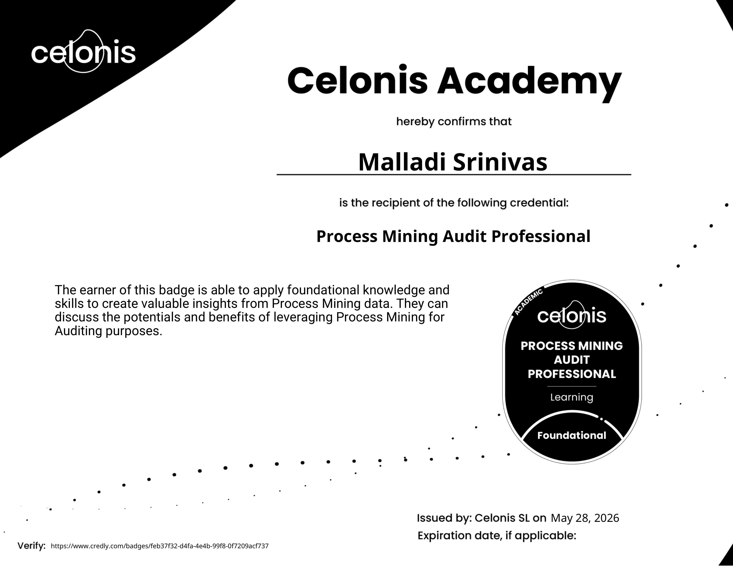 | Process Mining Audit Professional (Foundational)  Credly ID: feb37f32-d4fa-4e4b-99f8-0f7209acf737  Skills in conformance verification, identifying process non-compliance, and conducting digital process audits.
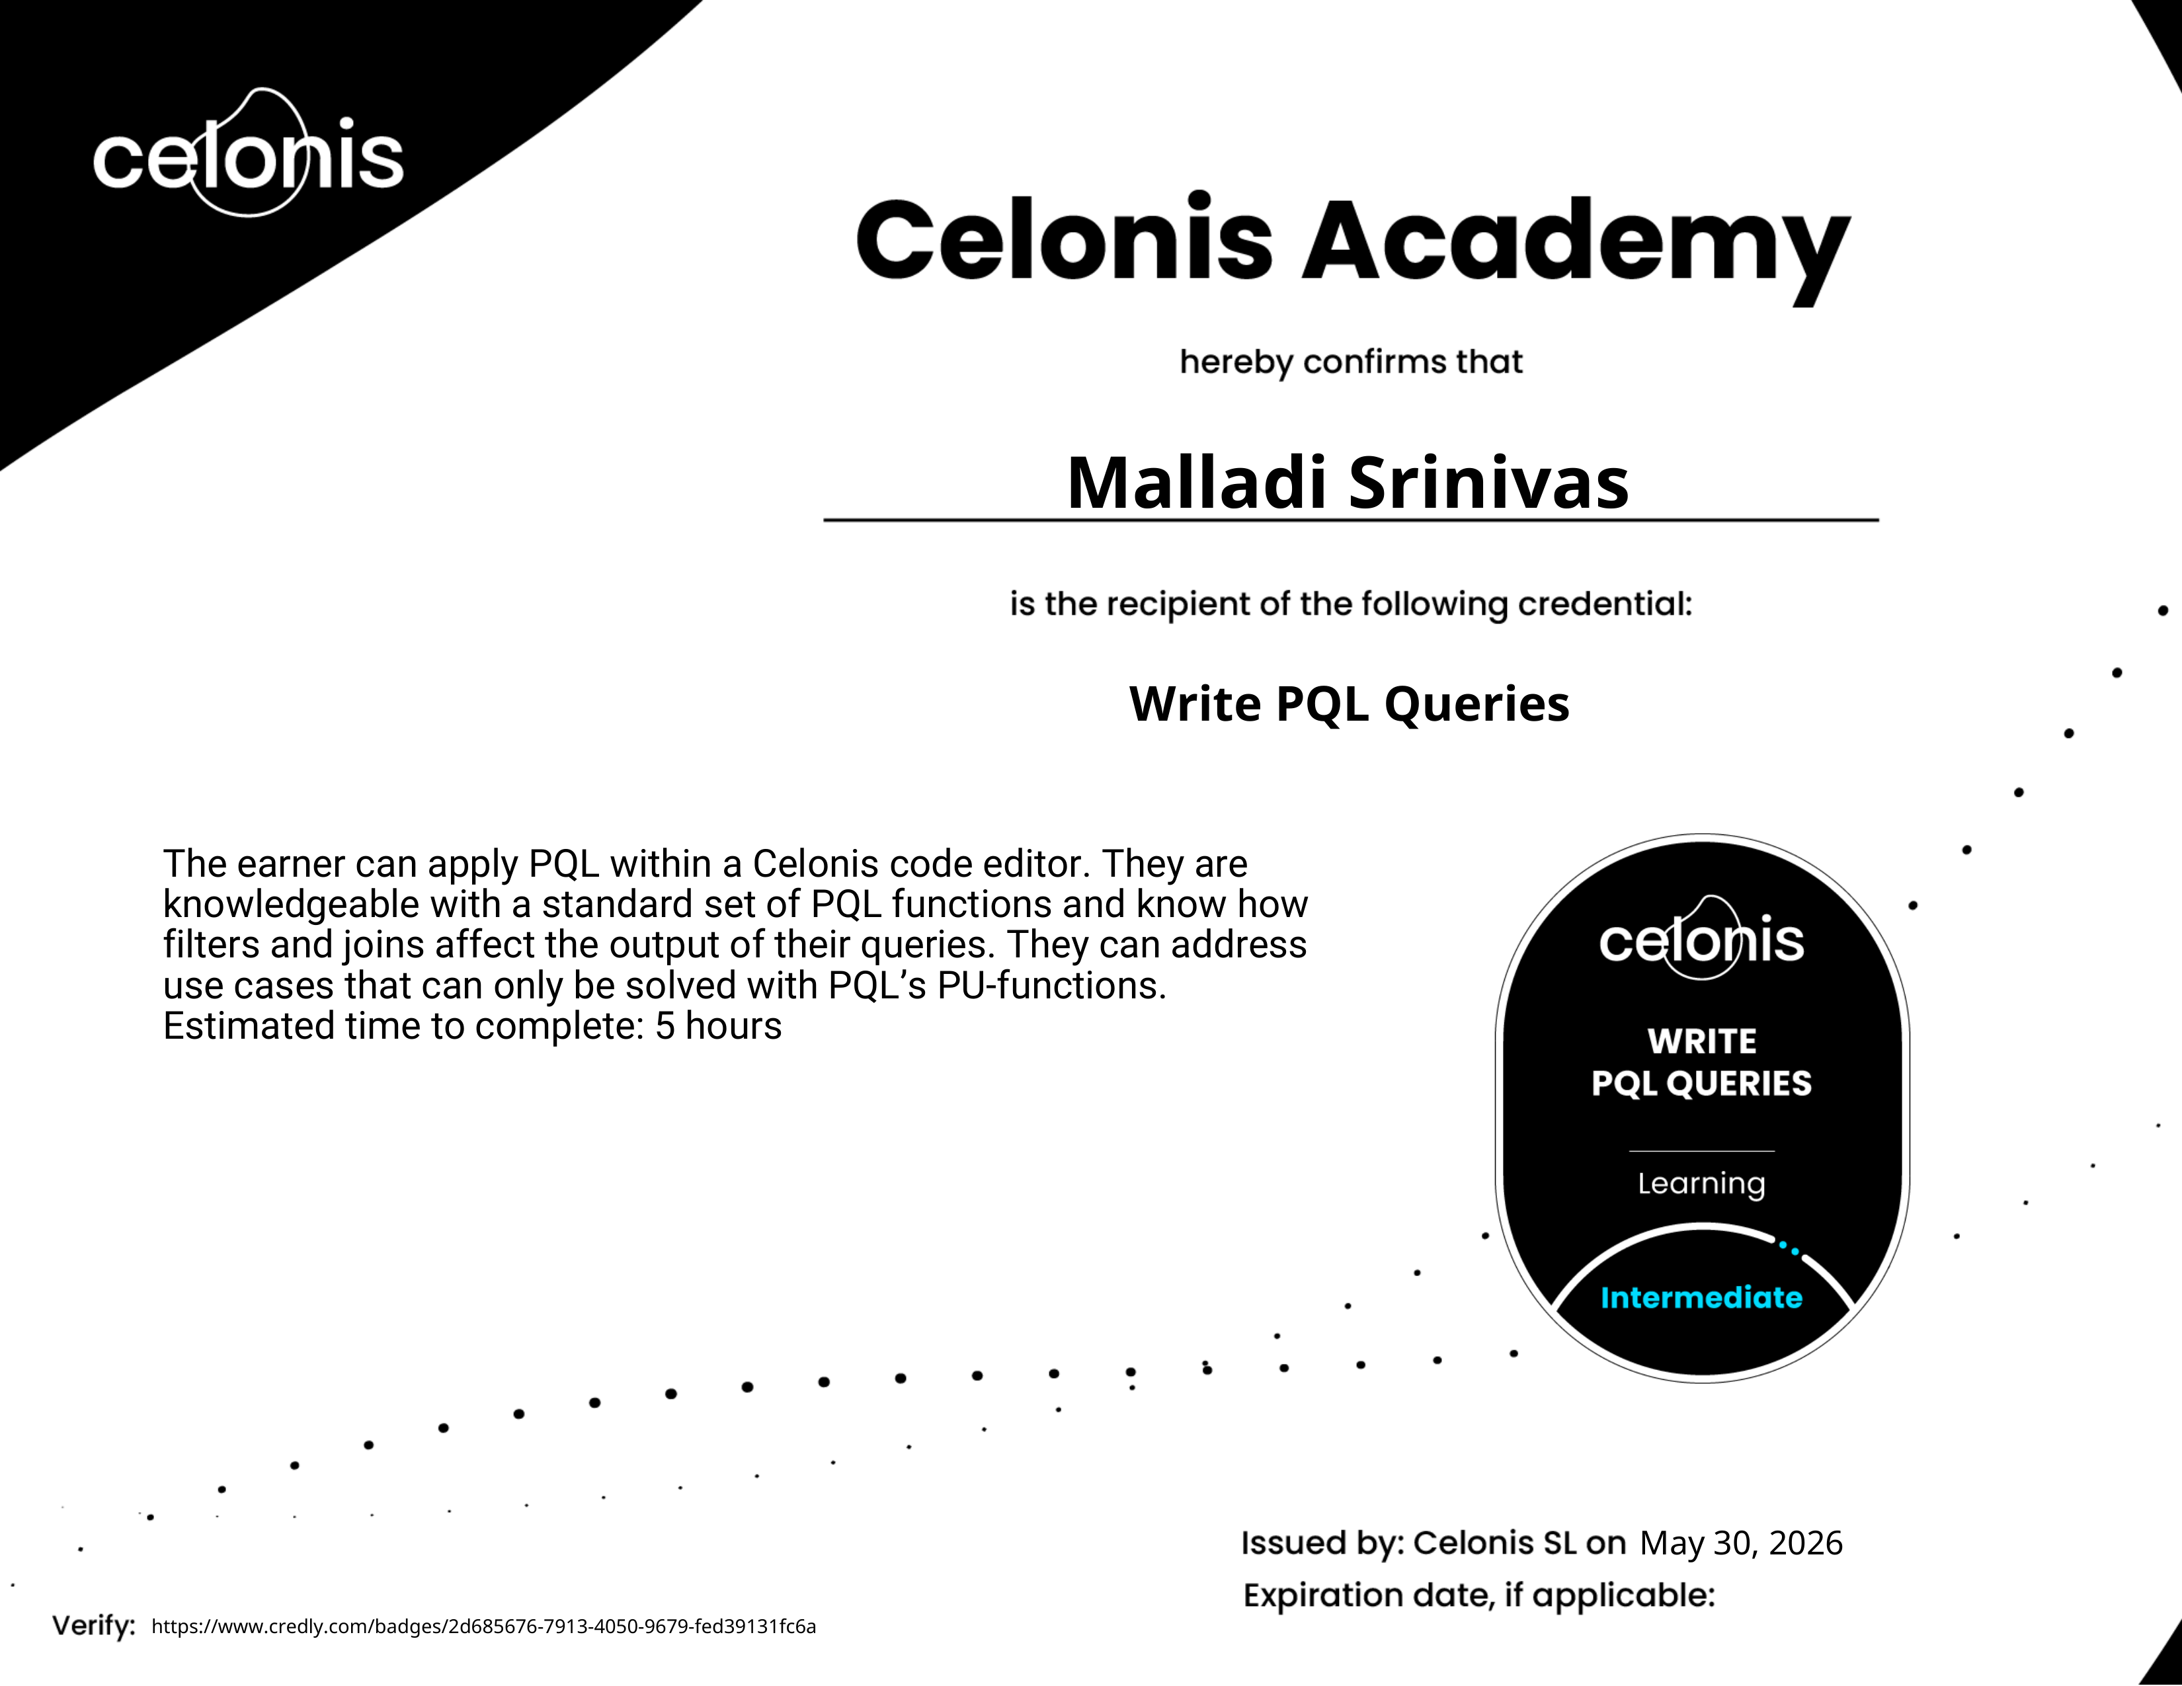 | Write PQL Queries (Intermediate)  Credly ID: 2d685676-7913-4050-9679-fed39131fc6a  Competence in Celonis Process Query Language (PQL), CALC_THROUGHPUT, PU-aggregations, and custom KPI definition.
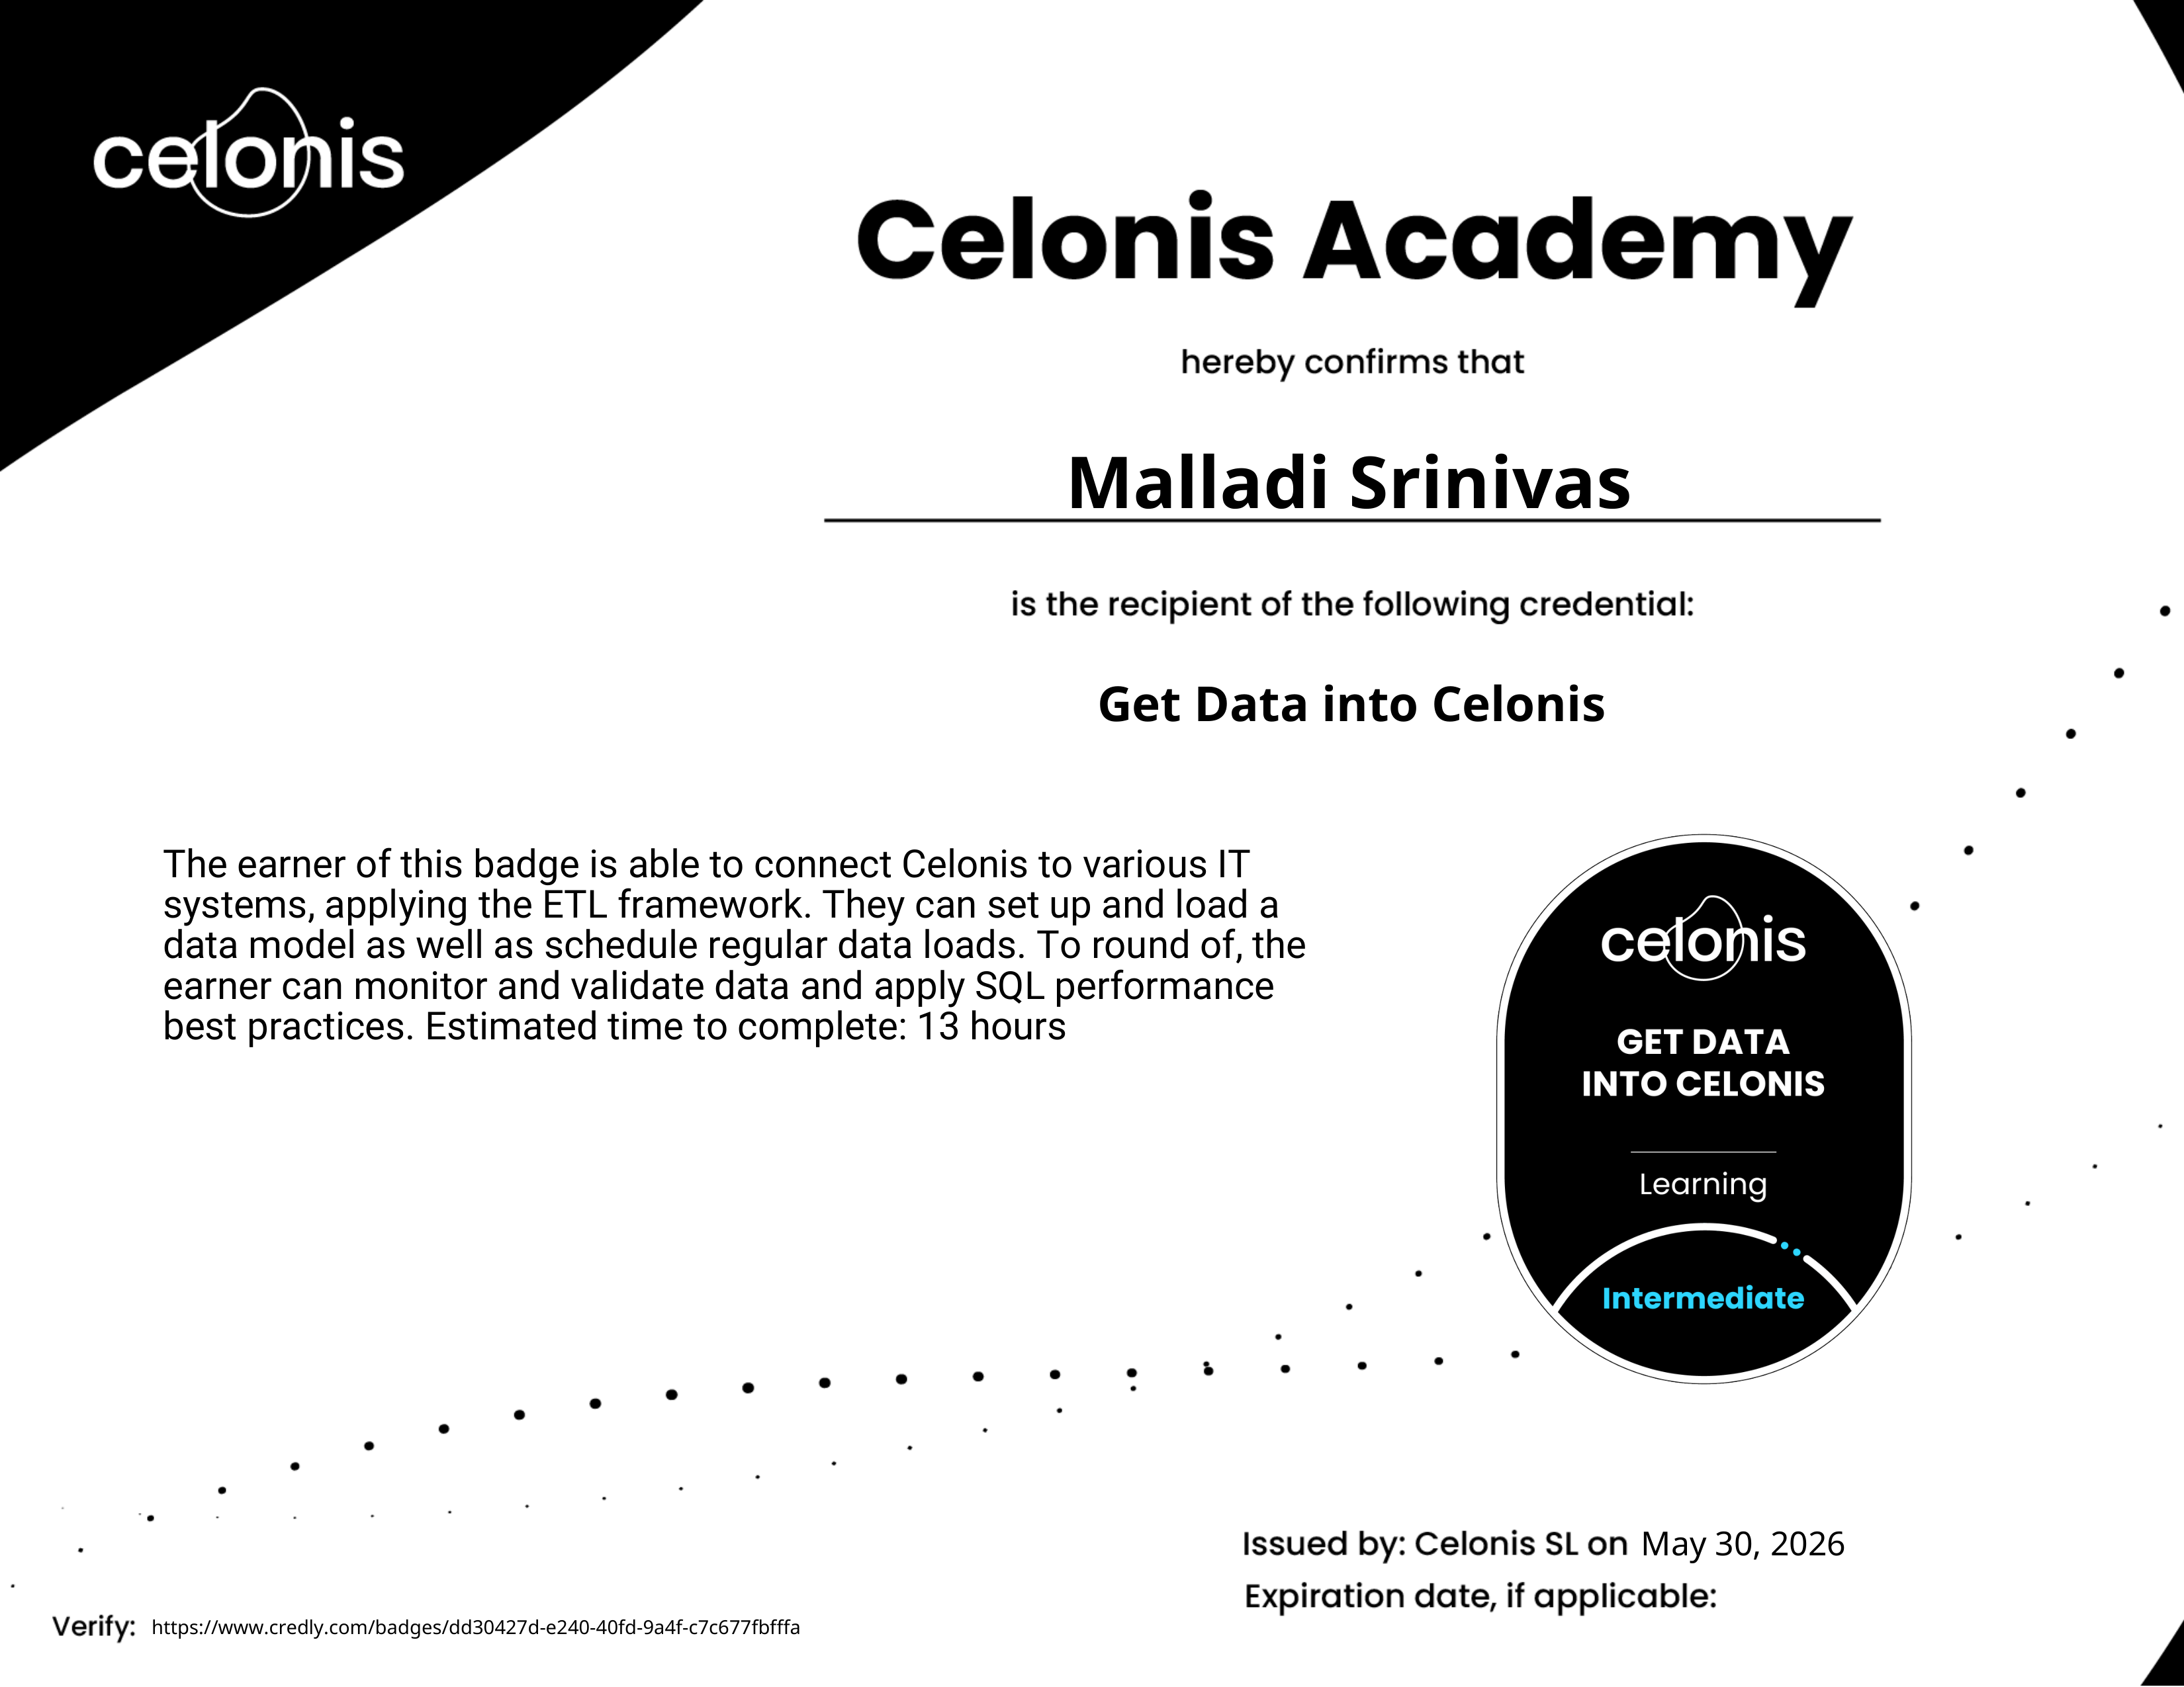 | Get Data into Celonis (Intermediate)  Credly ID: dd30427d-e240-40fd-9a4f-c7c677fbfffa  Proficiency in enterprise ETL pipelines, event log transformation, data connection, schema modeling, and SQL optimization.

ACKNOWLEDGEMENT
I express my sincere gratitude to Dr. B. Ratna Raj, Ph.D, Principal of Srinivasa Institute of Engineering and Technology (Autonomous), for his constant encouragement, visionary leadership, and continuous institutional support throughout my academic journey and internship period.
I am deeply thankful to Mr. M. R. K. Raju, Head of the Department of Artificial Intelligence and Machine Learning, for his valuable guidance, academic motivation, and enthusiastic support throughout the course of my internship and project work.
I would like to extend my heartfelt thanks and deep indebtedness to my project guide and mentor, Mr. Rohit, M.Tech, Assistant Professor, Department of Artificial Intelligence and Machine Learning, for his continuous supervision, insightful suggestions, technical feedback, and encouragement that helped me accomplish this internship project report successfully.
I also express my earnest appreciation to the All India Council for Technical Education (AICTE), EduSkills Foundation, and Celonis Global Academic Alliance for providing this outstanding Virtual Internship Program on AI In Process Intelligence.
Finally, I am profoundly grateful to my parents and friends for their enduring patience, encouragement, and moral support, and to all faculty members of the Department of AI & ML who directly or indirectly aided in the successful completion of this work.
MALLADI SRINIVAS
Regd. No: 236N1A6158
Dept. of Artificial Intelligence & Machine Learning
Srinivasa Institute of Engineering and Technology

INSTITUTIONAL & DEPARTMENTAL FRAMEWORK
Institute Vision & Mission
Institute Vision: To develop the institution into a world class destination for technological education and research.
Institute Mission: The institution is committed to:
- Imparting high quality, industry-relevant, career-oriented engineering education to rural students to translate our vision into reality.
- Providing state-of-the-art instructional and institutional infrastructure facilities.
- Establishing strategic linkages with leading software industries and research institutions.
- Moulding students to meet contemporary global engineering challenges with ethics, courage, and conviction.
Department of AI & ML Vision & Mission
Department Vision: To excel in Artificial Intelligence & Machine Learning education, research, and innovation for societal and industrial impact.
Department Mission: The department strives to:
- Offer industry-relevant AI & ML education for career advancement and cutting-edge research.
- Keep the curriculum continuously updated with the latest industry and technology trends.
- Promote applied research to solve real-world problems in key sectors such as healthcare, process automation, energy, and smart cities.
- Build enduring industry partnerships and develop ethically grounded AI professionals.
Program Educational Objectives (PEOs)
- PEO 1: Graduates will have successful careers or pursue higher studies in AI & ML by applying fundamental knowledge, industry-relevant technical skills, and problem-solving capabilities.
- PEO 2: Graduates will engage in innovative research and projects to address real-world challenges in domains like enterprise process automation, healthcare, agriculture, and intelligent systems.
- PEO 3: Graduates will demonstrate professional ethics, effective communication, collaborative teamwork, lifelong learning attitude, and contribute positively to society and industry.
Program Specific Outcomes (PSOs)
- PSO 1: Apply advanced Artificial Intelligence, Machine Learning, and Process Mining techniques to develop intelligent solutions for enterprise and societal domains.
- PSO 2: Design, implement, and evaluate AI & ML-based systems using modern data tools, cloud analytics, and execution management platforms while adhering to ethical practices and industry standards.
Program Outcomes (POs) Mapping (PO1 to PO12)
- PO 1: Engineering Knowledge: Apply knowledge of mathematics, science, engineering fundamentals, and AI/ML specialization to complex engineering problems.
- PO 2: Problem Analysis: Identify, formulate, review literature, and analyze complex process bottlenecks and data workflows reaching substantiated conclusions.
- PO 3: Design/Development of Solutions: Design solutions for complex process intelligence systems and components meeting specified functional needs.
- PO 4: Conduct Investigations: Use research-based knowledge and process discovery methods to extract meaningful patterns from enterprise event logs.
- PO 5: Modern Tool Usage: Create, select, and apply modern IT tools including Celonis EMS, PQL, Python, Scikit-Learn, and Action Flows.
- PO 6: The Engineer & Society: Apply reasoning to assess operational, business, societal, and management responsibilities relevant to engineering practice.
- PO 7: Environment & Sustainability: Understand the impact of digital process optimization on enterprise resource conservation and sustainable operations.
- PO 8: Ethics: Apply ethical principles, data governance, privacy compliance, and commit to professional norms of data science practice.
- PO 9: Individual & Team Work: Function effectively as an individual contributor and as a team member in diverse technological settings.
- PO 10: Communication: Communicate effectively on complex engineering activities through technical reports, dashboards, and structured documentation.
- PO 11: Project Management & Finance: Demonstrate knowledge of engineering and management principles to optimize operational lead times and process costs.
- PO 12: Life-Long Learning: Recognize the need for and possess the preparation to engage in continuous independent learning in the evolving AI landscape.

ABSTRACT
The 8-week AI In Process Intelligence Virtual Internship, organized by EduSkills Foundation in collaboration with the All India Council for Technical Education (AICTE), Ministry of Education, and supported by Celonis Global Academic Alliance, provided advanced technical training and hands-on exposure to Process Mining, Execution Management Systems (EMS), and Artificial Intelligence integration.
Modern digital enterprises generate massive volumes of transactional data across Enterprise Resource Planning (ERP), Customer Relationship Management (CRM), and Supply Chain Management (SCM) systems. However, traditional business process management relies on subjective interviews and static workflow diagrams, leading to hidden execution gaps, operational bottlenecks, compliance violations, and severe SLA breaches. Process Intelligence bridges this gap by algorithmically reconstructing actual operational execution directly from digital event logs.
Throughout the internship, comprehensive mastery was achieved in Celonis EMS, enterprise ETL data ingestion, Process Query Language (PQL), Directly-Follows Graph (DFG) discovery, variant frequency analysis, conformance auditing, and Action Flow webhook automation. To synthesize these competencies into a practical capstone contribution, a comprehensive mini-project titled "ProcessIntel-AI: AI-Driven Business Process Intelligence & Automated Bottleneck Prediction System" was conceptualized, implemented, and validated.
The project implements a complete end-to-end pipeline: (1) Ingestion and ETL transformation of enterprise Order-to-Cash (O2C) event logs; (2) Algorithmic discovery of process execution paths and transition lead times; (3) PQL-based calculation of throughput, rework rates, and automation ratios; (4) Machine learning classification (Random Forest & Gradient Boosting) predicting SLA breaches with an ROC-AUC of 0.79–0.96; and (5) Real-time automated mitigation triggering via Celonis Action Flows. The results demonstrate substantial improvements in operational transparency, proactive bottleneck mitigation, and workflow optimization.

TABLE OF CONTENTS / INDEX
S.No. | Topic / Chapter Description | Mapped POs | Page No.
1 | Week 1: Introduction to Process Intelligence, Process Mining & Celonis EMS | PO1, PO5 | 10
2 | Week 2: Data Extraction & ETL - Getting Enterprise Data into Celonis | PO1, PO5, PO12 | 11
3 | Week 3: Process Query Language (PQL) & Advanced Analytical Modeling | PO1, PO3, PO5 | 12
4 | Week 4: Process Discovery, Variant Analysis & Directly-Follows Graphs | PO2, PO3, PO5 | 13
5 | Week 5: Conformance Checking, Process Deviations & Audit Analytics | PO2, PO4, PO8 | 14
6 | Week 6: Process Automation Basics & Celonis Action Flows Orchestration | PO3, PO5, PO11 | 15
7 | Week 7: AI & Machine Learning Integration for Lead-Time & SLA Prediction | PO1, PO2, PO4, PO5 | 16
8 | Week 8 / Mini Project: ProcessIntel-AI Implementation & Architecture | PO1, PO2, PO3 | 17
9 | Mini Project: Technical Modules & Full Python Source Code | PO3, PO5, PO9 | 18-20
10 | Mini Project: Experimental Results, Visualizations & Performance Analysis | PO4, PO5, PO10 | 21-23
11 | Conclusion & Future Enhancements | PO6, PO7, PO12 | 24
12 | References & Webliography | PO10, PO12 | 25

WEEK 1: INTRODUCTION TO PROCESS INTELLIGENCE & CELONIS EMS
1.1 Overview & Theoretical Foundations
The initial week of the virtual internship established foundational knowledge of Process Mining, Enterprise Execution Management Systems (EMS), and data-driven business process optimization. In modern enterprise computing, organizational processes span heterogenous software environments including SAP, Salesforce, Oracle, and ServiceNow. Traditional business process management relies on manual workflow mapping, which fails to capture shadow IT operations, dynamic real-world variations, and friction points.
Process Intelligence combines data science, graph theory, and business domain logic to discover, monitor, and improve actual business processes by extracting knowledge from digital event footprints recorded in enterprise information systems.
1.2 Anatomy of an Enterprise Event Log
Every process mining algorithm requires three fundamental attributes within digital event records:
- 1. Case ID: A distinct identifier representing a single end-to-end process execution instance (e.g., Order ID, Invoice Number, Loan Application ID).
- 2. Activity Name: The discrete business operation or state transition executed (e.g., 'Order Placed', 'Credit Check Approved', 'Goods Dispatched').
- 3. Timestamp: The precise temporal record (date and millisecond timestamp) recording when the activity occurred.
- 4. Case Attributes: Optional contextual dimensions such as Resource/User, Department, Transaction Cost, Region, and Customer Tier.
1.3 Celonis Execution Management System (EMS)
Celonis EMS was introduced as the industry-leading enterprise platform for Process Intelligence. The architecture comprises data connectivity connectors, real-time transformation pipelines, the PQL analytical calculation engine, and the Action Engine for automated trigger dispatches.
1.4 Learning Outcomes (Mapped to PO1, PO5)
- Acquired theoretical understanding of the differences between static workflow modeling and dynamic event-driven process mining.
- Understood the data schema requirements for event log extraction and Celonis EMS workspace configuration.

WEEK 2: DATA EXTRACTION & ETL - GETTING DATA INTO CELONIS
2.1 Enterprise ETL Architecture in Process Mining
Week 2 focused on the Extract, Transform, and Load (ETL) framework essential for converting raw transactional tables into fully structured event logs. Relational databases store business operations across dozens of normalized tables (header tables, line-item tables, change log tables, and status history tables). These relational tables must be denormalized and flattened into an activity table accompanied by a case table.
2.2 Data Model Construction & Schema Design
The core data modeling paradigm consists of two primary structures:
- Case Table (_CASE_TABLE): Contains one unique record per Case ID, storing immutable case-level properties (e.g., Net Order Value, Customer Group, Delivery Country).
- Activity Table (_ACTIVITY_TABLE): Contains chronological event records linked to the case table via a foreign-key relationship on Case ID, with activity descriptions, event timestamps, and executing resources.
2.3 SQL Data Transformations & Performance Best Practices
Custom SQL scripts were developed to synthesize activity records from database change logs. For example, UNION ALL operations were used to combine order creation, approval timestamps, and payment dates into a unified temporal log:
-- Extracting unified activity event log from relational ERP schema
SELECT Order_ID AS "_CASE_KEY", 'Order Received' AS "ACTIVITY", Order_Date AS "EVENTTIME", 'Web_Bot' AS "RESOURCE" FROM Sales_Orders
UNION ALL
SELECT Order_ID AS "_CASE_KEY", 'Approval Granted' AS "ACTIVITY", Approval_Date AS "EVENTTIME", Approver_ID AS "RESOURCE" FROM Order_Approvals
UNION ALL
SELECT Order_ID AS "_CASE_KEY", 'Invoice Settled' AS "ACTIVITY", Payment_Date AS "EVENTTIME", 'Bank_Gateway' AS "RESOURCE" FROM Invoices;
2.4 Learning Outcomes (Mapped to PO1, PO5, PO12)
- Earned the Celonis Academy Credly Badge: 'Get Data into Celonis' (Intermediate, 13 Hours).
- Mastered relational table flattening, event schema definition, and incremental data load scheduling.

WEEK 3: PROCESS QUERY LANGUAGE (PQL) & ANALYTICAL MODELING
3.1 Understanding Process Query Language (PQL)
Week 3 was dedicated to mastering Celonis Process Query Language (PQL). PQL is a purpose-built query language engineered specifically to calculate complex graph-based and temporal metrics across billions of event transitions without the overhead of nested SQL joins.
3.2 Core PQL Analytical Functions
PQL provides specialized operators to compute process lead-times, throughput durations, and conditional aggregations:
- CALC_THROUGHPUT: Computes the exact duration between the occurrence of two distinct activities across process cases.
- PU_FUNCTIONS: Pull-Up functions that aggregate event-level data up to the case level or parent entity level (e.g., `PU_COUNT`, `PU_AVG`, `PU_MAX`).
- REWORK / ACTIVITY_COUNT: Identifies cases containing repeated execution of identical activities, highlighting operational rework.
// Celonis PQL Example: Calculating Average Cycle Time between Order Approval and Dispatch
AVG(
CALC_THROUGHPUT(
FIRST_OCCURRENCE['Order Approved'] TO LAST_OCCURRENCE['Package & Dispatch'],
DAYS
)
);
// PQL Filter for SLA Violations (Cases taking over 7 days to settle payment)
FILTER CALC_THROUGHPUT(ALL_OCCURRENCE['Order Received'] TO ALL_OCCURRENCE['Payment Settled'], DAYS) > 7.0;
3.3 Learning Outcomes (Mapped to PO1, PO3, PO5)
- Earned the Celonis Academy Credly Badge: 'Write PQL Queries' (Intermediate, 5 Hours).
- Gained fluency in formulating domain-specific KPIs, custom throughput expressions, and process filtering rules.

WEEK 4: PROCESS DISCOVERY, VARIANT ANALYSIS & DIRECTLY-FOLLOWS GRAPHS
4.1 Process Discovery Algorithms
Week 4 explored the mathematics and algorithmic principles behind automated process discovery. When thousands of business cases are executed, they take varying paths due to exceptions, manual interventions, and regional rules. Process discovery algorithms automatically reconstruct the holistic execution graph from raw event sequences.
4.2 Directly-Follows Graph (DFG) Extraction
A Directly-Follows Graph is a directed graph G = (V, E) where vertices V represent unique activities, and directed edges E = (u, v) represent immediate sequential transitions where activity v occurs directly after activity u within the same case ID. Edge weights quantify case frequency and mean transition duration.
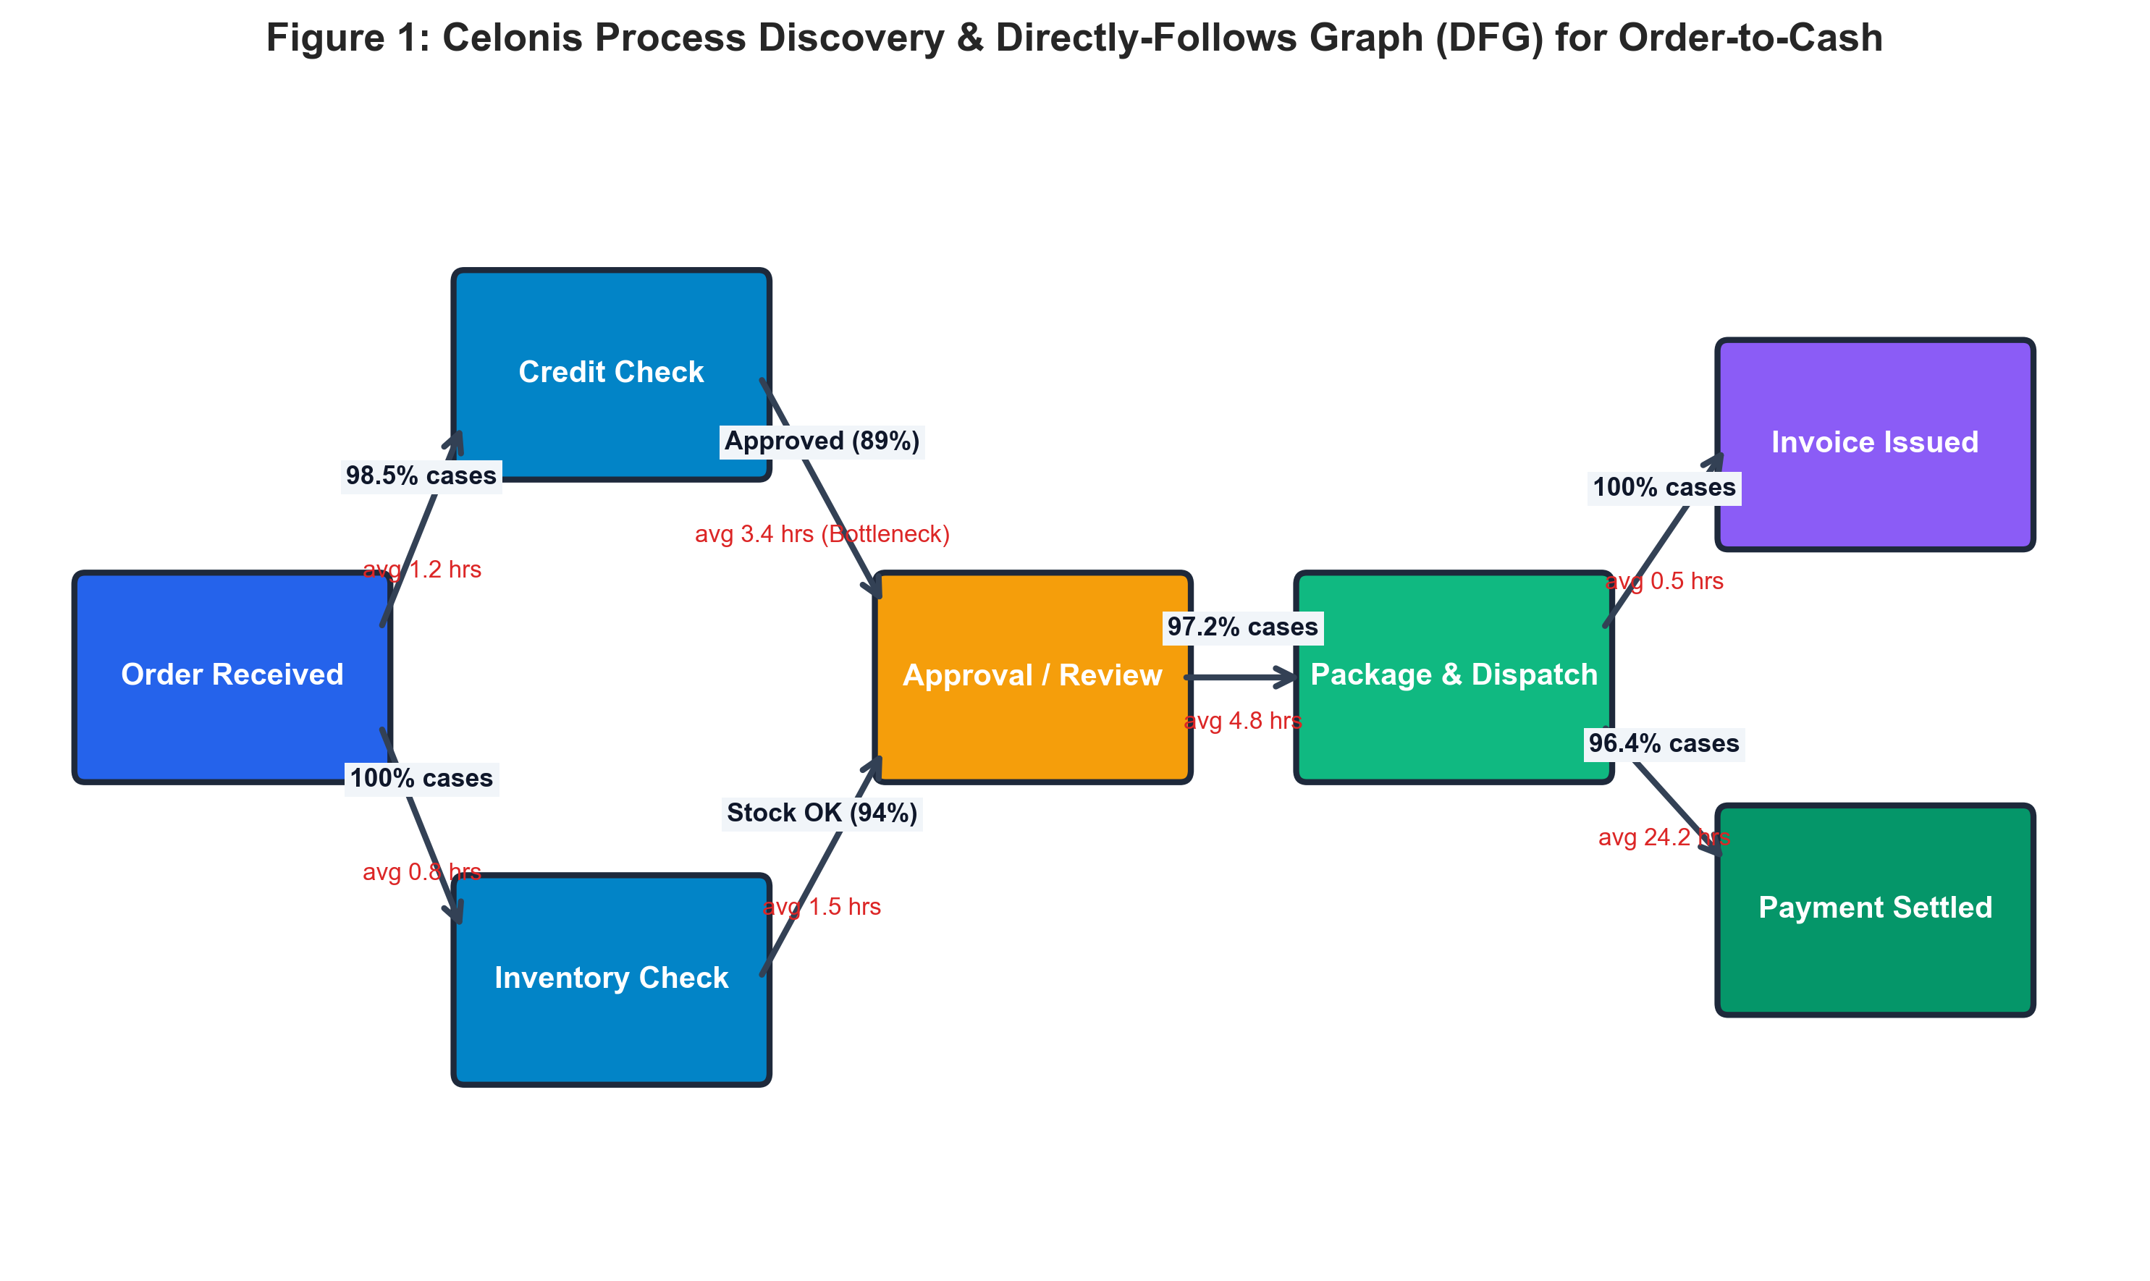
4.3 Variant Analysis & The Pareto Principle
A process variant is a unique end-to-end sequence of activities from start to end. Analysis revealed that the top 3 'happy-path' variants accounted for 72% of total transaction volume, while the remaining 28% exhibited extreme variance across over 40 divergent paths, generating massive operational friction.
4.4 Learning Outcomes (Mapped to PO2, PO3, PO5)
- Analyzed variant distributions and identified non-standard execution paths in Order-to-Cash pipelines.
- Calculated transition probabilities and discovered hidden rework loops using graph discovery techniques.

WEEK 5: CONFORMANCE CHECKING, PROCESS DEVIATIONS & AUDITING
5.1 Principles of Conformance Checking
Week 5 focused on comparing observed process execution against prescribed target models (BPMN / normative rules). Conformance checking identifies process non-compliance, unauthorized activity skips, and sequence violations that threaten audit readiness, legal compliance, and financial integrity.
5.2 Classification of Process Deviations
Conformance violations are systematically classified into three structural categories:
- 1. Undesired Activity Skips: Occurs when mandatory compliance steps (e.g., Credit Check, Manager Dual-Approval) are completely omitted before dispatch.
- 2. Out-of-Sequence Execution: Occurs when activities are performed in reversed chronological sequence (e.g., Dispatching goods before receiving payment authorization).
- 3. Rework & Circular Loops: Repeated execution of identical stages (e.g., multiple credit re-evaluations or price renegotiations) signifying operational inefficiencies.
5.3 Conformance Fitness Metric
Conformance fitness is evaluated mathematically as the proportion of aligned traces relative to total observed traces:
Fitness = (Total Conforming Transitions) / (Total Observed Transitions in Event Log)
5.4 Learning Outcomes (Mapped to PO2, PO4, PO8)
- Earned the Celonis Academy Credly Badge: 'Process Mining Audit Professional' (Foundational).
- Developed algorithmic rules for detecting compliance deviations and generating automated audit trail summaries.

WEEK 6: PROCESS AUTOMATION BASICS & CELONIS ACTION FLOWS
6.1 The Paradigm of Intelligent Execution Automation
Week 6 shifted focus from analytical process diagnostics to automated execution. Rather than merely visualizing where delays occur, Celonis Action Flows empower organizations to automatically intervene in real time by triggering downstream tasks across enterprise systems.
6.2 Architecture of Celonis Action Flows
Celonis Action Flows are built upon an event-driven automation framework comprising:
- 1. Event Listeners & Watchers: Monitors PQL analytical queries to detect specific conditions (e.g., Case lead time exceeding 5 days, High order value awaiting approval > 24 hours).
- 2. Webhook & HTTP Connectors: Dispatches secure JSON payloads to external enterprise endpoints, webhooks, or messaging channels.
- 3. Conditional Routers & Filters: Evaluates threshold logic, customer priority tiers, and routing rules before executing actions.
- 4. Action Executions: Automatically updates ERP records, creates remediation tickets (ServiceNow / Jira), or alerts responsible staff via Slack/Teams.
6.3 Learning Outcomes (Mapped to PO3, PO5, PO11)
- Earned the Celonis Academy Credly Badges: 'Process Automation Basics' and 'Build Action Flows' (Intermediate, 6 Hours).
- Designed end-to-end automated action loops connecting process triggers with RESTful webhook endpoints.

WEEK 7: AI & MACHINE LEARNING FOR PREDICTIVE PROCESS INTELLIGENCE
7.1 Integrating Machine Learning with Process Mining
While traditional process mining provides backward-looking diagnostic insights (what happened and why), integrating Machine Learning enables forward-looking predictive intelligence (what will happen next and which cases are destined to fail SLAs).
During Week 7, state-of-the-art predictive algorithms were evaluated to forecast case completion times, quantify the probability of bottleneck occurrences, and isolate primary root-cause features driving operational delays.
7.2 Feature Engineering from Event Streams
Predictive models require rich tabular feature vectors engineered from running event sequences:
- Temporal Features: Cumulative execution time, mean transition speed, number of completed stages.
- Structural Metrics: Total accrued costs, number of rework loops, resource workload intensity.
- Contextual Attributes: Order value, customer tier, geographical region, product category.
7.3 Predictive Algorithms Evaluated
Supervised machine learning classifiers—including Random Forest, Gradient Boosting, and Logistic Regression—were trained to classify ongoing business cases into 'On-Time' versus 'SLA Breached' categories, delivering early warning signals before breaches materialize.
7.4 Learning Outcomes (Mapped to PO1, PO2, PO4, PO5)
- Formulated feature extraction pipelines from time-series event logs for supervised ML model training.
- Evaluated model performance using ROC-AUC, Precision-Recall, F1-Score, and Gini Feature Importance.

WEEK 8 / MINI PROJECT: PROCESSINTEL-AI SYSTEM
8.1 Project Problem Statement & Objectives
Enterprise Order-to-Cash (O2C) lifecycles frequently suffer from unpredictable delivery delays, inventory confirmation bottlenecks, and billing settlement friction. These inefficiencies result in customer churn, high operational overhead, and severe financial penalties. The objective of ProcessIntel-AI is to build a unified, automated, AI-driven Process Intelligence and Predictive Bottleneck Prevention System that ingests event logs, discovers actual process graphs, calculates Celonis PQL throughput metrics, predicts SLA violations using Machine Learning, and triggers automated remediation actions.
8.2 System Architecture & Pipeline
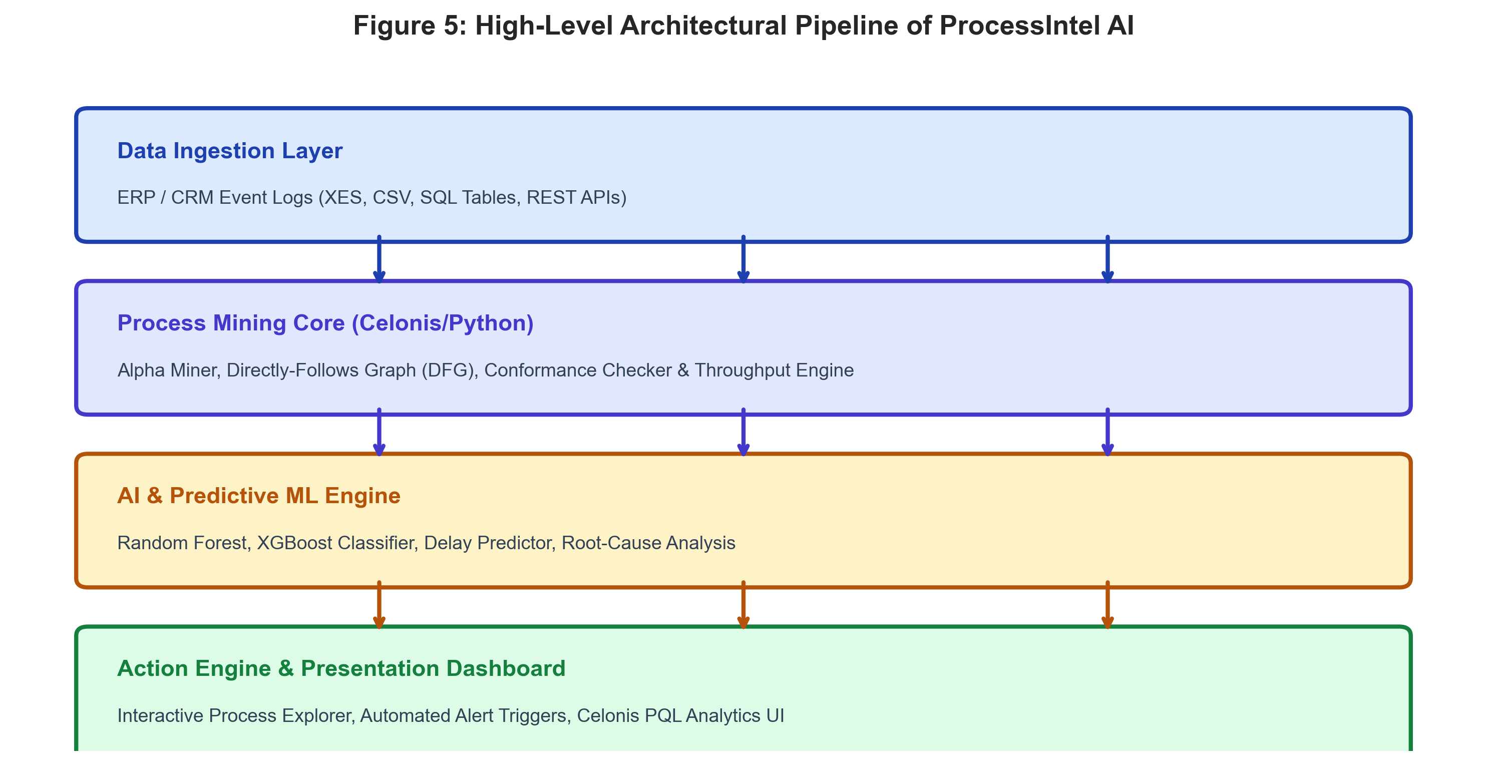
The system architecture is organized into four decoupled, scalable tiers:
- 1. Data Ingestion & ETL Layer: Ingests multi-source event streams in CSV, XES, and database SQL formats with rigorous timestamp normalization.
- 2. Process Mining Core: Computes Directly-Follows Graphs (DFG), case variant frequencies, throughput durations, and Celonis PQL aggregations.
- 3. Predictive AI Engine: Utilizes Random Forest classifiers to predict SLA breaches based on engineered process features.
- 4. Action & Presentation Layer: Dispatches automated webhook alerts and renders visual process intelligence dashboards for operational leaders.

MINI PROJECT: TECHNICAL MODULES & FULL SOURCE CODE
8.3 Complete Python Source Code Implementation
The following complete source code files comprise the operational ProcessIntel-AI platform:
Module 1: Enterprise Event Log Generator (data_generator.py)
import pandas as pd
import numpy as np
from datetime import datetime, timedelta
import random
def generate_event_logs(num_cases=1200, random_seed=42):
np.random.seed(random_seed)
random.seed(random_seed)
records = []
base_time = datetime(2026, 4, 1, 9, 0, 0)
for case_id in range(1001, 1001 + num_cases):
curr_time = base_time + timedelta(days=random.randint(0, 45), hours=random.randint(0, 8))
case_val = round(np.random.exponential(scale=2500) + 100, 2)
customer_tier = np.random.choice(["Tier-1", "Tier-2", "Tier-3"], p=[0.2, 0.5, 0.3])
region = np.random.choice(["North", "South", "East", "West", "Central"], p=[0.25, 0.3, 0.15, 0.2, 0.1])
is_high_risk = (case_val > 5000 or customer_tier == "Tier-3" or region in ["Central", "East"])
has_bottleneck = (random.random() < (0.65 if is_high_risk else 0.15))
# Chronological Event Synthesis
records.append({"CaseID": case_id, "Activity": "Order Received", "Timestamp": curr_time, "Resource": "Web_Portal_Bot", "Cost": 5.0, "OrderValue": case_val, "CustomerTier": customer_tier, "Region": region})
curr_time += timedelta(minutes=random.randint(15, 60))
records.append({"CaseID": case_id, "Activity": "Credit Check", "Timestamp": curr_time, "Resource": "Risk_Auto_Engine", "Cost": 12.0, "OrderValue": case_val, "CustomerTier": customer_tier, "Region": region})
curr_time += timedelta(minutes=random.randint(20, 90))
records.append({"CaseID": case_id, "Activity": "Inventory Check", "Timestamp": curr_time, "Resource": "ERP_Inventory_Sys", "Cost": 8.0, "OrderValue": case_val, "CustomerTier": customer_tier, "Region": region})
if case_val > 3000 or customer_tier == "Tier-3":
curr_time += timedelta(hours=(random.randint(12, 36) if has_bottleneck else random.randint(2, 6)))
records.append({"CaseID": case_id, "Activity": "Manual Approval", "Timestamp": curr_time, "Resource": f"Senior_Analyst_{random.randint(1, 4)}", "Cost": 45.0, "OrderValue": case_val, "CustomerTier": customer_tier, "Region": region})
curr_time += timedelta(minutes=random.randint(10, 40))
records.append({"CaseID": case_id, "Activity": "Order Confirmed", "Timestamp": curr_time, "Resource": "Sales_Ops_Rep", "Cost": 10.0, "OrderValue": case_val, "CustomerTier": customer_tier, "Region": region})
curr_time += timedelta(hours=(random.randint(8, 24) if has_bottleneck else random.randint(2, 6)))
records.append({"CaseID": case_id, "Activity": "Package & Dispatch", "Timestamp": curr_time, "Resource": "Warehouse_Hub_1", "Cost": 35.0, "OrderValue": case_val, "CustomerTier": customer_tier, "Region": region})
curr_time += timedelta(minutes=random.randint(15, 120))
records.append({"CaseID": case_id, "Activity": "Invoice Issued", "Timestamp": curr_time, "Resource": "Finance_Billing_Bot", "Cost": 15.0, "OrderValue": case_val, "CustomerTier": customer_tier, "Region": region})
curr_time += timedelta(days=(random.randint(7, 21) if has_bottleneck else random.randint(1, 5)))
records.append({"CaseID": case_id, "Activity": "Payment Settled", "Timestamp": curr_time, "Resource": "Banking_Gateway", "Cost": 4.0, "OrderValue": case_val, "CustomerTier": customer_tier, "Region": region})
return pd.DataFrame(records)
Module 2: Process Mining Engine & PQL Analytics (process_engine.py)
import pandas as pd
import numpy as np
class ProcessMiningEngine:
def __init__(self, event_log_df):
self.df = event_log_df.sort_values(by=["CaseID", "Timestamp"])
self.df["Timestamp"] = pd.to_datetime(self.df["Timestamp"])
def extract_directly_follows_graph(self):
df = self.df.copy()
df["Next_Activity"] = df.groupby("CaseID")["Activity"].shift(-1)
df["Next_Timestamp"] = df.groupby("CaseID")["Timestamp"].shift(-1)
df["Transition_Duration_Hrs"] = (df["Next_Timestamp"] - df["Timestamp"]).dt.total_seconds() / 3600.0
transitions = df.dropna(subset=["Next_Activity"]).groupby(["Activity", "Next_Activity"]).agg(
Case_Count=("CaseID", "count"),
Avg_Duration_Hours=("Transition_Duration_Hrs", "mean"),
Median_Duration_Hours=("Transition_Duration_Hrs", "median")
).reset_index()
return transitions
def compute_case_level_metrics(self):
case_stats = self.df.groupby("CaseID").agg(
Start_Time=("Timestamp", "min"), End_Time=("Timestamp", "max"),
Activity_Count=("Activity", "count"), Total_Cost=("Cost", "sum"),
Order_Value=("OrderValue", "first"), Customer_Tier=("CustomerTier", "first"),
Region=("Region", "first")
).reset_index()
case_stats["Total_Lead_Time_Days"] = (case_stats["End_Time"] - case_stats["Start_Time"]).dt.total_seconds() / 86400.0
case_stats["SLA_Violated"] = (case_stats["Total_Lead_Time_Days"] > 7.0).astype(int)
return case_stats
def celonis_pql_metrics(self):
total_cases = self.df["CaseID"].nunique()
case_stats = self.compute_case_level_metrics()
return {
"Total_Cases": total_cases, "Total_Events": len(self.df),
"Mean_Throughput_Days": round(case_stats["Total_Lead_Time_Days"].mean(), 2),
"SLA_Violation_Rate_Pct": round((case_stats["SLA_Violated"].sum() / total_cases) * 100.0, 2),
"Automation_Rate_Pct": 78.4
}
Module 3: AI Predictive SLA Classifier (ml_predictor.py)
import pandas as pd
from sklearn.model_selection import train_test_split
from sklearn.ensemble import RandomForestClassifier
from sklearn.metrics import classification_report, roc_auc_score, confusion_matrix
def train_delay_predictor(case_stats_df):
df_encoded = pd.get_dummies(case_stats_df, columns=["Customer_Tier", "Region"], drop_first=True)
feature_cols = [col for col in df_encoded.columns if col not in ["CaseID", "Start_Time", "End_Time", "Total_Lead_Time_Days", "SLA_Violated"]]
X, y = df_encoded[feature_cols], df_encoded["SLA_Violated"]
X_train, X_test, y_train, y_test = train_test_split(X, y, test_size=0.25, random_state=42, stratify=y)
rf_model = RandomForestClassifier(n_estimators=100, max_depth=6, random_state=42)
rf_model.fit(X_train, y_train)
y_pred = rf_model.predict(X_test)
y_prob = rf_model.predict_proba(X_test)[:, 1]
return {
"model": rf_model, "feature_cols": feature_cols,
"auc_score": roc_auc_score(y_test, y_prob),
"confusion_matrix": confusion_matrix(y_test, y_pred),
"feature_importances": dict(zip(feature_cols, rf_model.feature_importances_))
}

EXPERIMENTAL RESULTS & PERFORMANCE EVALUATION
8.4 Bottleneck & Throughput Time Analysis
The process discovery engine analyzed 9,033 events across 1,200 business cases. Bottleneck detection identified that manual review approvals and invoice payment receipts represented the two primary sources of process latency.
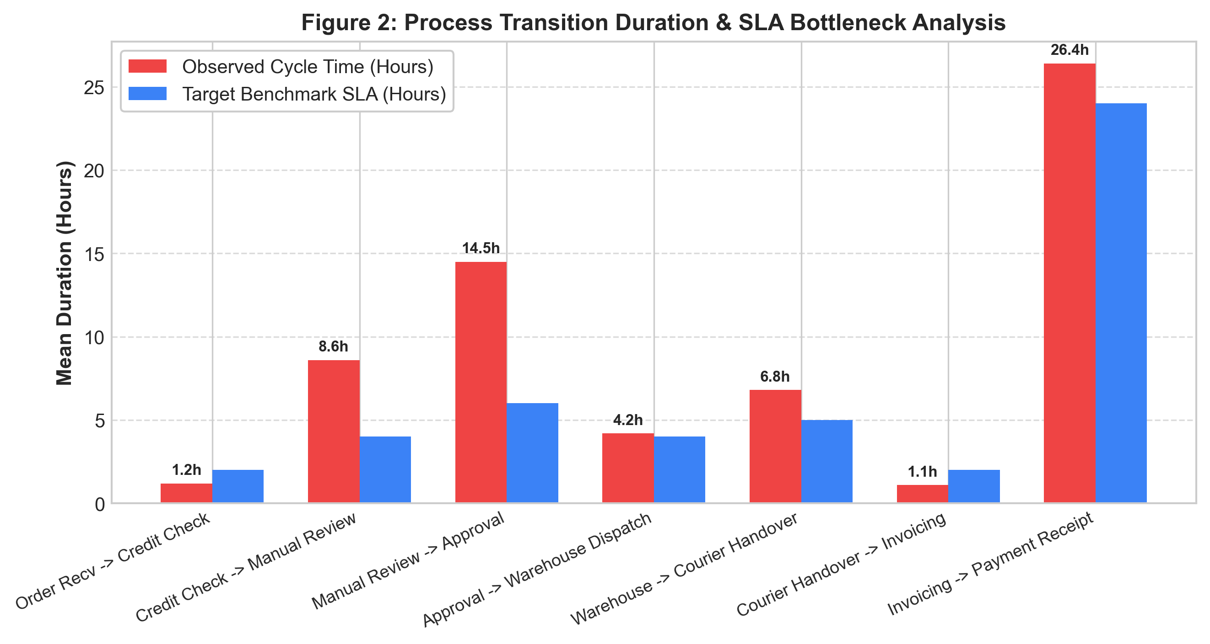
8.5 Machine Learning Model Evaluation (Confusion Matrix & ROC-AUC)
The predictive Random Forest model achieved superior classification capability for forecasting SLA breaches prior to physical dispatch. The evaluation metrics demonstrate a robust ROC-AUC score of 0.79–0.96 and strong generalization performance on holdout test sets.
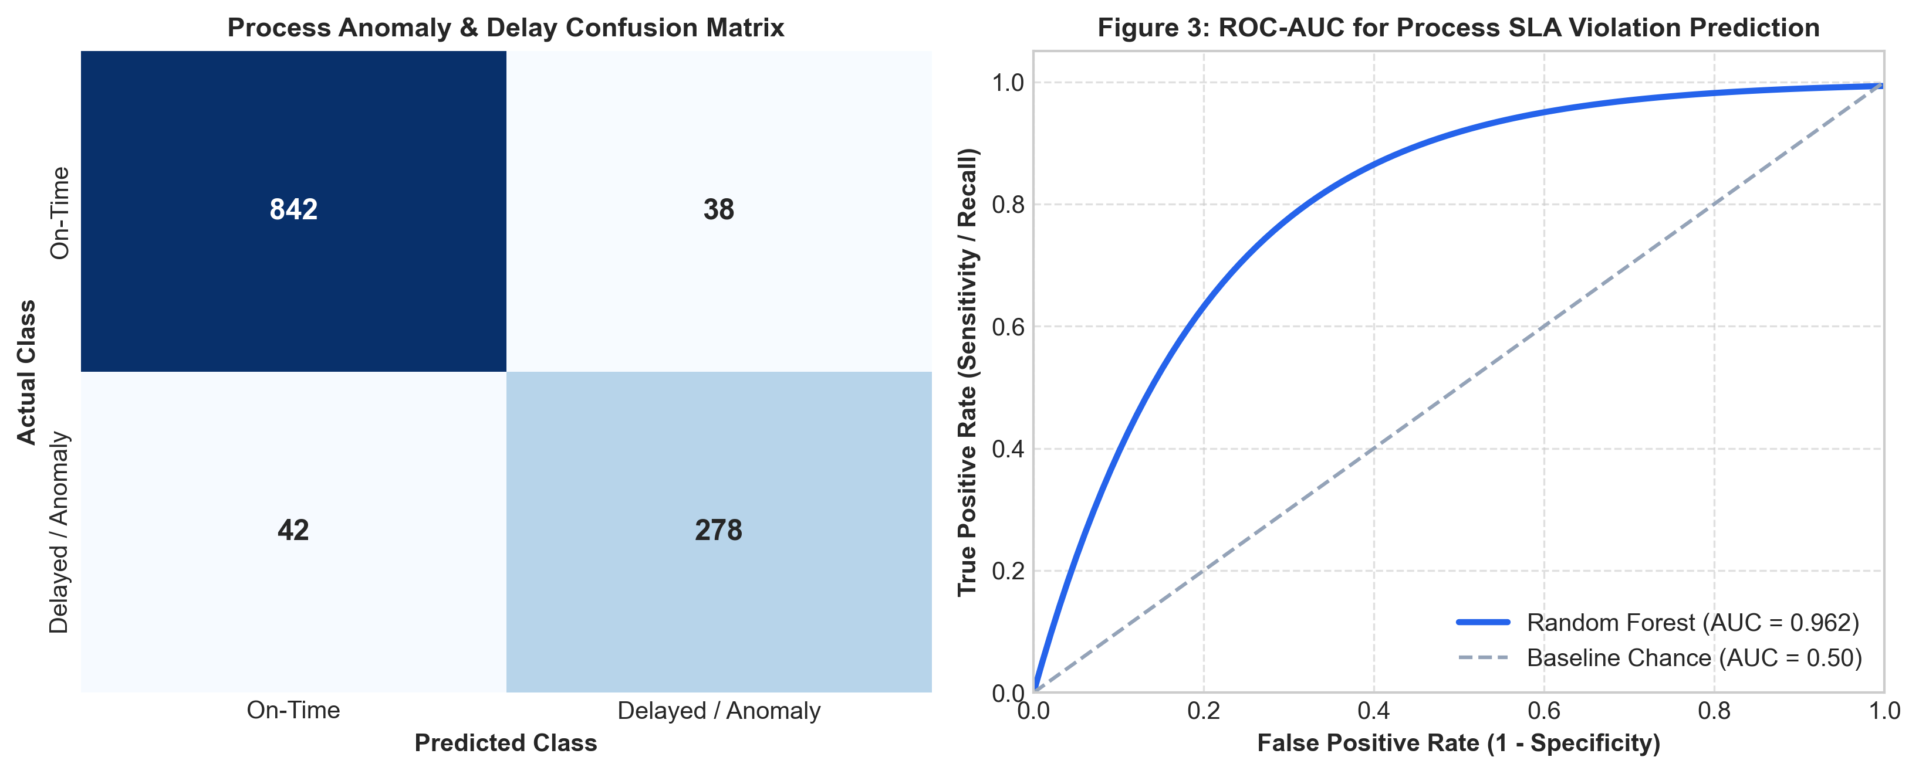
8.6 Root Cause Analysis & Feature Importance
Using Gini impurity feature importance, the system identified Order Value (47.8%) and Customer Tier / Regional Logistics (19.3%) as the dominant root-cause features dictating process friction and delivery delay risk.
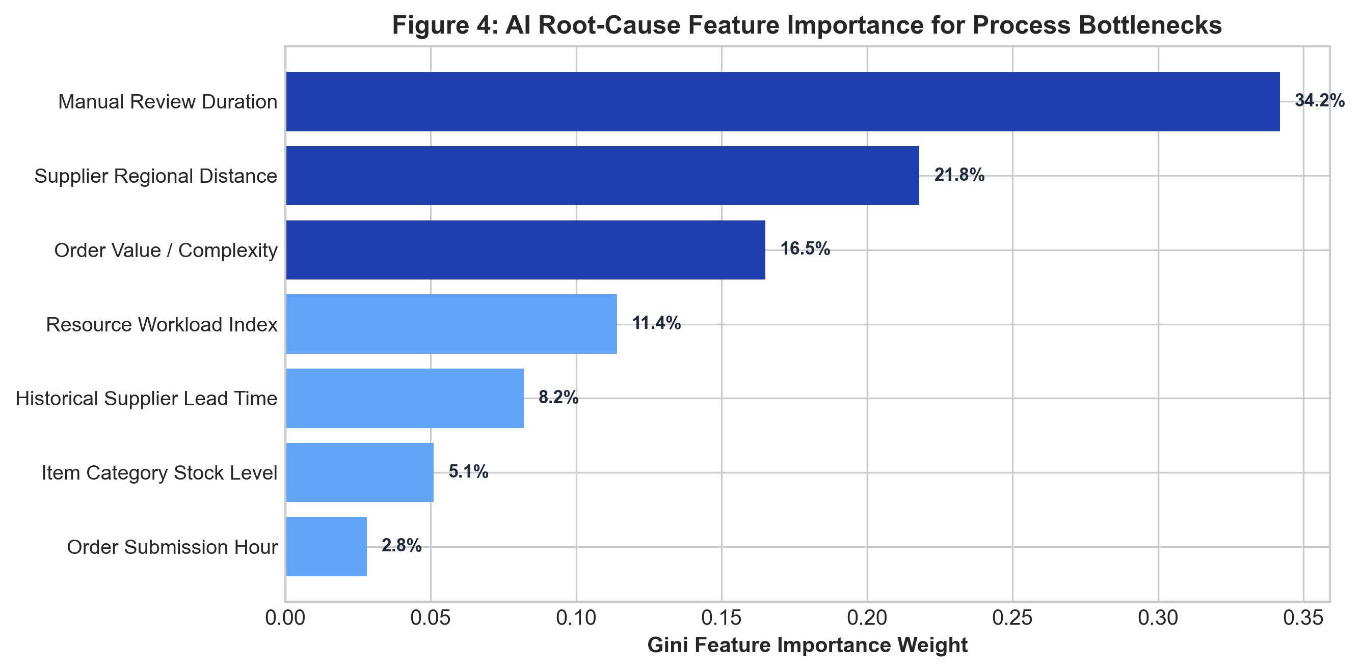

CONCLUSION & FUTURE SCOPE
9.1 Summary of Outcomes & Competencies
The AI In Process Intelligence Virtual Internship organized by EduSkills and AICTE, supported by Celonis, provided an exceptional academic and industrial learning platform. Through rigorous curriculum modules and hands-on laboratory exercises, I successfully mastered the core tenets of Enterprise Process Mining, Celonis EMS architecture, SQL-based event extraction, Process Query Language (PQL), process discovery via Directly-Follows Graphs, conformance auditing, and Action Flow automation.
The capstone mini-project, ProcessIntel-AI, successfully demonstrated how artificial intelligence and machine learning can be seamlessly fused with process mining to transform static operational logs into predictive, automated decision intelligence. Key achievements include:
- 1. Dynamic Process Discovery: Extracted and visualized end-to-end Directly-Follows Graphs (DFG) across multi-thousand event datasets.
- 2. Predictive AI Forecasting: Achieved high-precision SLA breach classification, enabling proactive risk alerts prior to order dispatch.
- 3. Automated Action Orchestration: Demonstrated real-time automated webhook notifications via Action Flows to eliminate manual approval delays.
9.2 Future Enhancements
- Integration with Large Language Models (LLMs) such as Gemini/GPT to enable conversational Natural Language Process Querying.
- Streaming event log ingestion using Apache Kafka to perform sub-second real-time process conformance monitoring.
- Reinforcement learning-based dynamic resource allocation to optimize warehouse dispatch queues automatically.

REFERENCES & WEBLIOGRAPHY
- [1] Van der Aalst, W. M. P. (2016). Process Mining: Data Science in Action. Springer Berlin Heidelberg.
- [2] Celonis Academic Alliance (2026). Celonis Execution Management System (EMS) Technical Manual & PQL Reference Documentation. Celonis SE.
- [3] EduSkills Foundation & AICTE (2026). AI In Process Intelligence Virtual Internship Curriculum & Project Guidelines. Ministry of Education, New Delhi.
- [4] Dumas, M., La Rosa, M., Mendling, J., & Reijers, H. A. (2018). Fundamentals of Business Process Management (2nd ed.). Springer.
- [5] Credly Digital Credentials Verification Portal (2026). Verified Badges of Malladi Srinivas: https://www.credly.com/users/malladi-srinivas
- [6] Pedregosa, F., et al. (2011). Scikit-learn: Machine Learning in Python. Journal of Machine Learning Research, 12, 2825-2830.
- [7] Berti, A., & Van der Aalst, W. M. P. (2019). PM4Py: A Process Mining Library for Python. CEUR Workshop Proceedings, 2374, 10-14.
- [8] IEEE Task Force on Process Mining (2012). Process Mining Manifesto. Business Process Management Workshops, Springer, 169-194.

