**(All are open sources)**

**Hardware Requirements:**

Intel Pentium IV or V with min. 8 GB RAM, 10 GB HDD Free Space and Windows 10/11 OS

**Software Requirements:**

**Java Development Kit version 17**

**Step 1:**

Access the following link to download JDK 17

<https://www.oracle.com/java/technologies/javase/jdk17-archive-downloads.html>

**Step 2:**

Scroll Down until **Java SE Development Kit 17**

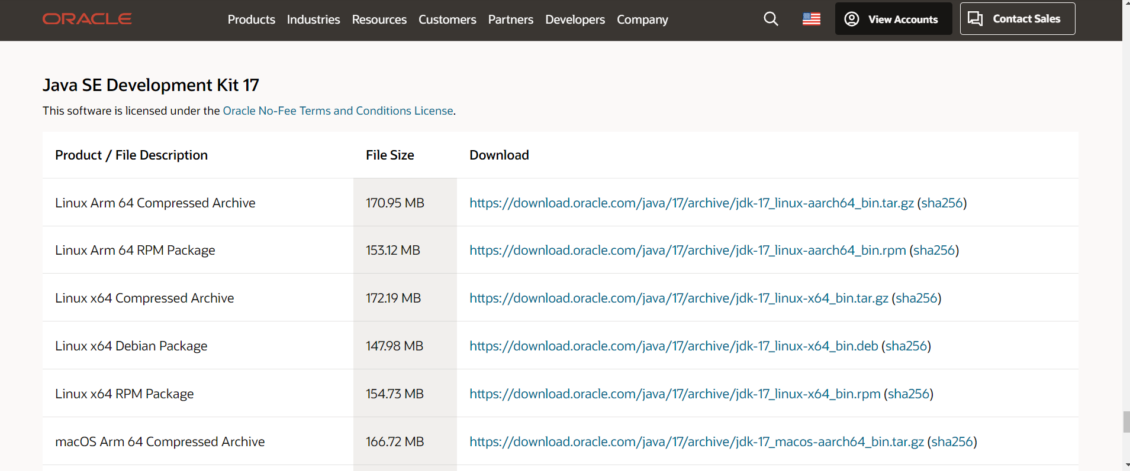

**Step 3:**

Select the appropriate option as per the OS. Using Windows in this case.

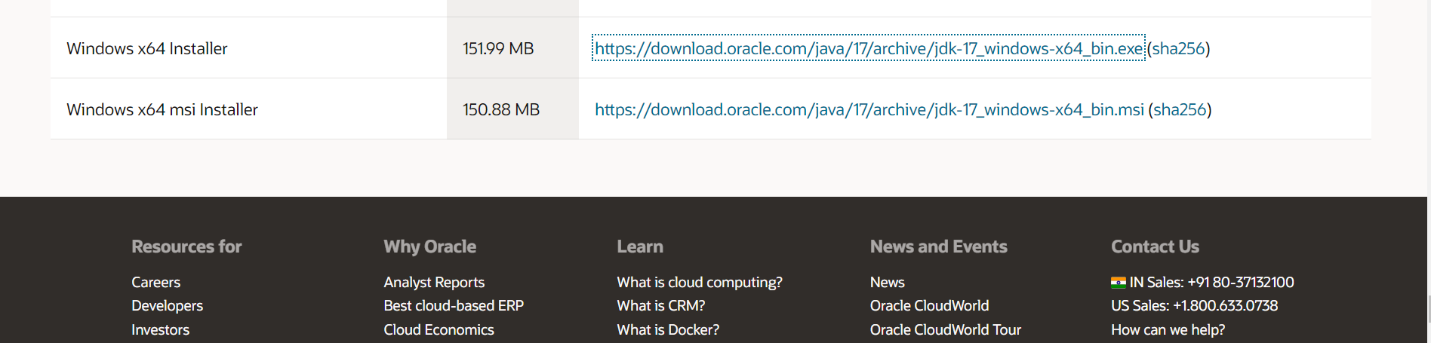

**Step 4:**

After clicking the link, a setup file will be downloaded. Run the setup file.



**Step 5:**

Click **Next**

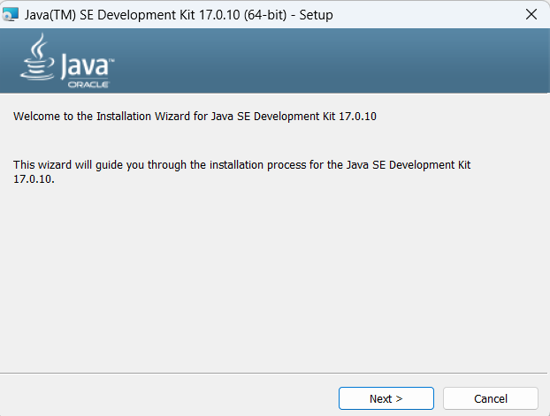

**Step 6:**

Click **Next**

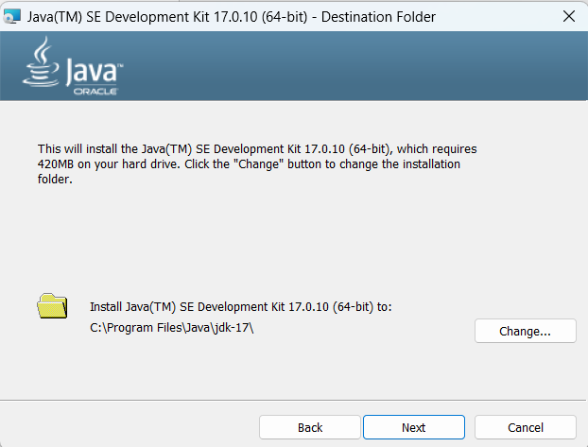

**Step 7:**

Click **Close** to complete the setup.

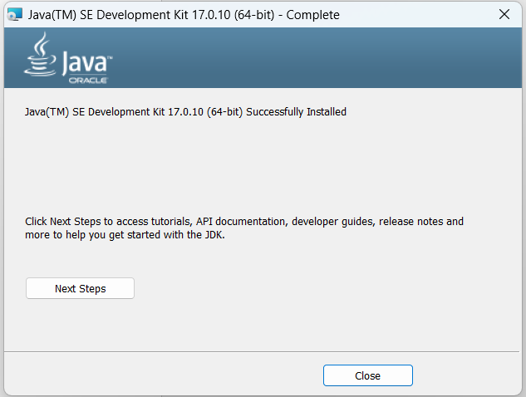

**Eclipse IDE for Java EE**

Eclipse IDE for Enterprise Java and Web Developers (includes Incubating components)

Version: 2024-03 (4.31.0)

Build id: 20240307-1437

**Step 1:**

Access the following link to install Eclipse IDE for Java EE

<https://www.eclipse.org/downloads/packages/release/2024-03/r>

**Step 2:**

Select the appropriate version as per the OS. 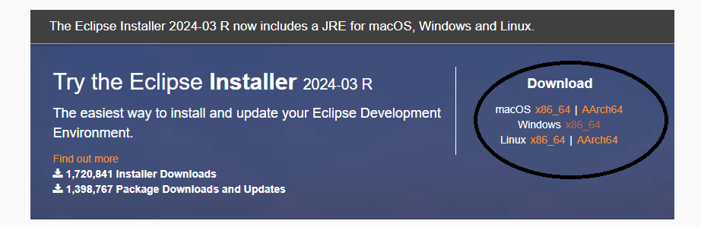

**Step 3:**

Click **Download**

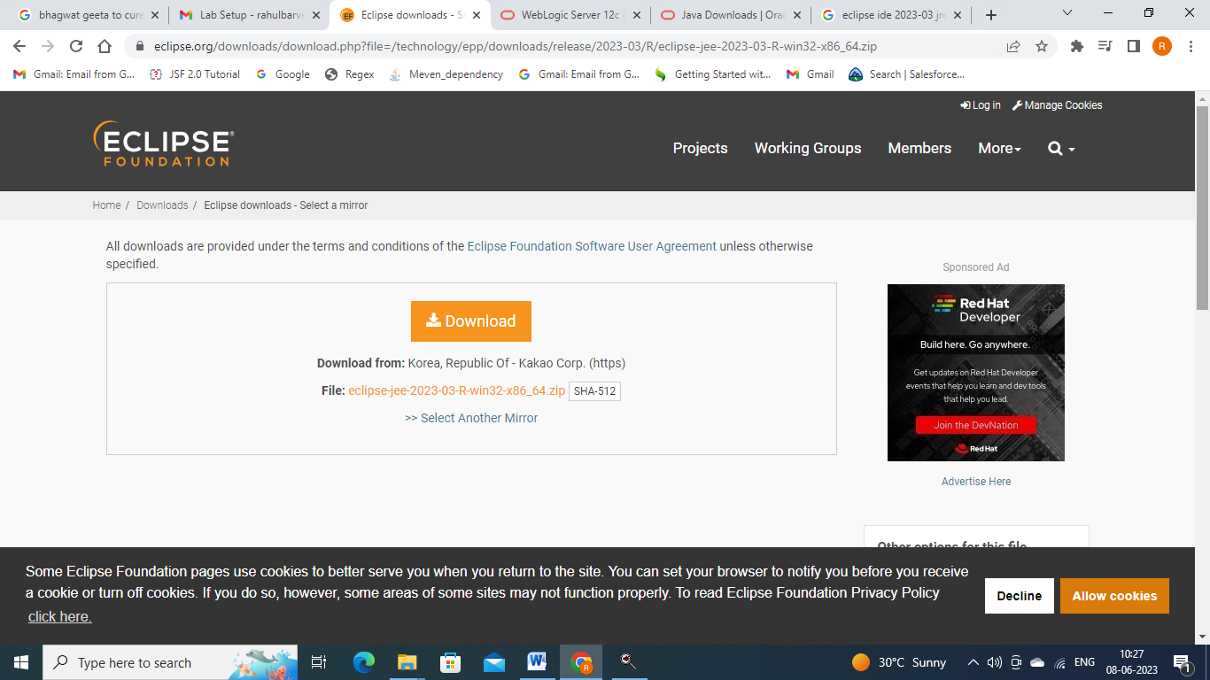

**Step 4:**

A exe file will be downloaded. Double click the downloaded file to start the installation.

Step 5:

** Important: select second option **“Eclipse IDE for Enterprise Java and Web Developers”**

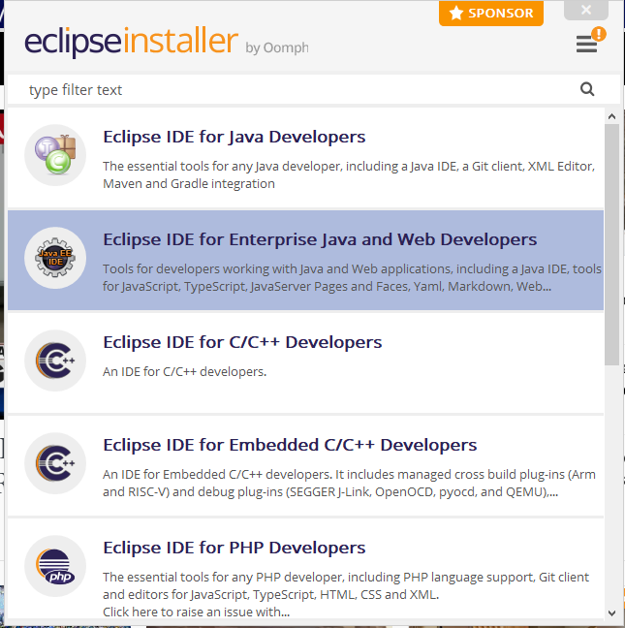

Step 6: Click Install

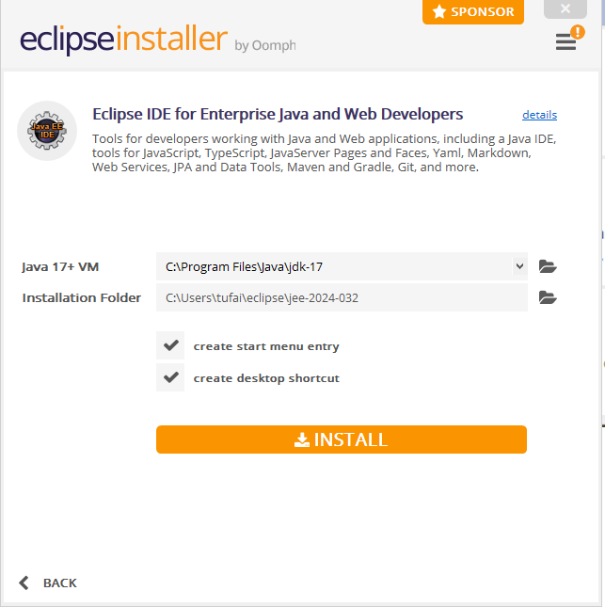

It will take some time and eclipse will get installed.

1. Download Postman:

Go to the Postman website.

<https://www.postman.com/downloads/>

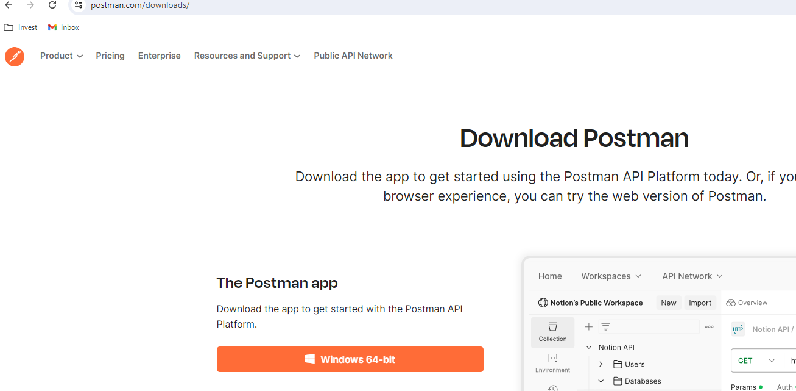

Click on the "Download" button for Windows.

Install Postman:

Once the download is complete, open the downloaded .exe file.

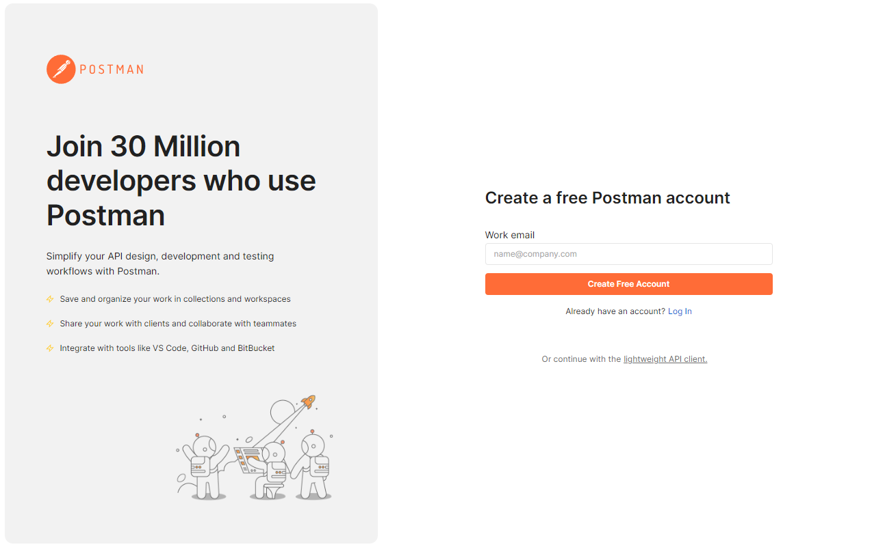

Follow the on-screen instructions to install Postman. This typically involves clicking "Next" through a few screens and agreeing to the license agreement.

After installation, Postman should launch automatically. If it doesn’t, you can start it from the Start Menu.

Done

1. **Download Kafka**

* <https://downloads.apache.org/kafka/3.8.0/kafka_2.13-3.8.0.tgz>
* **Don’t download the source,
* download the binary
* Unzip it