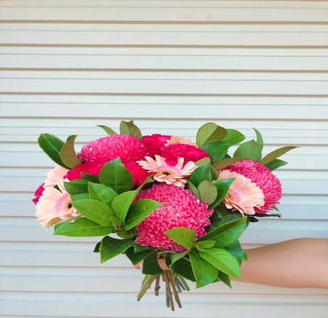

Name: Go to Blooms Bouquet

Prices start from: $50.00

Colours: Pinks, Blues, Purples, Neutral, Orange

Availability: All year round.

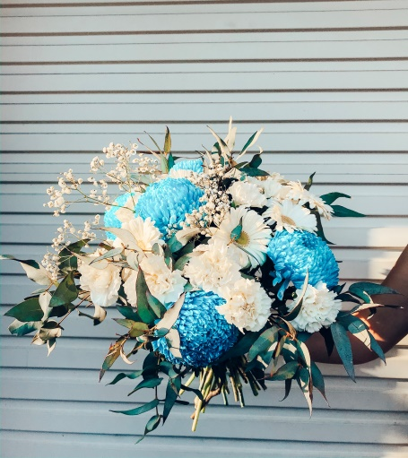

Name: Angel Dreams Bouquet

Prices start from: $85.00

Colours: Blues, pinks, Orange, purples, neutrals

Availability: All year round

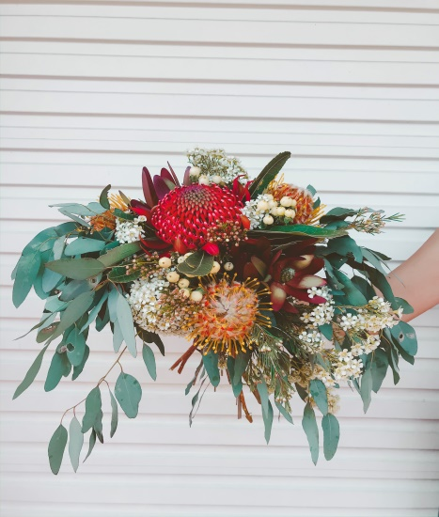

Name: Box of Blooms

Prices start from: $50

Colours: Yellows, Neutrals, Blues

Availability: All year round

Name: Wildflower Bouquet

Prices start from: $70.00

Colours: As per image

Availability: Seasonal

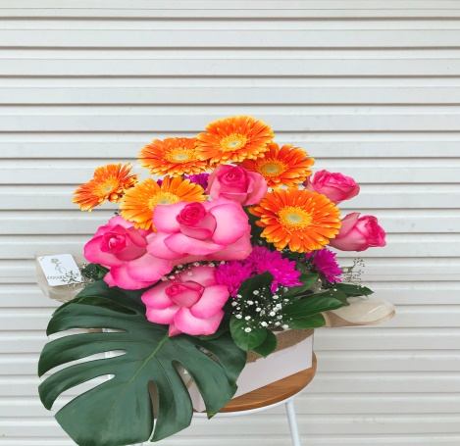



Name: Forever Classic Bouquet

Prices start from: $85.00

Colours: Roses can be changed to pink, white, orange yellow.

Availability: All year round

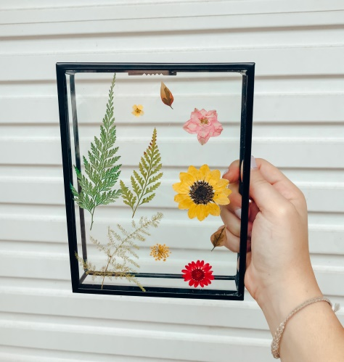

Name: Wire Pressed Flower Frame

Prices start from: $30.00

Colours: Pinks, Neutrals, Yellows, Purples

Availability: All year round

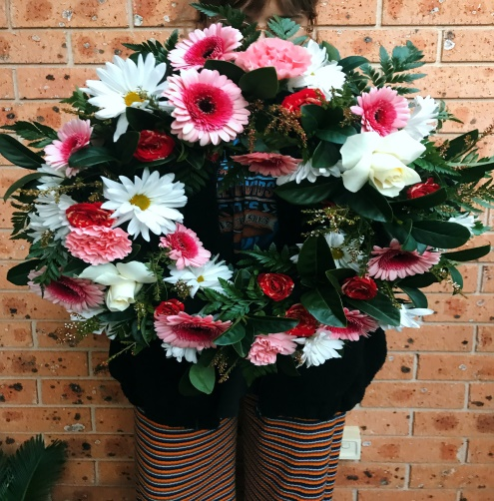

Name: Eternal Love Wreath

Prices start from: $75.00

Colours: Whites, Blues, Pinks, Purples, Neutral, etc

Availability: All year round.

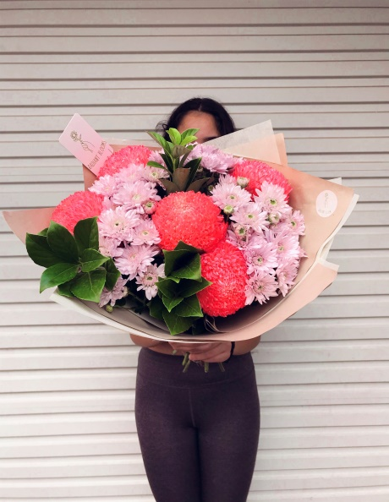

Name: The Sweetest Bunch Bouquet

Prices Start from: $60.00

Colours: Pinks, Blues, Purples, Neutrals, Orange.

Availability: All year round

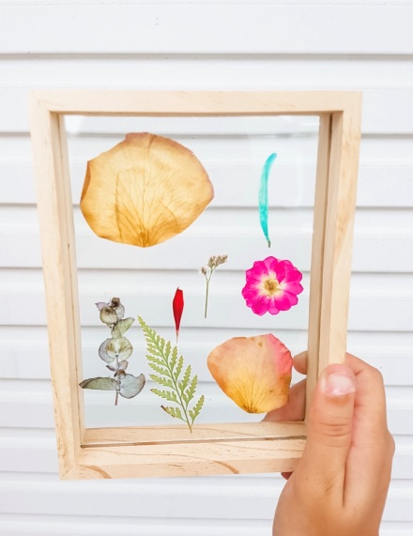

Name: Wooden Pressed Flower Frame

Prices Start from: $30.00

Colours: Pinks, Neutrals, Yellows, Purples

Availability: All year round.

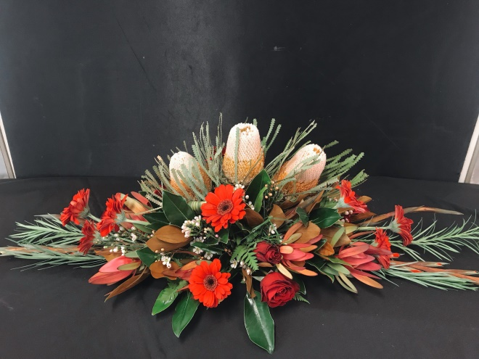

Name: Forever Love Casket Spray

Prices start from: $300

Colours: Can be changed to a variety of colours

Availability: Some flowers are subject to season availability.

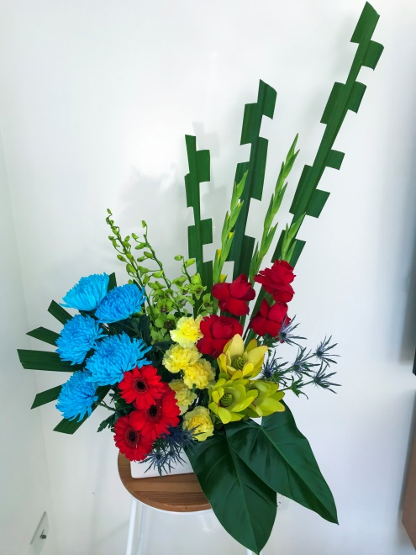

Name: Something Bold

Prices Start from: $80.00

Colours: Red, Blues, Orange, Pink, Purple, Blue, Neutrals

Availability: All year round

Included is a ceramic container

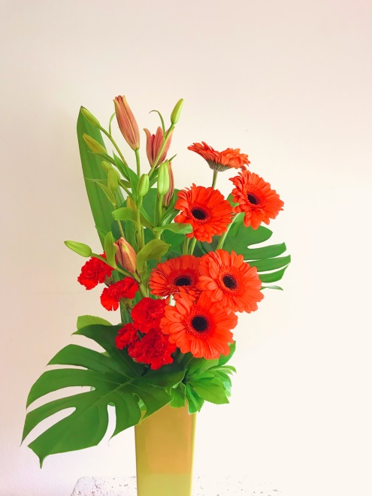

Name: Pop of Colour

Prices Start from: $60.00

Colours: Red, pink, Orange, Blue, Purple, yellow

Included is a ceramic container