Open Source Distributed Streaming Platform:
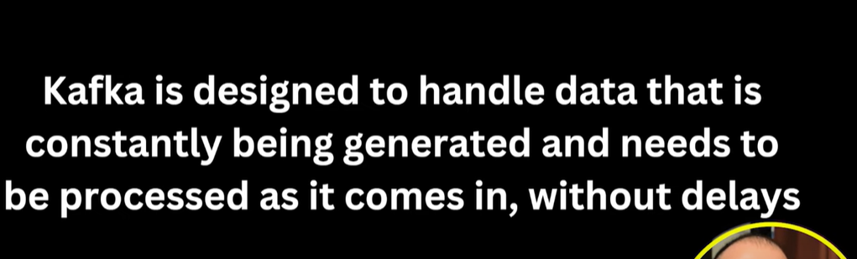
Social Media posting, comments constantly getting updates, all are these events, these events will collect by KAFKA and will distribute them
Producer Commenting on a post
Consumer Notification service

Kafka Cluster:
Group of brokers, Many servers where our kafka is running. Group of kafka servers
Kafka Producer:
It writes down data in kafka cluster
Kafka Consumer:
It takes data from Kafka cluster.
Zoo Keeper:
Tracks health of clusters
Kafka Connect:
It is used to bring data either from db inside from kafka, it is called as declarative integration like where we just say from where we get data. Data move in and out.
Kafka Stream:
Data transformation on cluster data
Downloading kafka tar.gz file and pasting it in C drive
Starting Zookeeper:
zookeeper-server-start.bat ..\..\config\zookeeper.properties
C:\kafka_2.13-3.9.0\bin\windows>zookeeper-server-start.bat ..\..\config\zookeeper.properties

Now start broker in another CMD window
kafka-server-start.bat ..\..\config\server.properties
Now create topic
kafka-topics.bat --create --topic my-topic --bootstrap-server localhost:9092 --replication-factor 1 --partitions 3
Topic is like a table where we store data like for USERS, STUDENTS etc
Now start producer
kafka-console-producer.bat --broker-list localhost:9092 --topic my-topic
Now start consumer
kafka-console-consumer.bat --bootstrap-server localhost:9092 --topic my-topic --from-beginning

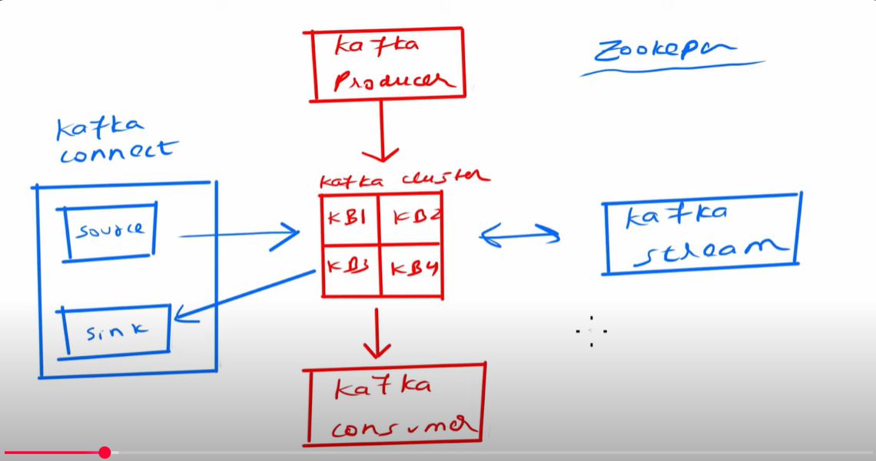

KAFKA TOPIC and PARTITIONS
