Laboratory – Permissions
Learn how to declare permissions so that your app can access restricted services

Objectives:
Familiarize yourself with declaring a permission and using that permission in order to dial a phone number (which is a permission-protected action). Create a simple application that dials a hard-coded phone number. Once you’ve completed this Lab you should understand how to declare that your app uses a given permission, how to ask users to grant that permission, and how to invoke a permission-protected action.

PermissionsLab
This lab involves an app called PermissionsLab. When it runs, the app displays a user interface like the one shown below.
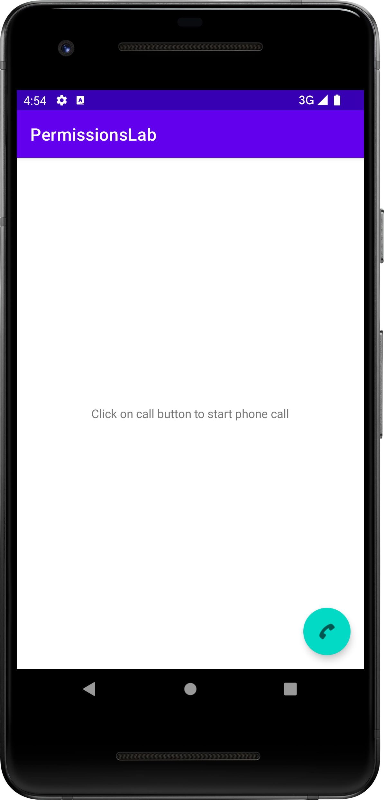
When the user clicks on the floating action button with the phone icon (fab), this application will initiate a phone call to a fixed phone number (without requiring the user to dial the phone number). This behavior is shown in the screenshot below.

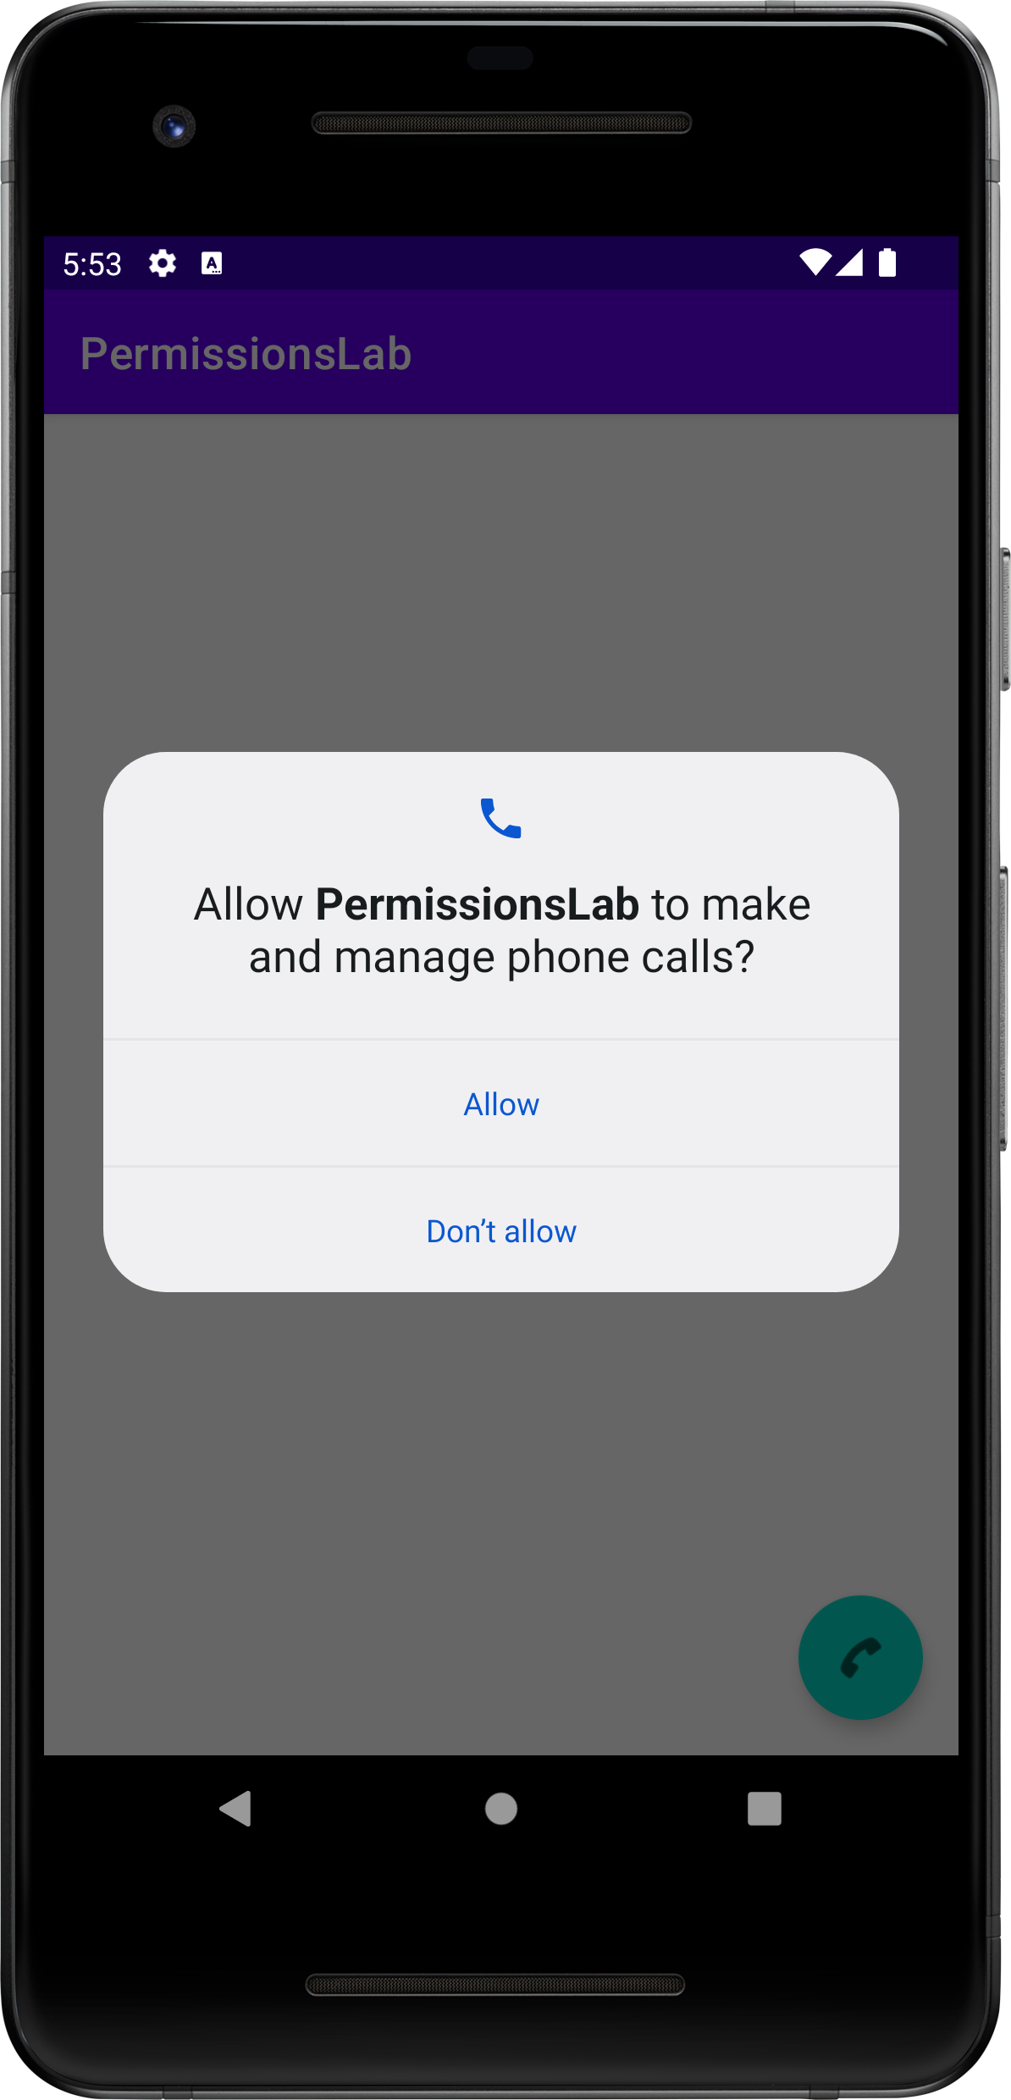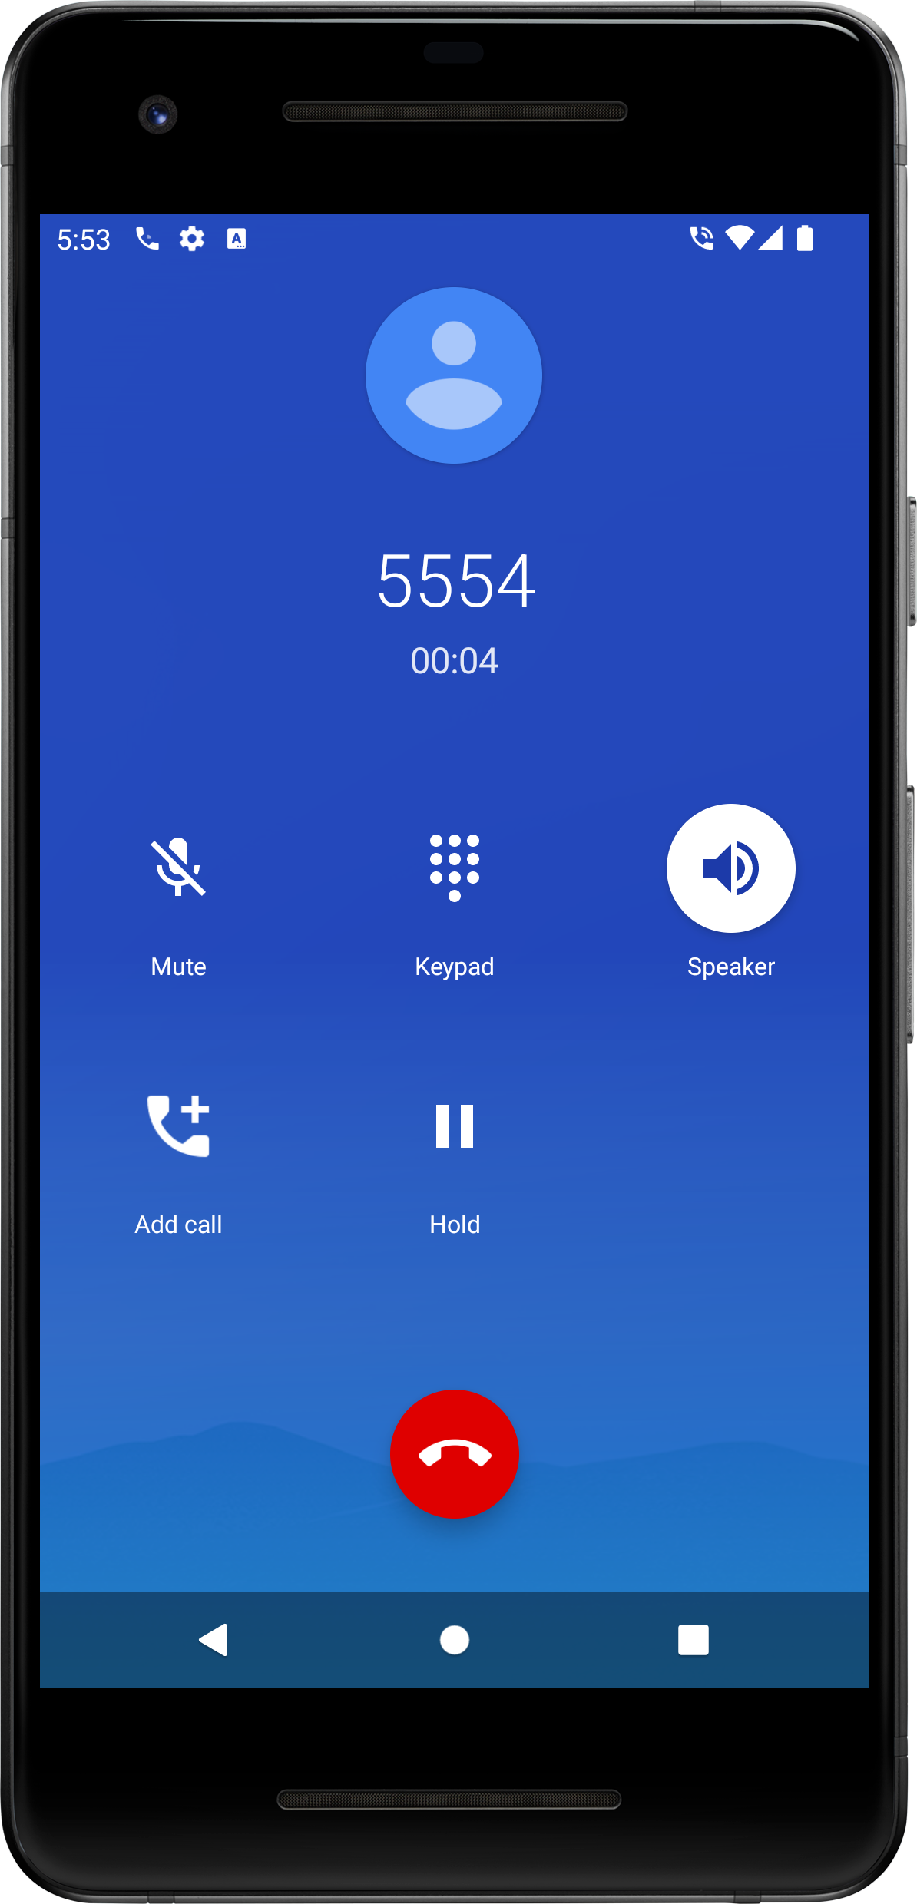

See the screencast, LabPermissions.mp4, that's included in the Lab directory.

Testing

After completing your solution, you will record a screencast of your app as you perform a manual test. Afterward, you will submit your code and the screencast via git. Put your screencast in the lab directory.

There is one test case with several evaluation points. This test case operates as follows:

- Ensure that PermissionsLab app is uninstalled on device
- Start the PermissionsLab app from the IDE
- Click on the fab
- When the permissions request dialog appears, reject the request.
- Check that a pop up appears explaining the need for the permission (evaluation point 1)
- Click on the fab
- When the “Snackbar” pops up click “ok”
- Click again on the fab
- When the permissions request dialog appears, accept the request.
- Check that device initiates a phone call to the hardcoded number (evaluation point 2)

Some Implementation Notes

We are providing template code and layout resources for this application. Only modify the areas marked with the word TODO.

We have done our testing on an emulator using a Pixel 5 AVD with API level 31. To limit configuration problems, you should test your app against a similar AVD.

Note that once you accept the permission, the app won’t ask again. Similarly, if you reject the permission twice, the app won’t ask again. To reset the permission requesting behavior, you may need to uninstall and then reinstall the app. You can uninstall by finding the PermissionsLab icon on the home screen; long clicking it, clicking on “App Info,” and then clicking on “uninstall.”

