Online Shoe Store

Introduction
Online Shoe Store is a Web based App Developed in Dotnet with React and Node.js to implement different concepts learned in this course.

My First Step was to think of the ERD to clear the flow of project. So, I created a rough ERD that included all required tables in this project.
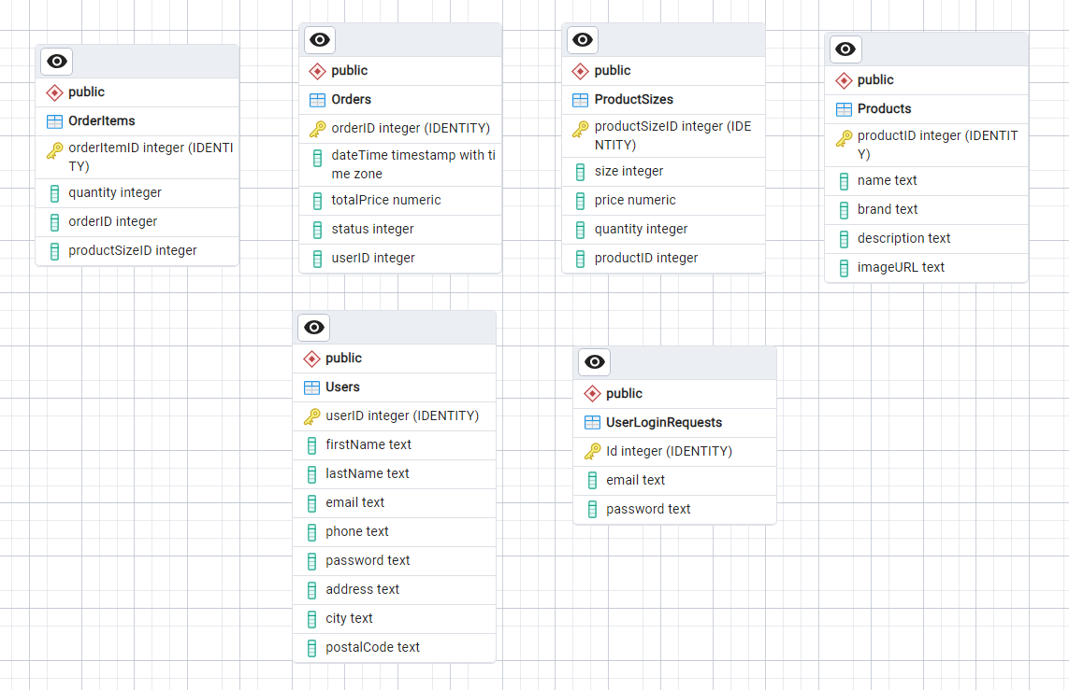
- Product Model contains all basic attributes of Product.
- Product Sizes table is linked to product table and it contains all product size/price/quantity information managing Inventory.
- Order Table contains total order summary information
- Order Item contains list of items linked to each Order.
- Users table contains Users/Customers Information.

Requirements
- For Backend:
  - Visual Studio 2022
  - Dotnet 8
- For Database:
  - PostgreSQL
- For Frontend:
  - Node.js
  - VS Code
- For Deployment
  - Any Web Browser

Database:
PostgreSQL
In Web API, We have used DbContext to communicate with database for CRUD operations.

Backend
Created dot net WEB API Project to create all Microservices in one project. Using Controllers and Models Design Pattern. There are no views, as frontend is implemented separately.
- Models Folder: Contains all Models in C#
- Controller Folder: Implements all microservices, Web API Calls with Proper routing (Post, Get, Put). It returns all data in json form.
- Services used:
  - Product (Add, Edit, View, Delete, Get Specific Product)
  - Product Sizes (Add, Edit, View, Delete, Get Specific Product Sizes)
  - Order (Add Order, View Order, Edit Order etc)
  - Order items (Add)
  - User (Signup/Login)

- I used Swagger to test API endpoints.
- Data Folder: DbContext Used for Database communication. Seed.cs file adds some default products to make project look good.
- Migrations: This folder contains migration data generated using EntityFramework.
- Used Swagger
- Used JWT Tokens for Authorization.

Frontend:
- Took a template in React and Node.js to modify it and make it work with our API.
- We have major 7 Pages/Modules here
- Localhost:3000 Homepage Shows landing page
- Localhost:3000/admin opens admin side, from where we can perform CRUD on products, orders and View Users.
- Localhost:3000/shop shows all products.
- Localhost:3000/authorization opens login/signup page for client/user registration.
- On Product click, a page open from where we can add product to cart or wishlist, both these functions use localstorage to save user products temporary. When user click on cart icon in menu and click proceed, it opens order confirmation steps, user need to login, then proceed to checkout , paypal and card testing integrations are used.

How to Run
Backend steps:
1. This project will work with the database name: backend1
2. we need to create database in pgAdmin and then check appsettings.json file in Web API verify database credentials and name.

3. Then run update-database command in PMC (package Manager Console)

4. Run project
5. Keep it running

frontend steps
Now do frontend steps : For that
1. Open frontend folder
2. Type cmd in path,
3. Then run command "npm install"
4. After that "npm start"
5. It will open url localhost:3000 which shows store.

- Next time
- You just need to open backend project and run that.
- Then open frontend folder and open cmd in that direct and type npm start
- It will work.

Project Flow:

Admin adds/edit/view/delete products and their sizes. While Adding Product, provide Image url from google, as shown in demo video.
Can View orders
Can view users

User opens website, browse through shop, add items to cart, go to account , signup, then go to cart, proceed, login, confirm address details, checkout.
user can also go to his account settings to view his orders and update his personal information.

