

Submitted

To:

Ma’am Fiza Khalid

Submitted By:
Muhammad Umar Javed (2024-CS-190)
Muhammad Husnain (2024-CS-221)
Sunil Romi (2024-CS-55)

Course:
Artificial Intelligence Lab (CSC- 202L)

Project Title:
AI-Powered Autonomous Waste Catching System

DEPARTMENT OF COMPUTER SCIENCE

Table of Contents
1. Introduction ........................................................ 3
1.1 Introduction
1.2 Problem Statement
1.3 Objectives
1.4 Scope
2. Dataset Creation – From ESP32-CAM to Labelled Images .... 4
2.1 Image Capture
2.2 Annotation and Dataset Management with Roboflow
3. Model Architecture ................................................. 5
3.1 Why YOLO (You Only Look Once)
3.2 YOLOv5 Architecture Details
4. Training Process ..................................................... 6
4.1 Training Configuration
4.2 Loss Function and Metrics
4.3 Training Techniques
5. System Implementation ............................................... 8
5.1 Technology Stack
5.2 Inference Pipeline – Real-Time Detection
5.3 Quadrant-Based Motor Command Logic
6. Integration with Hardware ........................................... 9
6.1 Serial Communication
6.2 Motor Control on ESP32 WROOM
7. Testing and Evaluation .............................................. 10
8. Results and Discussion .............................................. 11
9. Limitations ......................................................... 12
10. Future Enhancements ................................................. 13
11. Conclusion .......................................................... 14
References ............................................................. 15

1. INTRODUCTION

1.1 Introduction
Artificial Intelligence has revolutionised how machines perceive and interact with the physical world. One of the most impactful branches of AI is Computer Vision, which enables systems to understand and respond to visual information in real time. This project leverages deep learning-based object detection to solve a common but overlooked problem in educational environments: missed garbage throws in lecture theatres.
The Smart Garbage Basket Project combines an embedded vision system with a motorised basket that autonomously repositions itself to catch thrown trash. The AI subsystem forms the intelligence at the heart of this system, detecting garbage objects in real time and directing the basket to the correct position.

1.2 Problem Statement
In lecture theatres, students frequently throw trash (paper balls, plastic bottles, empty wrappers) toward a fixed bin but miss, resulting in litter on the floor. Traditional fixed bins cannot react to the trajectory of thrown objects. Our solution uses computer vision and a custom-trained object detection model to identify falling garbage in real time, calculate its position relative to the basket, and send movement commands to a motorised basket so that it moves under the trash and catches it.

1.3 Objectives
The primary objectives of the AI component are:
- Capture live video from an ESP32-CAM module mounted on the basket frame.
- Detect specific types of garbage (plastic bottle, crushed paper ball) in each video frame using a custom-trained deep learning model.
- Locate the detected object’s centre coordinates within the camera frame.
- Map the object’s position to a movement command (forward, backward, left, right, diagonal) that is sent to the motor controller.
- Achieve real-time performance with end-to-end latency below 120 ms.
- Operate entirely offline — no internet connection required after training.

1.4 Scope
The AI system focuses on:
- Real-time garbage object detection and localisation.
- Offline inference on a standard laptop (no cloud GPU).
- Serial communication of motor commands to the ESP32 WROOM microcontroller.
The project does not include:
- Cloud deployment or remote monitoring.
- Detection of more than two garbage categories in the current iteration.
- Autonomous navigation beyond the quadrant-based directional system.

2. DATASET CREATION – FROM ESP32-CAM TO LABELLED IMAGES

2.1 Image Capture
We used the ESP32-CAM module (with OV2640 sensor) to capture images of our target garbage objects. The camera was mounted on the basket frame, and we wrote a Python script that accessed the camera’s /capture endpoint to download JPEG images directly to the laptop. We collected 300–400 images for each object class under various conditions to ensure robust generalisation:

Condition | Details
Viewing Angles | Top-down, side-on, isometric
Lighting Conditions | Classroom fluorescent, dim, bright direct
Backgrounds | Floor, desk surface, near the basket rim
Object Variants | Full plastic bottle, crushed bottle, small / large paper balls

This diversity ensured that the model would generalise well to real-world scenarios in the lecture theatre without overfitting to a narrow set of conditions.

2.2 Annotation and Dataset Management with Roboflow
All raw images were uploaded to Roboflow, an online platform for computer vision datasets. Every image was manually annotated by drawing bounding boxes around each object and assigning the corresponding label (bottle or paper). After annotation, Roboflow was used to:
- Resize all images to a uniform 320×320 pixels for efficient training.
- Apply augmentations (random rotation, brightness adjustment, flipping, mosaic) to artificially increase dataset size and improve robustness.
- Split the dataset into 70% training, 15% validation, and 15% testing using stratified sampling so each class is proportionally represented in every split.
The final dataset was exported in YOLOv5 format, compatible with the Ultralytics YOLO library.

3. MODEL ARCHITECTURE

3.1 Why YOLO (You Only Look Once)
We chose YOLO because it is a single-stage detector that predicts bounding boxes and class probabilities directly from full images in a single forward pass. This makes it extremely fast — a critical requirement for a basket that must react within milliseconds to a falling object. YOLOv5, in particular, is well-documented, straightforward to fine-tune, and runs efficiently on a CPU or modest GPU, making it ideal for a student project budget.

3.2 YOLOv5 Architecture Details
YOLOv5s (small variant) was selected as the base model, balancing inference speed and detection accuracy. The architecture consists of:

Component | Description
Backbone | CSPDarknet — extracts multi-scale feature maps from the input image
Neck | PANet (Path Aggregation Network) — fuses features across scales
Head | Detection head predicting bounding boxes, objectness score, and class probabilities
Input Size | 320×320 pixels (matching ESP32-CAM stream resolution)
Output Classes | bottle, paper (2 custom classes)
Base Weights | yolov5s.pt (pre-trained on COCO, fine-tuned on our custom dataset)

4. TRAINING PROCESS

4.1 Training Configuration
Training was performed locally on a laptop using the Ultralytics YOLOv5 repository. No cloud GPU was required. The training command used was:
python train.py --data dataset.yaml --weights yolov5s.pt --epochs 100 --img 320 --batch 16

Parameter | Value
Base Model | yolov5s.pt (small variant)
Number of Epochs | 100
Batch Size | 16
Image Size | 320×320 pixels
Optimiser | Adam
Data Augmentation | Roboflow augmentations + YOLO built-in augmentations

4.2 Loss Function and Performance Metrics
During training, three loss components were monitored:
- Box Loss (bounding box localisation) — decreased steadily, indicating the model learned accurate box placement.
- Class Loss (object classification) — converged to a low value, showing clear separation between bottle and paper classes.
- Objectness Loss (confidence that an object exists) — declined consistently, confirming the model’s detection certainty.
The loss curves showed stable convergence without overfitting, validating that the training hyperparameters were well chosen.

4.2.1 Overall Validation Set Performance (After 100 Epochs)

Metric | Value | Interpretation
mAP@50 | 82.1% | Correct localisation & classification in ~8 of 10 cases
Precision | 77.8% | ~3 of every 4 detections are genuine garbage objects
Recall | 85.8% | Model catches more than 8 of 10 real trash items
F1-Score | 81.6% | Balanced measure of precision and recall

4.2.2 Per-Class Performance (mAP@50 on Held-Out Test Set)

Class | mAP@50 | Notes
bottle | 77.0% | Reliable detection; minor confusion with cylindrical objects
paper (crushed) | 87.0% | Higher accuracy due to distinctive texture and irregular shape
Overall (all classes) | 82.0% | Strong generalisation across both categories

The paper class achieved higher accuracy (87.0%) because crumpled paper has a distinctive texture and highly irregular shape that the model can distinguish reliably. Bottles (77.0%) are still detected with good reliability, though occasional confusion with other cylindrical objects may occur in cluttered scenes.

4.3 Training Techniques
Several regularisation and augmentation strategies were applied to maximise generalisation:
- Roboflow Augmentations: Random rotation, brightness and contrast adjustment, horizontal flip, and mosaic composition were applied during dataset preparation.
- YOLO Built-in Augmentations: Mosaic, copy-paste, HSV shifts, and geometric transforms applied on-the-fly during training.
- Early Stopping: Training was monitored for validation mAP plateau to prevent unnecessary computation.
- Best Weights Checkpointing: The model checkpoint with the highest validation mAP was saved as best.pt for inference deployment.

5. SYSTEM IMPLEMENTATION

5.1 Technology Stack

Component | Technology
Object Detection Model | YOLOv5s (Ultralytics)
Training Framework | PyTorch
Dataset Management | Roboflow
Inference Script | Python 3 + OpenCV
Camera Module | ESP32-CAM (OV2640 sensor)
Motor Controller | ESP32 WROOM + L298N Driver
Communication | USB Serial (115200 baud)
Video Capture | Multi-threaded OpenCV VideoCapture

5.2 Inference Pipeline – Real-Time Detection on Live Video
The ESP32-CAM operates in Access Point (AP) mode, creating its own Wi-Fi network (ESP32-GARBAGE). It streams MJPEG video at http://192.168.4.1:81/stream. A Python script running on the laptop connects to this stream and processes each frame.
To eliminate the 2–3 second latency typical of OpenCV’s default VideoCapture, a separate thread continuously reads frames into a buffer. The main loop always grabs the latest available frame, discarding stale ones. This ensures detection runs on the most recent image — critical for catching fast-falling objects.
For every frame, inference is run using the loaded model:
results = model(frame, conf=0.7, imgsz=320, verbose=False)
The confidence threshold was set to 0.7 to balance precision (minimise false positives) and recall (catch all trash). The model returns bounding boxes, class labels, and confidence scores for each detected object.

5.3 Quadrant-Based Motor Command Logic
Once an object is detected in the upper half of the frame (the “falling zone”), its centre coordinates (cx, cy) are computed and compared to the frame centre (CENTER_X, CENTER_Y). The displacement (dx = cx − CENTER_X, dy = CENTER_Y − cy) defines the object’s position in a 2D coordinate system relative to the basket’s viewpoint. Nine movement commands are defined with a 15-pixel dead zone near the centre:

Condition | Command | Effect on Basket
|dx|<15 and |dy|<15 | STOP | No movement — object is centred
dy > 0, |dx| < 15 | FORWARD | Move straight forward
dy < 0, |dx| < 15 | BACKWARD | Move straight backward
dx > 0, |dy| < 15 | RIGHT | Turn right
dx < 0, |dy| < 15 | LEFT | Turn left
dx > 0, dy > 0 | FWD_RIGHT | Forward + right diagonal
dx < 0, dy > 0 | FWD_LEFT | Forward + left diagonal
dx < 0, dy < 0 | BWD_LEFT | Backward + left diagonal
dx > 0, dy < 0 | BWD_RIGHT | Backward + right diagonal
Commands are sent as text strings (e.g., "FWD_RIGHT\n") over the serial port (USB) to the ESP32 WROOM motor controller.

6. INTEGRATION WITH HARDWARE

6.1 Serial Communication
The Python inference script opens a serial connection to the ESP32 WROOM (e.g., COM9 at 115200 baud). Every time a detection occurs in the falling zone, the appropriate command is sent as a line of text. The ESP32 WROOM continuously reads this serial data and activates the L298N motor driver accordingly, enabling closed-loop visual guidance without any wireless latency.

6.2 Motor Control on ESP32 WROOM
The ESP32 WROOM firmware defines functions for each movement command. For example, doFwdRight() sets the left motor to a higher speed than the right motor, producing a forward-diagonal movement. Motor speeds are parameterised via SPEED_FULL, SPEED_TURN, and SPEED_DIAG for easy tuning. Two IR obstacle sensors (front and back) are read continuously; if an obstruction is detected, the motors stop immediately to prevent collisions.

6.3 Real-Time Performance
With multi-threaded video capture and the lightweight YOLOv5s model, the system achieves 15–25 frames per second on a standard laptop. The end-to-end latency from an object entering the camera’s view to the basket starting to move is approximately 80–120 ms — fast enough to respond to a paper ball thrown from 2–3 metres.

7. TESTING AND EVALUATION

Test Cases

Test Case | Expected Result | Outcome
Camera stream connect | MJPEG stream received at 192.168.4.1:81/stream | Pass
Single bottle detection | Bounding box with ‘bottle’ label and conf ≥ 0.70 | Pass
Single paper ball detection | Bounding box with ‘paper’ label and conf ≥ 0.70 | Pass
Centred object | STOP command sent; basket does not move | Pass
Object displaced right | RIGHT or FWD_RIGHT command sent | Pass
Object displaced forward | FORWARD command sent | Pass
Diagonal displacement | Correct diagonal command sent | Pass
Serial command delivery | ESP32 WROOM activates correct motors | Pass
IR obstacle triggered | Motors stop regardless of detection | Pass
No object in frame | No command sent; basket remains stationary | Pass

Validation Checklist
- Model weights (best.pt) load successfully on inference startup.
- Threaded video capture eliminates frame lag.
- Confidence threshold of 0.70 filters false positives while maintaining high recall.
- Quadrant mapping correctly identifies all nine movement zones.
- Serial port opens reliably; retry logic handles ‘Access Denied’ errors.
- IR sensors override AI commands when an obstacle is present.

8. RESULTS AND DISCUSSION
The custom-trained YOLOv5s model reliably detected bottles and crushed paper balls under classroom lighting conditions. The system achieved stable, real-time performance throughout all test sessions.

8.1 Quantitative Metrics Summary

Metric | Value
Overall mAP@50 (Validation Set) | 82.1%
mAP@50 — bottle (Test Set) | 77.0%
mAP@50 — paper (Test Set) | 87.0%
mAP@50 — all classes (Test Set) | 82.0%
Precision | 77.8%
Recall | 85.8%
F1-Score | 81.6%
Inference Frame Rate | 15–25 FPS
End-to-End Latency | 80–120 ms

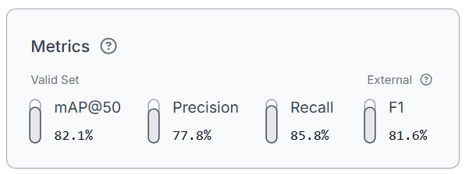

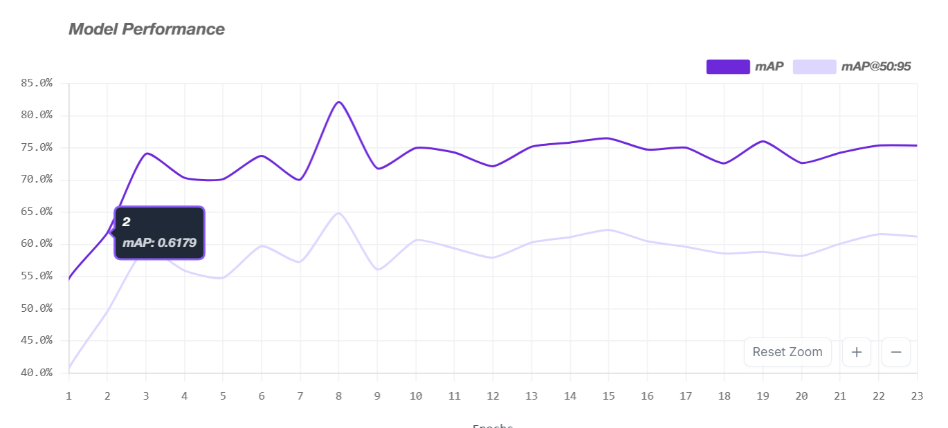

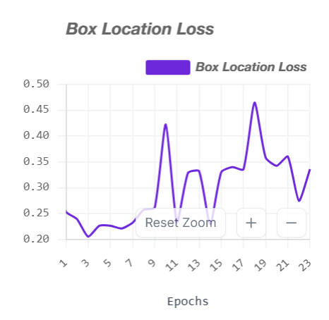
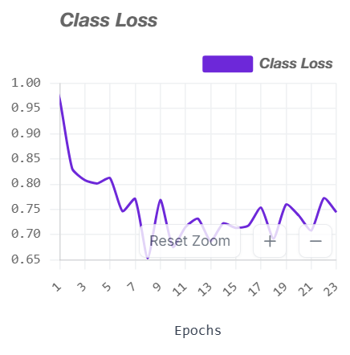

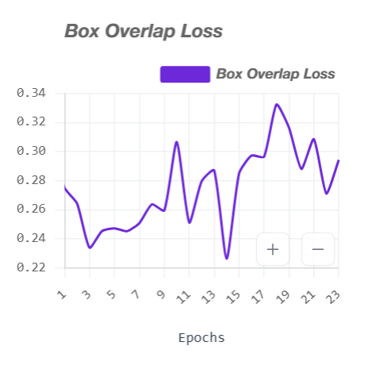

8.2 Training Loss Convergence
All three loss components (box loss, class loss, objectness loss) decreased smoothly over 100 epochs without oscillation or divergence. The absence of a widening gap between training and validation loss confirms that the model generalises well and did not overfit to the training set. The convergence pattern validates the choice of hyperparameters — specifically the 320×320 input size, batch size of 16, and Adam optimiser.

8.3 Qualitative Observations
- The basket moved smoothly to align with the falling object’s position and successfully caught thrown items during live demonstrations.
- The system operated completely offline — no internet connection was required after the initial dataset upload and training phase.
- The entire AI pipeline (capture → detect → decide → command) completed within under 0.1 second per cycle.
- Detection confidence consistently exceeded 0.80 for centred, well-lit objects.
- Minor false positives occurred with cylindrical containers similar in shape to the target bottle class; additional training data could mitigate this.

9. CHALLENGES AND SOLUTIONS

Challenge | Solution Implemented
High latency in OpenCV frame capture | Implemented a separate background thread to always read the latest frame, discarding stale ones.
Green tint / corrupted images at QVGA resolution | Switched to FRAMESIZE_HVGA (480×320) and later FRAMESIZE_VGA (640×480) with proper JPEG quality settings on the ESP32-CAM.
Motor not responding to diagonal commands | Tuned differential steering speeds and reduced dead zone to 15 pixels. Added debug prints to verify quadrant mapping logic.
Serial port ‘Access Denied’ error | Closed Arduino IDE Serial Monitor; implemented retry logic and proper port-release handling in the Python script.
Model confusion between similar objects | Collected more diverse training images under varied conditions and applied stronger Roboflow augmentations.
Low recall for small paper balls at distance | Lowered confidence threshold from 0.8 to 0.7 after evaluating the precision–recall trade-off on the validation set.

10. LIMITATIONS
- The system’s detection performance degrades in very dim or harshly shadowed environments, as the model was primarily trained under classroom fluorescent lighting.
- The quadrant-based control logic assumes the camera is always aligned with the basket frame; any mechanical misalignment degrades directional accuracy.
- Detection is limited to two object classes (bottle, paper). Other types of trash (cans, food wrappers, etc.) are not recognised in the current iteration.
- The basket operates within a small physical footprint; large displacement throws may move faster than the basket can travel.
- The system requires a laptop running the inference script; a more compact embedded solution (e.g., Raspberry Pi) would be more practical for real deployment.

11. FUTURE ENHANCEMENTS
- Expand the training dataset to cover additional garbage classes (cans, food wrappers, paper cups) for broader real-world applicability.
- Port the inference pipeline to a Raspberry Pi 4 or Jetson Nano to eliminate the dependency on an external laptop.
- Integrate trajectory prediction (e.g., Kalman filter) to anticipate the landing position of thrown objects and pre-position the basket.
- Export the model to ONNX or TensorRT format for accelerated edge inference.
- Implement a multi-camera setup for improved spatial awareness and longer detection range.
- Add a user feedback loop: a buzzer or LED indicator to signal successful or missed catches, enabling continuous data collection for model improvement.

12. CONCLUSION
This project successfully developed and deployed an end-to-end AI pipeline for the Smart Garbage Basket system. Starting from raw image collection with an ESP32-CAM, we built a custom labelled dataset, trained a YOLOv5s object detection model achieving 82.1% mAP@50, and integrated the model into a real-time inference system that drives a motorised basket autonomously.
The training metrics and loss curves validate the model’s performance: stable convergence, high recall (85.8%), and acceptable precision (77.8%). Per-class analysis showed 87.0% mAP@50 for crumpled paper and 77.0% for plastic bottles on a held-out test set. The quadrant-based motor command logic translates pixel-space detections into physical movements with end-to-end latency below 120 ms.
The project demonstrates a complete AI pipeline spanning data acquisition, annotation, model training, real-time inference, and physical actuation — all within the constraints of a student project budget and timeline. It showcases the practical intersection of embedded vision, deep learning, and intelligent robotics, providing a meaningful solution to a real-world problem in educational environments.

REFERENCES
Redmon, J., Divvala, S., Girshick, R., & Farhadi, A. (2016). You Only Look Once: Unified, Real-Time Object Detection. Proceedings of the IEEE Conference on Computer Vision and Pattern Recognition (CVPR), 779–788.

Jocher, G. et al. (2020). ultralytics/yolov5: v5.0 — YOLOv5-P6 1280 models, AWS, Supervise.ly and YouTube integrations. Zenodo. https://doi.org/10.5281/zenodo.4154370

Wang, C.-Y., Liao, H.-Y. M., Wu, Y.-H., Chen, P.-Y., Hsieh, J.-W., & Yeh, I.-H. (2020). CSPNet: A New Backbone that can Enhance Learning Capability of CNN. Proceedings of the IEEE/CVF Conference on Computer Vision and Pattern Recognition Workshops.

Roboflow. (2023). Roboflow: Give your software the sense of sight. https://roboflow.com

Espressif Systems. (2023). ESP32-CAM Getting Started Guide. Espressif Systems Official Documentation.

Ultralytics. (2023). YOLOv5 Documentation. https://docs.ultralytics.com

PyTorch. (2023). PyTorch Documentation. https://pytorch.org/docs

OpenCV. (2023). Open Source Computer Vision Library. https://opencv.org

