Digital Twin Builder
Technical Report
Version 1.0 | Unreal Engine 5.6+ | Editor Plugin | Author: Usamah

List of Figures
- Figure 1. System architecture (editor layer and preprocess layer)
- Figure 2. End-to-end processing pipeline
- Figure 3. Scene construction and runtime outputs
- Figure 4. Localization and 3D reconstruction models

1. Executive Summary
Digital Twin Builder reconstructs a 3D digital twin of a real interior from photographs or a single video. The method has three learning-based stages: camera localization, object detection, and single-image 3D mesh generation. The Unreal Editor plugin then spawns the twin in a dedicated level.
Camera localization uses Hierarchical Localization (hloc) with SuperPoint, LightGlue, and COLMAP to recover camera poses and a sparse 3D map. Object detection uses Ultralytics YOLOv8s-World with CLIP ViT-B/32. Object meshes are generated with TripoSR (stabilityai/TripoSR). The editor plugin is self-contained for picker, progress, and spawning. Detection, localization, and meshing run on system Python 3.12.

2. Purpose and Scope
The plugin is intended for editor-side visualization of a room from captured media. A complete session is:
- The user selects multiple images or one video.
- Camera localization (SuperPoint + LightGlue + COLMAP) recovers poses and a sparse 3D map when multi-view overlap is sufficient.
- YOLOv8s-World detects furniture and related objects in the frames.
- Detections are placed in the scene (SfM-fused coordinates when localization succeeds; otherwise image-to-XZ layout).
- TripoSR generates a 3D mesh from an object crop for each selected label.
- Unreal spawns the twin into /Game/DigitalTwin/Maps/Lvl_DigitalTwin. If TripoSR meshes are not imported, schematic BasicShapes are used.
- Progress is reported live in the Output Log.
This is an editor-only workflow. It is not a packaged runtime feature.

3. System Architecture
The Unreal plugin has two execution layers, shown in Figure 1.
Editor layer (Unreal Python). Registers a Tools menu item, opens a file picker, streams progress to the Output Log, and spawns the resulting scene.
Preprocess layer (system Python 3.12). Runs outside Unreal. It prepares frames, runs detection, and writes unreal_scene.json. The full scientific pipeline also includes hloc SfM localization and TripoSR meshing.
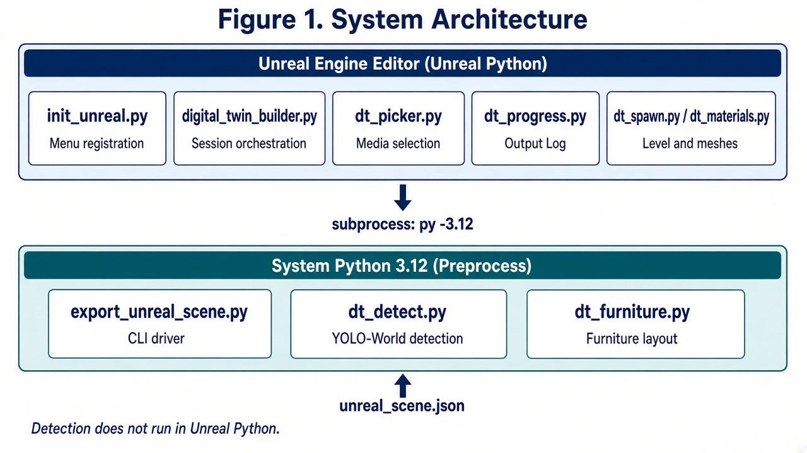
Figure 1. System architecture. Unreal Python orchestrates the session and spawning. System Python 3.12 performs detection and layout, then returns unreal_scene.json.
Detection, localization, and meshing do not run in Unreal’s embedded Python. The editor launches preprocess as a subprocess (py -3.12).

4. Processing Pipeline
Figure 2 summarizes the Unreal spawn path from media selection to the spawned level. Figure 4 shows the three learning-based stages that sit behind that path: localization, detection, and 3D reconstruction.
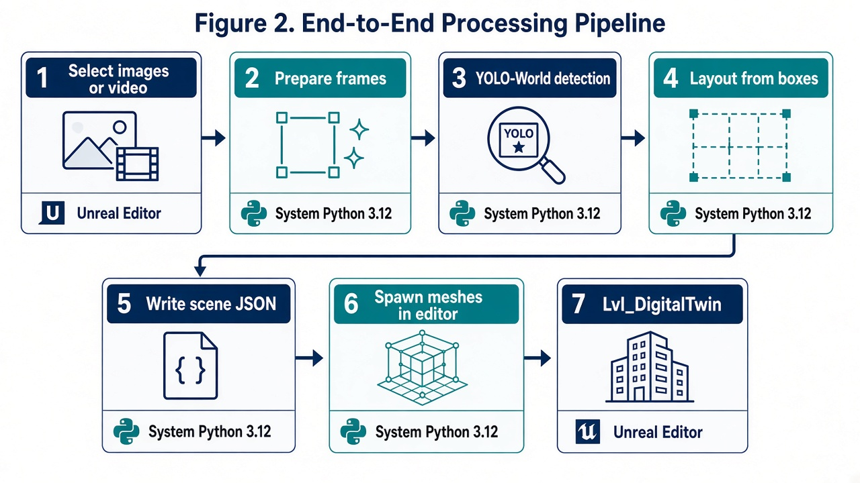
Figure 2. End-to-end Unreal spawn pipeline. Steps 2–5 run on system Python 3.12. Steps 1, 6, and 7 run in the Unreal Editor.

5. Editor Scripts
These scripts import Unreal and run only inside Unreal Editor.

5.1 init_unreal.py
Loaded when the plugin starts. Registers Tools → Digital Twin Builder → Build Digital Twin from Images/Video..., which calls digital_twin_builder.run().

5.2 digital_twin_builder.py
Main editor entry. Prevents concurrent builds, collects media, starts logging, launches the preprocess subprocess, then spawns the level from the resulting JSON.

5.3 dt_paths.py
Resolves plugin, pipeline, project, output, and log paths from the plugin location so the plugin works in any host project.

5.4 dt_picker.py
Windows multi-select file dialog. Accepts common image formats and video formats. Displays status and error dialogs.

5.5 dt_progress.py
Runs the preprocess command in a background thread and reports Packager-style progress in the Output Log. Locates system Python 3.12 and writes a session log under Saved/Logs.

5.6 dt_spawn.py
Creates or loads Lvl_DigitalTwin, removes previous twin actors, adds ground and lighting, spawns meshes from the scene JSON, converts Y-up coordinates to Unreal Z-up, frames the viewport, and saves the level.

5.7 dt_materials.py
Creates unlit materials per furniture color so spawned meshes are not washed-out white, and assigns them to static mesh components.

6. Preprocess Scripts
These scripts run with system Python 3.12. They do not import Unreal.

6.1 export_unreal_scene.py
Command-line driver for the Unreal JSON export. Prepares frames, runs YOLO-World detection, applies non-maximum suppression and class limits, places one desk at the origin, puts small items on the desk when their box overlaps it, and orients chairs toward the desk. Writes unreal_scene.json and progress lines for the editor.

6.2 dt_detect.py
YOLO-World detection. Loads Ultralytics YOLOv8s-World (yolov8s-world.pt) with CLIP ViT-B/32 (ViT-B-32.pt) for open-vocabulary class prompts. Extracts video keyframes and returns axis-aligned boxes with label and confidence.

6.3 dt_furniture.py
Schematic furniture as boxes and cylinders (desk, chair, monitor, laptop, keyboard, mouse, bottle, backpack, paper) used when TripoSR meshes are not spawned. Converts object placements into Unreal actor records and provides a fallback office layout.

6.4 Camera localization (hloc SfM)
The localization stage recovers camera poses and a sparse 3D map from overlapping views. It uses Hierarchical Localization (hloc):
- SuperPoint (superpoint_aachen / superpoint_v1) extracts local features.
- LightGlue (superpoint+lightglue) matches features between image pairs.
- COLMAP (via pycolmap) performs structure-from-motion: cameras, poses, and a 3D point map.
Object boxes can then be lifted into the same world frame as the map and fused across views into fixed coordinates. This stage requires sufficient visual overlap. If SfM cannot reconstruct a model, the Unreal export falls back to image-to-XZ layout.

6.5 3D object mesh (TripoSR)
TripoSR (stabilityai/TripoSR), developed by Tripo AI and Stability AI, generates a 3D mesh from a single object crop. Detected boxes are cropped, optionally background-removed, and passed to TripoSR to produce mesh.obj assets for each label (for example chair, desk items, bed, lamp). Those meshes are the 3D models of the twin. When they are not imported into Unreal, the spawn path uses schematic BasicShapes instead.

6.6 Supporting pipeline files
Pipeline/__init__.py is a package marker with no runtime logic.
requirements.txt lists ultralytics, opencv-python, and numpy for detection. Localization additionally requires hloc, pycolmap, and COLMAP. TripoSR requires PyTorch and the TripoSR package, with pretrained weights stabilityai/TripoSR.
py -3.12 -m pip install -r Content/Python/Pipeline/requirements.txt

6.7 Models used
The digital-twin method uses the following models. Detection weights are bundled with the plugin. Localization uses SuperPoint and LightGlue through hloc. 3D meshes use TripoSR.
Stage | Model | Role | Identifier
Camera localization | SuperPoint | Local feature extraction | superpoint_aachen / superpoint_v1
Camera localization | LightGlue | Feature matching | superpoint+lightglue
Camera localization | COLMAP | SfM poses and 3D map | pycolmap / COLMAP
Object detection | YOLOv8s-World | Open-vocabulary detector | yolov8s-world.pt
Object detection | CLIP ViT-B/32 | Open-vocabulary encoder | ViT-B-32.pt
3D reconstruction | TripoSR | Single-image object mesh | stabilityai/TripoSR

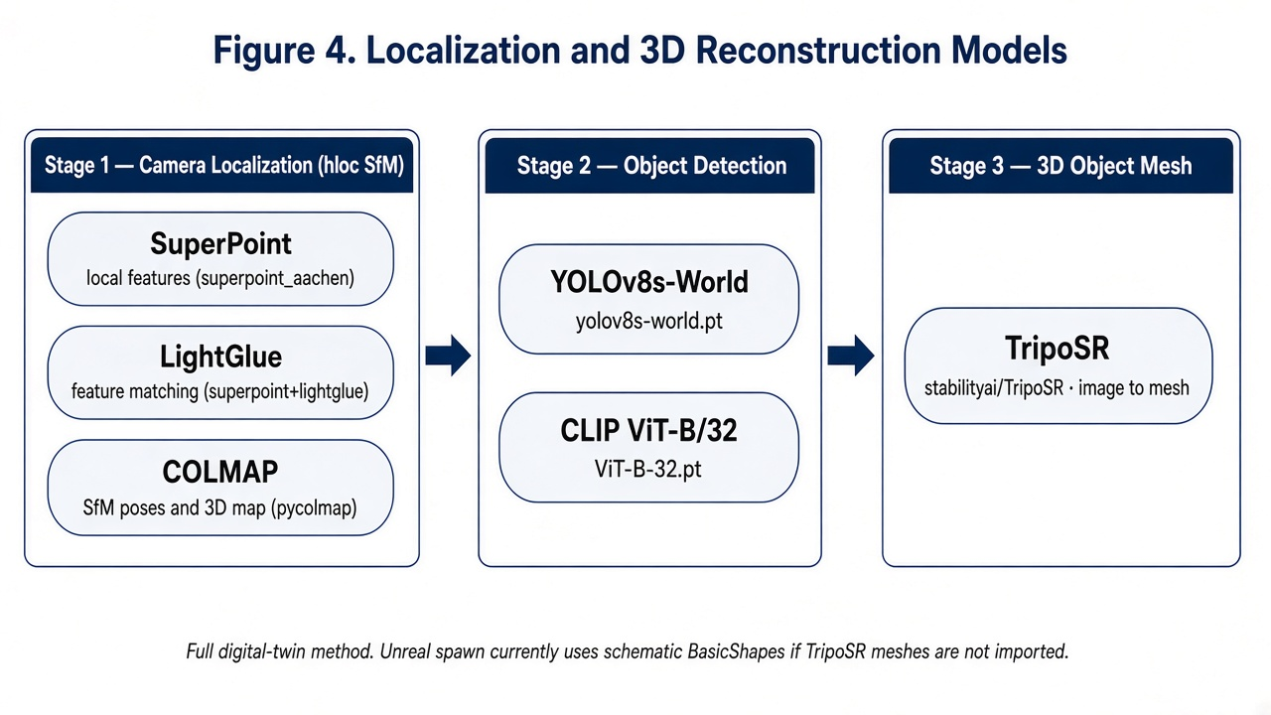
Figure 4. Localization and 3D reconstruction models. Stage 1: SuperPoint, LightGlue, and COLMAP. Stage 2: YOLOv8s-World and CLIP ViT-B/32. Stage 3: TripoSR (stabilityai/TripoSR).

7. Scene Construction and Outputs
Figure 3 illustrates the spawned twin and the artifacts produced by a build.
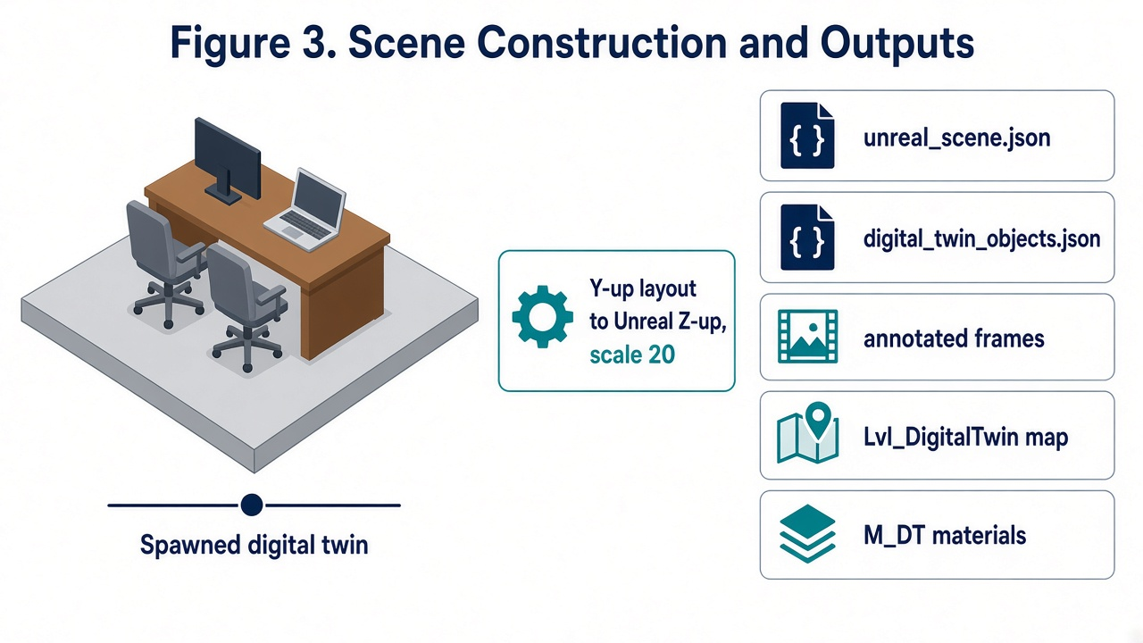
Figure 3. Scene construction and outputs. Layout is authored in Y-up space and converted to Unreal Z-up with a unit scale of 20.

7.1 Host project outputs
- Saved/DigitalTwin/last_run/unreal_scene.json — actors for spawn
- Saved/DigitalTwin/last_run/digital_twin_objects.json — object list
- Saved/DigitalTwin/last_run/media/, images/, annotated/ — source copies, frames, and boxed previews
- Saved/Logs/DigitalTwinBuilder_*.log — session log
- SfM work folder (when localization runs) — COLMAP reconstruction and feature matches
- TripoSR output/<label>/0/mesh.obj — per-object 3D meshes

7.2 Unreal content created on spawn
- Content/DigitalTwin/Maps/Lvl_DigitalTwin
- Content/DigitalTwin/Materials/M_DT_*

7.3 Coordinate conversion
Unreal X = Plotly X × 20
Unreal Y = Plotly Z × 20
Unreal Z = Plotly Y × 20
Engine cube scale is (size × 20) / 100 when schematic primitives are used.

8. Supporting Files
DigitalTwinBuilder.uplugin. Plugin descriptor. Depends on the Python Editor Script Plugin and Editor Scripting Utilities.
README.md and INSTALL_INSTRUCTIONS.txt. Install, enable, and usage instructions for Unreal Editor.
Bundled detection weights: yolov8s-world.pt and CLIP ViT-B-32.pt. Localization models are SuperPoint and LightGlue (hloc). The 3D model is TripoSR (stabilityai/TripoSR).

9. Installation and Operation
- Place the plugin at YourProject/Plugins/DigitalTwinBuilder.
- In Edit → Plugins, enable Python, Editor Scripting Utilities, and Digital Twin Builder, then restart.
- If the Tools menu item is missing, add this Python Additional Path: Plugins/DigitalTwinBuilder/Content/Python.
- Install the Python packages listed in Section 6.6.
- Run Tools → Digital Twin Builder → Build Digital Twin from Images/Video...

10. Limitations
- Editor only; not available in packaged builds.
- File picker is Windows-specific.
- The Unreal spawn path currently uses schematic BasicShapes unless TripoSR meshes are imported into the level.
- SfM localization requires overlapping viewpoints. If COLMAP cannot reconstruct a model, layout falls back to 2D bounding boxes.
- System Python 3.12 is required. Detection uses ultralytics. Localization uses hloc and pycolmap. Meshing uses TripoSR and PyTorch.

