**Exercise 1: Distance-Only Sensor**

In this exercise, you try to locate your friend using her cell phone signals. Suppose that in the map of Freiburg, the campus of the University of Freiburg is located at m0 = (10, 8)T , and your friend’s home is situated at m1 = (6, 3)T . You have access to the data received by two cell towers, which are located at the positions x0 = (12, 4)T and x1 = (5, 7)T , respectively. The distance between your friend’s cell phone and the towers can be computed from the intensities of your friend’s cell phone signals. These distance measurements are disturbed by independent zero-mean Gaussian noise with variances σ 20 = 1 for tower 0 and σ21 = 1.5 for tower 1. You receive the distance measurements d0 = 3.9 and d1 = 4.5 from the two towers.

1. Is your friend more likely to be at home or at the university? Explain your calculations.

We want to calculate the probability p(m | z) of being at a location m, given the sensor measurements z. We can use Bayes rule:

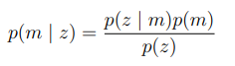

We do not have any prior information about the location, therefore we assume a uniform prior p(m). p(z) does not depend on m, therefore it can be regarded as a normalization factor. We can see that without prior information, p(m | z) is proportional to p(z | m):

p(m | z) ∝ p(z | m)

To answer the question, it is enough to check the likelihood of a measurement z, given the location m. We can assume that the measurements of both towers are independent of each other:

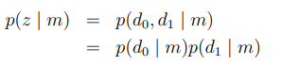

The distance measurements of the towers are disturbed by zero-mean Gaussian noise. To obtain the likelihood of our measurement, we calculate the true distances d between the towers and the query locations and compare them to the measured distances d. To this end, we evaluate our sensor model, the probability density of the normal distribution:

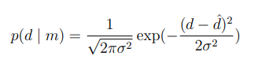

* At University:

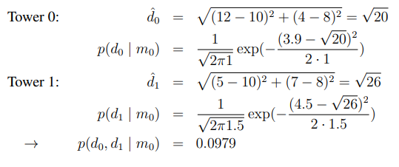

* At Home:

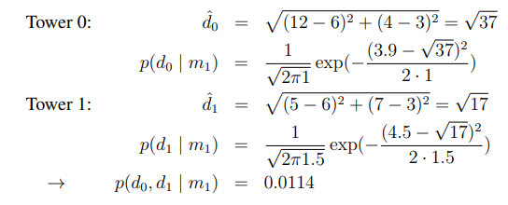

It is more likely to obtain the given measurements if our friend is at the university.

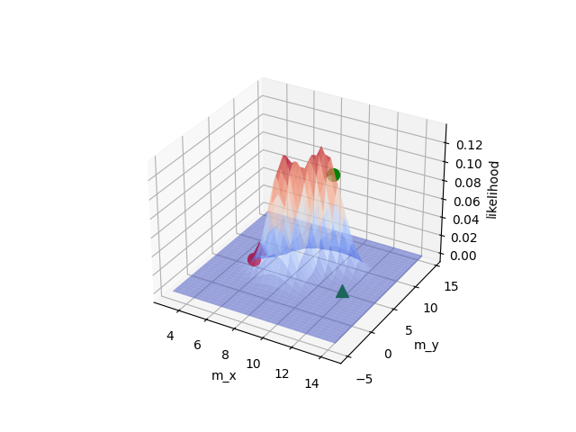

The plotted likelihood is not a probability density function, because we are plotting p(z | m) over map locations m, not measurements z. To get the probability distribution p(m | z) over map locations m, we need to know p(m) and p(z) to normalize the distribution.

1. Now, suppose you have prior knowledge about your friend’s habits which suggests that your friend currently is at home with probability P(at home) = 0.7, at the university with P(at university) = 0.3, and at any other place with P(other) = 0. Use this prior knowledge to recalculate the likelihoods of a)

We use Bayes Rule. We can either (a) calculate p(z) by summing over all possible values (law of total probability)



or (b) solve by normalizing.

(a) Explicitly calculate p(z):

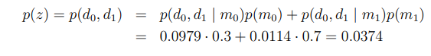

In 1:

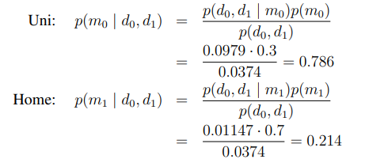

(b) Solve by normalizing:

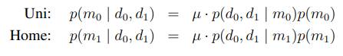

We use the fact that both probabilities need to sum up to 1 to calculate the normalization factor µ:

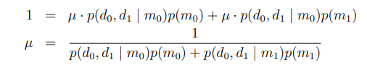

We can see that the normalization factor µ is just the reciprocal of p(z). Normalization therefore results in exactly the same calculations like in (a).

**Exercise 2: Sensor Model Remark:**

Remark: This exercise is to be solved without Python.

Assume you have a robot equipped with a sensor capable of measuring the distance and bearing to landmarks. The sensor furthermore provides you with the identity of the observed landmarks.

A sensor measurement 𝑧 = (𝑧𝑟, 𝑧θ) 𝑇 is composed of the measured distance 𝑧𝑟 and the measured bearing 𝑧θ to the landmark l. Both the range and the bearing measurements are subject to zero-mean Gaussian noise with variances 𝜎𝑟2 and 𝜎θ2 respectively. The range and the bearing measurements are independent of each other.

A sensor models

𝑝(𝑧|𝑥, 𝑙)

models the probability of a measurement z of landmark l observed by the robot from pose x.

Design a sensor model 𝑝(𝑧|𝑥, 𝑙) for this type of sensor. Furthermore, explain your sensor model.

**Solution:**

We want to design a sensor model p (z | x, l) to calculate the probability to obtain a measurement z, given a pose x and a landmark pose l. A sensor measurement z = (zr, zθ) consists of a distance zr and angle zθ measurement for the landmark. Both measurements are subject to Gaussian noise with variances σ2r and σ2θ, respectively. The robot pose is given by x = (xx, xy, xθ), the landmark position by l = (lx, ly). Range and bearing measurements are independent:

p (z | x, l) = p(zr, zθ | x, l) = p(zr | x, l)p(zθ | x, l)

To evaluate our sensor model, we need to evaluate the probability density of a normal distribution at the measurement zi , with the expected measurement zexp,i as the mean and the standard deviation σi :

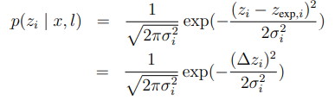

1. range measurement:

For the range, the expected distance measurement to the landmark is

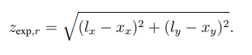

∆z is the difference between the measured and the true distance to landmark l:

1. bearing measurement:

For the bearing, the expected angle measurement to the landmark is



We cannot simply subtract the expected and measured bearing because of the discontinuity of the angle representation between (−π, π]. We use the dot product rule to find the smallest angle between the unit vectors vz = (cos(zθ),sin(zθ))T and vz,exp = (cos(zexp,θ),sin(zexp,θ))T , defined by zθ and zexp,θ:

