Introduction to databases
A database is a collection of data that is set up in a structured way. This is usually on a computer, but you could have a paper-based database as long as it is suitably structured.

KEY WORDS
database: an example of application software to store and manipulate data.
table: a set of data about one type of object, e.g. students.
field: an individual piece of data, e.g. date of birth.
record: all of the records in a table about one object, e.g. all the personal details about one student.
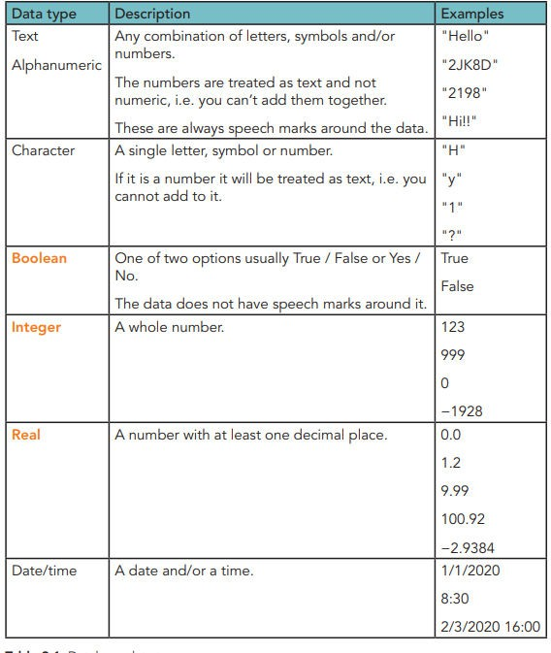

Primary key
A primary key is a unique field in a database. This means that it cannot appear twice in different records. It is used to uniquely identify a record.

Example:
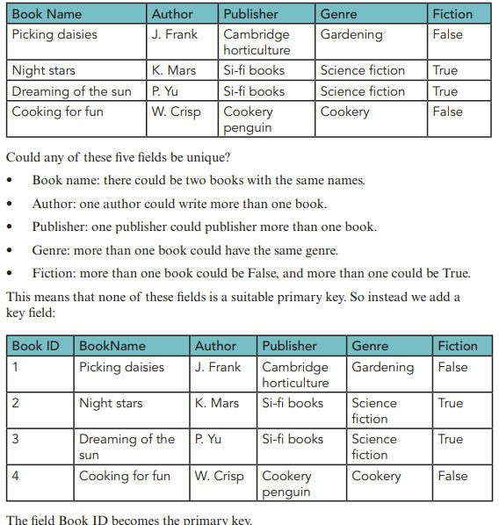

Defining a single-table database:
To define a single-table database you will need to decide:
- 1 the fields that you need
- 2 the data types for each field
- 3 the primary key

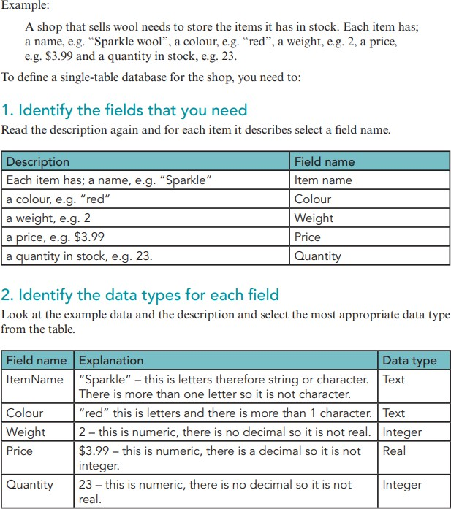
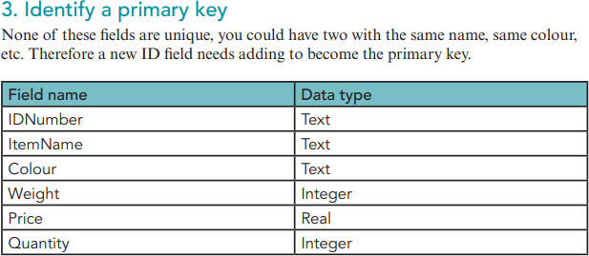

SQL
SQL stands for Structured Query Language.
This is a standard language that is used across most types or database to perform actions such as:
- define tables • change tables • add data to tables • search for data from tables (query) • perform calculations
using data from tables.
Queries

SELECT … FROM
This allows you select a set of fields from a table. All of the data in each field will be returned.
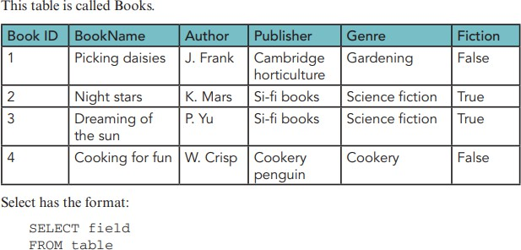
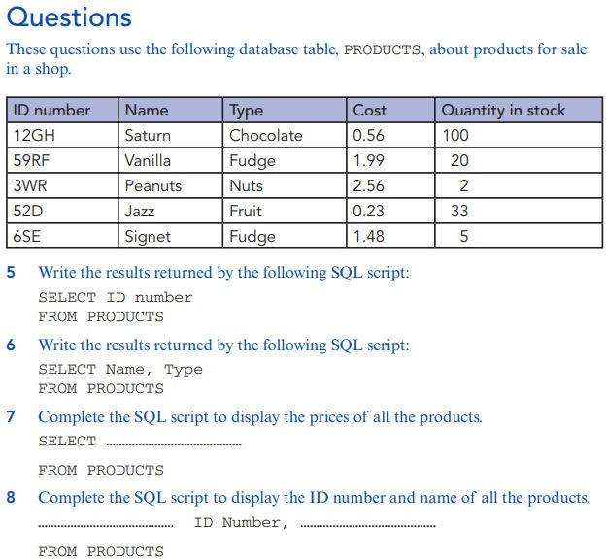

SELECT … FROM … WHERE
Including a WHERE clause in the SELECT statement allows you to select only specific data. For example, you only want gardening books, or items that cost more than $3.00.

Single condition (single WHERE)
This has only one condition. The condition needs a logical operator. These are the same operators that you use in programming (Table 9.2).
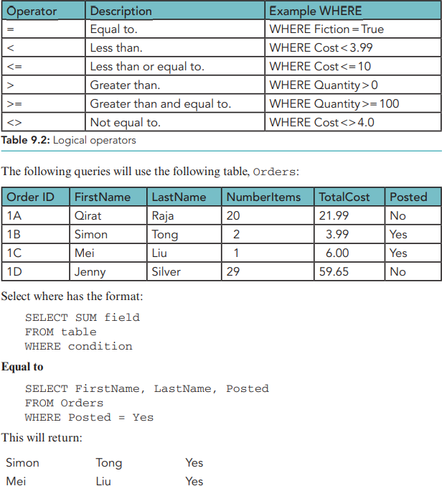

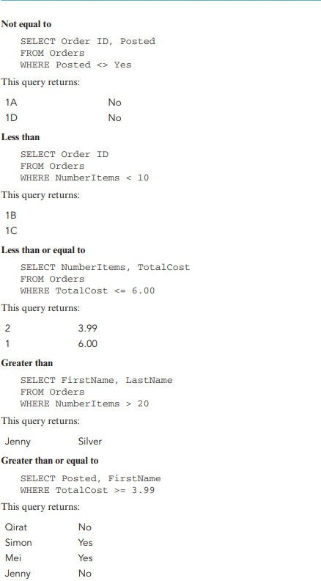

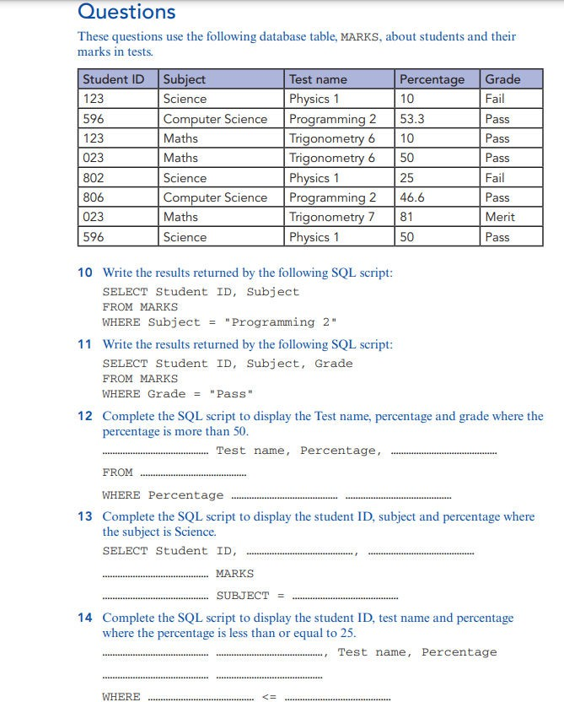

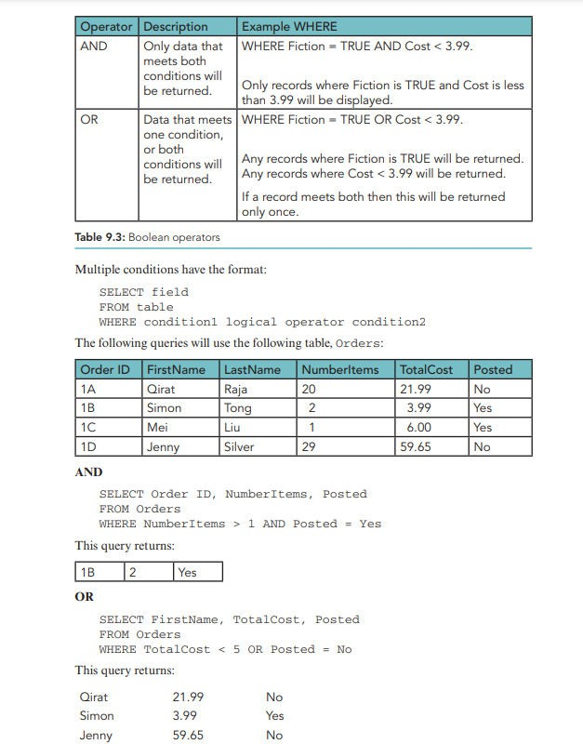

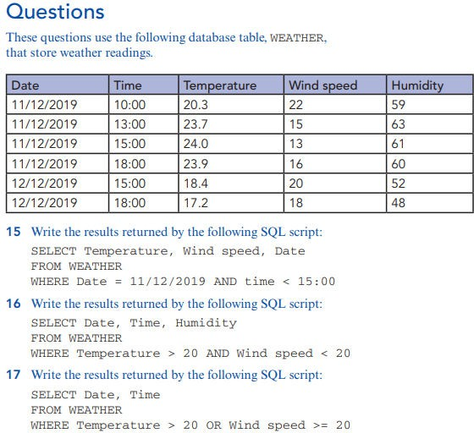
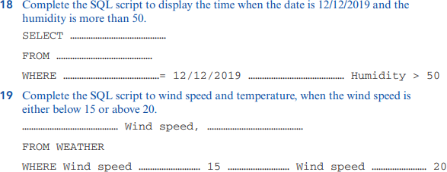

Order by
This command allows you to state which order the result will be displayed in. There are two options, ascending (ASC) and descending (DESC). The default is ascending.
The order by statement comes after the SELECT ... FROM or SELECT ... FROM ... WHERE. The following queries will use the following table, Orders:

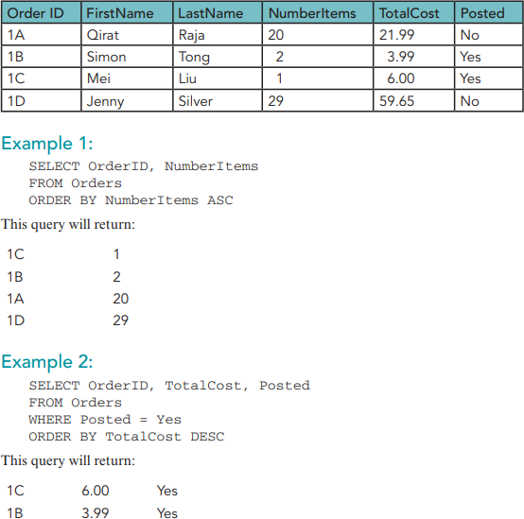

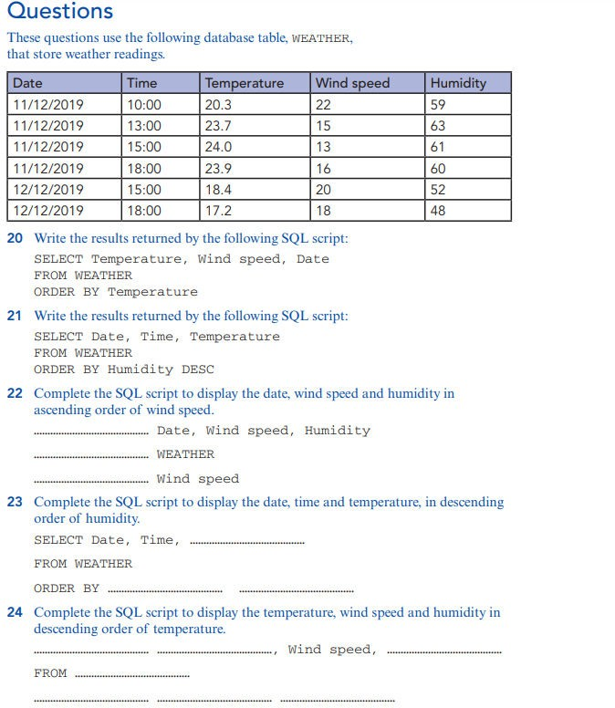

SUM
SUM command will add up the field that is written after it. It is written in the select statement in the format:
- SELECT SUM(field) FROM table
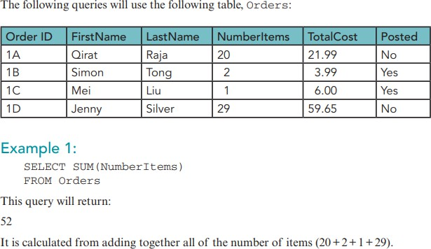

Example 2: SELECT SUM(TotalCost) FROM Orders WHERE Posted = No
This query will return: 81.64
It is calculated from adding together all the total costs where posted is No (21.99+59.65).

COUNT
This will count how many records meet the criteria, or how many fields are in the table. Count is in the format:
- SELECT COUNT(field) FROM table
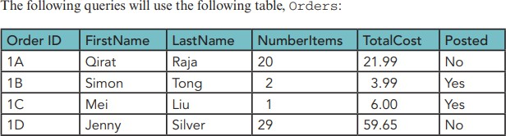

Example 1: SELECT COUNT(OrderID) FROM table
The query will return: 4

Example 2: SELECT COUNT(NumberItems) FROM table WHERE Posted = Yes
The query will return: 2
Example 3: SELECT COUNT(OrderID) FROM Orders WHERE NumberItems > 10
The query will return: 2
Practice Questions
