
1
COMPUTER SCIENCE XII

Chapter 01:

CONCEPTS OF COMPUTER PROGRAMMING

Programmer: A programmer is a person who writes and tests code to create software, applications, or systems that perform specific tasks on computers or other devices.
Programming: Programming is the process of designing, writing, testing, and maintaining code that tells a computer or device how to perform specific tasks or solve problems.

Computer Language: A computer language is a formal language used to communicate instructions to a computer. It allows programmers to write code that the computer can interpret and execute to perform specific tasks.

Types of Computer Languages:

- Low Level Language / Machine Language
- High level Language

Low-Level Languages: These are computer languages that are very close to the machine's hardware, like binary code, making them hard for humans to read but easy for computers to execute.

High-Level Languages: These are computer languages that are closer to human languages, making them easier for humans to write and understand. They are more abstract and require translation before the computer can execute them. E.g. Python, Java, C++ etc.

Steps of Programming Process:
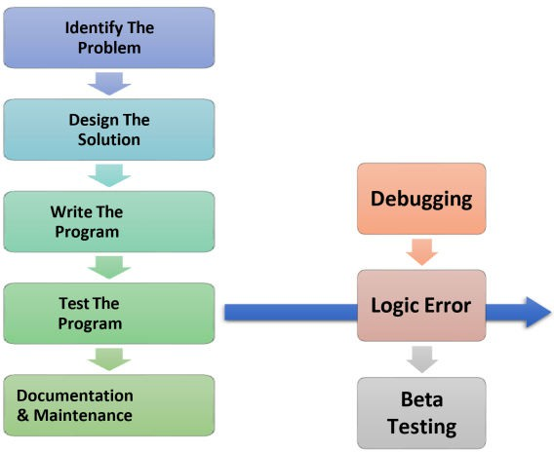

2
COMPUTER SCIENCE XII

Step 1: Identify the Problem
First you want to figure out what it is that you’re trying to solve you need to make a list of the Requirements you’ll need to accomplish this task and the specifications of the program you will be using.
Steps 2: Design the Solution
You need to plan out how you're going to solve this problem. The most commonly used design Method is call the Top-Down Design Method. There are many ways to create an algorithm to help you like pseudo codes or flowcharts
Step 3: Write the Program
First you must choose the correct programming language that best fits the needs of your solution remember to follow good programming style.
Step 4: Test the Program
Testing must be done to ensure your program is functioning properly. There are 3 main steps:
- Debugging – This ensures that the program works and everything is coded properly.
- Logic Errors – This ensures that what happens in the program makes sense (just because something functions doesn’t mean it will make sense).
- Beta Testing – Apply real-world variables to make sure the program can handle normal circumstances.
Steps 5: Documentation and Maintenance
Use Documentation to make sure that anyone using your program is adhering to how it works and the rules that revolve around it.

Errors and its Types:
There are three types of errors.

SYNTAX ERROR:
A syntax error is violation of the rules of whatever language the program is being written.
For example:
C = (A + B/2
In this example, the problem is missing closing parenthesis which should be placed in the appropriate place depending on the logic of the program.

LOGIC ERRORS:
The logical error is an error in planning the program’s logic. The computer actually does not know that an error has been made. It follows the program instruction and outputs the result, but the output is not correct.
Example:
You wanted to do the sum of A and B and put the result in the variable C. this is accomplished by typing: C = A + B

3
COMPUTER SCIENCE XII

But while typing the programmer has however typed the following expression: C = A – B
This expression will be properly executed but will obviously not give the correct output.

RUNTIME ERRORS:
These errors occur when a program is run on the computer and the results are not achieved due to some misinterpretation of a particular instruction.
Example:
Dividing a number by zero which results in a very large value of quotient.

Language Translators (or Language Processors)
They are software tools that convert code written in a high-level or assembly language into machine language that a computer can execute. There are three main types of language translators:

- Assembler: Converts assembly language code into machine code.
- Compiler: Translates an entire program written in a high-level language into machine code before execution. The program is then executed as a whole.
- Interpreter: Translates and executes high-level language code line by line, without converting the entire program into machine code beforehand.

DEBUGGING:
Debugging is the process of locating and eliminating program errors.

Tools/Methods of debugging:
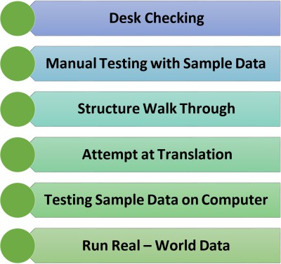

  - Desk checking
In desk checking a programmer checks the printout of the program while sitting at a desk.
The programmer goes through the listing line by line looking for syntax, logic and runtime errors. In other words, desk checking is a sort of proof reading.

  - Manual testing with sample data
Both correct and incorrect data are run through the program-manually, not with a computer-to test for correct processing results. This is called “dry run of program”.
  - Structured walkthrough:

4
COMPUTER SCIENCE XII

It is a process in which three or four programmers, including the creator of program, review the program.
  - Attempt at Translation
The translator attempts to translate the written program from the programming language into machine language of 1s and 0s. By translating the program syntax error can be identified.

Testing Sample data on computer
Sample data will be entered in program on computer to test each statement. Sample data should be made carefully to ensure that every part of the program is tested. This step is sometimes called alpha testing.
  - Run real – world data.
If the program is going to be sold commercially, it is released to a selected set of users to be tested with real data called beta testing. The selected users locate errors that were overlooked during the regular testing phase and report them to the company that is developing the program.

CHARACTERISTICS OF PROGRAMMING LANGUAGES:
Programming languages are different from each other but certain classes of instructions are present in every programming language, which can be categorized as follows:

Input/output instructions:
These instructions direct the computer to “read from” or “write to” a peripheral device (for example, disk drive or a printer)

Computation Instructions:
These instructions direct the computer to perform arithmetic operations (add, subtract, multiply, divide and raise a number to a power).
Example: Pay = hours *rate this computes gross earning for hourly employees.

Control Instructions:
These instructions can alter the sequence of the program’s execution or terminate execution.
Example: In an accounts receivable program, different sequences of instructions are executed for customers who pay on time and for those who pay after the due date.

Assignment Instructions:
These instructions transfer data internally from one RAM location to another. Example: A data item may be copied from one location to another, the result of a computation may be stored at a specified location, or an intermediate result may be retrieved from a given location.

5
COMPUTER SCIENCE XII

Object-Oriented Programming (OOP):
Object-Oriented Programming (OOP) is a method of programming that organizes code into objects, which represent real-world things or concepts. It makes code more modular, reusable, and easier to manage.
OOP is widely used because it helps in building large, complex applications in a more organized and efficient manner.

Key Concepts of OOP:
  - Objects:
  - Instances of classes that have attributes (properties) and methods (functions).
  - For example, a Car object might have attributes like color and model and methods like start() and stop ().
  - Classes: Blueprints for creating objects. A Car class would define what attributes and methods a car object should have.
  - Encapsulation: Keeping data and methods within an object private, so they can only be accessed through the object's methods. This protects the integrity of the data.
  - Inheritance: A way to create new classes based on existing ones, inheriting their attributes and methods while adding or modifying features. For example, a Truck class might inherit from the Vehicle class.
  - Polymorphism: Allows methods to do different things based on the object they’re acting on, even if they share the same name. For instance, a draw() method might behave differently for a Circle object than for a Rectangle object.
  - Abstraction: Simplifying complex systems by modeling classes appropriate to the problem, hiding unnecessary details from the user.

6
COMPUTER SCIENCE XII

ALGORITHM
Chapter 02:

ALGORITHMS & FLOWCHARTS

  - An algorithm is a set of instructions that a computer follows to perform a particular task or solve a specific problem.
  - It is a step-by-step procedure for solving a problem or achieving a specific goal.
  - An algorithm can be represented in a variety of ways, including as a flowchart, pseudocode, or programming code.

Methods to write an algorithm:
There are two main methods to write an algorithm.
- General English
- Pseudocode

Pseudocode
  - The pseudo code is a particular way to write an algorithm.
  - Pseudo code uses specified words for different purposes.
  - Pseudo code is near to the computer language.

Following are specific words which are used in a pseudo code:
    - Start: To start the algorithm
    - Exit: To end the algorithm
    - Read: To take input in a variable
    - Write: To print value of variable on monitor
    - If then: For condition checking
    - Repeat: For iteration

Examples of Algorithms
Example No. 1
Compute the distance travelled by train in the specific time.
- Step 1: Start the calculation.
- Step 2: Enter a value for SPEED.
- Step 3: Enter a value for TIME.
- Step 4: Calculate DISTANCE by using formula SPEED x TIME.
- Step 5: Write the value of DISTANCE.
- Step 5: Exit

Example No. 2
Find the Largest Number Among All the Entered Integers.
  - Step 1: Read the Integer A.
  - Step 2: Read Integer B.
  - Step 3: If B is greater than A, then print B, else A.

7
COMPUTER SCIENCE XII

FLOWCHART:
A type of diagram that represents a process or workflow. Flowcharts use different symbols to denote different types of actions or steps in a process, making them useful for visualizing how a process works. FLOWCHART SYMBOLS:
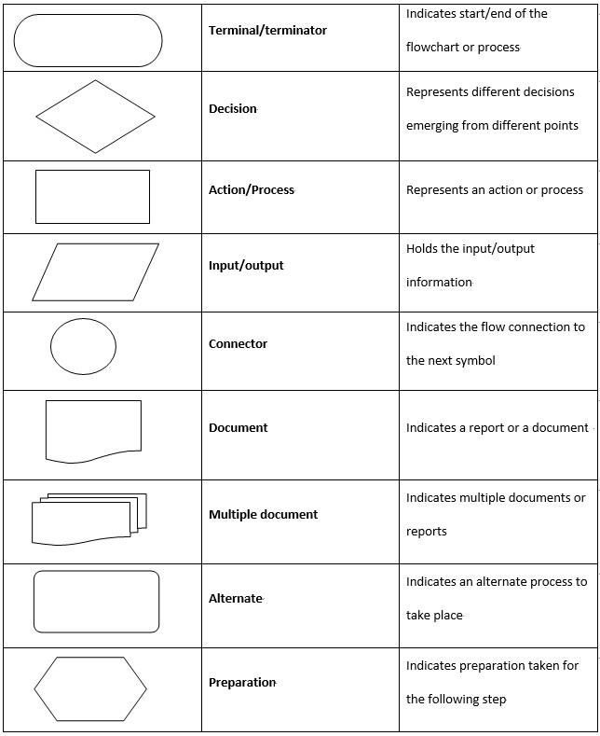
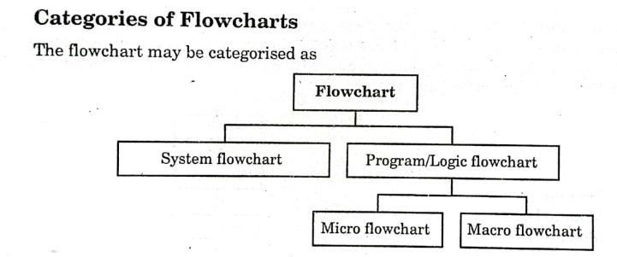

System Flowchart:
  - This generally refers to a flowchart that depicts the overall flow of data within a system, including inputs, processes, and outputs. It’s often used to illustrate the interaction between different parts of a system or organization.

Program/Logic Flowchart:
This refers to flowcharts that map out the logic of a program or algorithm. This type of flowchart typically focuses on the decision-making process within a program, showing the sequence of operations, conditions, and branching points.
The Program/Logic Flowchart is further divided into:

8
COMPUTER SCIENCE XII

- Micro Flowchart: Focuses on specific, detailed sections of a process, usually representing a small part of the overall system.
- Macro Flowchart: Provides a broader overview, representing major steps or components of a system, without going into granular details.

CONTROL STRUCTURES:
A control structure in programming is a block of code that determines the flow of control or the order in which instructions are executed. It allows the program to make decisions, repeat actions, or execute instructions sequentially based on specific conditions.

Three Types of Control Structures:
- Sequential Structure
- Selection Structure (Conditional Statements)
- Repetition/Iteration Structure (Loops)

Sequential Structure:
Definition: The sequence control structure executes instructions one after another in a linear order.
Key Point: Every statement is executed in the exact order it appears in the code.
Example: Initializing variables, performing calculations, and displaying results in a step-by-step manner.
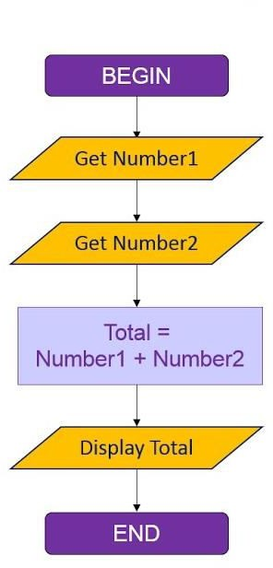

Selection Structure (Conditional Statements):
Definition: The selection control structure allows the program to choose different paths of execution based on certain conditions.
Types:
  - If-Else: Executes different blocks of code based on whether a condition is true or false.
  - Switch-Case: Selects one of many possible paths based on the value of a variable.
Key Point: It involves decision points where the flow of control splits into different branches.

9
COMPUTER SCIENCE XII
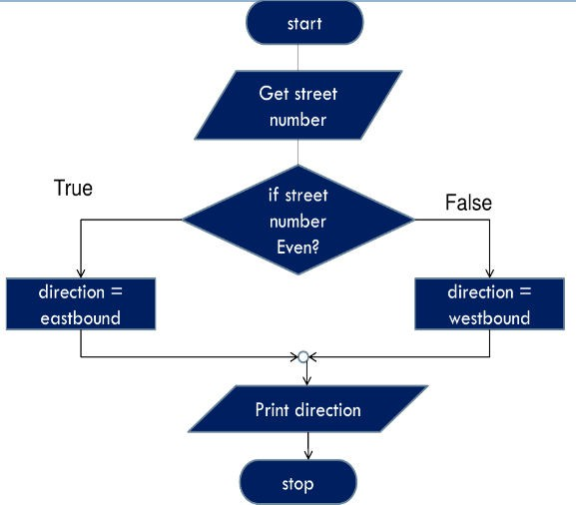

Repetition/Iteration Structure (Loops):
Definition: The iteration control structure repeats a block of code multiple times, as long as a specified condition is true.
Types:
  - For Loop: Repeats a block of code a specific number of times.
  - While Loop: Repeats a block of code as long as a condition remains true.
  - Do-While Loop: Similar to the while loop but ensures the code is executed at least once.
Key Point: It involves loops that continue executing until a condition is met or fails.
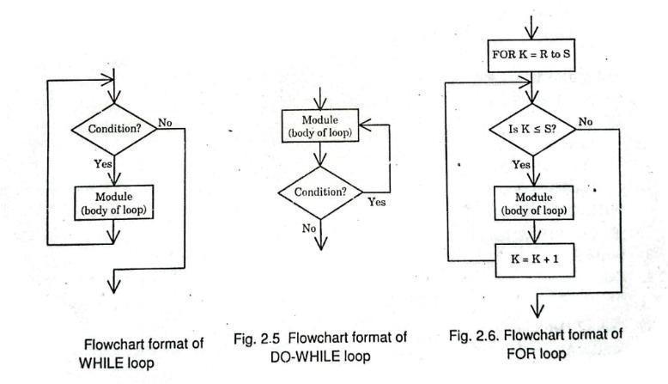

Types of Flowchart
There are four main types of flowchart which can be combined in different way to represent any given problem.

SEQUENTIAL FLOWCHART
This is the simplest type of flowchart, involving no decisions, branches or loops.

  - BRANCH (OR JUMP) FLOWCHART In this type, one or more decision boxes are introduced, and the action taken depends upon whether the result of the decision is ‘yes’ or ‘no’.
  - LOOP FLOWCHART A loop represents a procedure which may be repeated a definite or indefinite number of times.

  - NESTED LOOPS IN A FLOWCHART Loop within a loop are nested loops.

10
COMPUTER SCIENCE XII

Advantages of Flowchart:
  - Makes things easier to understand by breaking down complex processes into simple steps.
  - Provides clear visuals that show the process in a way that’s easy to follow.
  - Helps everyone understand and discuss the process, improving communication.
  - Makes it easier to spot and fix problems.
  - Useful for explaining and teaching how things work.
  - Clearly shows different choices and their outcomes, aiding decision-making.
  - Assists in finding and fixing mistakes (debugging).

Disadvantages of Flowchart:
  - Can become confusing and hard to follow for big projects.
  - Creating detailed flowcharts can be time-consuming.
  - Not always easy to update a flowchart once it’s made.
  - May oversimplify, leaving out important details.
  - If not done well, flowcharts can be unclear or misleading.
  - Depends on knowing how to read flowchart symbols, which not everyone might understand.
  - Showing repeating steps (loops) can be difficult in a flowchart.

Flowcharting Rules:
  - Start with a clear goal.
  - Use standard symbols (ovals, rectangles, diamonds, and arrows).
  - Make the flow go from top to bottom or left to right.
  - Keep the flowchart simple and easy to follow.
  - Clearly label each step and arrow.
  - Test the flowchart to ensure it makes sense.
  - Review and revise for clarity and accuracy.

11
COMPUTER SCIENCE XII

Chapter 03
AN OVERVIEW OF C LANGUAGE

INTRODUCTION TO THE C LANGUAGE:
C is a widely-used programming language developed in the early 1970s by Dennis Ritchie. It is known for its simplicity, efficiency, and ability to provide low-level access to computer memory. C is commonly used to write operating systems, games, and other performance-critical applications.

Why Learn C?
Learning C is important because it helps you understand how computers work at a deeper level. It is essential for developing software that requires high performance, such as system software, game development, and embedded systems.

- It provides a strong foundation for learning other programming languages.
- Allows for high-performance and efficient software development.
- Useful for system programming and applications requiring direct hardware control.

IDE OF C LANGUAGE:
- The IDE (Integrated Development Environment) is the programming environment for a specific language which provides the facilities of editing, compilation, debugging and running of a program.
- An IDE contain the menus having commands which help the programmer for easy to use programming from editing of the source code up to the screen output.

- The IDE contains the menus or commands having short cut keys to facilitate the programmer.

- It displays the error, warning and alerts to inform the programmer about a specific problem.

Example
- IDE of C language: Turbo C, visual studio, Dev-C++.
- It displays different programming text in different colors.

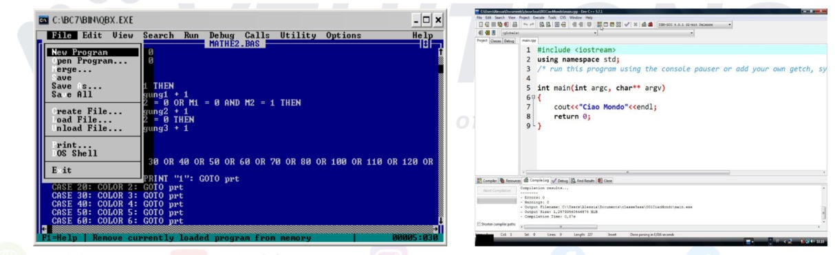
12
COMPUTER SCIENCE XII

IMPORTANT MENUS OF C LANGUAGE IDE:

- File Menu: Used for creating, opening, saving, and closing projects and files.
- Edit Menu: Provides options for editing code, such as cut, copy, paste, undo, and redo.
- View Menu: Allows customization of the IDE layout, like toggling toolbars, side panels, and showing or hiding line numbers.
- Build/Compile Menu: Contains options to compile code, build projects, and manage build configurations.
- Run/Debug Menu: Provides options to run or debug your program, including setting breakpoints and stepping through code.
- Tools/Options Menu: Offers customization settings for the IDE, such as configuring the compiler, setting up plugins, or changing editor themes.
- Help Menu: Provides access to IDE documentation, tutorials, and community support resources.

STRUCTURE OF A C PROGRAM
# include<stdio.h> // Header File
void main (void) OR int main ( ) OR void main ( ) // function name

{ // start of function

Statement # 1; //function body Statement # 2;

} //end of function

PROGRAM DEVELOPMENT CYCLE

Editing Source Code:
Write or update the program's code in a text editor or IDE. This is where the logic and functionality of the program are defined.

Compiling the Program:

13
COMPUTER SCIENCE XII

Convert the written code into machine code using a compiler. This process checks for syntax errors and prepares the code for execution.

Linking the Program:
Combine the compiled code with necessary libraries and modules. This creates an executable file that can run on the system.

Running the Program:
Execute the final executable to perform the intended operations. This step tests the program's functionality in a real environment.

ESCAPE SEQUENCES:
    - The escape sequences are the special purpose C language codes used for different purposes.
    - These codes are use with '\' backslash.
    - These are used in input and output statements in setting the cursor location and for some special purposes.
    - Sometimes it is used to print characters like backslash, inverted commas, sign of interrogation etc.
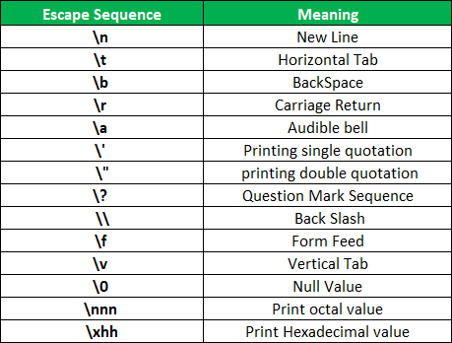

14
COMPUTER SCIENCE XII

Chapter 04

C FUNDAMENTALS

KEYWORDS
Keywords in C programming are reserved words that have a specific meaning and functionality within the programming language. These words are reserved by the language and cannot be used as variable names, function names, or any other identifiers in the code.

EXAMPLE:
int: The "int" keyword is used to define variables of integer type. For example: int x = 5;
float: The "float" keyword is used to define variables of floating-point type. For example: float y = 3.14;
char: The "char" keyword is used to define variables of character type. For example: char c = 'a';
if: The "if" keyword is used to create conditional statements.

IDENTIFIER
In C programming, an identifier is a name given to a variable, function, or any other user-defined item. An identifier is used to refer to the item in the code. Identifiers are case-sensitive in C, which means that "myVariable" and "myvariable" are two different identifiers.

Here are some examples of identifiers in C programming:
Variable names: Variables in C are declared using an identifier. For example:
int age; float salary; char gender; In this example, "age", "salary", and "gender" are all identifiers used to declare variables of different data types.

Rules for naming Identifiers in C:

- Identifier names must begin with a letter (A-Z or a-z), underscore (_), or dollar sign ($).
- After the first character, an identifier name can also contain digits (0-9).
- Identifier names are case sensitive. For example, "count" and "Count" are two different identifiers.
- The length of an identifier name is limited to 31 characters in most C implementations.
- The identifier name should not be a keyword or reserved word in the C language. For example, you cannot use "if", "while", or "switch" as an identifier name.
- White spaces, punctuation marks, and special characters (except underscore and dollar sign) cannot be used in identifier names.
- It is recommended to use meaningful and descriptive names for identifiers, which will make the code more readable and maintainable.

Here are some examples of valid identifier names in C:
- counter
- total_amount

15
COMPUTER SCIENCE XII

- maxScore
- _data
- $result

And here are some examples of invalid identifier names in C:
- 123num (Identifier name cannot begin with a digit)
- if (if is a reserved keyword in C)
- average score (Identifier name cannot contain white spaces)
- $amount% (Identifier name cannot contain special characters other than underscore and dollar sign)

DATA TYPES IN “C”
Data Type is the declaration of Variable in C.

- int: Used to store integers (whole numbers without decimals). Example: int num = 5;

- char: Used to store a single character. Example: char letter = 'a';

- float: Used to store single-precision floating-point numbers (numbers with decimals). Example: float pi = 3.14f;

- double: Used to store double-precision floating-point numbers (more precise than float). Example: double e = 2.71828;

MEMORY SIZE OF DIFFERENT DATA TYPES:
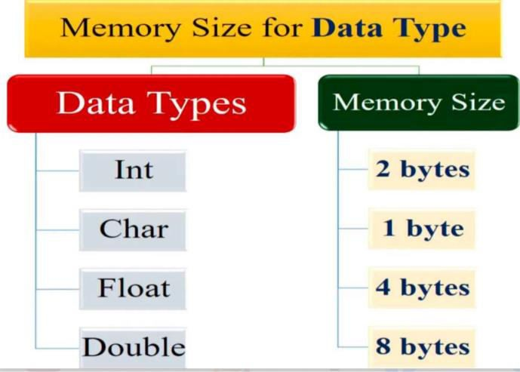

16
COMPUTER SCIENCE XII

VARIABLE
In C, a variable is a named storage location in memory that holds a value of a specific data type, which can be changed during the program's execution. Variables must be declared with a type (such as int, char, float, etc.) before they are used to store data.

EXAMPLE
- age: An integer variable representing a person’s age. Example: age = 25
- temperature: A floating-point variable representing the temperature in degrees. Example: temperature = 98.6
- grade: A character variable representing a student’s grade. Example: grade = 'A'

CONSTANT IN C
  - In C programming, a constant is a fixed value that cannot be changed during program execution, or we can say that the constants in C are the read-only variables whose values cannot be modified once they are declared in the C program.
  - The type of constant can be an integer constant, a floating pointer constant, a string constant, or a character constant.
  - In C language, the const keyword is used to define the constants.

Integer Constants

  - Decimal Constants: Represented without any prefix, using digits 0-9.
o Example: 42, 0, -100
  - Octal Constants: Represented with a leading zero (0).
    - Example: 075, 017
  - Hexadecimal Constants: Represented with a leading 0x or 0X.
    - Example: 0x1A, 0XFF, 0x2B

Floating-Point Constants

  - Represent numbers with a fractional part or exponent.
  - Example: 3.14, -0.001, 2.71828, 6.022e23

Character Constants

  - Represent a single character enclosed in single quotes.
  - Example: 'A', 'z', '\n' (newline character), '\t' (tab character)

String Constants (String Literals)

  - Represent a sequence of characters enclosed in double quotes.

17
COMPUTER SCIENCE XII

  - Example: "Hello, World!", "C Programming"

Enumeration Constants

  - Constants that represent integer values defined using the enum keyword.
  - Example:

ARRAY IN C
  - Arrays are used to store multiple values in a single variable, instead of declaring separate variables for each value.
  - To create an array, define the data type (like int) and specify the name of the array followed by square brackets [].
  - In C, the array index starts at 0, so the first element is accessed using index [0].

Declaration and Initialization of Array in C
For Example:

int num1=10, num2=15, num3=20, num4=27; We can do this by using single variable
- data-type array-name [constant-size]
int numbers[5]={12,16,28,65,98};

EXAMPLE CODE
#include <stdio.h> int main() {
int numbers[4] = {5, 10, 15, 20}; int sum = 0;

for (int i = 0; i < 4; i++) { sum += numbers[i]; }
printf("The sum of the array elements is: %d\n", sum);
}

18
COMPUTER SCIENCE XII

OPERATOR
Chapter 05

OPERATORS AND EXPRESSIONS

An operator is a symbol or character in programming that performs a specific action on data or variables, such as arithmetic calculations, comparisons, or logical evaluations. Operators are essential tools that allow a programmer to manipulate data, make decisions, and control the flow of a program.

CLASSIFICATION OF OPERATORS (ON BASES OF OPERANDS):
Operators fall into three classes:

- Unary Operators: The operators which requires one operand only is called unary operator. Example is ++ (increment operator), -- (decrement operator)
- Binary operators: The operator requires at least two operands for evaluation is called binary operators.
Examples are +, -, /, * etc.
- Ternary Operators: The operator which requires three operands are called ternary operators.

TYPES OF OPERATORS:

OPERATOR | OPERATION | EXAMPLE
Arithmetic | For mathematical  operations like Addition, subtraction, Division etc. | +, -, /, *
Assignment | To store some value in the  variables | +=, *=, /=
Relational | For comparison of data  values | < ,<=, >=
Logical | To take logical decision | &&, ||
Increment | (++): Adds 1 to the | int x = 5; x++;
and | variable. | int y = 5;
decrement | (--): Subtracts 1 from the | y--;
operator | variable.
OPERANDS:
The operands are defined as the variables, constants or identifiers on which the operands are applied.

19
COMPUTER SCIENCE XII

Explanation:
Operators are always supposed to be performed on some value which may be in form of a variable or constants. There may be multiple operands in a C statement to evaluate.

Example:

OPERATOR | C STATEMENT | OPERAND S
+ | c = a+b | a, b, c
- | d = a-b | a, b, d

OPERATOR PRECEDENCE IN C
It refers to the rules that determine the order in which different operators are evaluated in an expression. Operators with higher precedence are evaluated before operators with lower precedence.
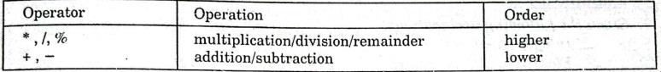

  - Arithmetic operators have higher precedence than assignment operators.
  - Unary operators have higher precedence than binary operators.
  - Multiplication and division operators have higher precedence than addition and subtraction operators.
  - Conditional operator has higher precedence than assignment operator.

EXPRESSION
In C programming language, an expression is a combination of values, variables, operators, and functions that produces a result.

Examples:
c=a+b; x++;
y= (2+5+x)/2;

Examples of Expressions in C
The following expressions in C are:

Arithmetic Expression
An arithmetic expression performs basic mathematical operations such as addition, subtraction, multiplication, and division.
int x = 5; int y = 10; int z = x + y;

Relational Expression
A relational expression compares two values and returns a Boolean value (either true or false). int a = 5;

20
COMPUTER SCIENCE XII

int b = 10;
if (a < b) // This is a relational expression that checks if a is less than b. printf("a is less than b\n");

Logical Expression
A logical expression combines two or more relational expressions using logical operators such as AND, OR, and NOT.
int a = 5; int b = 10;
if (a < b && b > 0) // This is a logical expression that checks if a is less than b

AND if b is greater than 0.
printf("a is less than b and b is greater than 0\n");

Assignment expression
An assignment expression in C is an expression that assigns a value to a variable. It uses the assignment operator = to assign the result of an expression to a variable.

a = 5 is an assignment expression that assigns the value 5 to the variable a.

Conditional Expression
A conditional expression is a shorthand way of writing an if-else statement.
int a = 5; int b = 10;

int max = (a > b) ? a : b; // This is a conditional expression that assigns the maximum of a and b to the variable max.

MODULUS OPERATOR IN C
In C programming language, the modulus operator is represented by the percentage symbol (%), and it is used to calculate the remainder of a division operation between two integers.

Example int a = 17; int b = 5; int result;
// Calculate the remainder of a divided by b result = a % b;
printf("The remainder of %d divided by %d is %d\n", a, b, result);

- In this example, the modulus operator is used to calculate the remainder of 17 divided by 5. The result is 2, because 17 divided by 5 is 3 with a remainder of 2.

21
COMPUTER SCIENCE XII

Chapter 06

INPUT AND OUTPUT STATEMENTS

UNFORMATTED INPUT OUTPUT FUNCTIONS
Unformatted I/O functions can only be used with character data types, character arrays, and character strings. These functions allow for the reading of a single user input at the console and the display of the value. Because we are unable to apply format specifiers in these functions and so cannot format them to meet our needs, they are referred to as unformatted I/O functions. The following list of unformatted I/O operations is provided:

- getch ( );
- getche ( );
- getchar ( );

getch ( );
- gets ( );
- puts ( );
- putch ( );
- putchar ( );

The user reads one character from the keyboard using the getch ( ) method, but that character is not displayed on the terminal screen, and the function returns right away without pushing the enter key. Conio.h, a header file, contains the declaration for this function, getch( ) is also used for hold the screen.

EXAMPLE OF GETCH ( );
#include<stdio.h> #include<conio.h> int main ( ) {
printf("\nHello, press any alphanumeric character to exit "); getch();
return 0;
}

getche ( );
The getche ( ) function reads a single character from the keyboard by the user and displays it on the console screen. This function is declared in conio.h (header file). It accepts only a single character from the keyboard.

EXAMPLE OF GETCHE ( );
#include<stdio.h> #include<conio.h> int main ( ) {
printf("Enter any character: "); getche ( );
return 0; }

22
COMPUTER SCIENCE XII

getchar ( );
The getchar ( ) function is used to read only a first single character from the keyboard whether multiple characters is typed by the user and this function reads one character at one time until and unless the enter key is pressed. This function is declared in stdio.h (header file).

EXAMPLE OF GETCHAR ( );
#include<stdio.h> #include<conio.h> int main ( ) {
char c;
printf ("Enter a character : "); c = getchar ( );
printf ("\nEntered character : %c ", c); return 0; }

- gets ( );
The gets ( ) function reads a group of characters or strings from the keyboard by the user and these characters get stored in a character array. This function allows us to write space-separated texts or strings. This function is declared in stdio.h (header file).

EXAMPLE OF GETS ( );

#include<stdio.h> #include<conio.h> int main() {
char c [40];
printf("Enter a string : "); gets(c); printf("\n%s",c); return 0; }

- puts ( );
In C programming puts ( ) function is used to display a group of characters or strings which is already stored in a character array. This function is declared in stdio.h (header file).

EXAMPLE OF PUTS ( );

#include<stdio.h> #include<conio.h> int main ( ) {
char c[25];
printf("Enter your Name : "); gets(c);
puts(c); return 0; }

23
COMPUTER SCIENCE XII

Putch ( );
The putch ( ) function is used to display a single character which is given by the user and that character prints at the current cursor location. This function is declared in conio.h (header file).

EXAMPLE OF PUTCH ( );
#include<stdio.h> #include<conio.h> int main ( ) {
char ch;
printf("Enter any character:\n "); ch = getch ( );
printf("\nEntered character is: "); putch(ch);
return 0;

Putchar ( );
The putchar ( ) function prints only one character at a time. This function is declared in stdio.h (header file).

EXAMPLE OF PUTCHAR ( );
#include<stdio.h> #include<conio.h> int main ( ) {
char c = 'K'; putchar(c); return 0; }

FORMATTED INPUT / OUTPUT FUNCTIONS
Formatted input/output functions in C are used to read input or write output in a specific format. They allow developers to control the appearance and interpretation of data during input and output operations.

Example:
printf ( ); is an example of formatted output function. scanf ( ); is an example of formatted input function.

printf:
The printf ( ) function is the most used function in the C language. This function is defined in the stdio.h header file and is used to show output on the console (standard output). This function is used to print a simple text sentence or value of any variable which can be of int, char, float, or any other datatype.

Example:
printf (“Hello World!”);

24
COMPUTER SCIENCE XII

The program will print the content of the string to the screen.
We can print the value of a variable, and it’s a bit tricky because we need to add a special character, a placeholder, which changes depending on the type of the variable.

For example
we use %d for a signed decimal integer digit: Int age = 25; printf (“Myage is %d”, age);

We can print more than one variable by using commas:
Int age_yesterday = 36; Int age_today = 37;
printf (“ Yesterday my age was %d and today is %d”, age_yesterday, age_today);

scanf ( );
scanf ( ) function is used to read/input values of variables using the standard input device such as keyboard. This function is used to get a value from the user running the program, from the command line. We must first define a variable that will hold the value we get from the input:
Int age;
Then we call scanf ( ) with 2 arguments: the format (type) of the variable, and the address of the variable:
scanf (“%d”, &age);
If we want to get a string as input, remember that a string name is a pointer to the first character, so you don’t need the & character before it:
char name[20]; scanf (“%s”, name);
Here’s a little program that uses both printf ( ) and scanf ( ):
#include<stdio.h> int main ( ) {
char name[20]; printf("Enter your name: "); scanf("%s", name);
printf("You entered %s", name); return 0;

25
COMPUTER SCIENCE XII

Chapter 07

SELECTION CONTROL STRUCTURES

SELECTION LOGIC OR CONDITIONAL FLOW
It selects a statement to execute on the basis of condition. Statement is executed when the condition is true and ignored when it is false e.g. if, if-else, nested if-else, switch structures.

if Statement:
The "if" statement allows conditional execution of a block of code. It evaluates a specified condition, and if the condition is true, the code block following the "if" statement is executed. If the condition is false, the code block is skipped, and the program proceeds to the next statement.

Example:
#include<stdio.h> int main ( ) {
int marks; printf("Enter marks: "); scanf("%d", &marks); if (marks >= 40) { printf("Pass");
}}

if-else Statement:
The "if-else" statement extends the "if" statement by providing an alternative block of code to execute if the condition evaluates to false. If the condition is true, the code block following the "if" statement is executed; otherwise, the code block following the "else" keyword is executed.

Example:
#include<stdio.h> int main ( ) {
int marks; printf("Enter marks: "); scanf("%d", &marks); if (marks >= 40) { printf("Pass");
}
else { printf("Fail"); }}

Nested if-else Statement:
Multiple "if-else" statements can be nested within each other to handle multiple conditions. This allows for more complex decision-making in the program.
Example: #include<stdio.h> int main ( ) {

26
COMPUTER SCIENCE XII

int marks = 269;
int attendance = 26; if (marks >= 250) {
if (attendance >= 24) { printf("Pass");
}
else {
printf("Sorry! Your attendance is LOW");
} }
else { printf("Fail");
}}

Else if Statement:
In C, the "else if" statement allows you to specify additional conditions to be checked if the previous if statements evaluates to false. It provides a way to handle multiple conditional cases in a structured manner.

EXAMPLE
#include<stdio.h> int main ( ) {
int marks;
printf("Please Input Your Marks: "); scanf("%d",&marks);
if (marks>= 250) { printf("First Position");
}
else if (marks>=200)
{
printf("Second Position");
}
else if(marks>= 175)
{
printf("Third Position");
}
else { printf("Fail");
} }

switch Statement:
It allows you to select one of many code blocks to be executed, based on the value of a variable or an expression.
The syntax for switch statement is as follows:
switch(expression) {
case constant-expression1: statement(s);
break;
case constant-expression2: statement(s); break; ... default:
statement(s); }

27
COMPUTER SCIENCE XII

- The switch statement evaluates the expression and then matches its value with each of the constant expressions (case) in the switch statement. If a match is found, the corresponding set of statements is executed. If no match is found, the default statements are executed.

Example:
#include <stdio.h> int main() {
char operator;
int num1, num2, result;

printf("Enter an operator (+, -, *, /): "); scanf("%c", &operator);

printf("Enter two numbers: "); scanf("%d %d", &num1, &num2);

switch (operator) {
case '+':
result = num1 + num2; printf("Result: %d\n", result); break;

case '-':
result = num1 - num2; printf("Result: %d\n", result); break;
case '*':
result = num1 * num2; printf("Result: %d\n", result); break;
case '/':
if (num2 != 0) {
result = num1 / num2; printf("Result: %d\n", result);
}
else {
printf("Error: Division by zero is not allowed.\n");
}
break;
default:
printf("Invalid operator! Please use +, -, *, or /.\n"); break; }
return 0;}

28
COMPUTER SCIENCE XII

ITERATION LOGIC OR REPETITIVE FLOW
Iteration logic, also known as repetitive flow or loop, is a programming construct that allows a sequence of instructions to be repeated multiple times based on a specified condition. It enables the execution of a block of code repeatedly until a certain condition is met or a specific number of iterations is reached.

for Loop:
It provides a concise way to repeatedly execute a block of code. It consists of an initialization statement, a condition, and an increment or decrement statement.

while Loop:
It repeatedly executes a block of code as long as a given condition is true. The condition is checked before each iteration.

do-while Loop:
It executes a block of code at least once and then repeatedly executes it as long as a specified condition is true. The condition is checked after each iteration.

29
COMPUTER SCIENCE XII

Chapter 08

ITERATION CONTROL STRUCTURE

For Loop
A for loop is used to repeat a block of code a specific number of times. You set it up with an initial value, a condition to keep looping while true, and an update step to change the value each time.

EXAMPLE
#include <stdio.h> int main() {
// Repeat the following block of code 5 times for (int i = 0; i < 5; i++) {
printf("i = %d\n", i); // Prints numbers 0 to 4
}
return 0; }

Nested For Loop
A nested for loop is a for loop inside another for loop. It's useful for tasks that need to loop through rows and columns, like printing a grid.

EXAMPLE
#include <stdio.h> int main() {

// Outer loop for rows for (int i = 0; i < 3; i++) {
// Inner loop for columns for (int j = 0; j < 3; j++) {

printf("(%d, %d) ", i, j); // Prints coordinates (0,0) to (2,2)
}
printf("\n"); // New line after each row
}
return 0;
}

While Loop:
A while loop keeps repeating a block of code as long as a certain condition is true. It's useful when you don't know in advance how many times you need to loop.

30
COMPUTER SCIENCE XII

Example:
#include <stdio.h>

int main() { int i = 0;
// Continue looping as long as i is less than 5 while (i < 5) {
printf("i = %d\n", i); // Prints numbers 0 to 4 i++; // Increase i by 1 each time
}
return 0;
}

2.2.Nested While Loop
A nested while loop is a while loop inside another while loop. This is useful for more complex tasks like printing a grid.
Example:
#include <stdio.h> int main() {
int i = 0;
// Outer loop for rows while (i < 3) {
int j = 0;
// Inner loop for columns while (j < 3) {
printf("(%d, %d) ", i, j); // Prints coordinates (0,0) to (2,2) j++;
}
printf("\n"); // New line after each row i++;
}
return 0;
}

Do-While Loop
A do-while loop is similar to a while loop, but it always runs the block of code at least once before checking the condition.

EXAMPLE
#include <stdio.h> int main() {
int i = 0;
// Repeat the following block of code at least once do {
printf("i = %d\n", i); // Prints numbers 0 to 4 i++; // Increase i by 1 each time
} while (i < 5); // Continue looping as long as i is less than 5 return 0;
}

31
COMPUTER SCIENCE XII

3.3.Nested Do-While Loop
A nested do-while loop is a do-while loop inside another do-while loop. This is useful for complex tasks like printing a grid where each block of code runs at least once.

Example:
#include <stdio.h> int main() {
int i = 0;

// Outer loop for rows do {
int j = 0;

// Inner loop for columns do {
printf("(%d, %d) ", i, j); // Prints coordinates (0,0) to (2,2) j++; }
while (j < 3); // Continue looping as long as j is less than 3 printf("\n"); // New line after each row
i++;
} while (i < 3); // Continue looping as long as i is less than 3 return 0;
}

RELATIONSHIP OF FOR AND WHILE LOOP
- Use a for loop when you know in advance how many times you need to execute a block of code.
- Use a while loop when you need to keep looping until a certain condition changes, and you may not know beforehand how many iterations will be required.
Both loops can be used to achieve the same results, but the choice between them often depends on the specific problem you're solving and your preference for readability and structure.

While Loop
#include <stdio.h> int main() {
int i = 0; while (i < 5) {
printf("%d\n", i); // Prints numbers 0 to 4 i++;
}
return 0;
}
For Loop
#include <stdio.h> int main() {
int sum = 0;
for (int i = 1; i <= 5; i++) { sum += i; // Add i to sum
}
printf("Sum: %d\n", sum); // Prints the sum return 0;
}

32
COMPUTER SCIENCE XII

BREAK STATEMENT:
The break statement is used to exit a loop or a switch statement immediately, even if the loop's
condition hasn't been met. It stops the loop completely.

Example:
#include <stdio.h> int main() {
int i;
printf("Using break statement:\n"); for(i = 1; i <= 5; i++) {
if(i == 3) {
break; // Loop stops when i equals 3
}
printf("%d ", i);
}
return 0;
}

CONTINUE STATEMENT:
The continue statement skips the current iteration of the loop and moves on to the next one. It doesn't stop the loop; it just skips over a specific step.
Example:
#include <stdio.h> int main() {
int i;
printf("Using continue statement:\n"); for(i = 1; i <= 5; i++) {
if(i == 3) {
continue; // Skips printing when i equals 3
}
printf("%d ", i);
}
return 0;
}

33
COMPUTER SCIENCE

FUNCTIONS IN C LANGUAGE
Chapter 09

FUNCTIONS

A function in C is a block of code that performs a specific task. It helps organize a program by breaking it into smaller, reusable pieces.

Function Structure: Every function has three main parts:

- Name: The name of the function (e.g., add()).
- Input (Parameters): The values that the function uses (optional).
- Output (Return Type): The result the function gives back (optional).

ADVANTAGES OF USING FUNCTIONS IN C

- Code Reusability: You can use the same function multiple times without rewriting the code.
- Modularity: Breaks the program into smaller parts, making it easier to understand and manage.
- Easier Debugging: Finding and fixing errors is simpler when the code is divided into small functions.
- Simplicity: Functions make the code shorter and more readable.
- Maintainability: Easier to update or improve parts of the program without affecting the whole code.
- Code Organization: Functions help organize large programs into logical sections.

CLASSIFICATION OF FUNCTIONS
There are two types of functions:
  - Built-in Functions/Library functions/Pre-Defined Functions
  - Use-defined functions

Built-in Functions/Library functions:
Built-in functions in C are functions that are already provided by the C standard library. These functions are pre-defined and can be used directly in your programs without needing to define them.

EXAMPLE

Input/output Functions:
  - printf(): Prints output to the screen.
  - scanf(): Reads input from the user.

Mathematical Functions (from <math.h> library):
  - sqrt(): Returns the square root of a number.
  - pow(): Raises a number to a power.
  - abs(): Returns the absolute value of an integer.

34
COMPUTER SCIENCE

User-Defined Functions:
These are functions created by the programmer to perform specific tasks. You define these functions according to the needs of your program.

EXAMPLE
#include <stdio.h>

// User-defined function to multiply two numbers
int multiply(int a, int b) { return a * b;
}
int main() {
int result = multiply(3, 4); // Calling the function
printf("The product is: %d\n", result); // Output: The product is: 12
return 0; }

FUNCTIONS WITH OR WITHOUT ARGUMENTS:

Function Without Arguments
This function doesn't take any arguments. It performs a task independently, like printing a message.

EXAMPLE
#include <stdio.h>

// Function without arguments
void greet() {
printf("Hello, welcome to the program!\n");
}
int main() {
greet(); // Calling the function
return 0;
}

Function With Arguments
This function takes arguments (inputs) and performs a task using them. For example, calculating the sum of two numbers.
#include <stdio.h>
// Function with arguments
int add(int a, int b) { return a + b;
}
int main() {
int num1 = 5, num2 = 7;
int sum = add(num1, num2); // Calling the function with arguments printf("The sum is: %d\n", sum);
return 0;
}

35
COMPUTER SCIENCE

RECURSIVE FUNCTION:

A recursive function is a function that calls itself to solve smaller parts of the same problem. It continues calling itself until it reaches a point where no more calls are needed (called the base case).

Example (Factorial):
#include <stdio.h>
// Recursive function to calculate factorial

int factorial(int n) {
if (n == 0) // Base case: stop when n is 0 return 1;
else
return n * factorial(n - 1); // Call itself with (n-1)
}

int main() { int num = 5;
printf("Factorial of %d is %d\n", num, factorial(num)); // Output: 120
return 0;
}

