Topic : Boolean Logic
2210/24/M/J/22
2 Four logic functions and five standard symbols for logic gates are shown.
Draw one line to link each logic function to its standard symbol. Not all standard symbols will be used.
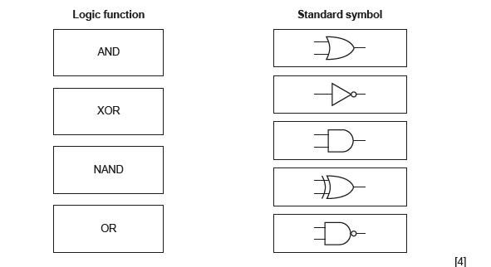
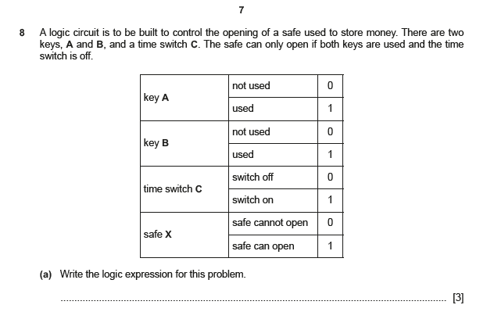

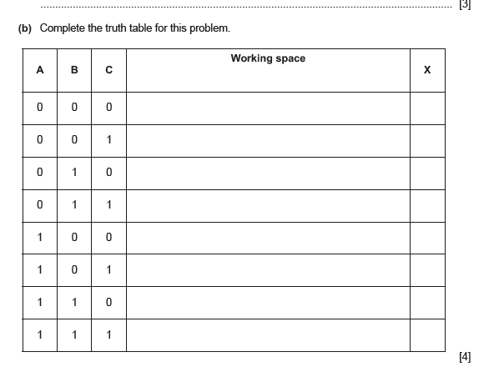
2210/24/M/J/21
8 Consider the logic expression:
Z = (R OR NOT T) XOR (NOT S AND T)
(a) Draw a logic circuit for this logic expression.
Each logic gate must have a maximum of two inputs.
Do not simplify this logic expression.
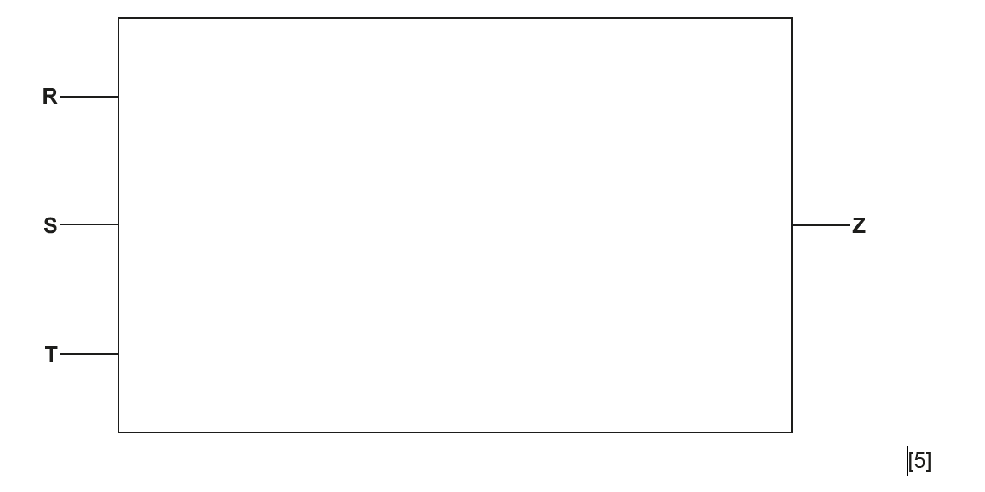
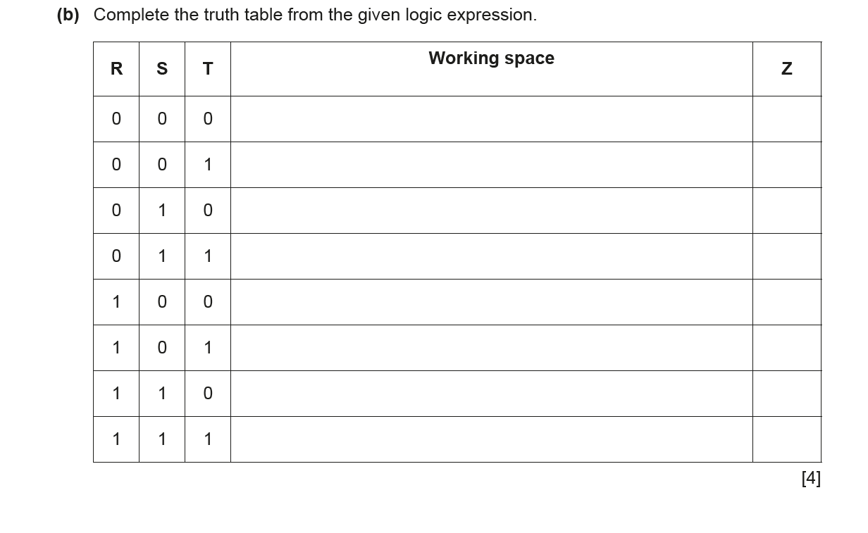
0478/24/F/M/22
7 Consider this logic expression.
X = (A OR NOT B) AND (B AND NOT C)
(a) Draw a logic circuit for this logic expression. Each logic gate must have a maximum of two
inputs. Do not simplify this logic expression.
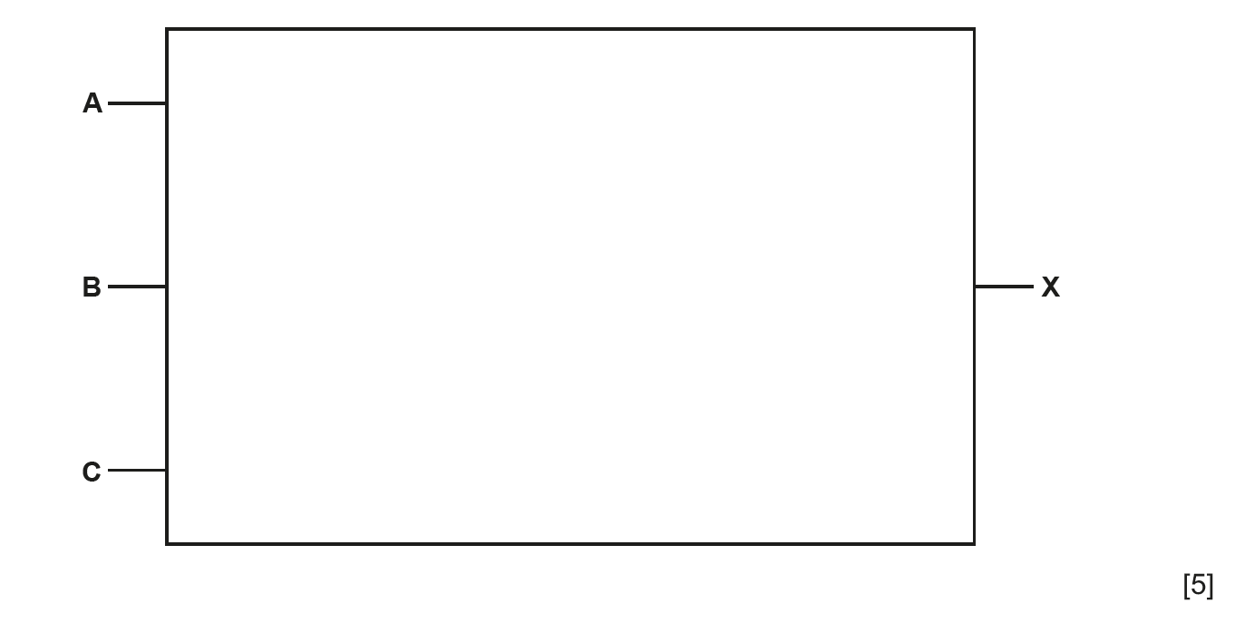
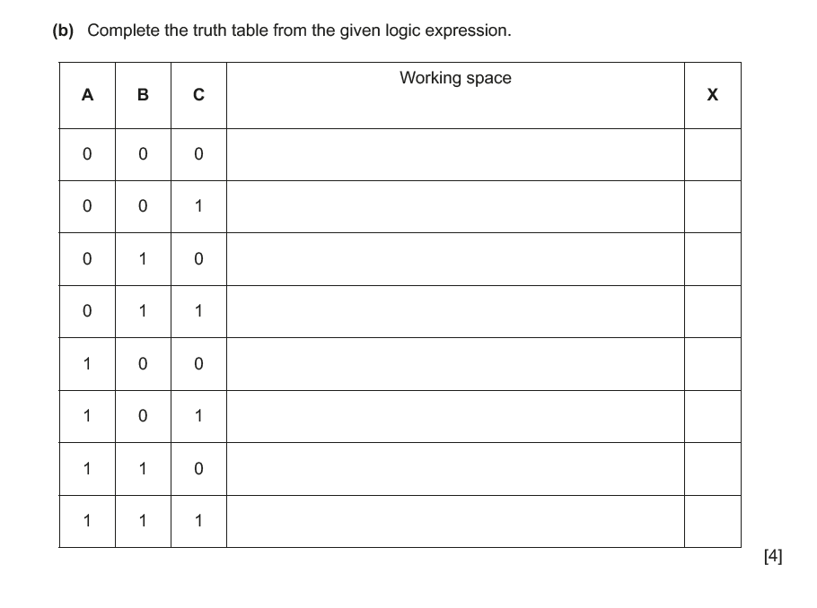
2210/23/O/N/23
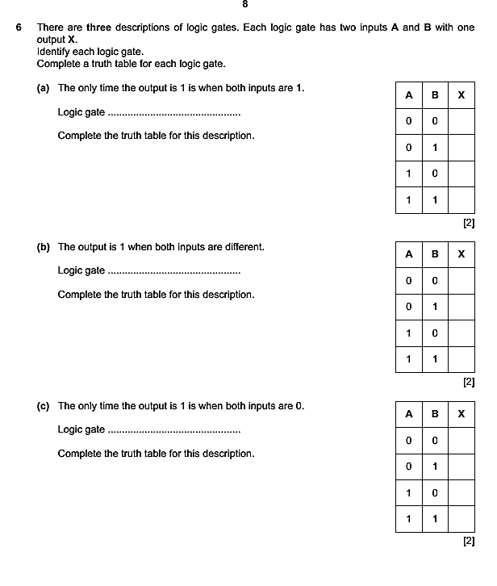
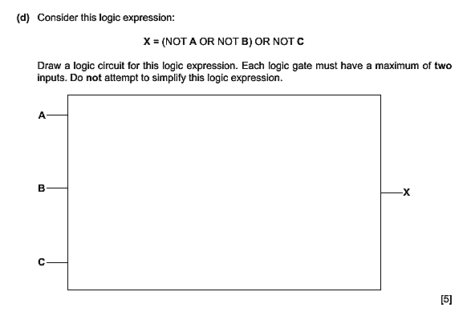

2210/23/O/N/22
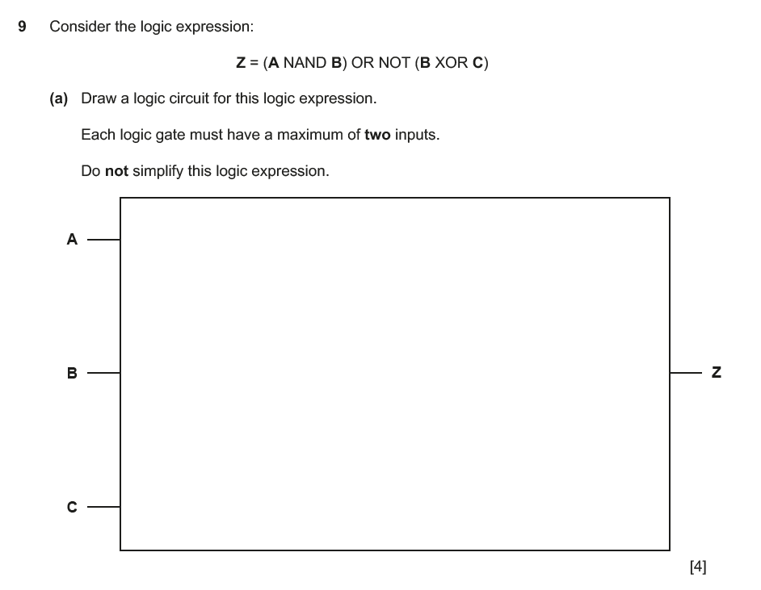
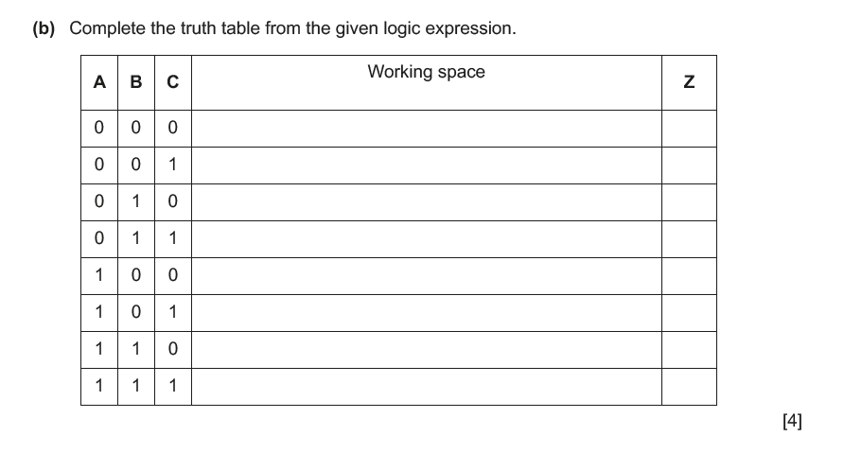
2210/23/M/J/22
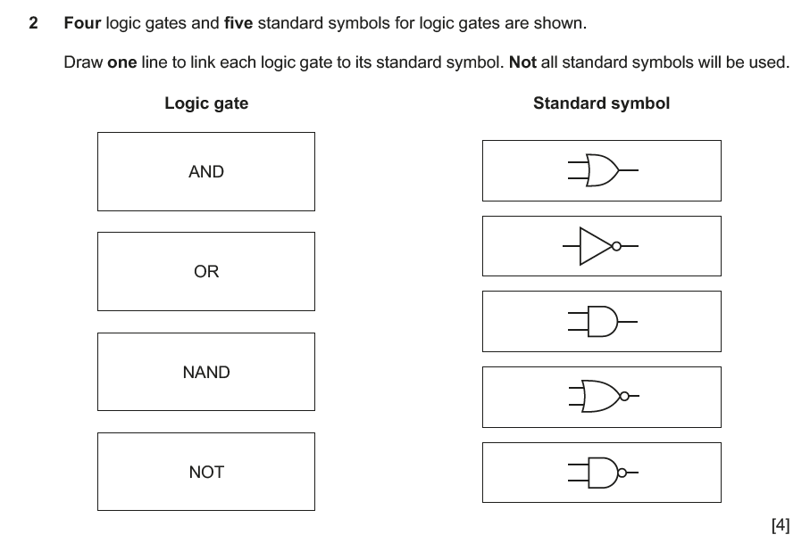
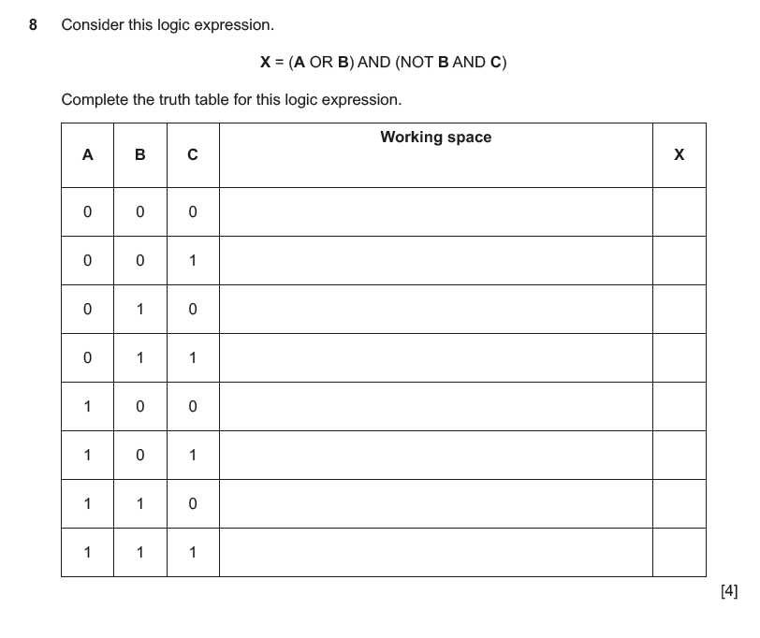
2210/23/M/J/21
9 Consider this logic expression.
Z = (NOT A OR B) AND (B XOR C)
(a) Draw a logic circuit for this logic expression.
Each logic gate must have a maximum of two inputs.
Do not simplify this logic expression.
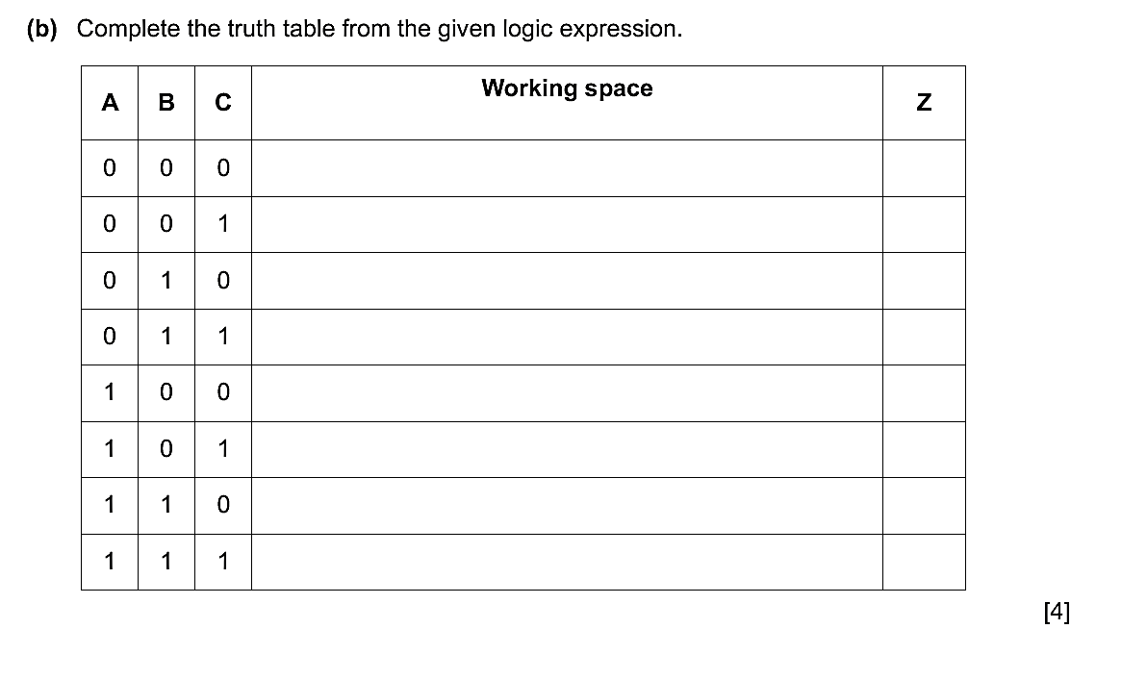
0478/23/F/M/22
7 Consider the logic expression:
X = (A XOR B) AND (NOT B AND C)
(a) Draw a logic circuit for this logic expression. Each logic gate must have a maximum of two
inputs. Do not simplify this logic expression.
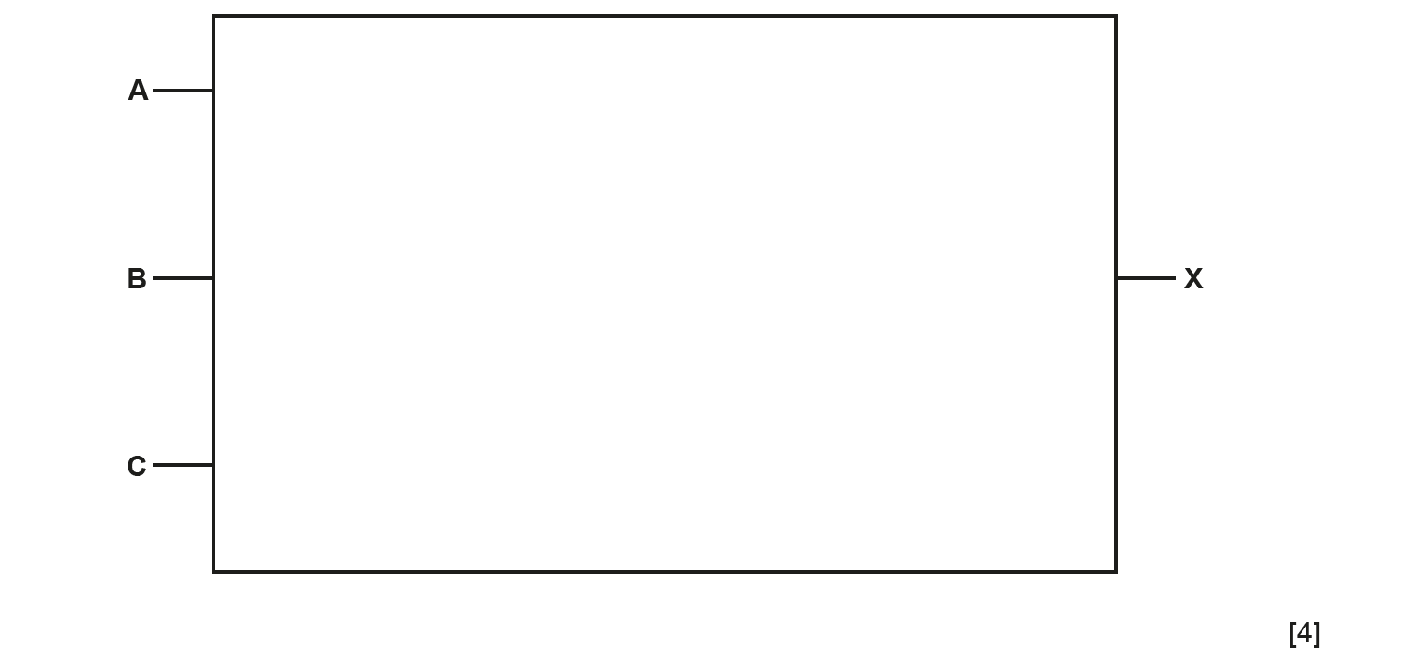
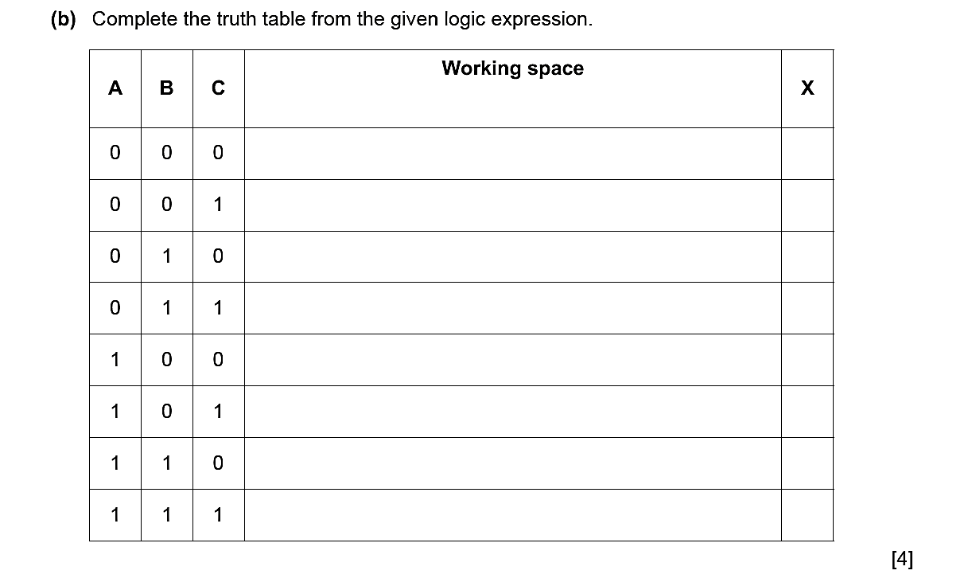

Specimen paper 2B

7 Consider the truth table:

A | B | C | X
0 | 0 | 0 | 0
0 | 0 | 1 | 0
0 | 1 | 0 | 0
0 | 1 | 1 | 0
1 | 0 | 0 | 1
1 | 0 | 1 | 0
1 | 1 | 0 | 0
1 | 1 | 1 | 1

- Draw a logic circuit to represent the given truth table. Each logic gate should have maximum of two inputs. Do not simplify the logic circuit.


A

B |  |  |  | X

C

[6]

- Write a logic expression for the given truth table. Do not simplify the logic expression.

...................................................................................................................................................

...................................................................................................................................................

...................................................................................................................................................

...................................................................................................................................................

...................................................................................................................................................

...................................................................................................................................................

...................................................................................................................................................

.............................................................................................................................................. [3]

Specimen paper 2A
6 Consider this logic expression.
X = ( A AND B ) OR ( B AND NOT C )
(a) Draw a logic circuit for this logic expression.
Each logic gate must have a maximum of two inputs.
Do not simplify this logic expression.
