Topic: Program development Life Cycle
2210/24/M/J/22
- Tick (✓) one box to identify a method used to design and construct a solution to a computing problem.

A analysis

B coding

C flowchart

D testing

[1]
- Identify three different tasks in the analysis stage of the program development life cycle.

  - .......................................................................................................................................................

..........................................................................................................................................................

  - .......................................................................................................................................................

..........................................................................................................................................................

3 .......................................................................................................................................................

..........................................................................................................................................................

[3]
2210/24/M/J/21
- Tick (_{ü}) one box to complete this sentence.

A validation check to make sure that an email address contains an ‘@’ sign is a

A range check.

B visual check.

C presence check.

D format check.

[1]

2210/23/M/J/22
1 Tick (✓) one box to identify the first stage of the program development life cycle.

A Analysis

B Coding

C Design

D Testing

[1]

- Identify three different ways that the design of a solution to a problem can be presented.

  - .......................................................................................................................................................

..........................................................................................................................................................

  - .......................................................................................................................................................

..........................................................................................................................................................

3 .......................................................................................................................................................

..........................................................................................................................................................

[3]

2210/23/M/J/21
1 (a) Four descriptions of stages in the program development life cycle are shown.

Draw one line to link each description to its most appropriate program development life cycle stage.

Not all program development life cycle stages will be used.

Program development life cycle description

develop an algorithm to solve the problem by using structure diagrams, flowcharts or pseudocode

detect and fix the errors in the program

identify the problem and its requirements

write and implement the instructions to solve the problem

Program development life cycle stage

analysis

coding

design

evaluation

testing

[4]

- Identify three of the component parts after a problem has been decomposed.

1 ................................................................................................................................................

...................................................................................................................................................

2 ................................................................................................................................................

...................................................................................................................................................

3 ................................................................................................................................................

...................................................................................................................................................

[3]

0478/23/F/M/22
1 Tick (✓) one box to show which task is part of the analysis stage of the program life cycle.

A coding

B decomposition

C design

D testing

[1]

Specimen paper 2B
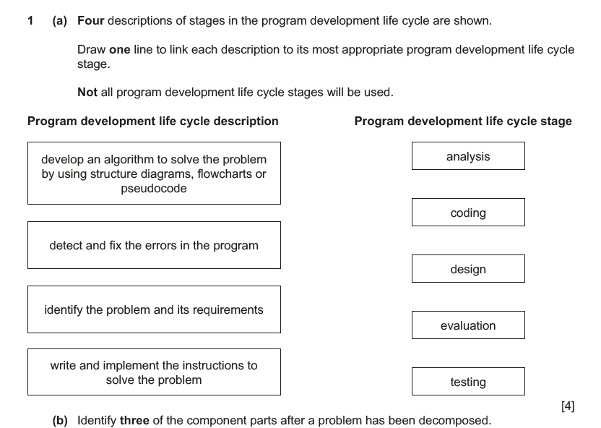
(b) Identify three of the component parts after a problem has been decomposed.
1 ................................................................................................................................................
...................................................................................................................................................
2 ................................................................................................................................................
...................................................................................................................................................
3 ................................................................................................................................................
...................................................................................................................................................
[3]
COMPUTER SCIENCE 2210/22
Paper 2 Algorithms, Programming and Logic May/June 2023
